APPENDIX A
Table A1: Comparison of different datasets
Dataset | Total Samples | Local Recurrence | Regional Recurrence | Distant Recurrence | Second Primary | Train Samples (80%) | Test Samples (20%)
METABRIC | 1980 | 520 | 480 | 780 | 200 | 1584 | 396
GSE2034 | 286 | 78 | 64 | 110 | 34 | 229 | 57
GSE2990 | 189 | 53 | 48 | 73 | 15 | 151 | 38
BCSC | 1500 | 410 | 365 | 570 | 155 | 1200 | 300
Coimbra | 116 | 22 | 20 | 60 | 14 | 93 | 23

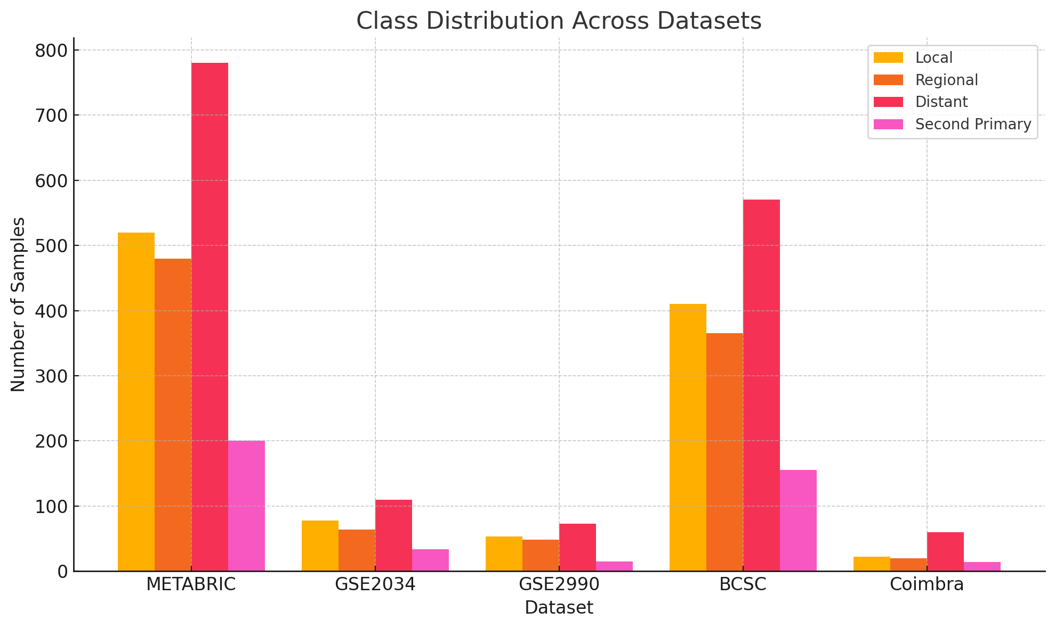
Figure A1: Class distribution across datasets
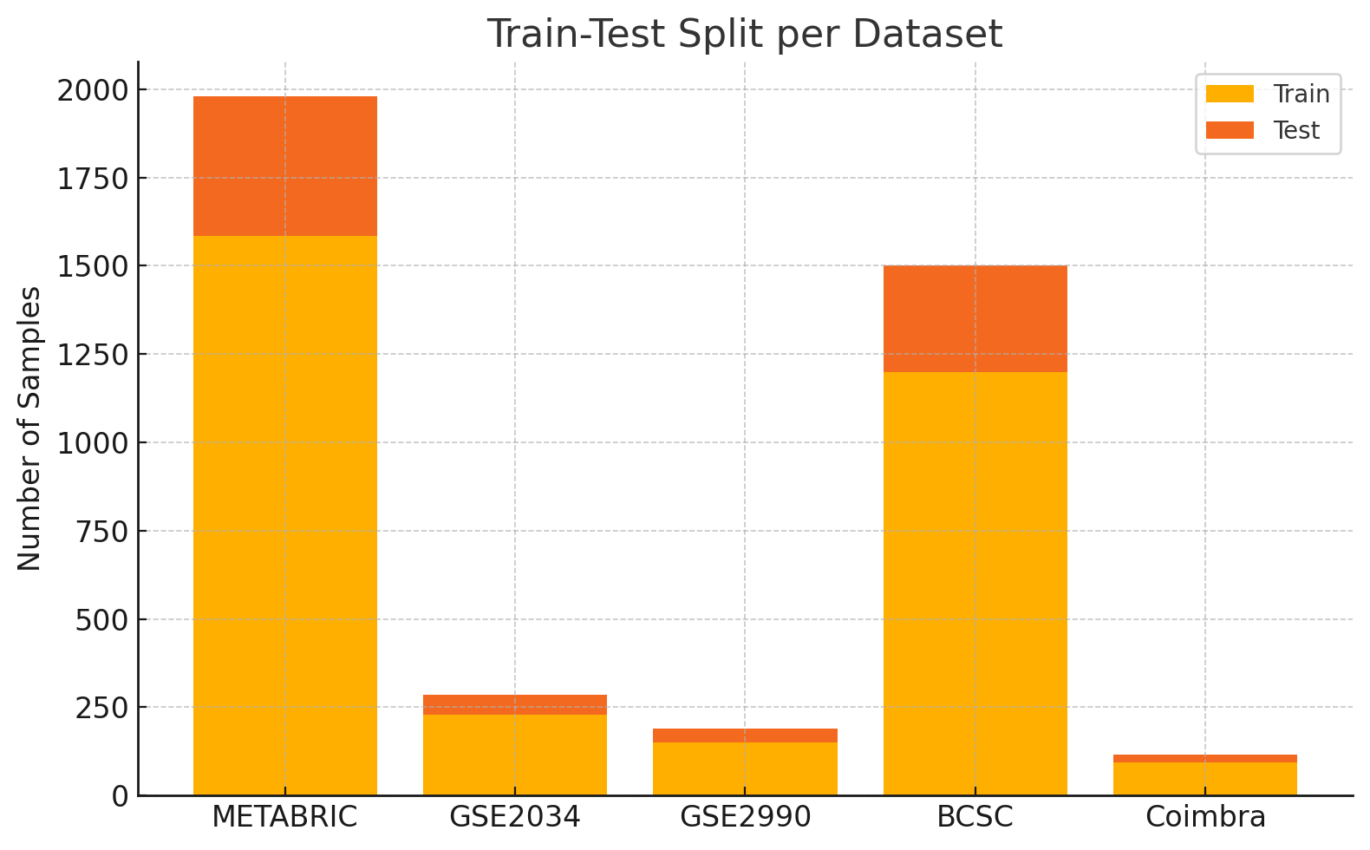
Figure A2: Train-Test Split per dataset

Table A2: Performance Comparison with Baseline Models
Model | Accuracy (%) | F1-Score | C-index
Proposed Unified Transformer (Ours) | 99.12 | 0.991 | 0.91
Cox Proportional Hazards (CoxPH) | 82.45 | 0.802 | 0.73
Random Survival Forest (RSF) | 85.3 | 0.832 | 0.76
DeepSurv (DL Survival) | 91.26 | 0.903 | 0.85
XGBoost Classifier | 88.4 | 0.877 | 0.79
Multimodal CNN + MLP (baseline) | 93.18 | 0.918 | 0.87

