Supplementary Fig. 1. Timeline of the SONFH model establishment and Bilobalide administration.
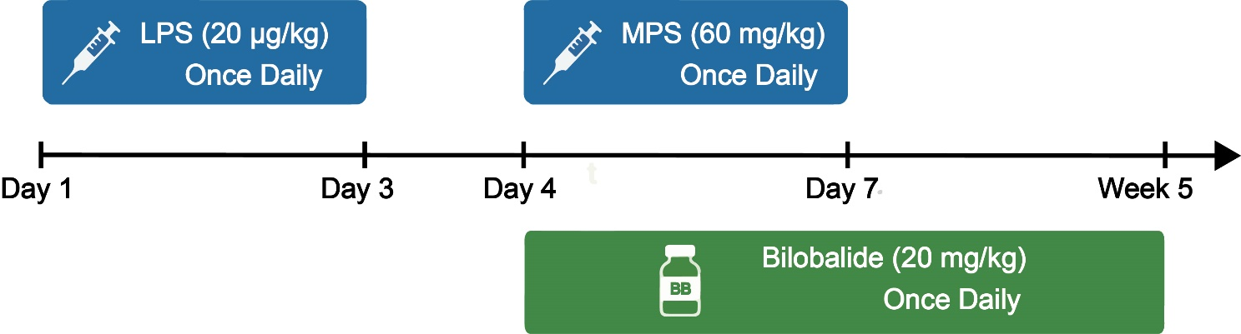

Supplementary Table S1. Sources and dilution factors of antibodies used in Western blotting, IHC, and IF.
Target | Host Species | Application | Dilution | Manufacturer | Catalog No.
Runx2 | Rabbit | IF | 1:600 | Proteintech, China | 20700-1-AP
OCN | Rabbit | IHC | 1:400 | Proteintech, China | 23418-1-AP
CD31 | Rabbit | IF | 1:500 | Proteintech, China | 11265-1-AP
VEGF (VEGF-A) | Rabbit | IHC | 1:100 | Proteintech, China | 19003-1-AP
Anti-Rabbit IgG (Alexa Fluor® 488) | Goat | IF | 1:1000 | Cell Signaling Technology, USA | #4412
Anti-Rabbit IgG (Alexa Fluor® 594) | Goat | IF | 1:1000 | Cell Signaling Technology, USA | #8889
HIF-1α | Rabbit | IF | 1:200 | Proteintech, China | 20960-1-AP
HIF-1α | Rabbit | WB | 1:2000 | Proteintech, China | 20960-1-AP
ERK1/2 | Rabbit | WB | 1:2000 | Proteintech, China | 11257-1-AP
P-ERK1/2 | Rabbit | WB | 1:1000 | Proteintech, China | 28733-1-AP
GAPDH | Rabbit | WB | 1:20000 | Proteintech, China | 10494-1-AP
HRP-Goat Anti-Rabbit | Goat | WB | 1:8000 | Proteintech, China | SA00001-2

