Figures

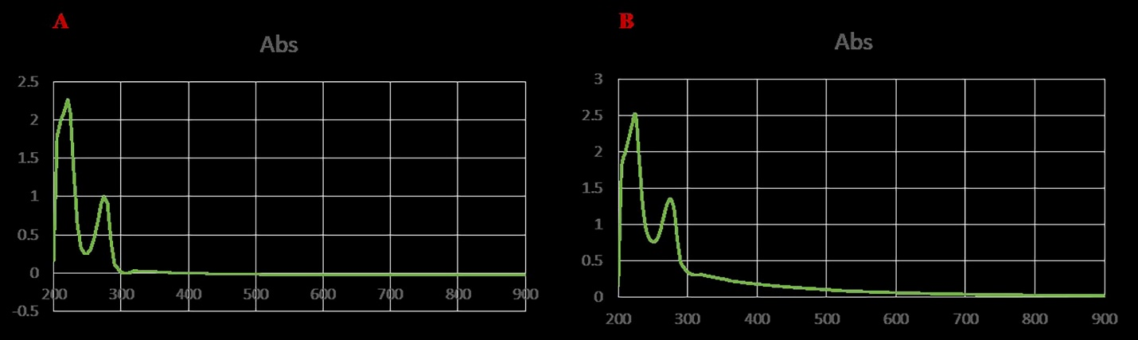
Figure S1. Spectral peak of known concentration in UV-Vis A thyme oil nano-emulsion (TNE), B thyme nano-emulsion containing silver (TNE – AgNPs).

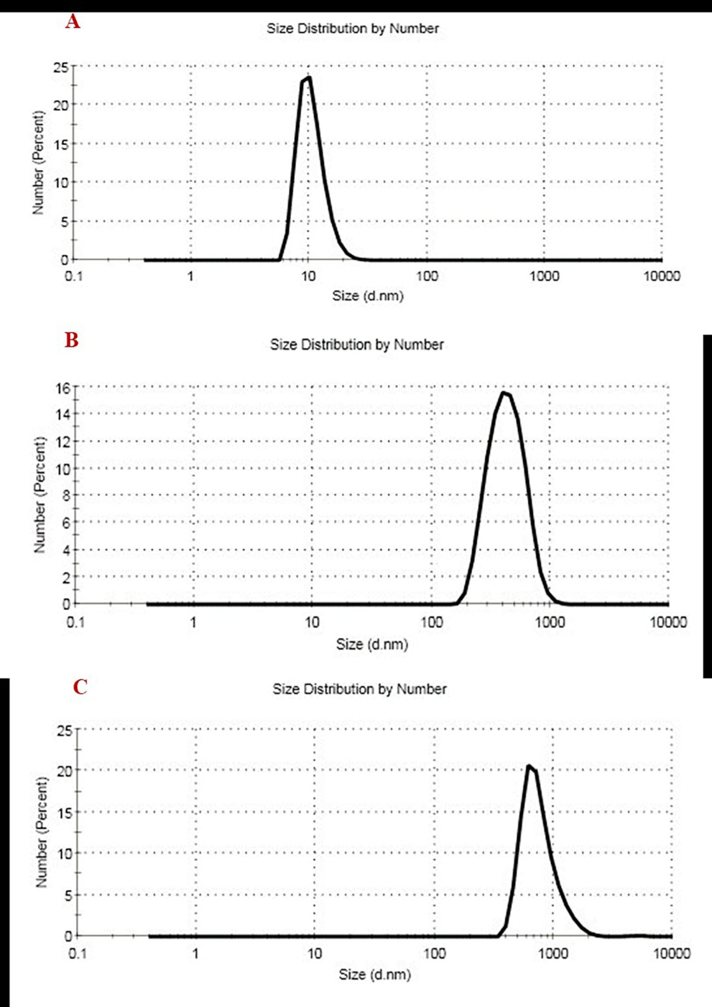
Figure S2. Size distribution by number for A. silver nanoparticle (AgNPs), B. thyme nano-emulsion (TNE), C. thyme nano-emulsion containing silver nanoparticles (TNE – AgNPs)

