Table S1：Distribution of samples and outcome events across training and test cohorts
Cohort | Dataset | No. of patients | No. of recurrence events | Recurrence rate(%)
High-risk recurrence | Training set | 203 | 149 | 73.4
 | Test set | 87 | 66 | 75.9
Local recurrence | Training set | 132 | 78 | 59.1
 | Test set | 56 | 35 | 62.5
Distant metastasis | Training set | 111 | 56 | 50.5
 | Test set | 47 | 27 | 57.4
Percentages may not sum exactly due to rounding.The number of patients for local recurrence and distant metastasis refers to the corresponding sub-cohorts used for recurrence pattern–specific modeling.
Table S2. Preoperative contrast-enhanced CT was performed using a GECT670 64-slice spiral CT scanner (GE Healthcare, USA), along with the corresponding equipment and scanning parameters.

Parameters | Tube voltage | Tube current | Section thickness | Pitch | Rotation time | Detector collimation
Settings | 120kv | 220mAs | 5mm | 1.375 | 0.5s | 646*0.625mm

Table S3. Baseline demographic and clinical characteristics of the local recurrence model population

Characteristic | ALL cohort  N=188 | Test cohort  N=56 | Training cohort  N=132 | P value
Age, Mean ± SD | 61.48±9.61 | 62.42±9.41 | 60.90±9.73 | 0.481
Sex, n(%) |  |  |  | 0.474
Male | 116(61.70%) | 46(65.71%) | 70(59.32%)
Female | 72(38.30%) | 24(34.29%) | 48(40.68%)
BMI (kg/m2), Mean ± SD | 23.87±3.31 | 24.20±3.58 | 23.67±3.14 | 0.479
Hemoglobin, Mean ± SD | 129.55±15.92 | 130.86±16.33 | 128.77±15.70 | 0.377
MCHC, Mean ± SD | 334.47±14.63 | 333.89±17.06 | 334.82±13.05 | 0.624
Platelet, M (Q₁, Q₃) | 211.00(180.00,258.0) | 226.00(178.50,251.50) | 210.00(183.00,269.00) | 0.756
Neutrophil, M (Q₁, Q₃) | 3.30 (2.73, 4.29) | 3.31 (2.64, 4.33) | 3.30 (2.76, 4.29) | 0.945
Eosinophils, M (Q₁, Q₃) | 0.11 (0.07, 0.20) | 0.10 (0.07, 0.20) | 0.12 (0.07, 0.20) | 0.489
Basophil granulocyte M (Q₁, Q₃) | 0.03 (0.02, 0.04) | 0.02 (0.02, 0.04) | 0.03 (0.02, 0.04) | 0.912
Mononuclear cell count, M (Q₁, Q₃) | 0.41 (0.30, 0.53) | 0.43 (0.32, 0.58) | 0.41 (0.30, 0.50) | 0.129
Platelet distribution width, M (Q₁, Q₃) | 15.55 (12.50, 16.20) | 15.70 (12.45, 16.30) | 15.50 (12.50, 16.00) | 0.318
AST, M (Q₁, Q₃) | 30.00(17.00,113.65) | 31.00 (15.95, 112.85) | 27.90 (18.00, 112.45) | 0.730
Total bilirubin, M (Q₁, Q₃) | 21.90(11.66,145.93) | 23.28 (11.59, 155.30) | 21.60 (12.20, 136.20) | 0.912
Direct bilirubin, M (Q₁,Q₃) | 7.77 (3.83, 106.09) | 9.86 (3.41, 117.68) | 7.08 (3.89, 104.17) | 0.757
Total bile acid, M (Q₁, Q₃) | 5.66 (2.38, 56.56) | 10.98 (2.30, 96.99) | 5.08 (2.40, 54.08) | 0.744
Total protein, M (Q₁, Q₃) | 64.74 (60.39, 69.91) | 62.63 (60.07, 68.57) | 66.80 (61.10, 71.20) | 0.051
Albumin, M (Q₁, Q₃) | 39.80 (37.48, 43.26) | 39.50 (37.70, 42.73) | 39.90 (37.10, 43.70) | 0.856
Glutamyl transpeptidase, M (Q₁, Q₃) | 41.00(16.00,648.00) | 52.00 (16.00, 707.70) | 39.50 (17.00, 618.50) | 0.444
Prothrombin time, M (Q₁, Q₃) | 10.90 (10.00, 12.00) | 10.90 (10.10, 12.60) | 10.90 (9.90, 11.50) | 0.222
Antithrombin Ⅲ, Mean ± SD | 108.62 ± 28.24 | 114.52 ± 26.05 | 104.67 ± 29.06 | 0.152
Fibrinogen, Mean ± SD | 3.35 ± 0.71 | 3.29 ± 0.58 | 3.39 ± 0.78 | 0.360
APTT, M (Q₁, Q₃) | 31.00 (27.80, 34.00) | 30.60 (26.30, 33.55) | 31.10 (28.48, 34.00) | 0.290
Thrombin time, M (Q₁, Q₃) | 14.80 (13.85, 16.35) | 15.00 (14.35, 15.80) | 14.70 (13.60, 17.00) | 0.317
Alpha-fetoprotein, M (Q₁, Q₃) | 3.27 (2.40, 4.53) | 3.26 (2.38, 4.67) | 3.28 (2.44, 4.43) | 0.855
Carcinoembryonic antigen, M (Q₁, Q₃) | 3.11 (2.08, 4.79) | 3.03 (2.04, 4.68) | 3.33 (2.25, 4.78) | 0.331
AJCC, n(%) |  |  |  | 0.178
IA | 14 (6.55%) | 9 (16.07%) | 5 (3.79%)
IB | 69 (39.20%) | 21 (37.50%) | 48 (36.36%)
IIA | 17 (9.66%) | 6 (10.71%) | 11 (8.33%)
IIB | 44 (25.00%) | 13 (23.21%) | 33 (25.00%)
III | 32 (18.18%) | 7 (12.50%) | 25 (18.94%)
Abdominal pain, n(%) |  |  |  | 0.958
No | 77(40.96%) | 28 (50.00%) | 49 (37.12%)
Yes | 111(59.04%) | 28 (50.00%) | 83 (62.88%)
Ventosity, n(%) |  |  |  | 0.696
No | 127(67.55%) | 49 (87.50%) | 78 (59.09%)
Yes | 61(32.45%) | 7 (12.50%) | 54 (40.91%)
Diabetes mellius, n(%) |  |  |  | 0.968
No | 138(73.40%) | 52 (92.86%) | 86 (65.15%)
Yes | 50(26.60%) | 4 (7.14%) | 46 (34.85%)
Adjuvant therapy, n(%) |  |  |  | 1.0
No | 56(29.79%) | 21 (37.50%) | 35 (26.52%)
Yes | 132(70.21%) | 35 (62.50%) | 97 (73.48%)
CA199 (U/mL), n(%) |  |  |  | 0.839
≤150 | 84(44.68%) | 33 (58.93%) | 51 (38.64%)
150-1000 | 77(40.96%) | 17 (30.36%) | 60 (45.45%)
＞1000 | 27(14.36%) | 6 (10.71%) | 21 (15.91%)
Tumor size, n(%) |  |  |  | 0.959
≤2 | 24(12.77%) | 9 (16.07%) | 15 (11.36%)
2-4 | 82(43.62%) | 30 (53.57%) | 52 (39.39%)
>4 | 82(43.61%) | 17 (30.36%) | 65 (49.24%)
Suspicious lymph nodes, n(%) |  |  |  | 0.604
0 | 131(69.68%) | 46 (82.14%) | 85 (64.39%)
1-3 | 51(27.13%) | 10 (17.86%) | 41 (31.06%)
≥4 | 6(3.19%) | 0 (0.00%) | 6 (4.55%)
Tumor location, n(%) |  |  |  | 1.0
Head/ Uncinate | 128(68.09%) | 28 (50.00%) | 100 (75.76%)
Body/ Tail | 60(31.915) | 28 (50.00%) | 32 (24.24%)
Bile duct dilatation, n(%) |  |  |  | 0.239
No | 87(46.28%) | 28 (50.00%) | 59(44.70%)
Yes | 101(53.72%) | 28 (50.00%) | 73(55.30%)
Pancreatic duct dilatation, n(%) |  |  |  | 1.0
No | 66(35.11%) | 25 (44.64%) | 41 (31.06%)
Yes | 122(64.89%) | 31 (55.36%) | 91 (68.94%)
Vascular invasion, n(%) |  |  |  | 0.968
No | 138(73.40%) | 52 (92.86%) | 86 (65.15%)
Yes | 50(26.60%) | 4 (7.14%) | 46 (34.85%)
Suspected lymph node involvement, n(%) |  |  |  | 0.355
No | 126(67.02%) | 43 (76.79%) | 83 (60.61%)
Yes | 62(32.98%) | 13 (23.21%) | 49 (28.79%)
Tumor enhancement pattern, n(%) |  |  |  | 0.847
Non-rim | 110(58.60%) | 38 (67.86%) | 72 (54.54%)
Rim enhancement | 78(41.40%) | 18 (32.14%) | 60 (55.46%)
Recurrence-free survival |  |  |  | 0.455
Recurrence | 75(39.89%) | 25 (44.64%) | 50 (37.88%)
Unrecurrence | 113(60.11%) | 31 (55.36%) | 82 (62.12%)
SD: standard deviation, M: Median, Q₁: 1st Quartile, Q₃: 3st Quartile
BMI:Body mass index;MCHC: Mean corpuscular hemoglobin concentration;AST:glutamic oxaloacetic transaminase;APTT:activated partial thromboplastin time;MCH:Mean corpuscular hemoglobin;AJCC:American Joint Committee on Cancer

Table S4. Surgical and pathological variables of patients in the local recurrence development and validation cohort

Characteristic | ALL cohort  N=188 | Test cohort  N=56 | Training cohort  N=132 | P value
T stage |  |  |  | 0.959
1 | 24(12.77%) | 7 (12.50%) | 17 (12.88%)
2 | 82(43.62%) | 24 (42.86%) | 58 (43.94%)
3 | 75(39.89%) | 22 (39.29%) | 53 (40.15%)
4 | 7(3.72%) | 3 (5.36%) | 4 (3.03%)
N stage |  |  |  | 0.604
0 | 131(69.68%) | 39 (69.64%) | 92 (69.70%)
1 | 51(27.13%) | 15 (26.79%) | 36 (27.27%)
2 | 6(3.19%) | 2 (3.57%) | 4 (3.03%)
Tumor location |  |  |  | 1.0
Head/Uncinate | 128(68.09%) | 38 (67.86%) | 90 (68.18%)
Body/Tail | 60(31.91%) | 18 (32.14%) | 42 (31.82%)
Bile duct dilatation |  |  |  | 0.239
No | 87(46.28%) | 26 (46.43%) | 61 (46.21%)
Yes | 101(53.72%) | 30 (53.57%) | 71 (53.79%)
Pancreatic duct dilatation |  |  |  | 0.388
No | 66(35.11%) | 20 (35.71%) | 46 (34.85%)
Yes | 122(64.89%) | 36 (64.29%) | 86 (65.15%)
Type of surgery |  |  |  | 1.0
PD | 60(31.91%) | 18 (32.14%) | 42 (31.82%)
DP | 128(68.09%) | 38 (67.86%) | 90 (68.18%)
Surgical procedure |  |  |  | 0.397
Laparoscopy | 34(18.09%) | 10 (17.86%) | 24 (18.18%)
Laparotomy | 154(81.91%) | 46 (82.14%) | 108 (81.82%)
Vascular resection |  |  |  | 0.968
No | 138(73.40%) | 41 (73.21%) | 97 (73.48%)
Yes | 50(26.60%) | 15 (26.79%) | 35 (26.52%)
Lymphovascular invasion |  |  |  | 0.355
No | 122(64.89%) | 36 (64.29%) | 86 (65.15%)
Yes | 66(35.11%) | 20 (35.71%) | 46 (34.85%)
Invasion of adjacent organs |  |  |  | 0.894
No | 126(67.02%) | 38 (67.86%) | 88 (66.67%)
Yes | 62(32.98%) | 18 (32.14%) | 44 (33.33%)

Table S5. Baseline demographic and clinical characteristics of the distant metastatic model population

Characteristic | ALL cohort  N=158 | Test cohort  N=47 | Training cohort  N=111 | P value
Age, Mean ± SD | 61.68±9.98 | 62.42±9.41 | 60.90±9.73 | 0.48
Sex, n(%) |  |  |  | 0.94
Male | 103(65.19%) | 41(64.06%) | 62(65.96%)
Female | 55(34.81%) | 23(35.94%) | 32(34.04%)
BMI(kg/m²), Mean ± SD | 23.87±3.31 | 24.20±3.58 | 23.67±3.14 | 0.479
Hemoglobin, Mean ± SD | 131.33 ± 15.60 | 129.32 ± 15.66 | 133.07 ± 15.43 | 0.136
Mean Corpuscular Volume, M (Q₁, Q₃) | 90.50 (88.10, 93.70) | 90.55(87.47,94.70) | 90.50(88.40,92.90) | 0.804
MCH, M (Q₁, Q₃) | 30.40(29.40,31.80) | 30.70(29.50,31.83) | 30.20(29.30,31.75) | 0.427
MCHC, Mean ± SD | 335.32 ± 12.41 | 334.01 ± 12.07 | 336.46 ± 12.67 | 0.223
Platelet, M (Q₁, Q₃) | 210.00(180.50,247.50) | 221.50(178.75,250.75) | 206.00(182.00,246.50) | 0.848
Lymphocyte, M (Q₁, Q₃) | 1.43 (1.16, 1.90) | 1.42 (1.14, 1.77) | 1.43 (1.18, 1.91) | 0.613
Neutrophil, M (Q₁, Q₃) | 3.22 (2.54, 4.10) | 3.34 (2.65, 4.41) | 3.16 (2.32, 3.79) | 0.099
Eosinophils, M (Q₁, Q₃) | 0.11 (0.07, 0.20) | 0.10 (0.07, 0.19) | 0.12 (0.06, 0.20) | 0.672
Basophil granulocyte, M (Q₁, Q₃) | 0.03 (0.02, 0.04) | 0.02 (0.02, 0.04) | 0.03 (0.02, 0.04) | 0.784
Mononuclear cell count, M (Q₁, Q₃) | 0.40 (0.32, 0.53) | 0.42 (0.32, 0.59) | 0.40 (0.32, 0.47) | 0.233
Platelet volume, Mean ± SD | 10.98 ± 6.94 | 10.70 ± 1.30 | 11.22 ± 9.42 | 0.640
Platelet distribution width, M (Q₁, Q₃) | 15.20 (12.05, 16.20) | 15.55 (12.40, 16.22) | 14.30 (11.70, 16.20) | 0.128
AST, M (Q₁, Q₃) | 29.90 (15.00, 113.50) | 31.75 (15.97, 119.15) | 22.50 (14.22, 106.50) | 0.499
Total bilirubin, M (Q₁, Q₃) | 21.70 (11.84, 153.69) | 21.74 (11.62, 154.94) | 21.70 (12.49, 152.53) | 0.722
Direct bilirubin, M (Q₁, Q₃) | 8.89 (3.60, 119.93) | 8.84 (3.34, 115.94) | 8.89 (3.80, 120.95) | 0.572
Total bile acid, M (Q₁, Q₃) | 5.29 (2.50, 42.59) | 10.98 (2.48, 132.77) | 4.87 (2.50, 33.12) | 0.435
Total protein, Mean ± SD | 64.41 ± 8.31 | 63.91 ± 6.00 | 64.85 ± 9.90 | 0.487
Albumin, M (Q₁, Q₃) | 39.40 (37.70, 42.73) | 39.45 (37.71, 42.73) | 39.11 (37.60, 42.87) | 0.899
Glutamyl transpeptidase, M (Q₁, Q₃) | 40.64 (15.12, 561.62) | 65.95 (19.00, 703.55) | 30.95 (14.95, 453.50) | 0.114
Prothrombin time, M (Q₁, Q₃) | 10.80 (9.80, 12.50) | 10.95 (10.10, 12.55) | 10.50 (9.70, 12.30) | 0.142
Antithrombin Ⅲ, Mean ± SD | 110.35 ± 27.95 | 115.45 ± 26.16 | 105.93 ± 28.85 | 0.094
Fibrinogen, Mean ± SD | 3.34 ± 0.74 | 3.30 ± 0.55 | 3.38 ± 0.88 | 0.455
APTT, M (Q₁, Q₃) | 30.70 (27.85, 34.30) | 30.60 (26.30, 33.52) | 30.80 (29.20, 35.00) | 0.243
Thrombin time, M (Q₁, Q₃) | 15.00 (14.10, 16.60) | 15.00 (14.25, 15.83) | 15.10 (13.95, 17.45) | 0.654
Alpha-fetoprotein, M (Q₁, Q₃) | 3.17 (2.38, 4.53) | 3.31 (2.46, 4.80) | 3.04 (2.38, 4.36) | 0.344
Carcinoembryonic antigen, M (Q₁, Q₃) | 3.05 (1.98, 5.26) | 2.93 (2.02, 4.60) | 3.12 (1.98, 6.38) | 0.557
AJCC, n(%) |  |  |  | 0.128
IA | 15 (9.49%) | 6 (12.77%) | 9 (8.11%)
IB | 59 (37.34%) | 21 (44.68%) | 38 (34.23%)
IIA | 17 (10.76%) | 5 (10.64%) | 12 (10.81%)
IIB | 48 (30.38%) | 8 (17.02%) | 40 (36.04%)
III | 19 (12.03%) | 7 (14.89%) | 12 (10.81%)
Abdominal pain, n(%) |  |  |  | 0.424
No | 69(43.67%) | 18 (38.30%) | 51 (45.95%)
Yes | 89(56.33%) | 29 (61.70%) | 60 (54.05%)
Ventosity, n(%) |  |  |  | 0.093
No | 107(67.72%) | 28 (59.57%) | 79 (71.17%)
Yes | 51(32.28%) | 19 (40.43%) | 32 (28.83%)
Diabetes mellius, n(%) |  |  |  | 0.388
No | 119(75.32%) | 37 (78.72%) | 82 (73.87%)
Yes | 39(24.68%) | 10 (21.28%) | 29 (26.13%)
Adjuvant therapy, n(%) |  |  |  | 1.0
No | 47(29.75%) | 14 (29.79%) | 33 (29.73%)
Yes | 111(70.25%) | 33 (70.21%) | 78 (70.27%)
CA199 (U/mL), n(%) |  |  |  | 0.098
≤150 | 87(55.06%) | 29 (61.70%) | 58 (52.25%)
150-1000 | 58(36.71%) | 16 (34.04%) | 42 (37.84%)
＞1000 | 13(8.23%) | 2 (4.26%) | 11 (9.91%)
Tumor size, n(%) |  |  |  | 0.186
≤2 | 22(14.01%) | 6 (12.77%) | 16 (14.41%)
2-4 | 74(47.13%) | 22 (46.81%) | 52 (46.85%)
>4 | 61(38.85%) | 19 (40.42%) | 43 (38.74%)
Suspicious lymph nodes, n(%) |  |  |  | 0.199
0 | 107(67.72%) | 32 (68.09%) | 75 (67.57%)
1-3 | 47(29.75%) | 13 (27.66%) | 34 (30.63%)
≥4 | 4(2.53%) | 2 (4.25%) | 2 (1.80%)
Tumor location, n(%) |  |  |  | 0.255
Head/ Uncinate | 99(62.66%) | 30 (63.83%) | 69 (62.16%)
Body/ Tail | 59(37.34%) | 17 (36.17%) | 42 (37.84%)
Bile duct dilatation, n(%) |  |  |  | 0.829
No | 72(45.57%) | 21 (44.68%) | 51 (45.95%)
Yes | 86(54.43%) | 26 (55.32%) | 60 (54.05%)
Pancreatic duct dilatation, n(%) |  |  |  | 0.462
No | 61(38.61%) | 18 (38.30%) | 43 (38.74%)
Yes | 97(61.39%) | 29 (61.70%) | 68 (61.26%)
Vascular invasion, n(%) |  |  |  | 0.968
No | 117(74.05%) | 35 (74.47%) | 82 (73.87%)
Yes | 41(25.95%) | 12 (25.53%) | 29 (26.13%)
Suspected lymph node involvement, n(%) |  |  |  | 1.0
No | 106(67.09%) | 31 (65.96%) | 75 (67.57%)
Yes | 52(32.91%) | 16 (34.04%) | 36 (32.43%)
Suspected peripheral organ invasion, n(%) |  |  |  | 0.849
No | 111(70.25%) | 33 (70.21%) | 78 (70.27%)
Yes | 47(29.75%) | 14 (29.79%) | 33 (29.73%)
Tumor enhancement pattern, n(%) |  |  |  | 0.939
Non-rim | 92(58.23%) | 27 (57.45%) | 65 (58.56%)
Rim enhancement | 66(41.77%) | 20 (42.55%) | 46 (41.44%)
Recurrence-free survival , n(%) |  |  |  | 1.0
Recurrence | 75(47.47%) | 22 (46.81%) | 53 (47.75%)
Unrecurrence | 83(52.53%) | 25 (53.19%) | 58 (52.25%)
SD: standard deviation, M: Median, Q₁: 1st Quartile, Q₃: 3st Quartile
BMI:Body mass index;MCHC: Mean corpuscular hemoglobin concentration;AST:glutamic oxaloacetic transaminase;APTT:activated partial thromboplastin time;MCH:Mean corpuscular hemoglobin;AJCC:American Joint Committee on Cancer

Table S6. Surgical and pathological variables of patients in the distant metastasis development and validation cohort

Characteristic | ALL cohort  N=158 | Test cohort  N=47 | Training cohort  N=111 | P value
T stage |  |  |  | 0.214
1 | 22(13.92%) | 6 (12.77%) | 16 (14.41%)
2 | 75(47.47%) | 22 (46.81%) | 53 (47.75%)
3 | 52(32.91%) | 15 (31.91%) | 37 (33.33%)
4 | 9(5.70%) | 4 (8.51%) | 5 (4.50%)
N stage |  |  |  | 0.199
0 | 107(67.72%) | 32 (68.09%) | 75 (67.57%)
1 | 47(29.75%) | 13 (27.66%) | 34 (30.63%)
2 | 4(2.53%) | 2 (4.26%) | 2 (1.80%)
Tumor location |  |  |  | 0.255
Head/ Uncinate | 99(62.66%) | 30 (63.83%) | 69 (62.16%)
Body/ Tail | 59(37.34%) | 17 (36.17%) | 42 (37.84%)
Bile duct dilatation |  |  |  | 0.829
No | 72(45.57%) | 21 (44.68%) | 51 (45.95%)
Yes | 86(54.43%) | 26 (55.32%) | 60 (54.05%)
Pancreatic duct dilatation |  |  |  | 0.462
No | 61(38.61%) | 18 (38.30%) | 43 (38.74%)
Yes | 97(61.39%) | 29 (61.70%) | 68 (61.26%)
Type of surgery |  |  |  | 0.113
PD | 60(37.97%) | 18 (38.30%) | 42 (37.84%)
DP | 98(62.03%) | 29 (61.70%) | 69 (62.16%)
Surgical procedure |  |  |  | 0.502
Laparoscopy | 22(13.92%) | 7 (14.89%) | 15 (13.51%)
Laparotomy | 136(86.08%) | 40 (85.11%) | 96 (86.49%)
Vascular resection |  |  |  | 0.968
No | 117(74.05%) | 35 (74.47%) | 82 (73.87%)
Yes | 41(25.95%) | 12 (25.53%) | 29 (26.13%)
Lymphovascular invasion |  |  |  | 1.0
No | 106(67.09%) | 32 (68.09%) | 74 (66.67%)
Yes | 52(32.91%) | 15 (31.91%) | 37 (33.33%)
Invasion of adjacent organs |  |  |  | 0.849
No | 111(70.25%) | 33 (70.21%) | 78 (70.27%)
Yes | 47(29.75%) | 14 (29.79%) | 33 (29.73%)

Table S7.Variance inflation factor (VIF) analysis of variables retained in the final multivariate Cox model
Features | VIF
Diabetes mellitus | 1.375272
Neutrophil | 2.818834
CA19-9 | 1.811862
Tumor enhancement pattern | 1.407688
AJCC | 3.389054

Table S8. Lasso-Cox proportional hazard analyses of predictors of recurrence pattern of radiomics model in study population

Model name | Covariate | Coef | 95%CI | HR | HR lower 95% | P value
Recurrence | intra_wavelet_LLL_ngtdm_Contrast | -0.11 | -0.35-0.12 | 0.892 | 0.703-1.131 | 0.34
 | intra_wavelet_HLH_glcm_Correlation | -0.25 | -0.46--0.04 | 0.779 | 0.634-0.959 | 0.02
 | intra_exponential_ngtdm_Contrast | -0.15 | -0.37-0.07 | 0.858 | 0.689-1.069 | 0.17
 | intra_log_sigma_3_0_mm_3D_ngtdm_Complexity | -0.04 | -0.24-0.15 | 0.958 | 0.790-1.160 | 0.66
 | intra_square root_glszm_Small Area Low Gray Level Emphasis | -0.06 | -0.27-0.16 | 0.946 | 0.760-1.177 | 0.62
 | intra_original_shape_Flatness | 0.15 | -0.03-0.32 | 1.159 | 0.973-1.382 | 0.10
 | intra_log_sigma_3_0_mm_3D_firstorder_Root Mean Squared | 0.07 | -0.14-0.28 | 1.074 | 0.872-1.323 | 0.50
 | intra_wavelet_LLL_ngtdm_Busyness | 0.19 | -0.01-0.39 | 1.206 | 0.988-1.472 | 0.07
 | intra_lbp_3D_m2_ngtdm_Complexity | 0.25 | 0.08-0.43 | 1.290 | 1.088-1.530 | <0.005
 | intra_exponential_glcm_Imc2 | -0.01 | -0.24-0.22 | 0.988 | 0.785-1.244 | 0.92
Local recurrence | intra_wavelet_HLH_firstorder_Skewness | -0.26 | -0.51--0.02 | 0.767 | 0.600-0.980 | 0.034
 | intra_wavelet_HHL_glcm_ClusterShade | -0.23 | -0.58-0.12 | 0.797 | 0.563-1.129 | 0.202
 | intra_wavelet_HHH_firstorder_Median | -0.22 | -0.59-0.16 | 0.804 | 0.552-1.169 | 0.253
 | intra_wavelet_LLL_firstorder_Maximum | -0.21 | -0.52-0.09 | 0.810 | 0.596-1.100 | 0.176
 | intra_exponential_glszm_Zone Variance | -0.22 | -0.52-0.07 | 0.800 | 0.597-1.071 | 0.133
 | intra_wavelet_HLL_glcm_Correlation | -0.18 | -0.48-0.11 | 0.831 | 0.618-1.119 | 0.222
 | intra_log_sigma_3_0_mm_3D_ngtdm_Complexity | -0.09 | -0.39-0.22 | 0.917 | 0.676-1.244 | 0.578
 | intra_square root_glszm_Small Area Low Gray Level Emphasis | -0.14 | -0.43-0.15 | 0.872 | 0.654-1.162 | 0.350
 | intra_log_sigma_3_0_mm_3D_firstorder_Skewness | -0.11 | -0.35-0.13 | 0.895 | 0.702-1.141 | 0.370
 | intra_exponential_ngtdm_Contrast | -0.03 | -0.32-0.26 | 0.970 | 0.724-1.298 | 0.836
 | intra_lbp_3D_k_glszm_Zone Percentage | -0.00 | -0.27-0.27 | 0.997 | 0.762-1.306 | 0.983
 | intra_log_sigma_3_0_mm_3D_firstorder_Root Mean Squared | 0.05 | -0.27-0.36 | 1.049 | 0.765-1.438 | 0.767
 | intra_log_sigma_3_0_mm_3D_firstorder_Kurtosis | 0.05 | -0.21-0.32 | 1.056 | 0.807-1.381 | 0.692
 | intra_lbp_3D_m2_glcm_Imc2 | 0.08 | -0.19-0.35 | 1.088 | 0.830-1.426 | 0.542
 | intra_lbp_3D_m2_ngtdm_Complexity | 0.10 | -0.16-0.35 | 1.100 | 0.856-1.413 | 0.456
 | intra_wavelet_HHH_firstorder_Skewness | 0.16 | -0.10-0.41 | 1.169 | 0.908-1.506 | 0.225
 | intra_wavelet_HLH_glcm_Cluster Shade | 0.16 | -0.19-0.50 | 1.168 | 0.826-1.652 | 0.380
 | intra_wavelet_LHL_firstorder_Kurtosis | 0.19 | -0.05-0.44 | 1.214 | 0.948-1.554 | 0.124
 | intra_wavelet_LLL_firstorder_Kurtosis | 0.20 | -0.06-0.45 | 1.218 | 0.942-1.574 | 0.133
Distant metastatic | intra_wavelet_LHL_firstorder_Median | -0.73 | -1.12--0.33 | 0.483 | 0.325-0.718 | 0.001
 | intra_wavelet_HLL_firstorder_Maximum | -0.65 | -1.24--0.05 | 0.524 | 0.290-0.948 | 0.032
 | intra_log_sigma_3_0_mm_3D_ngtdm_Contrast | -0.61 | -1.28-0.07 | 0.546 | 0.277-1.075 | 0.079
 | intra_wavelet_HLH_firstorder_Median | -0.31 | -0.67-0.05 | 0.734 | 0.514-1.047 | 0.087
 | intra_log_sigma_3_0_mm_3D_glcm_Idn | -0.45 | -1.07-0.17 | 0.638 | 0.344-1.183 | 0.153
 | intra_wavelet_LLL_firstorder_Root Mean Squared | -0.22 | -0.54-0.11 | 0.804 | 0.581-1.114 | 0.190
 | intra_lbp_3D_k_glszm_Zone Percentage | -0.19 | -0.56-0.18 | 0.826 | 0.572-1.192 | 0.304
 | intra_log_sigma_1_0_mm_3D_firstorder_Maximum | -0.21 | -0.76-0.34 | 0.812 | 0.469-1.406 | 0.458
 | intra_wavelet_LHL_ngtdm_Busyness | -0.33 | -0.97-0.30 | 0.716 | 0.379-1.354 | 0.304
 | intra_wavelet_LLH_ngtdm_Busyness | -0.06 | -0.76-0.65 | 0.944 | 0.468-1.907 | 0.873
 | intra_wavelet_LLH_glszm_Zone Variance | 0.13 | -0.46-0.73 | 1.143 | 0.631-2.070 | 0.658
 | intra_lbp_3D_m2_firstorder_Range | 0.20 | -0.23-0.62 | 1.218 | 0.798-1.860 | 0.360
 | intra_lbp_3D_m2_ngtdm_Complexity | 0.19 | -0.24-0.62 | 1.209 | 0.789-1.853 | 0.383
 | intra_wavelet_HLL_ngtdm_Strength | 0.40 | -0.28-1.08 | 1.491 | 0.754-2.947 | 0.250
 | intra_wavelet_HLH_glcm_Cluster Shade | 0.52 | 0.01-1.04 | 1.689 | 1.011-2.820 | 0.045
 | intra_wavelet_LLL_glszm_Size Zone Non Uniformity | 0.75 | -0.14-1.64 | 2.113 | 0.867-5.150 | 0.099
 | intra_wavelet_HHH_firstorder_Mean | 0.54 | 0.18-0.91 | 1.720 | 1.192-2.4481 | 0.003
 | intra_exponential_firstorder_Skewness | 0.52 | 0.20-0.85 | 1.689 | 1.225-2.328 | 0.001

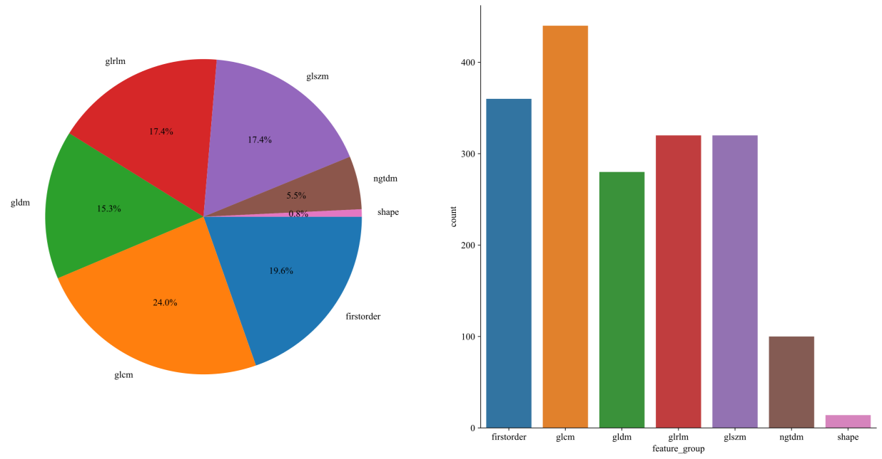
Figure S1. A total of 1,834 radiomic features were extracted using Pyradiomics 3.0.1, with the specific number of features in each category shown in the figure.
Figure S2. Correlation matrix of clinical variables retained in the final multivariate Cox model.
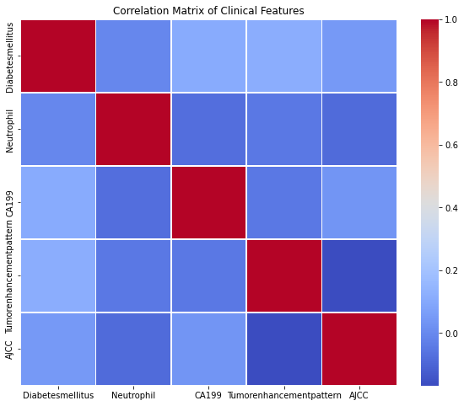

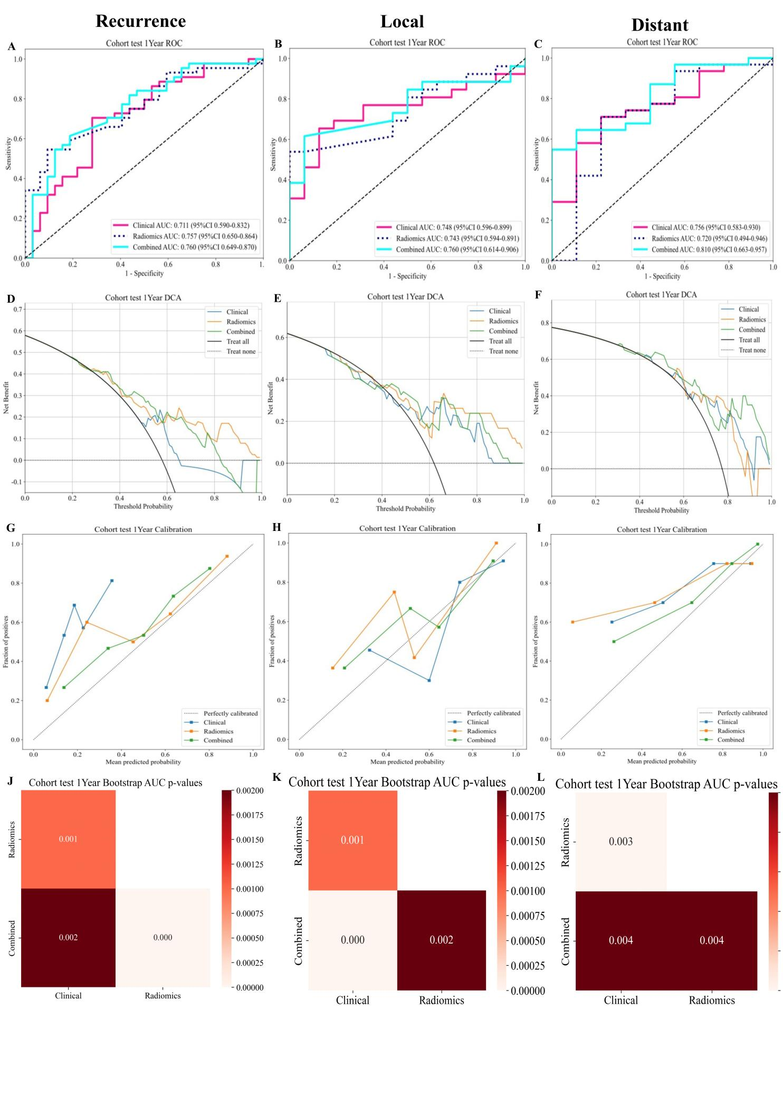
Figure S3. Evaluation of the models for predicting 1-year distinct patterns recurrence-free survival: time-dependent ROC curves (A-C), decision curve analyses(D-F), calibration plots(G-I) and bootstrap AUC p-value (J-L)in the test cohorts.

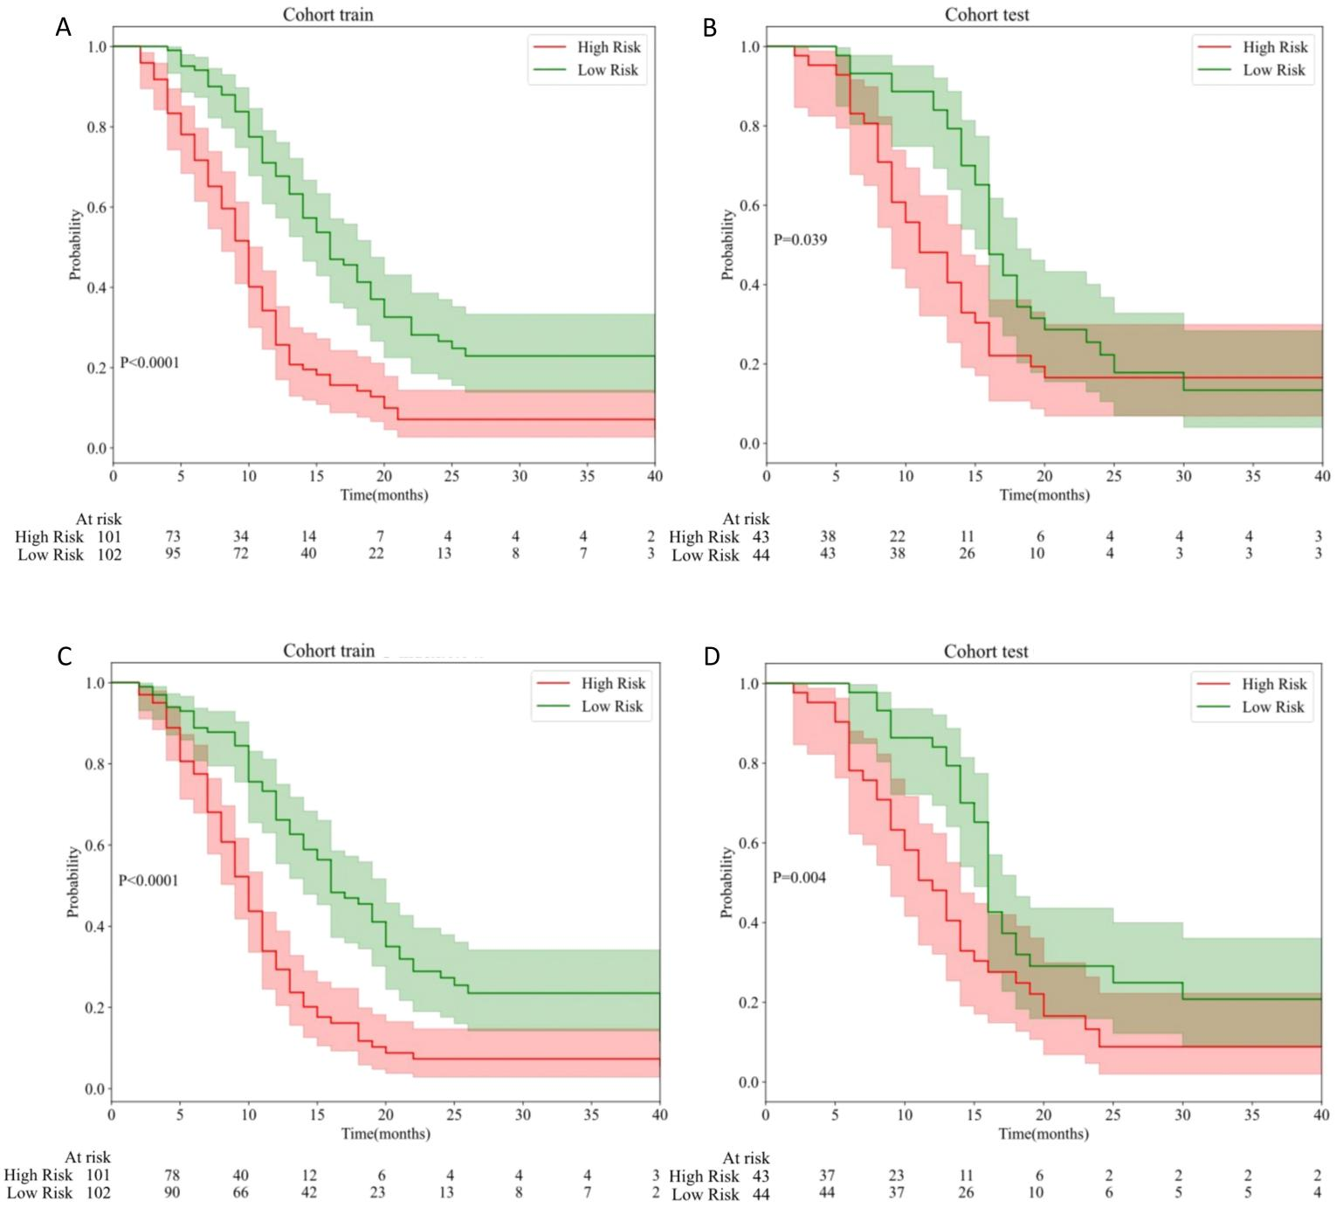

Figure S4. Kaplan-Meier curves of the radiomics model in the training set (A) and test set (B), as well as the clinical model in the training set (C) and test set (D), for predicting high-risk 1-year recurrence after curative resection of pancreatic ductal adenocarcinoma (PDAC). Patients with high risk scores showed significantly lower RFS probabilities compared to those with low risk scores.（P ＜ 0.05）.

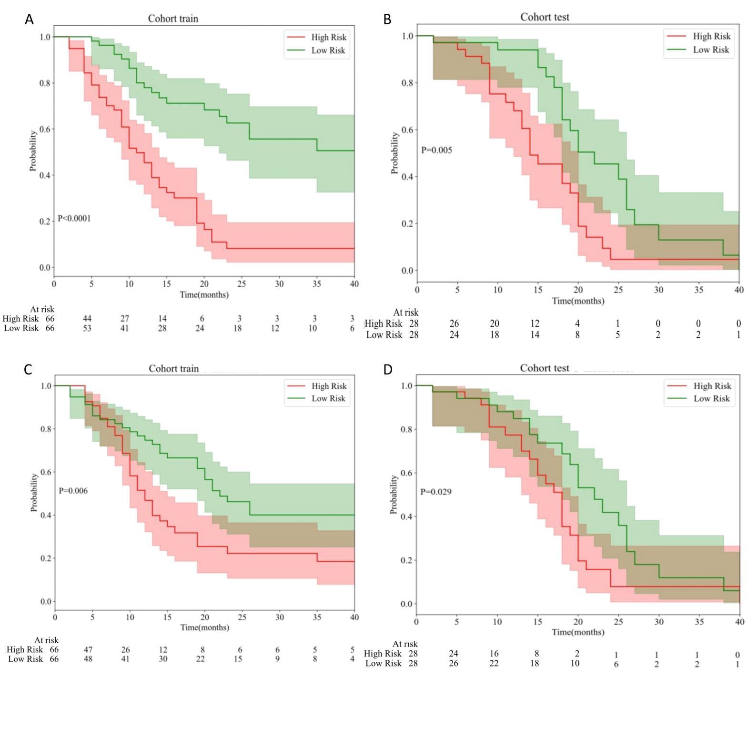Figure S5. Kaplan-Meier curves of the radiomics model in the training set (A) and test set (B), as well as the clinical model in the training set (C) and test set (D), for predicting high-risk 1-year local recurrence after curative resection of pancreatic ductal adenocarcinoma (PDAC). Patients with high risk scores showed significantly lower RFS probabilities compared to those with low risk scores.（P ＜ 0.05）.

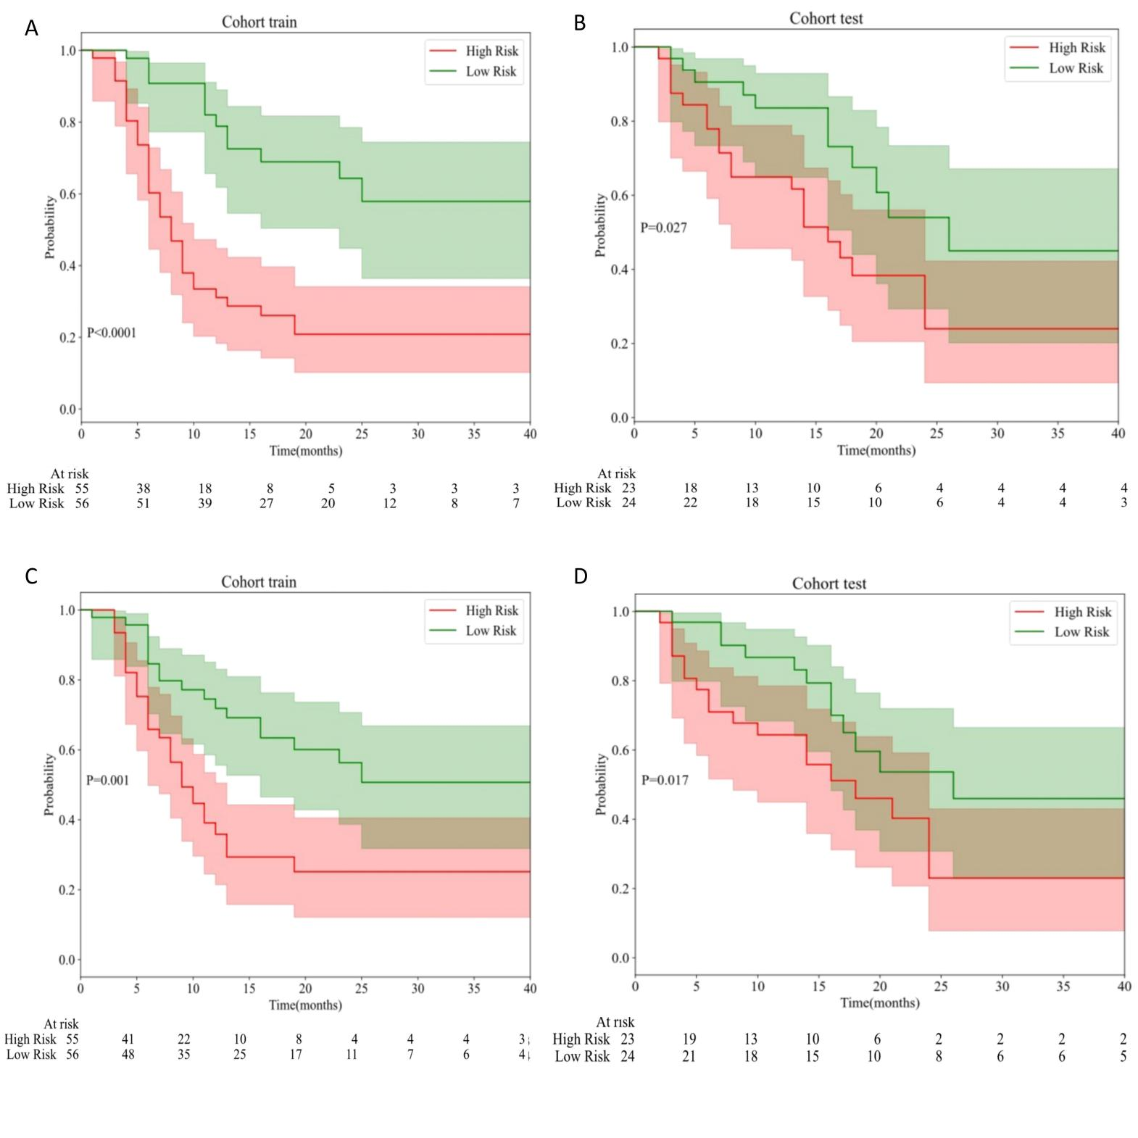Figure S6. Kaplan-Meier curves of the radiomics model in the training set (A) and test set (B), as well as the clinical model in the training set (C) and test set (D), for predicting high-risk 1-year distant metastasis after curative resection of pancreatic ductal adenocarcinoma (PDAC). Patients with high risk scores showed significantly lower RFS probabilities compared to those with low risk scores（P ＜ 0.05）.

A Predictive Model for 1-Year Postoperative Recurrence Risk in Patients with Resected Pancreatic Ductal Adenocarcinoma. Survival formula based on radiomic features selected by LASSO.

Survive = -0.057295 * intra_wavelet_LLL_ngtdm_Contrast -0.044440 * intra_exponential_glcm_Imc2 -0.043952 * intra_wavelet_HLH_glcm_Correlation -0.026745 * intra_exponential_ngtdm_Contrast -0.012060 * intra_log_sigma_3_0_mm_3D_ngtdm_Complexity -0.003534 * intra_squareroot_glszm_SmallAreaLowGrayLevelEmphasis +0.019404 * intra_original_shape_Flatness +0.029285 * intra_log_sigma_3_0_mm_3D_firstorder_RootMeanSquared +0.111948 * intra_wavelet_LLL_ngtdm_Busyness +0.127822 * intra_lbp_3D_m2_ngtdm_Complexity

A Predictive Model for 1-Year Postoperative Local Recurrence Risk in Patients with Resected Pancreatic Ductal Adenocarcinoma. Survival formula based on radiomic features selected by LASSO.

Survive = -0.213257 * intra_wavelet_HLH_firstorder_Skewness -0.178317 * intra_wavelet_HHL_glcm_ClusterShade -0.145918 * intra_wavelet_HHH_firstorder_Median -0.136535 * intra_wavelet_LLL_firstorder_Maximum -0.133839 * intra_exponential_glszm_ZoneVariance -0.119603 * intra_wavelet_HLL_glcm_Correlation -0.101242 * intra_log_sigma_3_0_mm_3D_ngtdm_Complexity -0.059561 * intra_squareroot_glszm_SmallAreaLowGrayLevelEmphasis -0.046815 * intra_log_sigma_3_0_mm_3D_firstorder_Skewness -0.008053 * intra_exponential_ngtdm_Contrast -0.005881 * intra_lbp_3D_k_glszm_ZonePercentage +0.003244 * intra_log_sigma_3_0_mm_3D_firstorder_RootMeanSquared +0.025515 * intra_log_sigma_3_0_mm_3D_firstorder_Kurtosis +0.035553 * intra_lbp_3D_m2_glcm_Imc2 +0.067342 * intra_lbp_3D_m2_ngtdm_Complexity +0.090279 * intra_wavelet_HHH_firstorder_Skewness +0.107336 * intra_wavelet_HLH_glcm_ClusterShade +0.122889 * intra_wavelet_LHL_firstorder_Kurtosis +0.128102 * intra_wavelet_LLL_firstorder_Kurtosis

A Predictive Model for 1-Year Postoperative Distant Metastasis Risk in Patients with Resected Pancreatic Ductal Adenocarcinoma. Survival formula based on radiomic features selected by LASSO.

Survive = -0.587394 * intra_wavelet_LHL_firstorder_Median -0.493256 * intra_wavelet_HLL_firstorder_Maximum -0.290695 * intra_log_sigma_3_0_mm_3D_ngtdm_Contrast -0.246023 * intra_wavelet_HLH_firstorder_Median -0.244812 * intra_log_sigma_3_0_mm_3D_glcm_Idn -0.178371 * intra_wavelet_LLL_firstorder_RootMeanSquared -0.166798 * intra_lbp_3D_k_glszm_ZonePercentage -0.164548 * intra_log_sigma_1_0_mm_3D_firstorder_Maximum -0.156127 * intra_wavelet_LHL_ngtdm_Busyness +0.008537 * intra_wavelet_LLH_ngtdm_Busyness +0.118091 * intra_wavelet_LLH_glszm_ZoneVariance +0.135987 * intra_lbp_3D_m2_firstorder_Range +0.214460 * intra_lbp_3D_m2_ngtdm_Complexity +0.278727 * intra_wavelet_HLL_ngtdm_Strength +0.319548 * intra_wavelet_HLH_glcm_ClusterShade +0.430167 * intra_wavelet_LLL_glszm_SizeZoneNonUniformity +0.434662 * intra_wavelet_HHH_firstorder_Mean +0.442637 * intra_exponential_firstorder_Skewness

