Plötner et al. 2026_Supplementary Material 4 (Figures S1–S4)

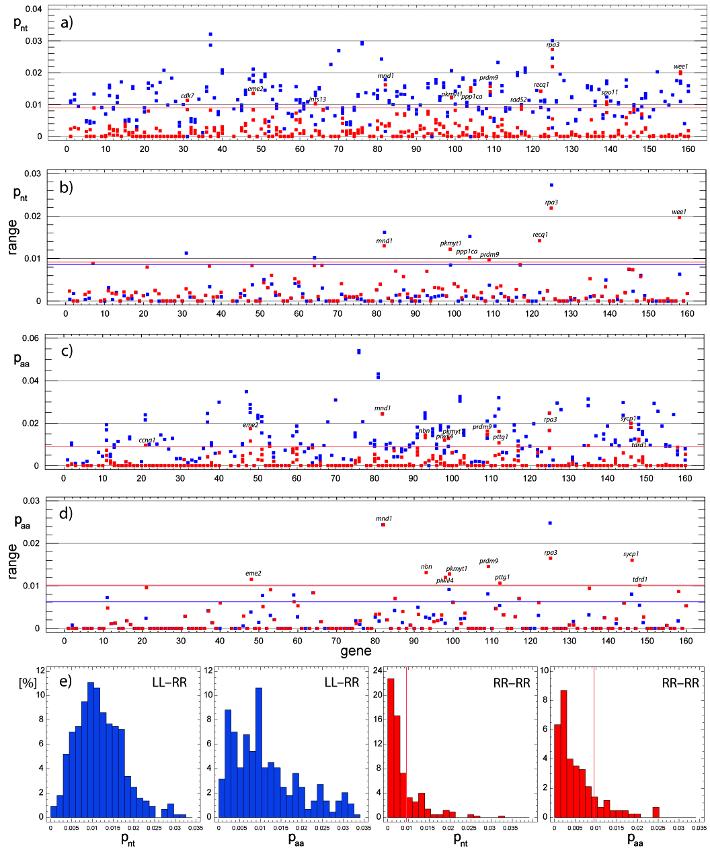
Fig. S3 Scatterplots of pairwise uncorrected distances (a, c), based on nucleotide sequences (p_{nt}) and corresponding amino acid sequences (p_{aa}), their ranges of variation (b, d), and frequency distributions (e), calculated for 160 gametogenic genes. Blue: interspecific comparisons between P. lessonae (LL) and P. ridibundus (RR); red: intraspecific comparisons among P. ridibundus individuals (RR1/RR2, RR1/RR3, RR2/RR3). Values outside the 95% percentile (indicated by blue and red lines) correspond to genes exhibiting unusually low interspecific or unusually high intraspecific distance values. Gene names are listed in Table S1, Supplementary Material 1.

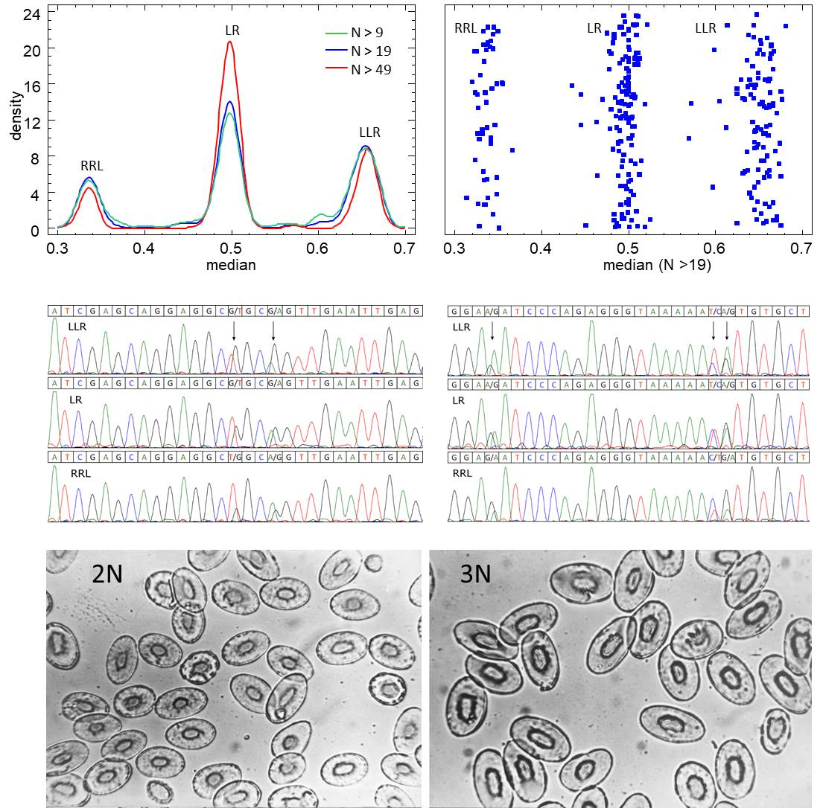
Fig. S2 Methods used to determine the ploidy and genotype of Pelophylax esculentus. Top: Read-based genotyping. The number of L-specific reads per SNP was divided by the total coverage (L + R). Because of gene dosage effects, triploid hybrids with two L genomes and one R genome (LLR) are expected to have a higher proportion of L-specific reads (≈ 0.67), whereas diploid hybrids (LR) and triploid RRL hybrids are expected to have values of ≈0.5 and ≈0.33, respectively. The density plot (left) and scatter plot (right) are largely consistent with these expectations, even when individuals with fewer SNPs (9 < N < 20) were included. Center: Sanger sequence-based genotyping, as described by Tecker et al. (2017) and Krage et al. (2022), also exploits gene dosage effects. Electropherograms of uqcrfs1 sequences show that LLR genotypes display significantly higher L-specific peaks, RRL genotypes show higher R-specific peaks at the heterozygous (species-specific) positions, and LR hybrids exhibit nearly equal L- and R-specific peak heights. Bottom: Ploidy determination by measuring erythrocytes (e.g., Uzzell and Berger 1975; Günther 1977). Blood smears of diploid (left) and triploid (right) hybrids (640x magnification, from Günther 1977). Erythrocytes of triploid hybrids (LLR, RRL) are, on average, one-third larger than those of diploids (LR), as caused by an additional set of chromosomes.

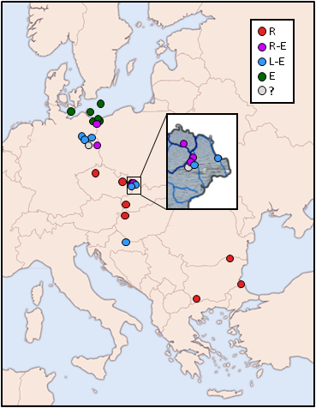
Fig S3 Map of the sampling area.
R: all-ridibundus populations
R-E: ridibundus-esculentus populations
L-E: lessonae-esculentus populations
E: all-hybrid (esculentus) populations
?: population system unclear

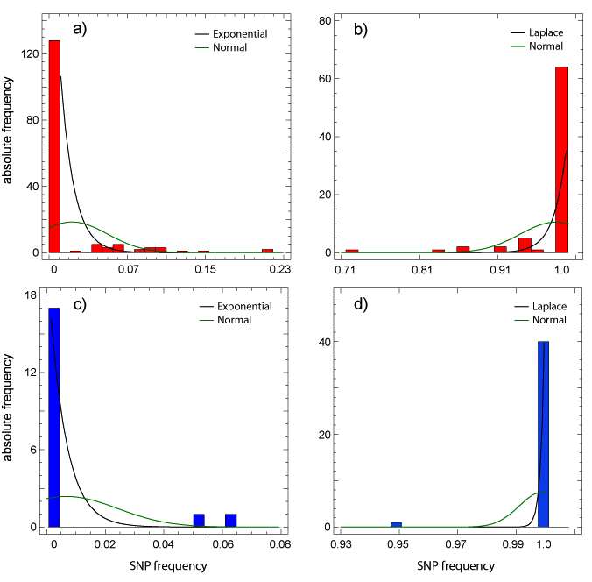

Fig. S4 Zero-inflated (a, c) and one-inflated (b, d) distributions of the frequencies of putative species-specific SNPs for P. ridibundus (red) and P. lessonae (blue). Frequencies deviating from 0 or 1 may indicate introgression of lessonae-specific alleles into the ridibundus gene pool, or vice versa.

References
Günther, R. Die Erythrozytengröße als Kriterium zur Unterscheidung diploider und triploider Teichfrösche, Rana "esculenta" L. (Anura). Biol Zentralblatt 96, 457–466 (1977).
Krage, S., Schreiber, R., John, S., Plötner, M. & Plötner, J. Morphologisch-morphometrische und genetische Untersuchungen an Wasserfröschen (Pelophylax spp.) im Müritz-Nationalpark (Mecklenburg-Vorpommern) unter besonderer Berücksichtigung des Kleinen Wasserfroschs (Pelophylax lessonae). Z Feldherpetol 29, 184–208 (2022).
Tecker, A., Göcking, C., Menke, N., Schreiber, R., & Plötner, J. Neue Daten zur Morphologie, Genetik und Verbreitung der Wasserfrösche (Pelophylax spp.) im Münsterland (NRW) unter besonderer Berücksichtigung des Kleinen Wasserfroschs (Pelophylax lessonae). Z Feldherpetol 24, 19–44 (2017).
Uzzell, T. & Berger, L. Electrophoretic phenotypes of Rana ridibunda, Rana lessonae and their hybridogenetic associate Rana esculenta. Proc Acad Nat Sci Philadelphia 127, 13–24 (1975).

