SUPPORTING INFORMATION

Insights into the Structural Differences between Homo- and Heterodimers Enriched from A Cocktail of Monoclonal Antibodies Against SARS-CoV-2
Jennifer B. Nguyen¹*, Sophia Liu¹, Yuetian Yan², Deepanshu Choudhary¹, Zachary R. Oberholtzer¹,
Yi Zhou², Donna J. Skow², Mushhood Sheikh², Cristinel Sandu², Shunhai Wang², Ning Li²,
Matthew C. Franklin², Michael P. Rosconi¹, and Erica A. Pyles¹
¹Protein Biochemistry, Regeneron Pharmaceuticals, Inc., 777 Old Saw Mill River Road, Tarrytown, NY 10591, United States.
²Analytical Chemistry, Regeneron Pharmaceuticals, Inc., 777 Old Saw Mill River Road, Tarrytown, NY 10591, United States.
³Therapeutic Proteins, Regeneron Pharmaceuticals, Inc., 777 Old Saw Mill River Road, Tarrytown, NY 10591, United States.
*Corresponding author. Protein Biochemistry, Regeneron Pharmaceuticals, Inc., 777 Old Saw Mill River Road, Tarrytown, NY 10591. Email: jennifer.nguyen@regeneron.com

Keywords: Heterodimers, homodimers, co-formulated biotherapeutics, monoclonal antibodies, SARS-COV-2, REGEN-COV; molecular interactions; stability

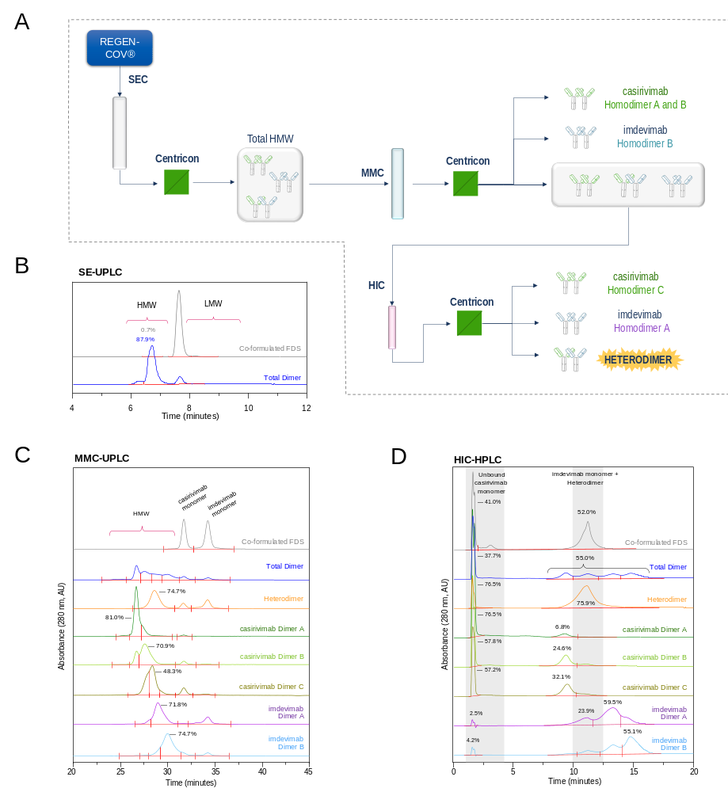
FDS: formulated drug substance; cas: casirivimab; imd: imdevimab
Supplementary Figure S1. Enrichment of homo- and heterodimers from REGEN-COV®. (A) Process flow diagram for the enrichment of homo- and heterodimers. (B) SE-UPLC (C) MMC-UPLC and (D) HIC-HPLC analytics of enriched dimer samples. Elution characteristics of the co-formulated FDS control, enriched total dimer, and enriched heterodimer samples were previously reported in Liu et al. (2024) and reprinted as a visual aid. Traces corresponding to each individually enriched homodimer (casirivimab Dimer A, B, C and imdevimab Dimer A, B) represent updated information.

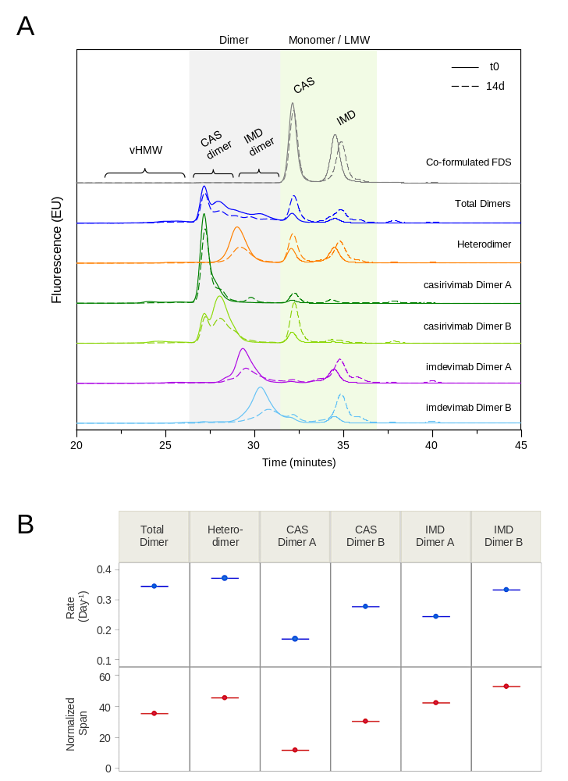
Supplementary Figure S2. Reversibility of Dimer Species at 37°C. (A) Example MMC-FLR-UPLC chromatograms at t=0 and t=14 days for each sample. Monomer and dimer peaks are shaded. (B) Comparison of rates and extent of dimer dissociation (“span”) across all enriched dimer samples based on global fitting of all dissociation data for each sample. The heterodimer and imdevimab Dimer B exhibited the fastest rates of dissociation, similar to the enriched total dimer sample. Casirivimab Dimer A exhibited the slowest rate and least amount of dissociation at 37°C. Span is normalized to the relative abundance of all dimer species in each sample at t0. CAS: casirivimab; IMD: imdevimab. Dissociation profiles corresponding the co-formulated FDS control, enriched total dimer, and enriched heterodimer samples were previously reported in Liu et al. (2024) and reprinted as a visual aid. Data corresponding to each individually enriched homodimer (casirivimab Dimer A, B, C and imdevimab Dimer A, B) represent updated information.
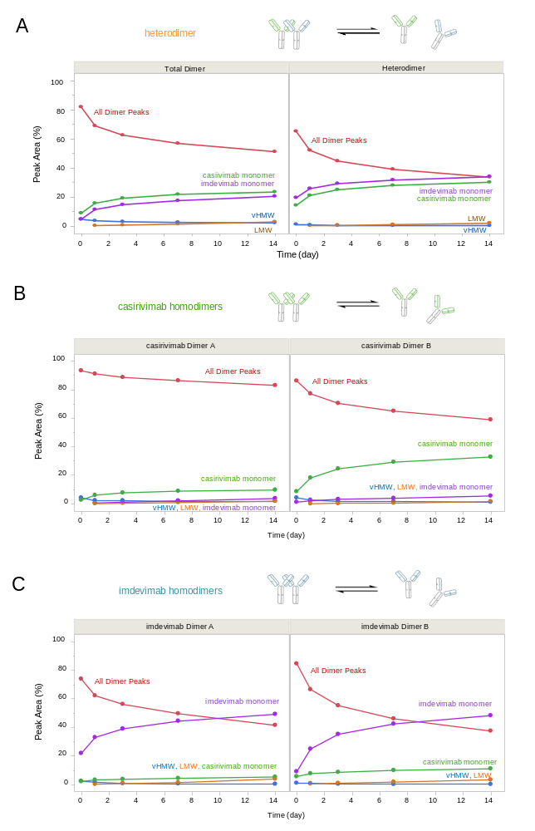
Supplementary Figure S3. Casirivimab and imdevimab homodimers from REGEN-COV® were incubated at 37ºC and subjected to analytical MMC-FLR-UPLC to assess dimer stability/reversibility. Peak area quantitation of monomer, dimer, very high molecular weight (vHMW) species, and low molecular weight (LMW) species for each sample throughout the time course based on MMC-FLR-UPLC are presented for (A) total dimers and enriched heterodimer, (B) casirivimab homodimers, and (C) imdevimab homodimers. Results indicate that most enriched dimer forms are partially dissociable, although casirivimab dimer A (top left) appears to be the most stable under these conditions. Dissociation for the enriched total dimer and enriched heterodimer samples was previously reported in Liu et al. (2024) and reprinted as a visual aid.
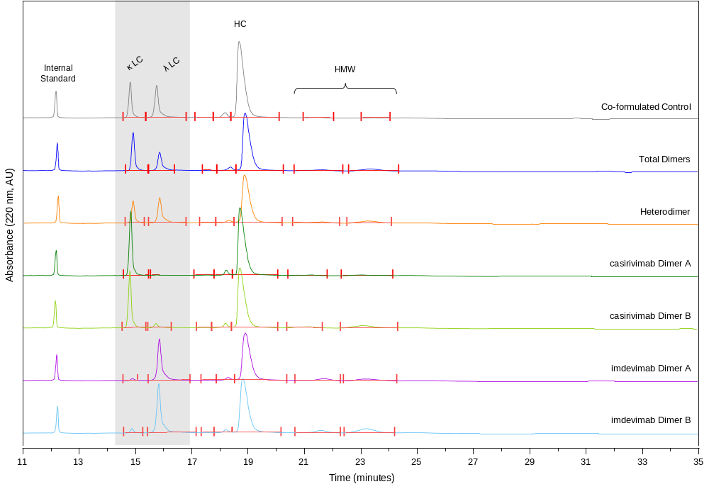
Supplementary Figure S4. Non-Dissociable and/or Covalent Dimer Species from REGEN-COV®. Under reducing conditions, two prominent peaks are observed in the CE-SDS electropherograms at migration times ~14.5 and 15.9 minutes, reflecting the kappa and lambda light chains (LC). Because the primary sequence for the lambda LC is actually composed of fewer amino acidic than the kappa LC, this migration time difference reflects an intrinsic property of the LC, likely hydrophobicity. Reduced CE-SDS was not performed for casirivimab Dimer C due to low sample availability.

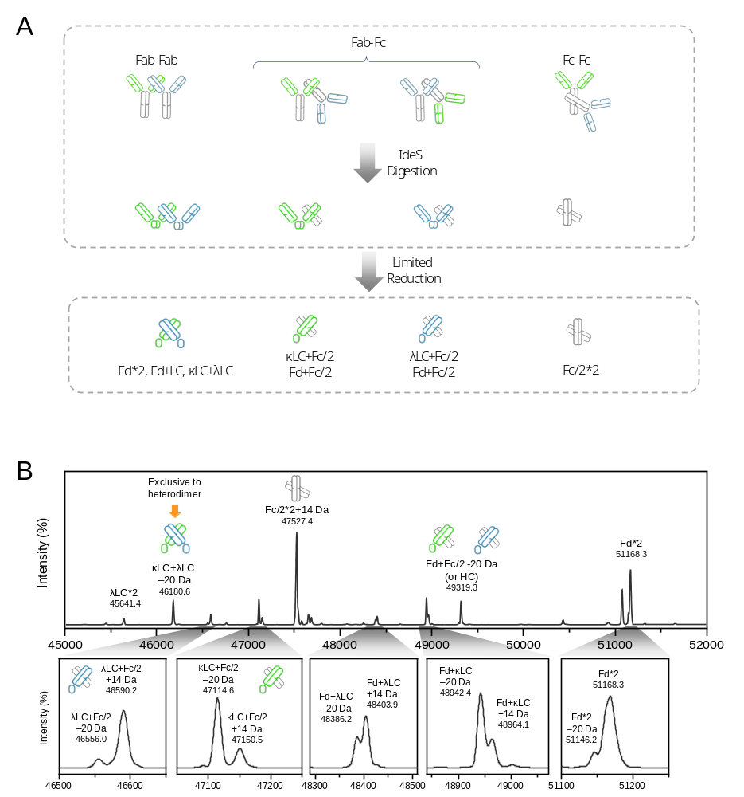
Supplementary Figure S5. Covalent interactions in the enriched heterodimer sample are contributed by His-His (+14 Da) and
Ser-Lys (-20 Da) crosslinks. (A) Middle-up analysis workflow for enriched dimer samples. (B) Subunit analysis of the enriched heterodimer sample using SEC-PCD-MS of reveals a heterogeneous assortment of covalent Fab-Fab, Fab-Fc, and Fc-Fc crosslinks. The casirivimab and imdevimab Fd sequences are distinct, but these polypeptides share identical molecular masses. However, a specific peak corresponding to a Ser-Lys cross-link between the κLC and λLC was observed, which is exclusive to the heterodimer and confirms the presence of a covalent Fab-Fab interaction.

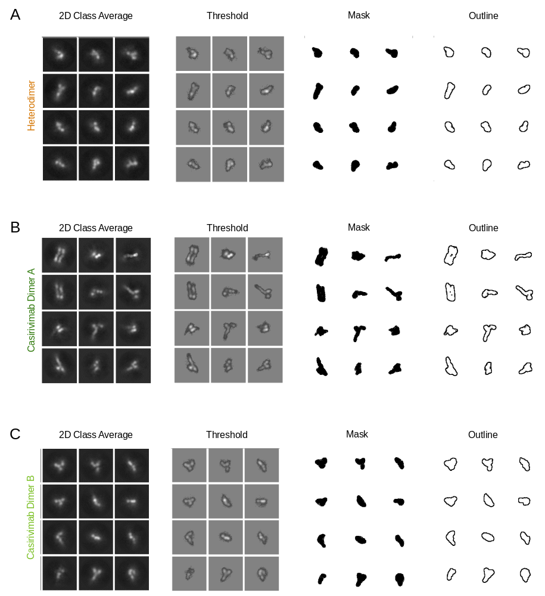

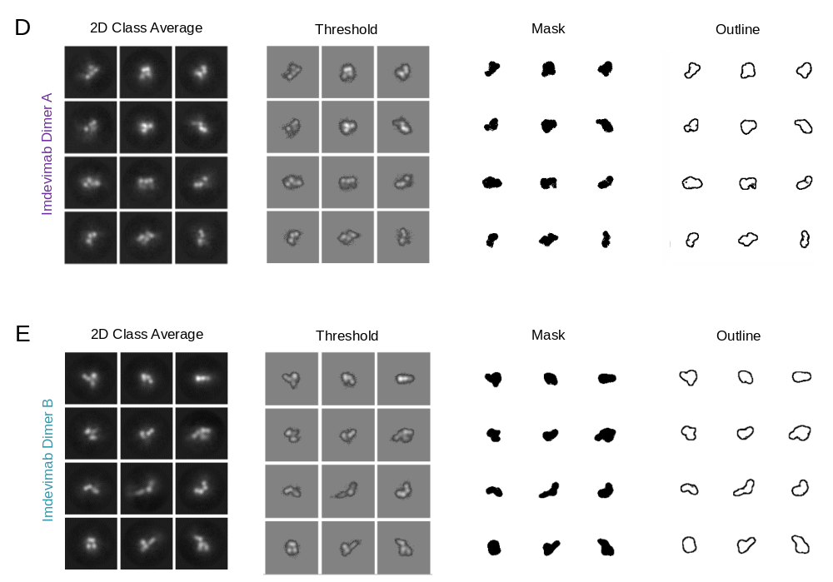
Supplementary Figure S6. Structural analysis of homo- and heterodimers enriched from REGEN-COV® by negative stain electron microscopy. Representative 2D class averages are shown on the left for (A) heterodimer (B-C) casirivimab Dimer A and B (D-E) imdevimab Dimer A and B. The panels on the right demonstrate the image analysis parameters used to generate particle size histograms shown in Figure 4.

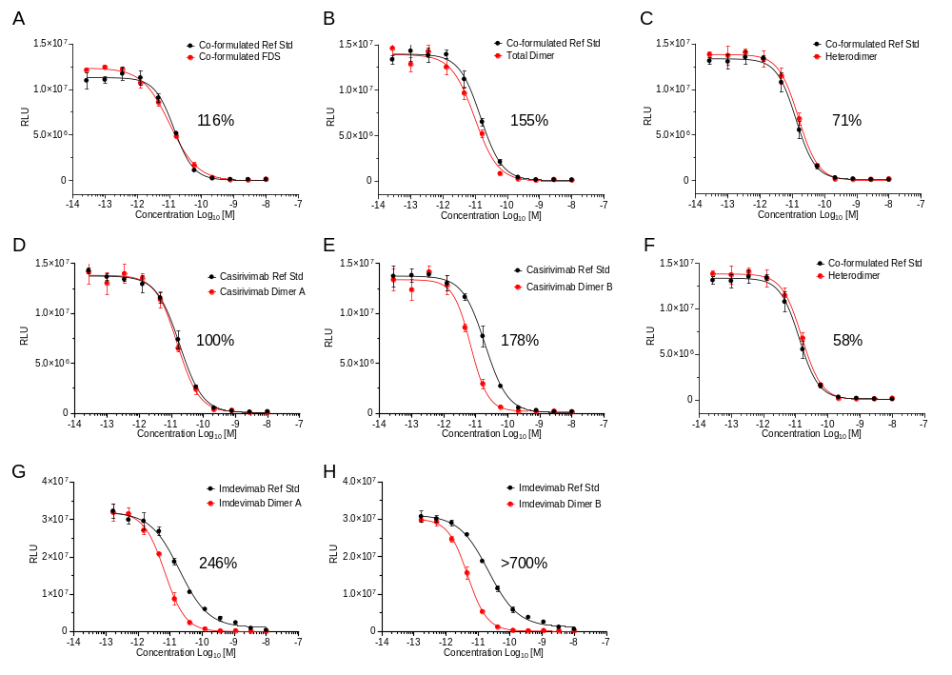
Supplementary Figure S7. Relative potencies of REGEN-COV® samples by pseudovirus neutralization from a single representative data set. Values represent the average relative potency calculated from four separate data sets. Ref Std, reference standard.

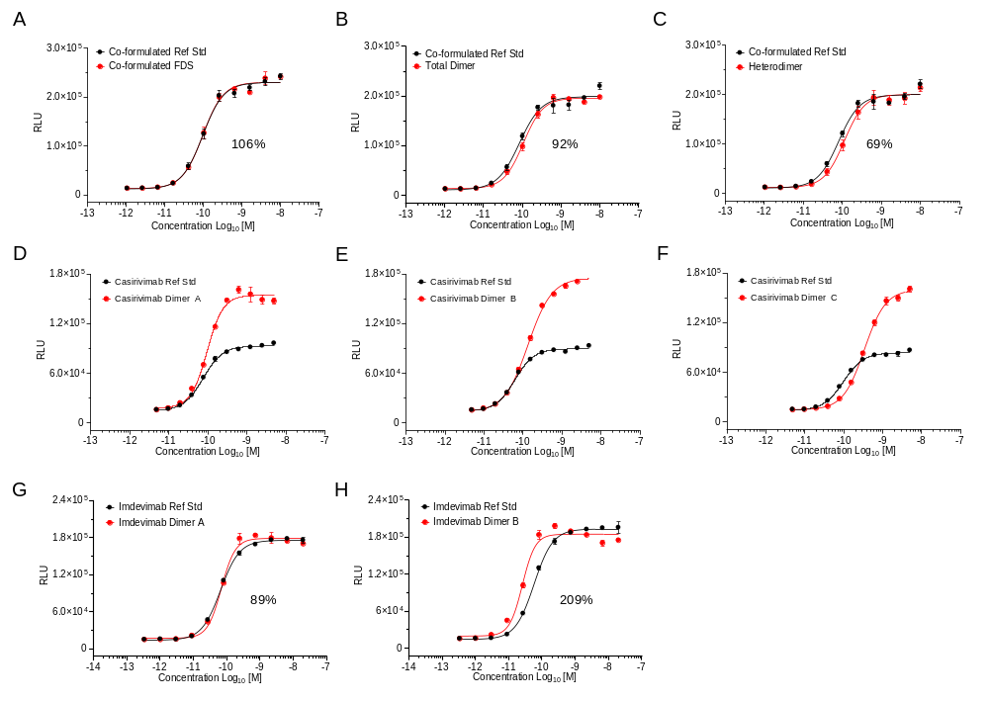
Supplementary Figure S8. Relative potencies of REGEN-COV® samples by ADCC from a single representative data set. Values represent the average relative potency calculated from at least three independent data sets. Because all three casirivimab homodimer samples (panels D, E, F) exhibited a higher efficacy window compared to monomeric casirivimab reference standard, average relative potency could not be accurately quantitated. Panels A and C are reprinted from Liu et al.¹⁶

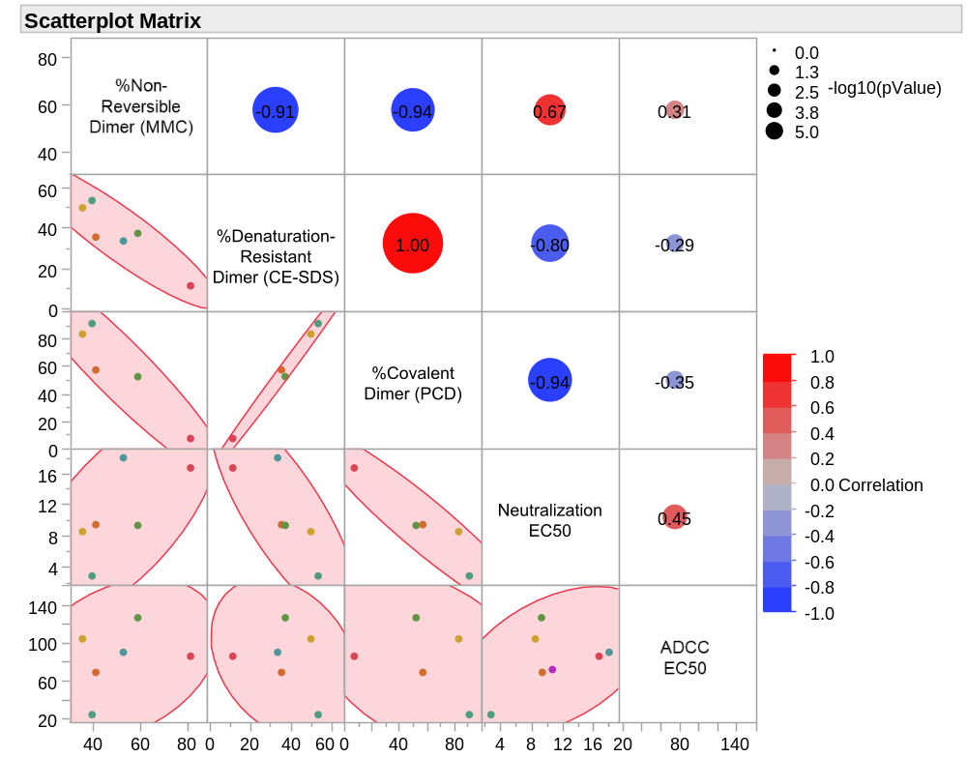
Supplementary Figure S9. Scatterplot matrix from a multivariate analysis of the distribution of non-reversible, denaturation-resistant, and covalent dimer species (derived from MMC, CE-SDS, and PCD-nSEC-MS assays, respectively) compared to EC50 values from pseudovirus neutralization and ADCC activity assays. Each colored dot represents one of the six enriched dimer samples. Red and blue indicate positive or negative correlations, wherein larger circles indicate greater statistical significance, as indicated by a higher negative log of the p-value.

Supplementary Table T1. Dimer Domain interactions quantified by Middle-Up PCD-nSEC-MS performed on IdeS digested homo-and heterodimers from REGEN-COV®.
Sample |  | SEC-UV-MS | Dimer Domain Interactions by Middle-Up PCD-nSEC-MS^{c}
 |  | Total  Dimer (%) ^{b} | F(ab)ʹ₂- F(ab)ʹ₂ (%) | F(ab)ʹ₂-Fc (%) | Fc-Fc (%)
Casirivimab  Homodimers ª | Dimer A* | 97.4 | 86.6 | 5.8 | 7.5
Casirivimab  Homodimers ª | Dimer B | 83.7 | 56.8 | 20.3 | 22.9
 | Dimer C | 79.9 | 47.1 | 26.5 | 26.4
Imdevimab  Homodimers ª | Dimer A | 69.9 | 61.0 | 31.9 | 7.1
Imdevimab  Homodimers ª | Dimer B* | 79.5 | 39.4 | 31.7 | 29.0
Enriched Heterodimer |  | 58.3 | 16.9 ^{d} | 31.5 ^{e, f} | 37.0 ^{f}
ª The asterisk denotes the predominant homodimer configuration.
^{b} The abundance of dimer determined by SEC-UV-MS may be underestimated due to dimer dissociation under sample treatment conditions.
^{c} The distribution of dimer domain interactions calculated for each sample reflects a molar distribution of different covalent species and has been corrected based on the corresponding UV area. Values are also normalized to the total abundance of dimer determined by SEC-UV-MS.
^{d} The reported level of Fab-Fab interactions in the heterodimer sample reflects only the unique contribution of Fab-Fab interactions containing one casirivimab Fab arm paired with one imdevimab Fab arm. This value excludes the contribution from casirivimab and imdevimab homodimers associated via Fab-Fab interactions (~14.7% total).
^{e} Fab-Fc interactions for the enriched heterodimer sample include a contribution of ~17.7% casirivimab Fab-Fc interactions and ~13.8% imdevimab Fab-Fc interactions
^{f} The absolute quantitation for Fab-Fc and Fc-Fc interactions determined for the heterodimer sample may be influenced by contributions from low levels of co-purified homodimer.

Supplementary Table T2. Biophysical parameters of each unfractionated and enriched dimer sample from co-formulated REGEN-COV®.
Sample |  | SV-AUC |  |  | Negative Stain EM
 |  | S-value | f/f₀ | R_{h} (nm)ª | Shape
Co-formulated FDS ^{b} |  | 6.5 | 1.53 | 5.3 | Not  performed
Total Dimer |  | 9.2 | 1.70 | 7.5 | Not  performed
Casirivimab | Dimer A* | 9.0 | 1.76 | 7.7 | Elongated
Casirivimab | Dimer B | 9.3 | 1.69 | 7.4 | Compact
Imdevimab | Dimer A | Not performed |  |  | Compact
Imdevimab | Dimer B* | 9.4 | 1.66 | 7.3 | Compact
Enriched Heterodimer |  | 9.6 | 1.64 | 7.2 | Very Compact
SV-AUC: Sedimentation Velocity Analytical Ultracentrifugation; EM: Electron Microscopy
ª R_{h} was calculated from a modified Svedberg equation based upon the frictional ratio of the predominant species within the sample.
^{b} For co-formulated FDS, the S-value, f/fo, and R_{h} values correspond to the predominant monomer peak in the c(S) distribution. For all other samples, each value reflects the hydrodynamic radius of the dimer unless otherwise noted.
*asterisk denotes the predominant homodimer configuration

Supplementary Table T3. Overall summary of proposed dimer arrangements, physicochemical attributes, and domain interactions observed from homo- and heterodimers enriched from REGEN-COV®.
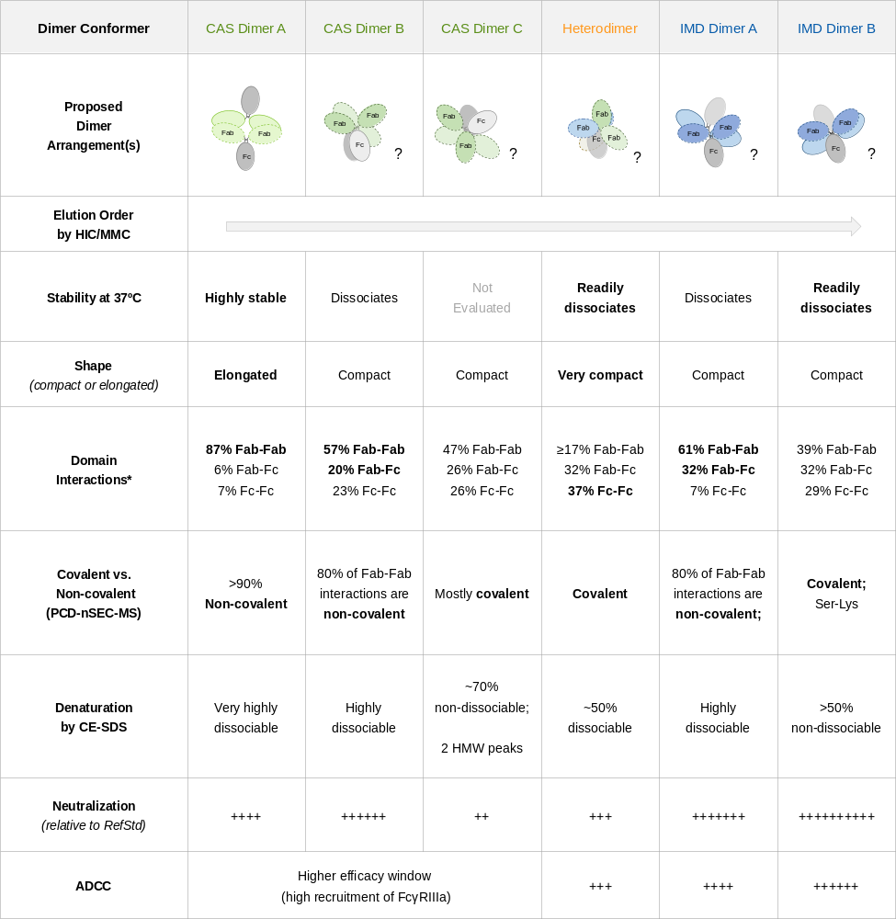* Covalent Fc-Fc domain interactions were determined to be exclusively mediated by stable His-His crosslinks.

Boldface type indicates unique attributes or predominant species.

