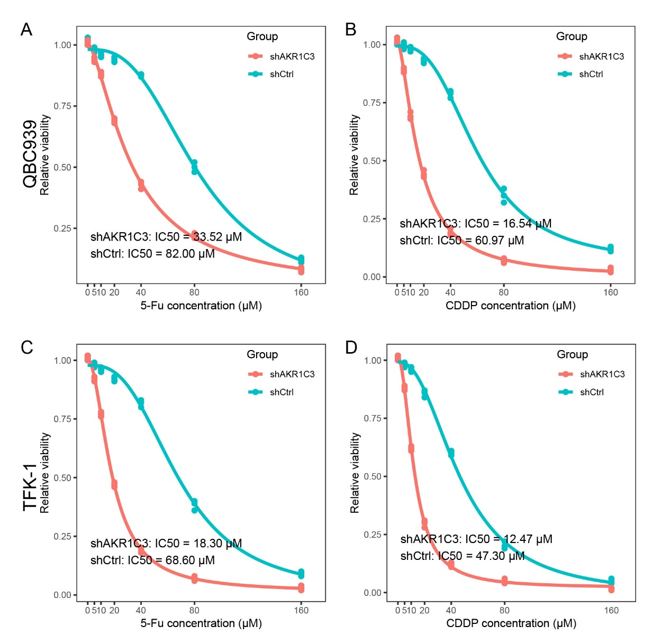
Supplementary Figure 1: AKR1C3 knockdown enhances cholangiocarcinoma cell sensitivity to 5-fluorouracil (5-FU) and cisplatin (CDDP). Dose–response curves showing relative viability of shAKR1C3 (red) versus shCtrl (teal) cells following 72-h treatment with increasing concentrations of 5-FU or CDDP. (A) QBC939 cells + 5-FU (IC₅₀: shAKR1C3 = 33.52 µM; shCtrl = 82.00 µM). (B) QBC939 cells + CDDP (IC₅₀: shAKR1C3 = 16.54 µM; shCtrl = 60.97 µM). (C) TFK-1 cells + 5-FU (IC₅₀: shAKR1C3 = 18.30 µM; shCtrl = 68.60 µM). (D) TFK-1 cells + CDDP (IC₅₀: shAKR1C3 = 12.47 µM; shCtrl = 47.30 µM). Data represent mean ± SD of three independent experiments.
Supplementary Figure 2：Immunofluorescence characterization of isolated cancer-associated fibroblasts (CAFs). Cells were stained for the fibroblast marker α-SMA (green) (top row) and the epithelial marker CK-19 (green) (bottom row), with nuclei counterstained by DAPI (blue). Merged images confirm strong α-SMA expression and lack of CK-19 signal, indicating a pure fibroblast population. The reliability of CK19 negativity was confirmed by parallel staining of CK19-high CCA cell lines (HuH28) performed under identical conditions, which showed strong positive staining. Scale bar, 50 µm.

Supplementary Figure 3: Time-dependent IL-6 secretion by cancer-associated fibroblasts (CAFs). Conditioned media were collected from CAF cultures at 1, 2, 4, and 8 h and subjected to ELISA for IL-6 quantification. Bars represent mean ± SD of three independent experiments. Statistical significance was determined by one-way ANOVA with Tukey’s multiple comparisons test (**p < 0.01; ***p < 0.001).
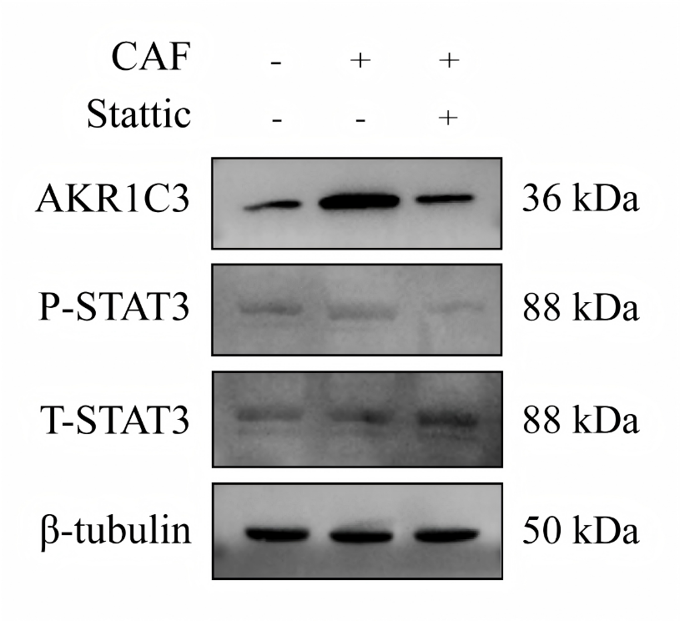
Supplementary Figure 4：(C) After CAF treatment with or without Stattic for 8h, the expression of AKR1C3, P-STAT3, and T-STAT3 were detected by Western blot in QBC939 cells.

