Supplementary Information
Supplementary Figure 1. Relative expression changes, corresponding Wes-generated electropherograms and Wes-generated pseudobands of active β-catenin in microglia stimulated with LPS and/or Wnt-3a, and PBS or the canonical pathway inhibitor DKK1. All values are shown as mean ± standard error of the mean (SEM). **p<0.01, ***p<0.001. N=5–6/group.

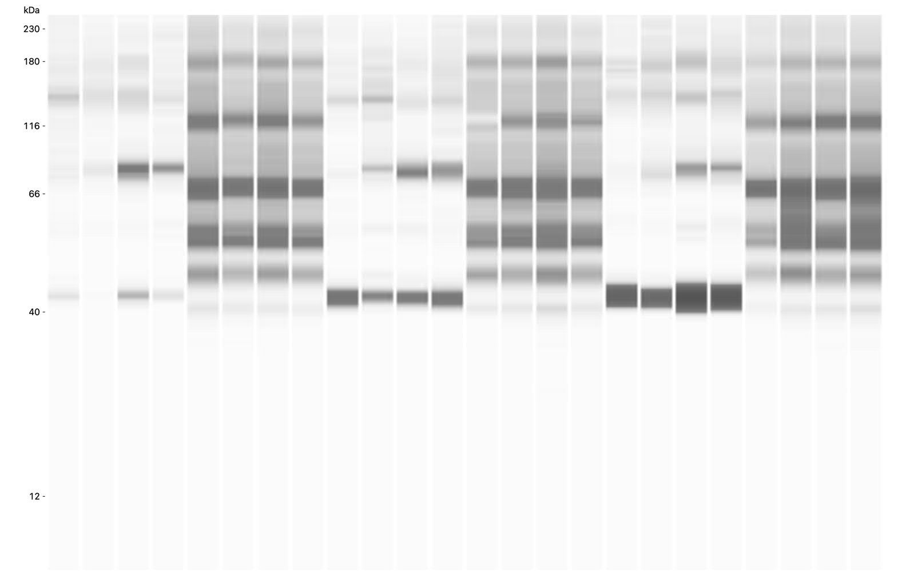
Supplementary Figure 2. Uncropped Wes-generated pseudobands of phospho-IKKα/β expression (lanes 1-4, 9-12, 17-20) and corresponding total protein (lanes 5-8, 13-16, 21-25) for data represented in Figure 1B.

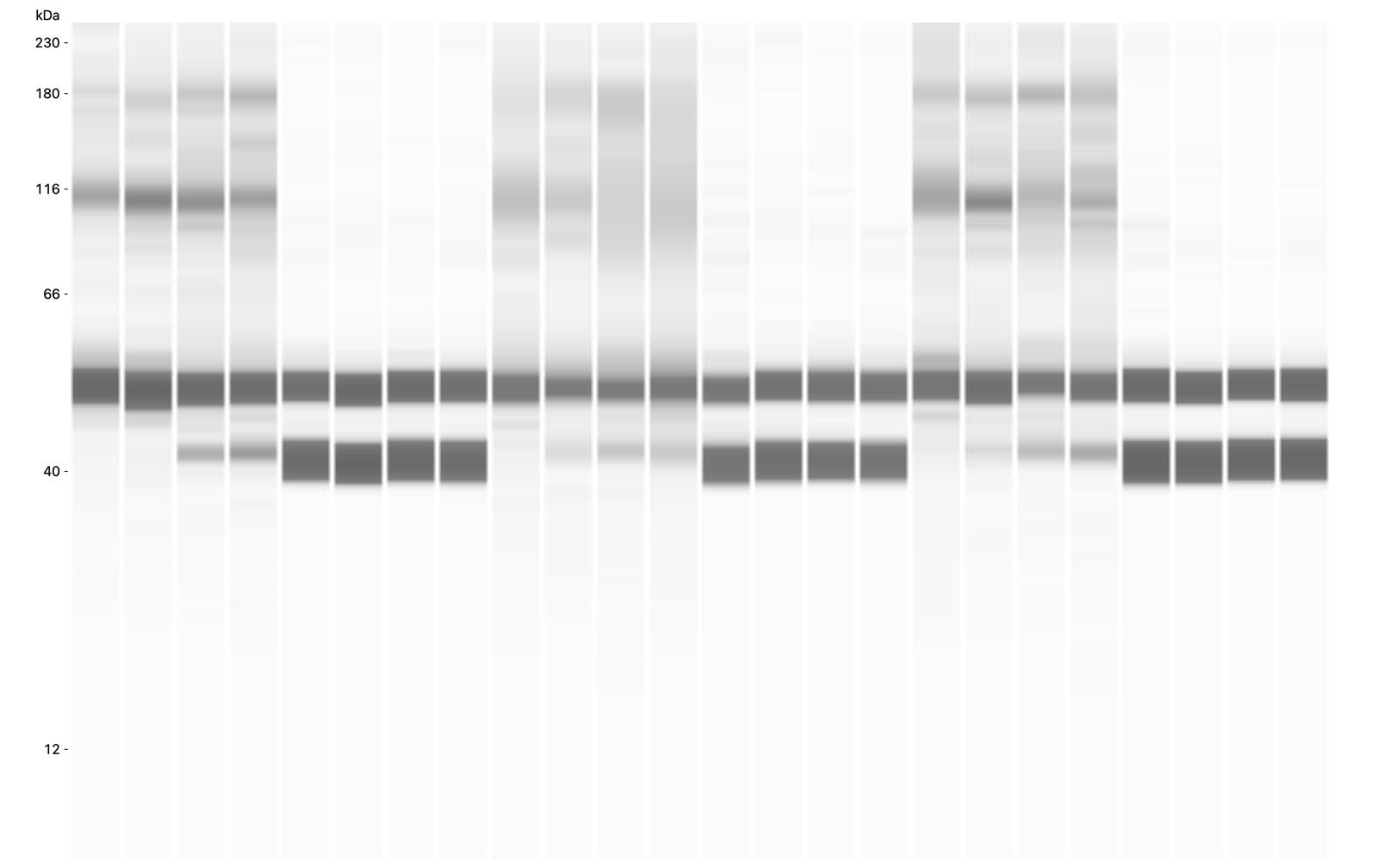

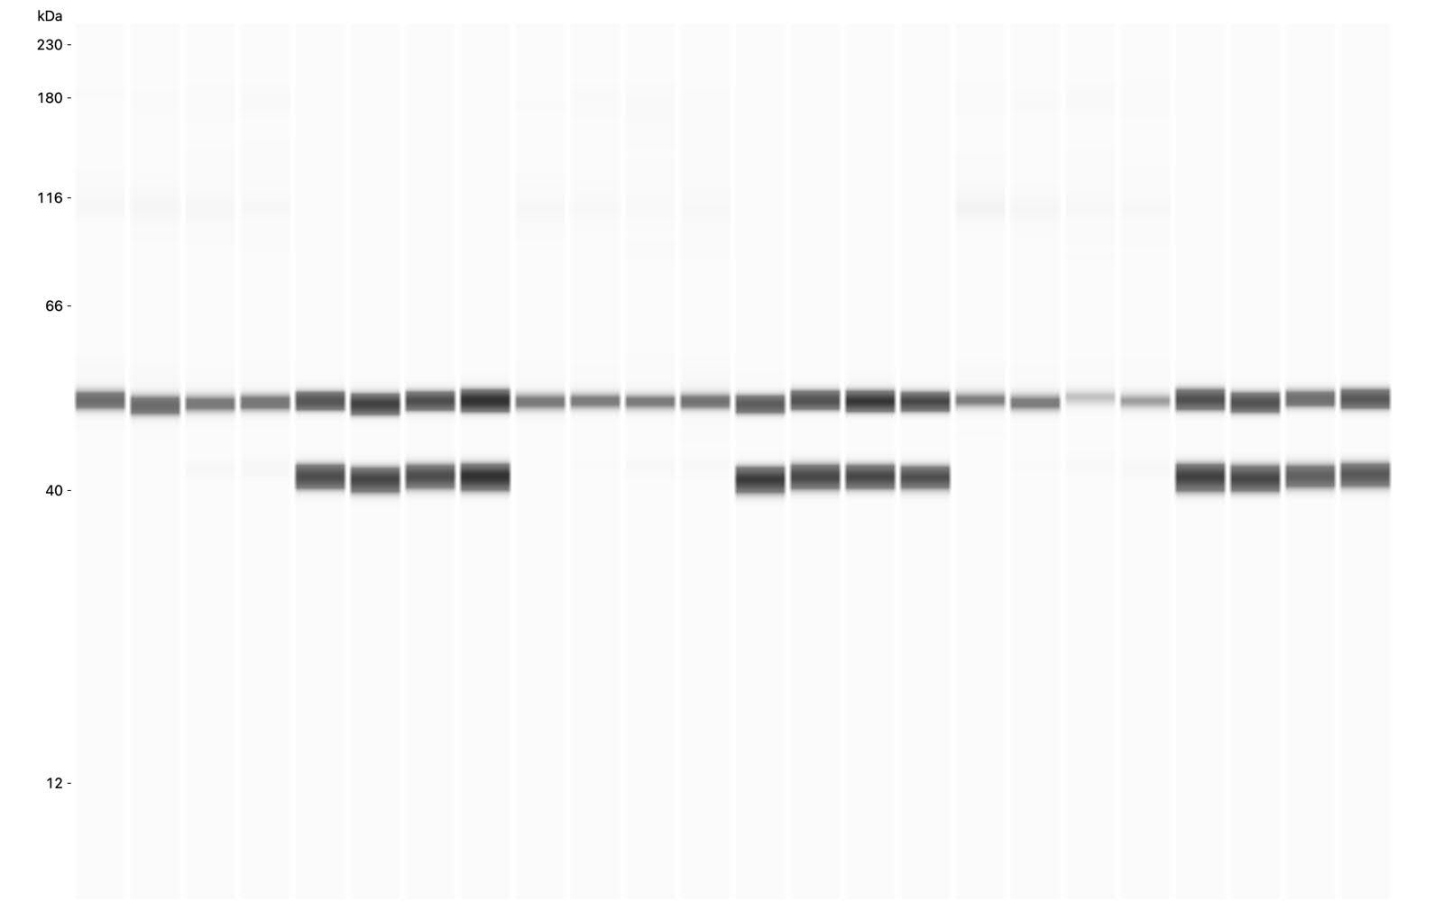
Supplementary Figure 3. Top panel: Uncropped Wes-generated pseudobands of phospho-IκBα expression (lanes 1-4, 9-12, 17-20) and corresponding GAPDH expression (lanes 5-8, 13-16, 21-25) for data represented in Figure 1C. Bottom panel: Decreased exposure of GAPDH.

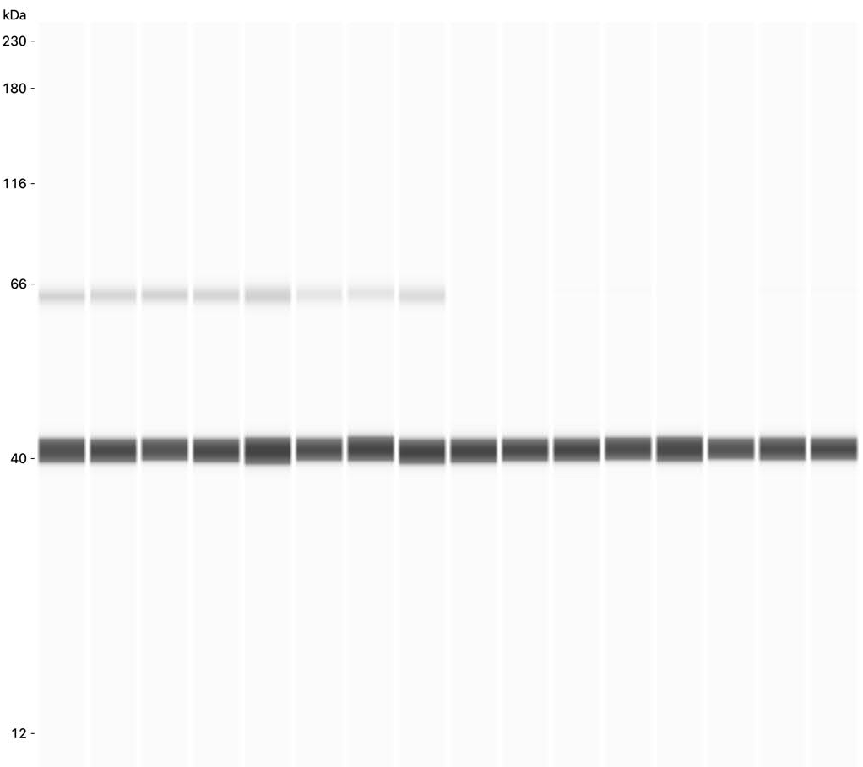

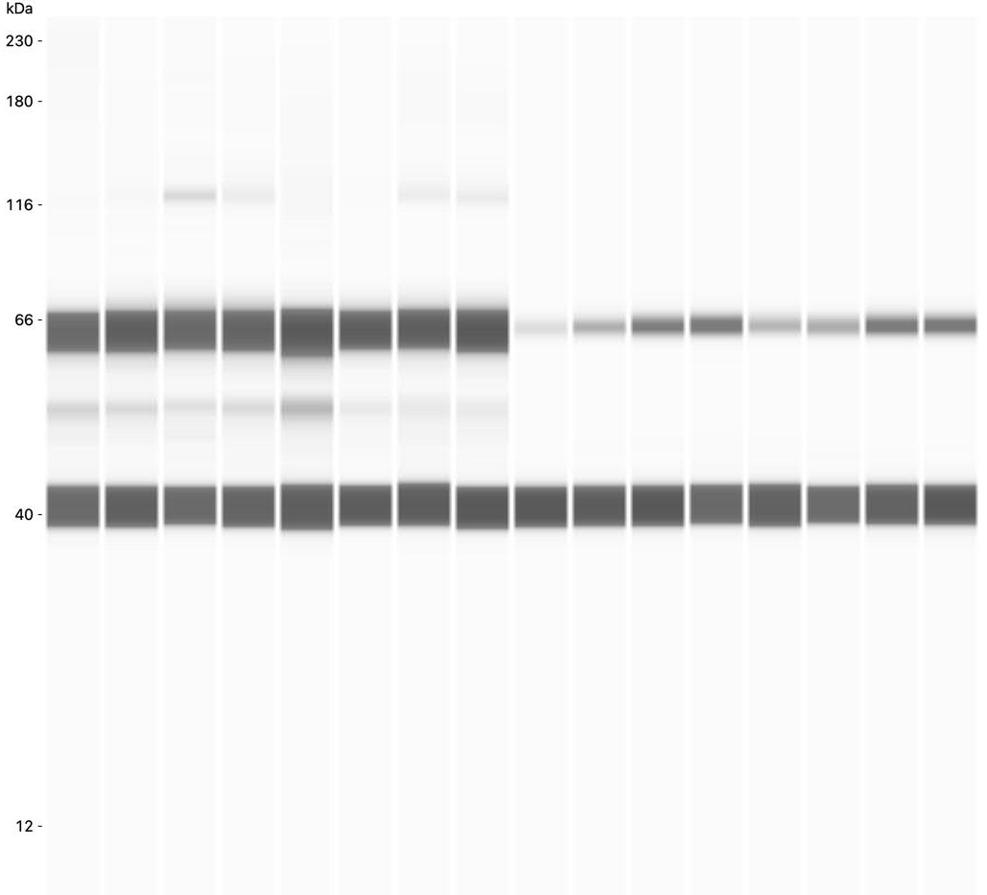
Supplementary Figure 4. Top panel: Uncropped Wes-generated pseudobands of total NFκB + GAPDH expression (lanes 1-8) and active NFκB + GAPDH expression (lanes 9-16) for data represented in Figure 1D-E. Bottom panel: Increased exposure for active NFκB.
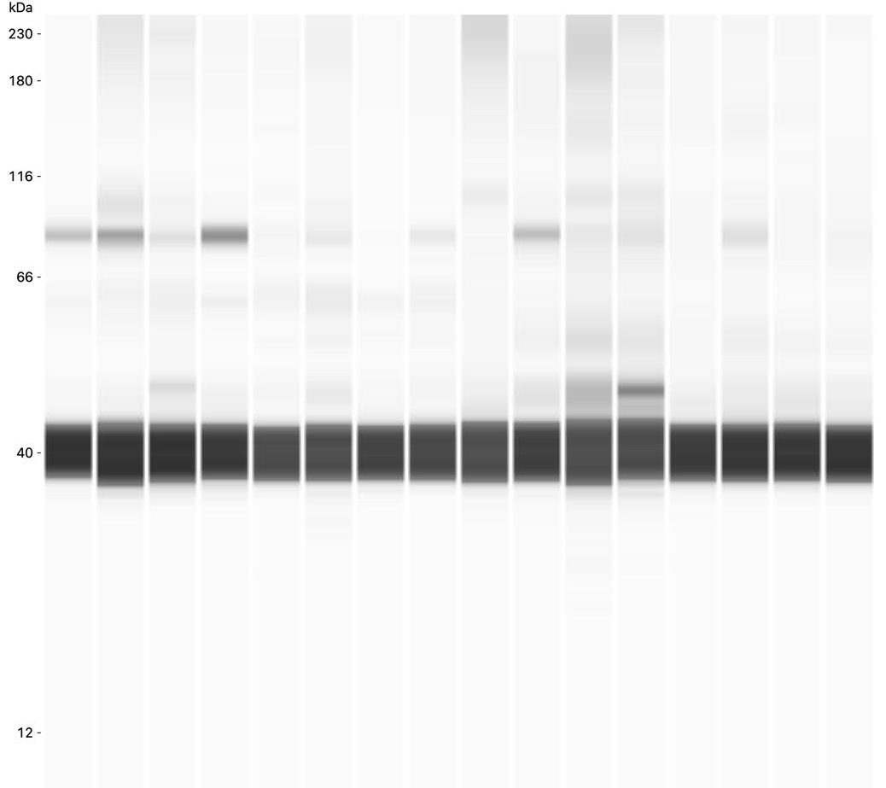
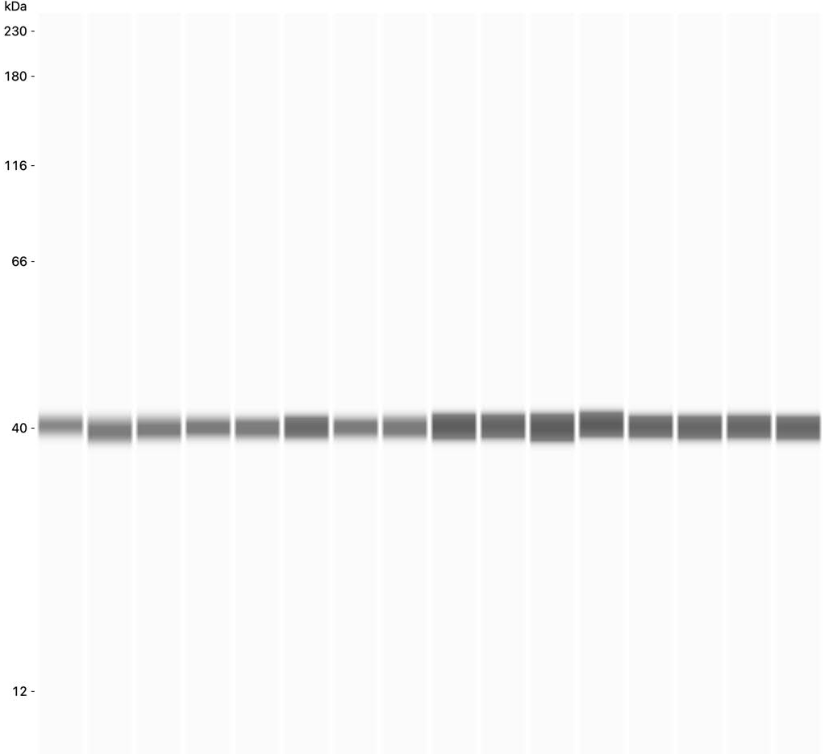
Supplementary Figure 5. Top panel: Uncropped Wes-generated pseudobands of total β-catenin + GAPDH expression (lanes 1-8) and active β-catenin + GAPDH expression (lanes 9-16) for data represented in Figure 2A-B. Bottom panel: Decreased exposure for GAPDH.
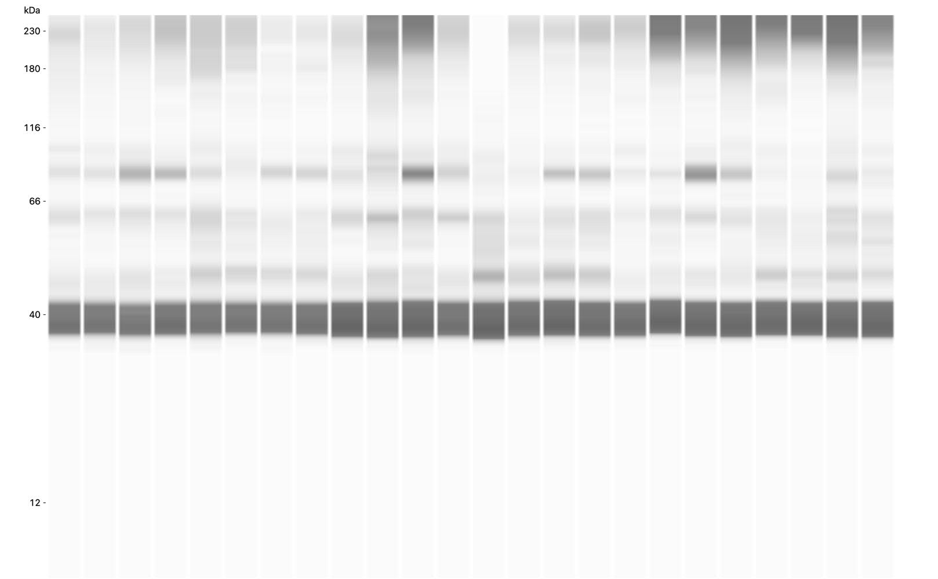
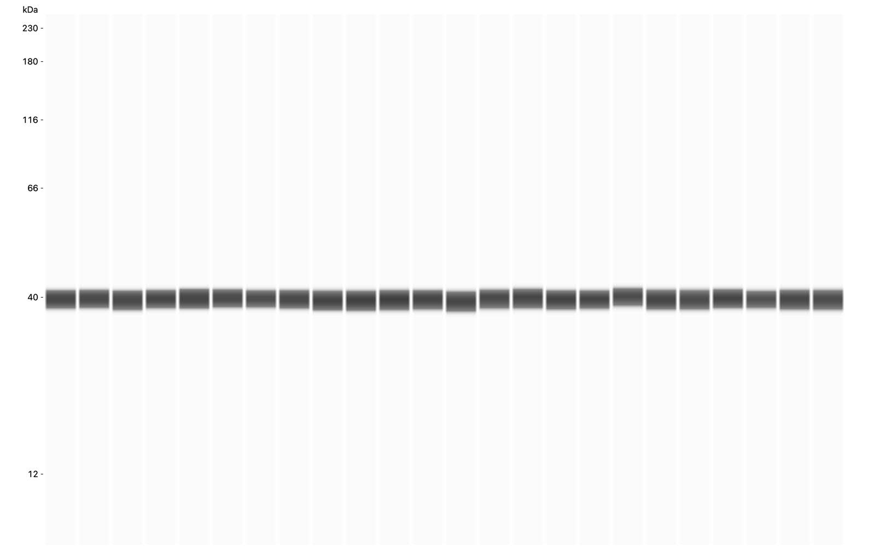
Supplementary Figure 6. Top panel: Uncropped Wes-generated pseudobands of active β-catenin + GAPDH for data represented Supplementary Figure 1. Bottom panel: Decreased exposure for GAPDH.

