Supplementary Figures
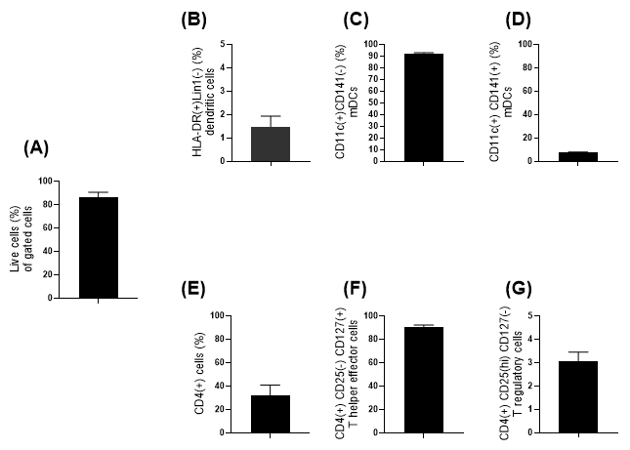

Supplementary Figure 1. Analysis of cell viability and frequencies of dendritic cell and T helper cell subpopulations in thawed PBMCs from four blood donors. Panel A: On average, 86.1 % of gated cells were viable after thawing. Panels B–D: Frequencies of HLA-DR⁺ Lin⁻ cells (dendritic cells), CD141⁻ mDCs, and CD141⁺ mDCs. Panels E–G: Frequencies of CD4⁺ T helper cells, T helper effector cells, and T regulatory cells.

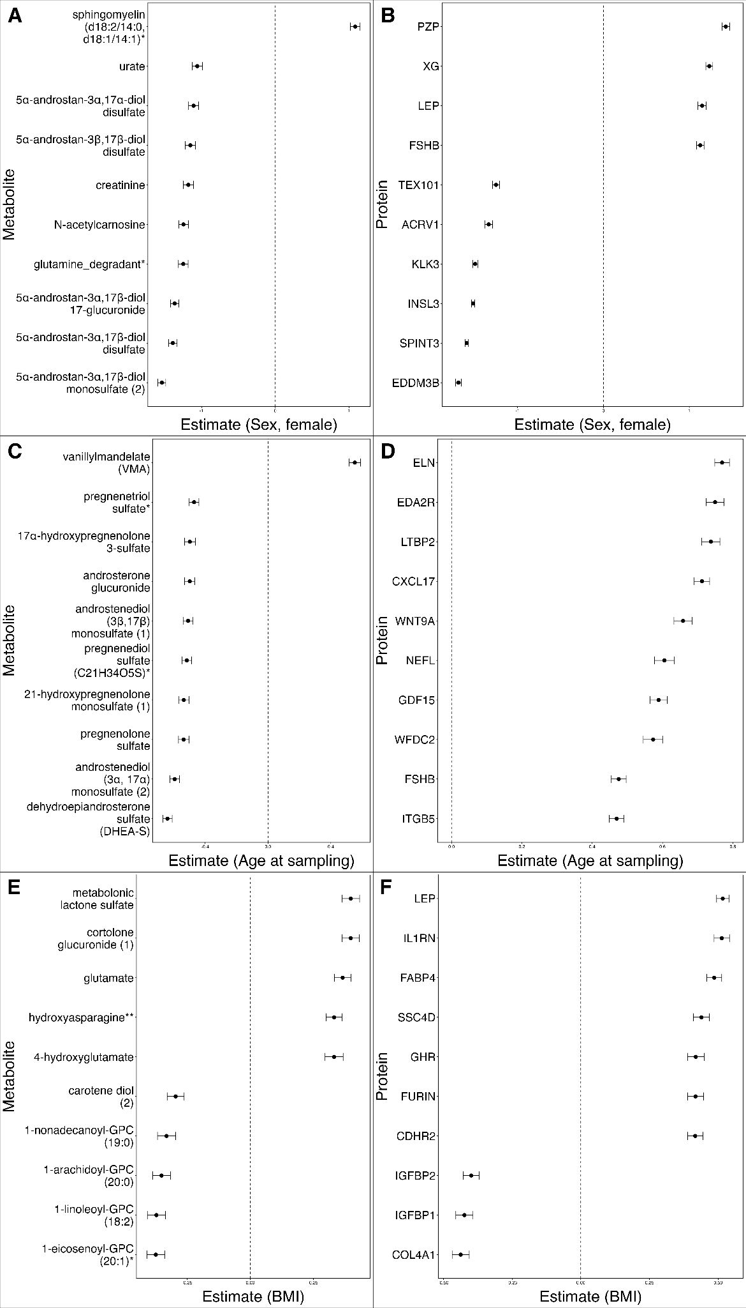

Supplementary Figure 2. Forest plots of proteomics and metabolomics association analysis results with standard errors. Top ten associations are shown with the lowest FDR values for each covariate for metabolomics and proteomics. Metabolomics and proteomics values for female sex (A, B), age (C, D) and BMI (E, F).

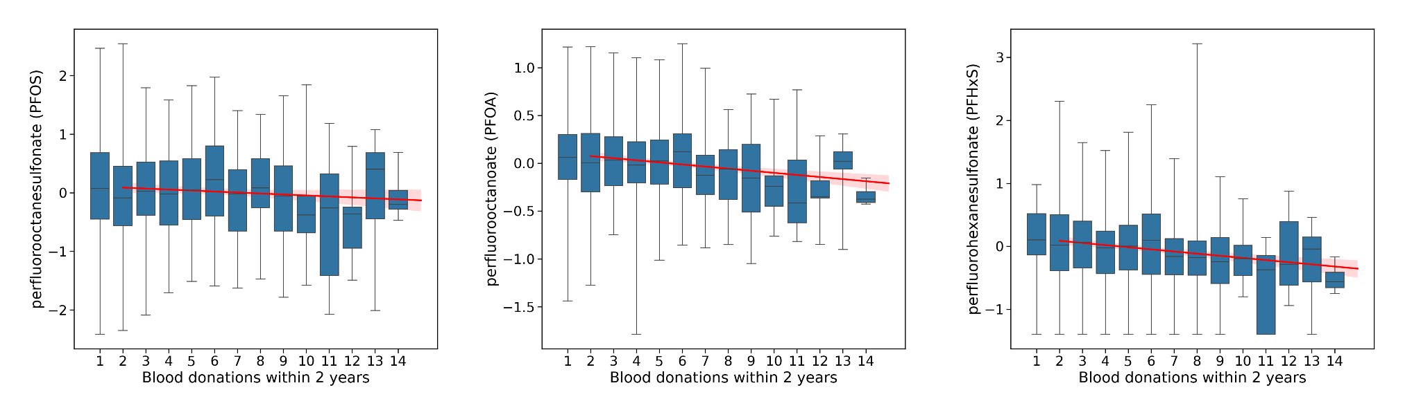
Supplementary Figure 3. Levels of three PFAS compounds PFOS, PFOA and PFHxS show a decreasing trend with increasing numbers of blood donations.. Log transformed PFAS concentrations are plotted against blood donation frequency, with the fitted trend line shown in red.

Supplementary Tables S1-S11
Association analysis results and other supplementary tables can be found in Supplementary Tables S1-11. All studied parameters for metabolomics, proteomics, clinical chemistry and complete blood count can be found in Supplementary Table S3.

Supplementary Methods
Genotyping of the samples
The biobank samples were genotyped as part of the FinnGen project with the FinnGen ThermoFisher Axiom custom array v1 or v2. Genotyping, quality control, and genome imputation protocols, R11, are described in detail in the FinnGen Gitbook (https://finngen.gitbook.io/documentation). In brief, genotype calling was performed with the AxiomGT1 algorithm. Prior to the imputation, genotyped samples were pre-phased with Eagle 2.3.5 with the default parameters, except the number of conditioning haplotypes was set to 20,000. Genotype imputation was performed using the population-specific imputation reference panel SISu v3 including 3,775 high coverage (25–30x) whole genome sequence data, with Beagle 4.1 (version 08Jun17.d8b). Genotypes were then returned to the Blood Service Biobank.

Sample collection
The collection of samples from FinnGen-genotyped blood donors was done whenever they visited the Blood Service for their regular blood donation visit. No specific recalls were done. The sample collection was done in the Greater Helsinki area at three donation sites to ensure fast sample processing. All samples were processed within 4 hours from the time of collection at the donation site. This is a critical time window for several of the downstream analyses of this study, especially the metabolomics and proteomics analyses. To increase the geographical coverage, ~20% of the samples were collected at the blood donation sites of the cities of Oulu (North West Finland) and Kuopio (North East Finland). The plasma and serum samples were prepared on site following the same protocols in all locations.
Venous whole blood samples for plasma and serum aliquots were collected from the diversion pouch without anticoagulant immediately after blood donation. For plasma, two 4 ml EDTA tubes and one 4 ml serum tube were collected. Both plasma and serum tubes were centrifuged for 10 minutes at 2000 x g, and samples were subsequently aliquoted in 230 μL aliquots in FluidX 0.26 ml cryotubes with 2D barcodes (Cat. No. 68-0303-01). Aliquoting of plasma and plasma and serum was performed on a Hamilton Easy Blood Star liquid handling robot. The samples were tested and were all negative for human immunodeficiency virus (HIV), hepatitis A, B and C, viruses including parvovirus, and syphilis.
Venous whole blood samples were collected from the diversion pouch immediately after blood donation and used for harvesting the buffy coat (BC). Peripheral blood mononuclear cells (PBMCs) were isolated from BCs with Ficoll isogradient centrifugation. The BC preparation was diluted in 1:1 ratio with Dulbecco’s Phosphate Buffered Saline without Ca and Mg (DPBS, Gibco, Cat. NoA12856-01). The diluted blood was placed on top of 20 ml of Ficoll (GE Healthcare, Cat.No. 17-1440-03) in two 50 ml conical Falcon tubes. The tubes were centrifuged for 25 minutes at 800 x g (Eppendorf 5810R) at room temperature (RT) with no brake during the deceleration step. The upper plasma layer was removed by aspirating with a sterile glass Pasteur pipette. Then, the white layer containing the mononuclear cells was collected with a sterile individually-packed plastic Pasteur pipette. The cells were then transferred into a new 50 ml conical Falcon tube containing 40 ml DPBS. The tube was then filled to 50ml of DPBS and centrifuged at 300g for five minutes at RT. The supernatant was carefully removed by aspiration and the cell pellet was resuspended in 50 ml of DPBS and the cells were spun down as in the previous step. In total, the cells were washed three times with 50 ml of DPBS. After the washing steps, the cells were gently suspended in 3 ml of RPMI1640 cell culture medium supplemented with 5% of heat-inactivated human AB serum, 2mM L-glutamine and 1% of Pen-Strep. The cells were counted with an automated Bio-Rad TC20 cell counter or Burker chamber with trypan blue staining. To minimize variation across the samples the same serum batch was used for isolation and freezing of PBMC. The serum was aliquoted in 3-5 ml batches and kept frozen at -80 centigrades until used.

Freezing and thawing protocols
For freezing, the density of the cells was adjusted to ~2x10⁷ cells/ml. Then 5 ml of +4ºC RPMI1640 cell culture medium with 5% of heat inactivated human AB serum, 2mM L-glutamine and 1% Pen-Strep and 20% of DMSO was added dropwise slowly while swaying the tube to gently mix the cell suspension (final solution: 10% DMSO in RPMI1640 medium supplemented with 5% inactivated human AB serum, 2mM L-glutamine and 1% Pen-Strep, herein freezing media). The cells suspended in the freezing medium were then mixed with gentle pipetting. Cell suspension was then aliquoted in the cryovials. One ml (1ml) of the cell suspension was transferred to a cryovial (FluidX 1.8ml screw cap tube with external threading). The tubes were closed and put immediately in a CoolCell LX (Corning) cell freezing container for temperature-controlled cooling of the cells. The CoolCell LX container was immediately transferred into a -80ºC freezer overnight. The cryovials were transferred the next day into the automated gas phase liquid nitrogen freezer for long-term storing at -180ºC.
The cryovials were quickly thawed in a heat-block pre-warmed at 37ºC in an incubator. Once the cells began to thaw, warm RPMI1640 cell culture with 10% of heat inactivated human AB serum, 2mM L-glutamine and 1% of Pen-Strep (referred as thawing media from here on) was added on the top of icy cell suspension. Thawed cell suspension was repeatedly transferred in a 15 ml Falcon tube containing 10 ml of 37ºC thawing media. The Falcon tubes were filled with 15 ml of thawing media and centrifuged for 10 minutes at 300 x g. The supernatant was carefully aspirated, and the pelleted cells were gently re-suspended in 5ml of regular culture media. Cells were centrifuged for 10 minutes at 300 x g and the supernatant was aspirated. Finally, the cells were re-suspended in 1 ml of regular cell culture medium and the cells were counted and viability of the cells was analyzed with an automated Bio-Rad TC20 cell counter or Burker chamber.

Immune cell profiling
Thawed cells were stained with fluorochrome conjugated antibodies targeting cell surface antigens. For staining, cells were incubated at room temperature for 20 min, in dark, with a surface staining cocktail containing anti-CD4, anti-CD141, anti-CD123, anti- CD11c+, anti- HLA-DR, anti-CD127, anti- CD25 antibodies, and lineage cocktail 1 in a final volume of 150 µl. Subsequently, cells were washed once, resuspended in 0.5% BSA-PBS and kept on ice until FACS analysis. Analysis of 6 immune cell subpopulations (Treg-DC panel) was performed with BD Influx™ (BD Biosciences). Dead cells were excluded from analysis by SYTOX® Blue staining. The cell populations were defined as following: Teff (CD3+CD4+CD25intCD127+), Treg (CD3+CD4+CD25hiCD127-), mDC1, (HLADR+CD11c+CD141-), mDC2 (HLADR+CD11c+CD141+), (pDC: HLADR+CD123+CD4+) and monocytes (CD4lowHLA-DR+). Gating strategy of the immune cell population is presented in Figure 3A. The list of antibodies and other reagents used in the FACS analysis is provided in the Supplementary Table S9.

Immune cell activation and cytokine response
Frozen PBMCs were quickly thawed and resuspended in cell culture medium. PBMCs were stimulated for 48 h with plate-bound anti-CD3 (BD Pharmingen) and soluble anti-CD28 (1µg/ml) (BD Pharmingen). For T-cell stimulation, a 96-well cell culture plate (Nunclon) was pre-coated with anti-CD3 by incubating the cell culture plate with anti-CD3 at a concentration of 5µg/ml in PBS (50 µl in well) for 4 h at 37 °C in the presence of 5 % CO2. In total, six replicates of 2 x 10⁵ PBMCs were stimulated. The final density of the cells in the stimulation was 1x10⁶ / 1ml. After the stimulation, the cell culture supernatant was collected for cytokine analysis.
The serum concentrations of cytokines, chemokines and growth factors were analyzed using the 38-plexed Milliplex MAP Kit (cat.no. HCYTMAG-60K-PX38) according to the manufacturer’s recommendations (Merck-Millipore Corp., Billerica, MA, USA). Analyses were performed with single reactions. Quantification of the markers was performed with the Bio-plex 200 Luminex instrument and Bio-Plex Manager software (Bio-Rad, Sweden). Concentration of each marker was determined from an 8-point standard curve using five-parameter logistic regression. Minimum detectable concentration (MinDC) was determined for each marker separately using the lowest concentration on the standard curves linear phase (MinDC=c(low)+2SD). The samples below MinDC were given a value of 50% of MinDC. The following analytes were included in the 38-plex kit: sCD40L, EGF, Eotaxin, FGF2, FLT3L, Fractalkine, GCSF, GMCSF, GRO, IFNalpha, IFNgamma, IL1alpha, IL1beta, IL1RA, IL2, IL3, IL4, IL5, IL6, IL7, IL8, IL9, IL10, IL12p40, IL12p70, IL13, IL15, IL17A, IP10, MCP1, MCP3, CCL22, MIP1alpha, MIP1beta, TGFalpha, TNFalpha, TNFbeta, VEGF.

