Supplemental Table 1：Spearman correlation analysis between different muscle indicates and laboratory index.

 | L3 SMA |  |  | T3 SMA |  |  | L3 SMI |  |  | T3 SMI
 | r | P |  | r | P |  | r | P |  | r | P
L3 SMA | 1 | <0.001 |  | 0.833 | <0.001 |  | -0.941 | <0.001 |  | 0.728 | <0.001
T3 SMA | 0.833 | <0.001 |  | 1 | <0.001 |  | 0.742 | <0.001 |  | 0.930 | <0.001
L3 SMI | 0.941 | <0.001 |  | 0.742 | <0.001 |  | 1 | <0.001 |  | 0.747 | <0.001
T3 SMI | 0.728 | <0.001 |  | 0.930 | <0.001 |  | 0.747 | <0.001 |  | 1 | <0.001
CRP | -0.123 | 0.128 |  | -0.172 | 0.033 |  | -0.130 | 0.108 |  | -0.189 | 0.019
ALB | 0.181 | 0.004 |  | 0.169 | 0.007 |  | 0.193 | 0.002 |  | 0.173 | 0.005
NLR | -0.131 | 0.036 |  | -0.084 | 0.181 |  | -0.126 | 0.044 |  | -0.061 | 0.328
PLR | -0.202 | 0.001 |  | -0.144 | 0.021 |  | -0.181 | 0.004 |  | -0.113 | 0.072
PNI | 0.185 | 0.003 |  | 0.152 | 0.015 |  | 0.200 | 0.001 |  | 0.154 | 0.013
SMA: skeletal muscle area; SMI: skeletal muscle insex; CRP:C-reactive protein；ALB: albumin; NLR: neutrophil to lymphocyte ratio; PLR: platelet to lymphocyte ratio; PNI: prognostic nutritional index.

Supplemental Table 2: The univariable and multivariable linear regression model of L3 SMA.
 | B | β | P | F | Adjusted R²
Univariable model
T3 SMA | 0.543 (0.497, 23.215) | 0.821 | <0.001 | 528.220 | 0.673
Constant | 13.275 (3.334, 23.215) |  | 0.009
Multivariable model
Sex | -13.979 (-19.8, -7.807) | -0.199 | <0.001 | 310.843 | 0.829
Weight | 1.250 (1.069, 1.431) | 0.426 | <0.001
Age | -0.364 (-0.529, -0.170) | -0.109 | 0.001
T3 SMA | 0.272 (0.214, 0.333) | 0.411 | <0.001
Constant | 32.380 (5.032, 57.028) |  | 0.015

Supplemental Table 3: Interaction of age and gender in the relationship between T3 SMA/SMI and risk of death.
Variants | N=257  n (%) | HR (95%CI) | P | P after interaction
T3 SMA
Overall |  | 0.99(0.99, 1.00) | 0.005
Age, years |  |  |  | 0.01
<65 | 190(73.9) | 0.99(0.98, 1.00) | <0.001
≥65 | 67(26.1) | 1.00(1.00, 1.01) | 0.344
Sex |  |  |  | 0.207
Male | 161(62.6) | 0.99(0.98, 1.00) | 0.014
Female | 96(37.4) | 0.98(0.96, 1.00) | 0.016
T3 SMI
Overall |  | 0.98(0.99, 0.99) | 0.006
Age, years |  |  |  | 0.005
<65 | 190(73.9) | 0.97(0.95, 0.98) | <0.001
≥65 | 67(26.1) | 1.02(0.99, 1.05) | 0.242
Sex |  |  |  | 0.312
Male | 161(62.6) | 0.98(0.95, 1.00) | 0.058
Female | 96(37.4) | 0.95(0.91, 0.99) | 0.026

Supplemental Table 4：Interaction of age and gender in the relationship between L3 SMA/SMI and risk of death.
Variants | N=257  n (%) | HR (95%CI) | P | P after interaction
L3 SMA
Overall |  | 0.99(0.99, 1.00) | 0.04
Age, years |  |  |  | 0.003
<65 | 190(73.9) | 0.99(0.98, 1.00) | 0.002
≥65 | 67(26.1) | 1.00(1.00, 1.03) | 0.115
Sex |  |  |  | 0.848
Male | 161(62.6) | 0.99(0.98, 1.00) | 0.088
Female | 96(37.4) | 0.99(0.97, 1.01) | 0.285
L3 SMI
Overall |  | 0.98(0.95, 1.00) | 0.065
Age, years |  |  |  | 0.001
<65 | 190(73.9) | 0.95(0.92, 0.98) | 0.002
≥65 | 67(26.1) | 1.05(1.00, 1.10) | 0.061
Sex |  |  |  | 0.788
Male | 161(62.6) | 0.98(0.94, 1.01) | 0.213
Female | 96(37.4) | 0.97(0.92, 1.03) | 0.308

Supplemental Figure 1：The correlation between L3 SMA and L3 SMI (A and B), T3 SMA and T3 SMI (C and D) quartile group and prognosis via Kaplan-Meier (K-M) curves in patients with colorectal cancer.
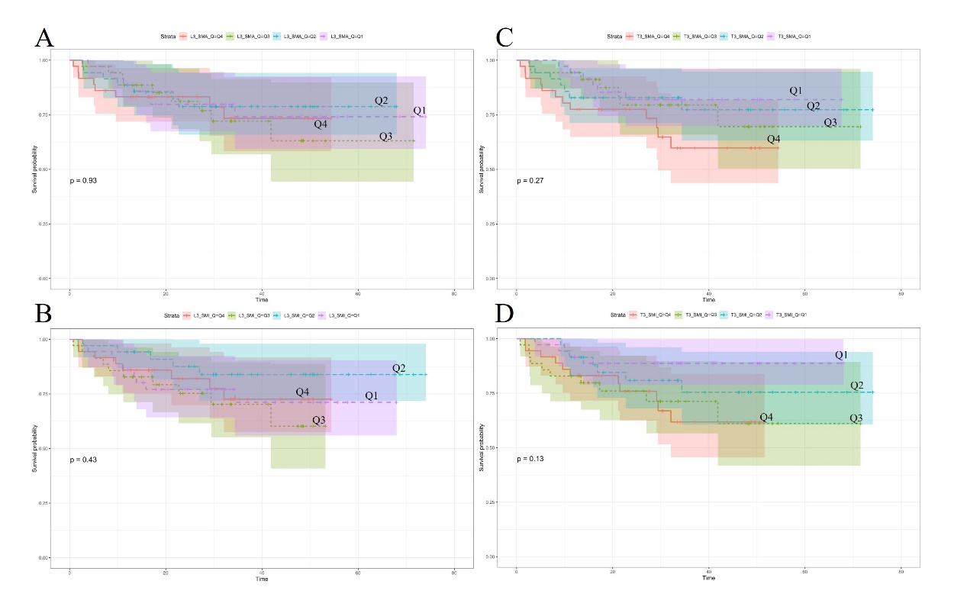
The log-rank test was used to compare the differences between the survival curves. A p-value less than 0.05 usually indicates a significant difference between the groups.

Supplemental Figure 2：The correlation between L3 SMA and L3 SMI (A and B), T3 SMA and T3 SMI (C and D) tertile group and prognosis via Kaplan-Meier (K-M) curves in patients with gastric cancer.
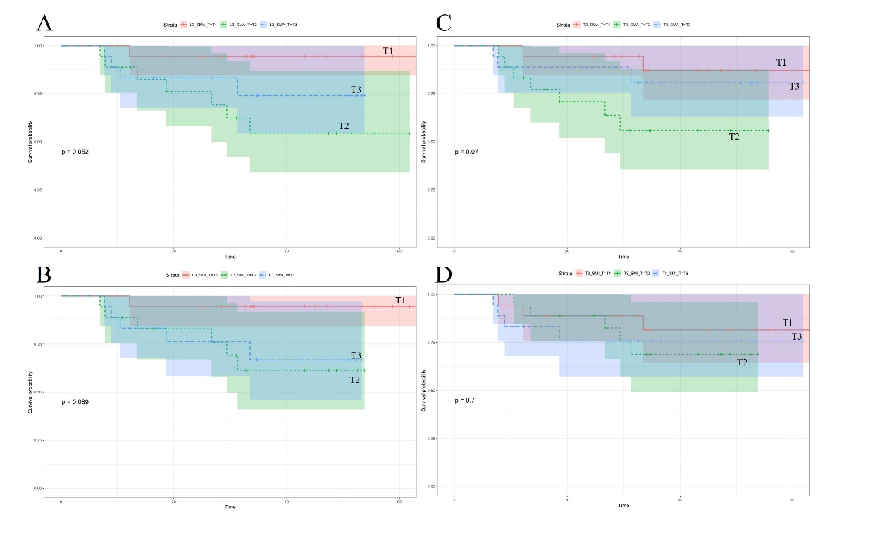
The log-rank test was used to compare the differences between the survival curves. A p-value less than 0.05 usually indicates a significant difference between the groups.

