Supplemental information of
INHBA: A mitochondrial-related pan-cell death gene associated with the prognosis and immunity of OSCC
Xiaoting Zhang ^{1,3}, Mouyuan Sun ^{3, *}, Tao Qiu³, Di He ⁴, Tian Zhang ^{3,4}, & Jin Li ^{2, *}
1. Department of Stomatology, Wuhan No.1 Hospital, Wuhan, China.
2. Affiliated Hangzhou First People’s Hospital, School of Medicine, Westlake University, Hangzhou, China.
3. Stomatology Hospital, School of Stomatology, Zhejiang University School of Medicine, Zhejiang Provincial Clinical Research Center for Oral Diseases, Zhejiang Key Laboratory of Oral Biomedical, Hangzhou, China.
4. Department of Oral and Maxillofacial Surgery, Second Affiliated Hospital, Zhejiang University School of Medicine, Zhejiang Province, Hangzhou, China
*Correspondence：sunmouyuan777@zju.edu.cn; lijin_6666@163.com

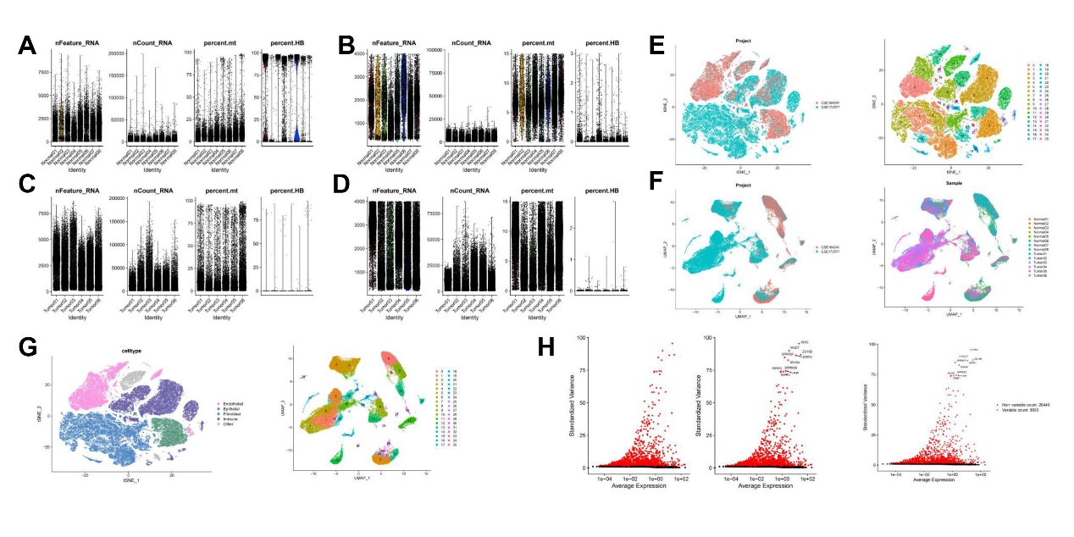
Figure S1. Single-cell expression atlas flow diagram in OSCC tissues
(A, C) All single-cell RNA sequencing data included in the analysis. (B, D) Data quality control: cells with < 200 genes, > 5,000 genes, > 20% mitochondrial genes, and > 3% hemoglobin content were filtered out. (E-G) UMAP plots for cells clustering and visualization. (H) Identification of highly variable genes based on average expression values (>0.125 and <3) and dispersion (>0.5).

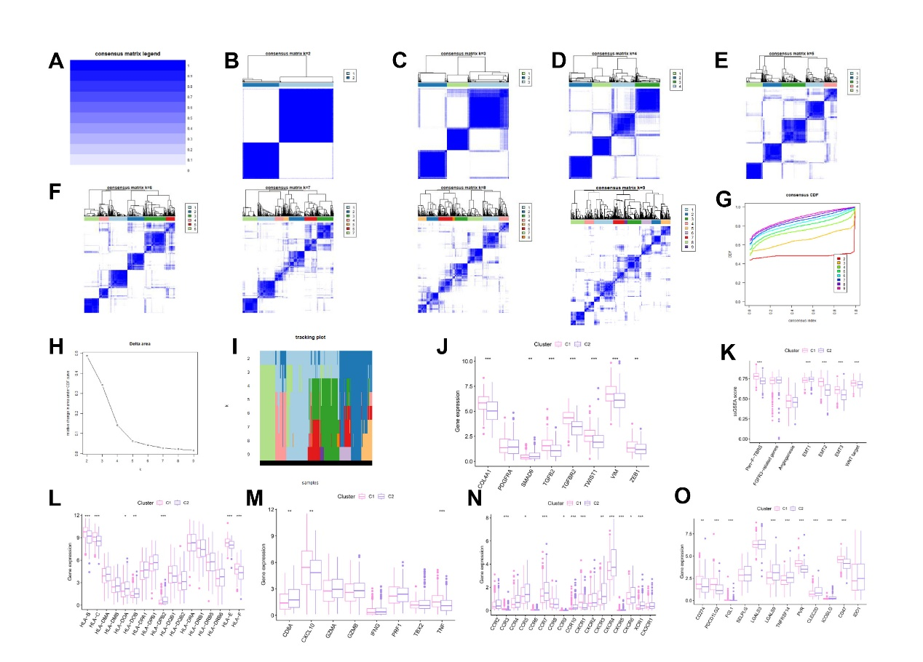
Figure S2: Unsupervised learning by MAPGs classification.
(A-I) Unsupervised clustering of 19 MAPGs. (J) Expression levels of TGFβ- EMT pathway-related gene between the two clusters. (K) Expression difference of 7 matrix related pathways between the two clusters. (L) Expression levels of HLA gene between the two clusters. (M) Expression levels of immune-activation related gene between the two clusters. (N) Expression levels of chemokine genes and receptor genes between the two clusters. (O) Different immune cell landscape between the two clusters. *p<0.05, **p<0.01, ***p<0.001, ****p<0.0001.

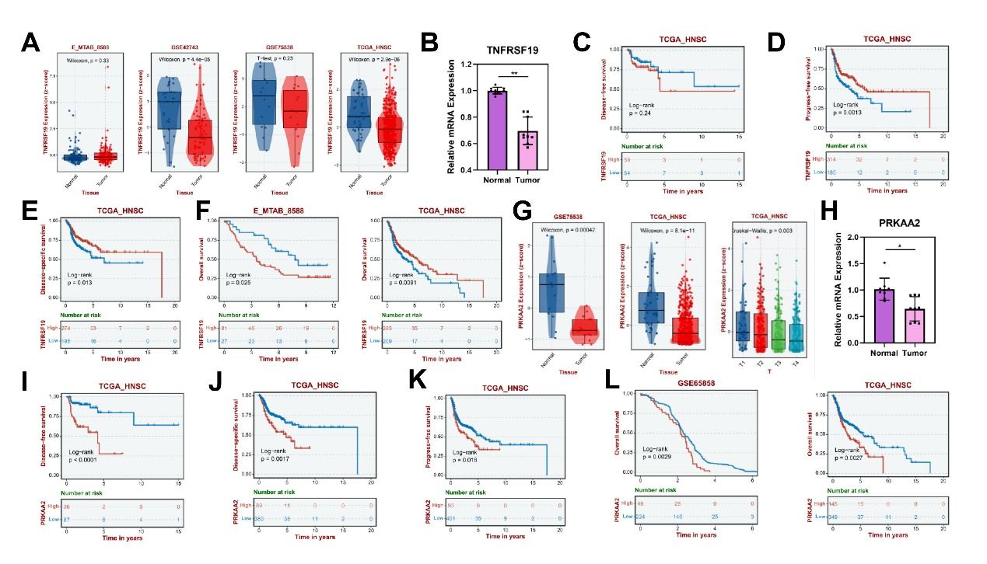
Figure S3: Correlation analysis of key MAPGs (TNFRSF19\PRKAA2) in HNSCC
(A) The expression levels of TNFRSF19 in validation set E_MTAB_8588, GSE42743, GSE75538 and TCGA_HNSC. (B) The expression level of TNFRSF19 detected by RT-qPCR in clinical sample. (C) Kaplan-Meier curve to show the disease-free survival of HNSCC patients in low TNFRSF19 expression and high TNFRSF19 expression subgroups. (D) Kaplan-Meier curve to show the progress-free survival of HNSCC patients in low TNFRSF19 expression and high TNFRSF19 expression subgroup. (E) Kaplan–Meier Curves for disease-specific survival of TNFRSF19 high-expression and TNFRSF19 low-expression subgroups. (F) Kaplan-Meier curve to show the overall survival of HNSCC patients in low TNFRSF19 expression and high TNFRSF19 expression subgroups. (G) The expression levels of PRKAA2 in validation set GSE75538 and TCGA_HNSC. (H) The expression level of PRKAA2 detected by RT-qPCR in clinical sample. (I) Kaplan-Meier curve to show the disease-free survival of HNSCC patients in low PRKAA2 expression and high PRKAA2 expression subgroups. (J) Kaplan–Meier Curves for disease-specific survival of PRKAA2 high-expression and PRKAA2 low-expression subgroups. (K) Kaplan-Meier curve to show the progress-free survival of HNSCC patients in low PRKAA2 expression and high PRKAA2 expression subgroup. (L) Kaplan-Meier curve to show the overall survival of HNSCC patients in low PRKAA2 expression and high PRKAA2 expression subgroups. *p<0.05, **p<0.01, ***p<0.001, ****p<0.0001.

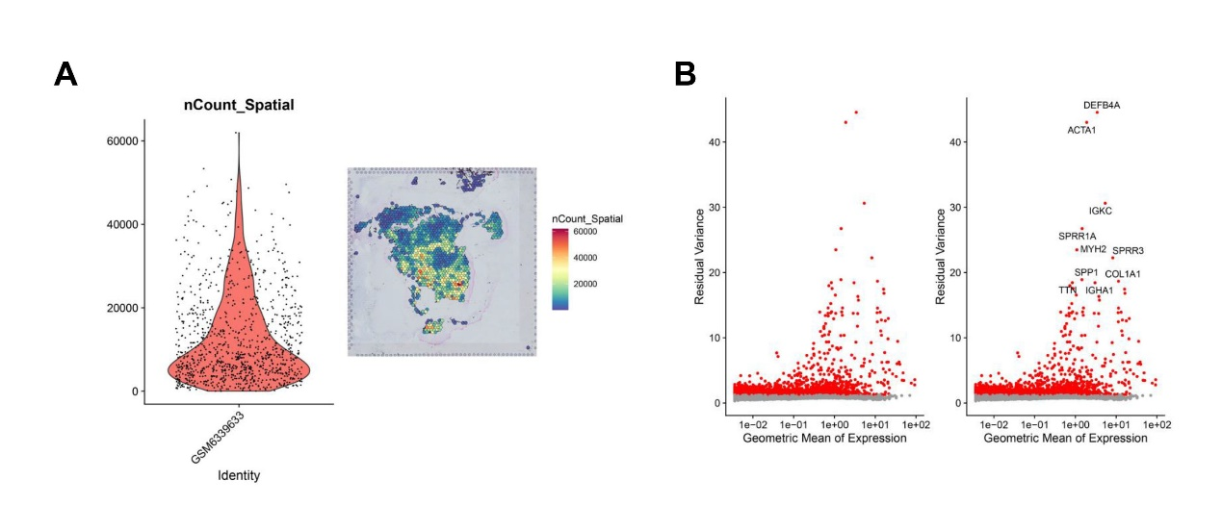
Figure S4. The spatial arrangement of cell clusters via Spatial transcriptomics Analysis.

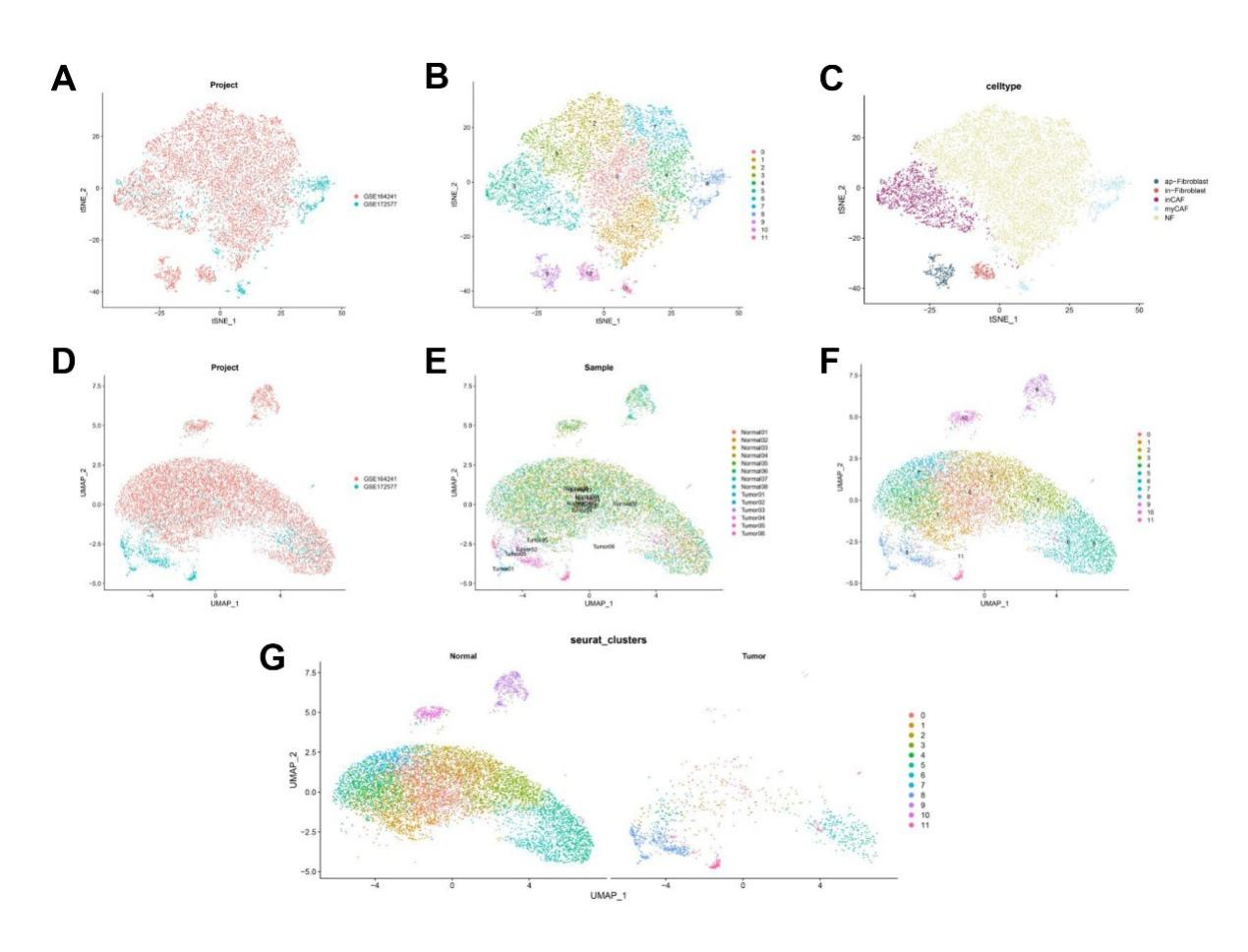
Figure S5. Single-cell subsets atlas based on INHBA expression
(A-G) UMAP of fibroblast subpopulation aggregation and visualization in normal and tumor tissues.

Table S1. Primer sequences in RT-qPCR
 | Forward:5′ to 3′ | Reverse:3’ to 5’
INHBA | GGAGCTCAGACAGCTCTTACC | CCAGCAACTTGCCAACAGAA
TNFRSF19 | CCAGCAAGGTCAACCTCGT | CAGAGCCGTTGTACTGAATGT
PRKAA2 | ATGCACCACCTGAAGTCATCTC | TCATCAAATGGGAGGGTGCC
GAPDH | AATGGGCAGCCGTTAGGAAA | GCGCCCAATACGACCAAATC

Table S2. Top 10 Genes Ranked by Feature Importance in Machine Learning Models
Machine learning | Ranking of importance
SVM-CV | Gene symbol | PRKAA2 | PLK1 | PPARG | AURKA | TNFRSF19 | INHBA | KIT | ITGA5 | PLAU | ERBB3
 | Feature importance | 0.727703 | 0.684233 | 0.515543 | 0.434583 | 0.433219 | 0.359331 | 0.283834 | 0.167404 | 0.160493 | 0.156533
QDA-CV | Gene symbol | INHBA | IL1A | AURKA | ITGA5 | TNFRSF12A | CAV1 | PRKAA2 | LAMC2 | TNFRSF19 | PLK1
 | Feature importance | 0.075 | 0.059333 | 0.052667 | 0.046 | 0.043 | 0.038 | 0.025 | 0.023667 | 0.022667 | 0.022
GB-CV | Gene symbol | TNFRSF19 | PRKAA2 | PPARG | PLK1 | TGFB1 | TNFRSF12A | INHBA | SERPINE1 | AURKA | CSF2
 | Feature importance | 0.085226 | 0.085077 | 0.073841 | 0.06609 | 0.063455 | 0.062677 | 0.060878 | 0.058699 | 0.055298 | 0.051851
RF | Gene symbol | TNFRSF19 | PRKAA2 | ITGA5 | TGFB1 | SERPINE1 | INHBA | PLAU | AURKA | TNFRSF12A | PLK1
 | Feature importance | 14.41034 | 14.28674 | 14.01979 | 13.87979 | 13.82225 | 13.57602 | 13.12404 | 13.08907 | 13.05003 | 13.04614
DT | Gene symbol | INHBA | ITGA5 | PRKAA2 | TGFB1 | SERPINE1 | TNFRSF12A | PLAU | TNFRSF19 | EEF1A2 | PPARG
 | Feature importance | 35.11592 | 29.43892 | 29.0956 | 28.16648 | 26.95531 | 26.43268 | 24.02033 | 23.87272 | 21.55911 | 17.16141
XGBoost | Gene symbol | TNFRSF19 | TNFRSF12A | PLK1 | KIT | PRKAA2 | PPARG | INHBA | AURKA | TGFB1 | LAMC2
 | Feature importance | 100 | 78.64795 | 73.23532 | 72.34108 | 68.12663 | 68.0961 | 61.00558 | 55.19157 | 53.60315 | 53.57775
GBM | Gene symbol | PRKAA2 | TNFRSF19 | AURKA | ERBB3 | PLK1 | PLAU | KIT | TGFB1 | INHBA | ITGA5
 | Feature importance | 100 | 97.6997 | 96.2825 | 64.4511 | 58.3518 | 52.781 | 50.394 | 48.3395 | 46.844 | 43.199
* INHBA expression levels were maintained as original input values without transformation or correction during all machine learning procedures. LASSO and SVM-RFE are feature selection algorithms used to identify optimal gene subsets and do not generate feature importance rankings; therefore, no corresponding importance metrics are reported for these methods.

