Supplemental material
Table of Contents
A. Genotype assignment and sequence data 3
Sequences sources 3
Sequence data quality control 3
Sequence alignment and ORF identification 4
Phylogeny construction 5
Genetic distance threshold determination for six internal genes 6
Data Records 8
Technical Validation 11
B. Data processing for other data sources 13
Basic Unit of Study - Grid Data 13
Global Chicken and Duck Density 13
Poultry Heterogeneity Index (PHI) 13
H5 HPAI Outbreak Poultry Farms 14
11 Land Cover Types 14
C. Reassortment hot spot analysis 16
D. Matched pair study design 18
E. Simple Conditional Logistic Regression Analysis 20
F. PRS construction 21
PRS: Logistic regression 22
G. Multivariate Logistic Regression Model 23
Table S1. Bootstrap values of each lineage node from the sampling Tree of each internal gene. 24
Table S2. Simple logistic regression result of all variable. 26
Table S3. Model result and performance (2014-2021). 30
Figure S1. Data pre-processing. 31
Figure S2. ORF identification. 32
Figure S3. Internal genes agreement statistics across MPD threshold and sampling tree. 33
Figure S4. Internal genes sampling tree with the merged lineages. 35
Figure S5. Genetic distances of avian influenza virus (AIV) sequences for intra- and inter-lineage of each internal gene. 36
Figure S6. Study method flow chart in Risk Factor Analysis of RA Hotspot 37
Figure S7. Temporal distribution of the data used for the risk factor analysis of RA hotspot Stage III 38
Figure S8. Distribution of study grid (2014-2021) 39
Figure S9. Distribution of study grid (before 2013) 40
Figure S10. Bird species integrating process: Logistic regression 41
Figure S11. Wild bird time stream 42
References 43

- Genotype assignment and sequence data

Sequences sources
The avian influenza virus (AIV) genome sequences and metadata are downloaded from Global Initiative for Sharing All Influenza Database (GISAID) (https://platform.epicov.org/) and Bacterial and Viral Bioinformatics Research Center (BV-BRC, https://www.bv-brc.org/) until 26, June, 2023 [1, 2]. From these sources, we collected 320,698 sequences from GISAID and 216,734 sequences from NCBI. After removing 177,730 duplicated sequences based on accession numbers, 359,702 unique sequences with 65,904 viruses were used for quality control with the pipeline shown in supplementary fig S1A. These stringent filtering steps ensured the integrity and reliability of the dataset for subsequent evolutionary and phylogenetic analyses.

Sequence data quality control
The sequence quality control is performed based on the following criteria: serotypes, collection location and time, genome length, and nucleotide ambiguities. The following steps were applied:
Step 1: Each sequence must explicitly record the HA and NA subtypes. 15,694 sequences with ambiguous subtype information, including mixed, unknown HA or NA subtypes, are removed, leaving 344,008 sequences for the next step.
Step 2: Each sequence must contain complete geography and temporal information. The collection location should be recorded at least at the country level, and the collection time must be specified at least by year. Thus, 68 sequences were excluded, leaving 343,940 sequences for the next step.
Step 3: Sequences lacking the complete open reading frame (ORF) of the gene segments were removed. Examining the sequence length distribution of all gene fragments, the majority of the sequence length is close to the length of ORF (supplementary fig S1B). To balance data inclusivity and quality, the threshold of 80% of the median length was chosen. Sequences shorter than the threshold were removed, resulting in 15,262 sequences excluded and leaving 328,678 for the next step. This step avoids the potential biases to be introduced in the follow-up analysis due to incomplete genomic sequencing but also maintains the dataset integrity.
Step 4 is to determine the cut-off for the proportion of ambiguous nucleotides. The ambiguous nucleotides or the non-ATCG nucleotides are usually generated during sequencing and recorded as N or X symbols. The ambiguities nucleotide proportion is calculated by dividing the number of ambiguities nucleotides by the genome length of each sequence. Sequences with a high proportion of ambiguous nucleotides fail to offer sufficient information in evolution analysis despite meeting the genome length criteria. In our analysis, most sequences don’t contain ambiguous nucleotides; thus, a 5% threshold could remove these low-quality sequences (supplementary fig S1C). Sequences with more than 5% ambiguous nucleotide proportion will be removed, resulting in 801 sequences excluded and leaving 327,877 sequences for open reading frame (ORF) identification (next section).

Sequence alignment and ORF identification
327,877 sequences, which passed the quality controls, were subjected to ORF identification, including PB2: 38068, PB1: 37801, PA: 38009, HA: 51493, NP: 38504, NA: 43599, MP: 40537, and NS: 39866. These sequences were organized into individual files by segment and serotype, resulting in 31 files. The individual sequence file was aligned by MAFFT (v7.490) with default settings (1). In H5, multiple furin cleavage site mutations lead to numerous gaps after alignment, resulting in incorrect ORF identification (supplementary fig S2B, top panel). To correctly identify the ORFs, the analytical pipeline (supplementary fig S2A) was executed by R through the following steps.
Step 1 was to perform gap translocation in H5. H5 contains multi-basic proteolytic cleavage sites, which are associated with high pathogenicity and mutation rates (2). The gap translocation is required to ensure accurate ORF identification. The gap translocation procedure is finished by following the guidelines. Firstly, the hypermutation regions are identified based on the following criteria: (1) coordinates containing over 95% gap proportion, (2) regions within 10 nucleotide base pairs (bps) are regarded as the same hypermutation region, and (3) the hypermutation region is longer than 100 bps. Secondly, the nucleotides were moved to the 5’ terminal, and the gaps were transferred to the 3’ terminal within the identified hypermutation regions, which created continuous nucleotides followed by gaps (supplementary fig S2B, bottom panel).
Step 2 was to remove the coordinates containing a high gap proportion. After alignment, the sequences will fill gaps that indicate the natural deletions, insertions, or potential manual errors. The coordinates with a high gap proportion could represent the technical sequencing errors. Therefore, an optimal gap-proportion threshold is essential for accurately identifying ORFs and eliminating sequences with technical errors. We evaluate the ORF length and the number of stop codons within the ORF at various gap proportions from 40% to 100% (supplementary fig S2C, D). Stable ORF length and numbers of stop codons are observed to be up to 98% of the gap proportion for the internal genes, except for the NS segment. In the NS segment, stable ORF length and the number of stop codons are identified only up to a 86% gap threshold. The abnormal length of ORF and an unusual number of stop codons indicated incorrect ORF identification outside this range. Based on these findings, the appropriate gap-proportion threshold can be set to 40%-86% to remove problematic coordinates. Consequently, we selected 86% as the threshold for accurate ORF identification and to maximize coordinate retention, consistent with the published article (3).
Step 3 was to identify the ORF start and stop codon. The start codon coordinate is determined by the consensus sequence built from the sequence alignment. The first encountered ‘ATG’ was assigned as the start codon. The rest of the sequence after the start codon was cut into three-mers nucleotides. We first investigated the number of stop codons among the amino acid coordinates of each gene segment. Multiple stop codons, equal to or greater than 5, were found in the MP and NS genes (supplementary fig S2E). However, only the NS segment has been reported to generate variable gene length associated with viral virulence (4). After investigation, 99% of MP sequences utilized the first encounter stop codon at a consistent amino acid position, with more stop codons appearing downstream. In contrast, only 22% of NS sequences used the first encountered stop codon; the rest of the sequences used the downstream stop codons, leading to the gene length variation (supplementary fig S2F). Therefore, the stop codon coordinates in most gene segments except the NS segment were determined by the location where the stop codon was most frequently used. In the NS segment, the stop codon was defined as the first encountered stop codon in each sequence. The sequence following the stop codon, including the stop codon itself, will be removed. As a result, the identified ORFs contain the start codon but not the stop codon.
Molecular clock outlier identification
Maximum-likelihood (ML) trees for each gene segment were constructed by FastTree (v.2.1.11) with default settings (5). The ML phylogenies were used to identify molecular clock outliers (sequences with extremely high or low root-to-tip divergence relative to their sampling time) using TempEst (v.1.5.3) (6). The outliers in each segment were identified and subsequently removed from the ORF fasta file. After removing 124 outliers, the final AIV sequence dataset contains 57,181 viruses, with a total of 327,753 sequences passing the quality controls. The final sequence numbers distributed across eight gene segments are PB2: 38066, PB1: 37798, PA: 38008, HA: 51443, NP: 38502, NA: 43537, MP: 40534, and NS: 39865. These sequences were used to construct the phylogeny for clade identification, as illustrated in the following section.

Phylogeny construction
To assign lineages to similar evolutionary populations, we employed two commonly used phylogenetic tree-construction tools, FastTree (v2.1.11) (5) and IQ-TREE (1.6.12) (7). The dual-tools approach assumed that the phylogenetic methods should produce consistent evolutionary relationships for the same gene segment to enhance the reliability of the lineage assignment. A total of 327,753 sequences, organized into 31 gene segment files, were applied to FastTree with the command fasttree -gtr -nt and IQ-TREE with the command iqtree -st DNA -m GTR+I+G -nt AUTO -bb 1000 for maximum likelihood (ML) tree construction of each gene segment.

Agreement statistic
Agreement statistics were developed to evaluate the robustness of lineage assignments across different phylogenetic tree construction methods.
$$AS= \frac{ The sequence pairs within same lineage or distinct lineages }{C_{2}^{n}}$$
$$AS-Same= \frac{ The sequence pairs within same lineage }{C_{2}^{n}}$$
The agreement statistic (AS) was defined as the ratio of the number of sequence pairs within the same lineage or in distinct lineages across different methods, divided by the total number of sequence pairs. At the same time, AS-Same specifically measured the proportion of sequence pairs assigned to the same lineage, which provides further insight into lineage assignment resolution, as shown in supplementary figures S3 and S4. The elbow method, a visual approach for determining the optimal number of clusters in K-means clustering (8), will be applied in the following section.

Genetic distance threshold determination for six internal genes
To assign lineages, we established a pipeline to determine the optimal mean pairwise patristic distance (MPD) threshold for six internal genes, following the steps shown below. For the internal genes, we incorporated a filtering and sampling step before calculating the MPD to avoid sequences with high identity, which can compromise the tree topology and yield low MPD.
Step 1 was to generate global and sampled datasets for the internal gene segments. Due to low mutation rates, internal genes, especially in LPAIVs, contain a large number of highly identical sequences. Therefore, the sequence filtering and sampling procedure was performed to improve the phylogenetic tree resolution. The total sequences were filtered based on the identified amino acid sequences; only one sequence per unique 100% amino acid identity was retained and included in the global dataset. After filtering, 5% of the sequences were randomly selected without replacement and will be referred to as the sampled dataset for phylogenetic tree construction in Step 2.
Step 2 was to construct the phylogenetic tree and calculate MPD. Two ML trees were constructed for each gene segment by FastTree and IQ-TREE. For internal genes, separate trees were generated from the global and sampled datasets, referred to as the global and sampling trees, respectively. Next, we calculated patristic distances, defined as the sum of the branch lengths connecting two sequences. The MPD for each node was determined by averaging all pairwise patristic distances among sequences within that node. This step was performed only based on the sampling tree.
Step 3 was to assign lineages across various MPD Thresholds. Lineages were identified across a range of MPD thresholds starting from 0.01 and increasing by 0.01 to the highest MPD in each gene segment. At each MPD threshold, nodes with MPD values exceeding the predefined threshold were removed (named "removed nodes"), and the remaining nodes were retained (named "survived nodes"). The sequences under the largest independent surviving nodes will be assigned to the same lineage. This process was iteratively repeated until all sequences were assigned to survival nodes. Lineages of each gene segment were independently identified in trees constructed by both FastTree and IQ-TREE. We only performed this step based on the sampling tree.
Step 4 was to calculate AS and determine the Optimal MPD Threshold. The optimal threshold to define lineages was based on the following criterion: (1) the AS value should be higher than 80; (2) the assigned lineages should be ranged between 3 and 20 to avoid under- or over-assignment of the lineages; (3) the optimal threshold was determined at the elbow point of the AS-Same versus MPD threshold curve moving from the high to low thresholds. If no elbow points exist, the threshold was selected near the elbow point where the AS value remained above 80; (4) the sequence numbers per lineage should be more than 3; (5) the pre-assigned lineages need to have bootstrap support value higher than 70%; if the node support value was lower than that, further merging the pre-assigned lineage manually to the upper hierarchical node until the bootstrap value meets the 70% criteria (supplementary fig S3, S4).
Step 5 was to assign lineages on the global tree based on the MPD thresholds of the sampling trees and the global tree topologies for all the internal gene fragments (supplementary fig S5).

Data Records
The virus genotype dataset is available at ‘https://doi.org/10.6084/m9.figshare.27014134’. This Figshare respiratory include pooled raw data, pre-processed data and associated R script for the sequence pre-processing and lineage assignment.
- The file, named “sequence_meta_information_raw.csv”, comprise comprehensive metadata, raw virus genome and genome features.
Columns 1: Isolate_Id. The unique identifier for each virus.
Columns 2: header. The sequences header from collected data.
Columns 3: seq. The raw virus genome.
Columns 4: Strain_name. The unique name of each virus.
Columns 5: Strain_number. The unique identifier of each sequences.
Columns 6: segment. The gene segments of each sequences.
Columns 7: Subtype. The explicit virus subtypes composed by HA and NA serotype.
Columns 8: Clade. The HA clades information collected from GISAID.
Columns 9: Location. The virus collection location, specified at least to country level.
Columns 10: Host. The host from which the virus was collected through downloaded metadata.
Columns 11: Collection_Date. The virus collection time.
Columns 12: Submission_Date. The virus submission time.
Columns 13: strain_host. The host from which the virus was collected from the sequence header.
Columns 14: nt_number. Virus genome length.
Columns 15: non_nt_number. Numbers of the ambiguous nucleotide’s in the genome.
Columns 16: non_nt_percent. Pproportion of the ambiguous nucleotide’s in the genome.
- The file, named “seqeunce_meta_information_preprocessed.csv”, comprise the comprehensive metadata, identified open reading frame (ORF) and ORF features.
Columns 1: Isolate_Id. The unique identifier for each virus.
Columns 2: header. The sequences header from collected data.
Columns 3: seq. The raw genome.

Columns 4: orf. The identified ORF of each virus genome.
Columns 5: Strain_name. The unique name of each virus.
Columns 6: Strain_number. The unique identifier of each sequences.
Columns 7: segment. The gene segments of each sequences.
Columns 8: Subtype. The explicit virus subtypes composed by HA and NA serotype.
Columns 9: Clade. The HA clades information collected from GISAID.
Columns 10: Location. The virus collection location, specified at least to country level.
Columns 11: Host. The host from which the virus was collected through downloaded metadata.
Columns 12: Collection_Date. The virus collection time.
Columns 13: Submission_Date. The virus submission time.
Columns 14: strain_host. The host from which the virus was collected from the sequence header.
Columns 15: orf_nt_number. The identified ORF length.
Columns 16: orf_non_nt_number. Numbers of the ambiguous nucleotides in the ORF.
Columns 17: orf_non_nt_percent. The proportion of the ambiguous letters in the ORF.
- The file, named “virus_genotype_meta_information.csv”, comprises comprehensive metadata and lineage information for viral genotypes across eight gene segments of the corresponding final AIV sequence dataset. The file contains 20 variables for each sequence.

Columns 1: Isolate_Id. The unique identifier for each virus.
Columns 2: Subtype. The explicit virus subtypes composed by HA and NA serotype.
Columns 3: Clade. The HA clades information collected from GISAID.
Columns 4: Location. The virus collection location, specified at least to country level.
Columns 5: Collection_Date. The virus collection time specified at least to year level.
Columns 6: Host. The host from which the virus was collected.
Columns 7: Scientific_name. Scientific name of the collected host.
Columns 8: H_order. The taxonomic information order of the collected host.
Columns 9: H_family. The taxonomic family of the collected host.
Columns 10: PB2. The assigned lineage of PB2 in this study.
Columns 11: PB1. The assigned lineage of PB1in this study.
Columns 12: PA. The assigned lineage of PA in this study.
Columns 13: HA. The HA serotypes of the virus.
Columns 14: NP. The assigned lineage of NP in this study.
Columns 15: NA. The NA serotypes of the virus.
Columns 16: MP. The assigned lineage of MP in this study.
Columns 17: NS. The assigned lineage of NS in this study.
Columns 18: Genotype. Genotype represented as a combination string of the assigned lineage for the eight gene segments, ordered as PB2, PB1, PA, HA, NP, NA, NP, and NS.
Columns 19: Complete. Indicating whether the virus contains complete eight gene segments with 1 indicating complete, 0 indicating incomplete and 2 indicating mixed population with more than 2 viruses in the same isolate.
Columns 20: Multiple_genotypes. This column includes the possible genotypes of the same isolate with mixed populations.
- The script folder contains the custom R scripts for data processing.
  - function.R: Custom R functions for data processing.
- meta_clean.R: Performing the metadata and sequence quality control.
- patristic_distance_analysis.R: calculating the pairwise patristic distance from the phylogentic tree.
- ORF_ident.R: Identified the open reading frame from the aligned genome for each gene segment.
- samping_tree_agreement.R: Performing the agreement analysis between two phylogenetic tree and determining the optimize MPD threshold.
- lineage_assign.R, identifying the global tree lineages based on the determined sampling tree MPD threshold and global tree topology.

Technical Validation
The partitioning of the phylogenetic tree is challenging, and there is currently no consensus methodology for identifying clusters or lineages, particularly when the sequences used to construct the phylogenies are large. However, the common ground across studies for assigning lineage is to consider genetic distances, phylogenetic topology, branch support, and epidemiologic information, which supports transmission clusters (9, 10). Lineage or partition selection can be based on absolute genetic and patristic distance values. However, the definition of a transmission cluster is not standardized either. Transmission clusters could be due to geographical constraints, revealed as sub-trees of phylogenies containing at least distinct sequences with pre-defined numbers. The branch support of the subtrees needs to be high, usually defined by bootstrap support or posterior probability, ranging from 70 to 100%. With the ongoing evolution and global expansion of AIV, genome sequence data have been generated rapidly and in high volume. Therefore, any lineage-naming system must be capable of handling hundreds of thousands of virus genomes sampled longitudinally, yet practical in assigning reasonable numbers of lineages and in providing epidemiological information to conceptualize transmission. The focus of this study provides a framework for allocating the major lineages of different gene fragments of AIV, thereby denoting the genotypes of each virus. Hence, rather than naming every possible new lineage, classification will focus on those that have exhibited ongoing spread in different geographic regions or hosts. The focus will be on those virus genotypes that contribute most to global transmission and gene fragment recombination.
For the above reasons, we conducted several validations to ensure the reliability and robustness of the assigned lineages across the internal gene segments. These validations involved evaluating bootstrap values, genetic distances, and geographical distributions of viral sequences as described in appendix pp 5-12. First, we summarize the bootstrap values and sequence numbers for each lineage’s nodes in Table S1. All node bootstrap values were greater than 70 in the sampling tree, indicating strong support for these lineage assignments. Also, the assigned lineages from the sampled tree showed tree topologies similar to those of the global tree, suggesting that this lineage-assignment approach is consistent and reliable (Fig. S3, S5).
Second, we calculated inter- and intra-lineage genetic distances using GTR+I+G, as generated by IQ-TREE. Statistically significant differences were observed by the Wilcoxon rank-sum test between intra-lineage and inter-lineage groups across the internal genes with lower distance within intra-lineage (supplementary fig S6). This result provides further support for the genetic diversity present among the assigned lineages. Third, we further examined the geographic distribution of the major lineages for each gene segment. The majority of the lineages were confined to one or two continents, indicating a strong geographic concentration (supplementary fig S5). This observation reinforces that the assigned lineages were well supported by both genetic and geographical patterns of viral evolution.
In summary, we constructed the phylogenetic tree of the internal genes based on agreement statistics, which measure the consistency of lineage assignments between two phylogenetic construction tools. The final assigned lineages of the internal genes showed strong bootstrap support, with distinct inter-lineage genetic distances and epidemiological information on AIV transmission and gene recombination. Furthermore, we reorganized the metadata to provide the most comprehensive information, including sample collection date and location, host species with names up to order and family, and virus genotypes.

- Data processing for other data sources

Basic Unit of Study - Grid Data
In this study, grids serve as the fundamental spatial unit for analysis. The Eurasian region was divided into grids measuring 100 x 100 km² using the Quantum Geographic Information System (QGIS) version 3.22.10. There are 2257 grids for Europe, 7790 for Asia, and 109 overlapping grids between the two continents.

Global Chicken and Duck Density
In a previous study (11), livestock distribution data for various years and resolutions were obtained from agricultural yearbooks, national ministries, or statistical agencies. Livestock numbers were modelled using dasymetric and areal-weighted models. This study used a dasymetric model, incorporating additional spatial predictors, including population density, vegetation indices, and topography. This approach refines simulations from lower-resolution data to produce livestock distribution grids at an approximate 10 × 10 km² resolution.
The data used in this study were sourced from the Livestock Systems section on the Food and Agriculture Organization of the United Nations (FAO) website (https://www.fao.org/livestock-systems/global-distributions/en/). Chicken and duck farming distribution grids from 2015 were utilized for the study. Using the QGIS, we overlapped the 100 × 100 km² analysis grid layer with the 10 × 10 km² livestock density grid layer. The total livestock numbers within each analysis grid were computed by the sum of values from all smaller grids intersecting with the larger grid.
Since both layers are grid-based, small grids often span across the boundaries of larger ones. In this study, any small grid that touches the boundary of a large grid is included in the count. While this approach may result in some double-counting, all grids are subject to the same condition. Therefore, although there may be minor discrepancies in actual counts, the overall trend in livestock density remains unaffected.
Grid area was calculated using QGIS polygon area functions, providing the actual area for each grid. The livestock count in each grid was then divided by its location to derive chicken or duck density, expressed in units of heads/km².

Poultry Heterogeneity Index (PHI)
In a previous study conducted in Taiwan from 2015 to 2017 on H5N2 and H5N8 (12), PHI was shown to have a significant positive correlation with disease hotspots. This may be related to differences in the virus’s adaptability and pathogenicity between terrestrial and aquatic poultry species. In this study, we aim to investigate whether the spatial distribution of this index is associated with virus reassortment hotspots (RA-hotspots), analyzing whether differences in poultry species or farming practices are more likely to promote virus reassortment. The calculation formula is as follows:
$$PHI=1-\frac{\left|N_{C}-N_{D}\right|}{N_{C}+N_{D}}$$
Where $N_{C}$ represents the number of chickens in the grid, and $N_{D}$ represents the number of ducks in the grid. When $N_{C}$ + $N_{D}$ is constant, a more balanced ratio of chickens to ducks results in a higher PHI, while a more uneven ratio results in a lower PHI. When $N_{C}$ − $N_{D}$ is constant, the higher the total number of chickens or ducks, the higher the PHI. Therefore, this index increases when there are larger numbers of poultry or smaller differences between the numbers of each species.

H5 HPAI Outbreak Poultry Farms
Data were sourced from the Emergency Prevention System (EMPRES) website of the Food and Agriculture Organization of the United Nations (FAO) (https://empres-i.apps.fao.org/). This database collects spatial and temporal distribution information for various animal diseases worldwide. For avian influenza, key information includes disease name, observation and reporting dates, geographic coordinates, virus subtype and pathogenicity, host type, host species, and diagnostic confirmation status.
Data were downloaded through October 8, 2024, totaling 55865 records. The following filters were applied:
- Records with observation year: 53515 records
- Records with observation time within 2014 to 2021: 18211 records
- Records with serotype field classified as H5 HPAI: 15911 records
- Records with Animal type field marked as Domestic: 10859 records
- Records with Diagnosis.status field marked as Confirmed: 10859 records
- Among these, non-avian species such as Canine, Cats, Dogs, Ferret, and Swine were excluded from the Species field, leaving 10846 records.
The filtered dataset was overlaid with the analysis grid using QGIS. Grids containing outbreak poultry farms were assigned a value of 1, while those without outbreaks were assigned a value of 0.

11 Land Cover Types
The data are sourced from the WorldCover website (https://esa-worldcover.org/en/data-access) for 2021. This dataset is generated using radar imagery from the Sentinel-1 and Sentinel-2 Earth observation satellites under the Copernicus Programme of the European Space Agency (ESA), which can penetrate cloud cover to gather geographic information. The satellites complete a full orbit of the Earth every five days, providing real-time land cover information with a resolution of approximately 10 × 10 m². To ensure data accuracy, independent validation is conducted by Wageningen University and regional experts.
The dataset includes 11 land cover types defined by the United Nations Land Cover Classification System (UN-LCCS): Trees, Shrubland, Grassland, Cropland, Built-up, Barren/Sparse Vegetation, Snow and Ice, Open Water, Herbaceous Wetland, Mangroves, and Moss and Lichen. Due to its comprehensiveness, the dataset is widely used in various fields, including food security, carbon assessment, land use, biodiversity monitoring, and climate change impact evaluation.
For the analysis, the data were applied to a 100 × 100 km² grid layer. Each land cover type was converted into a percentage within each grid cell. These land cover types were incorporated as different variables into a multiple logistic regression model. For each grid, if a land cover type exceeded 10%, the grid was considered to possess that characteristic and was coded as 1; otherwise, it was coded as 0. Since land cover can be diverse within a grid, multiple land cover factors could be coded as 1 for the same grid if their distribution was sufficiently balanced.

- Reassortment hot spot analysis
QGIS was used to integrate point data within grids from 2000 to 2013 and from 2014 to 2021. R was then used to calculate the number of distinct genotypic viruses in each grid. Using the number of virus genotypes in each grid as a numeric value, the localmoran function from the spdep package in R was applied to compute the local Moran’s I ($I_{i}$) for each grid, based on local spatial autocorrelation (13). The formula for $I_{i}$ is as follows:
$$I_{i}= \frac{(x_{i}-\overline{x})}{\sum_{j=1}^{n}{{{(x_{j}-\overline{x})}^{2}}/{(n-1)}}}\sum_{j=1}^{n}{w_{ij}(x_{j}-\overline{x})}$$
In this formula:
$x_{i}$ represents the number of virus genotypes in the i-th grid.
$x_{j}$ represents the number of virus genotypes in the neighboring grids of grid i, where j = 1,…,n (grid i has n neighbors).
$\overline{x}$ is the arithmetic mean of virus genotypes across all grids.
$w_{ij}$ is the spatial weight for neighboring grids, defined as $w_{ij}=1/n$.
For example, if grid i has 8 neighboring grids, $w_{ij}=1/8=0.125$, and so forth. In this analysis, neighbors are defined as any grids that share a point or an edge with grid i with a maximum of 8 neighboring grids per grid.
After calculating the local Moran’s I values, a z-score is computed for each $I_{i}$, and a two-tailed Z-test is performed to test the statistical significance of $I_{i}$. The z-score formula is as follows:
$$z_{Ii}= \frac{I_{i}-E(I_{i})}{\sqrt{Var(I_{i})}}$$
where:
$$E\left(I_{i}\right)=-\frac{\sum_{j=1}^{n}{w_{ij}}}{(n-1)}$$
$$Var\left(I_{i}\right)=E\left({I_{i}}^{2}\right)-{E(I_{i})}^{2}$$

$E\left(I_{i}\right)$ is the expected value of local Moran’s I under spatial randomness.
$Var(I_{i})$ is the variance of $I_{i}$.

The hypotheses for the test are as follows:
H₀ : The value of grid i has no statistically significant spatial autocorrelation with its neighboring grids ($I_{i}= E(I_{i})$)
H_{a} : The value of grid i has statistically significant spatial autocorrelation with its neighboring grids ($I_{i}≠ E(I_{i})$)
The computed $z_{Ii}$ is placed in a standard normal distribution to obtain the p-value.
The z-score, p-value, and the sign of the difference between the value of grid i and the mean ($x_{i}$ - $\overline{x}$) are used to classify the grid into the following types:
- Grid with a high value and significant clustering with high-value neighbors (high- high；H-H) :
p-value < 0.05 / ($x_{i}$ - $\overline{x}$) > 0 / $z_{Ii}$ > 0
- Grid with a high value and significant clustering with low-value neighbors (high- high；H-L) :
p-value < 0.05 / ($x_{i}$ - $\overline{x}$) > 0 / $z_{Ii}$ < 0
- Grid with a low value and significant clustering with high-value neighbors (high- high；L-H) :
p-value < 0.05 / ($x_{i}$ - $\overline{x}$) < 0 / $z_{Ii}$ > 0
- Grid with a low value and significant clustering with low-value neighbors (high- high；L-L) :
p-value < 0.05 / ($x_{i}$ - $\overline{x}$) < 0 / $z_{Ii}$ < 0
- Not significant: p-value > 0.05
- No neighbors: Grid without neighboring grids

- Matched pair study design
Matched control grid selection
After completing the RA-hotspots analysis, grids classified as H-H were defined as case grids. Matched pair study designs were conducted separately for Europe and Asia. For 2014-2021 as an example, Europe had 2257 grids, with 96 case grids. Asia had 7790 grids, with 62 case grids. Since not all grids have the capacity for virus sampling, laboratory diagnosis, sequencing, and data submission, we applied varying levels of stringency when selecting control grids for subsequent matched-pair study design analysis. We used the EMPRES-i database to identify grids with records of avian influenza (regardless of pathogenicity, serotype, or host) up to 2021. These grids were taken in union with grids identified in the previously processed GISAID dataset containing avian influenza records to create the first sets of control grids. Additionally, we analyzed grids containing avian influenza records exclusively from the GISAID dataset to form the second control group. In Europe, the first set of control grids comprised 626 grids, while the second set comprised 141 grids. In Asia, the first set of control grids comprised 1216 grids, while the second set comprised 248 grids.
Each bird species was analyzed individually. Using the birds' propensity scores, a one-to-one matching between case and control grids was performed. The matching method in a bird species involves the following steps. First, find the control grid with the closest propensity score for each case grid and calculate the difference in their propensity scores. Second, in the set of propensity score (PS) differences, the maximum value is used as the upper and lower bounds. One control grid was then randomly selected within this range for pairing. Under these conditions, the combination with the largest difference would always match a fixed control grid, while other case grids would have a broader range to select a control grid with a similar propensity score. The grids with observation records of the bird are defined as exposed, while grids without observation records are defined as unexposed. Based on this matching scheme, a simple conditional logistic regression analysis is used to estimate the odds ratio (OR) of bird presence associated with avian influenza virus RA-hotspots from 2014 to 2021. A significant positive correlation was defined as an odds ratio greater than 1 with a p-value less than 0·05. The results of the matching are shown in the table below:

 |  | Control
 |  | Exposed | Non-exposed
Case | Exposed | A | B
Case | Non-exposed | C | D
In the example, grids with observation records of the bird are defined as exposed, while grids without observation records are defined as unexposed.
Based on this matching scheme, a simple conditional logistic regression analysis is used to estimate the odds ratio (OR) of bird presence associated with avian influenza virus RA-hotspots from 2014 to 2021. A significant positive correlation was defined as an odds ratio greater than 1 with a p-value less than 0.05.

- Simple Conditional Logistic Regression Analysis
There are I-matched pairs (i = 1, …, I), with each pair consisting of one case grid and one control grid. Considering a univariate case for a single bird species, the conditional likelihood of a grid becoming a virus recombination hotspot is expressed as follows:
$$\operatorname{Pr}\left(y=1 | x\right)=\prod_{i=1}^{I}{\frac{exp⁡({β_{1}X}_{i01}+β_{0})}{\sum_{j=0}^{1}{exp⁡(β_{1}X_{ij1}+β_{0})}}}$$
In this context, $X_{i01}$ represents whether the bird species is present in the case grid of the i-th matched pair, while $X_{i11}$ represents whether the bird species is present in the control grid of the i-th matched pair, $β_{0}$ is the intercept term for the i-th stratum, and $β_{1}$ is the estimated coefficient. By exponentiating $β_{1}$ with base 𝑒 (where 𝑒 ≈ 2.71828), the odds ratio for the matched pair can be obtained. The analysis is performed using the clogit function from the survival package in R.

- PRS construction
In the second stage, due to the correlations and confounding effects among different bird species, as well as the complex transmission network, we propose integrating all risk-associated bird species into a single score, polygenic Risk Score (PRS), to facilitate the construction of multivariable models with other environmental factors. When selecting bird species for PRS calculation, we intentionally avoid using the conventional 0.05 significance threshold. In reality, it is often difficult or even impossible to collect sufficient evidence for potentially risky but lesser-known bird species. This may result in non-significant statistical outcomes, even if the species do contribute to viral reassortment. Using results from simple conditional logistic regression, all bird species are ranked in ascending order based on their p-values and sequentially added into a logistic regression model. The same case/control is used as the dependent variable, with the included bird species as explanatory variables. For each iteration, we record the area under the ROC curve (AUC) and the model’s Akaike Information Criterion (AIC), comparing predicted probabilities with actual values. Finally, the 50 bird species with the lowest AIC values are selected as the final inclusion set. The predicted probabilities from the logistic regression model are then converted to binary values using Youden’s J statistic, yielding the PRS. We also try to use the fuzzy Shannon index, fuzzy Simpson index, and richness to integrate the bird species. Among these indices, models incorporate only bird species with positive point estimates, only negatively associated species, or a mix of both. In conclusion, we select the mixed population for the logistic regression method and the positive population for other methods.

PRS: Logistic regression
In the logistic regression, all bird species variables were binary, indicating presence or absence (1/0). We sequentially added bird species to the model, from most to least significant, and recorded the model’s AIC and the AUC from the ROC curve, based on predicted probabilities and observed binary outcomes. The selection criterion was to identify the model with the lowest AIC among the top 50 bird species, which was then used to determine the optimal level of species inclusion. The trained PRS model derived from this process was adopted as the final predictive PRS model.
Final model for estimating the probability of a grid PRS:
$$\operatorname{Pi}\left(y=1 | x\right)=\frac{exp(\sum_{k=1}^{K}{β_{k}}X_{ik}+β_{0})}{1+exp⁡(\sum_{k=1}^{K}{β_{k}}X_{ik}+β_{0})}$$
The probability $P$_{i} for the i-th grid is calculated based on K bird species, their coefficients $β_{k}$ and the constant term $β_{0}$.
The Youden index is defined as:
$$J_{max}=\max_{t}\left\{sensitivity\left(t\right)+specificity\left(t\right)-1\right\}$$

- Multivariate Logistic Regression Model
In the second stage, we use the same case-control set to estimate a multivariate logistic regression model. The aim is to combine the effects of PRS, anthropogenic, and environmental factors into a single model. Analyses are conducted separately for each continent and each control set.
The initial model (null model) contains no variables, while the full model includes the PRS and other anthropogenic or environmental factors. Other anthropogenic or environmental variables include chicken density, duck density, the Poultry Heterogeneity Index (PHI), H5 HPAI outbreak poultry farms, and 11 land cover types.
We employed the elastic net method for variable selection in model construction. The parameters α (alpha) and λ (lambda) were each evenly divided into 200 values ranging from 0 to 1, resulting in a total of 40,000 combinations. For each combination, 10-fold cross-validation was performed to calculate the mean squared error (MSE), and the parameter set yielding the lowest MSE was selected as the optimal combination. Variables with non-zero coefficients in the resulting elastic net model were retained and subsequently entered into a logistic regression model to construct the final model. The final model is then used to estimate the probability of a grid becoming a viral RA-hotspots.
Final model for estimating the probability of a grid becoming a viral RA-hotspots:
$$\operatorname{Pi}\left(y=1 | x\right)=\frac{exp(\sum_{k=1}^{K}{β_{k}}X_{ik}+β_{0})}{1+exp⁡(\sum_{k=1}^{K}{β_{k}}X_{ik}+β_{0})}$$
The probability $P$_{i} for the i-th grid is calculated based on K variables, their coefficients $β_{k}$ and the constant term $β_{0}$

Table S1. Bootstrap values of each lineage node from the sampling Tree of each internal gene.
The bootstrap support (BS) values in percentage were calculated by IQ-TREE (iqtree -st DNA -m GTR+I+G -nt AUTO -bb 1000) and presented on the major lineages of the sampling tree. The number of sequences for each assigned lineage of six internal gene segments (PB2, PB1, PA, NP, NS, MP) was also shown.

 | Major Lineage | BS-Sampling tree | Sampling tree sequences | Global tree sequences
PB2 | L1 | 82 | 506 | 4,881
 | L2 | 82 | 268 | 3,680
 | L3 | 95 | 3 | 57
 | L4 | 100 | 22 | 276
 | L5 | 100 | 19 | 170
 | L6 | 94 | 5 | 31
 | L7 | 87 | 94 | 1,080
 | L8 | 87 | 14 | 213
 | L9 | 100 | 27 | 227
 | L10 | 100 | 3 | 57
 | L11 | 100 | 340 | 3,680
 | L12 | 100 | 479 | 4,373
 | L13 | 100 | 63 | 676
 | L14 | 91 | 4 | 50
 | L15 | 100 | 37 | 332
 | L16 | 93 | 6 | 41
 | L17 | 97 | 5 | 59
 | L18 | 100 | 8 | 116
PB1 | L1 | 99 | 699 | 6,369
 | L2 | 99 | 662 | 6,513
 | L3 | 100 | 522 | 4,901
 | L4 | 100 | 6 | 46
PA | L1 | 99 | 1,014 | 10,112
 | L2 | 99 | 337 | 4,008
 | L3 | 100 | 331 | 2,378
 | L4 | 100 | 198 | 1,840
 | L5 | 100 | 13 | 97
 | L6 | 100 | 7 | 121
NP | L1 | 76 | 1,429 | 8,334
 | L2 | 76 | 59 | 296
 | L3 | 88 | 409 | 2,637
 | L4 | 100 | 3 | 15
 | L5 | 100 | 14 | 77
 | L6 | 100 | 11 | 56
NS | L1 | 65 | 653 | 980
 | L2 | 65 | 416 | 4,059
 | L3 | 100 | 561 | 5,958
 | L4 | 100 | 362 | 2,558
MP | L1 | 69 | 945 | 1,918
 | L2 | 69 | 116 | 317
 | L3 | 86 | 564 | 1,026
 | L4 | 96 | 367 | 761
 | L5 | 96 | 34 | 207

Table S2. Simple logistic regression result of all variable.
 | 2014-2021 (Second wave) |  |  |  |  |  |  |  |  | 2000-2013 (First wave)
 | AS CC-1 | AS CC-2 |  | EU CC-1 |  | EU CC-2 |  | AS CC-1 |  |  | AS CC-2 |  | EU CC-1 |  | EU CC-2
Variable | AOR¹  (95% CI²) | AOR¹  (95% CI²) |  | AOR¹  (95% CI²) |  | AOR¹  (95% CI²) |  | AOR¹  (95% CI²) |  |  | AOR¹  (95% CI²) |  | AOR¹  (95% CI²) |  | AOR¹  (95% CI²)
Barren or Sparse Vegetation | 0·08*  (0-0·38) |  | 0·09*  (0·01-0·45) |  | 0  (0-104881163610·764) |  | 0  (0-3·63795498073887e+63)
Built up | 7·72*  (4·39-13·35) |  | 2·56*  (1·4-4·66) |  | 3·44*  (1·27-8·5) |  | 5·47*  (1·29-37·25)
Chicken stocking density | 1·0002*  (1·0001-1·0002) |  | 1·0001*  (1-1·0002) |  | 1·0007*  (1·0004-1·0009) |  | 1·0011*  (1·0006-1·0016) |  | 1·0001*  (1-1·0002) |  |  | 1·0001  (1-1·0002) |  | 0·9975  (0·9932-1) |  | 0·9967  (0·9922-0·9995)
Cropland | 1·13  (0·67-1·95) |  | 1·02  (0·57-1·84) |  | 5·24*  (2·44-13·64) |  | 4·4*  (1·88-12·11)
Duck stocking density | 1·0003  (1-1·0009) |  | 1·0014*  (1·0004-1·0025) |  | 1·0003  (0·995-1·004) |  | 1  (0·99-1·01) |  | 1·0003  (0·9999-1·0008) |  |  | 1·0013*  (1·0002-1·0025) |  | 1  (0·98-1·01) |  | 1·01  (0·99-1·03)
Grassland | 0·13*  (0·04-0·29) |  | 0·18*  (0·06-0·43) |  | 3·65*  (1·32-15·15) |  | 2·62  (0·79-11·83)
H5 HPAI outbreak poultry farm | 6·64*  (3·62-13·18) |  | 5·31*  (2·78-10·91) |  | 5·58*  (3·24-10·25) |  | 4·75*  (2·56-9·3) |  | 3·58*  (1·84-7·84) |  |  | 6·01*  (2·9-13·78) |  | 2·08  (0·52-7·47) |  | 5·24*  (1·12-23·55)
Herbaceous Wetland | 0  (0-41425025·0112) |  | 0  (0-2·73945383692485e+41) |  | 0  (0-14218816409·6557) |  | 0  (0-1·00259357853216e+41)
Mangroves | 0  (0-18485749017200414720)
Moss and Lichen | 0  (0-5676173095756·56) |  | 0  (0-2·73945383683788e+41) |  | 0  (0-2·54848992752665e+23) |  | 0  (0-3·63795498071695e+63)
Open Water | 0·4  (0·02-1·87) |  | 0·32  (0·02-1·68) |  | 0·47  (0·08-1·61) |  | 0·58  (0·08-2·75)
Poultry heterogeneity index | 6·93*  (1·66-25·75) |  | 3·28  (0·71-14·42) |  | 0·05*  (0-0·37) |  | 0·13  (0·01-0·92) |  | 11·6*  (3·1-40·88) |  |  | 5*  (1·02-25·91) |  | 2·79  (0·04-44·69) |  | 6·35  (0·11-221·12)
PRS | 24·88*  (13·59-48·76) |  | 9·08*  (4·82-18·08) |  | 31·28*  (16·88-63·7) |  | 24·53*  (12·55-50·63) |  | 21·81*  (11·77-43·72) |  |  | 7·24*  (3·84-14) |  | 2·56  (0·63-17·12) |  | 2·44  (0·61-9·81)
Shrubland | 0  (0-588403467·7374) |  | 0  (0-2·29874475639958e+21) |  | 0  (0-306186514·5753) |  | 0  (0-1·00259357851535e+41)
Snow and Ice | 0  (0-6·89950710862779e+23) |  | 0  (0-2·53234029049512e+72) |  | 0  (0-1·10758380145698e+37) |  | 0  (0-9·28762888198705e+71)
Trees | 8·57*  (3·15-35·26) |  | 7·89*  (2·8-33·05) |  | 2·11  (1·01-5·14) |  | 1·51  (0·61-4·1)
¹Adjusted odds ratio
²95% confidence interval
*P-value < 0.05

Table S3. Model result and performance (2014-2021).
 | AUC | AIC | Variable number | Include bird number | P value threshold | Youden index | Alpha | Lambda
Model
Asia CC-1 | 0·9406 | 309·8272 | 11 | 37 | 0·2150 | 0·0593 | 0·3367 | 0·0050
Asia CC-2 | 0·8664 | 246·6730 | 15 | 15 | 0·0971 | 0·1838 | 0·0050 | 0·0302
Europe CC-1 | 0·9039 | 368·6109 | 15 | 19 | 0·0578 | 0·1367 | 0·2060 | 0·0000
Europe CC-2 | 0·8900 | 207·2248 | 8 | 16 | 0·0217 | 0·4910 | 0·7688 | 0·0151

Figure S1. Data pre-processing.
(A) Workflow diagram showing the sequence pre-processing steps, including downloading sequences from BV-BRC and GISAID databases, merging, and filtering steps. (B) Heatmaps displaying the genome length distribution across internal gene segments (PB2, PB1, PA, NP, MP, and NS). The x-axis shows the length bins (in 10 base pair increments), and the y-axis lists the gene segments. The colour ranges from grey to blue, indicating the percentage of sequences at the indicated length. The red line indicates the ORF length for each gene segment. The black line indicates the length threshold we chose. (C) Scatterplot illustrating the ambiguous letter proportion distribution for each internal gene segment (PB2, PB1, PA, NP, MP, NS). Sequences with more than 5% ambiguous letters are marked for removal (orange dots), while the retained ones are shown as blue dots.
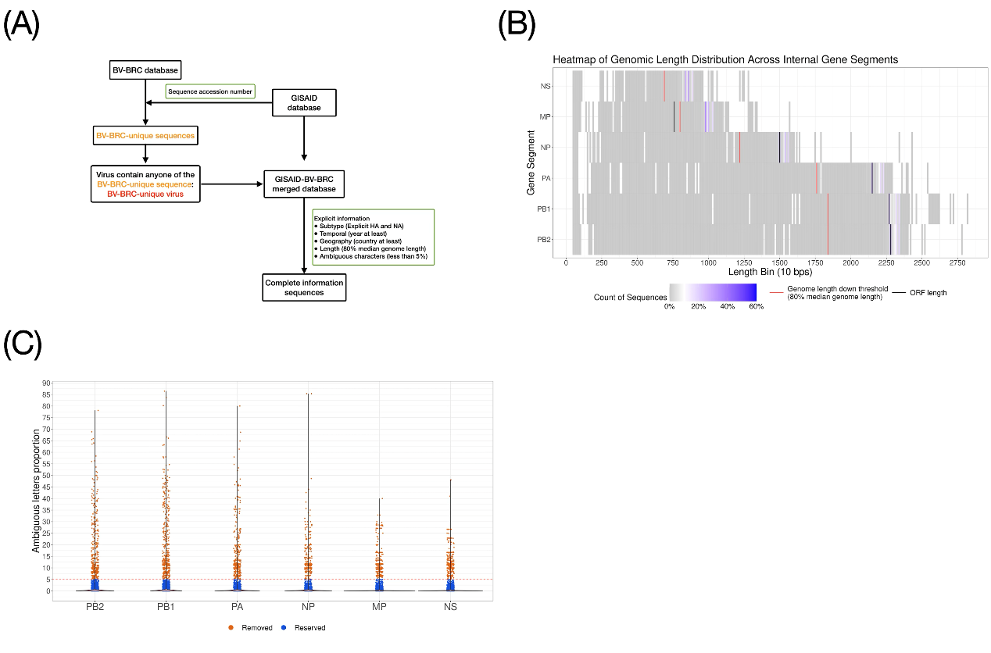

Figure S2. ORF identification.
(A) Workflow illustration of the ORF identification process. Steps include aligning sequences, applying the gap-filling procedure for H5, and removing coordinates with more than 86% gaps. Start codons were identified from consensus sequences, and stop codons were identified by examining the common first encountered stop codon. (B) Visual representation of H5 subtype sequences before and after the gap-filling procedure. The top panel shows the distribution of gaps in aligned sequences, while the bottom panel shows the result after gap-filling. (C-D) Analysis of total stop codon frequencies across gap thresholds. (C) shows the total number of stop codons in various internal gene segments (PB2, PB1, PA, MP, NS) across the gap thresholds after ORF identification. (D) Identifies ORF length variations across the gap thresholds. (E) Proportion of stop codon numbers for each sequence in each gene segment. The figure illustrates the stop codon usage within each sequence, showing the distribution of stop codon numbers from the first encountered start codon to the 3' terminal. (F) The heatmap displays the distribution of stop codon usage across amino acid coordinates in internal gene segments (PB2, PB1, PA, MP, NS). The colour ranges from grey to blue, indicating the stop codon usage across amino acid coordinates.
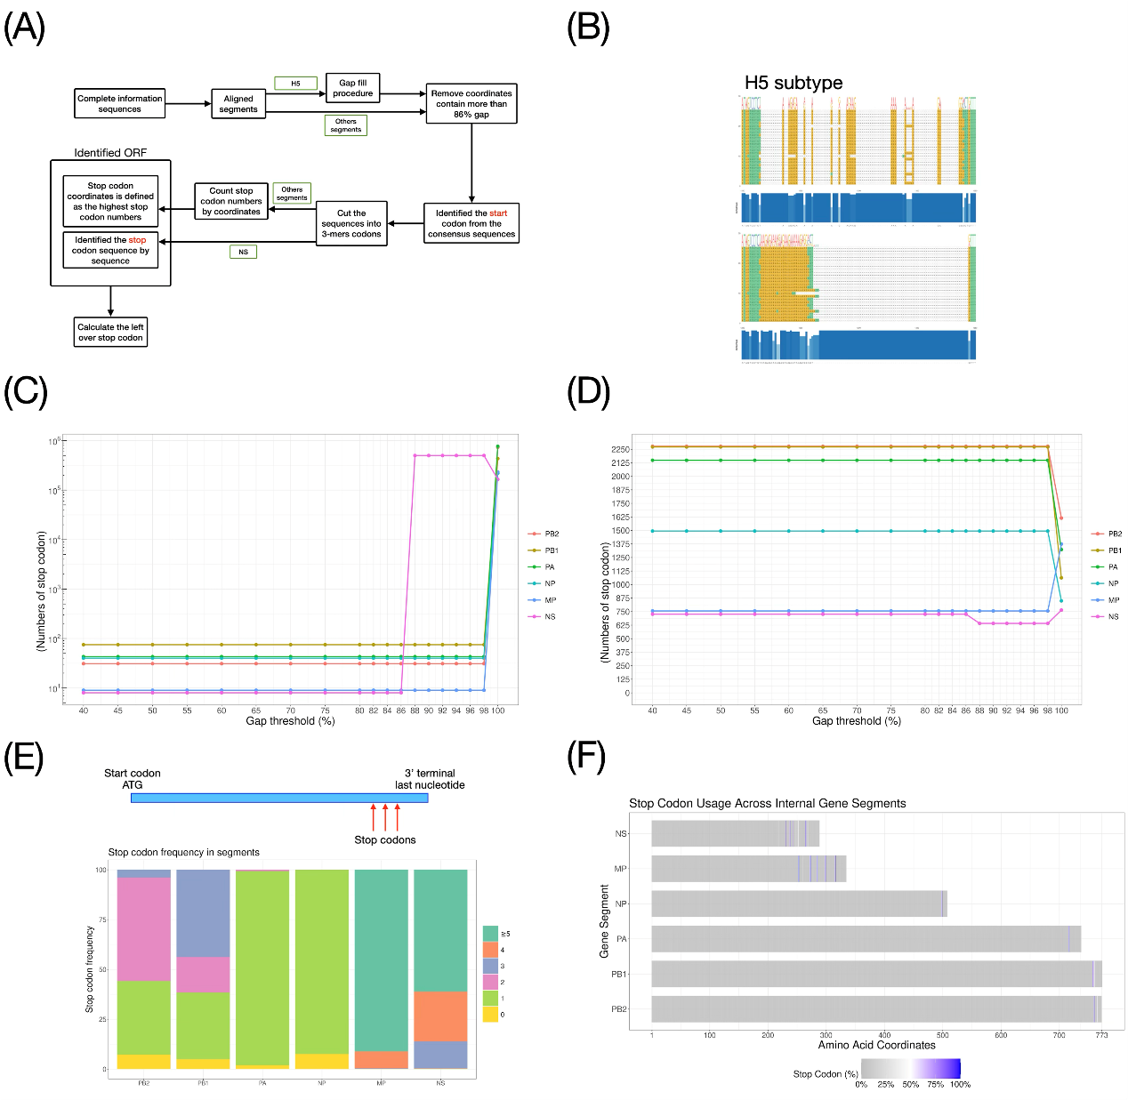

Figure S3. Internal genes agreement statistics across MPD threshold and sampling tree.
(A) The process of assigning lineages in internal genes. This process includes phylogenetic tree construction, calculating mean pairwise patristic distance (MPD), and determining optimal lineage assignments based on agreement statistics between trees. (B, D, F, H, J, L) Agreement statistic evaluation. These panels represent the consistency of lineage assignments across MPD thresholds for six internal gene segments (PB2, PB1, PA, NP, MP, NS). The number of assigned lineages is displayed as gray bars and the numbers, while the agreement (orange line) and agreement-same (blue line) statistics between FastTree and IQ-TREE methods are shown for each MPD threshold. The black box indicates the thresholds meet the groups criteria, more than 3 and less than 20. The red box indicates the MPD threshold selected based on the criterion. (C, E, G, I, K, M) A sampling tree for each internal gene segment was constructed using IQ-TREE. The tips were coloured according to assigned lineages, with the heatmaps illustrating the feature distribution, such as continent, subtype, clade, and year.
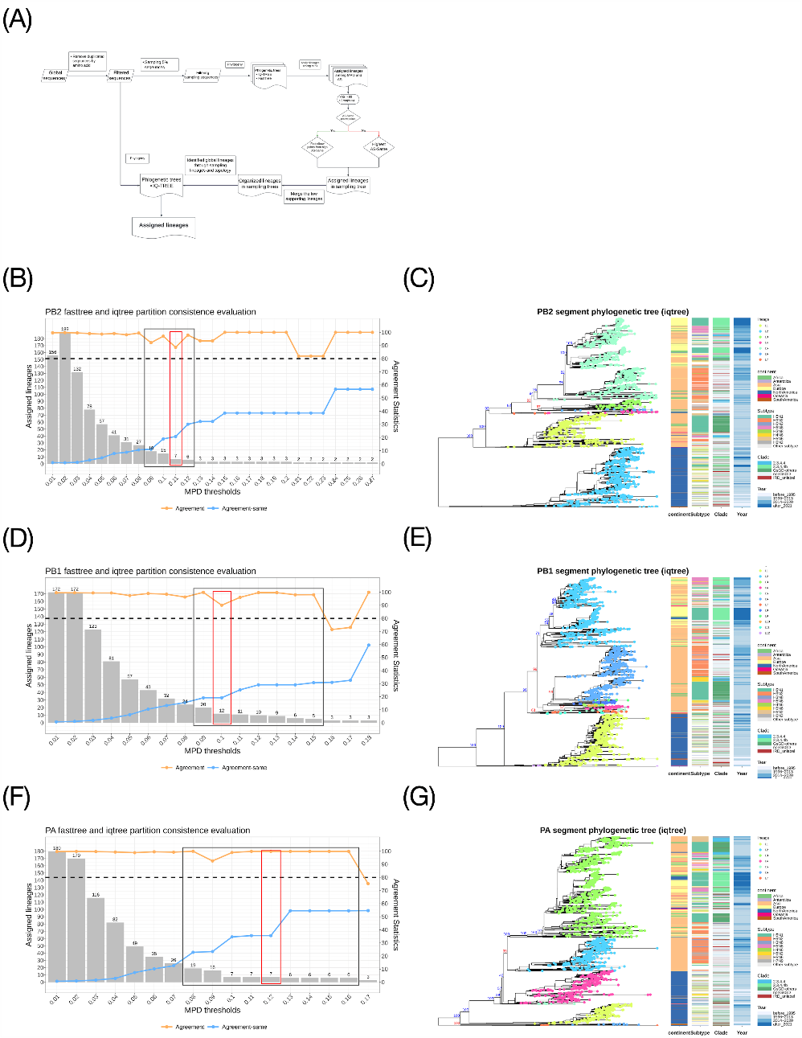
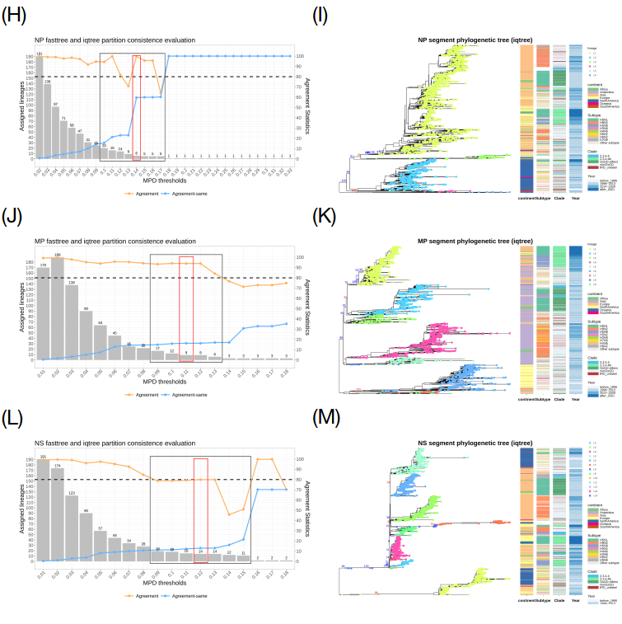

Figure S4. Internal genes sampling tree with the merged lineages.
The lineages with low bootstrap value were merged.
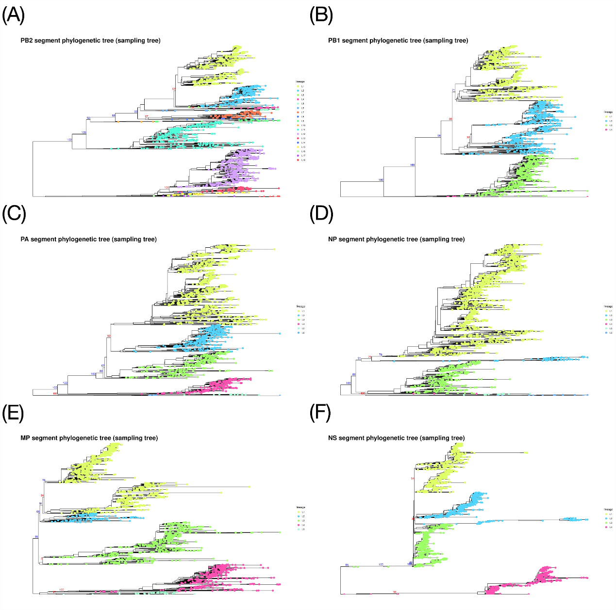

Figure S5. Genetic distances of avian influenza virus (AIV) sequences for intra- and inter-lineage of each internal gene.
The boxplot displays the genetic distance (in percentages) for six internal gene segments (PB2, PB1, PA, NP, MP, NS) using the General Time Reversible (GTR) model by IQ-TREE. The genetic distances are categorized as intra-lineage and inter-lineage genetic distances. The Wilcoxon rank-sum test was applied to compare the statistical significance between intra- and inter-lineage genetic distances for each gene segment. The p-values were indicated above the boxplots.
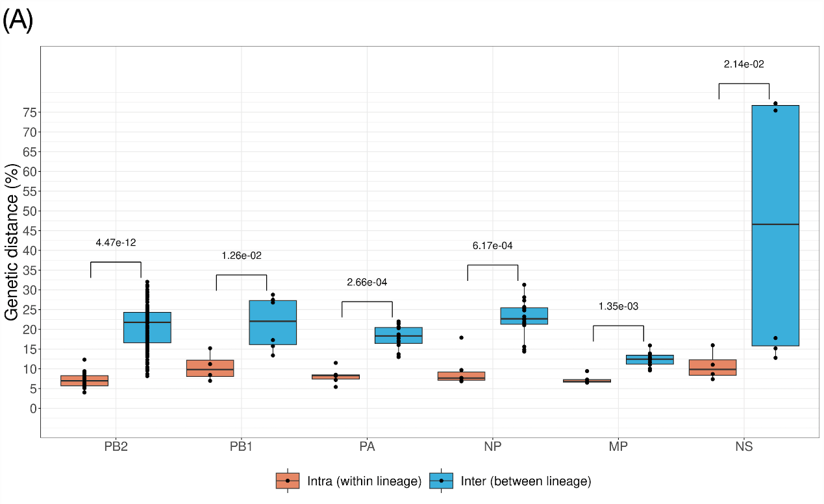

Figure S6. Study method flow chart in Risk Factor Analysis of RA Hotspot
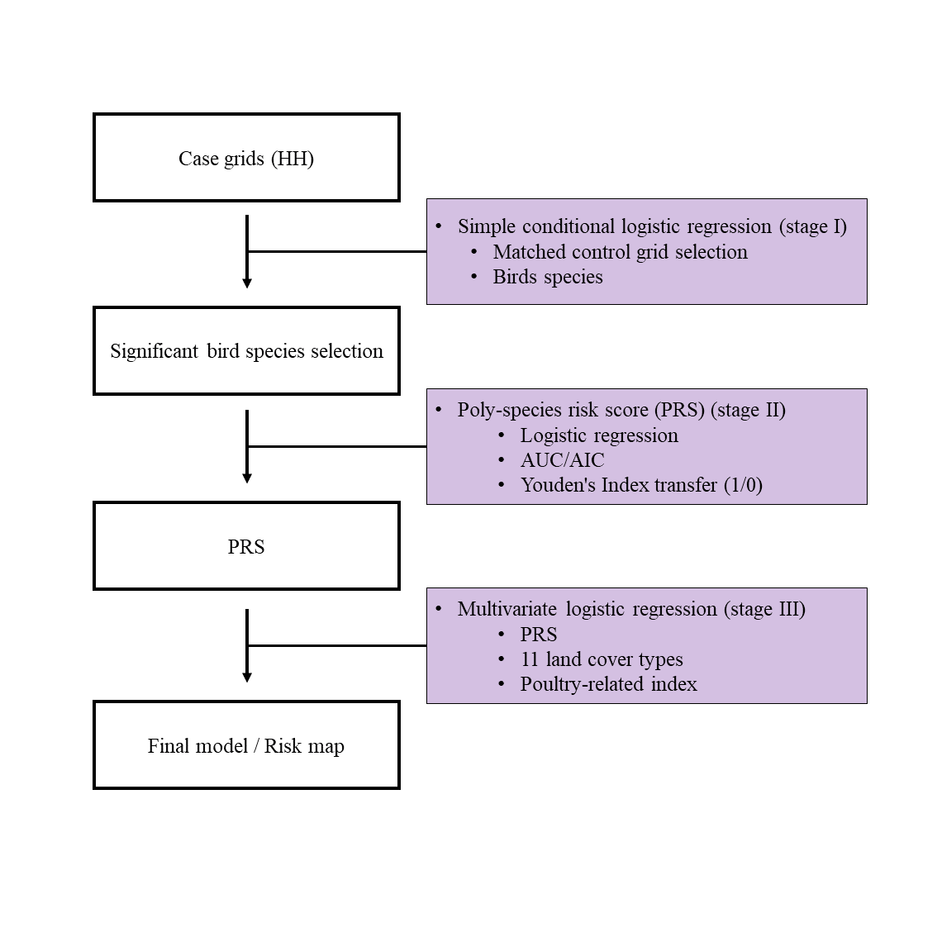

Figure S7. Distribution of study grid (wave 2)
Figure S7a, b represents Europe CC-1 and CC-2 grids respectively. Figure S7c, d represents Asia CC-1 and CC-2 grids respectively. QGIS v3.22 was used to generate maps based on the analytical results by R (R Core Team, v4.4.2) with the original map obtained from the original world administrative boundaries map (https://www.nationalarchives.gov.uk/doc/open-government-licence/version/3/)”.
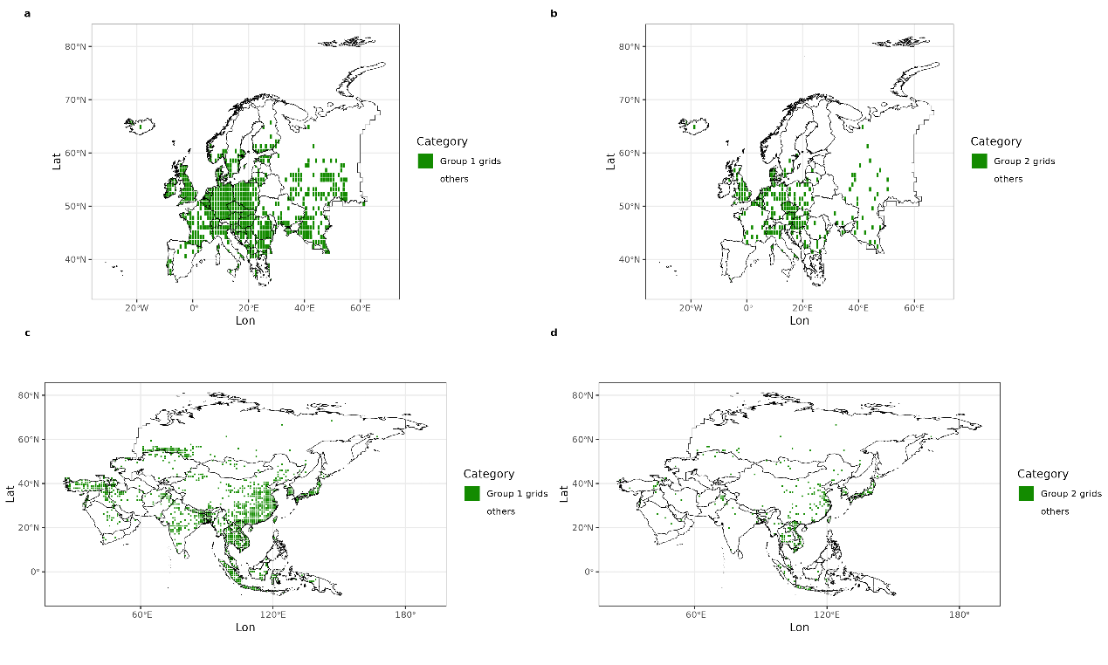

Figure S8. Distribution of study grid (wave 1)
Figure S8a, b represents Europe CC-1 and CC-2 grids respectively. Figure S8c, d represents Asia CC-1 and CC-2 grids respectively. QGIS v3.22 was used to generate maps based on the analytical results by R (R Core Team, v4.4.2) with the original map obtained from the original world administrative boundaries map (https://www.nationalarchives.gov.uk/doc/open-government-licence/version/3/)”.
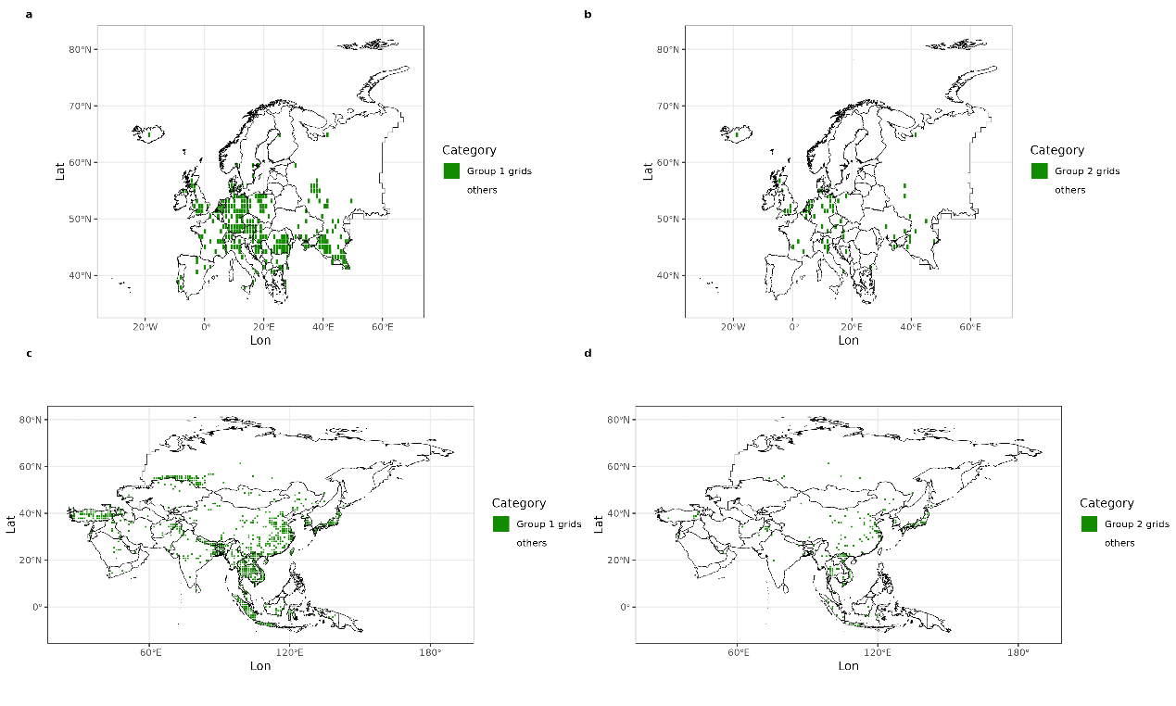

Figure S9. Temporal distribution of the data used for the risk factor analysis of RA hotspot Stage III
In this figure, the black arrow line represents the timeline, and yellow circles indicate the key years. The black dashed lines extend the corresponding years. The temporal distribution of each dataset (response variable and predictor variables) is shown using colored points and lines. Colored points represent datasets corresponding to a specific year, while colored lines denote datasets covering a time interval. The light blue and light red colors indicate the datasets (response variable and predictor variables) used in the risk factor analysis of RA hotspots at stage III for wave 1 and wave 2, respectively.
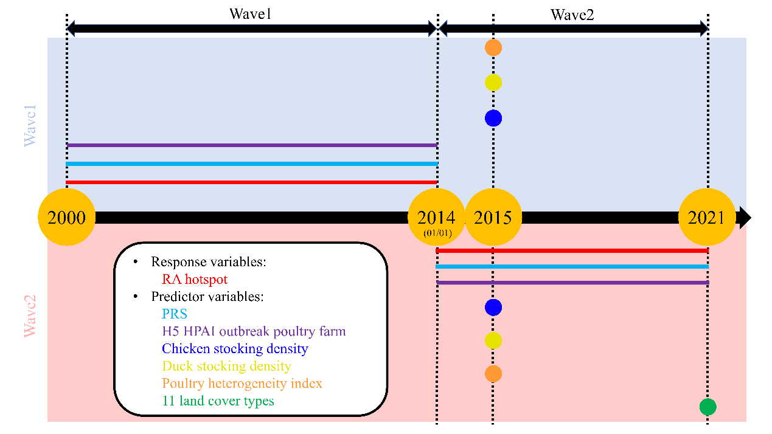

Figure S10. Bird species integrating process: Logistic regression
The plot shows the process of integrating bird species into PRS with the logistic regression method. The row of figures represents different study groups (Asia group 1: S10a, S10b, S10c; Asia group 2: S10d, S10e, S10f; Europe group 1: S10g, S10h, S10i; Europe group 2: S10j, S10k, S10l). The column of figures represents different subsets of bird species from simple conditional logistic regression (Mixed point estimation positive and negative: S10a, S10d, S10g, S10j; Point estimation negative: S10b, S10e, S10h, S10k; Point estimation positive: S10c, S10f, S10i, S10l).
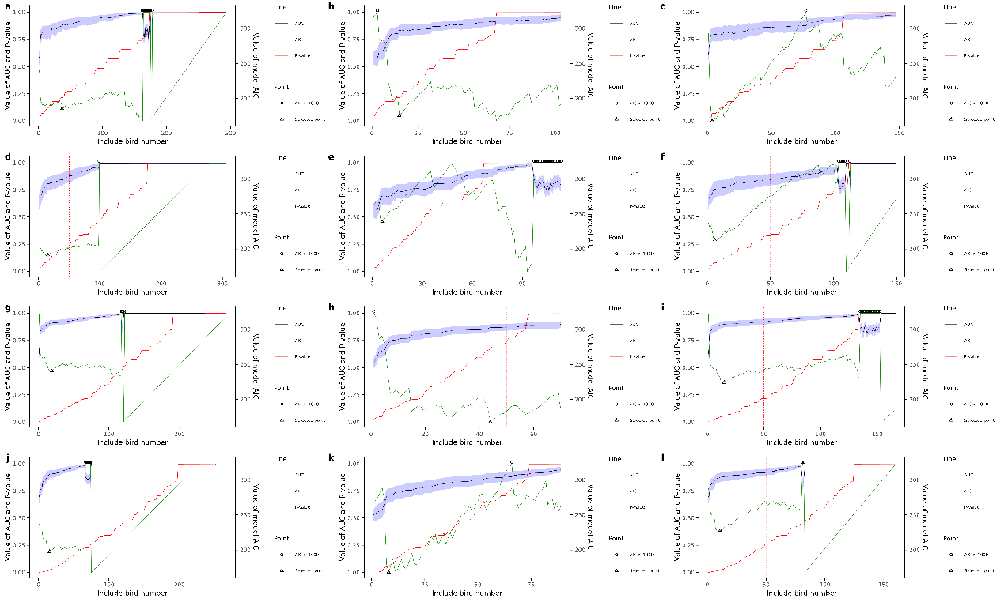

Figure S11. Wild bird time stream
The figure records the number of documented genotypes each year in the bubbles plot. The stacked bar plot shows the data from the Food and Agriculture Organization of the United Nations (EMPRES-I, https://empres-i.apps.fao.org/general), which displays outbreaks in wild birds in different continents per year, with the value on the left. The line plot shows the data from the World Organisation for Animal Health (WAHIS, https://wahis.woah.org/#/dashboards/qd-dashboard), which displays the wild bird cases and death numbers per year, with the value on the right.
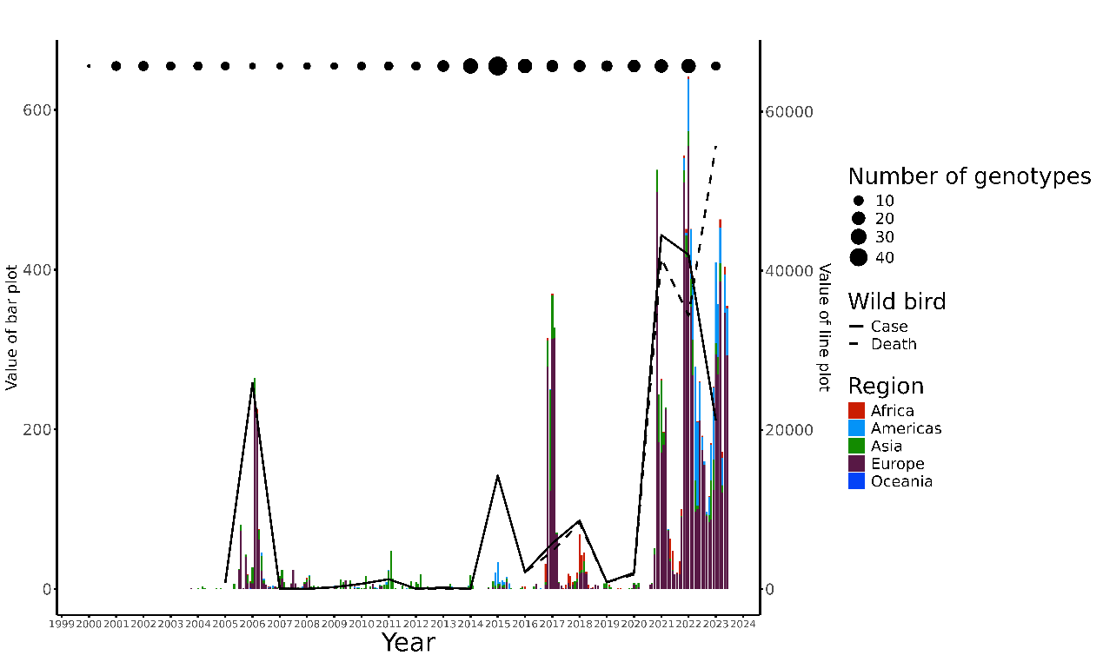

Figure S12. Wild bird time stream
Figure S12a, Annual distribution of H5 HPAIV isolates with complete 8-segment genomic information collected in the genetic databases (GISAID + BV-BRC), with different continents distinguished by color. Figure S12b, Annual distribution of H5 HPAIV case numbers recorded in the WOAH database, with different continents distinguished by color. Figure S12c presents the annual proportion of complete H5 HPAIV genome sequences obtained from reported cases across different continents. The numerator are the number of H5 HPAIV isolates with complete 8-segment genomic information collected in the genetic databases (GISAID + BV-BRC), while the denominator are the annual number of H5 HPAIV cases recorded in the WOAH database. The y-axis values were transformed using the formula $y=\log_{10}\left(X+{10}^{-6}\right)+6$ (where X is the original value and Y is the transformed value) to facilitate visualization of original proportions ranging from 0 to ${10}^{-1}$. Larger color blocks indicate higher proportions of complete viral genome data in that continent and year. It is important to note that areas with a visualized proportion of zero (i.e., no color block) correspond to years and regions where the denominator was zero (no WOAH records), which can be cross-validated with Figure 12b.
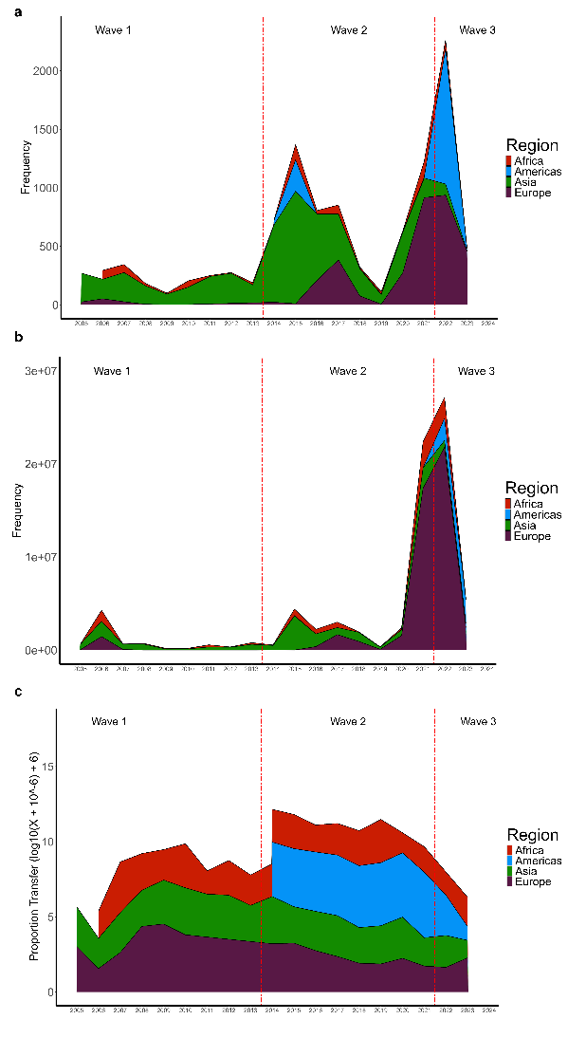

References
1. Katoh K, Standley DM. MAFFT multiple sequence alignment software version 7: improvements in performance and usability. Mol Biol Evol. 2013;30(4):772-80.
2. Senne D, Panigrahy B, Kawaoka Y, Pearson J, Süss J, Lipkind M, et al. Survey of the hemagglutinin (HA) cleavage site sequence of H5 and H7 avian influenza viruses: amino acid sequence at the HA cleavage site as a marker of pathogenicity potential. Avian diseases. 1996:425-37.
3. Xie R, Edwards KM, Wille M, Wei X, Wong S-S, Zanin M, et al. The episodic resurgence of highly pathogenic avian influenza H5 virus. Nature. 2023;622(7984):810-7.
4. Blaurock C, Breithaupt A, Scheibner D, Bagato O, Karger A, Mettenleiter Thomas C, et al. Preferential Selection and Contribution of Non-Structural Protein 1 (NS1) to the Efficient Transmission of Panzootic Avian Influenza H5N8 Virus Clades 2·3.4·4A and B in Chickens and Ducks. Journal of Virology. 2021;95(18):10·1128/jvi.00445-21.
5. Price MN, Dehal PS, Arkin AP. FastTree 2 – Approximately Maximum-Likelihood Trees for Large Alignments. PLOS ONE. 2010;5(3):e9490.
6. Kimura M. A simple method for estimating evolutionary rates of base substitutions through comparative studies of nucleotide sequences. J Mol Evol. 1980;16(2):111-20.
7. Nguyen LT, Schmidt HA, von Haeseler A, Minh BQ. IQ-TREE: a fast and effective stochastic algorithm for estimating maximum-likelihood phylogenies. Mol Biol Evol. 2015;32(1):268-74.
8. Syakur MA, Khotimah BK, Rochman EMS, Satoto BD. Integration K-Means Clustering Method and Elbow Method For Identification of The Best Customer Profile Cluster. IOP Conference Series: Materials Science and Engineering. 2018;336(1):012017.
9. Rambaut A, Holmes EC, O’Toole Á, Hill V, McCrone JT, Ruis C, et al. A dynamic nomenclature proposal for SARS-CoV-2 lineages to assist genomic epidemiology. Nature Microbiology. 2020;5(11):1403-7.
10. Fusaro A, Pu J, Zhou Y, Lu L, Tassoni L, Lan Y, et al. Proposal for a Global Classification and Nomenclature System for A/H9 Influenza Viruses. Emerg Infect Dis. 2024;30(8):1-13.
11. Gilbert M, Nicolas G, Cinardi G, Van Boeckel TP, Vanwambeke SO, Wint GRW, et al. Global distribution data for cattle, buffaloes, horses, sheep, goats, pigs, chickens and ducks in 2010. Sci Data. 2018;5:180227.
12. Liang WS, He YC, Wu HD, Li YT, Shih TH, Kao GS, et al. Ecological factors associated with persistent circulation of multiple highly pathogenic avian influenza viruses among poultry farms in Taiwan during 2015-17. PLoS One. 2020;15(8):e0236581.
13. Anselin L. Local indicators of spatial association—LISA. Geographical analysis. 1995;27(2):93-115.

