Supporting Information
Targeted HDAC8 Inhibition with Non-Hydroxamate s85
[1,2,4]Triazolo[4,3-a] Quinoline Compounds
N.V.M. Rao Bandaru^{a,c}, Ashna Fathima^{b}, Suryansh Sengar^{b}, Markus Schweipert^{d,e},
Kosana Sai Chaitanyaª, Muzaffar-Ur-Rehman Mohammed,^{f} Suraj T. Gore^{c}, Trinath Jamma^{b}, Vivek Sharma^{b}, Chandrasekhar Abbineni^{c}, Franz-Josef Meyer-Almes*^{d,e}, Kondapalli Venkata Gowri Chandra Sekhar∗ª
ªDepartment of Chemistry, Birla Institute of Technology and Science, Pilani, Hyderabad Campus, Jawahar Nagar, Hyderabad 500 078, Telangana, India
^{b}Department of Biological Sciences, Birla Institute of Technology and Science, Pilani, Hyderabad Campus, Jawahar Nagar, Hyderabad 500 078, Telangana, India
^{c}Aurigene Oncology Limited, 39-40 KIADB Industrial Area Electronic City Phase II, Hosur Road, Bangalore 560 100, India
^{d}Department of Chemical Engineering and Biotechnology, University of Applied Sciences Darmstadt, Haardtring 100, 64295 Darmstadt, Germany.
^{e}European University of Technology, European Union
^{f}Department of Pharmacy, Birla Institute of Technology and Science, Pilani Campus,
Pilani 333031, Rajasthan, India

∗Corresponding authors
E-mail: kvgc@hyderabad.bits-pilani.ac.in (KVGCS); franz-josef.meyer-almes@h-da.de (Franz)

List of contents:
1. | Analytical data of final compounds 9a to 9u
2. | IC50 graphs
3. | Original blots of 9h and 9m

- Analytical data of final compounds 9a to 9u
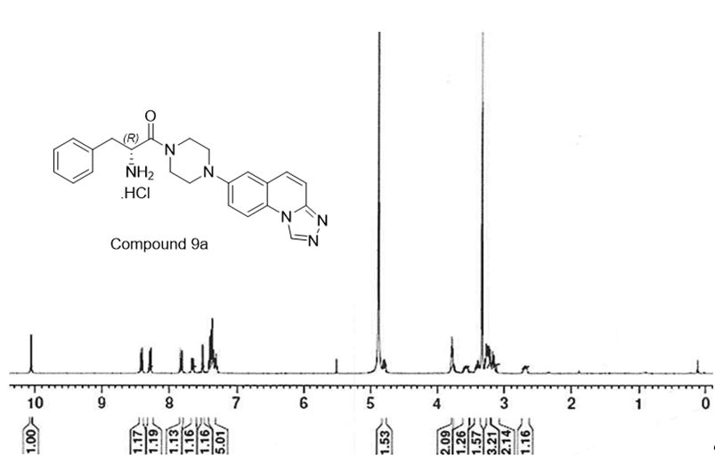
Figure S1. ¹H NMR spectrum of compound 9a in CD3OD

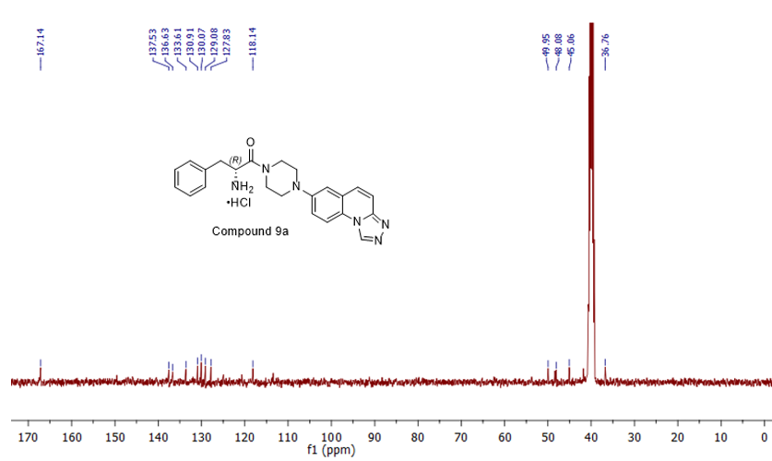
Figure S2. ¹³C NMR spectrum of compound 9a in DMSO-d₆

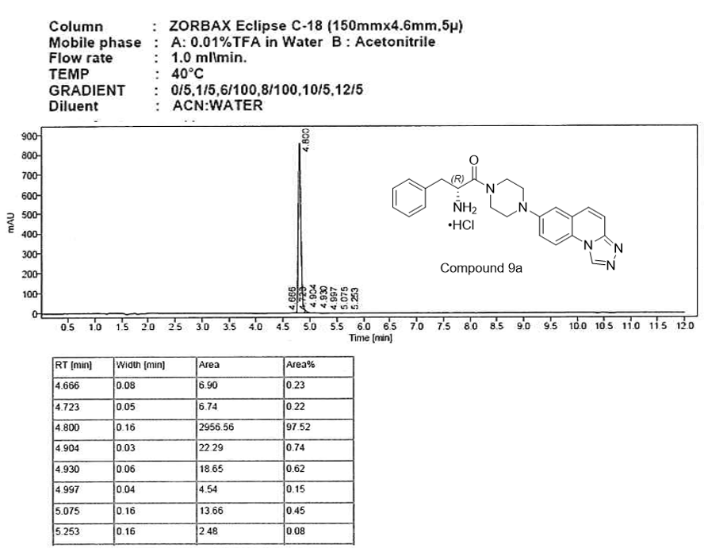
Figure S3. The HPLC chromatogram of compound 9a

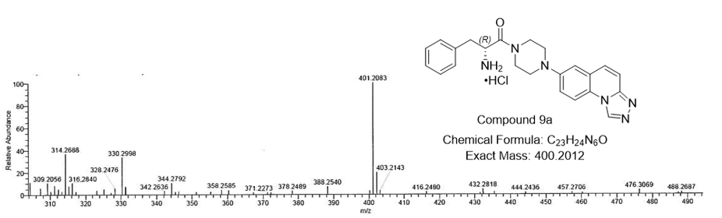
Figure S4. The HRMS chromatogram of compound 9a

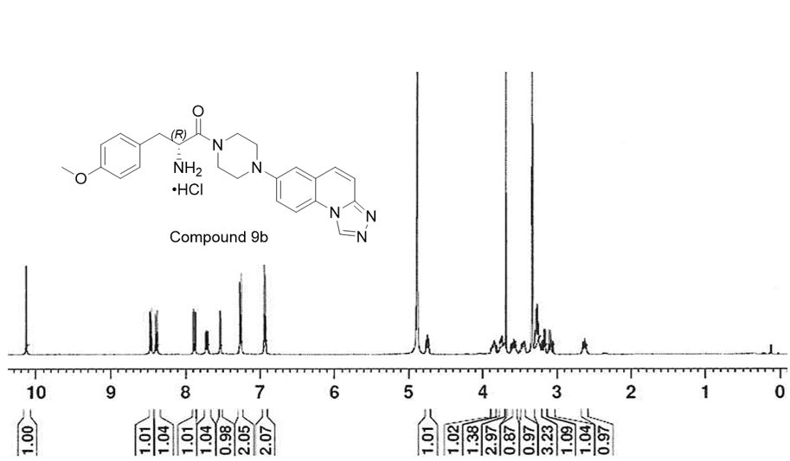
Figure S5. The ¹H NMR spectrum of compound 9b in CD3OD
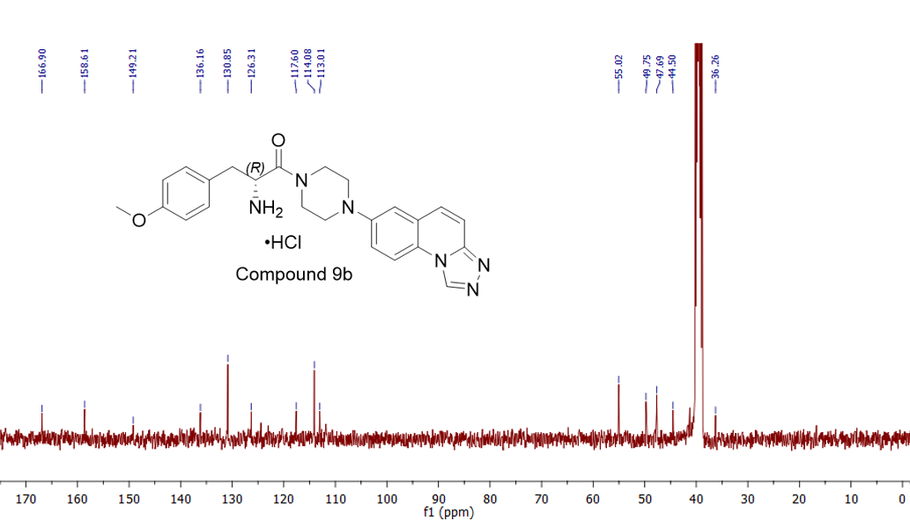
Figure S6. The ¹³C NMR spectrum of compound 9b in DMSO-d₆

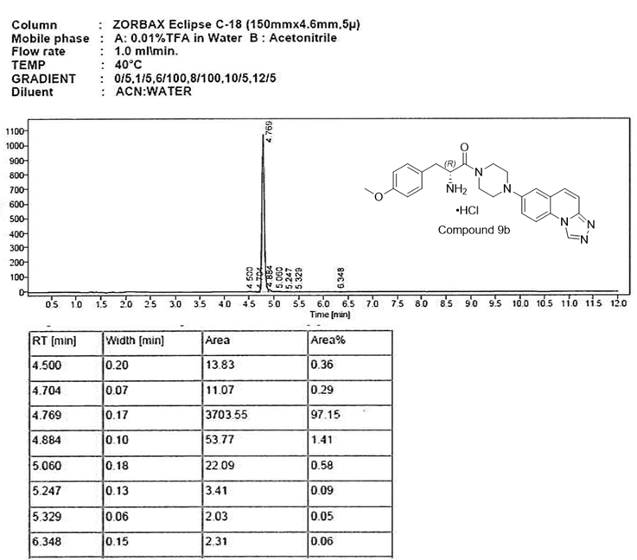
Figure S7. The HPLC chromatogram of compound 9b

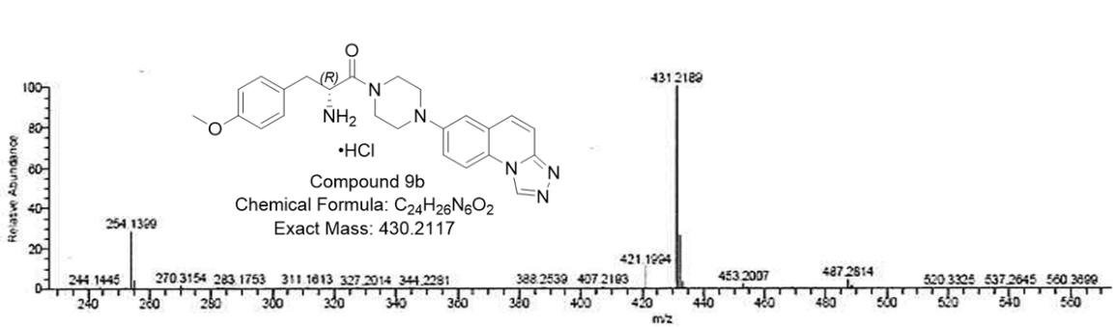
Figure S8. The HRMS chromatogram of compound 9b

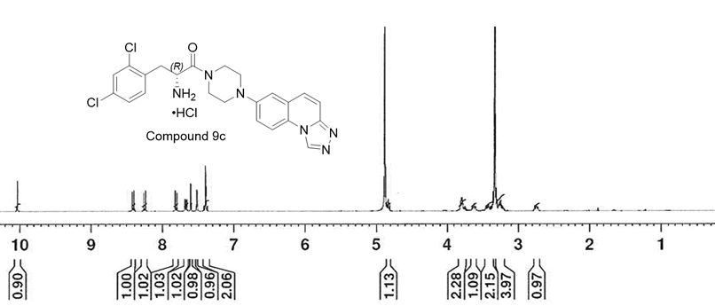
Figure S9. The ¹H NMR spectrum of compound 9c in CD3OD

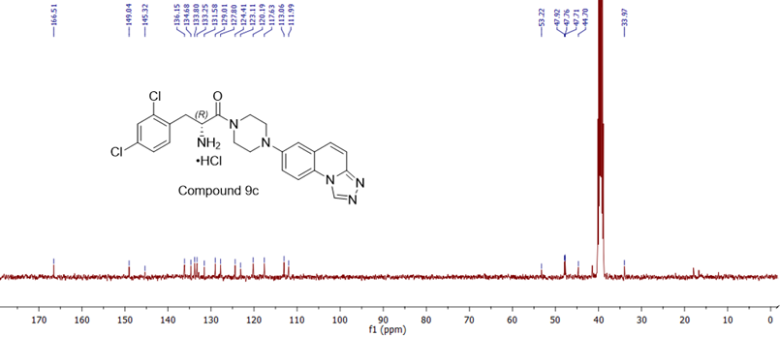
Figure S10. The ¹³C NMR spectrum of compound 9c in DMSO-d₆

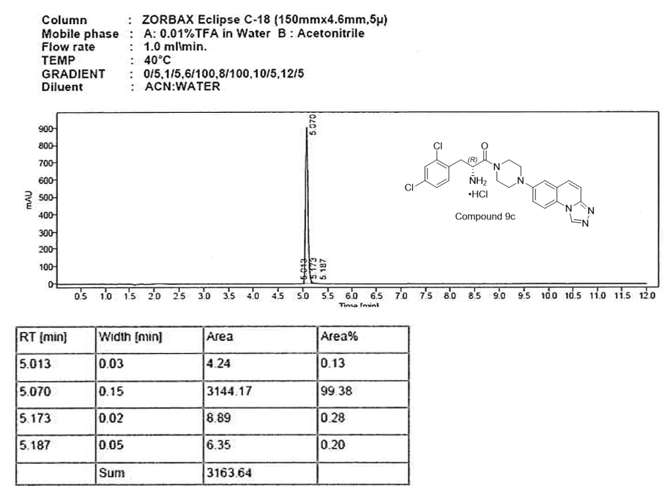
Figure S11. The HPLC chromatogram of compound 9c

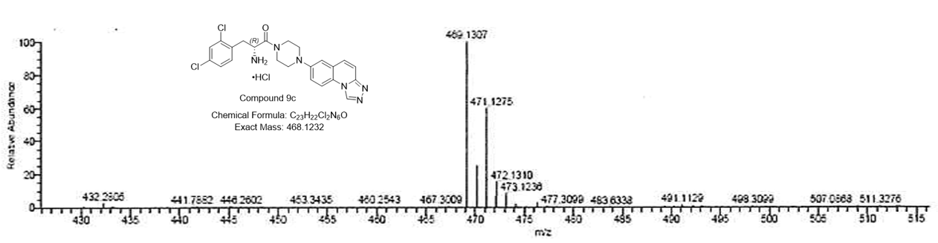
Figure S12. The HRMS chromatogram of compound 9c

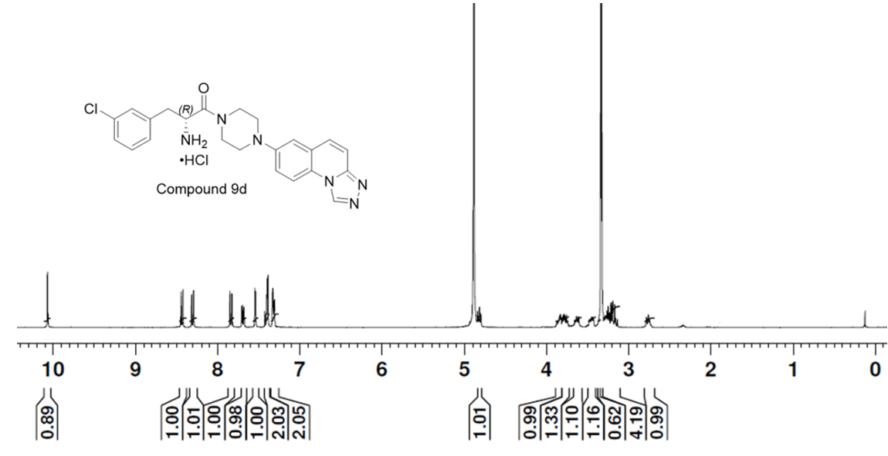
Figure S13. The ¹H NMR spectrum of compound 9d in CD3OD

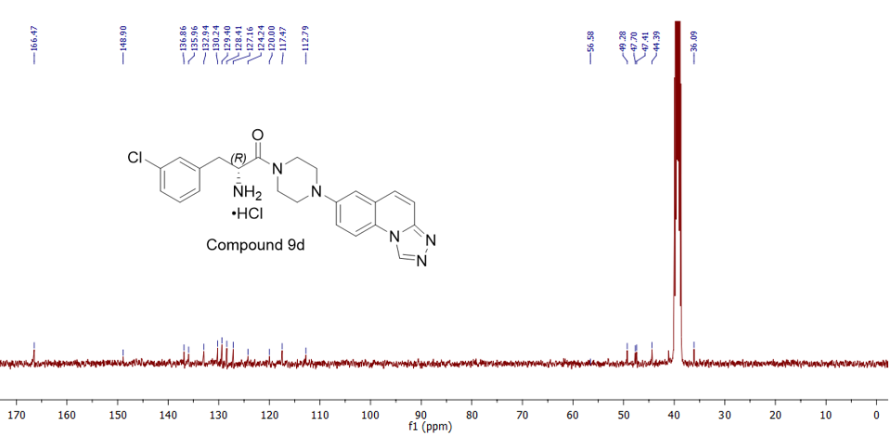
Figure S14. The ¹³C NMR spectrum of compound 9d in DMSO-d₆

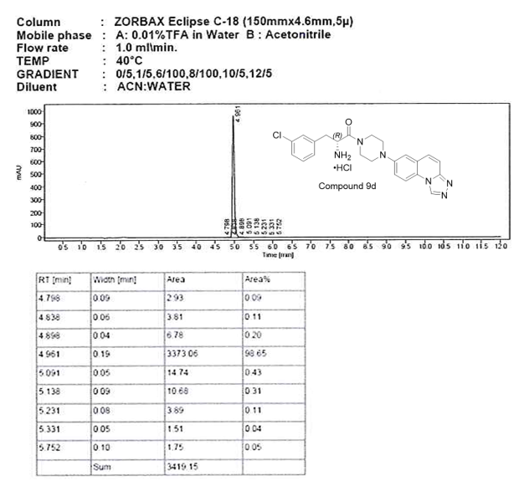
Figure S15. The HPLC chromatogram of compound 9d
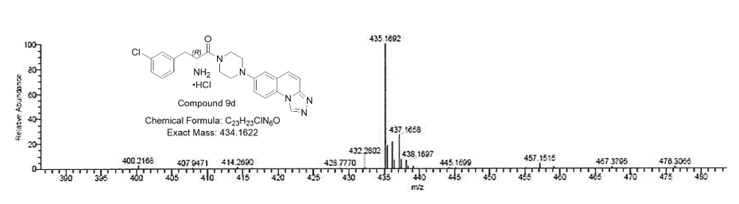
Figure S16. The HRMS chromatogram of compound 9d
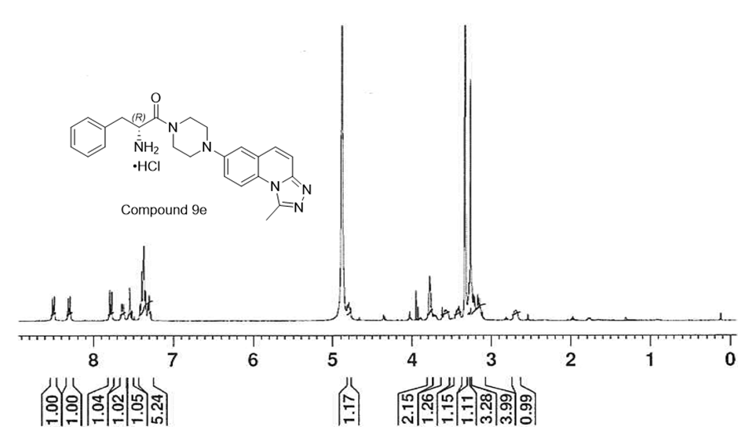
Figure S17. The ¹H NMR spectrum of compound 9e in CD3OD

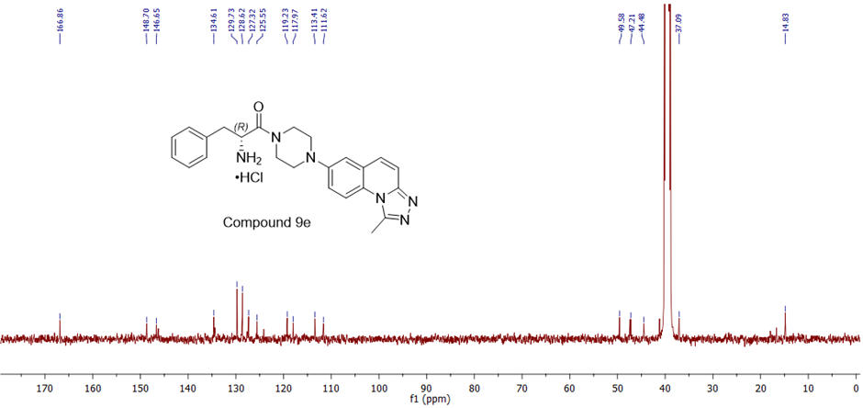
Figure S18. The ¹³C NMR spectrum of compound 9e in DMSO-d₆

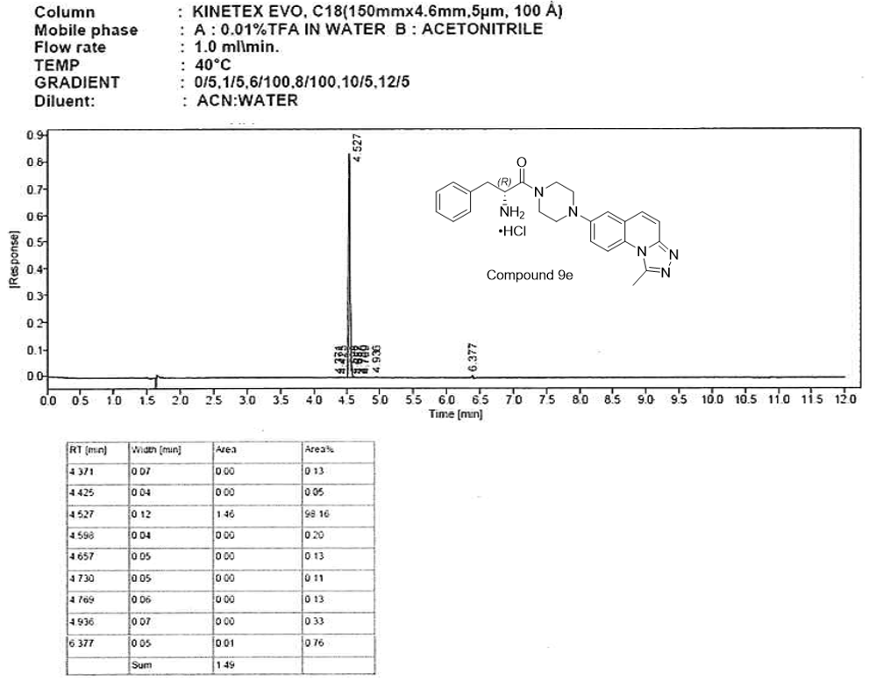
Figure S19. The HPLC chromatogram of compound 9e

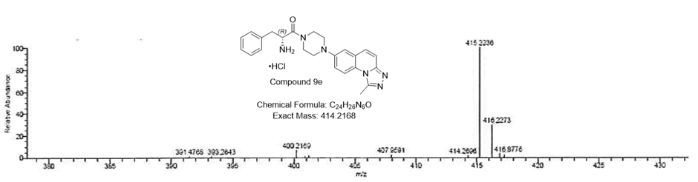
Figure S20. The HRMS chromatogram of compound 9e

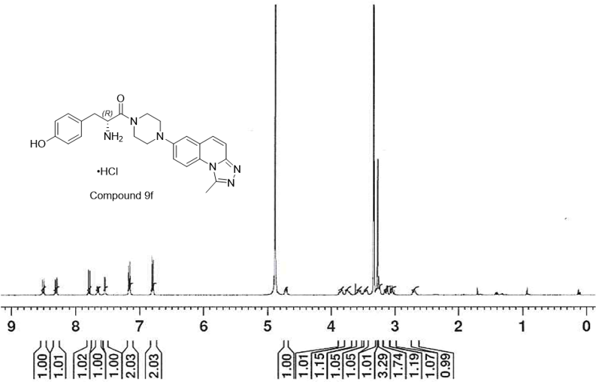
Figure S21. The ¹H NMR spectrum of compound 9f in CD3OD

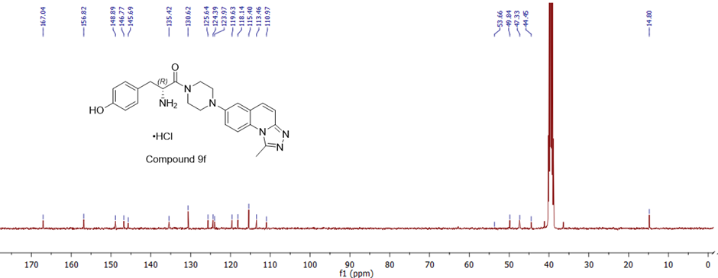
Figure S22. The ¹³C NMR spectrum of compound 9f in DMSO-d₆

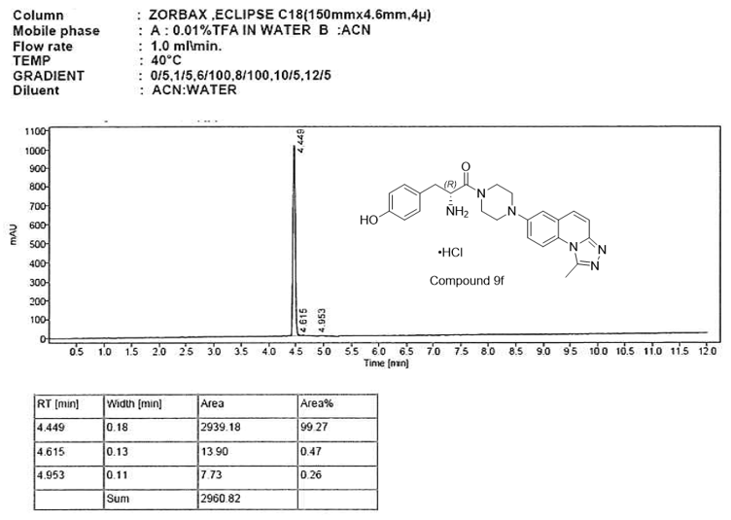
Figure S23. The HPLC chromatogram of compound 9f
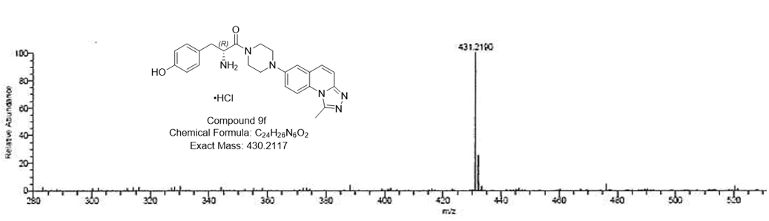
Figure S24. The HRMS chromatogram of compound 9f

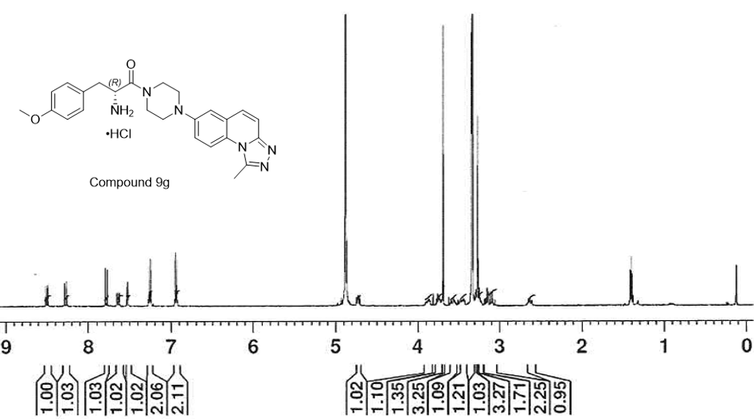
Figure S25. The ¹H NMR spectrum of compound 9g in CD3OD
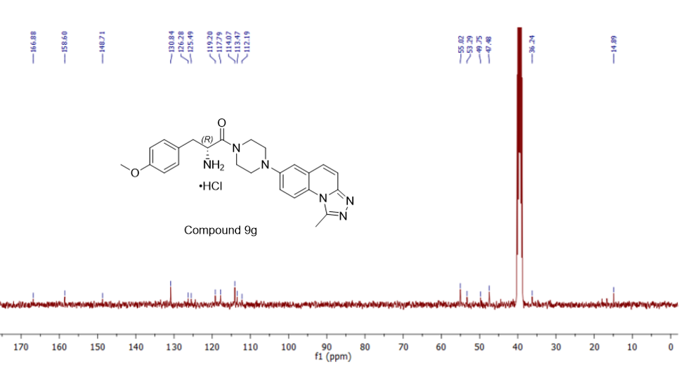
Figure S26. The ¹³C NMR spectrum of compound 9g in DMSO-d₆

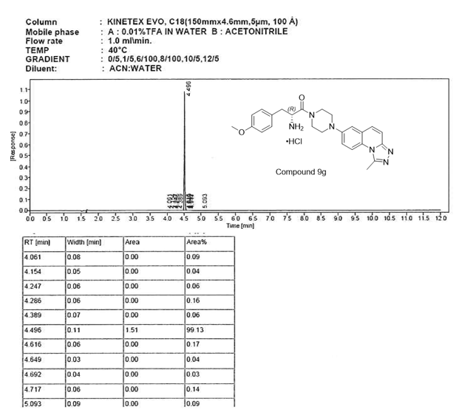
Figure S27. The HPLC chromatogram of compound 9g
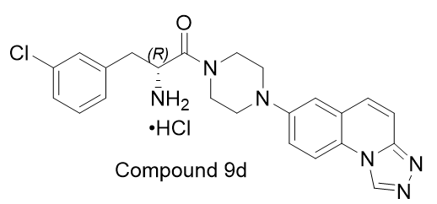
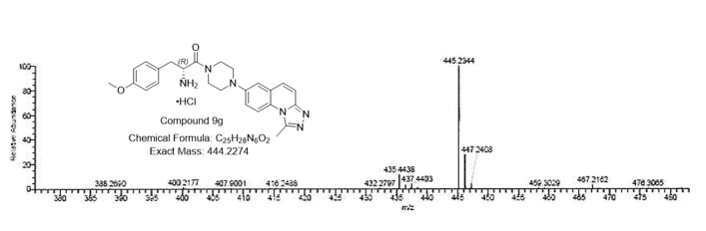
Figure S28. The HRMS chromatogram of compound 9g

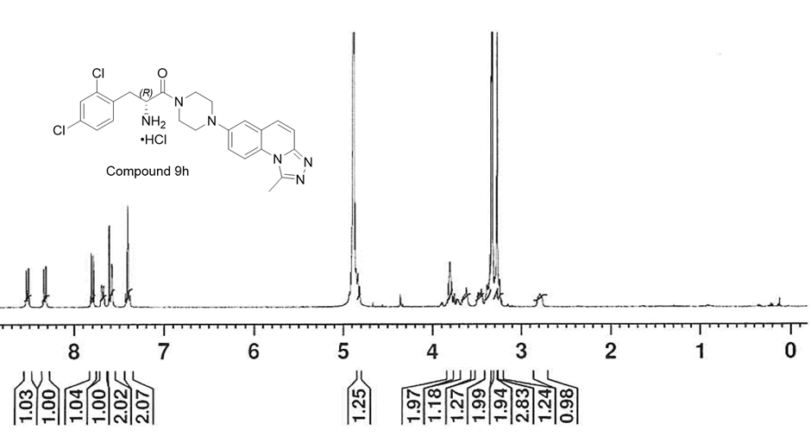
Figure S29. The ¹H NMR spectrum of compound 9h in CD3OD

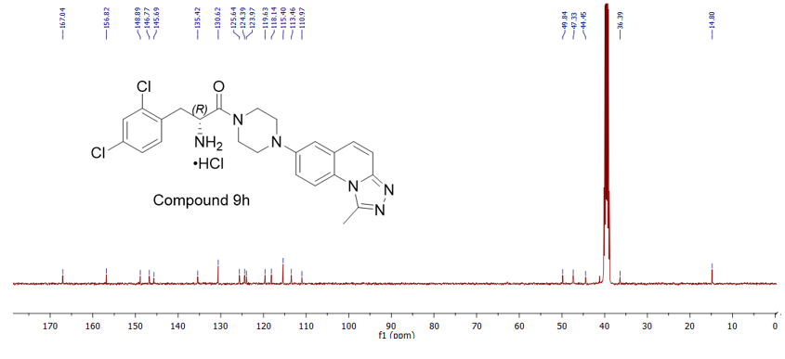
Figure S30. The ¹³C NMR spectrum of compound 9h in DMSO-d₆

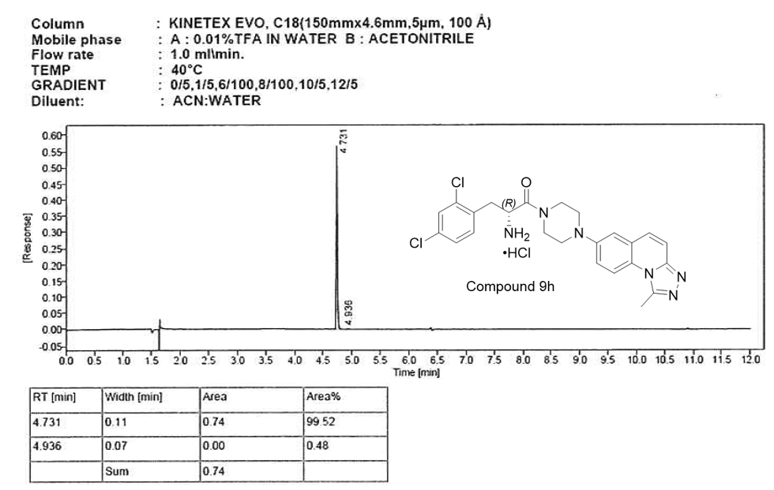
Figure S31. The HPLC chromatogram of compound 9h
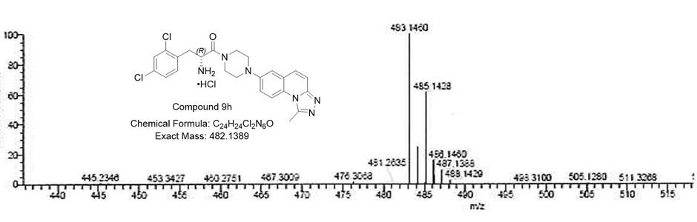
Figure S32. The HRMS chromatogram of compound 9h

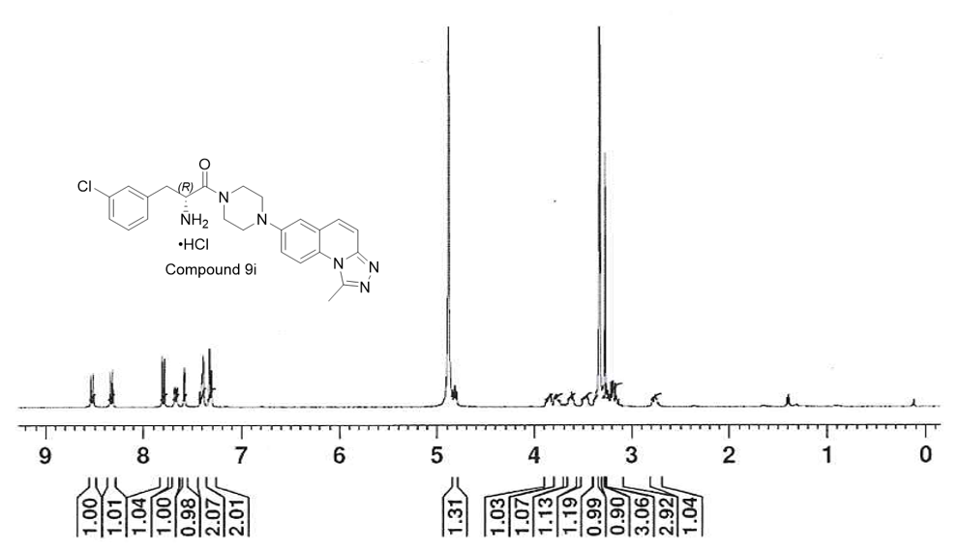
Figure S33. The ¹H NMR spectrum of compound 9i in CD3OD

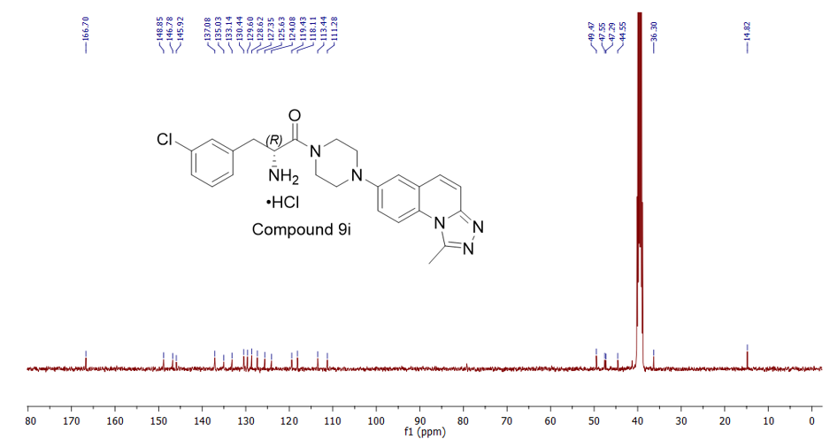
Figure S34. The ¹³C NMR spectrum of compound 9i in DMSO-d₆

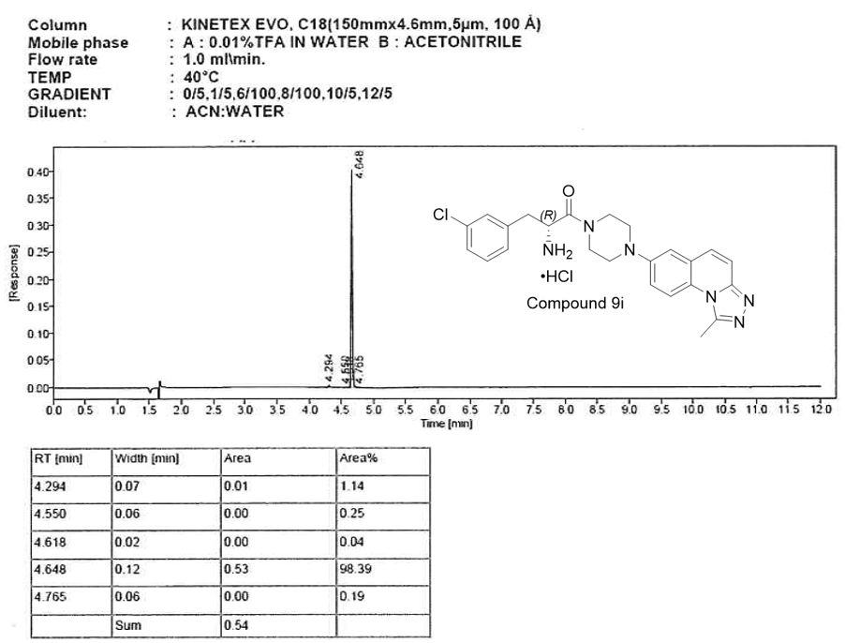
Figure S35. The HPLC chromatogram of compound 9i
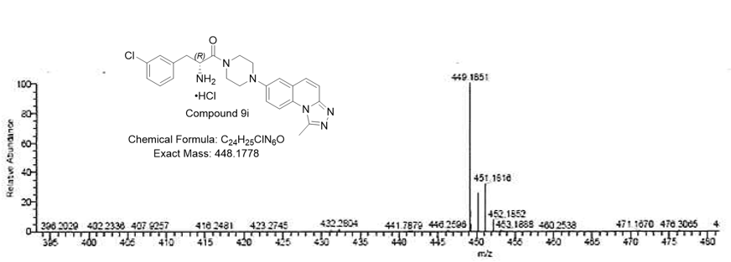
Figure S36. The HRMS chromatogram of compound 9i

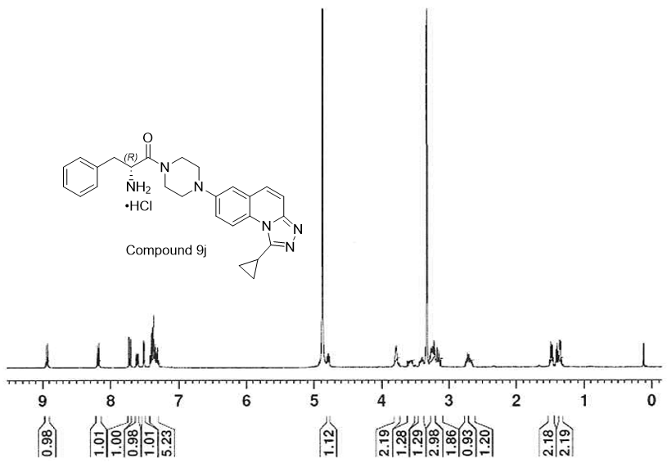
Figure S37. The ¹H NMR spectrum of compound 9j in CD3OD

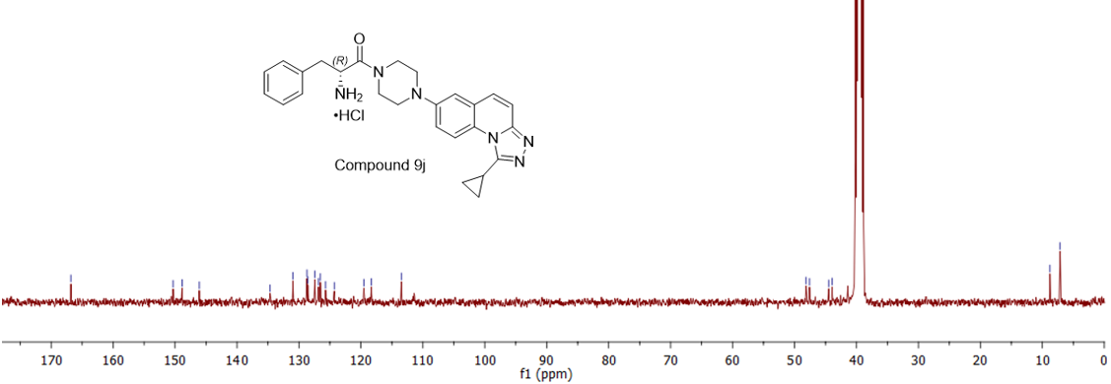
Figure S38. The ¹³C NMR spectrum of compound 9j in DMSO-d₆

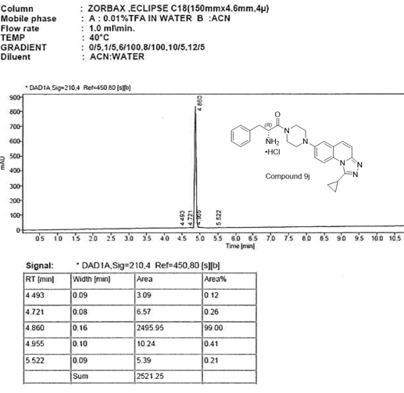
Figure S39. The HPLC chromatogram of compound 9j

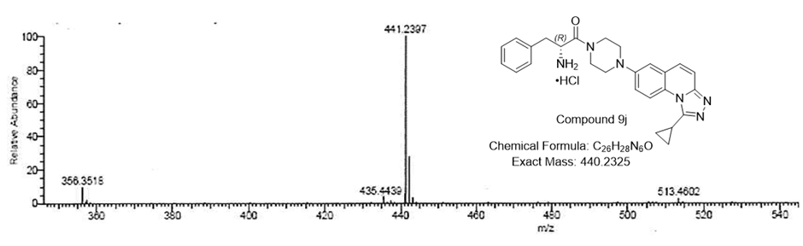
Figure S40. The HRMS chromatogram of compound 9j

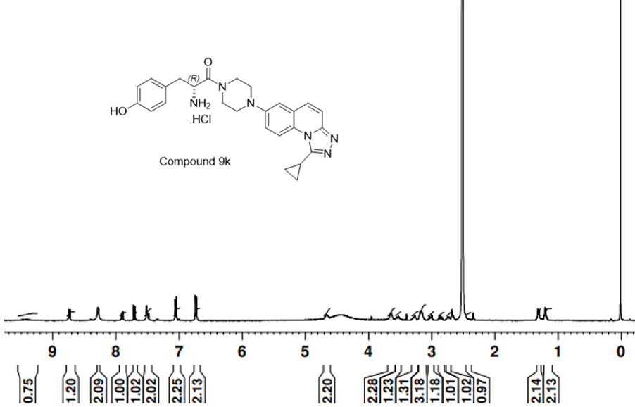
Figure S41. The ¹H NMR spectrum of compound 9k in DMSO-d₆

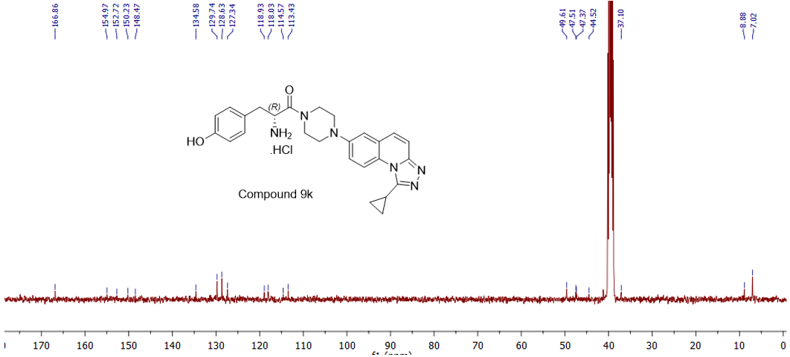
Figure S42. The ¹³C NMR spectrum of compound 9k in DMSO-d₆

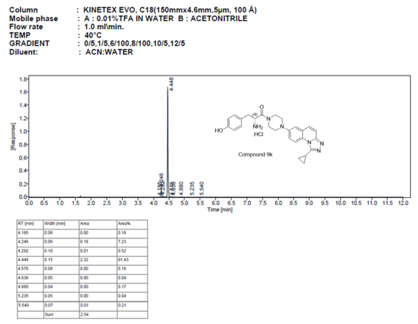
Figure S43. The HPLC chromatogram of compound 9k

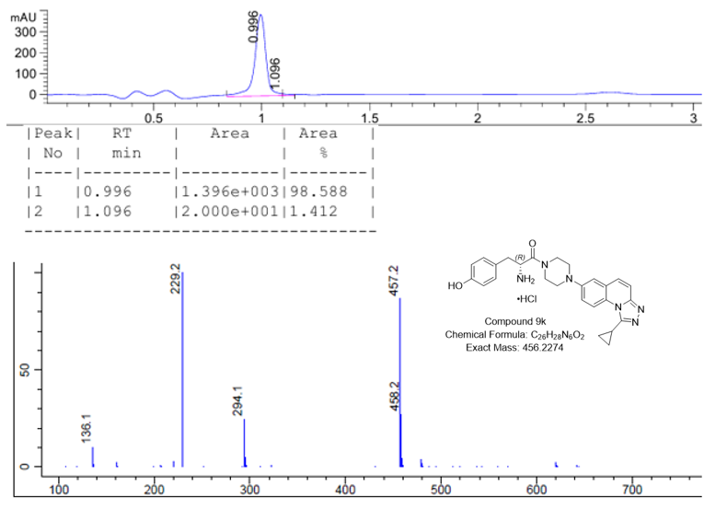
Figure S44. The LC-MS chromatogram of compound 9k

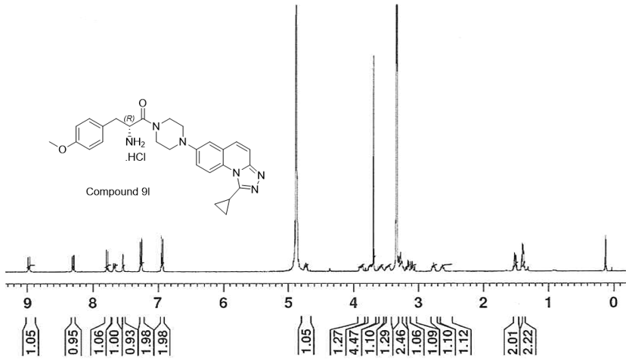
Figure S45. The ¹H NMR spectrum of compound 9l in CD3OD

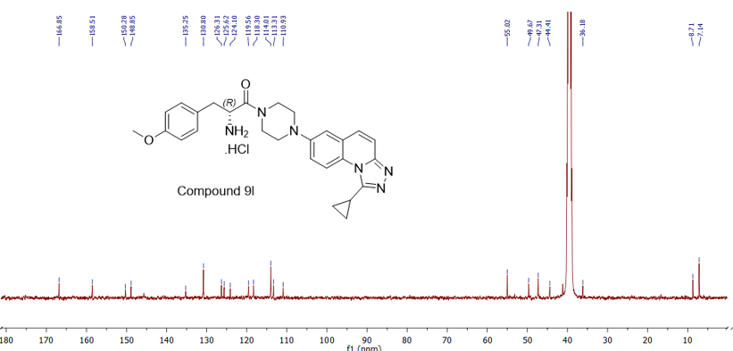
Figure S46. The ¹³C NMR spectrum of compound 9l in DMSO-d₆

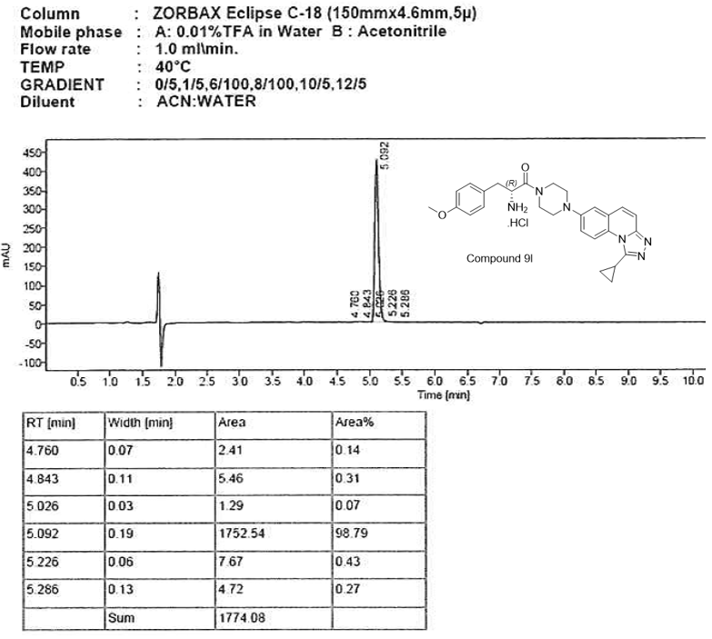
Figure S47. The HPLC chromatogram of compound 9l

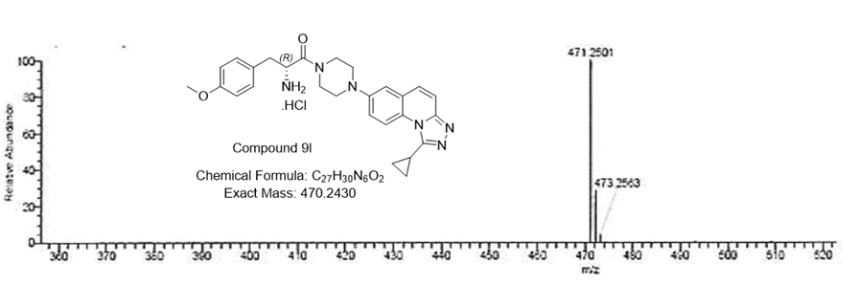
Figure S48. The HRMS chromatogram of compound 9l

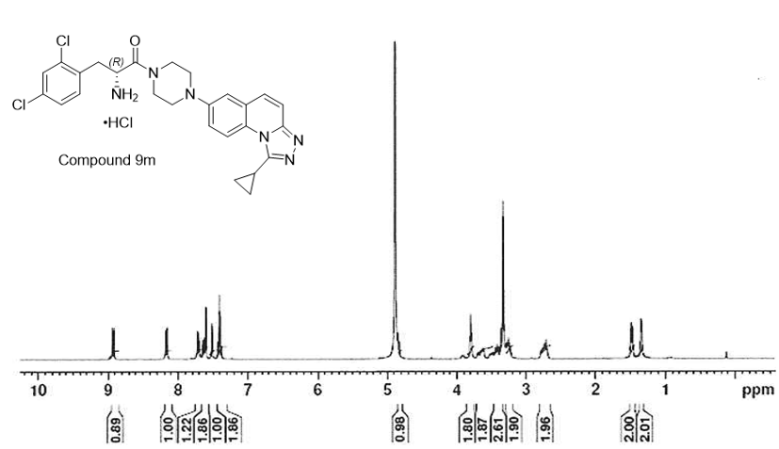
Figure S49. The ¹H NMR spectrum of compound 9m in CD3OD

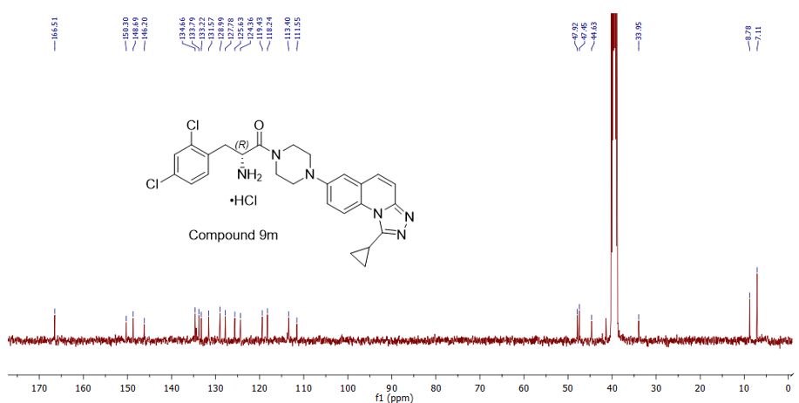
Figure S50. The ¹³C NMR spectrum of compound 9m in DMSO-d₆

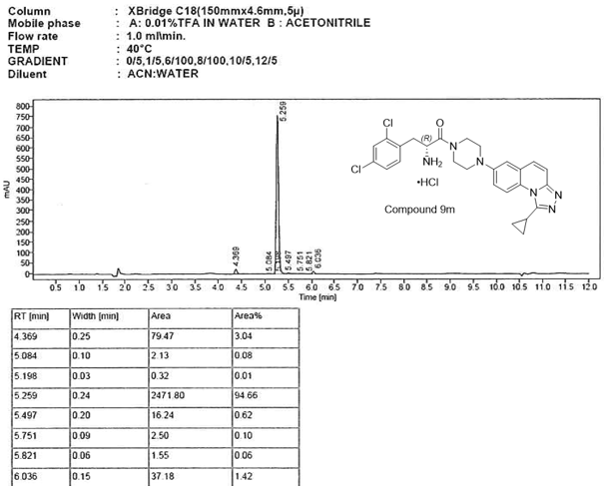
Figure S51. The HPLC chromatogram of compound 9m

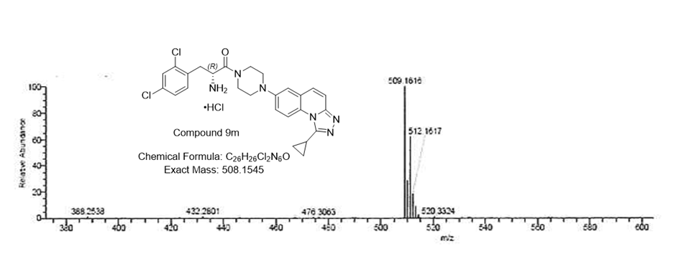
Figure S52. The HRMS chromatogram of compound 9m

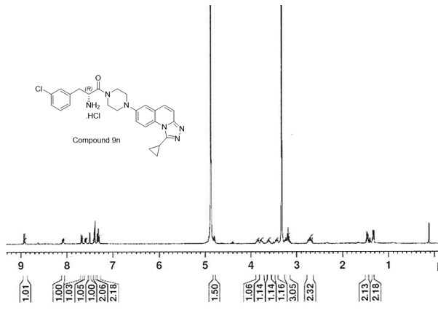
Figure S53. The ¹H NMR spectrum of compound 9n in CD3OD

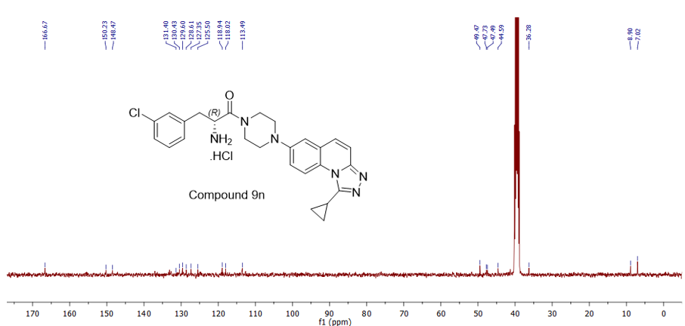
Figure S54. The ¹³C NMR spectrum of compound 9n in DMSO-d₆

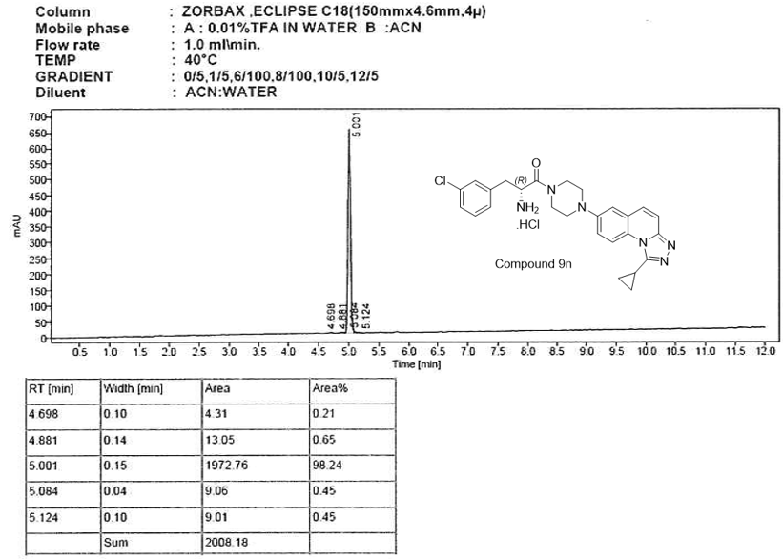
Figure S55. The HPLC chromatogram of compound 9n

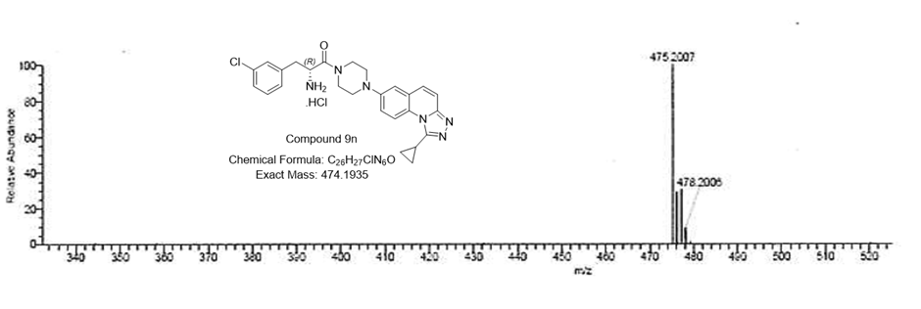
Figure S56. The HRMS chromatogram of compound 9n

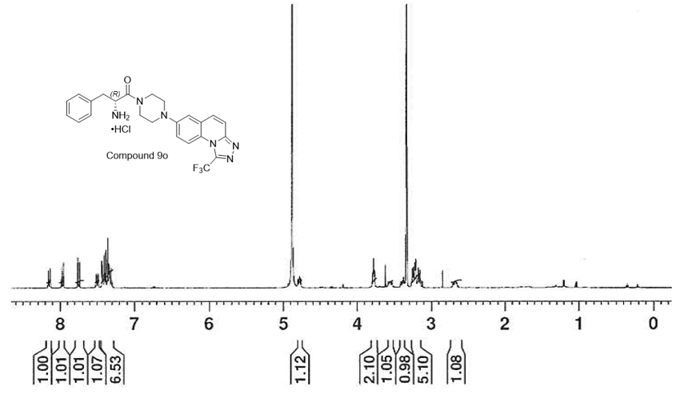
Figure S57. The ¹H NMR spectrum of compound 9o in CD3OD

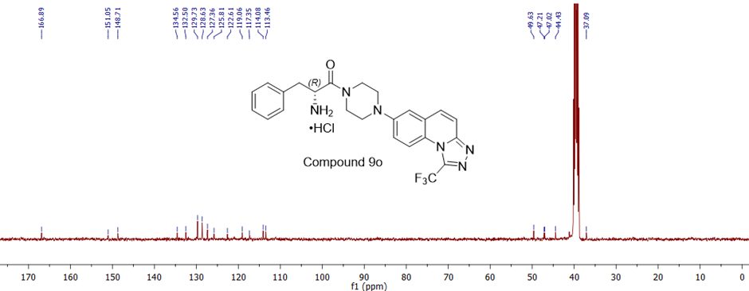
Figure S58. The ¹³C NMR spectrum of compound 9o in DMSO-d₆

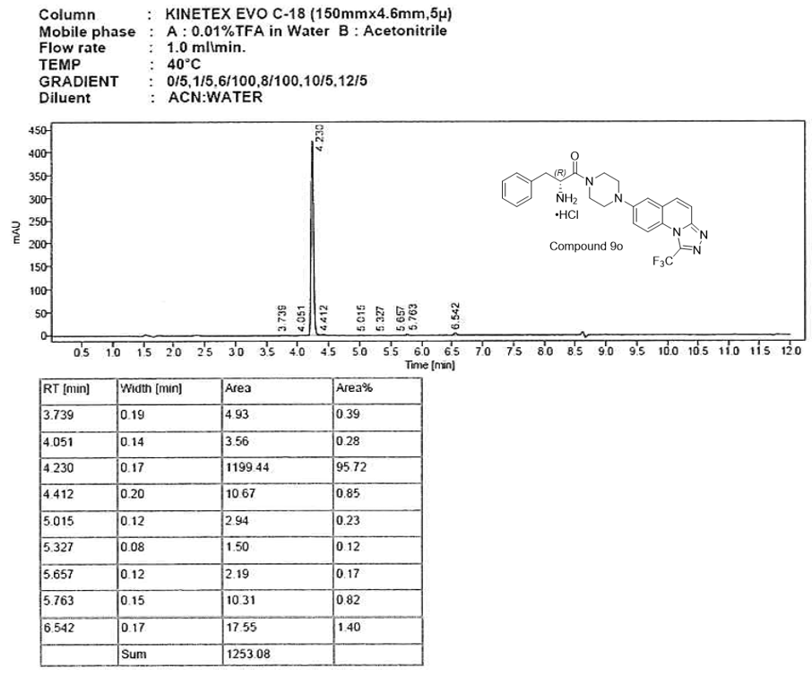
Figure S59. The HPLC chromatogram of compound 9o

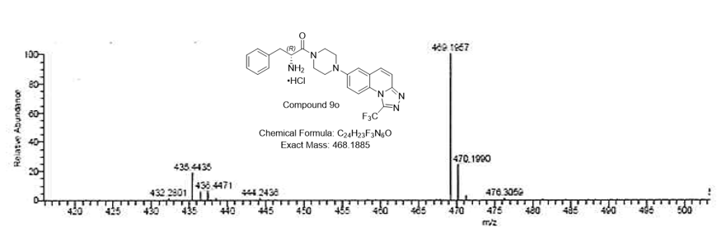
Figure S60. The HRMS chromatogram of compound 9o

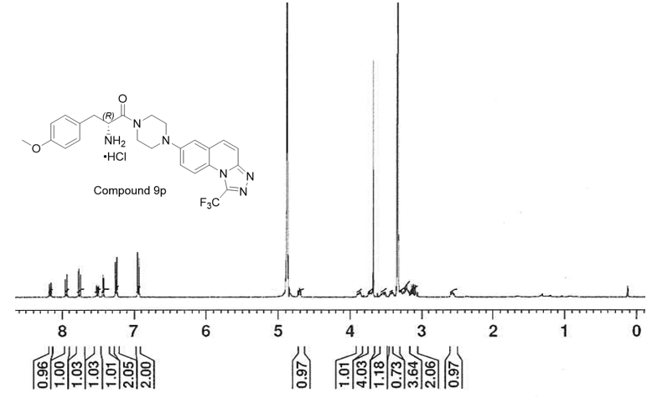
Figure S61. The ¹H NMR spectrum of compound 9p in CD3OD

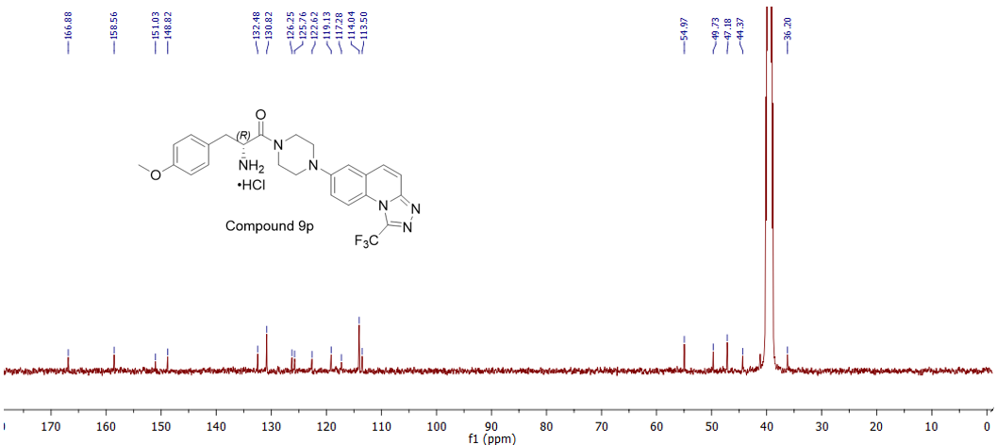
Figure S62. The ¹³C NMR spectrum of compound 9p in DMSO-d₆

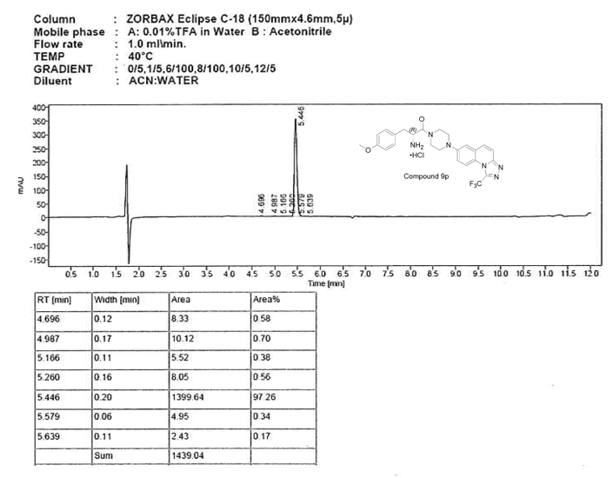
Figure S63. The HPLC chromatogram of compound 9p

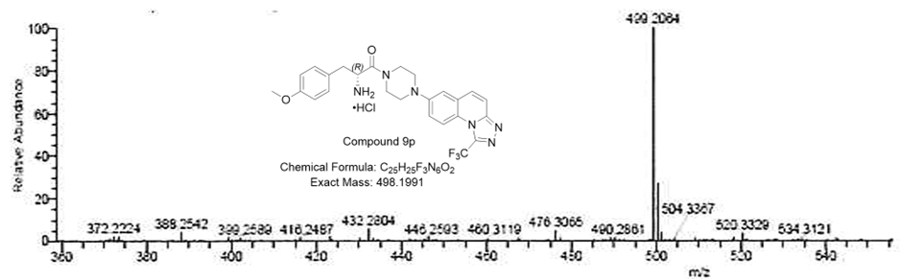
Figure S64. The HRMS chromatogram of compound 9p

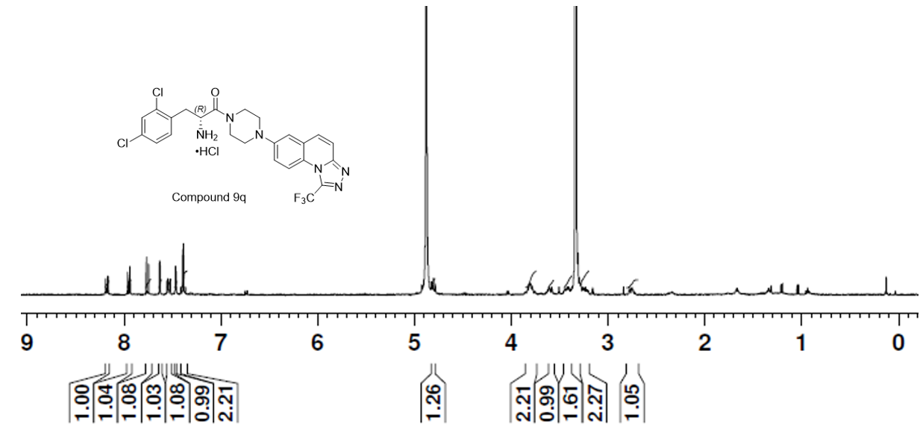
Figure S65. The ¹H NMR spectrum of compound 9q in CD3OD

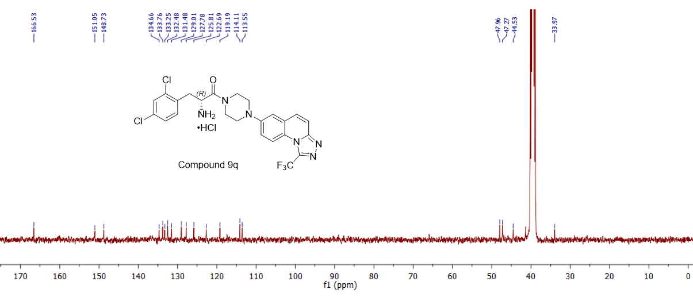
Figure S66. The ¹³C NMR spectrum of compound 9q in DMSO-d₆

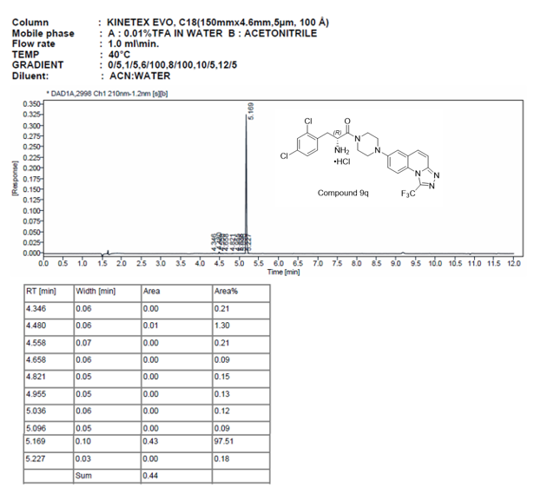
Figure S67. The HPLC chromatogram of compound 9q

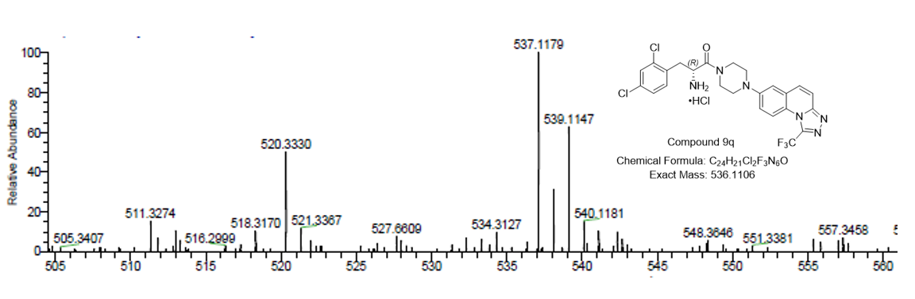
Figure S68. The HRMS chromatogram of compound 9q
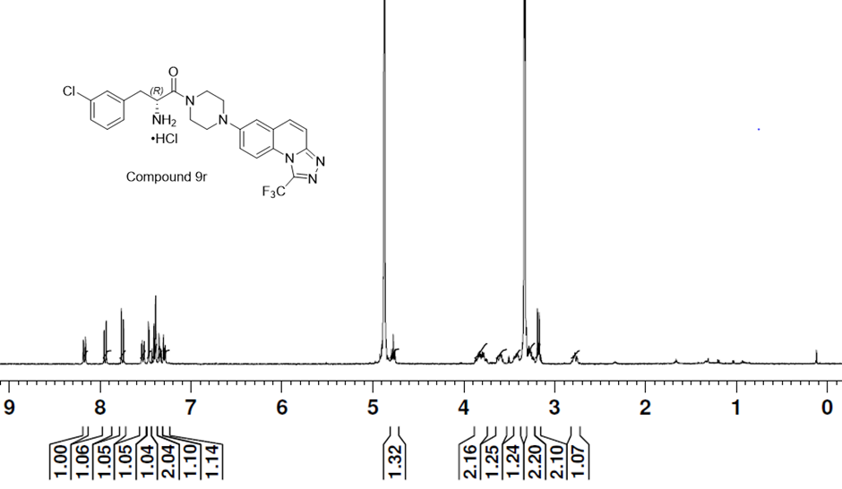
Figure S69. The ¹H NMR spectrum of compound 9r in CD3OD

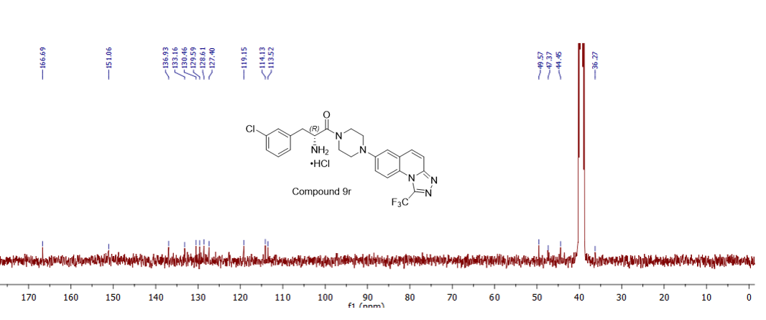
Figure S70. The ¹³C NMR spectrum of compound 9r in DMSO-d₆

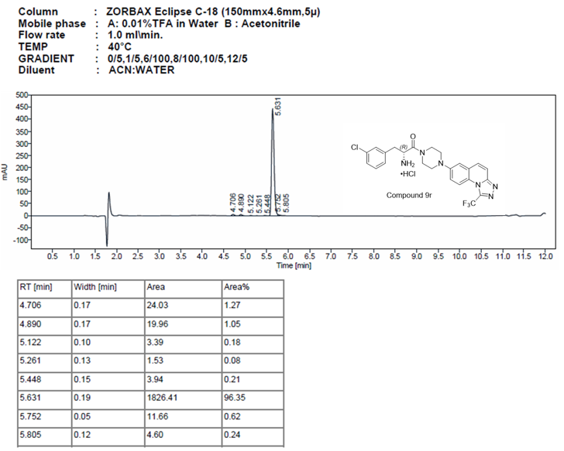
Figure S71. The HPLC chromatogram of compound 9r

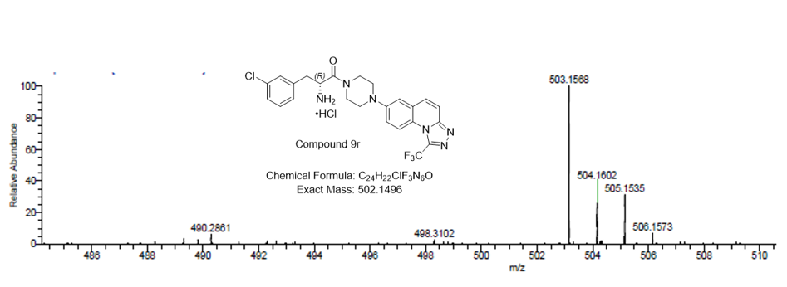
Figure S72. The HRMS chromatogram of compound 9r

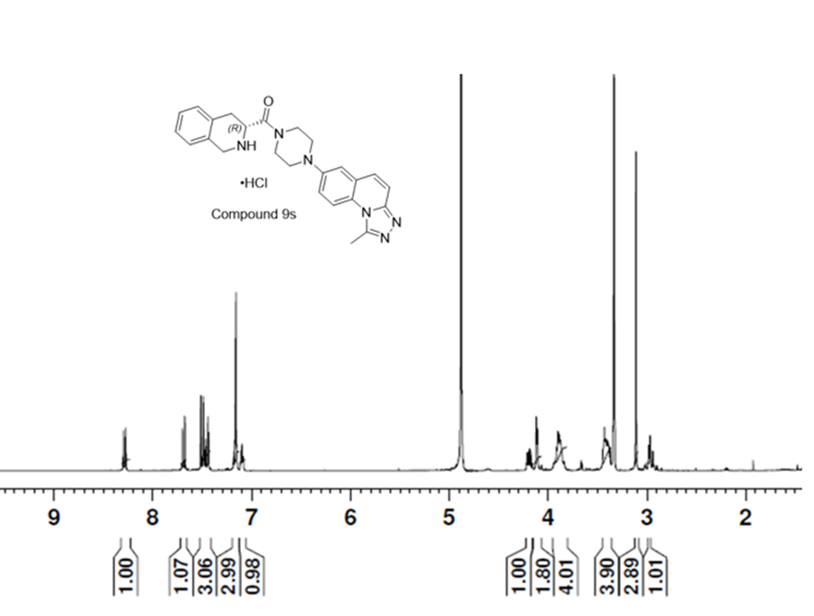
Figure S73. The ¹H NMR spectrum of compound 9s in CD3OD
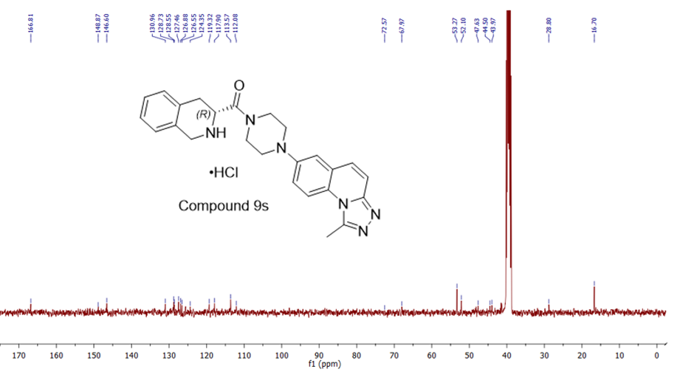
Figure S74. The ¹³C NMR spectrum of compound 9s in DMSO-d₆

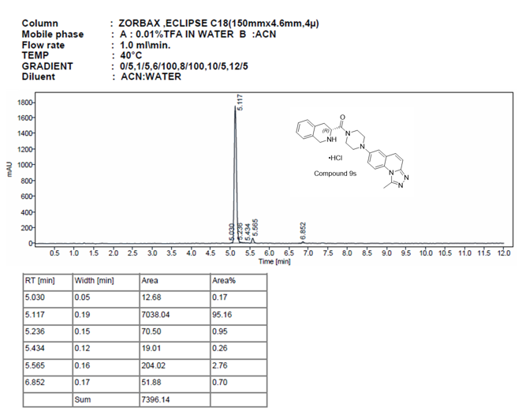
Figure S75. The HPLC chromatogram of compound 9s

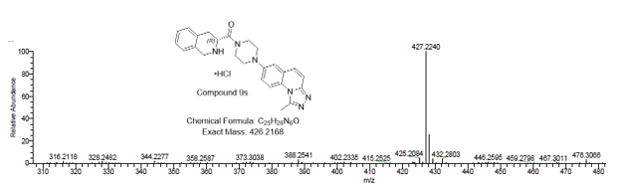
Figure S76. The HRMS chromatogram of compound 9s

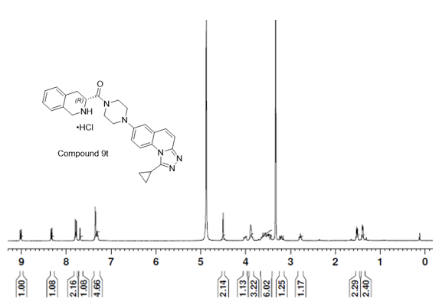
Figure S77. The ¹H NMR spectrum of compound 9t in CD3OD

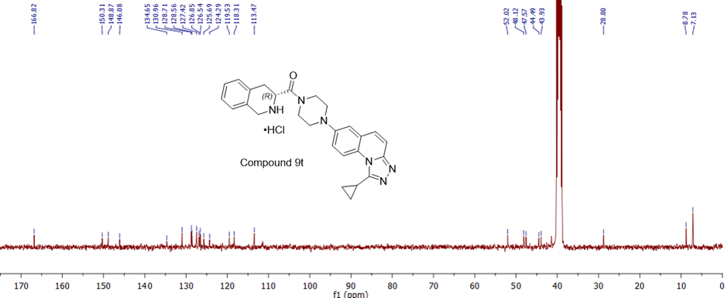
Figure S78. The ¹³C NMR spectrum of compound 9t in DMSO-d₆

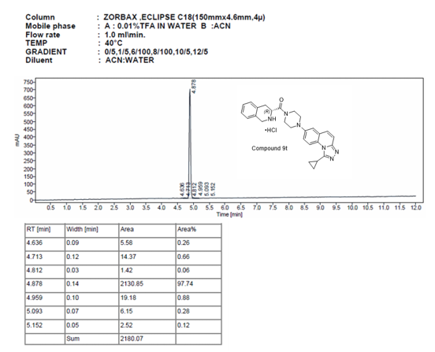
Figure S79. The HPLC chromatogram of compound 9t

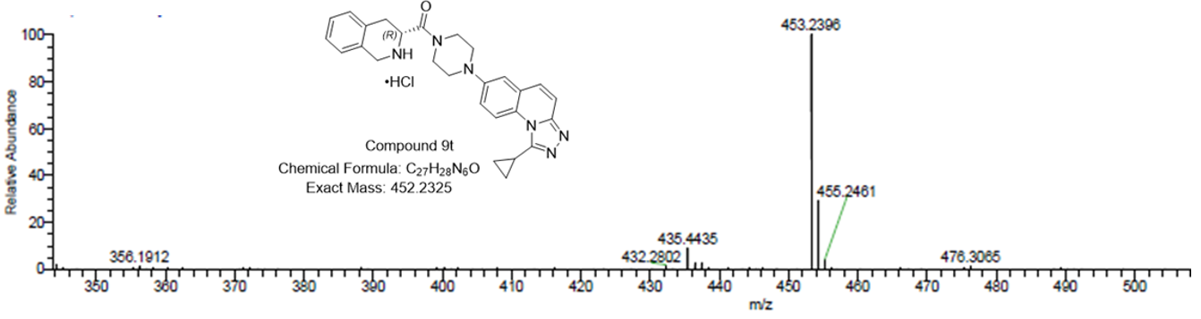
Figure S80. The HRMS chromatogram of compound 9t

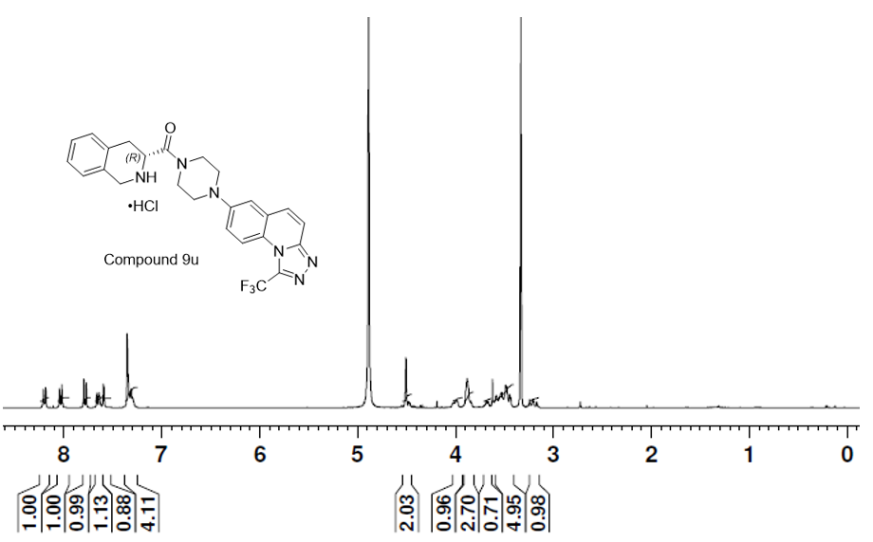
Figure S81. The ¹H NMR spectrum of compound 9u in CD3OD

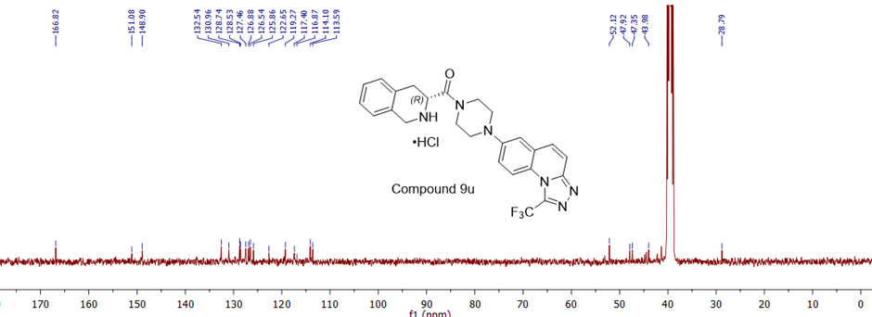
Figure S82. The ¹³C NMR spectrum of compound 9u in DMSO-d₆

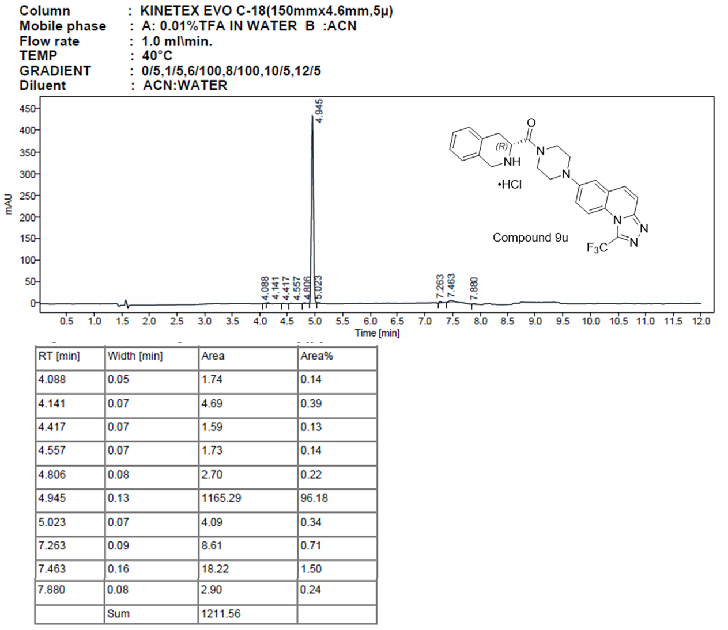
Figure S83. The HPLC chromatogram of compound 9u

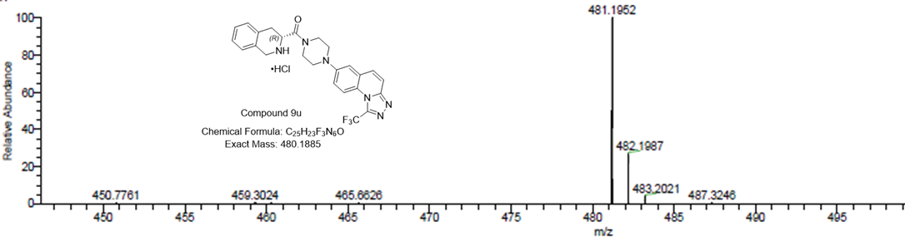
Figure S84. The HRMS chromatogram of compound 9u
- IC₅₀ graphs
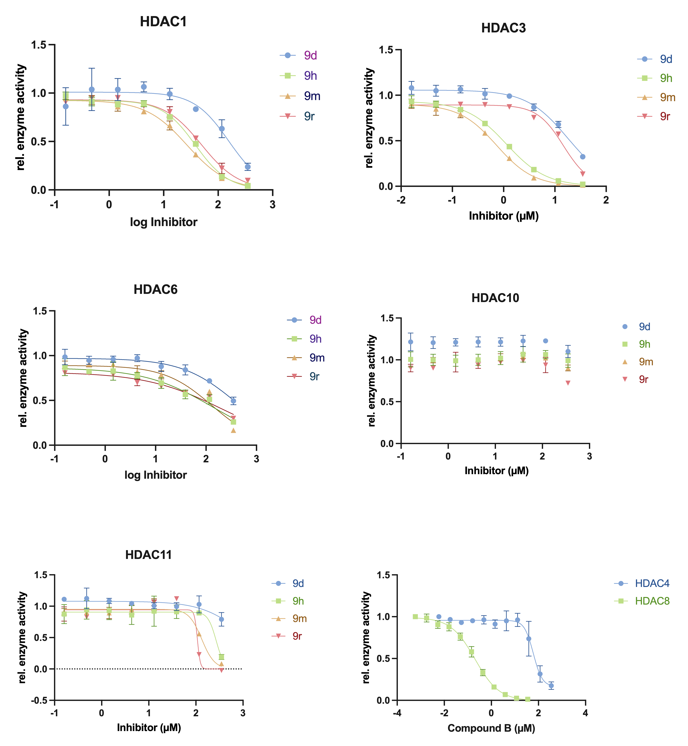
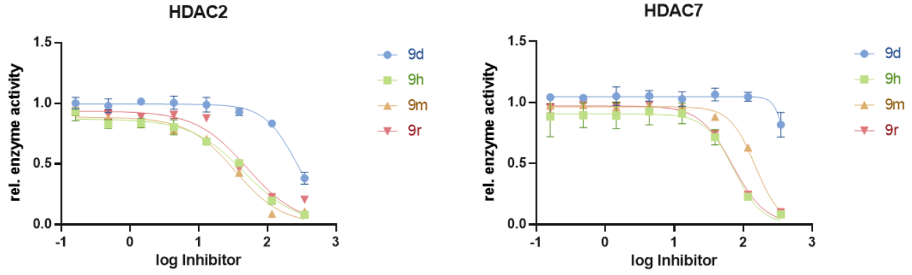

Figure S85. Isoenzyme selectivity of most potent inhibitors (9d, 9h, 9m & 9r) against HDAC8.

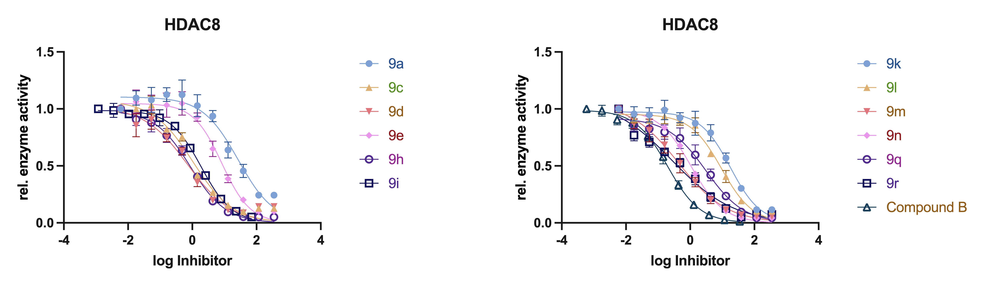
Figure S86. IC₅₀ graphs of tested compounds against HDAC8.

- Original blots of 9h and 9m
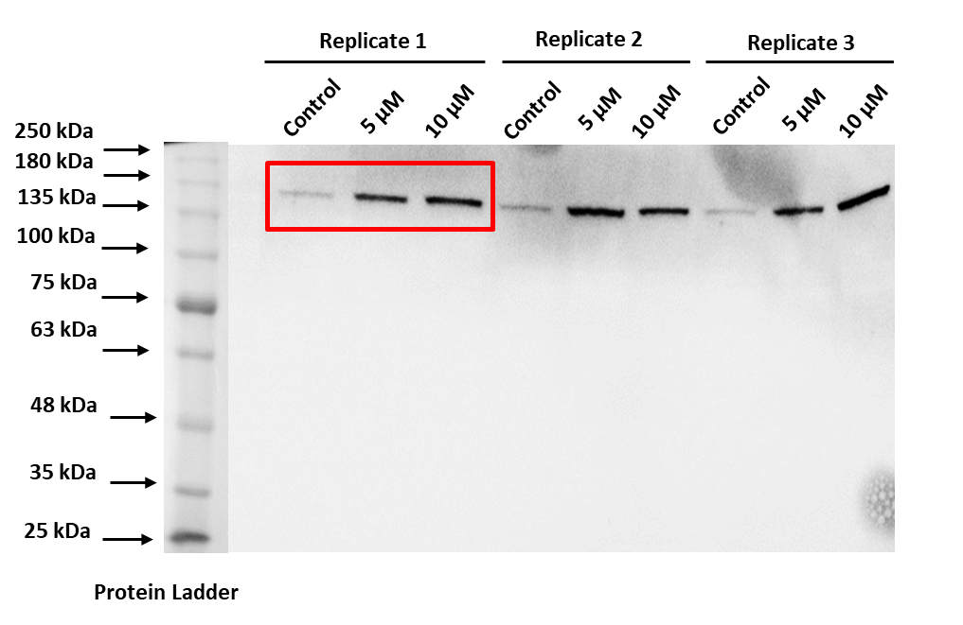
Fig. 87 A. Full blot of acetyl SMC3 (Compound 9h) used in fig.9A. The blot shows three biological replicates. The blot used in fig.9A is marked with red square.

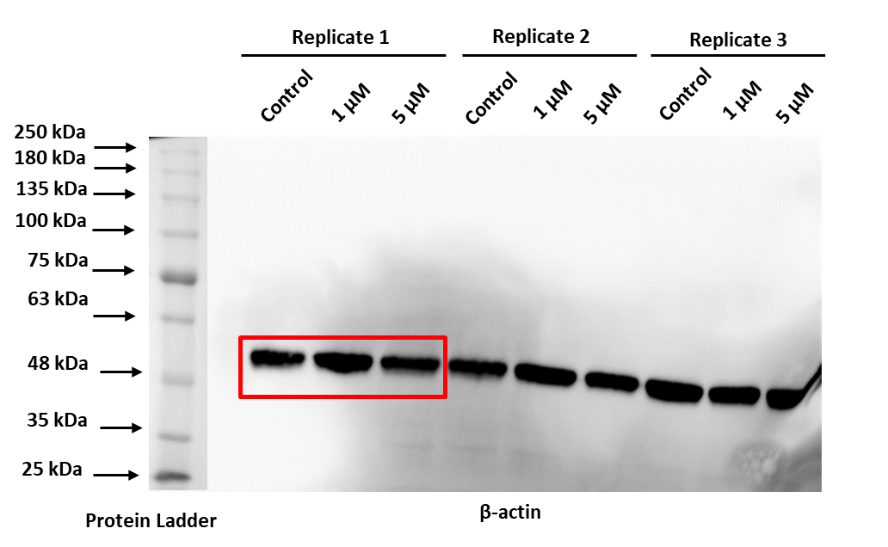
Fig. 87 B. Full blot of acetyl SMC3 actin (Compound 9h) used in fig.9A. The blot shows three biological replicates. The blot used in fig.9A is marked with red square.
.

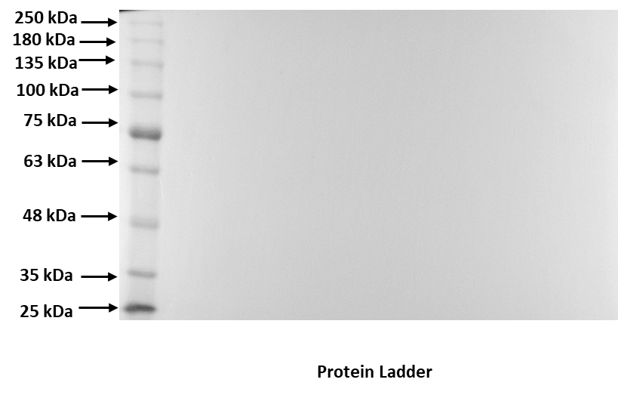
Fig. 87 C. Full length ladder of acetyl smc3 and actin ladder (Compound 9h).

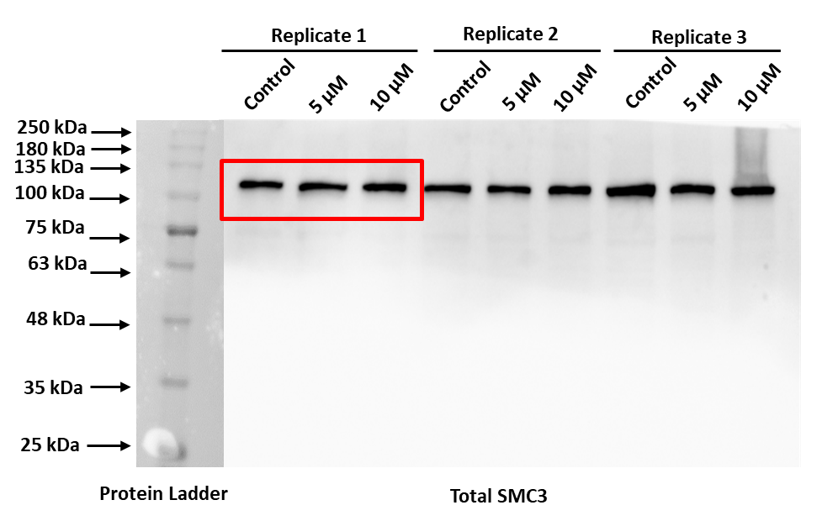
Fig. 87 D. Full blot of total SMC3 (Compound 9h) used in fig.9A. The blot shows three biological replicates. The blot used in fig.9A is marked with red square.

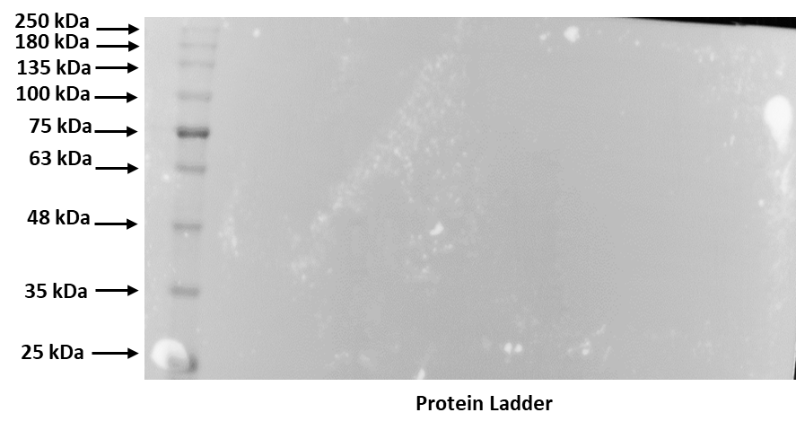
Fig. 87 E. Full length ladder of total SMC3 (Compound 9h)

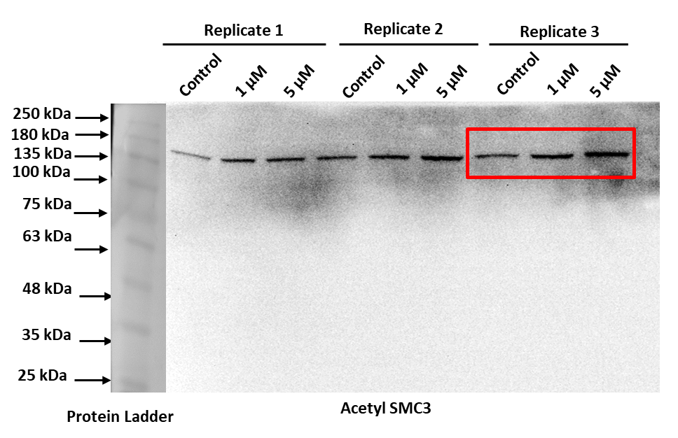
Fig. 88 A. Full blot of acetyl SMC3 (Compound 9m) used in fig.9B. The blot shows three biological replicates. The blot used in fig.9B is marked with red square.

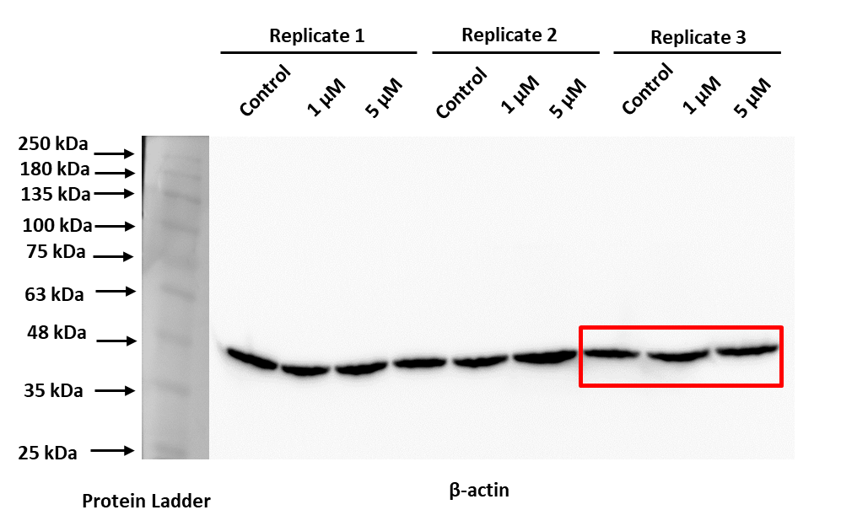

Fig. 88 B. Full blot of acetyl SMC3 actin (Compound 9m) used in fig.9B. The blot shows three biological replicates. The blot used in fig.9B is marked with red square.

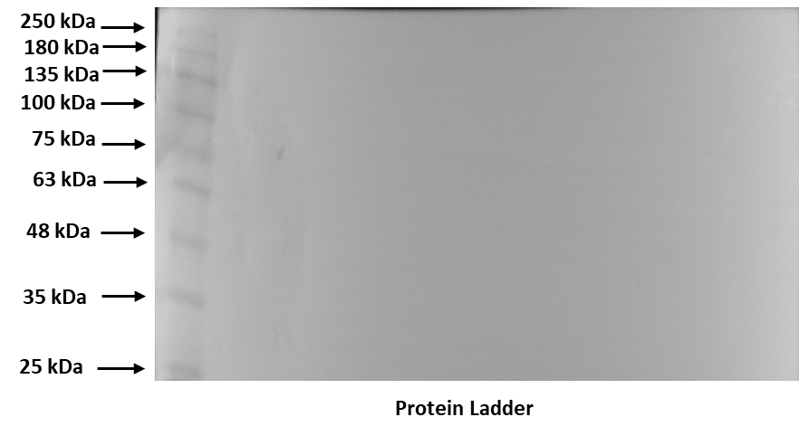
Fig. 88 C. Full length acetyl SMC3 and actin ladder (Compound 9m)

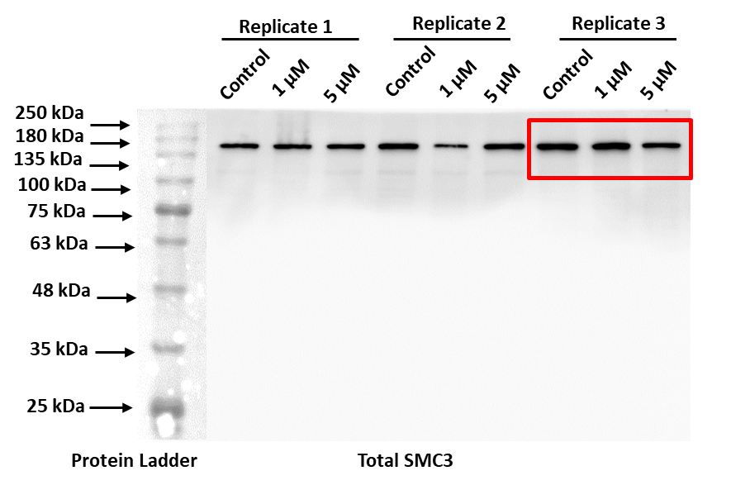
Fig. 88 D. Full blot of total SMC3 (Compound 9m) used in fig.9B. The blot shows three biological replicates. The blot used in fig.9B is marked with red square.

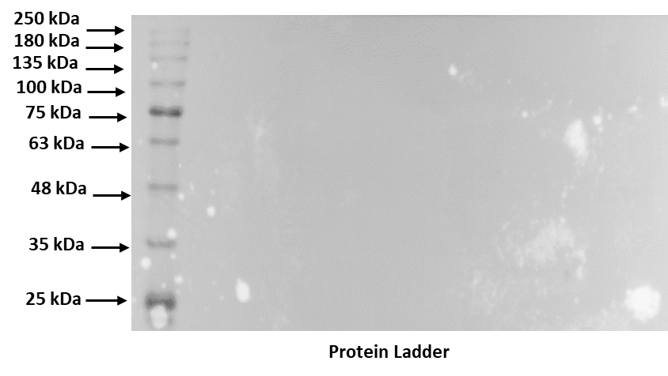
Fig. 88 E. Full length total SMC3 ladder (Compound 9m).

