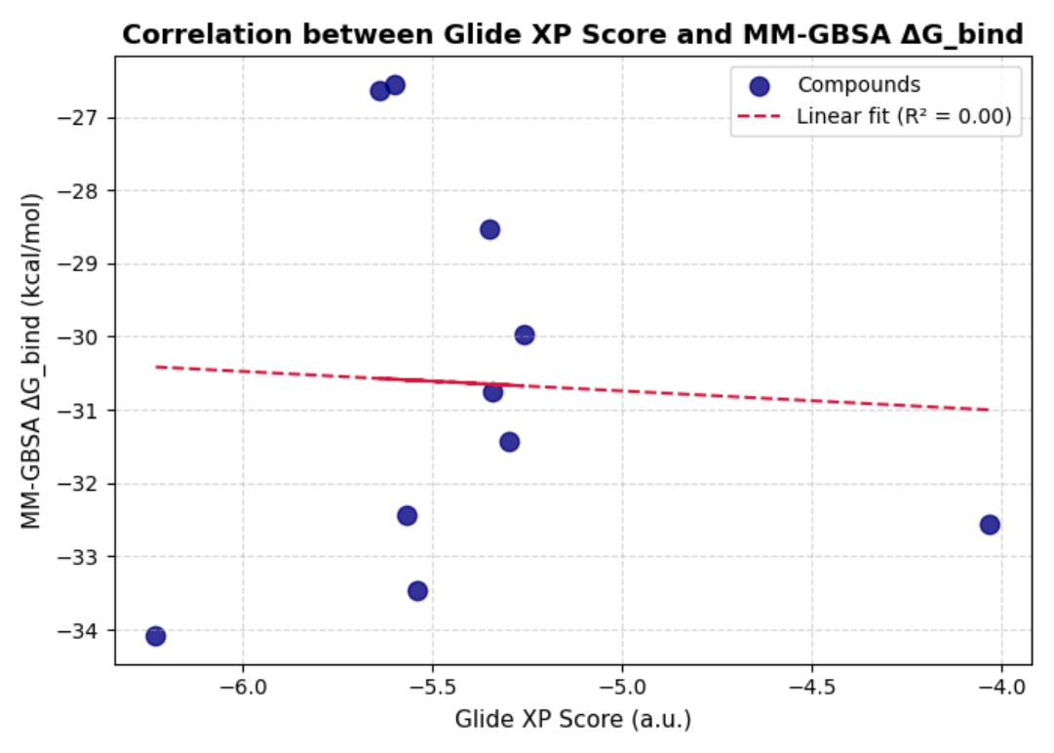

Figure S3. Correlation between Glide XP docking scores (a.u.) and MM-GBSA estimated binding free energies (ΔGbind, kcal/mol) for the top-ranked compounds. The weak correlation (R² ≈ 0.00) indicates that the two scoring functions evaluate binding from distinct theoretical perspectives.

