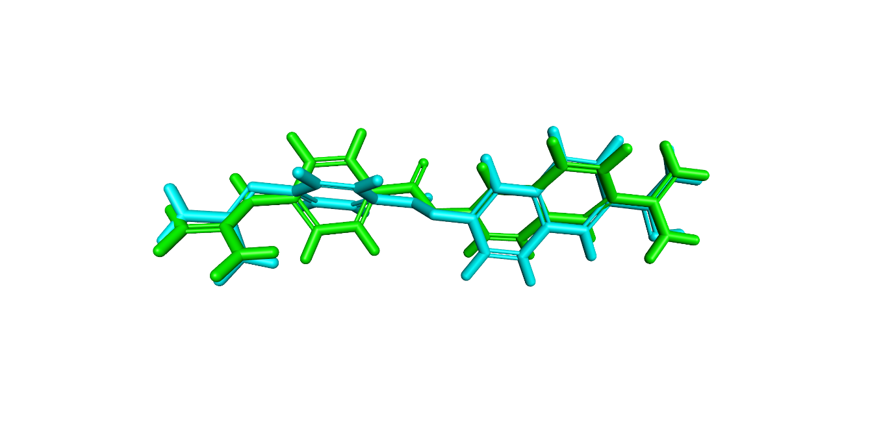

Supplementary Figure S2. Superimposed structures of cocrystal ligand (CID_4413) and its redocked conformer with an RMSD of 1.6 Angstrom.

