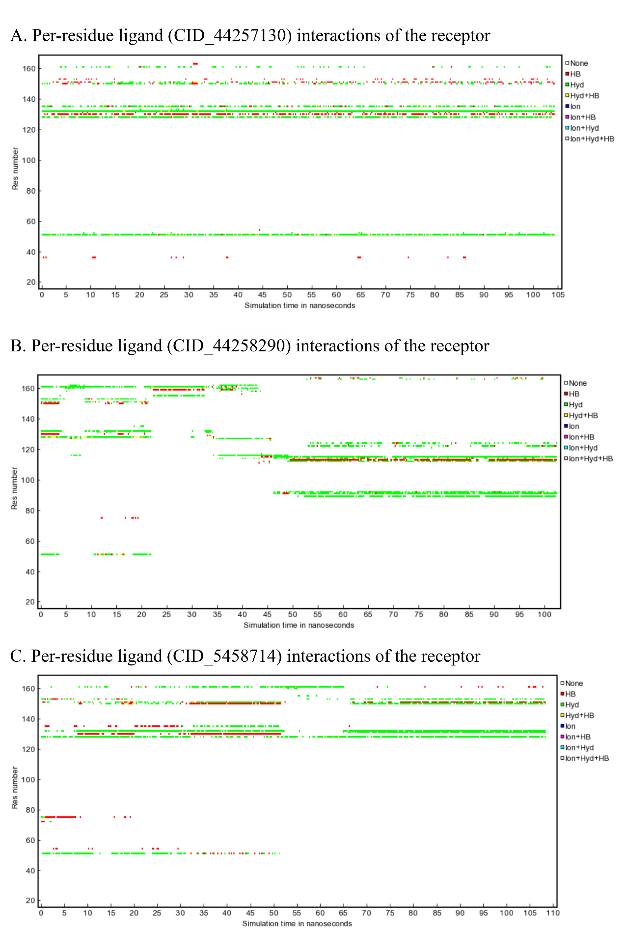
Supplementary Figure S4. Per-Residue Contact Analysis of NS2B–NS3 Protease in Complex with Jackfruit-Derived Phytochemicals that are Cyanomaclurin (PubChem ID: 44257130), Oxidihydroartocarpesin (PubChem ID: 44258290), and Dihydromorin (PubChem ID: 5458714)

