Table S1. Statistical significance of the t-tests comparing mean MALAT1/TALAM1 expression levels in MCL samples from peripheral blood (Cohort#3) according to the status of factors with prognostic value
Factor |  | Comparison groups (n) |  |  | P-value (MALAT1) | P-value (TALAM1)
SOX11 expression |  | SOX11+ (n=26) vs SOX11- (n=18) |  |  | 0.244 | 0.21
TP53 alterations |  | WT (n=27) / MUT_DEL (n=14) |  |  | 0.622 | 0.456
CDKN2A copy number status |  | WT (n=37) / DEL (n=5) |  |  | 0.633 | 0.972
Copy number alterations |  | Less than 5 (n=22)/ 5 or more (n=20) |  |  | 0.609 | 0.612

Table S2. Significant differentially expressed genes upon MALAT1 silencing in 3 SOX11 positive PDLS-MCL
HGNC.symbol | EnsemblGeneStableID | log2 Fold Change | baseMean | lfcSE | pvalue | padj | Direction
RIMBP3C | ENSG00000183246.8 | -9.0943 | 33.6994 | 2.9756 | 5.77E-09 | 7.55E-05 | Down
ATF7-NPFF | ENSG00000267281.3 | -8.9107 | 32.2025 | 3.0172 | 3.03E-08 | 0.000264625 | Down
MALAT1 | ENSG00000251562.9 | -2.3949 | 274709.9125 | 0.0810 | 2.54E-196 | 6.66E-192 | Down
SYCP2 | ENSG00000196074.13 | -1.6829 | 138.4277 | 0.5198 | 2.60E-05 | 0.042650949 | Down
NOMO2 | ENSG00000185164.15 | 0.4766 | 2474.2735 | 0.1381 | 1.88E-05 | 0.03288605 | Up
BCL9L | ENSG00000186174.13 | 0.4919 | 2476.5792 | 0.1282 | 4.51E-06 | 0.009852277 | Up
TEP1 | ENSG00000129566.13 | 0.5726 | 1387.9628 | 0.1445 | 2.85E-06 | 0.009050584 | Up
HLA-DQA1 | ENSG00000228284.8 | 0.5808 | 4951.5657 | 0.1491 | 3.34E-06 | 0.009050584 | Up
HIVEP2 | ENSG00000010818.10 | 0.6476 | 4392.6243 | 0.1598 | 1.70E-06 | 0.007418512 | Up
CASZ1 | ENSG00000130940.15 | 0.6592 | 1272.9434 | 0.1460 | 2.61E-07 | 0.001706406 | Up
DOCK7 | ENSG00000116641.18 | 0.7677 | 1087.0179 | 0.2177 | 1.35E-05 | 0.025246956 | Up
DOCK4 | ENSG00000128512.24 | 0.7831 | 732.6531 | 0.2015 | 3.80E-06 | 0.009050584 | Up
CSNK2B | ENSG00000204435.15 | 0.8875 | 864.7287 | 0.2298 | 3.76E-06 | 0.009050584 | Up
TUBGCP5 | ENSG00000276856.3 | 2.0554 | 125.5646 | 0.5382 | 2.20E-06 | 0.008219046 | Up
CNTNAP3 | ENSG00000106714.18 | 3.1821 | 66.4992 | 0.8815 | 1.05E-06 | 0.005499457 | Up

Table S3A. Significantly enriched pathways by GSEA (C2 geneset) of correlated genes with MALAT1 expression in samples from PB and derived PDLS-MCL
 |  | SIZE | ES |  |  | NES |  | NOM  p-val |  |  |  | FDR  q-val |  |  | FWER p-val |  |  | RANK AT MAX
Positive enrichments
DODD_NASOPHARYNGEAL_CARCINOMA_UP |  | 297 | 0.24 |  |  | 3.67 |  | <0.001 |  |  |  | <0.001 |  |  | <0.001 |  |  | 1476
CREIGHTON_ENDOCRINE_THERAPY_RESISTANCE_2 |  | 96 | 0.31 |  |  | 3.12 |  | <0.001 |  |  |  | <0.001 |  |  | <0.001 |  |  | 1117
FLORIO_NEOCORTEX_BASAL_RADIAL_GLIA_UP |  | 59 | 0.3 |  |  | 2.47 |  | <0.001 |  |  |  | 0.025 |  |  | 0.121 |  |  | 1507
MITSIADES_RESPONSE_TO_APLIDIN_UP |  | 100 | 0.24 |  |  | 2.41 |  | <0.001 |  |  |  | 0.033 |  |  | 0.192 |  |  | 1387
MIKKELSEN_NPC_HCP_WITH_H3K27ME3 |  | 48 | 0.31 |  |  | 2.38 |  | <0.001 |  |  |  | 0.034 |  |  | 0.238 |  |  | 1616
SENGUPTA_NASOPHARYNGEAL_CARCINOMA_DN |  | 69 | 0.27 |  |  | 2.37 |  | <0.001 |  |  |  | 0.03 |  |  | 0.255 |  |  | 1283
BENPORATH_ES_WITH_H3K27ME3 |  | 129 | 0.21 |  |  | 2.35 |  | 0.004 |  |  |  | 0.029 |  |  | 0.276 |  |  | 1414
KEGG_OLFACTORY_TRANSDUCTION |  | 16 | 0.5 |  |  | 2.35 |  | <0.001 |  |  |  | 0.026 |  |  | 0.286 |  |  | 1415
NAKAYAMA_SOFT_TISSUE_TUMORS_PCA2_DN |  | 16 | 0.5 |  |  | 2.28 |  | <0.001 |  |  |  | 0.039 |  |  | 0.425 |  |  | 965
NAGASHIMA_NRG1_SIGNALING_UP |  | 39 | 0.33 |  |  | 2.27 |  | 0.004 |  |  |  | 0.037 |  |  | 0.442 |  |  | 1416
PEREZ_TP53_TARGETS |  | 200 | 0.17 |  |  | 2.27 |  | <0.001 |  |  |  | 0.034 |  |  | 0.447 |  |  | 1300
PICCALUGA_ANGIOIMMUNOBLASTIC_LYMPHOMA_DN |  | 37 | 0.34 |  |  | 2.23 |  | <0.001 |  |  |  | 0.042 |  |  | 0.543 |  |  | 1518
 |  | SIZE | ES |  |  | NES |  | NOM  p-val |  |  | FDR  q-val |  |  | FWER p-val |  |  | RANK AT MAX
Negative enrichments
DODD_NASOPHARYNGEAL_CARCINOMA_DN |  | 236 | -0.40 |  |  | -6.03 |  |  | <0.001 |  | <0.001 |  |  | <0.001 |  |  | 1195
WEI_MYCN_TARGETS_WITH_E_BOX |  | 198 | -0.42 |  |  | -6.00 |  |  | <0.001 |  | <0.001 |  |  | <0.001 |  |  | 1172
PUJANA_BRCA1_PCC_NETWORK |  | 273 | -0.36 |  |  | -5.95 |  |  | <0.001 |  | <0.001 |  |  | <0.001 |  |  | 1194
KRIGE_RESPONSE_TO_TOSEDOSTAT_24HR_DN |  | 236 | -0.38 |  |  | -5.87 |  |  | <0.001 |  | <0.001 |  |  | <0.001 |  |  | 1194
LEE_BMP2_TARGETS_DN |  | 201 | -0.41 |  |  | -5.73 |  |  | <0.001 |  | <0.001 |  |  | <0.001 |  |  | 1195
CAIRO_HEPATOBLASTOMA_CLASSES_UP |  | 131 | -0.47 |  |  | -5.60 |  |  | <0.001 |  | <0.001 |  |  | <0.001 |  |  | 1194
PUJANA_CHEK2_PCC_NETWORK |  | 130 | -0.44 |  |  | -5.32 |  |  | <0.001 |  | <0.001 |  |  | <0.001 |  |  | 1194
KRIGE_RESPONSE_TO_TOSEDOSTAT_6HR_DN |  | 206 | -0.35 |  |  | -5.08 |  |  | <0.001 |  | <0.001 |  |  | <0.001 |  |  | 1203
MANALO_HYPOXIA_DN |  | 71 | -0.51 |  |  | -4.80 |  |  | <0.001 |  | <0.001 |  |  | <0.001 |  |  | 1160
NIKOLSKY_BREAST_CANCER_8Q23_Q24_AMPLICON |  | 60 | -0.55 |  |  | -4.77 |  |  | <0.001 |  | <0.001 |  |  | <0.001 |  |  | 1101
WONG_EMBRYONIC_STEM_CELL_CORE |  | 60 | -0.53 |  |  | -4.55 |  |  | <0.001 |  | <0.001 |  |  | <0.001 |  |  | 1051
KINSEY_TARGETS_OF_EWSR1_FLII_FUSION_UP |  | 224 | -0.30 |  |  | -4.49 |  |  | <0.001 |  | <0.001 |  |  | <0.001 |  |  | 1202
DIAZ_CHRONIC_MEYLOGENOUS_LEUKEMIA_UP |  | 267 | -0.27 |  |  | -4.44 |  |  | <0.001 |  | <0.001 |  |  | <0.001 |  |  | 1074
FISCHER_DREAM_TARGETS |  | 137 | -0.35 |  |  | -4.38 |  |  | <0.001 |  | <0.001 |  |  | <0.001 |  |  | 1261
BERENJENO_TRANSFORMED_BY_RHOA_UP |  | 106 | -0.39 |  |  | -4.35 |  |  | <0.001 |  | <0.001 |  |  | <0.001 |  |  | 1194
RHEIN_ALL_GLUCOCORTICOID_THERAPY_DN |  | 79 | -0.42 |  |  | -4.24 |  |  | <0.001 |  | <0.001 |  |  | <0.001 |  |  | 1066
BOYAULT_LIVER_CANCER_SUBCLASS_G3_UP |  | 50 | -0.52 |  |  | -4.20 |  |  | <0.001 |  | <0.001 |  |  | <0.001 |  |  | 1145
CASORELLI_ACUTE_PROMYELOCYTIC_LEUKEMIA_DN |  | 123 | -0.35 |  |  | -4.17 |  |  | <0.001 |  | <0.001 |  |  | <0.001 |  |  | 1236
RODRIGUES_THYROID_CARCINOMA_POORLY_DIFFERENTIATED_UP |  | 139 | -0.33 |  |  | -4.11 |  |  | <0.001 |  | <0.001 |  |  | <0.001 |  |  | 1203
NIKOLSKY_BREAST_CANCER_8Q12_Q22_AMPLICON |  | 49 | -0.50 |  |  | -4.10 |  |  | <0.001 |  | <0.001 |  |  | <0.001 |  |  | 1112
WANG_RESPONSE_TO_GSK3_INHIBITOR_SB216763_DN |  | 80 | -0.42 |  |  | -4.09 |  |  | <0.001 |  | <0.001 |  |  | <0.001 |  |  | 1194
REACTOME_TRANSLATION |  | 52 | -0.52 |  |  | -4.09 |  |  | <0.001 |  | <0.001 |  |  | <0.001 |  |  | 1171
HSIAO_HOUSEKEEPING_GENES |  | 76 | -0.42 |  |  | -4.05 |  |  | <0.001 |  | <0.001 |  |  | <0.001 |  |  | 1149
ONKEN_UVEAL_MELANOMA_UP |  | 171 | -0.29 |  |  | -3.95 |  |  | <0.001 |  | <0.001 |  |  | <0.001 |  |  | 787
WANG_TUMOR_INVASIVENESS_UP |  | 70 | -0.42 |  |  | -3.93 |  |  | <0.001 |  | <0.001 |  |  | <0.001 |  |  | 1154
SCHUHMACHER_MYC_TARGETS_UP |  | 32 | -0.60 |  |  | -3.89 |  |  | <0.001 |  | <0.001 |  |  | <0.001 |  |  | 924
PATIL_LIVER_CANCER |  | 127 | -0.32 |  |  | -3.85 |  |  | <0.001 |  | <0.001 |  |  | <0.001 |  |  | 1136
PUJANA_ATM_PCC_NETWORK |  | 233 | -0.25 |  |  | -3.84 |  |  | <0.001 |  | <0.001 |  |  | <0.001 |  |  | 1197
WONG_MITOCHONDRIA_GENE_MODULE |  | 41 | -0.53 |  |  | -3.84 |  |  | <0.001 |  | <0.001 |  |  | <0.001 |  |  | 1021
REACTOME_RRNA_PROCESSING |  | 38 | -0.54 |  |  | -3.83 |  |  | <0.001 |  | <0.001 |  |  | <0.001 |  |  | 1160
BERTUCCI_MEDULLARY_VS_DUCTAL_BREAST_CANCER_UP |  | 45 | -0.50 |  |  | -3.77 |  |  | <0.001 |  | <0.001 |  |  | <0.001 |  |  | 1115
REACTOME_METABOLISM_OF_RNA |  | 120 | -0.31 |  |  | -3.73 |  |  | <0.001 |  | <0.001 |  |  | <0.001 |  |  | 1192
TARTE_PLASMA_CELL_VS_PLASMABLAST_DN |  | 49 | -0.47 |  |  | -3.70 |  |  | <0.001 |  | <0.001 |  |  | <0.001 |  |  | 1074
FULCHER_INFLAMMATORY_RESPONSE_LECTIN_VS_LPS_UP |  | 119 | -0.32 |  |  | -3.68 |  |  | <0.001 |  | <0.001 |  |  | <0.001 |  |  | 1196
FEVR_CTNNB1_TARGETS_DN |  | 96 | -0.34 |  |  | -3.63 |  |  | <0.001 |  | <0.001 |  |  | <0.001 |  |  | 1039
YAO_TEMPORAL_RESPONSE_TO_PROGESTERONE_CLUSTER_17 |  | 42 | -0.48 |  |  | -3.58 |  |  | <0.001 |  | <0.001 |  |  | <0.001 |  |  | 1167
BASSO_CD40_SIGNALING_UP |  | 32 | -0.54 |  |  | -3.57 |  |  | <0.001 |  | <0.001 |  |  | <0.001 |  |  | 840
CD40BASSO_UP |  | 32 | -0.54 |  |  | -3.57 |  |  | <0.001 |  | <0.001 |  |  | <0.001 |  |  | 840
SHEDDEN_LUNG_CANCER_POOR_SURVIVAL_A6 |  | 78 | -0.36 |  |  | -3.52 |  |  | <0.001 |  | <0.001 |  |  | <0.001 |  |  | 1166
ACEVEDO_LIVER_TUMOR_VS_NORMAL_ADJACENT_TISSUE_UP |  | 173 | -0.25 |  |  | -3.49 |  |  | <0.001 |  | <0.001 |  |  | <0.001 |  |  | 1195
DESERT_STEM_CELL_HEPATOCELLULAR_CARCINOMA_SUBCLASS_UP |  | 47 | -0.44 |  |  | -3.48 |  |  | <0.001 |  | <0.001 |  |  | <0.001 |  |  | 1167
BUYTAERT_PHOTODYNAMIC_THERAPY_STRESS_DN |  | 106 | -0.31 |  |  | -3.44 |  |  | <0.001 |  | <0.001 |  |  | <0.001 |  |  | 1186
GARY_CD5_TARGETS_DN |  | 101 | -0.31 |  |  | -3.43 |  |  | <0.001 |  | <0.001 |  |  | <0.001 |  |  | 1132
RUTELLA_RESPONSE_TO_HGF_UP |  | 80 | -0.35 |  |  | -3.42 |  |  | <0.001 |  | <0.001 |  |  | <0.001 |  |  | 1193
GRAESSMANN_RESPONSE_TO_MC_AND_DOXORUBICIN_DN |  | 140 | -0.27 |  |  | -3.36 |  |  | <0.001 |  | <0.001 |  |  | <0.001 |  |  | 1007
KARLSSON_TGFB1_TARGETS_UP |  | 32 | -0.51 |  |  | -3.36 |  |  | <0.001 |  | <0.001 |  |  | <0.001 |  |  | 1163
GRADE_COLON_AND_RECTAL_CANCER_UP |  | 69 | -0.35 |  |  | -3.34 |  |  | <0.001 |  | <0.001 |  |  | <0.001 |  |  | 1266
MOOTHA_MITOCHONDRIA |  | 81 | -0.34 |  |  | -3.31 |  |  | <0.001 |  | <0.001 |  |  | <0.001 |  |  | 1223
FOURNIER_ACINAR_DEVELOPMENT_LATE_2 |  | 67 | -0.36 |  |  | -3.31 |  |  | <0.001 |  | <0.001 |  |  | <0.001 |  |  | 1194
MUELLER_PLURINET |  | 53 | -0.40 |  |  | -3.29 |  |  | <0.001 |  | <0.001 |  |  | <0.001 |  |  | 1212
BORCZUK_MALIGNANT_MESOTHELIOMA_UP |  | 69 | -0.36 |  |  | -3.29 |  |  | <0.001 |  | <0.001 |  |  | <0.001 |  |  | 926
MITSIADES_RESPONSE_TO_APLIDIN_DN |  | 39 | -0.46 |  |  | -3.25 |  |  | <0.001 |  | <0.001 |  |  | <0.001 |  |  | 1115
LI_WILMS_TUMOR_VS_FETAL_KIDNEY_1_DN |  | 30 | -0.51 |  |  | -3.24 |  |  | <0.001 |  | <0.001 |  |  | <0.001 |  |  | 975
MARTENS_TRETINOIN_RESPONSE_DN |  | 141 | -0.25 |  |  | -3.23 |  |  | <0.001 |  | <0.001 |  |  | <0.001 |  |  | 1214
BASSO_B_LYMPHOCYTE_NETWORK |  | 35 | -0.47 |  |  | -3.22 |  |  | <0.001 |  | <0.001 |  |  | <0.001 |  |  | 1214
REACTOME_INNATE_IMMUNE_SYSTEM |  | 169 | -0.23 |  |  | -3.21 |  |  | <0.001 |  | <0.001 |  |  | <0.001 |  |  | 1121
SCHLOSSER_MYC_TARGETS_REPRESSED_BY_SERUM |  | 33 | -0.50 |  |  | -3.20 |  |  | <0.001 |  | <0.001 |  |  | <0.001 |  |  | 1194
RUTELLA_RESPONSE_TO_CSF2RB_AND_IL4_UP |  | 56 | -0.37 |  |  | -3.16 |  |  | <0.001 |  | <0.001 |  |  | 0.001 |  |  | 1055
MOOTHA_HUMAN_MITODB_6_2002 |  | 76 | -0.32 |  |  | -3.15 |  |  | <0.001 |  | <0.001 |  |  | 0.001 |  |  | 1206
QI_PLASMACYTOMA_UP |  | 48 | -0.40 |  |  | -3.15 |  |  | <0.001 |  | <0.001 |  |  | 0.001 |  |  | 1007
KIM_BIPOLAR_DISORDER_OLIGODENDROCYTE_DENSITY_CORR_UP |  | 125 | -0.26 |  |  | -3.13 |  |  | <0.001 |  | <0.001 |  |  | 0.001 |  |  | 1173
YAO_TEMPORAL_RESPONSE_TO_PROGESTERONE_CLUSTER_14 |  | 34 | -0.47 |  |  | -3.12 |  |  | <0.001 |  | <0.001 |  |  | 0.001 |  |  | 1068
LEE_LIVER_CANCER_SURVIVAL_DN |  | 39 | -0.43 |  |  | -3.12 |  |  | <0.001 |  | <0.001 |  |  | 0.001 |  |  | 1191
DANG_BOUND_BY_MYC |  | 194 | -0.22 |  |  | -3.10 |  |  | <0.001 |  | <0.001 |  |  | 0.001 |  |  | 1168
SHAFFER_IRF4_TARGETS_IN_ACTIVATED_B_LYMPHOCYTE |  | 21 | -0.59 |  |  | -3.10 |  |  | <0.001 |  | <0.001 |  |  | 0.001 |  |  | 1160
GOBERT_OLIGODENDROCYTE_DIFFERENTIATION_UP |  | 80 | -0.31 |  |  | -3.08 |  |  | <0.001 |  | <0.001 |  |  | 0.001 |  |  | 1102
REACTOME_REGULATION_OF_EXPRESSION_OF_SLITS_AND_ROBOS |  | 24 | -0.54 |  |  | -3.07 |  |  | <0.001 |  | <0.001 |  |  | 0.001 |  |  | 1187
CHEMNITZ_RESPONSE_TO_PROSTAGLANDIN_E2_UP |  | 29 | -0.49 |  |  | -3.07 |  |  | <0.001 |  | <0.001 |  |  | 0.001 |  |  | 1191
KRIEG_KDM3A_TARGETS_NOT_HYPOXIA |  | 46 | -0.39 |  |  | -3.05 |  |  | <0.001 |  | <0.001 |  |  | 0.001 |  |  | 967
RHODES_UNDIFFERENTIATED_CANCER |  | 15 | -0.66 |  |  | -3.04 |  |  | <0.001 |  | <0.001 |  |  | 0.001 |  |  | 971
WP_VEGFAVEGFR2_SIGNALING_PATHWAY |  | 86 | -0.30 |  |  | -3.03 |  |  | <0.001 |  | <0.001 |  |  | 0.001 |  |  | 1192
DANG_MYC_TARGETS_UP |  | 33 | -0.46 |  |  | -3.00 |  |  | <0.001 |  | <0.001 |  |  | 0.001 |  |  | 1191
VECCHI_GASTRIC_CANCER_EARLY_UP |  | 85 | -0.29 |  |  | -2.98 |  |  | <0.001 |  | <0.001 |  |  | 0.001 |  |  | 788
MARSON_BOUND_BY_E2F4_UNSTIMULATED |  | 110 | -0.27 |  |  | -2.97 |  |  | <0.001 |  | <0.001 |  |  | 0.001 |  |  | 1201
MCLACHLAN_DENTAL_CARIES_UP |  | 44 | -0.39 |  |  | -2.96 |  |  | <0.001 |  | <0.001 |  |  | 0.003 |  |  | 1159
DIRMEIER_LMP1_RESPONSE_LATE_UP |  | 20 | -0.56 |  |  | -2.95 |  |  | <0.001 |  | <0.001 |  |  | 0.003 |  |  | 884
REACTOME_INFECTIOUS_DISEASE |  | 132 | -0.24 |  |  | -2.95 |  |  | <0.001 |  | <0.001 |  |  | 0.003 |  |  | 1194
REACTOME_SRP_DEPENDENT_COTRANSLATIONAL_PROTEIN_TARGETING_TO_MEMBRANE |  | 17 | -0.60 |  |  | -2.94 |  |  | <0.001 |  | <0.001 |  |  | 0.003 |  |  | 1149
ZHANG_RESPONSE_TO_CANTHARIDIN_DN |  | 20 | -0.55 |  |  | -2.93 |  |  | <0.001 |  | <0.001 |  |  | 0.003 |  |  | 1149
SENGUPTA_NASOPHARYNGEAL_CARCINOMA_UP |  | 37 | -0.41 |  |  | -2.92 |  |  | <0.001 |  | <0.001 |  |  | 0.004 |  |  | 1262
KIM_MYC_AMPLIFICATION_TARGETS_UP |  | 36 | -0.43 |  |  | -2.91 |  |  | <0.001 |  | <0.001 |  |  | 0.004 |  |  | 1047
GOLDRATH_ANTIGEN_RESPONSE |  | 67 | -0.32 |  |  | -2.90 |  |  | <0.001 |  | <0.001 |  |  | 0.004 |  |  | 1084
SHIPP_DLBCL_VS_FOLLICULAR_LYMPHOMA_UP |  | 15 | -0.63 |  |  | -2.90 |  |  | <0.001 |  | <0.001 |  |  | 0.004 |  |  | 904
GRUETZMANN_PANCREATIC_CANCER_UP |  | 68 | -0.31 |  |  | -2.89 |  |  | <0.001 |  | <0.001 |  |  | 0.004 |  |  | 1124
ACEVEDO_LIVER_CANCER_UP |  | 185 | -0.20 |  |  | -2.89 |  |  | <0.001 |  | <0.001 |  |  | 0.004 |  |  | 1112
GRAESSMANN_APOPTOSIS_BY_DOXORUBICIN_DN |  | 309 | -0.17 |  |  | -2.88 |  |  | <0.001 |  | <0.001 |  |  | 0.004 |  |  | 599
BENPORATH_MYC_TARGETS_WITH_EBOX |  | 51 | -0.35 |  |  | -2.88 |  |  | <0.001 |  | <0.001 |  |  | 0.004 |  |  | 1144
POOLA_INVASIVE_BREAST_CANCER_UP |  | 46 | -0.38 |  |  | -2.87 |  |  | <0.001 |  | <0.001 |  |  | 0.005 |  |  | 1159
REACTOME_MITOCHONDRIAL_TRANSLATION |  | 18 | -0.59 |  |  | -2.87 |  |  | <0.001 |  | <0.001 |  |  | 0.006 |  |  | 1171
SOTIRIOU_BREAST_CANCER_GRADE_1_VS_3_UP |  | 23 | -0.50 |  |  | -2.86 |  |  | <0.001 |  | <0.001 |  |  | 0.006 |  |  | 1166
CREIGHTON_ENDOCRINE_THERAPY_RESISTANCE_1 |  | 99 | -0.26 |  |  | -2.86 |  |  | <0.001 |  | <0.001 |  |  | 0.006 |  |  | 1115
PID_MYC_ACTIV_PATHWAY |  | 24 | -0.51 |  |  | -2.85 |  |  | <0.001 |  | <0.001 |  |  | 0.007 |  |  | 475
YAO_TEMPORAL_RESPONSE_TO_PROGESTERONE_CLUSTER_13 |  | 27 | -0.47 |  |  | -2.84 |  |  | <0.001 |  | <0.001 |  |  | 0.007 |  |  | 1193
ICHIBA_GRAFT_VERSUS_HOST_DISEASE_35D_UP |  | 29 | -0.44 |  |  | -2.83 |  |  | <0.001 |  | <0.001 |  |  | 0.007 |  |  | 1170
ALFANO_MYC_TARGETS |  | 48 | -0.36 |  |  | -2.83 |  |  | <0.001 |  | <0.001 |  |  | 0.007 |  |  | 1174
RODWELL_AGING_KIDNEY_UP |  | 81 | -0.28 |  |  | -2.81 |  |  | <0.001 |  | <0.001 |  |  | 0.009 |  |  | 1214
MATTIOLI_MGUS_VS_PCL |  | 25 | -0.48 |  |  | -2.81 |  |  | <0.001 |  | <0.001 |  |  | 0.009 |  |  | 975
GAVIN_FOXP3_TARGETS_CLUSTER_T7 |  | 24 | -0.49 |  |  | -2.81 |  |  | <0.001 |  | <0.001 |  |  | 0.009 |  |  | 1102
REACTOME_CYTOKINE_SIGNALING_IN_IMMUNE_SYSTEM |  | 147 | -0.22 |  |  | -2.80 |  |  | <0.001 |  | <0.001 |  |  | 0.009 |  |  | 1126
REACTOME_INFLUENZA_INFECTION |  | 28 | -0.45 |  |  | -2.80 |  |  | <0.001 |  | <0.001 |  |  | 0.009 |  |  | 1149
WP_METABOLIC_REPROGRAMMING_IN_COLON_CANCER |  | 16 | -0.59 |  |  | -2.79 |  |  | <0.001 |  | <0.001 |  |  | 0.009 |  |  | 1013
REACTOME_HOST_INTERACTIONS_OF_HIV_FACTORS |  | 22 | -0.50 |  |  | -2.78 |  |  | <0.001 |  | <0.001 |  |  | 0.01 |  |  | 1194
REACTOME_GLUCOSE_METABOLISM |  | 17 | -0.58 |  |  | -2.78 |  |  | <0.001 |  | <0.001 |  |  | 0.01 |  |  | 615
KOBAYASHI_EGFR_SIGNALING_24HR_DN |  | 37 | -0.40 |  |  | -2.77 |  |  | <0.001 |  | <0.001 |  |  | 0.01 |  |  | 1050
REACTOME_SIGNALING_BY_ROBO_RECEPTORS |  | 33 | -0.41 |  |  | -2.77 |  |  | <0.001 |  | <0.001 |  |  | 0.011 |  |  | 1231
TONKS_TARGETS_OF_RUNX1_RUNX1T1_FUSION_MONOCYTE_UP |  | 42 | -0.38 |  |  | -2.76 |  |  | <0.001 |  | <0.001 |  |  | 0.011 |  |  | 1239
SCHLOSSER_MYC_TARGETS_AND_SERUM_RESPONSE_DN |  | 20 | -0.53 |  |  | -2.75 |  |  | <0.001 |  | <0.001 |  |  | 0.013 |  |  | 1212
LINDGREN_BLADDER_CANCER_CLUSTER_3_UP |  | 59 | -0.32 |  |  | -2.75 |  |  | <0.001 |  | <0.001 |  |  | 0.013 |  |  | 1172
MALONEY_RESPONSE_TO_17AAG_DN |  | 15 | -0.59 |  |  | -2.75 |  |  | <0.001 |  | <0.001 |  |  | 0.013 |  |  | 971
REACTOME_SIGNALING_BY_INTERLEUKINS |  | 63 | -0.31 |  |  | -2.73 |  |  | <0.001 |  | <0.001 |  |  | 0.014 |  |  | 1117
LINDSTEDT_DENDRITIC_CELL_MATURATION_B |  | 15 | -0.58 |  |  | -2.73 |  |  | <0.001 |  | <0.001 |  |  | 0.014 |  |  | 1187
ICHIBA_GRAFT_VERSUS_HOST_DISEASE_D7_UP |  | 32 | -0.43 |  |  | -2.72 |  |  | <0.001 |  | <0.001 |  |  | 0.014 |  |  | 1195
REACTOME_RRNA_MODIFICATION_IN_THE_NUCLEUS_AND_CYTOSOL |  | 18 | -0.54 |  |  | -2.70 |  |  | <0.001 |  | <0.001 |  |  | 0.015 |  |  | 1144
BILD_MYC_ONCOGENIC_SIGNATURE |  | 67 | -0.29 |  |  | -2.69 |  |  | <0.001 |  | <0.001 |  |  | 0.016 |  |  | 1191
LU_IL4_SIGNALING |  | 20 | -0.52 |  |  | -2.69 |  |  | <0.001 |  | <0.001 |  |  | 0.016 |  |  | 1370
HOSHIDA_LIVER_CANCER_SUBCLASS_S1 |  | 43 | -0.36 |  |  | -2.69 |  |  | <0.001 |  | <0.001 |  |  | 0.016 |  |  | 1042
COLINA_TARGETS_OF_4EBP1_AND_4EBP2 |  | 63 | -0.30 |  |  | -2.69 |  |  | <0.001 |  | <0.001 |  |  | 0.016 |  |  | 644
REACTOME_EUKARYOTIC_TRANSLATION_INITIATION |  | 21 | -0.50 |  |  | -2.68 |  |  | <0.001 |  | <0.001 |  |  | 0.016 |  |  | 1149
LI_INDUCED_T_TO_NATURAL_KILLER_UP |  | 56 | -0.31 |  |  | -2.67 |  |  | <0.001 |  | <0.001 |  |  | 0.019 |  |  | 1167
WP_PYRIMIDINE_METABOLISM |  | 16 | -0.57 |  |  | -2.67 |  |  | <0.001 |  | <0.001 |  |  | 0.019 |  |  | 585
REACTOME_NONSENSE_MEDIATED_DECAY_NMD_ |  | 17 | -0.56 |  |  | -2.66 |  |  | <0.001 |  | <0.001 |  |  | 0.019 |  |  | 1259
SPIELMAN_LYMPHOBLAST_EUROPEAN_VS_ASIAN_UP |  | 70 | -0.28 |  |  | -2.66 |  |  | <0.001 |  | <0.001 |  |  | 0.019 |  |  | 1191
ZHAN_MULTIPLE_MYELOMA_CD2_DN |  | 16 | -0.56 |  |  | -2.65 |  |  | <0.001 |  | <0.001 |  |  | 0.022 |  |  | 759
UDAYAKUMAR_MED1_TARGETS_UP |  | 27 | -0.44 |  |  | -2.65 |  |  | <0.001 |  | <0.001 |  |  | 0.022 |  |  | 1051
REACTOME_HIV_INFECTION |  | 46 | -0.34 |  |  | -2.65 |  |  | 0.002 |  | <0.001 |  |  | 0.022 |  |  | 1194
MOHANKUMAR_HOXA1_TARGETS_UP |  | 80 | -0.26 |  |  | -2.64 |  |  | <0.001 |  | <0.001 |  |  | 0.027 |  |  | 1242
REACTOME_INTERFERON_SIGNALING |  | 43 | -0.36 |  |  | -2.64 |  |  | <0.001 |  | <0.001 |  |  | 0.03 |  |  | 1098
MARZEC_IL2_SIGNALING_UP |  | 27 | -0.43 |  |  | -2.63 |  |  | <0.001 |  | <0.001 |  |  | 0.031 |  |  | 1315
REACTOME_TCR_SIGNALING |  | 18 | -0.52 |  |  | -2.63 |  |  | <0.001 |  | <0.001 |  |  | 0.033 |  |  | 1187
SASAKI_ADULT_T_CELL_LEUKEMIA |  | 26 | -0.45 |  |  | -2.60 |  |  | <0.001 |  | <0.001 |  |  | 0.04 |  |  | 1019
REACTOME_NEUTROPHIL_DEGRANULATION |  | 87 | -0.25 |  |  | -2.60 |  |  | <0.001 |  | <0.001 |  |  | 0.04 |  |  | 1197
WELCSH_BRCA1_TARGETS_DN |  | 43 | -0.34 |  |  | -2.60 |  |  | <0.001 |  | <0.001 |  |  | 0.04 |  |  | 924
TIEN_INTESTINE_PROBIOTICS_24HR_UP |  | 98 | -0.24 |  |  | -2.60 |  |  | <0.001 |  | <0.001 |  |  | 0.04 |  |  | 1166
IVANOVA_HEMATOPOIESIS_EARLY_PROGENITOR |  | 82 | -0.25 |  |  | -2.59 |  |  | <0.001 |  | <0.001 |  |  | 0.041 |  |  | 1036
STARK_PREFRONTAL_CORTEX_22Q11_DELETION_DN |  | 82 | -0.26 |  |  | -2.59 |  |  | <0.001 |  | <0.001 |  |  | 0.041 |  |  | 1214
SCHLOSSER_MYC_TARGETS_AND_SERUM_RESPONSE_UP |  | 15 | -0.56 |  |  | -2.59 |  |  | <0.001 |  | <0.001 |  |  | 0.043 |  |  | 1083
HELLER_SILENCED_BY_METHYLATION_UP |  | 45 | -0.33 |  |  | -2.57 |  |  | <0.001 |  | <0.001 |  |  | 0.046 |  |  | 1195
MARTINEZ_RESPONSE_TO_TRABECTEDIN_DN |  | 53 | -0.31 |  |  | -2.57 |  |  | <0.001 |  | <0.001 |  |  | 0.046 |  |  | 1167
SPIELMAN_LYMPHOBLAST_EUROPEAN_VS_ASIAN_DN |  | 119 | -0.22 |  |  | -2.57 |  |  | <0.001 |  | <0.001 |  |  | 0.048 |  |  | 1021
REACTOME_GLYCOLYSIS |  | 15 | -0.55 |  |  | -2.56 |  |  | <0.001 |  | <0.001 |  |  | 0.048 |  |  | 615

Table S3B. Significantly enriched pathways by GSEA (HALLMARKS) of correlated genes with expression in samples from PB and derived PDLS MCL
 |  |  |  |  |  |  | SIZE |  | ES | NES | NOM  p-val | FDR  q-val | FWER  p-val | RANK AT MAX
Negative enrichments
AVOIDING IMMUNE DESTRUCTION |  |  |  |  |  |  | 158 |  | -0.235 | -3.141 | <0.001 | <0.001 | <0.001 | 1236
ENABLING REPLICATIVEI MMORTALITY |  |  |  |  |  |  | 26 |  | -0.405 | -2.413 | <0.001 | 0.003 | 0.002 | 1367
DEREGULATION CELLULAR ENERGETICS |  |  |  |  |  |  | 186 |  | -0.156 | -2.170 | 0.002 | 0.006 | 0.007 | 759
SUSTAINING PROLIFERATIVE SIGNALING |  |  |  |  |  |  | 281 |  | -0.124 | -2.016 | <0.001 | 0.008 | 0.015 | 606

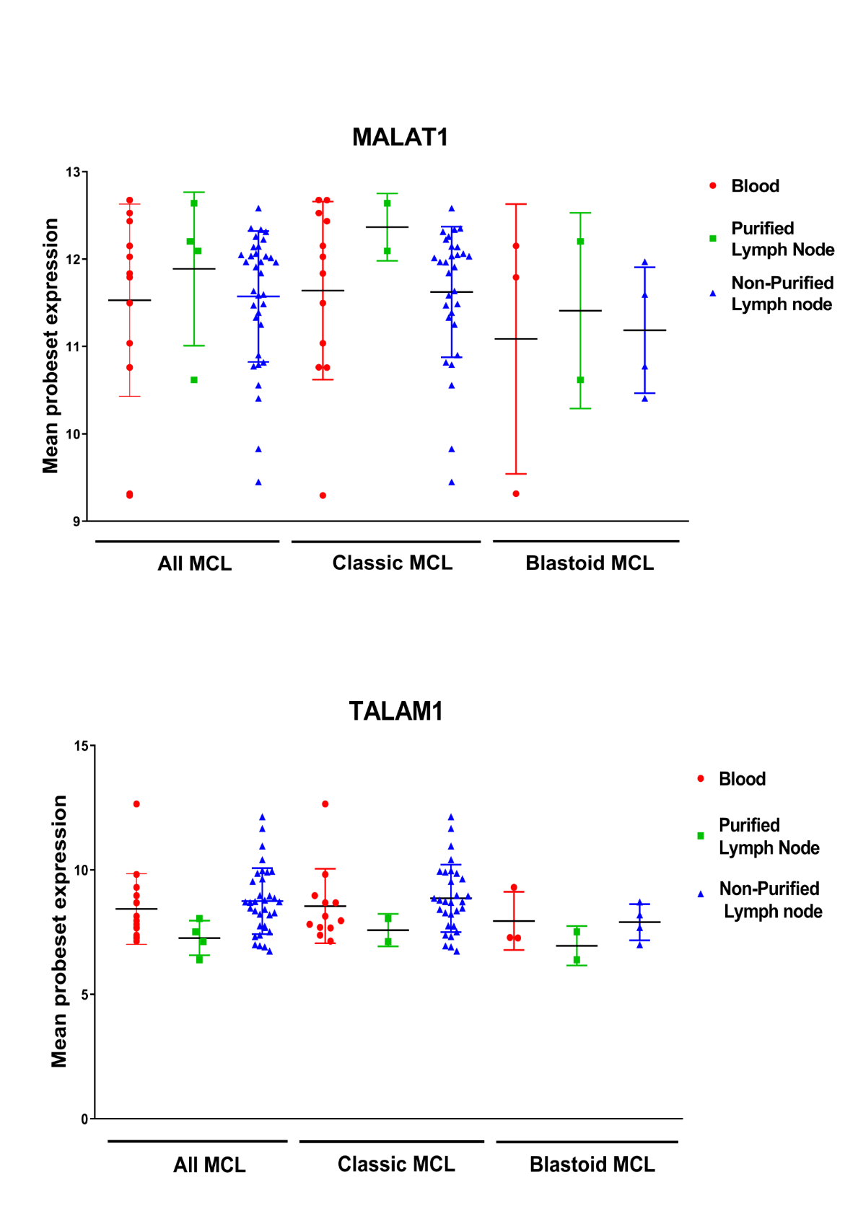

Fig. S1. Mean MALAT1/TALAM1 levels in MCL samples from blood, and CD19 purified or non-purified lymph nodes, and according to MCL cytological variants from cohort#1. No significant differences after correction for multiple comparisons were found according to the sample origin for MALAT1/TALAM1 in the whole series, or in the cytological variants. Median values and interquartile range are depicted.
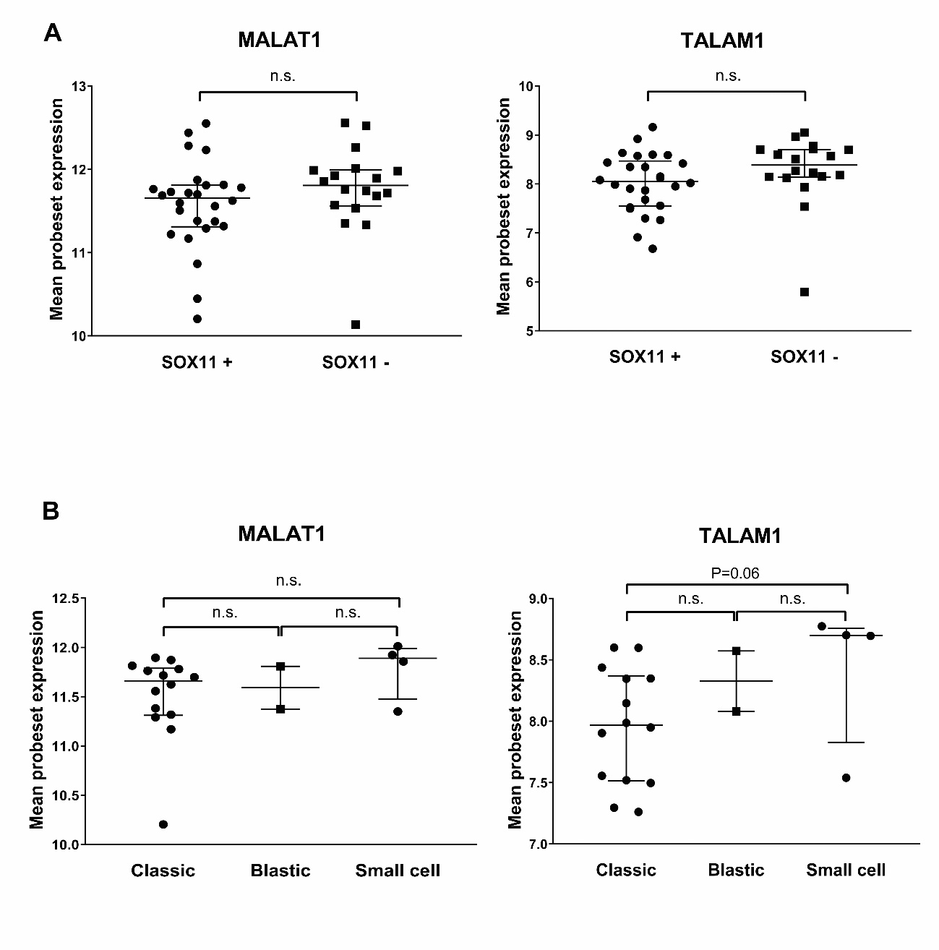

Fig. S2. a. MALAT1/TALAM1 expression in leukemic SOX11+ (N=26) or SOX11- (N=18) MCL samples from cohort #3 shows similar levels in both groups. b. Similar MALAT1/TALAM1 levels were found in different MCL cytological variants (classic N=14, blastoid N=2, and small cell N=4). Median values and interquartile range are depicted. n.s.: non-significant.
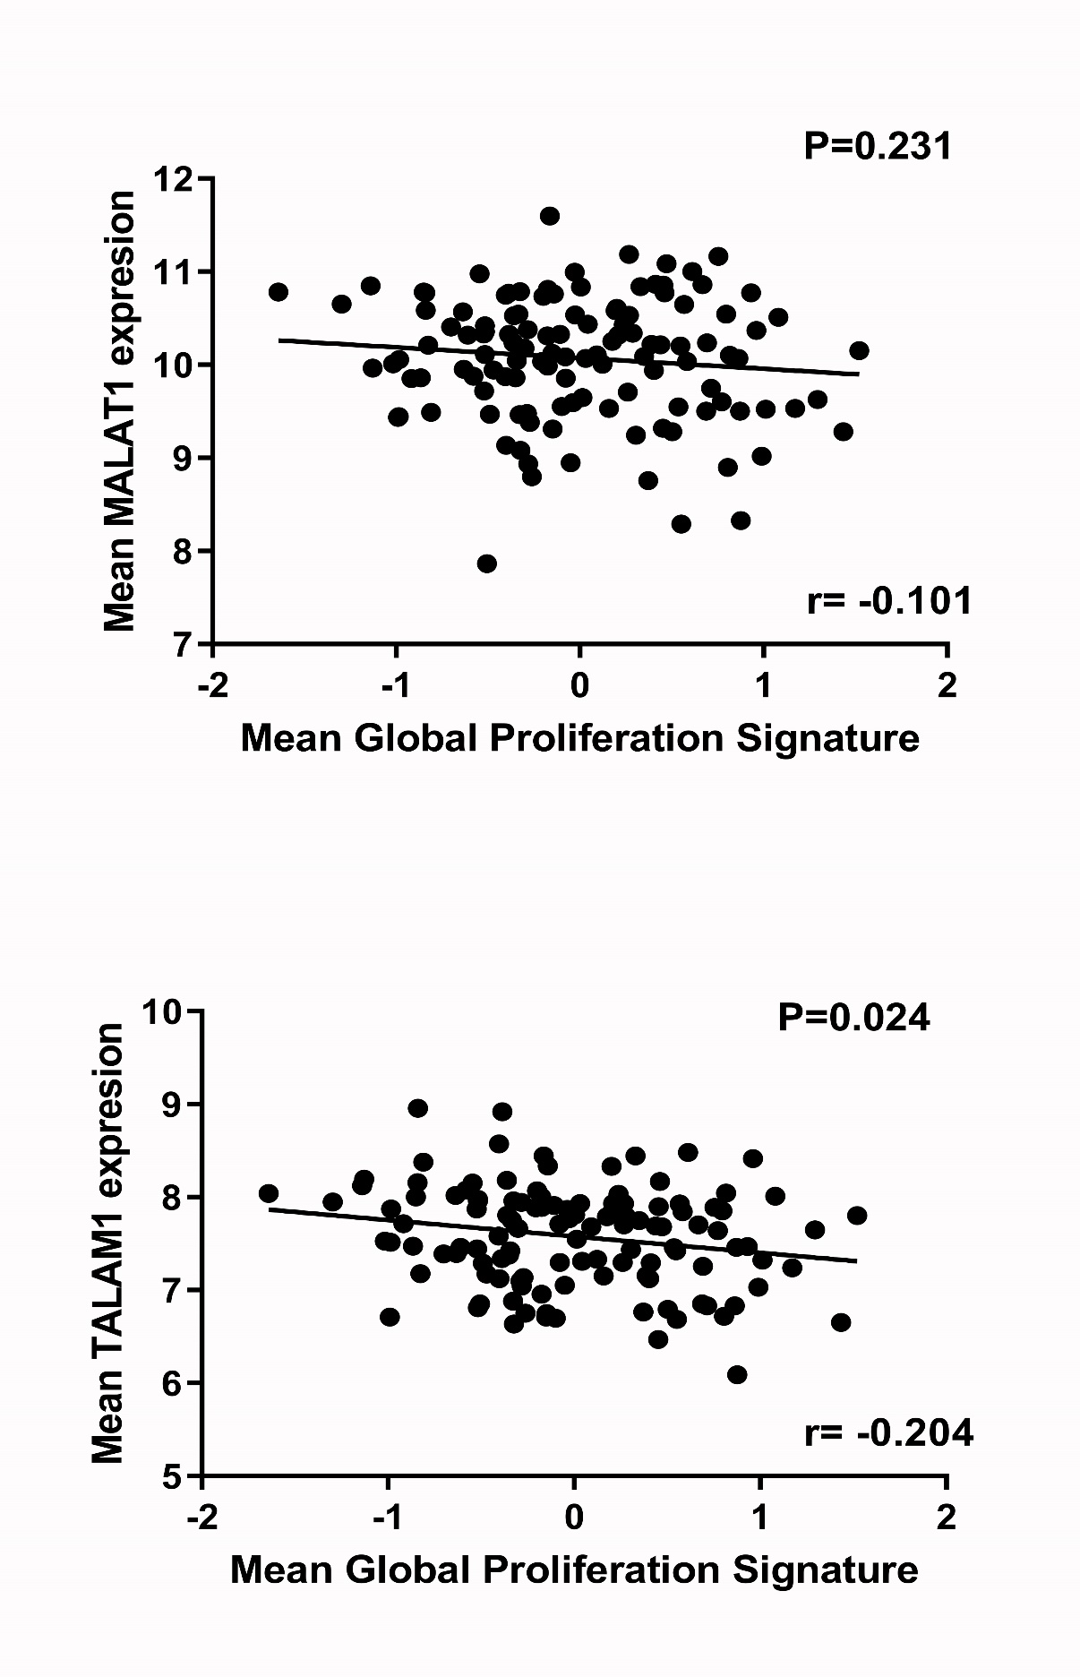
Fig. S3. Scatter plots showing linear inverse correlations and the global proliferation signature and MALAT1/TALAM1, that did not reach statistical significance for MALAT1.

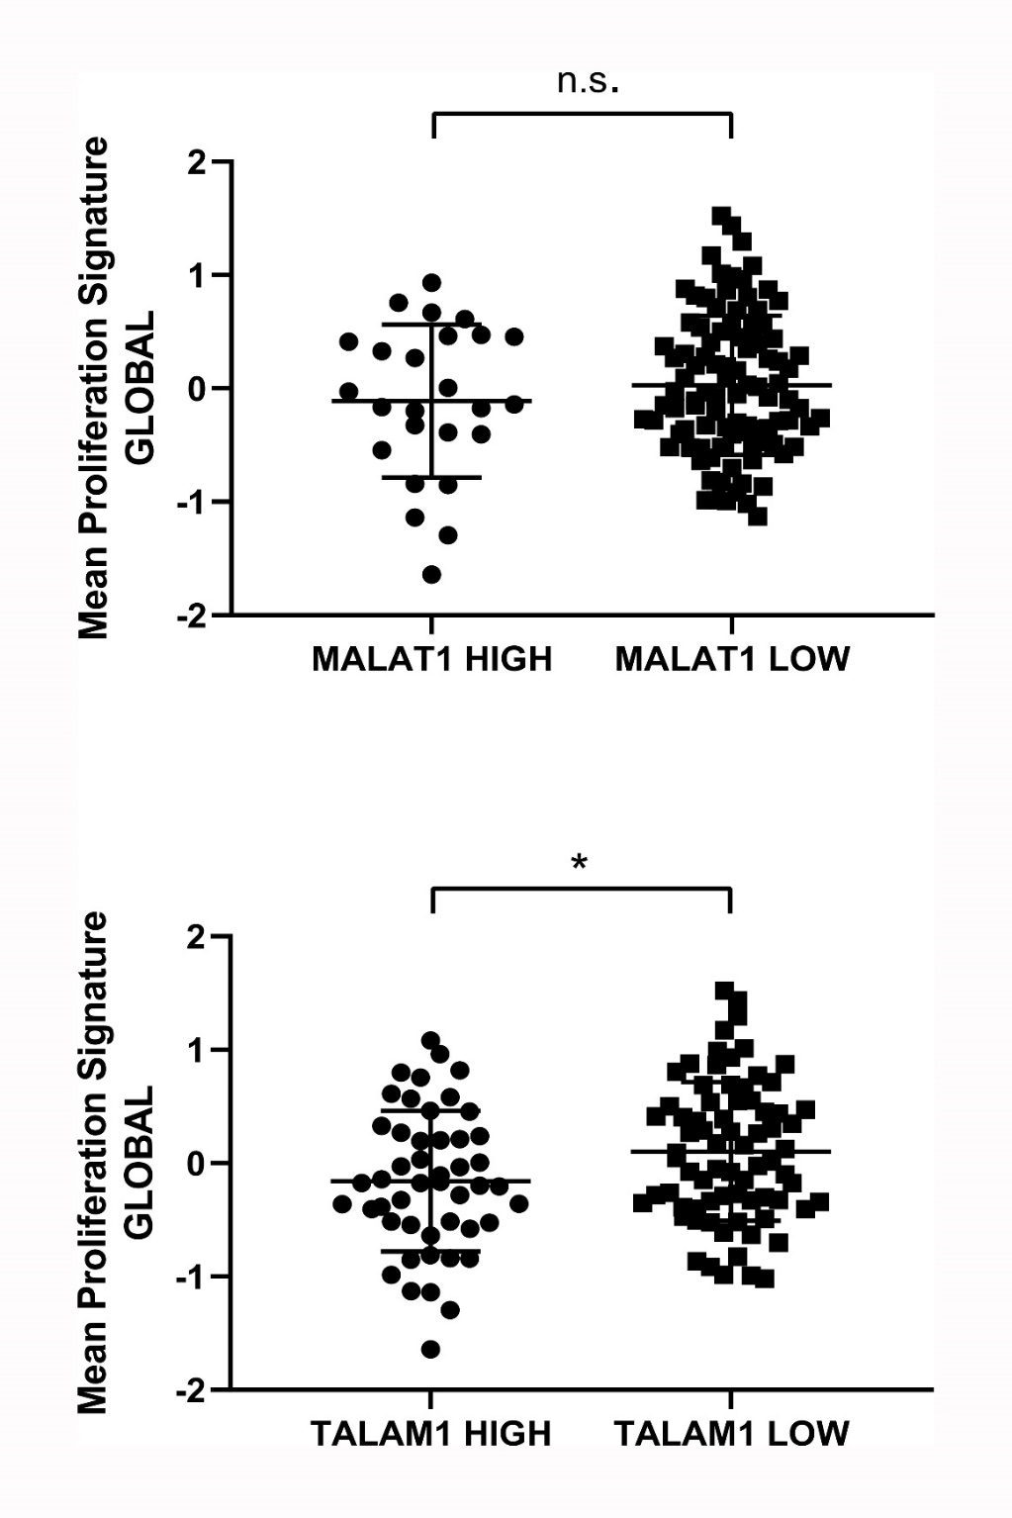

Fig. S4. The global proliferation signature measured by microarrays in the 122 nodal MCL subset from cohort#2 was significantly lower in the MCL sample group with high TALAM1 levels. Median values and interquartile range are depicted.

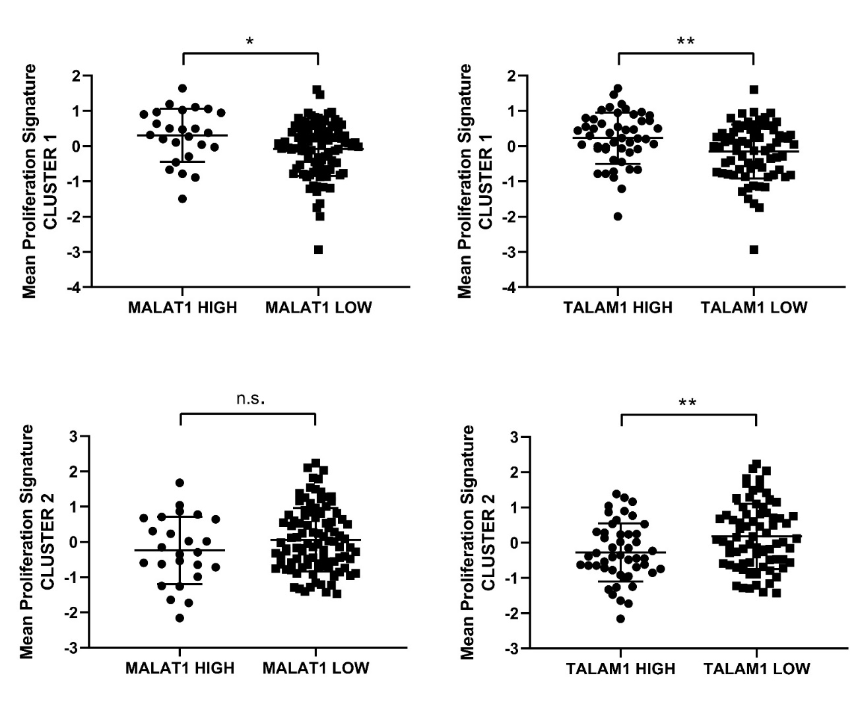
Fig. S5. Analysis of the difference in the proliferation signature gene clusters between the groups of MCL samples defined by their levels of MALAT1 /TALAM1 levels with prognostic significance. The mean proliferation signature of cluster#1 was higher in the MCL sample group with high levels of MALAT1 or TALAM1, whereas the opposite was found for cluster#2 and TALAM1. Median values and interquartile range are depicted. n.s.: non-significant.

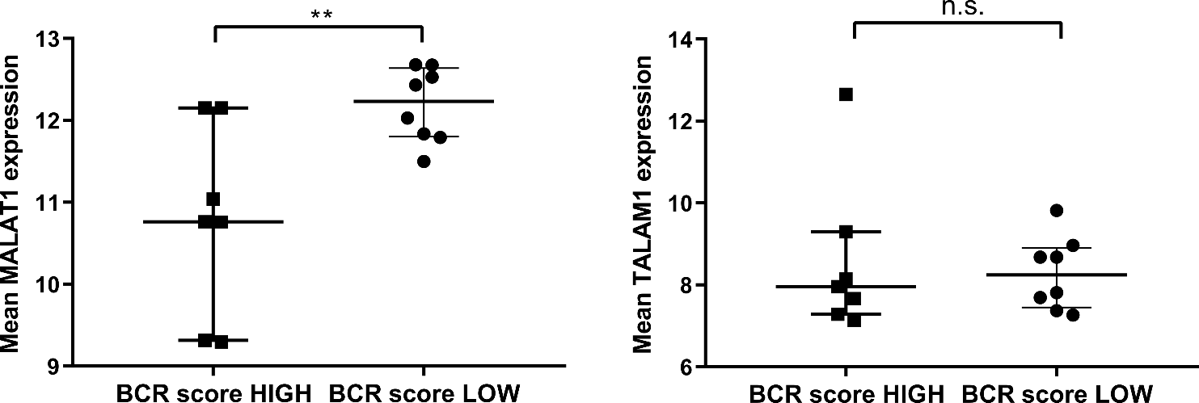

Fig. S6. Mean MALAT1 levels in 15 informative PB MCL cases from cohort#1 were significantly higher in the cases with low 27-gene BCR signature whereas TALAM1 levels were similar between BCR level groups. This signature was already established in the original paper to be associated with poor prognosis in MCL.¹⁶ Median values and interquartile range are depicted. n.s.: non-significant.

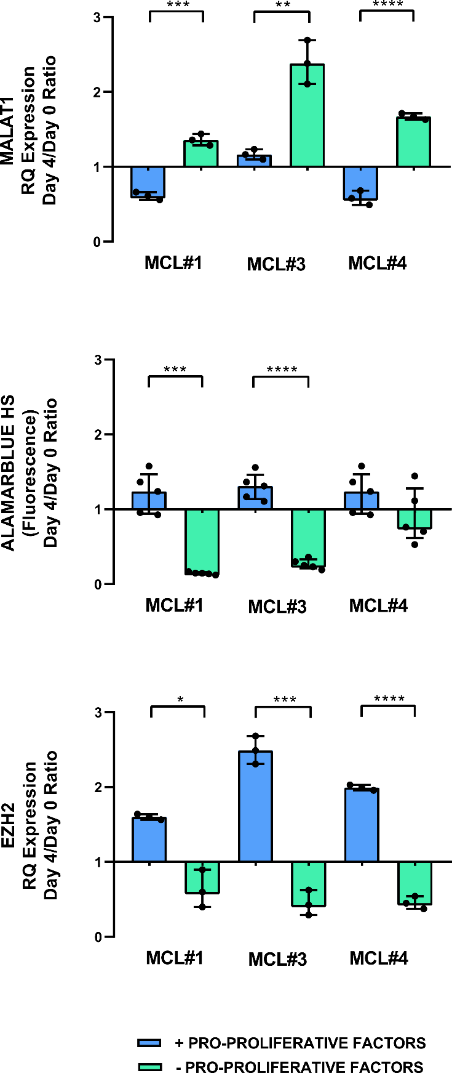

Fig. S7. Comparison of MALAT1 levels and its inverse relationship with EZH2 levels and cell growth measured by AlamarBlue HS assay in the control PDLS-MCL samples from the three cases assayed in the experiments using the EZH2 inhibitor GSK126. This inverse association was observed irrespectively of the presence of pro-proliferative factors. Median values and interquartile range are depicted. Non-significant comparisons are not depicted.

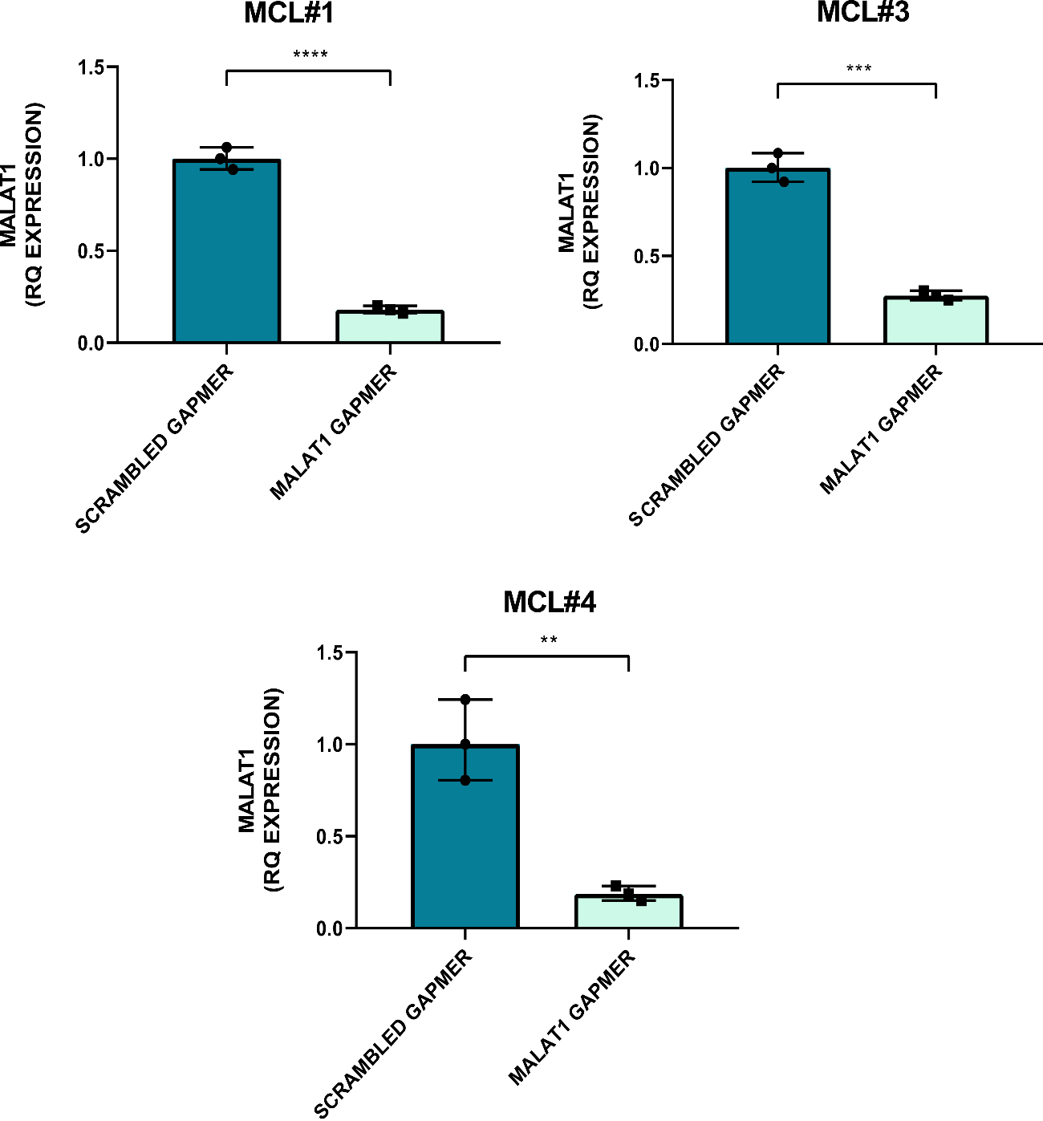
Fig. S8. MALAT1 silencing in three classic PDLS-MCL samples. A noticeable significant downregulation of MALAT1 levels was achieved after 4 days of silencing with a specific Gapmer compared to a scrambled one, in cells from three MCL patients growing with pro-proliferative factors (MCL#1 P<0.0001, MCL#3 P=0.0001 and MCL#4 P=0.003).

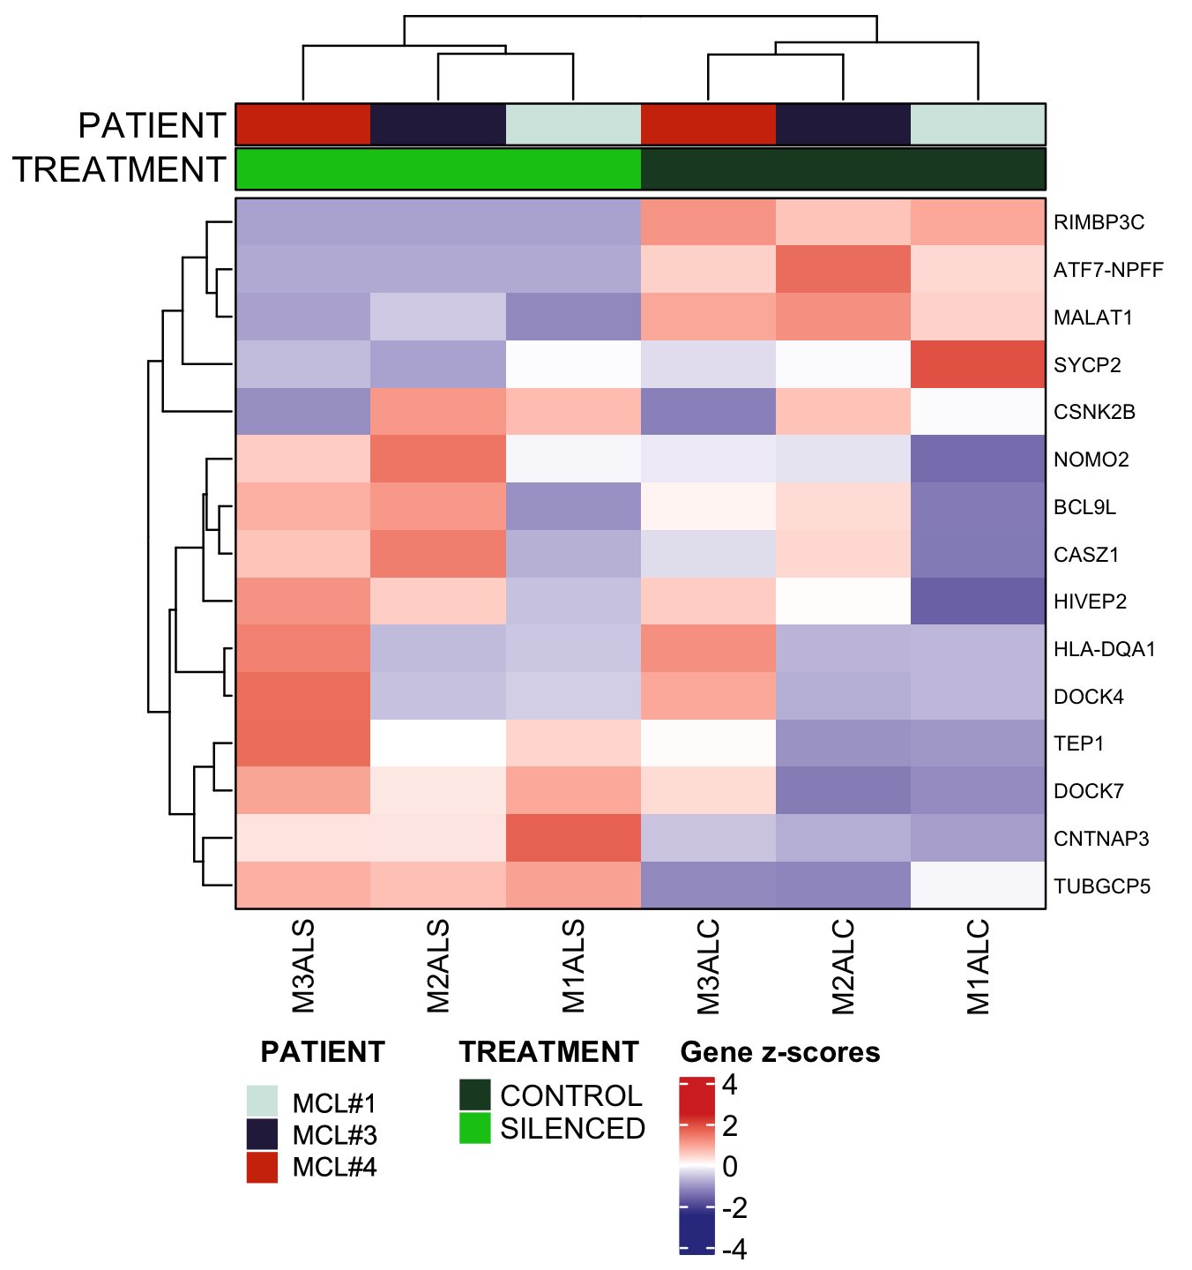
Fig. S9. Heatmap displaying the normalized expression of the 14 genes significantly found differentially expressed, together with MALAT1 expression across the samples analyzed by RNAseq in MALAT1 silencing experiments performed on three SOX11 positive PDLS-MCL cases.

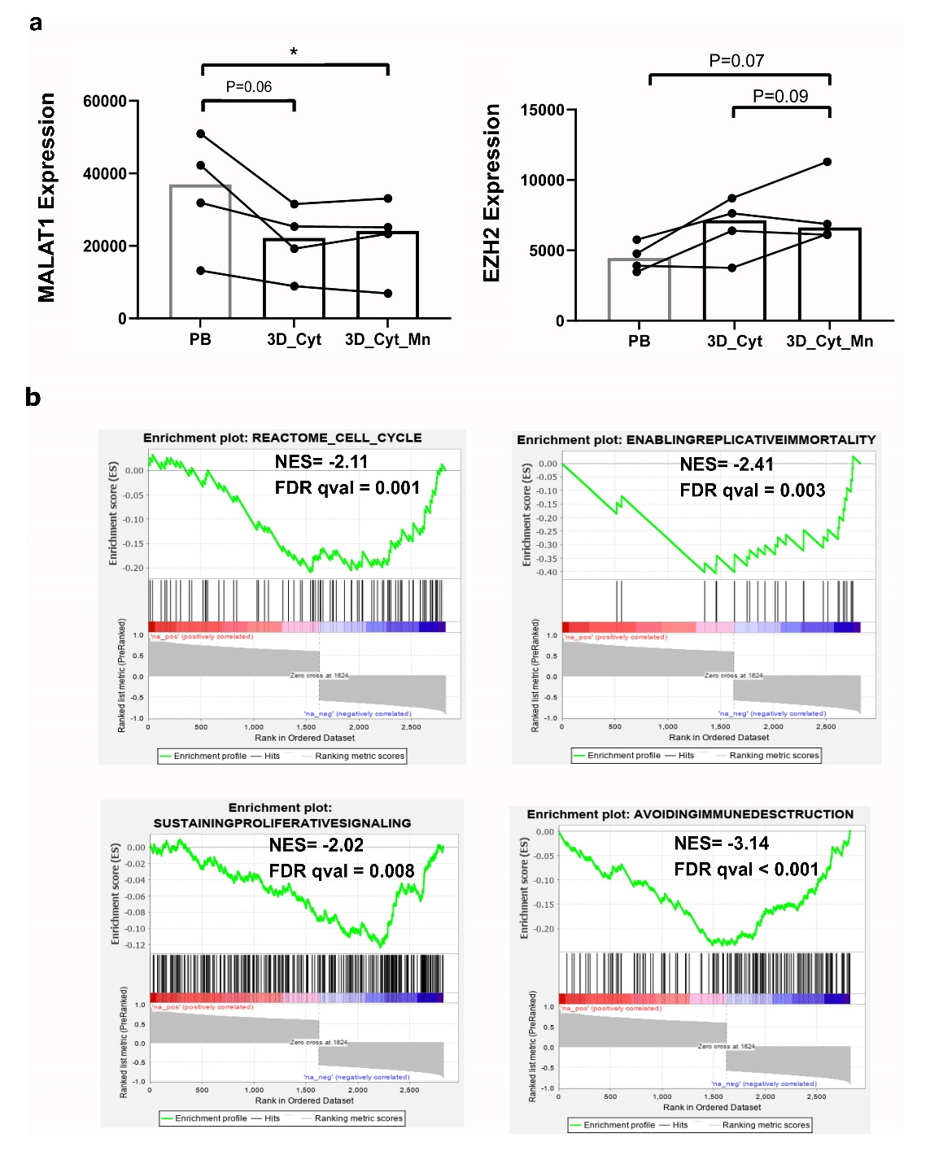

Fig. S10. The levels of MALAT1 decrease and EZH2 tend to increase in MCL PDLS growing in presence of pro-proliferative factors and correlated genes with MALAT1 expression showed significant negative enrichments in pathways related to more aggressive tumor behavior. a. The expression of MALAT1 significantly decreased whereas EZH2 tend to increase compared to the PB samples at the beginning of the experiment with those cells after 6 days of growing in medium supplemented with IL-4, CD40L, HA-Tag and BAFF) (3D_Cyt) with or without monocytes (Mn) (P=0.0360 for MALAT1 expression). b. Coding genes correlated with MALAT1 expression showed significant negative enrichments by GSEA in pathways related to cell proliferation, immortality, resistance to cell death and to immune destruction.

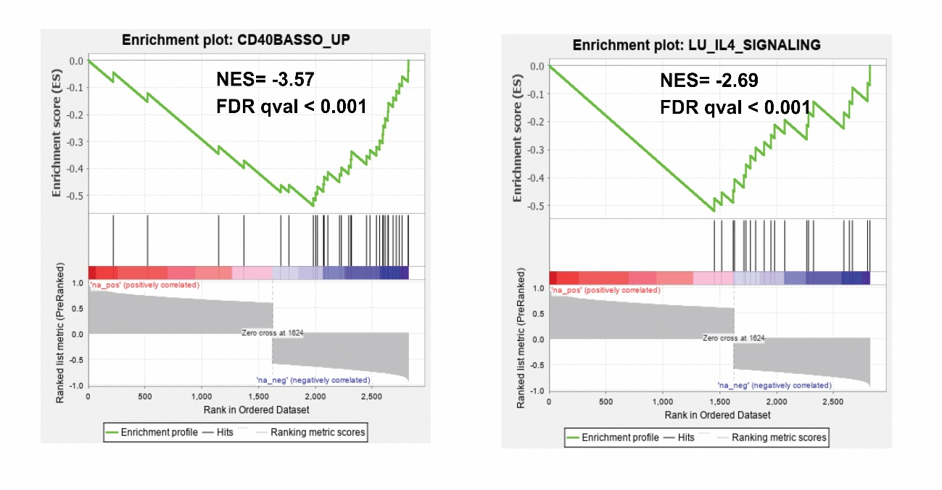

Fig. S11. Coding genes correlated with MALAT1 expression in PDLS of MCL patients showed significant negative enrichments in pathways related to microenvironment stimuli in MCL.

