Supplementary Table 1. Selection of items to calculate frailty score
Items | Categorization
Ⅰ. Physical/ADL/IADL limitations (n=18)
Difficulty with walking 100 Metres. | 0=did not have any problems with the activity; 1=some difficulty with the activity or could not do the activity.
Difficulty with controlling urination and defecation.

Difficulty with getting up from chair after sitting for long periods.

Difficulty with climbing several flights of stairs without resting.

Difficulty with stooping, kneeling,or crouching.

Difficulty with reaching or extending arms above shoulder level.
Difficulty with lifting or carrying weights over 10 Jin (5kg).
Difficulty with picking up a small coin from a table.
Difficulty with dressing.
Difficulty with bathing or showering.
Difficulty with eating.
Difficulty with getting out of bed and walking.
Difficulty with using the toilet, including getting up or down.
Difficulty with managing money.
Difficulty with taking medications.
Difficulty with shopping for groceries.
Difficulty with preparing a hot meal.
Difficulty with cleaning house.
Ⅱ. CES-D (n=10)

Felt depressed much of the time during the past week. | 0=Rarely or none of the time; 1= Some or a little of the time/ Occasionally or a moderate amount of the time/ Most or all of the time.
Felt sleep was restless.
Was not happy most of the time.
Felt lonely.
Bothered by little things.
Could not get going.
Had trouble keeping mind on what is doing.
Felt fearful.
Felt everything they did during the past week was an effort. | 0=Most or all of the time; 1=Some or a little of the time/ Occasionally or a moderate amount of the time/ Rarely or none of the time.
Felt hopeful about the future.
Ⅲ. Comorbidities (n=13)

Hypertension. | 0=never diagnosed; 1=ever diagnosed.
Diabetes. | 0=never diagnosed; 1=ever diagnosed.
Lung disease. | 0=never diagnosed; 1=ever diagnosed.
Heart problem. | 0=never diagnosed; 1=ever diagnosed.
Stroke. | 0=never diagnosed; 1=ever diagnosed.
Psych problem. | 0=never diagnosed; 1=ever diagnosed.
Arthritis. | 0=never diagnosed; 1=ever diagnosed.
Dyslipidemia. | 0=never diagnosed; 1=ever diagnosed.
Liver disease. | 0=never diagnosed; 1=ever diagnosed.
Kidney disease. | 0=never diagnosed; 1=ever diagnosed.
Stomach/digestive disease. | 0=never diagnosed; 1=ever diagnosed.
Asthma. | 0=never diagnosed; 1=ever diagnosed.
Memory problem. | 0=never diagnosed; 1=ever diagnosed.
Ⅳ. History of trauma (n=2)

Fractured hip. | 0=never experienced; 1=ever experienced.
Fallen down. | 0=never experienced; 1=ever experienced.
Ⅴ. Cognition (n=4)
Cannot answer correct month given. | 0=can correctly answer; 1=cannot correctly answer.
Cannot answer correct year given. | 0=can correctly answer; 1=cannot correctly answer.
Cannot answer correct day given. | 0=can correctly answer; 1=cannot correctly answer.
Numeracy. | 0=can correctly answer; 1=cannot correctly answer.
Ⅵ. Others (n=4)
Hearing problem. | 0=never had; 1=ever had.
Eyesight problem. | 0=never had; 1=ever had.
Self reported pain. | 0=never troubled with any body pains; 1=a little/ somewhat/ quite a bit/ very often troubled with body pains.
Self reported health. | 0=very good/ good; 1=fair/ poor/ very poor.
*The frailty index was calculated by summing the number of deficits reported by the respondents and dividing by the total number of possible (answered) deficits. Then, a frailty index with a potential range from 0 to 1 was generated, with a higher score indicating more serious frailty.

Supplementary Table 2. Information about exposures, outcomes, and covariates
Exposures: Frailty (yes or no) and frailty index.
Outcomes: Knee osteoarthritis (yes or no)
Covariates:
- Gender (male vs. female)
- Age at baseline (CHARLS 2011)
- Smoking status (non-smoker, ex-smoker, current smoker)
- Alcohol drinker status (non-drinker, ex-drinker, current drinker)
- Education based on the college/university degree (yes or no)
- Body mass index (BMI) based on the ranges established by the World Health Organization (WHO). BMI was then categorized as underweight (<18.5 kg/m²), normal (18.5–24.9 kg/m²), overweight (25.0–29.9 kg/m²), or obese (≥30.0 kg/m²) based on the ranges established by the World Health Organization (WHO).
- The residential area was categorized as either “rural” or “urban” and confirmed based on household and community IDs recorded in CHARLS.

Supplementary Table 3. Comparison of baseline characteristics between included and excluded participants

Characteristic | Included  (n = 14,079) | Excluded  (n = 3,627) | P Value
Age, mean (SD), y | 58.63 (9.51) | 57.96 (12.50) | 0.003
Body mass index, mean (SD), kg/m² | 24.06 (30.00) | 24.57 (54.13) | 0.646
Frailty index, mean (SD) | 0.12 (0.11) | 0.20 (0.16) | <0.001
Sex, n (%) |  |  | <0.001
Female | 7,022 (49.9) | 2,206 (60.8)
Male | 7,057 (50.1) | 1,421 (39.2)
Education level, n (%) |  |  | <0.001
College or above | 663 (4.7) | 155 (4.3)
High school | 4,236 (30.1) | 867 (24.0)
Primary school or below | 9,180 (65.2) | 2,591 (71.7)
Smoking status, n (%) |  |  | <0.001
Current smoker | 4,055 (30.0) | 807 (23.7)
Ex-smoker | 1,142 (8.5) | 275 (8.1)
Non-smoker | 8,303 (61.5) | 2,325 (68.2)
Drinking status, n (%) |  |  | <0.001
< Once a month | 1,111 (8.5) | 270 (8.1)
> Once a month | 2,690 (20.7) | 486 (14.5)
None of these | 9,207 (70.8) | 2,590 (77.4)
Frailty status, n (%) |  |  | <0.001
Non-frail | 12,531 (89.4) | 2,450 (68.6)
Frail | 1,492 (10.6) | 1,123 (31.4)
Location, n (%) |  |  | 0.232
City/town | 3,131 (22.3) | 838 (23.2)
Village | 10,924 (77.7) | 2,770 (76.8)
Social isolation, n (%) |  |  | <0.001
No | 3,604 (64.1) | 766 (55.6)
Yes | 2,015 (35.9) | 612 (44.4)
Symptomatic Knee Osteoarthritis, n (%) |  |  | <0.001
No | 13,121 (93.2) | 1,885 (82.9)
Yes | 958 (6.8) | 389 (17.1)
Data are presented as mean (SD) for continuous variables and n (%) for categorical variables.
Comparisons were performed using Student's t-test for continuous variables and Chi-square test for categorical variables.
Abbreviations: SD, standard deviation; BMI, body mass index; KOA, knee osteoarthritis.

Supplementary Table 4. Baseline characteristics of the study population before and after imputation
Characteristic | Imputed Dataset  (Complete)  (n = 14,079) | Original Dataset  (With missing)  (n = 14,079) | SMD
Age, mean (SD), y | 58.63 (9.51) | 58.63 (9.51) | <0.001
Sex, n (%) |  |  | <0.001
Female | 7,022 (49.9) | 7,022 (49.9)
Male | 7,057 (50.1) | 7,057 (50.1)
Body mass index, mean (SD), kg/m² | 23.53 (3.85) | 23.45 (3.83) | 0.021
BMI categories, n (%) |  |  | 0.021
<25 kg/m² | 9,678 (68.7) | 7,702 (69.7)
25–29.9 kg/m² | 3,700 (26.3) | 2,832 (25.6)
≥30 kg/m² | 701 (5.0) | 519 (4.7)
Frailty index, mean (SD) | 0.12 (0.11) | 0.12 (0.11) | <0.001
Frailty status, n (%) |  |  | <0.001
Non-frail | 12,581 (89.4) | 12,531 (89.4)
Frail | 1,498 (10.6) | 1,492 (10.6)
Symptomatic Knee Osteoarthritis, n (%) |  |  | <0.001
No | 13,121 (93.2) | 13,121 (93.2)
Yes | 958 (6.8) | 958 (6.8)
Social isolation, n (%) |  |  | 0.16
No | 10,079 (71.6) | 3,604 (64.1)
Yes | 4,000 (28.4) | 2,015 (35.9)
Smoking status, n (%) |  |  | 0.02
Non-smoker | 8,520 (60.5) | 8,303 (61.5)
Ex-smoker | 1,220 (8.7) | 1,142 (8.5)
Current smoker | 4,339 (30.8) | 4,055 (30.0)
Drinking status, n (%) |  |  | 0.025
None | 9,812 (69.7) | 9,207 (70.8)
< Once a month | 1,223 (8.7) | 1,111 (8.5)
> Once a month | 3,044 (21.6) | 2,690 (20.7)
Education level, n (%) |  |  | <0.001
Primary school or below | 9,180 (65.2) | 9,180 (65.2)
High school | 4,236 (30.1) | 4,236 (30.1)
College or above | 663 (4.7) | 663 (4.7)
Residential location, n (%) |  |  | 0.001
Village | 10,946 (77.7) | 10,924 (77.7)
City/town | 3,133 (22.3) | 3,131 (22.3)
Regular physical activity, n (%) |  |  | <0.001
No | 9,143 (64.9) | 9,143 (64.9)
Yes | 4,936 (35.1) | 4,936 (35.1)
Abbreviations: SMD, standardized mean difference; SD, standard deviation; BMI, body mass index.
Data are presented as mean (SD) for continuous variables and frequency (percentage) for categorical variables.

Supplementary Table 5. Stratified cox regression results for the association between frailty and incident KOA
Variable | Comparison | HR (95% CI) | P-value | Total N | Number of Events | AIC
FI | FI (Q4 vs Q1) | 4.16 (3.32–5.21) | <0.05 | 14,079 | 958 | 14406.28
Frailty | Phenotypic Frailty (Yes vs No) | 2.10 (1.78–2.48) | <0.05 | 14,079 | 958 | 14544.53
Abbreviations: HR, hazard Ratio; CI, confidence Interval; FI, frailty index.
All were adjusted for age, sex, BMI, smoking status, drinking status, race, education, location, marital, and regular physical activity.
Variables stratified due to violation of the proportional hazards assumption were: age, marital status, and location.
Bold indicates statistical significance at the p < 0.05 level.

Supplementary Table 6. Subgroup analysis of the association between frailty index and incident KOA (Cox proportional hazards model)
Variable | Count | Percent | Frailty index | HR (95% CI) | P value | P for interaction
Sex |  |  |  |  |  | 0.311
Female | 7022 | 49.9 | Q1
 |  |  | Q2 | 1.65 (1.19 , 2.29) | <0.05
 |  |  | Q3 | 2.79 (2.07 , 3.76) | <0.05
 |  |  | Q4 | 4.04 (3.02 , 5.41) | <0.05
Male | 7057 | 50.1 | Q1
 |  |  | Q2 | 1.83 (1.26 , 2.66) | <0.05
 |  |  | Q3 | 2.27 (1.56 , 3.29) | <0.05
 |  |  | Q4 | 4.44 (3.12 , 6.34) | <0.05
Age |  |  |  |  |  | 0.929
<60 | 8283 | 58.8 | Q1
 |  |  | Q2 | 1.69 (1.27 , 2.25) | <0.05
 |  |  | Q3 | 2.58 (1.97 , 3.39) | <0.05
 |  |  | Q4 | 3.87 (2.95 , 5.08) | <0.05
≥60 | 5796 | 41.2 | Q1
 |  |  | Q2 | 1.87 (1.16 , 3.03) | <0.05
 |  |  | Q3 | 2.80 (1.78 , 4.39) | <0.05
 |  |  | Q4 | 4.66 (3.02 , 7.18) | <0.05
BMI |  |  |  |  |  | 0.892
<25kg/㎡ | 9678 | 68.7 | Q1
 |  |  | Q2 | 1.76 (1.30 , 2.40) | <0.05
 |  |  | Q3 | 2.69 (2.01 , 3.60) | <0.05
 |  |  | Q4 | 4.50 (3.39 , 5.97) | <0.05
25–29.9kg/㎡ | 3700 | 26.3 | Q1
 |  |  | Q2 | 1.74 (1.12 , 2.70) | <0.05
 |  |  | Q3 | 2.53 (1.67 , 3.83) | <0.05
 |  |  | Q4 | 3.51 (2.34 , 5.27) | <0.05
≥30kg/㎡ | 701 | 5 | Q1
 |  |  | Q2 | 1.37 (0.47 , 3.97) | 0.565
 |  |  | Q3 | 2.29 (0.88 , 6.02) | 0.091
 |  |  | Q4 | 3.74 (1.53 , 9.14) | <0.05
Location |  |  |  |  |  | 0.607
City/town | 3133 | 22.3 | Q1
 |  |  | Q2 | 1.92 (1.13 , 3.25) | <0.05
 |  |  | Q3 | 2.49 (1.50 , 4.14) | <0.05
 |  |  | Q4 | 3.67 (2.20 , 6.13) | <0.05
Village | 10946 | 77.7 | Q1
 |  |  | Q2 | 1.70 (1.29 , 2.24) | <0.05
 |  |  | Q3 | 2.66 (2.05 , 3.45) | <0.05
 |  |  | Q4 | 4.32 (3.36 , 5.56) | <0.05
Education |  |  |  |  |  | 0.33
College or above | 663 | 4.7 | Q1
 |  |  | Q2 | 4.95 (1.27 , 19.29) | <0.05
 |  |  | Q3 | 2.25 (0.48 , 10.64) | 0.305
 |  |  | Q4 | 3.63 (0.73 , 18.06) | 0.115
High school | 4236 | 30.1 | Q1
 |  |  | Q2 | 2.10 (1.38 , 3.19) | <0.05
 |  |  | Q3 | 2.61 (1.72 , 3.96) | <0.05
 |  |  | Q4 | 4.53 (2.99 , 6.86) | <0.05
Primary school or below | 9180 | 65.2 | Q1
 |  |  | Q2 | 1.51 (1.10 , 2.05) | <0.05
 |  |  | Q3 | 2.53 (1.90 , 3.37) | <0.05
 |  |  | Q4 | 3.92 (2.98 , 5.16) | <0.05
Smoking |  |  |  |  |  | 0.561
Non-smoker | 8520 | 60.5 | Q1
 |  |  | Q2 | 1.66 (1.24 , 2.23) | <0.05
 |  |  | Q3 | 2.49 (1.90 , 3.28) | <0.05
 |  |  | Q4 | 4.14 (3.18 , 5.39) | <0.05
Current smoker | 4339 | 30.8 | Q1
 |  |  | Q2 | 2.16 (1.29 , 3.62) | <0.05
 |  |  | Q3 | 3.20 (1.94 , 5.28) | <0.05
 |  |  | Q4 | 5.24 (3.19 , 8.61) | <0.05
Ex-smoker | 1220 | 8.7 | Q1
 |  |  | Q2 | 1.06 (0.41 , 2.71) | 0.91
 |  |  | Q3 | 1.80 (0.77 , 4.20) | 0.18
 |  |  | Q4 | 1.80 (0.77 , 4.22) | 0.18
Drinking |  |  |  |  |  | 0.406
Drink but less than once a month | 1223 | 8.7 | Q1
 |  |  | Q2 | 0.92 (0.36 , 2.35) | 0.868
 |  |  | Q3 | 2.51 (1.16 , 5.41) | <0.05
 |  |  | Q4 | 4.21 (1.92 , 9.21) | <0.05
Drink more than once a month | 3044 | 21.6 | Q1
 |  |  | Q2 | 1.74 (1.00 , 3.04) | 0.051
 |  |  | Q3 | 1.81 (1.02 , 3.20) | <0.05
 |  |  | Q4 | 3.80 (2.19 , 6.57) | <0.05
None of these | 9812 | 69.7 | Q1
 |  |  | Q2 | 1.81 (1.36 , 2.41) | <0.05
 |  |  | Q3 | 2.80 (2.14 , 3.67) | <0.05
 |  |  | Q4 | 4.28 (3.30 , 5.56) | <0.05
Marital |  |  |  |  |  | 0.175
Non-married | 1679 | 11.9 | Q1
 |  |  | Q2 | 2.33 (0.65 , 8.38) | 0.194
 |  |  | Q3 | 6.61 (2.03 , 21.54) | <0.05
 |  |  | Q4 | 8.61 (2.69 , 27.56) | <0.05
Married | 12400 | 88.1 | Q1
 |  |  | Q2 | 1.72 (1.34 , 2.22) | <0.05
 |  |  | Q3 | 2.46 (1.94 , 3.12) | <0.05
 |  |  | Q4 | 3.98 (3.16 , 5.02) | <0.05
Regular physical activity |  |  |  |  |  | 0.302
No | 9143 | 64.9 | Q1
 |  |  | Q2 | 1.54 (1.12 , 2.11) | <0.05
 |  |  | Q3 | 2.63 (1.96 , 3.51) | <0.05
 |  |  | Q4 | 4.20 (3.17 , 5.57) | <0.05
Yes | 4936 | 35.1 | Q1
 |  |  | Q2 | 2.05 (1.39 , 3.03) | <0.05
 |  |  | Q3 | 2.62 (1.79 , 3.83) | <0.05
 |  |  | Q4 | 4.09 (2.81 , 5.94) | <0.05
Abbreviations: HR, hazard Ratio; CI, confidence interval; KOA, knee osteoarthritis.
Adjusted for age, sex, BMI, smoking status, drinking status, race, education, location, marital, regular physical activity.

Supplementary Table 7. Comparison of predictive performance (AUC) between the Base Model and the Full Model incorporating Frailty Index

Time Horizon | Base Modelª | Full Model^{b} | AUC Increase | P Value^{c}
Time Horizon | AUC (95% CI) | AUC (95% CI) | AUC Increase | P Value^{c}
2 Years | 0.648 (0.610-0.686) | 0.744 (0.714-0.774) | 0.096 | <0.001
3 Years | 0.635 (0.612-0.657) | 0.737 (0.719-0.756) | 0.102 | <0.001
4 Years | 0.637 (0.615-0.659) | 0.740 (0.722-0.759) | 0.104 | <0.001
5 Years | 0.644 (0.622-0.665) | 0.756 (0.738-0.774) | 0.112 | <0.001
6 Years | 0.644 (0.622-0.665) | 0.756 (0.738-0.774) | 0.112 | <0.001
7 Years | 0.623 (0.602-0.644) | 0.706 (0.686-0.725) | 0.083 | <0.001
Abbreviations: AUC, area under the receiver operating characteristic curve; CI, confidence interval.
ª Base Model includes sex, BMI, age, smoking, drinking, marital status, education, location, and physical activity.
^{b} Full Model includes Base Model predictors plus Frailty Index.
^{c} P values were calculated comparing the AUCs of two models.

Supplementary Table 8. Causal mediation analysis of the association between frailty and incident KOA mediated by social isolation

Effect Type | Estimate | 95% CI | P-value
Total Effect | 0.0962 | 0.0800, 0.1138 | <0.001
Natural Direct Effect (NDE)  (Frailty → KOA) | 0.0954 | 0.0788, 0.1133 | <0.001
Natural Indirect Effect (NIE)  (Frailty → Social Isolation → KOA) | 0.0008 | -0.0001, 0.0020 | 0.074
Proportion Mediated (%) | 0.79% | -0.07%, 2.09% | 0.074
Estimates are based on the causal mediation framework using 1000 bootstrap simulations.
Models were adjusted for age, sex, BMI, smoking status, drinking status, race, education, location, marital status, and regular physical activity.
Abbreviations: CI, confidence interval; KOA, knee osteoarthritis; NDE, natural direct effect; NIE, natural indirect effect.

Supplementary Table 9. Associations of frailty and frailty index with the risk for incident KOA in the CHARLS cohorts, excluding cases within the first 2 years
Outcome | Expose | Total NO. of Participants (%) | NO. of KOA cases (%) | Model 1 HR (95% Cl) | Model 2 HR (95% Cl)
KOA | Frailty
 | No | 12455 (89.5) | 640(80.7) | 1 (reference) | 1 (reference)
 | Yes | 1459 (10.5) | 153(19.3) | 2.40 (2.01, 2.86) | 2.09 (1.73, 2.51)
 | P for trend |  |  | <0.05 | <0.05
 | Frailty index
 | Quartile 1 | 3528 (25.4) | 96 (12.1) | 1 (reference) | 1 (reference)
 | Quartile 2 | 3490 (25.1) | 156 (19.7) | 1.70 (1.32, 2.20) | 1.64 (1.27, 2.11)
 | Quartile 3 | 3486 (25.1) | 218 (27.5) | 2.47 (1.94, 3.14) | 2.27 (1.78, 2.90)
 | Quartile 4 | 3410 (24.5) | 323 (40.7) | 4.09 (3.25, 5.14) | 3.59 (2.84, 4.55)
 | P for trend |  |  | <0.05 | <0.05
Quartiles: Patients were divided into 4 quartiles, quartiles 1-4 (Q1-4) based on nine adiposity-related markers measures across quartiles.

Model 1: (crude model) was unadjusted;
Model 2: adjusted for age, sex, BMI, smoking status, drinking status, race, education, location, marital, regular physical activity.
Abbreviations: HR, hazard ratio; CI, confidence interval; KOA, knee osteoarthritis.
Bold indicates statistical significance at the p < 0.05 level.

Supplementary Figure 1. Schoenfeld residuals test for the proportional hazards assumption
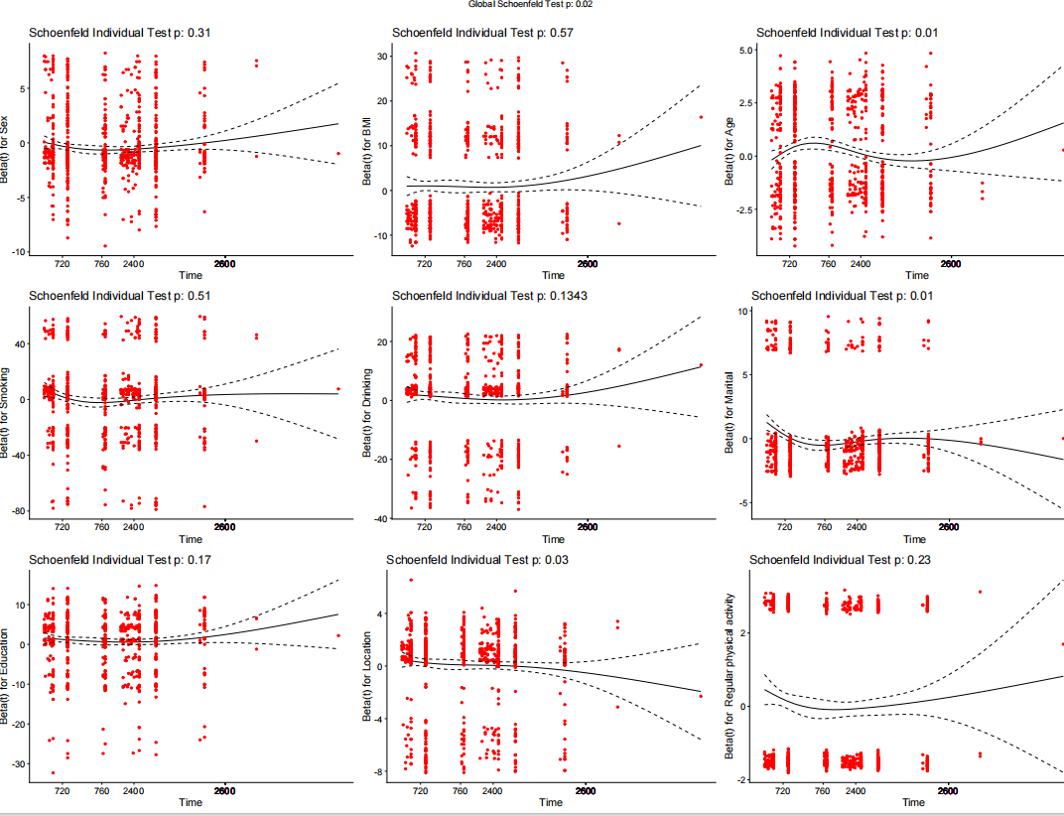
Each plot shows the relationship between the residuals and time for individual variables, with the dotted lines representing the 95% confidence intervals.

Supplementary Figure 2. ROC diagram for phenotypic frailty and frailty index in relation to incident KOA
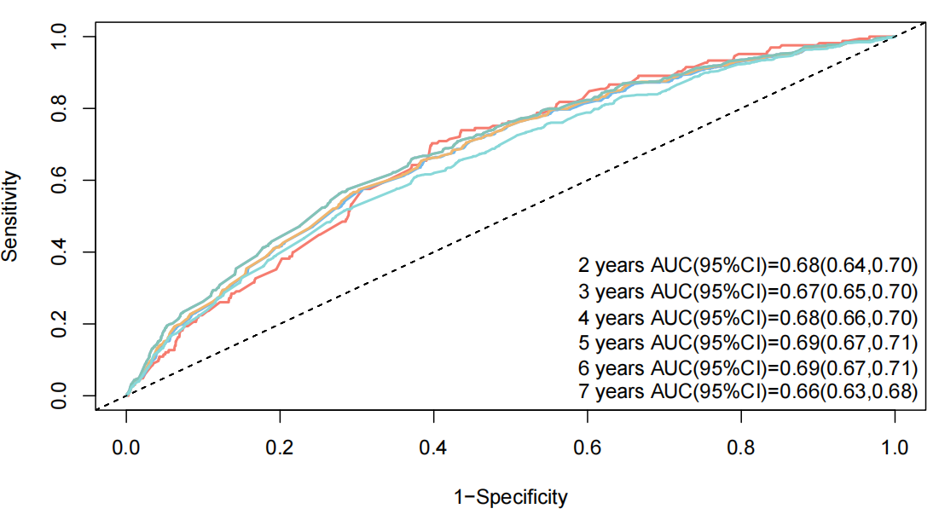 | 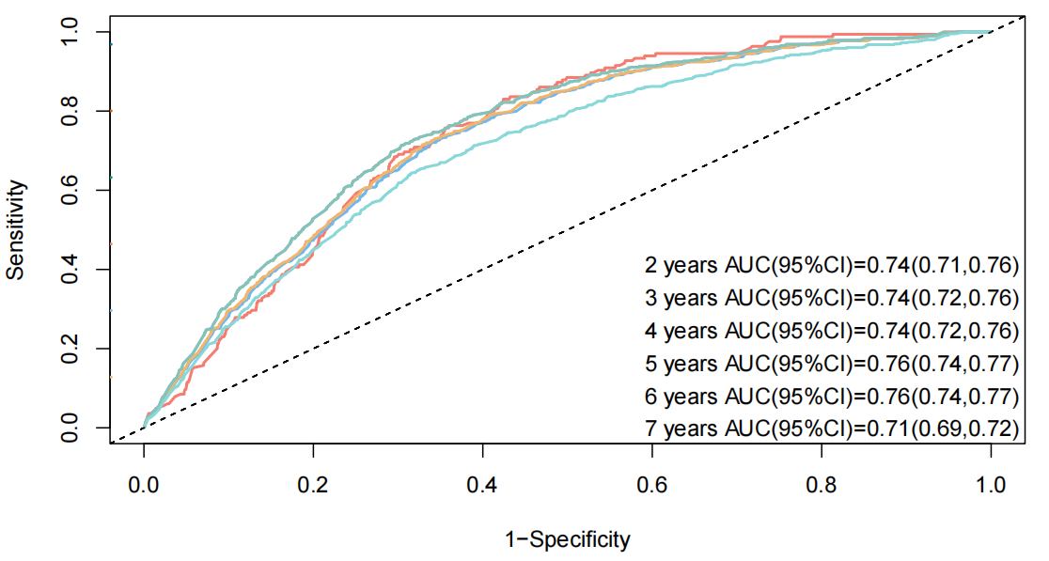
A | B
A: Diagram of ROC for frailty in relation to incident KOA.
B: Diagram of ROC for FI in relation to incident KOA.
Abbreviations: HR, hazard ratio; CI, confidence Interval; KOA, knee Osteoarthritis; FI, frailty index; ROC, receiver operating characteristic; AUC, area under the curve.

