List of supplementary Tables

Supplementary Table S1: Identifying dysregulated metabolites between D0 and D56. Results of a series of univariate logistic models regressing the level of each (of the N=419) metabolites against the (binary) variable indicating whether the measurement was obtained at D56 (vs. D0). For each of the features we report the chemical family or pathway the feature has been mapped to, the feature name, the effect size estimate (β) and the p-value for the test of the null hypothesis of no association (H₀: β=0). Metabolites are reported in increasing order of their p-value. Features found significantly dysregulated between D0 and D56 at a Bonferroni-corrected per test significance levels are reported in bold.

Supplementary Table S2: Identifying metabolites associated with radiance. Results of a series of univariate linear models regressing the level of each (of the N=419) metabolites against the radiance score. Models were adjusted for (binary) variable indicating whether the measurement was obtained at D56 or D0. For each of the features we report the chemical family or pathway the feature has been mapped to, the feature name, the effect size estimate (β) and the p-value for the test of the null hypothesis of no association (H₀: β=0). Metabolites are reported in increasing order of their p-value. Features found significantly associated with radiance at a Bonferroni-corrected per test significance levels are reported in bold.

Supplementary Table S3: Identifying metabolites associated with skin texture. Results of a series of univariate linear models regressing the level of each (of the N=419) metabolites against the skin texture score. Models were adjusted for (binary) variable indicating whether the measurement was obtained at D56 or D0. For each of the features we report the chemical family or pathway the feature has been mapped to, the feature name, the effect size estimate (β) and the p-value for the test of the null hypothesis of no association (H₀: β=0). Metabolites are reported in increasing order of their p-value. Features found significantly associated with skin texture at a Bonferroni-corrected per test significance levels are reported in bold.

Supplementary Table S4: Identifying metabolites associated with skin smoothness. Results of a series of univariate linear models regressing the level of each (of the N=419) metabolites against the skin smoothness score. Models were adjusted for (binary) variable indicating whether the measurement was obtained at D56 or D0. For each of the features we report the chemical family or pathway the feature has been mapped to, the feature name, the effect size estimate (β) and the p-value for the test of the null hypothesis of no association (H₀: β=0). Metabolites are reported in increasing order of their p-value. Features found significantly associated with skin smoothness at a Bonferroni-corrected per test significance levels are reported in bold.

Supplementary Table S5: Identifying metabolites associated with cheeks colour (mean L). Results of a series of univariate linear models regressing the level of each (of the N=419) metabolites against the cheek colour (mean L) measurement. Models were adjusted for (binary) variable indicating whether the measurement was obtained at D56 or D0. For each of the features we report the chemical family or pathway the feature has been mapped to, the feature name, the effect size estimate (β) and the p-value for the test of the null hypothesis of no association (H₀: β=0). Metabolites are reported in increasing order of their p-value. Features found significantly associated with cheek colour (mean L) at a Bonferroni-corrected per test significance levels are reported in bold.

Supplementary Table S6: Identifying metabolites associated with cheeks colour (mean H). Results of a series of univariate linear models regressing the level of each (of the N=419) metabolites against the cheek colour (mean H) measurement. Models were adjusted for (binary) variable indicating whether the measurement was obtained at D56 or D0. For each of the features we report the chemical family or pathway the feature has been mapped to, the feature name, the effect size estimate (β) and the p-value for the test of the null hypothesis of no association (H₀: β=0). Metabolites are reported in increasing order of their p-value. Features found significantly associated with cheek colour (mean H) at a Bonferroni-corrected per test significance levels are reported in bold.

Supplementary Table S7: Identifying metabolites associated with cheeks sebaceous pores. Results of a series of univariate linear models regressing the level of each (of the N=419) metabolites against the cheek sebaceous pores. Models were adjusted for (binary) variable indicating whether the measurement was obtained at D56 or D0. For each of the features we report the chemical family or pathway the feature has been mapped to, the feature name, the effect size estimate (β) and the p-value for the test of the null hypothesis of no association (H₀: β=0). Metabolites are reported in increasing order of their p-value.

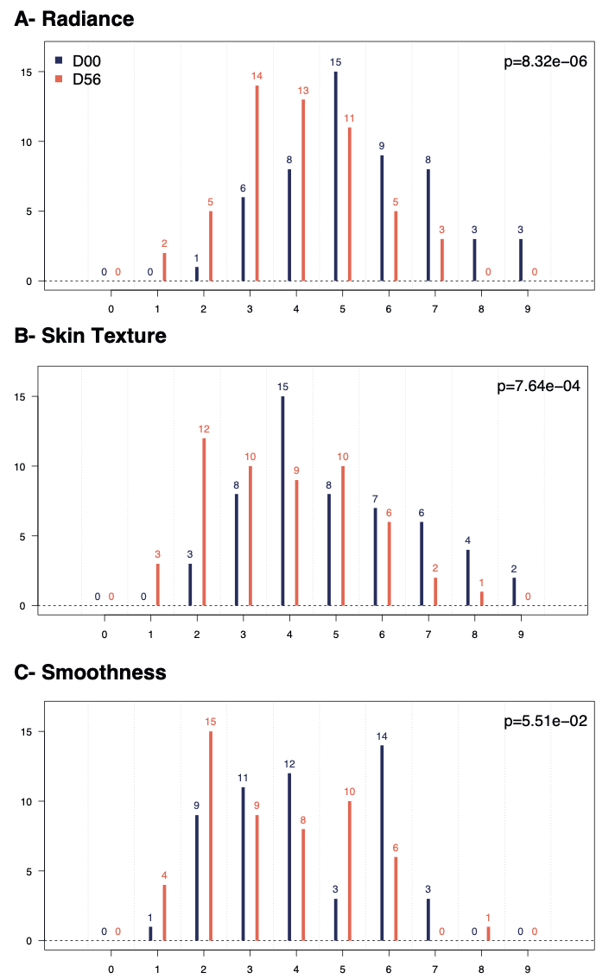

Supplementary Figure S1. Dermatologist assessment. Distribution of dermatologist scores (ranging from 0 to 9, X axis) at recruitment (D0, in blue) and at the end of the study (D56, in orange) across the (N=53) study participants. We report the participant counts (Y axis) for each value of the score. Results are presented for skin radiance (A), skin texture (B), and skin smoothness (C). For each sign we report the p-value of the student T-test comparing the mean values at D0 vs. D56.
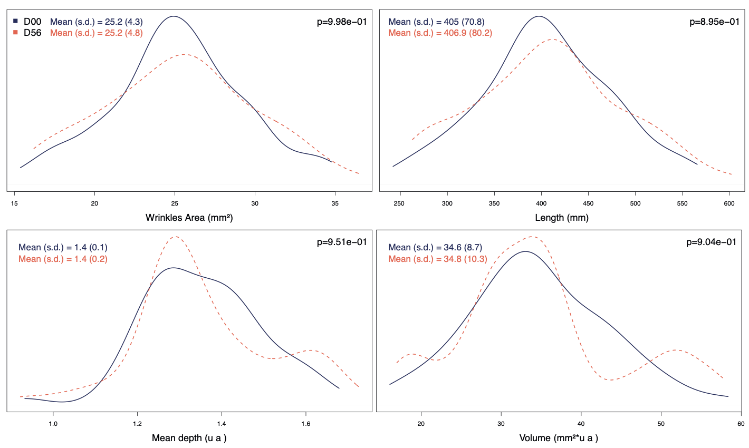
Supplementary Figure S2. Instrumental assessment of skin roughness. Distribution of four characteristics: estimate of wrinkle area (in mm², top left), length of the wrinkles (in mm, top right), mean depth of the wrinkle (arbitrary unit, bottom left) and the volume affected by wrinkles (in mm²*u.a, bottom right) defined as the product of the surface affected by wrinkles (mm²) and the mean depth of the wrinkles (in ua). Results are presented before (D0, in blue) and after (D56, in orange) the study in the (N=55) study participants. We report the p-value of the student T-test comparing the mean of each measurement at D0 and at D56.

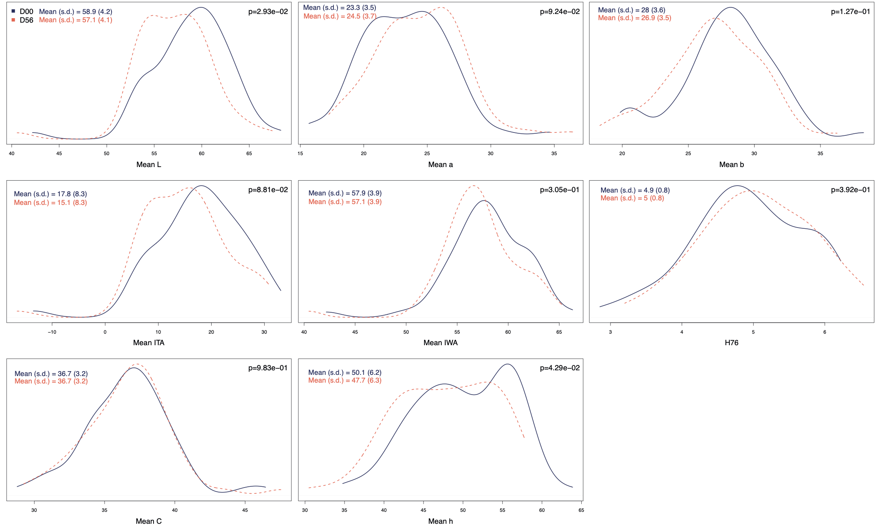
Supplementary Figure S3. Instrumental assessment of the colour of the cheeks. Distribution of eight characteristics defining the color of the cheeks. Results are presented before (D0, in blue) and after (D56, in orange) the study in the (N=55) study participants. We report the p-value of the student T-test comparing the mean of each measurement at D0 and at D56.
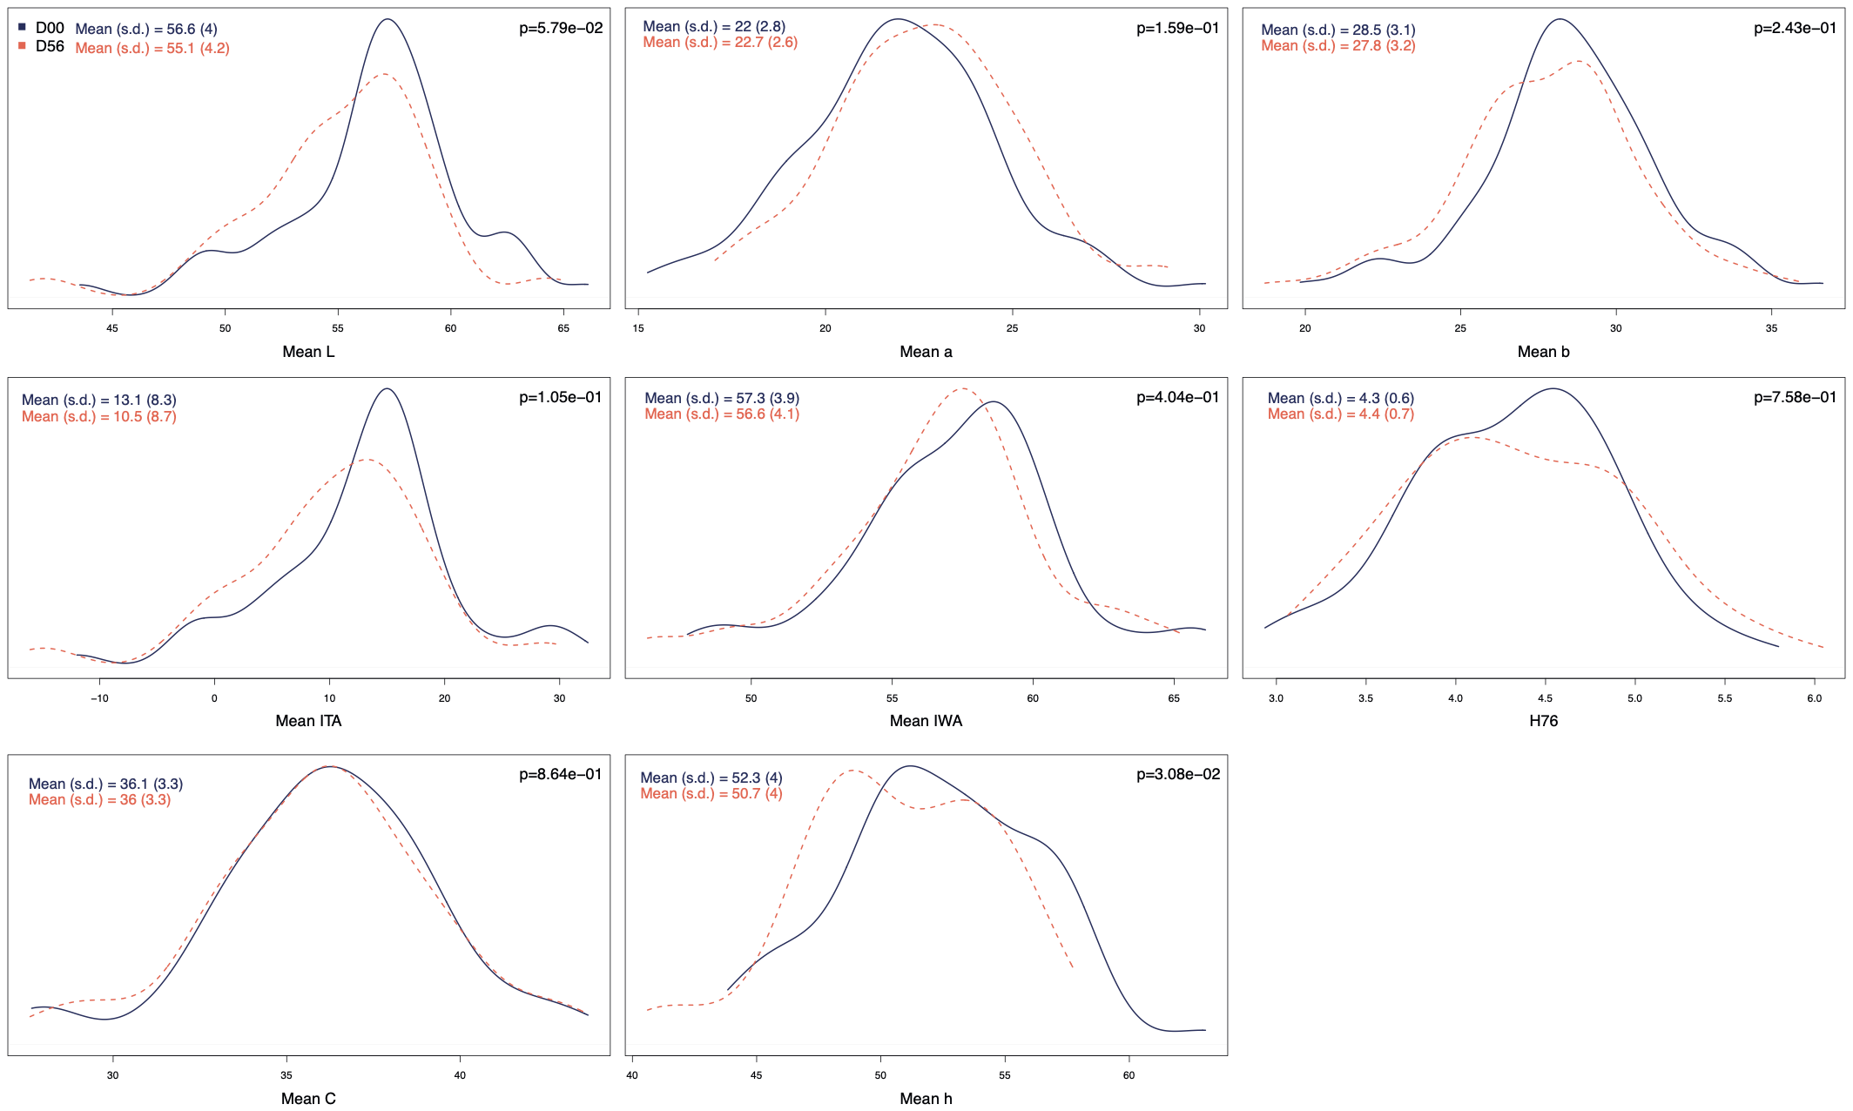
Supplementary Figure S4. Instrumental assessment of the colour of the temples. Distribution of eight characteristics defining the color of the temples. Results are presented before (D0, in blue) and after (D56, in orange) the study in the (N=55) study participants. We report the p-value of the student T-test comparing the mean of each measurement at D0 and at D56.

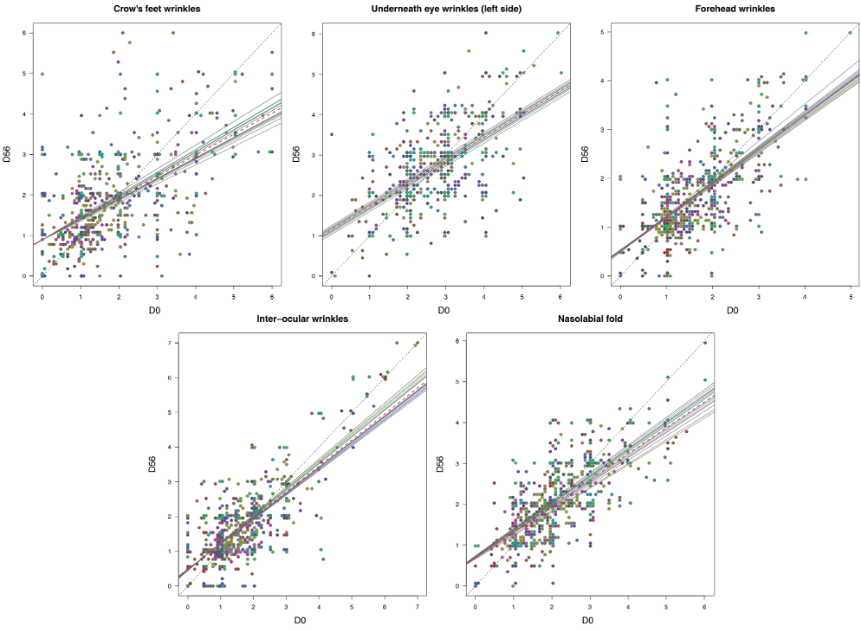
Supplementary Figure S5. Expert panel evaluation of wrinkles. For each of the (N=5) variables, a scatter plot describing the score at D0 (X axis) and D56 (Y axis) given by each expert (N=15) to each participant is plotted. Marks given by a given expert to all (N=55) participants share the same color. A linear mixed model including an expert random slope was fitted to the data and we report the estimated regression line (dashed line) along with all the expert-specific regression lines including the per-expert random slope estimate (plain line).
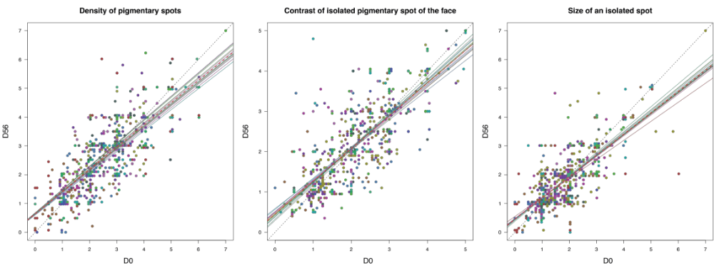

Supplementary Figure S6. Expert panel evaluation of spots. For each of the (N=3) variables, a scatter plot describing the score at D0 (X axis) and D56 (Y axis) given by each expert (N=15) to each participant is plotted. Marks given by a given expert to all (N=55) participants share the same color. A linear mixed model including an expert random slope was fitted to the data and we report the estimated regression line (dashed line) along with all the expert-specific regression lines including the per-expert random slope estimate (plain line).
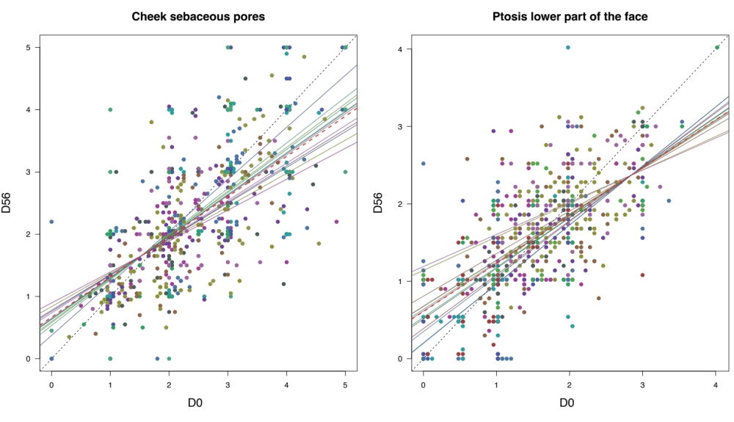

Supplementary Figure S7. Expert panel evaluation of cheek sebaceous pores (left) and ptosis on the lower part of the face (right). For both variables, a scatter plot describing the score at D0 (X axis) and D56 (Y axis) given by each expert (N=15) to each participant is plotted. Marks given by a given expert to all (N=55) participants share the same color. A linear mixed model including an expert random slope was fitted to the data and we report the estimated regression line (dashed line) along with all the expert-specific regression lines including the per-expert random slope estimate (plain line).

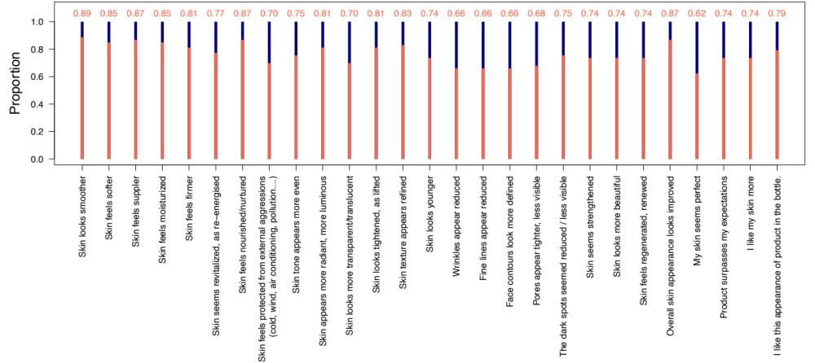

Supplementary Figure S8. Self-evaluation of the treatment effect in (N=55) study participants. Each of the study participants completed a questionnaire informing on their perception of the effect of the cream on their skin. A total of 27 questions (X-axis) were asked and for each, participants were asked to provide a score ranging from 1 (disagree) to 5 (agree). We report for each question the proportion (Y axis) of participants answering ‘agree’ or ‘somewhat agree’ (in orange) and those answering ‘Neither agree or disagree’, ‘somewhat disagree’, or ‘disagree’ (in blue).

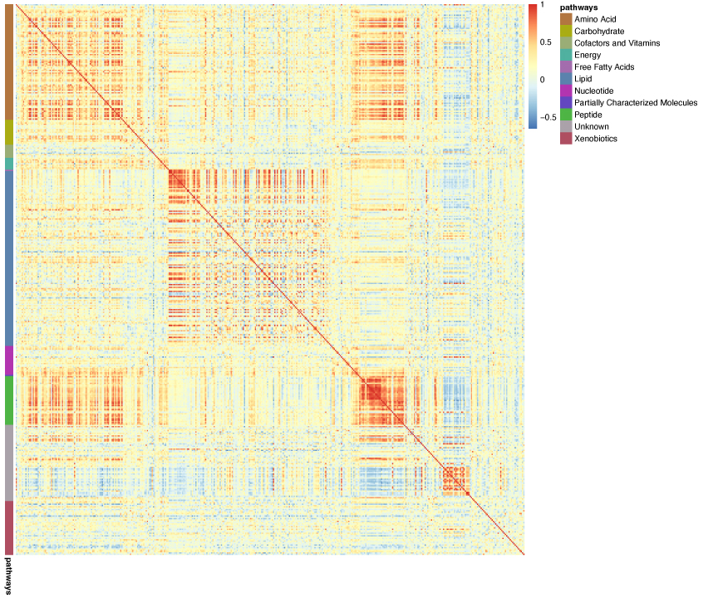

Supplementary Figure S9. Correlation heatmap across the 419 metabolic features measured in the (N=32) study participants. For each pair of metabolic features, we report the pairwise Pearson correlation coefficient. These were calculated at D0. Features are ordered according to the metabolic pathways they have been mapped to (color coded legend along the Y axis).

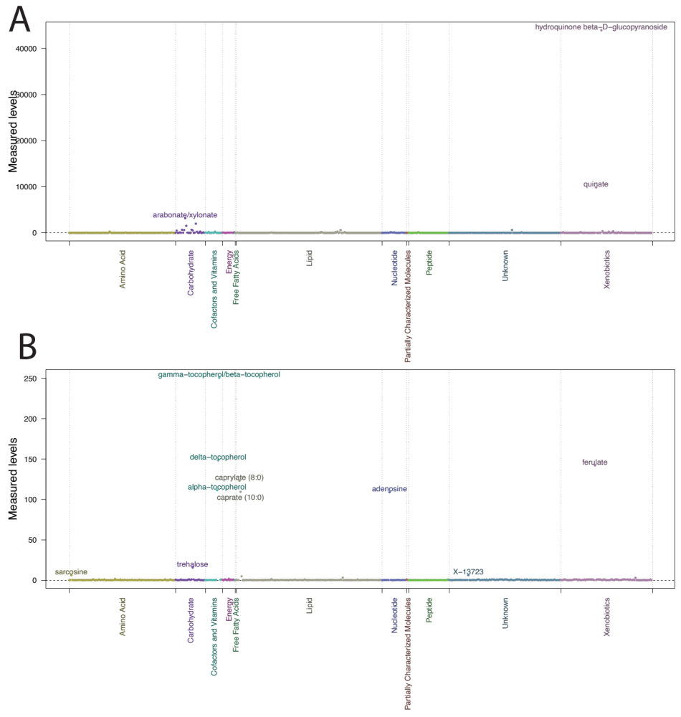

Supplementary Figure S10. Characterisation of the red powder (A) and green gel (B). Measured levels of the 419 compounds in red powder and green gel. Levels are represented on the log scale for green gel. For clarity we report the (N=3) more abundant compounds in the red powder (levels>2,000) and the (N=10) more abundant compounds (with levels >5) in the green gel.

