Thermoregulatory strategies in the heat varies among Australian insectivorous bats.

Table S1. Comparison of subcutaneous body temperature (T_{sub}), whole animal evaporative water loss (EWL), whole animal resting metabolic rate (RMR), and evaporative heat loss/metabolic heat production (EHL/MHP) at high air temperatures (T_{a)} between female (F) and male (M) Chalinolobus gouldii, Vespadelus vulturnus and Nyctophilus geoffroyi from Calperum Station, SA, Australia (16 December 2023 - 26 February 2024). Estimated marginal means (EMM) and SE values presented.

 |  | Chalinolobus gouldii |  |  |  |  | Vespadelus vulturnus |  |  |  |  | Nyctophilus geoffroyi
T_{sub} (°C)
T_{a} (°C) | Sex | emmean | SE | df | Lower  CL | Upper  CL | emmean | SE | df | Lower  CL | Upper  CL | emmean | SE | df | Lower  CL | Upper  CL
32 | F | 35.9 | 0.183 | 114 | 35.5 | 36.3 | 35 | 0.212 | 99 | 34.6 | 35.4 | na | na | na | na | na
 | M | 35.8 | 0.17 | 114 | 35.5 | 36.1 | 35.1 | 0.258 | 99 | 34.6 | 35.6 | na | na | na | na | na
36 | F | 38.4 | 0.136 | 114 | 38.1 | 38.6 | 37.9 | 0.178 | 99 | 37.5 | 38.3 | 38.2 | 0.14 | 93 | 37.89 | 38.48
 | M | 38.3 | 0.126 | 114 | 38 | 38.5 | 38 | 0.235 | 99 | 37.5 | 38.5 | 38.2 | 0.13 | 93 | 37.94 | 38.47
40 | F | 40.9 | 0.118 | 114 | 40.6 | 41.1 | 40.8 | 0.201 | 99 | 40.4 | 41.2 | 40.86 | 0.1 | 93 | 40.65 | 41.07
 | M | 40.8 | 0.117 | 114 | 40.5 | 41 | 40.9 | 0.257 | 99 | 40.4 | 41.4 | 40.88 | 0.09 | 93 | 40.68 | 41.07
42 | F | 42.1 | 0.126 | 114 | 41.8 | 42.3 | 42.3 | 0.231 | 99 | 41.8 | 42.7 | 42.19 | 0.11 | 93 | 41.97 | 42.41
 | M | 42 | 0.129 | 114 | 41.7 | 42.2 | 42.4 | 0.283 | 99 | 41.8 | 42.9 | 42.21 | 0.1 | 93 | 42 | 42.42
44 | F | 43.3 | 0.142 | 114 | 43.1 | 43.6 | 43.7 | 0.268 | 99 | 43.2 | 44.3 | 43.53 | 0.13 | 93 | 43.27 | 43.79
 | M | 43.2 | 0.149 | 114 | 42.9 | 43.5 | 43.8 | 0.316 | 99 | 43.2 | 44.4 | 43.55 | 0.13 | 93 | 43.29 | 43.81
46 | F | 44.6 | 0.165 | 114 | 44.2 | 44.9 | na | na | na | na | na | 44.86 | 0.16 | 93 | 44.54 | 45.19
 | M | 44.5 | 0.174 | 114 | 44.1 | 44.8 | na | na | na | na | na | 44.88 | 0.16 | 93 | 44.56 | 45.21
RMR (W)
T_{a} (°C) | Sex | emmean | SE | df | Lower  CL | Upper  CL | emmean | SE | df | lower.CL | upper.CL | emmean | SE | df | lower.CL | upper.CL
36 | F | 0.111 | 0.00601 | 91 | 0.0986 | 0.122 | 0.114 | 0.0065 | 92 | 0.101 | 0.127 | 0.07 | 0.003 | 93 | 0.0638 | 0.0774
 | M | 0.12 | 0.00563 | 91 | 0.1086 | 0.131 | 0.114 | 0.0060 | 92 | 0.102 | 0.126 | 0.06 | 0.003 | 93 | 0.0538 | 0.0663
40 | F | 0.15 | 0.0042 | 91 | 0.142 | 0.159 | 0.155 | 0.0044 | 92 | 0.146 | 0.164 | 0.09 | 0.002 | 93 | 0.0905 | 0.1003
 | M | 0.16 | 0.00406 | 91 | 0.1512 | 0.168 | 0.155 | 0.0042 | 92 | 0.146 | 0.163 | 0.08 | 0.002 | 93 | 0.0804 | 0.0894
42 | F | 0.17 | 0.00412 | 91 | 0.162 | 0.178 | 0.175 | 0.0043 | 92 | 0.166 | 0.184 | 0.1 | 0.002 | 93 | 0.1028 | 0.1129
 | M | 0.18 | 0.00419 | 91 | 0.1711 | 0.188 | 0.175 | 0.0044 | 92 | 0.166 | 0.184 | 0.09 | 0.002 | 93 | 0.0924 | 0.1022
44 | F | 0.19 | 0.00471 | 91 | 0.1807 | 0.199 | 0.195 | 0.0049 | 92 | 0.185 | 0.205 | 0.12 | 0.003 | 93 | 0.1142 | 0.1263
 | M | 0.20 | 0.00493 | 91 | 0.1896 | 0.209 | 0.195 | 0.0053 | 92 | 0.185 | 0.206 | 0.11 | 0.003 | 93 | 0.1037 | 0.1158
46 | F | 0.21 | 0.00575 | 91 | 0.1985 | 0.221 | na | na | na | na | na | 0.13 | 0.003 | 93 | 0.1252 | 0.1402
 | M | 0.22 | 0.00607 | 91 | 0.2072 | 0.231 | na | na | na | na | na | 0.12 | 0.003 | 93 | 0.1145 | 0.1298
EWL
(H₂O g h⁻¹)
T_{a} (°C) | Sex | emmean | SE | df | Lower  CL | Upper  CL | emmean | SE | df | Lower  CL | Upper  CL | emmean | SE | df | Lower  CL | Upper  CL
40 | F | 0.154 | 0.0188 | 70 | 0.116 | 0.191 | 0.15 | 0.0188 | 69 | 0.112 | 0.187 | 0.09 | 0.01 | 68 | 0.0751 | 0.119
 | M | 0.135 | 0.0172 | 70 | 0.1 | 0.169 | 0.141 | 0.0176 | 69 | 0.106 | 0.176 | 0.07 | 0.01 | 68 | 0.0553 | 0.094
42 | F | 0.305 | 0.0143 | 70 | 0.277 | 0.334 | 0.3 | 0.0146 | 69 | 0.271 | 0.329 | 0.17 | 0.01 | 68 | 0.1605 | 0.196
 | M | 0.286 | 0.0141 | 70 | 0.258 | 0.314 | 0.292 | 0.0145 | 69 | 0.263 | 0.321 | 0.15 | 0.01 | 68 | 0.1392 | 0.1725
44 | F | 0.457 | 0.0152 | 70 | 0.426 | 0.487 | 0.451 | 0.0156 | 69 | 0.42 | 0.482 | 0.26 | 0.01 | 68 | 0.2385 | 0.2804
 | M | 0.438 | 0.0167 | 70 | 0.404 | 0.471 | 0.442 | 0.0168 | 69 | 0.409 | 0.476 | 0.23 | 0.01 | 68 | 0.2153 | 0.2588
46 | F | 0.608 | 0.0209 | 70 | 0.567 | 0.65 | na | na | na | na | na | 0.34 | 0.02 | 68 | 0.3113 | 0.3699
 | M | 0.589 | 0.0232 | 70 | 0.543 | 0.635 | na | na | na | na | na | 0.31 | 0.02 | 68 | 0.2872 | 0.3492
EHL/
MHP
T_{a} (°C) | Sex | emmean | SE | df | Lower  CL | Upper  CL | emmean | SE | df | Lower  CL | Upper  CL | emmean | SE | df | Lower  CL | Upper  CL
40 | F | 0.679 | 0.0656 | 60 | 0.548 | 0.81 | 0.37 | 0.113 | 29 | 0.139 | 0.601 | 0.66 | 0.05 | 68 | 0.556 | 0.778
 | M | 0.546 | 0.0752 | 60 | 0.396 | 0.697 | 0.633 | 0.097 | 29 | 0.434 | 0.831 | 0.68 | 0.04 | 68 | 0.59 | 0.785
42 | F | 1.134 | 0.0473 | 60 | 1.04 | 1.229 | 0.803 | 0.0622 | 29 | 0.676 | 0.93 | 1.03 | 0.04 | 68 | 0.946 | 1.126
 | M | 1.001 | 0.0571 | 60 | 0.887 | 1.116 | 1.066 | 0.0709 | 29 | 0.92 | 1.211 | 1.05 | 0.09 | 68 | 0.972 | 1.14
44 | F | 1.589 | 0.0511 | 60 | 1.487 | 1.691 | 1.236 | 0.079 | 29 | 1.074 | 1.397 | 1.4 | 0.05 | 68 | 1.298 | 1.511
 | M | 1.456 | 0.0574 | 60 | 1.341 | 1.571 | 1.498 | 0.1092 | 29 | 1.275 | 1.722 | 1.42 | 0.05 | 68 | 1.315 | 1.535
46 | F | 2.044 | 0.0736 | 60 | 1.897 | 2.191 | na | na | na | na | na | 1.77 | 0.07 | 68 | 1.625 | 1.921
 | M | 1.911 | 0.076 | 60 | 1.759 | 2.063 | na | na | na | na | na | 1.79 | 0.07 | 68 | 1.636 | 1.95

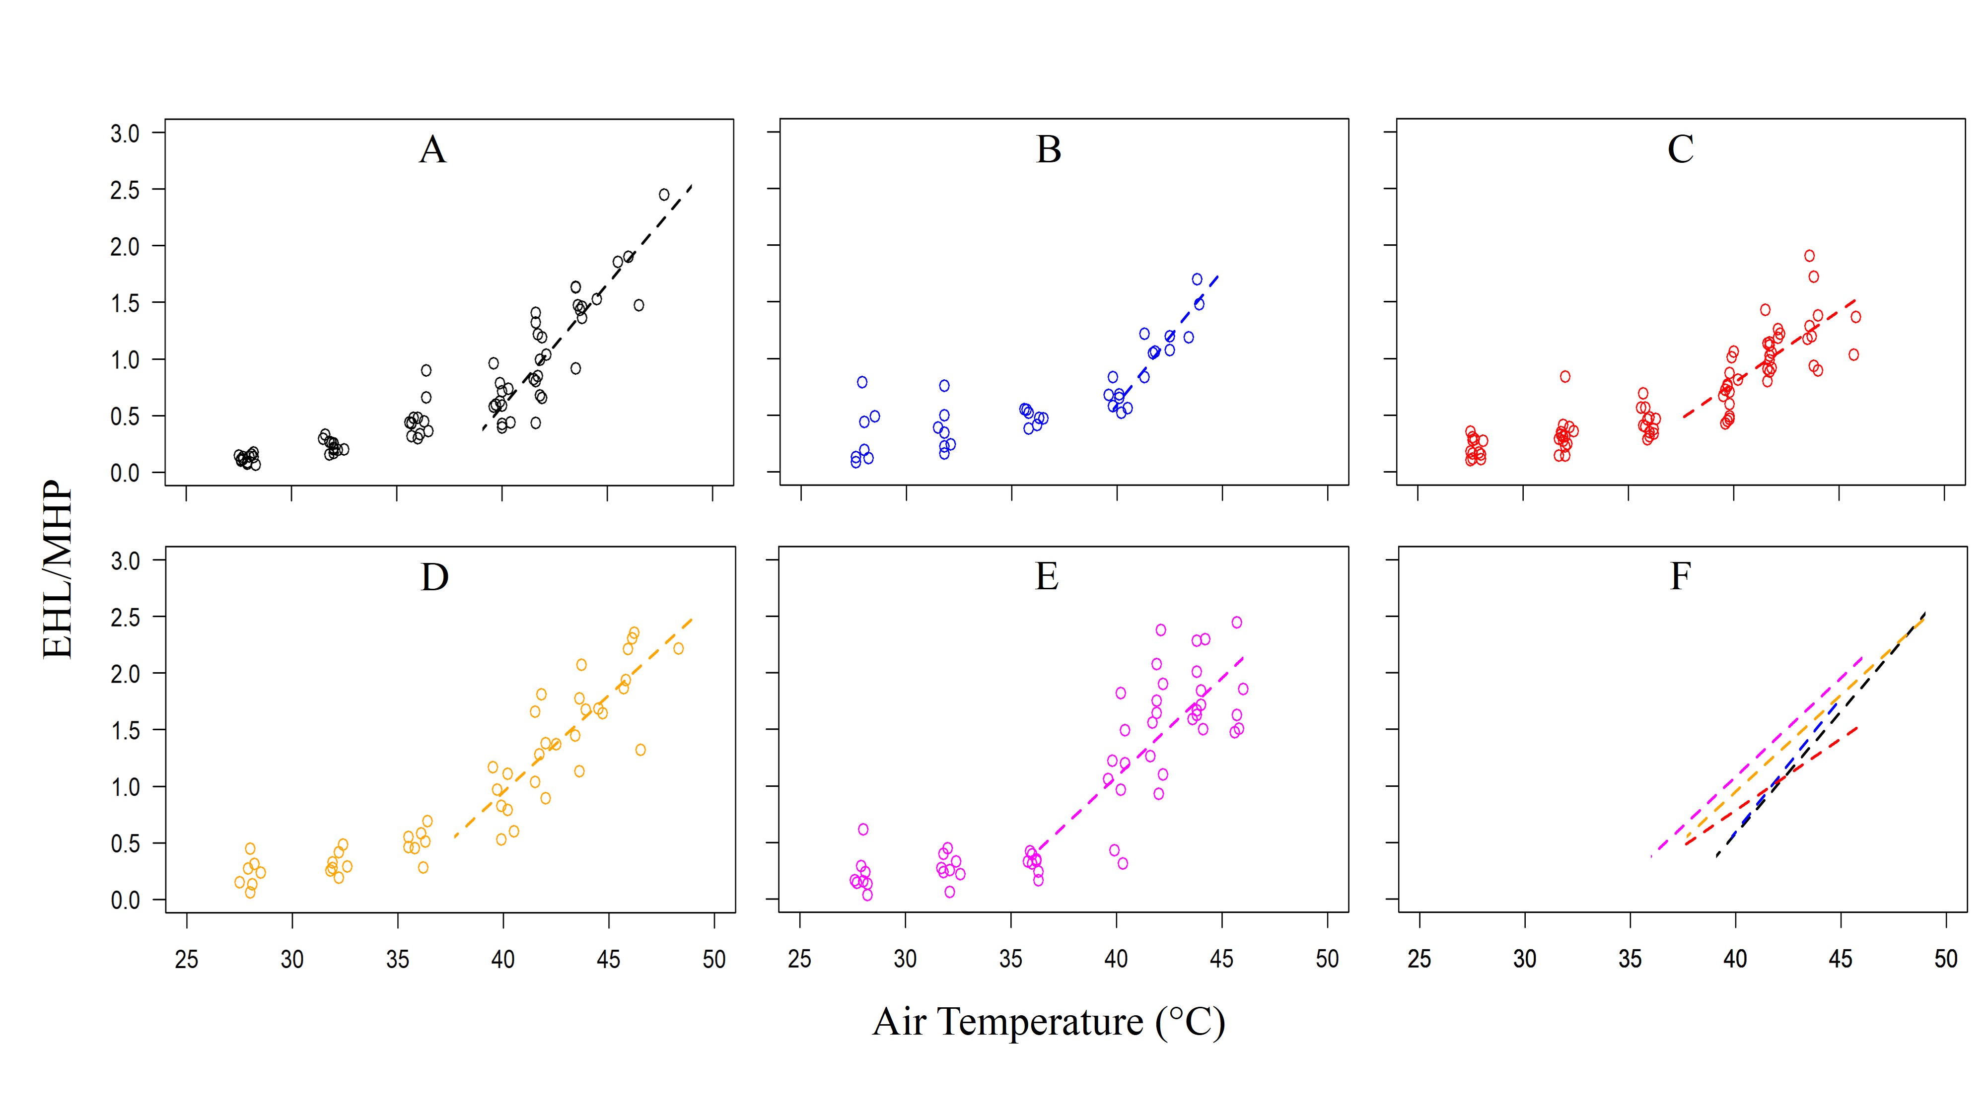
Figure S1. Evaporative heat loss (EHL)/metabolic heat production (MHP) at high air temperatures of A: Gould’s wattled bat (Chalinolobus gouldii) (black: males = 10), B: Little forest bat (Vespadelus vulturnus ) (blue: males = 7), C: Lesser long eared bat (Nyctophilus geoffroyi) (red: males = 14), D: South-eastern long eared bat (Nyctophilus corbeni ) (orange: males = 7) and E: Inland free-tailed bat (Ozimops petersi) (magenta: males = 9). Dashed lines represent regressions fitted above inflection points. F: regression lines of all species.
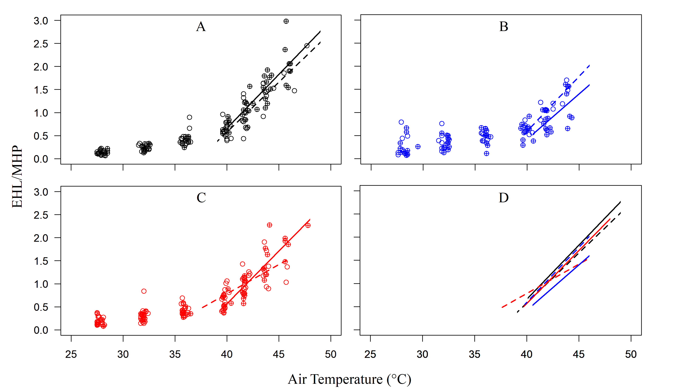
Figure S2. Evaporative heat loss (EHL)/ metabolic heat production (MHP) at high air temperatures of A: Gould’s wattled bat (Chalinolobus gouldii) (black: females = 12, males = 10), B: Little forest bat (Vespadelus vulturnus) (blue: females = 12, males = 7) and C: Lesser long eared bat (Nyctophilus geoffroyi) (red: females = 11, males = 14). Filled circles indicate females and open circles indicate males. Solid and dashed lines represent regressions fitted above inflection points for females and males separately. D: regression lines above inflection points of all species.

Table S2. Final reduced linear mixed effect model output of thermoregulatory performance as a function of chamber air temperature (T_{a}) in male Gould’s wattled bat (Chalinolobus gouldii), Lesser long eared bat (Nyctophilus geoffroyi), South-eastern ling eared bat (Nyctophilus corbeni), Inland free-tailed bat (Ozimops petersi) and Little forest bat (Vespadelus vulturnus) from Calperum Station, SA, Australia (16 December 2023 - 26 February 2024). Thermoregulatory variables include subcutaneous temperature (T_{sub}), whole animal resting metabolic rate (RMR) and whole animal evaporative water loss (EWL). Numbers in parenthesis = (no. of observations, no. of individuals). Interactions between fixed effects denoted with ‘x’. Significant differences in bold.
Dependant variable | R² | Fixed effect | df | t | p
T_{sub} (208,41) | 0.93 | T_{a} | 166.33330 | 25.032 | <2e-16
 |  | Species (N. geoffroyi) | 183.84641 | -1.703 | 0.0902
 |  | Species (N. corbeni) | 178.17060 | 2.135 | 0.0341
 |  | Species (O.petersi) | 179.90626 | -1.078 | 0.2825
 |  | Species (V. vulturnus) | 181.18814 | -1.960 | 0.0515
 |  | T_{a} x Species (N. geoffroyi) | 180.92611 | 1.681 | 0.0945
 |  | T_{a} x Species (N. corbeni) | 163.63787 | -2.373 | 0.0188
 |  | T_{a} x Species (O.petersi) | 167.32640 | 0.607 | 0.5450
 |  | T_{a} x Species (V. vulturnus) | 164.73554 | 1.872 | 0.0630
RMR (170,41) | 0.93 | T_{a} | 127.687217 | 20.650 | <2e-16
 |  | Species (N. geoffroyi) | 146.066652 | 1.443 | 0.15127
 |  | Species (N. corbeni) | 131.663031 | 2.308 | 0.02254
 |  | Species (O.petersi) | 153.024619 | -0.897 | 0.37092
 |  | Species (V. vulturnus) | 157.990360 | -3.127 | 0.00211
 |  | Mass | 28.940299 | -2.147 | 0.04030
 |  | T_{a} x Species (N. geoffroyi) | 139.058933 | -1.775 | 0.07807
 |  | T_{a} x Species (N. corbeni) | 124.983689 | -2.523 | 0.01290
 |  | T_{a} x Species (O.petersi) | 127.172472 | -0.174 | 0.86219
 |  | T_{a} x Species (V. vulturnus) | 128.102097 | 2.496 | 0.01383
EWL (119,40) | 0.81 | T_{a} | 82.62443 | 9.148 | 3.43e-14
 |  | Species (N. geoffroyi) | 96.91596 | 1.472 | 0.14425
 |  | Species (N. corbeni) | 80.71698 | -1.513 | 0.13416
 |  | Species (O.petersi) | 83.61162 | -0.945 | 0.34722
 |  | Species (V. vulturnus) | 87.40052 | -2.857 | 0.00535
 |  | Mass | 27.42588 | -2.411 | 0.02285
 |  | T_{a} x Species (N. geoffroyi) | 95.32076 | -1.703 | 0.09178
 |  | T_{a} x Species (N. corbeni) | 79.62588 | 1.339 | 0.18454
 |  | T_{a} x Species (O.petersi) | 79.65260 | 0.381 | 0.70425
 |  | T_{a} x Species (V. vulturnus) | 83.60018 | 2.491 | 0.01472
EHL/MHP (142, 48) | 0.82 | T_{a} | 112.32479 | 7.687 | 6.16e-12
 |  | Species (N. geoffroyi) | 108.57805 | 1.312 | 0.1924
 |  | Species (N. corbeni) | 113.53408 | 2.292 | 0.0238
 |  | Species (O.petersi) | 113.09508 | 1.201 | 0.2323
 |  | Species (V. vulturnus) | 110.76673 | -0.581 | 0.5625
 |  | Mass | 39.88810 | -0.995 | 0.3256
 |  | T_{a} x Species (N. geoffroyi) | 108.11119 | -1.132 | 0.2602
 |  | T_{a} x Species (N. corbeni) | 109.01052 | -2.484 | 0.0145
 |  | T_{a} x Species (O.petersi) | 110.01171 | -1.006 | 0.3168
 |  | T_{a} x Species (V. vulturnus) | 107.45865 | 0.456 | 0.6490

Table S3. Comparison of subcutaneous body temperature (T_{sub}), whole animal evaporative water loss (EWL), whole animal resting metabolic rate (RMR), and evaporative heat loss/metabolic heat production (EHL/MHP) at high air temperatures (T_{a)} between Chalinolobus gouldii, Nyctophilus geoffroyi, Nyctophilus corbeni, Ozimops petersi and Vespadelus vulturnus from Calperum Station, SA, Australia (16 December 2023 - 26 February 2024). Estimated marginal means (EMM) and SE values presented.

 | T_{a} (°C) | Species | emmean | SE | df | Lower  CL | Upper  CL
T_{sub} (°C) | 28 | C. gouldii | 33.1 | 0.346 | 161.2 | 32.4 | 33.8
 |  | N. geoffroyi | 31.4 | 0.942 | 197.3 | 29.6 | 33.3
 |  | N. corbeni | 33.8 | 0.431 | 150.5 | 33.0 | 34.7
 |  | O. petersi | 32.1 | 0.417 | 164.6 | 31.2 | 32.9
 |  | V. vulturnus | 32.2 | 0.344 | 85.8 | 31.5 | 32.9
 | 32 | C. gouldii | 35.7 | 0.270 | 93.2 | 35.1 | 36.2
 |  | N. geoffroyi | 34.5 | 0.680 | 193.9 | 33.2 | 35.8
 |  | N. corbeni | 36.1 | 0.348 | 89.1 | 35.4 | 36.7
 |  | O. petersi | 34.7 | 0.329 | 103.0 | 34.1 | 35.4
 |  | V. vulturnus | 35.1 | 0.289 | 46.2 | 34.5 | 35.7
 | 36 | C. gouldii | 38.3 | 0.218 | 44.6 | 37.8 | 38.7
 |  | N. geoffroyi | 37.6 | 0.445 | 129.3 | 36.7 | 38.5
 |  | N. corbeni | 38.3 | 0.287 | 45.0 | 37.7 | 38.9
 |  | O. petersi | 37.4 | 0.262 | 50.1 | 36.9 | 37.9
 |  | V. vulturnus | 38.0 | 0.268 | 34.5 | 37.4 | 38.5
 | 40 | C. gouldii | 40.8 | 0.210 | 37.5 | 40.4 | 41.3
 |  | N. geoffroyi | 40.7 | 0.310 | 45.2 | 40.1 | 41.3
 |  | N. corbeni | 40.5 | 0.263 | 32.1 | 40.0 | 41.0
 |  | O. petersi | 40.1 | 0.238 | 35.0 | 39.6 | 40.6
 |  | V. vulturnus | 40.8 | 0.290 | 46.6 | 40.2 | 41.4
 | 42 | C. gouldii | 42.1 | 0.224 | 47.8 | 41.7 | 42.6
 |  | N. geoffroyi | 42.2 | 0.325 | 52.1 | 41.6 | 42.9
 |  | N. corbeni | 41.6 | 0.270 | 35.1 | 41.1 | 42.2
 |  | O. petersi | 41.4 | 0.246 | 40.1 | 40.9 | 41.9
 |  | V. vulturnus | 42.3 | 0.315 | 62.7 | 41.6 | 42.9
 | 44 | C. gouldii | 43.4 | 0.248 | 68.7 | 42.9 | 43.9
 |  | N. geoffroyi | 43.8 | 0.395 | 92.6 | 43.0 | 44.6
 |  | N. corbeni | 42.7 | 0.287 | 44.9 | 42.1 | 43.3
 |  | O. petersi | 42.8 | 0.267 | 54.6 | 42.2 | 43.3
 |  | V. vulturnus | 43.7 | 0.347 | 86.0 | 43.0 | 44.4
 | 46 | C. gouldii | 44.7 | 0.280 | 99.6 | 44.2 | 45.3
 |  | N. geoffroyi | 45.3 | 0.496 | 147.5 | 44.4 | 46.3
 |  | N. corbeni | 43.8 | 0.314 | 62.6 | 43.2 | 44.5
 |  | O. petersi | 44.1 | 0.297 | 79.8 | 43.5 | 44.7
 |  | V. vulturnus | 45.1 | 0.383 | 114.3 | 44.4 | 45.9
 | 48 | C. gouldii | 46.0 | 0.318 | 134.5 | 45.4 | 46.6
 |  | N. geoffroyi | 46.9 | 0.614 | 182.3 | 45.7 | 48.1
 |  | N. corbeni | 45.0 | 0.348 | 88.4 | 44.3 | 45.6
 |  | O. petersi | 45.5 | 0.335 | 113.1 | 44.8 | 46.1
 |  | V. vulturnus | 46.6 | 0.424 | 142.7 | 45.7 | 47.4
RMR (W) | 28 | C. gouldii | 0.00221 | 0.01490 | 135.9 | -0.02727 | 0.0317
 |  | N. geoffroyi | -0.15182 | 0.04550 | 156.2 | -0.24170 | -0.0619
 |  | N. corbeni | 0.00549 | 0.01730 | 136.2 | -0.02875 | 0.0397
 |  | O. petersi | 0.04423 | 0.01020 | 131.7 | 0.02405 | 0.0644
 |  | V. vulturnus | 0.03237 | 0.02550 | 117.0 | -0.01820 | 0.0830
 | 32 | C. gouldii | 0.04763 | 0.01190 | 89.8 | 0.02390 | 0.0714
 |  | N. geoffroyi | -0.07013 | 0.03350 | 158.9 | -0.13626 | -0.0040
 |  | N. corbeni | 0.04928 | 0.01420 | 93.0 | 0.02106 | 0.0775
 |  | O. petersi | 0.06178 | 0.00807 | 81.6 | 0.04572 | 0.0778
 |  | V. vulturnus | 0.05081 | 0.02100 | 72.6 | 0.00895 | 0.0927
 | 36 | C. gouldii | 0.09305 | 0.00975 | 47.3 | 0.07344 | 0.1127
 |  | N. geoffroyi | 0.01156 | 0.02210 | 145.0 | -0.03215 | 0.0553
 |  | N. corbeni | 0.09307 | 0.01170 | 50.8 | 0.06950 | 0.1166
 |  | O. petersi | 0.07932 | 0.00648 | 40.0 | 0.06622 | 0.0924
 |  | V. vulturnus | 0.06924 | 0.01780 | 41.3 | 0.03329 | 0.1052
 | 40 | C. gouldii | 0.13847 | 0.00892 | 33.2 | 0.12034 | 0.1566
 |  | N. geoffroyi | 0.09325 | 0.01320 | 54.9 | 0.06678 | 0.1197
 |  | N. corbeni | 0.13686 | 0.01040 | 31.6 | 0.11572 | 0.1580
 |  | O. petersi | 0.09686 | 0.00590 | 28.4 | 0.08479 | 0.1089
 |  | V. vulturnus | 0.08767 | 0.01670 | 32.4 | 0.05358 | 0.1218
 | 42 | C. gouldii | 0.16119 | 0.00915 | 36.1 | 0.14264 | 0.1797
 |  | N. geoffroyi | 0.13410 | 0.01170 | 35.6 | 0.11041 | 0.1578
 |  | N. corbeni | 0.15875 | 0.01030 | 30.1 | 0.13782 | 0.1797
 |  | O. petersi | 0.10564 | 0.00610 | 32.6 | 0.09323 | 0.1180
 |  | V. vulturnus | 0.09688 | 0.01720 | 35.5 | 0.06204 | 0.1317
 | 44 | C. gouldii | 0.18390 | 0.00979 | 45.7 | 0.16419 | 0.2036
 |  | N. geoffroyi | 0.17495 | 0.01330 | 53.9 | 0.14824 | 0.2016
 |  | N. corbeni | 0.18064 | 0.01050 | 33.6 | 0.15921 | 0.2021
 |  | O. petersi | 0.11441 | 0.00659 | 44.2 | 0.10112 | 0.1277
 |  | V. vulturnus | 0.10610 | 0.01820 | 43.7 | 0.06941 | 0.1428
 | 46 | C. gouldii | 0.20661 | 0.01080 | 62.4 | 0.18508 | 0.2281
 |  | N. geoffroyi | 0.21579 | 0.01730 | 102.5 | 0.18157 | 0.2500
 |  | N. corbeni | 0.20254 | 0.01120 | 42.4 | 0.17993 | 0.2251
 |  | O. petersi | 0.12318 | 0.00733 | 64.4 | 0.10853 | 0.1378
 |  | V. vulturnus | 0.11531 | 0.01970 | 57.7 | 0.07581 | 0.1548
 | 48 | C. gouldii | 0.22932 | 0.01200 | 85.0 | 0.20545 | 0.2532
 |  | N. geoffroyi | 0.25664 | 0.02230 | 141.8 | 0.21254 | 0.3007
 |  | N. corbeni | 0.22443 | 0.01220 | 57.4 | 0.20004 | 0.2488
 |  | O. petersi | 0.13195 | 0.00825 | 91.2 | 0.11556 | 0.1483
 |  | V. vulturnus | 0.12453 | 0.02170 | 76.9 | 0.08138 | 0.1677
EWL (g H₂O/ h) | 28 | C. gouldii | -0.766615 | 0.0756 | 104.8 | -0.9165 | -0.6167
 |  | N. geoffroyi | -0.955239 | 0.2270 | 101.9 | -1.4061 | -0.5044
 |  | N. corbeni | -0.769746 | 0.0799 | 106.4 | -0.9281 | -0.6114
 |  | O. petersi | -0.369379 | 0.0857 | 94.0 | -0.5395 | -0.1992
 |  | V. vulturnus | -0.328394 | 0.1930 | 102.1 | -0.7105 | 0.0537
 | 32 | C. gouldii | -0.465672 | 0.0577 | 107.3 | -0.5801 | -0.3512
 |  | N. geoffroyi | -0.636584 | 0.1700 | 104.6 | -0.9731 | -0.3001
 |  | N. corbeni | -0.452302 | 0.0636 | 105.3 | -0.5785 | -0.3261
 |  | O. petersi | -0.201078 | 0.0648 | 102.5 | -0.3295 | -0.0726
 |  | V. vulturnus | -0.202384 | 0.1440 | 107.9 | -0.4886 | 0.0838
 | 36 | C. gouldii | -0.164730 | 0.0422 | 78.3 | -0.2487 | -0.0808
 |  | N. geoffroyi | -0.317928 | 0.1140 | 108.0 | -0.5440 | -0.0919
 |  | N. corbeni | -0.134858 | 0.0494 | 74.7 | -0.2332 | -0.0365
 |  | O. petersi | -0.032776 | 0.0452 | 105.7 | -0.1224 | 0.0568
 |  | V. vulturnus | -0.076375 | 0.1010 | 88.8 | -0.2773 | 0.1246
 | 40 | C. gouldii | 0.136212 | 0.0324 | 35.5 | 0.0704 | 0.2020
 |  | N. geoffroyi | 0.000727 | 0.0655 | 74.2 | -0.1298 | 0.1312
 |  | N. corbeni | 0.182585 | 0.0394 | 36.6 | 0.1027 | 0.2624
 |  | O. petersi | 0.135525 | 0.0298 | 48.7 | 0.0756 | 0.1954
 |  | V. vulturnus | 0.049635 | 0.0724 | 36.2 | -0.0972 | 0.1965
 | 42 | C. gouldii | 0.286684 | 0.0316 | 31.6 | 0.2223 | 0.3511
 |  | N. geoffroyi | 0.160055 | 0.0508 | 38.0 | 0.0572 | 0.2629
 |  | N. corbeni | 0.341307 | 0.0371 | 29.1 | 0.2653 | 0.4173
 |  | O. petersi | 0.219676 | 0.0262 | 30.2 | 0.1662 | 0.2732
 |  | V. vulturnus | 0.112639 | 0.0698 | 30.9 | -0.0297 | 0.2549
 | 44 | C. gouldii | 0.437155 | 0.0340 | 40.1 | 0.3685 | 0.5058
 |  | N. geoffroyi | 0.319383 | 0.0514 | 38.0 | 0.2153 | 0.4235
 |  | N. corbeni | 0.500029 | 0.0373 | 29.4 | 0.4239 | 0.5762
 |  | O. petersi | 0.303826 | 0.0271 | 34.3 | 0.2488 | 0.3589
 |  | V. vulturnus | 0.175644 | 0.0768 | 42.7 | 0.0207 | 0.3306
 | 46 | C. gouldii | 0.587626 | 0.0389 | 60.4 | 0.5098 | 0.6654
 |  | N. geoffroyi | 0.478711 | 0.0669 | 72.5 | 0.3453 | 0.6121
 |  | N. corbeni | 0.658751 | 0.0397 | 37.5 | 0.5783 | 0.7392
 |  | O. petersi | 0.387977 | 0.0321 | 60.9 | 0.3238 | 0.4522
 |  | V. vulturnus | 0.238649 | 0.0913 | 69.4 | 0.0565 | 0.4208
 | 48 | C. gouldii | 0.738097 | 0.0456 | 85.1 | 0.6474 | 0.8288
 |  | N. geoffroyi | 0.638039 | 0.0899 | 101.1 | 0.4598 | 0.8163
 |  | N. corbeni | 0.817473 | 0.0441 | 54.2 | 0.7290 | 0.9060
 |  | O. petersi | 0.472128 | 0.0397 | 94.8 | 0.3933 | 0.5510
 |  | V. vulturnus | 0.301654 | 0.1100 | 95.4 | 0.0825 | 0.5208
EHL/MHP | 28 | C. gouldii | -1.782 | 0.4260 | 127.3 | -2.6249 | -0.938
 |  | N. geoffroyi | -0.966 | 0.3340 | 129.7 | -1.6270 | -0.306
 |  | N. corbeni | -0.799 | 0.3330 | 126.0 | -1.4583 | -0.140
 |  | O. petersi | -1.084 | 0.1990 | 127.0 | -1.4768 | -0.691
 |  | V. vulturnus | -2.461 | 0.7460 | 120.7 | -3.9383 | -0.984
 | 32 | C. gouldii | -0.941 | 0.3280 | 130.8 | -1.5903 | -0.292
 |  | N. geoffroyi | -0.275 | 0.2760 | 109.9 | -0.8222 | 0.272
 |  | N. corbeni | -0.310 | 0.2540 | 130.5 | -0.8122 | 0.193
 |  | O. petersi | -0.365 | 0.1520 | 129.4 | -0.6669 | -0.064
 |  | V. vulturnus | -1.514 | 0.5560 | 129.6 | -2.6132 | -0.415
 | 36 | C. gouldii | -0.101 | 0.2410 | 106.9 | -0.5781 | 0.376
 |  | N. geoffroyi | 0.416 | 0.2280 | 69.7 | -0.0382 | 0.870
 |  | N. corbeni | 0.180 | 0.1850 | 95.2 | -0.1874 | 0.547
 |  | O. petersi | 0.353 | 0.1120 | 87.3 | 0.1302 | 0.575
 |  | V. vulturnus | -0.567 | 0.3830 | 115.3 | -1.3250 | 0.191
 | 40 | C. gouldii | 0.739 | 0.1800 | 50.8 | 0.3779 | 1.101
 |  | N. geoffroyi | 1.107 | 0.1960 | 41.0 | 0.7110 | 1.502
 |  | N. corbeni | 0.670 | 0.1420 | 41.9 | 0.3837 | 0.956
 |  | O. petersi | 1.071 | 0.0864 | 37.4 | 0.8961 | 1.246
 |  | V. vulturnus | 0.380 | 0.2650 | 45.8 | -0.1531 | 0.913
 | 42 | C. gouldii | 1.160 | 0.1700 | 39.9 | 0.8168 | 1.502
 |  | N. geoffroyi | 1.452 | 0.1890 | 35.7 | 1.0684 | 1.836
 |  | N. corbeni | 0.914 | 0.1380 | 37.3 | 0.6352 | 1.194
 |  | O. petersi | 1.430 | 0.0838 | 33.3 | 1.2598 | 1.601
 |  | V. vulturnus | 0.854 | 0.2530 | 38.2 | 0.3407 | 1.366
 | 44 | C. gouldii | 1.580 | 0.1770 | 44.2 | 1.2242 | 1.935
 |  | N. geoffroyi | 1.798 | 0.1900 | 36.0 | 1.4131 | 2.182
 |  | N. corbeni | 1.159 | 0.1480 | 48.2 | 0.8612 | 1.457
 |  | O. petersi | 1.789 | 0.0893 | 42.8 | 1.6094 | 1.969
 |  | V. vulturnus | 1.327 | 0.2820 | 55.0 | 0.7613 | 1.893
 | 46 | C. gouldii | 2.000 | 0.1990 | 62.9 | 1.6024 | 2.398
 |  | N. geoffroyi | 2.143 | 0.1970 | 41.9 | 1.7454 | 2.541
 |  | N. corbeni | 1.404 | 0.1700 | 74.3 | 1.0650 | 1.743
 |  | O. petersi | 2.149 | 0.1020 | 67.5 | 1.9459 | 2.351
 |  | V. vulturnus | 1.801 | 0.3420 | 91.8 | 1.1222 | 2.479
 | 48 | C. gouldii | 2.420 | 0.2330 | 90.6 | 1.9582 | 2.882
 |  | N. geoffroyi | 2.489 | 0.2110 | 53.9 | 2.0658 | 2.912
 |  | N. corbeni | 1.649 | 0.2000 | 105.7 | 1.2524 | 2.045
 |  | O. petersi | 2.508 | 0.1190 | 100.5 | 2.2726 | 2.743
 |  | V. vulturnus | 2.274 | 0.4190 | 122.0 | 1.4457 | 3.103

