Supplementary Material to The Role of Habitat Mosaics on Biological Communities at Hydrothermal Vents and Their Periphery
Van Audenhaege Loïc^{1,2}*, Sarrazin Jozée², Ramière Annah², Borremans Catherine², Marcillat Marin², Soto Vega Pedro Juan², Cannat Mathilde³, Marticorena Julien⁴, Colaço Ana⁵, Matabos Marjolaine²
¹ National Oceanography Centre, Southampton, United Kingdom
² Univ Brest, Ifremer, BEEP, F-29280 Plouzané, France
³ Université Paris Cité, Institut de Physique du Globe de Paris, UMR 7154 CNRS, Paris, France
⁴ ABYSSA, French Company for the Deep-Ocean Exploration, Anglet, France
⁵ University of the Azores, Institute of Marine Sciences – OKEANOS, Horta, Portugal
*Corresponding author: loic.vanaudenhaege@gmail.com/loicva@noc.ac.uk

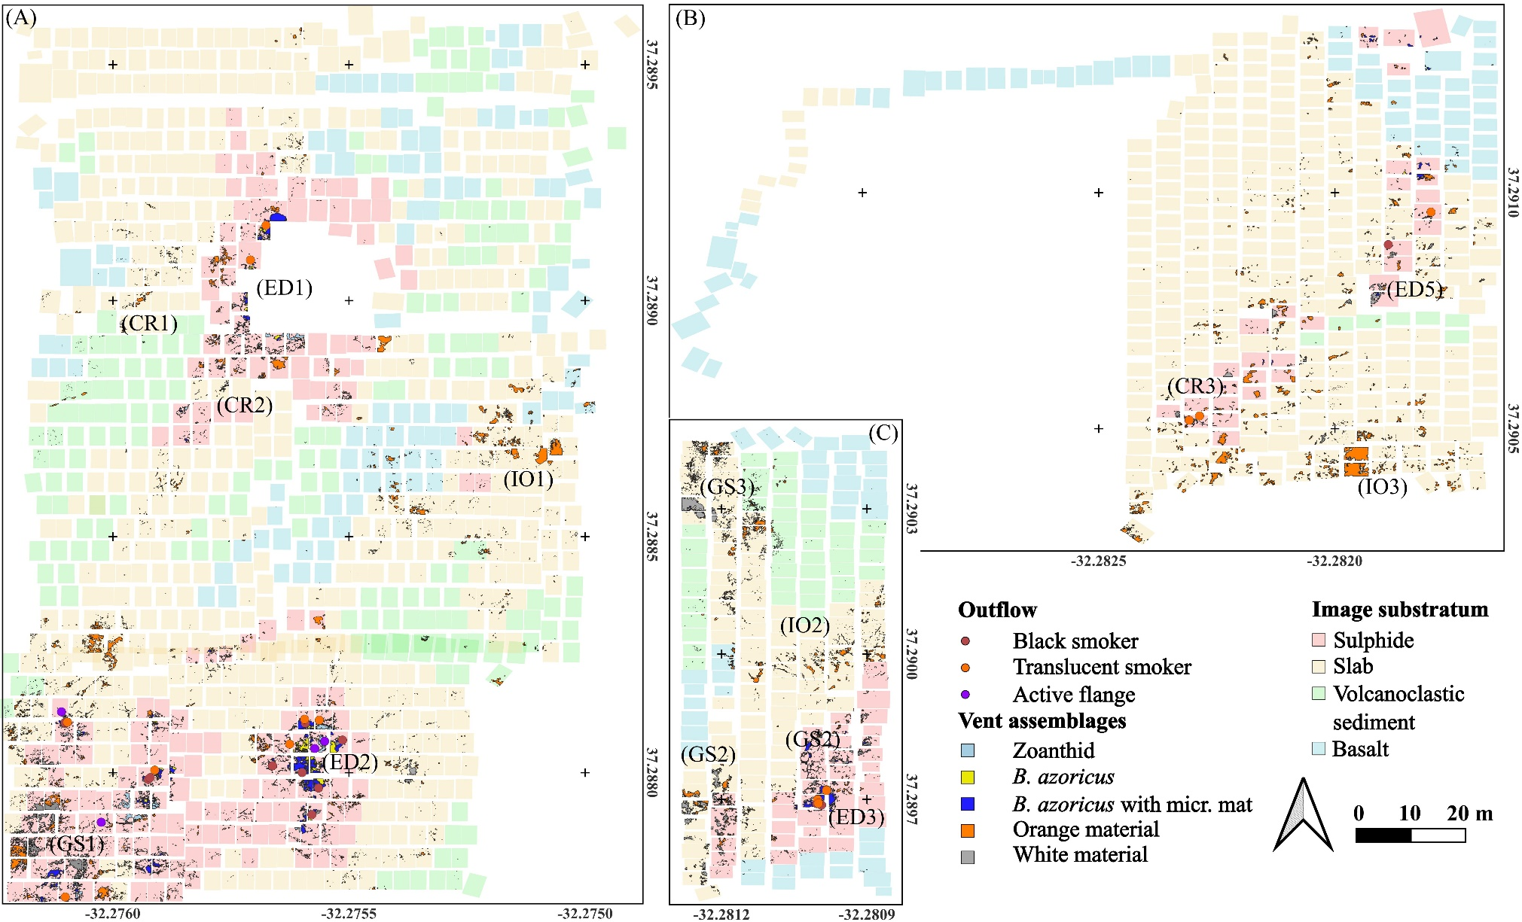 Supplementary Figure 1 – Maps of distribution of hydrothermal features and substrata for the sites in the south-east (A) including Eiffel Tower in the north and Montségur in the south-east, and in the south-west centre including (B) Sapins and (C) White Castle. Image substrata are plot with a colour code associated with the imprint of each image annotated. Outflows and flanges are located with colour-specific points. To ease presentation of the results, the presence of different types of hydrothermal settings is presented with a character code: ED = Main edifice, GS = Grey sandy areas, CR = Cracks in the periphery of the main edifice and IO = isolated orange material. Vent assemblages are shown with polygons of different colours. The coordinate grid is expressed in WGS84. Note the gap in A showing the location of the Eiffel Tower edifice, a structure ~ 11 m high that was not possible to image with a downward-looking camera configuration.

