APPENDIX
- PACF Plot for Paikgacha
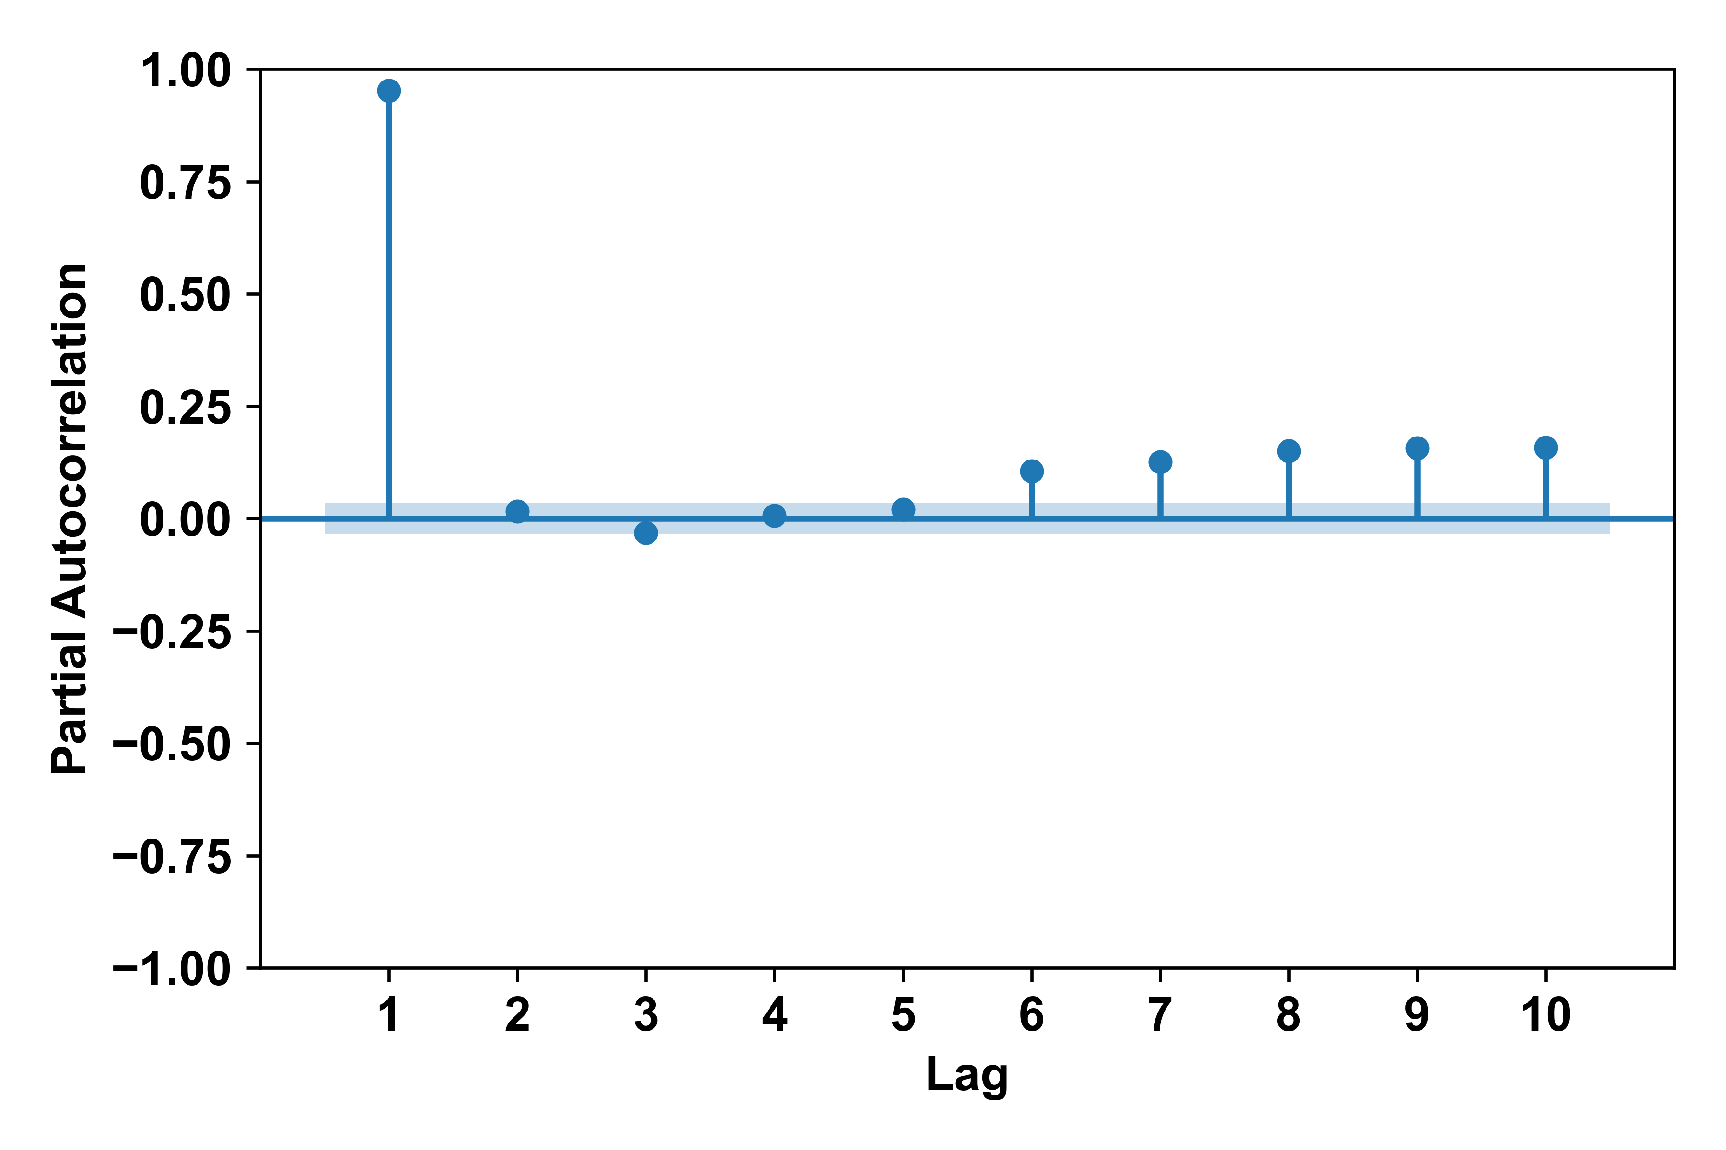
Figure S1: PACF plot for Paikhgacha station

- PACF Plot for Taluk-Simulbari
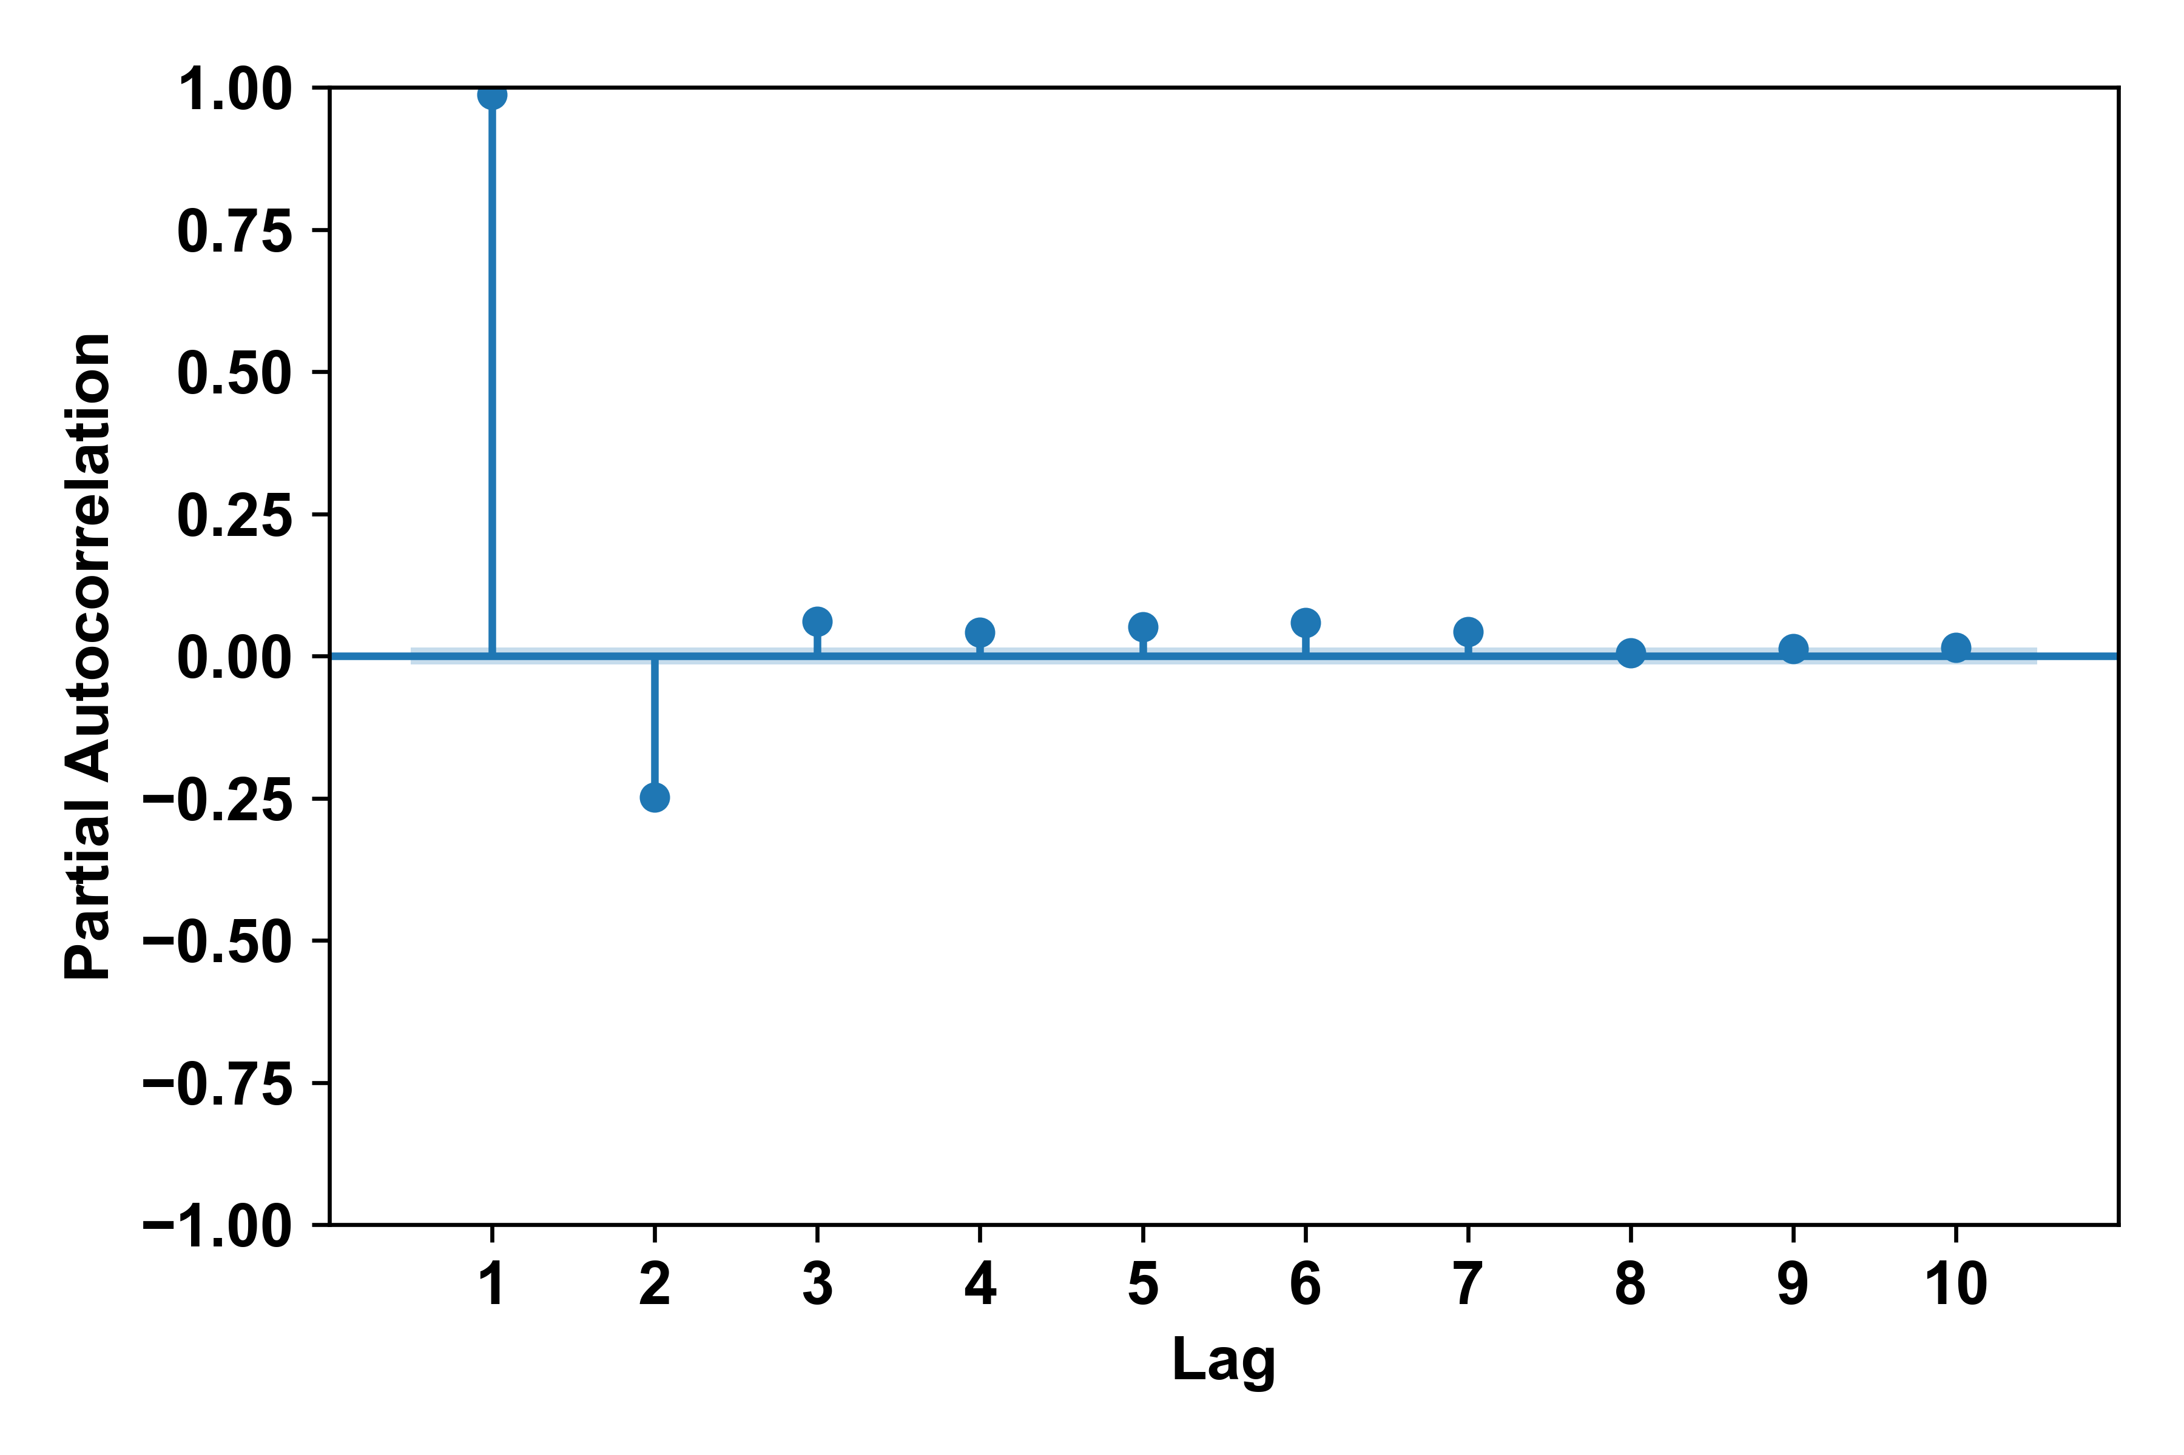
Figure S2: PACF plot for Taluk-Simulbari station

- PACF Plot for Aquilla
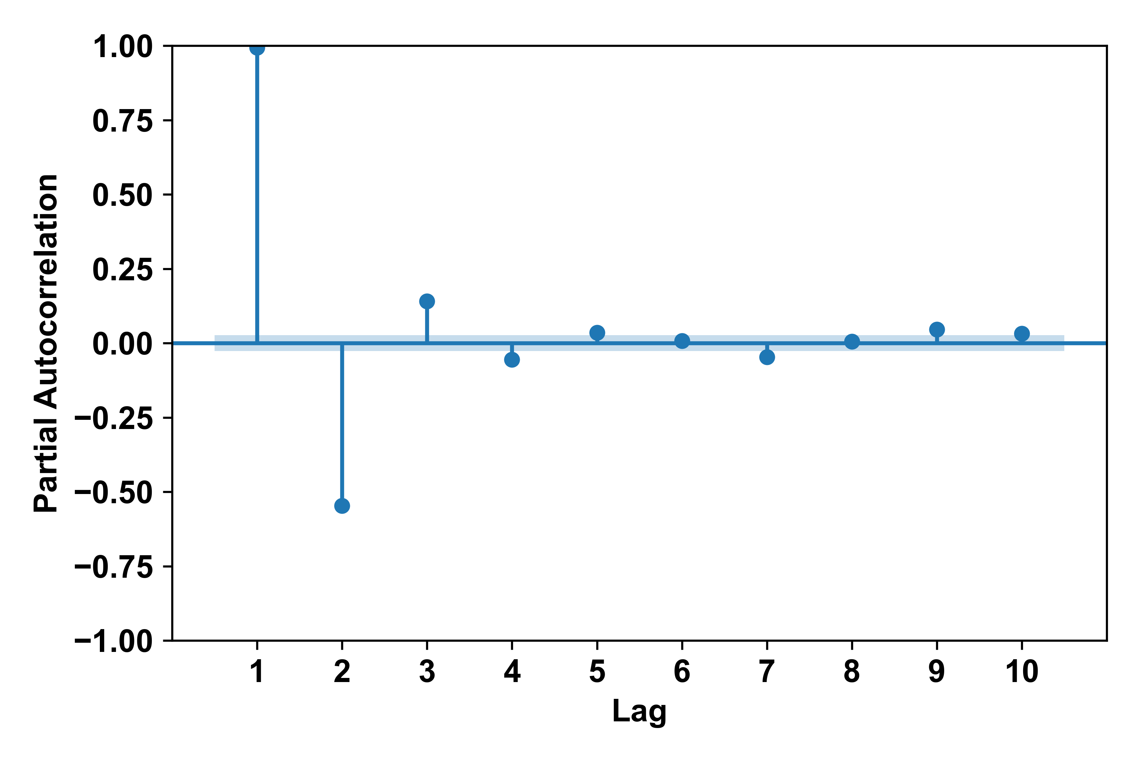
Figure S3: PACF plot for Aquilla station

