Supplementary Materials

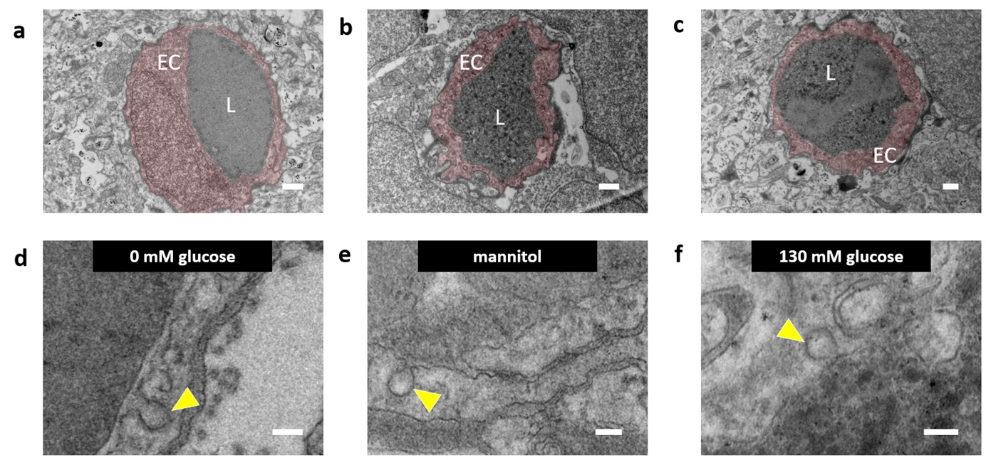
Supplementary Figure S1. TEM analysis of caveolae after hyperglycemia in zebrafish larval cerebral vasculature. (a) Optimized TEM images of individual cerebral blood vessels (cross-sectional) in Tg(fli1:EGFP) zebrafish at 5 dpf. Morphology of cerebral blood vessels with endothelial cells (EC) pseudocoloured red, and lumen (L). (b, c) Representative TEM images of individual cerebral blood vessels (cross-sectional) in Tg(fli1:EGFP) zebrafish at 5 dpf. Morphology of cerebral blood vessels with endothelial cells (EC) pseudocoloured red, and lumen (L). Scale bars in a-c: 500 nm. High-magnification TEM images of vascular endothelial cells in Tg(fli1:EGFP) zebrafish at 5 dpf for (d) 0 mM glucose, (e) mannitol, or (f) hyperglycemic (130 mM glucose) conditions. Examples of a caveola are indicated with a yellow arrow. Scale bars in d-f: 100 nm.

