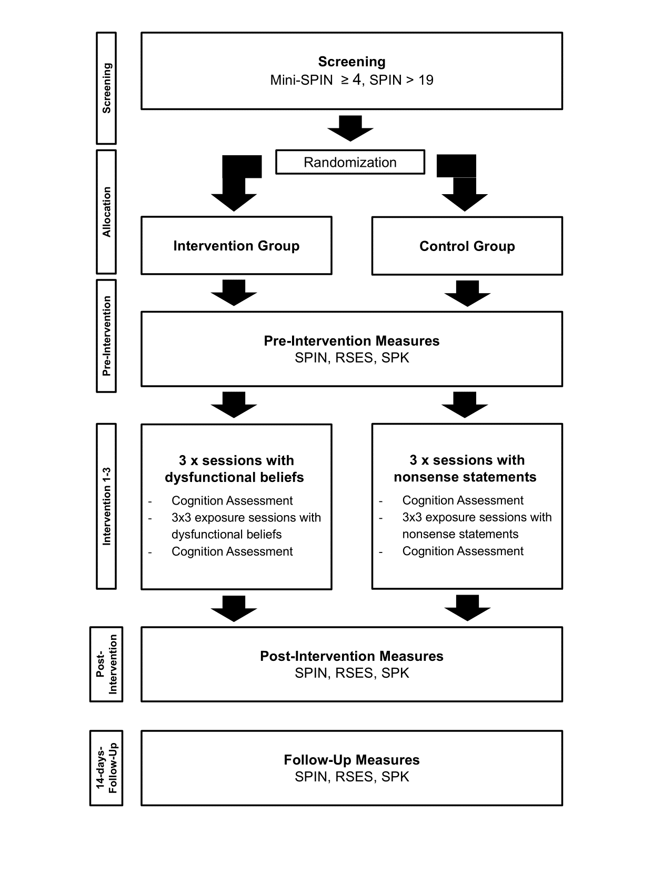
Supplementary Figure S1. Flow chart of the study's experimental procedure. Note. Mini-SPIN = Mini - social phobia inventory, SPIN = Social Phobia Inventory, RSES = Rosenberg Self Esteem Scale., SPK = Social Cognitions Questionnaire

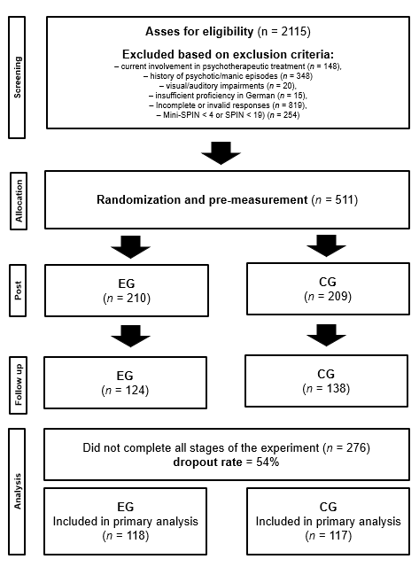

Supplementary Figure S2. Flow chart of participant progression through the study, including numbers of participants at each stage, exclusions and dropouts. Note. EG = intervention group, CG = control group.

