Cold-inducible RNA-binding protein is a potential therapeutic target for bleomycin-induced pulmonary fibrosis

Yasutaka Mochizuka, M.D.¹, Hironao Hozumi, M.D., Ph. D.^{1*}, Hirofumi Watanabe, M.D., Ph. D.¹, Atsuki Fukada, M.D., Ph. D.¹, Hyogo Naoi M.D., Ph. D.¹, Yusuke Inoue, M.D., Ph. D.¹, Hideki Yasui, M.D., Ph. D.¹, Yuzo Suzuki, M.D., Ph. D.¹, Masato Karayama, M.D., Ph. D.¹, Kazuki Furuhashi, M.D., Ph. D.¹, Noriyuki Enomoto, M.D., Ph. D.¹, Tomoyuki Fujisawa, M.D., Ph. D.¹, Naoki Inui, M.D., Ph. D.^{1,2}, Takafumi Suda, M.D., Ph. D.¹

Affiliations:
¹ Second Division, Department of Internal Medicine, Hamamatsu University School of Medicine, 1-20-1 Handayama Higashiku, Hamamatsu 431-3192, Japan
² Department of Clinical Pharmacology and Therapeutics, Hamamatsu University School of Medicine, 1-20-1 Handayama Higashiku, Hamamatsu 431-3192, Japan

*Corresponding author: Hironao Hozumi, M.D., Ph. D.
Second Division, Department of Internal Medicine, Hamamatsu University School of Medicine, 1-20-1 Handayama Higashiku, Hamamatsu 431-3192, Japan
Email: hozumi@hama-med.ac.jp; Tel: +81(53)435-2263; Fax: +81(53)435-2354
ORCID ID: 0000-0001-5439-1543
Supplementary Figure 1. Flow cytometric gating strategy for isolating primary lung fibroblasts.
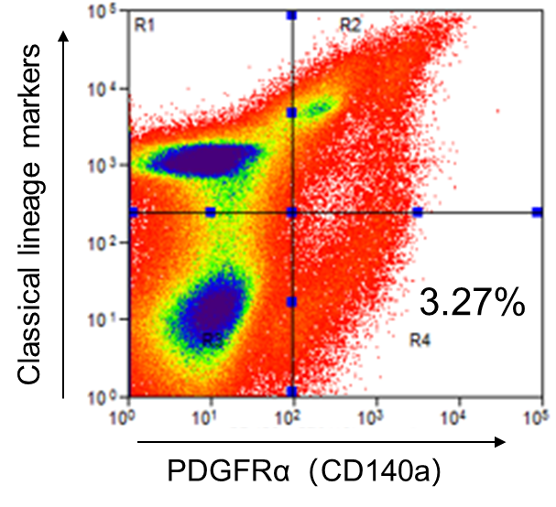
Cells were defined as lineage marker-negative (CD45⁻, TER-119⁻, CD31⁻, CD324⁻, CD146⁻, LYVE-1⁻) and PDGFRα-positive (CD140a⁺), corresponding to the R4 gate in this plot.
Supplementary Figure 2. Gene ontology (GO) biological processes enriched by CIRBP stimulation in primary lung fibroblasts.
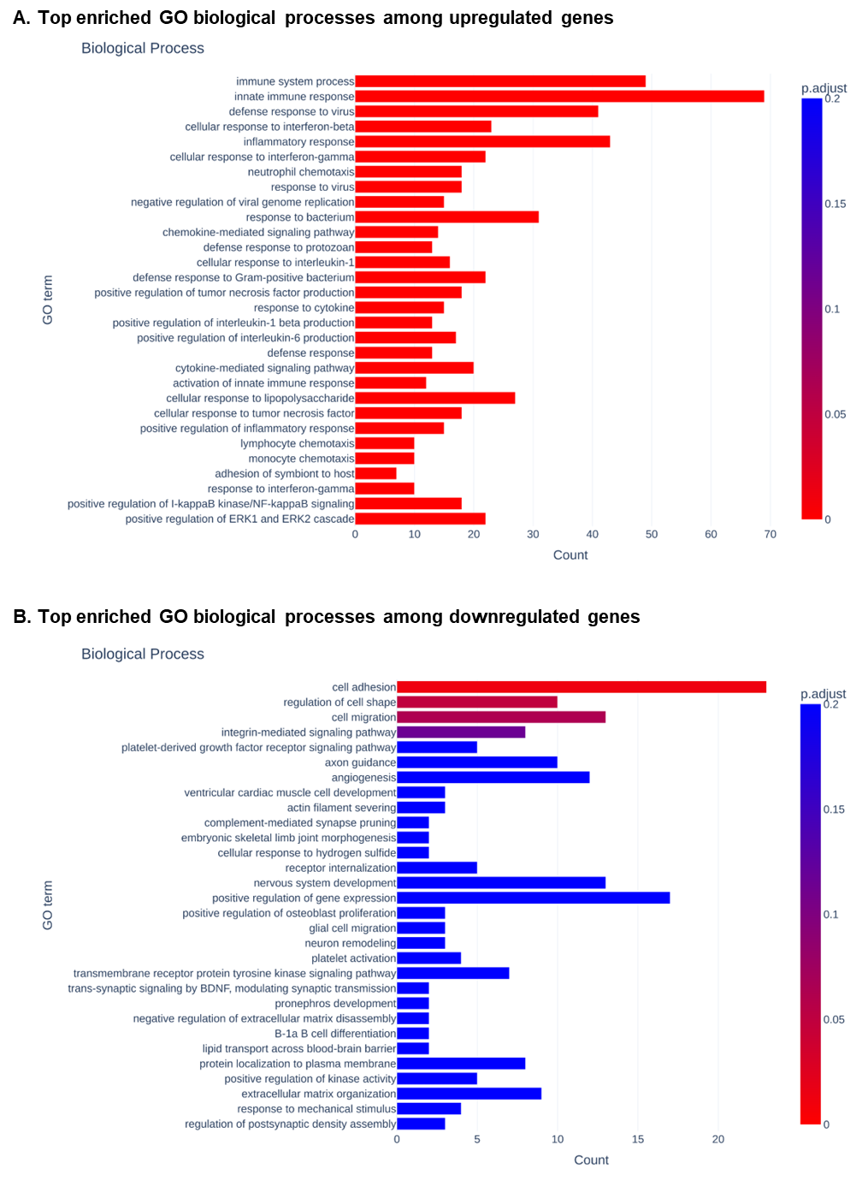
(A) Top enriched GO biological processes among genes upregulated in fibroblasts treated with recombinant CIRBP (rmCIRBP).
(B) Top enriched GO biological processes among the downregulated genes.
Supplementary Figure 3. GO molecular function terms enriched in CIRBP-stimulated fibroblasts.
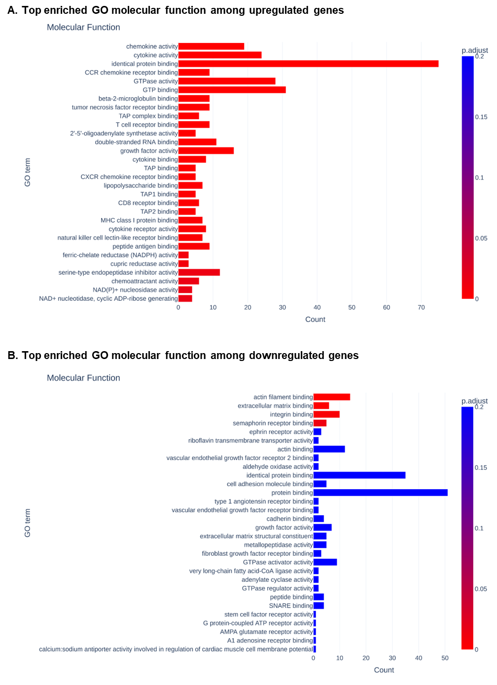
(A) Top enriched GO molecular functions among the upregulated genes.
(B) Top enriched GO molecular functions among the downregulated genes.
Supplementary Figure 4. GO cellular component categories enriched in CIRBP-regulated genes.
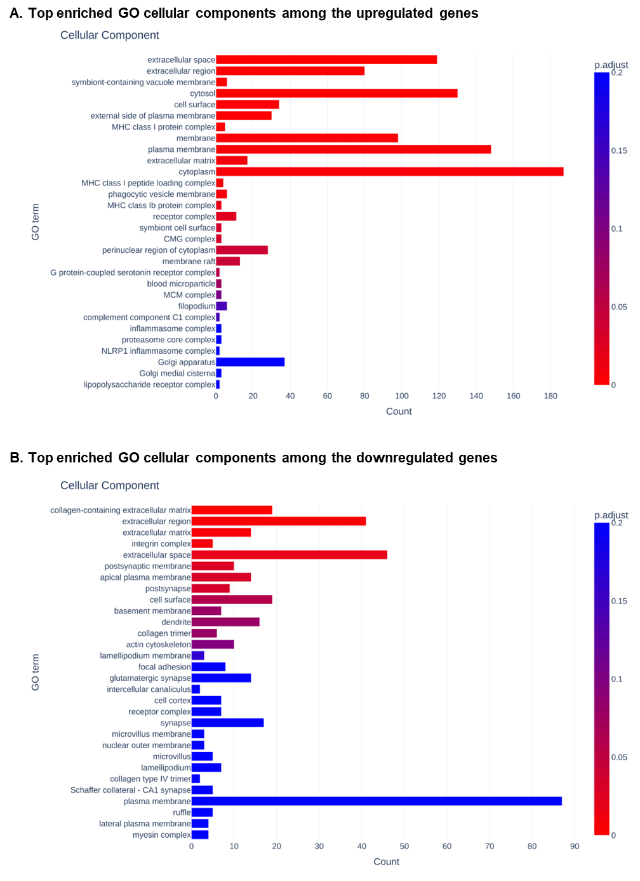
(A) Top enriched GO cellular components among the upregulated genes.
(B) Top enriched GO cellular components among the downregulated genes.
Supplementary Figure 5. Expression profile of cytokine- and chemokine-related genes in fibroblasts treated with CIRBP.
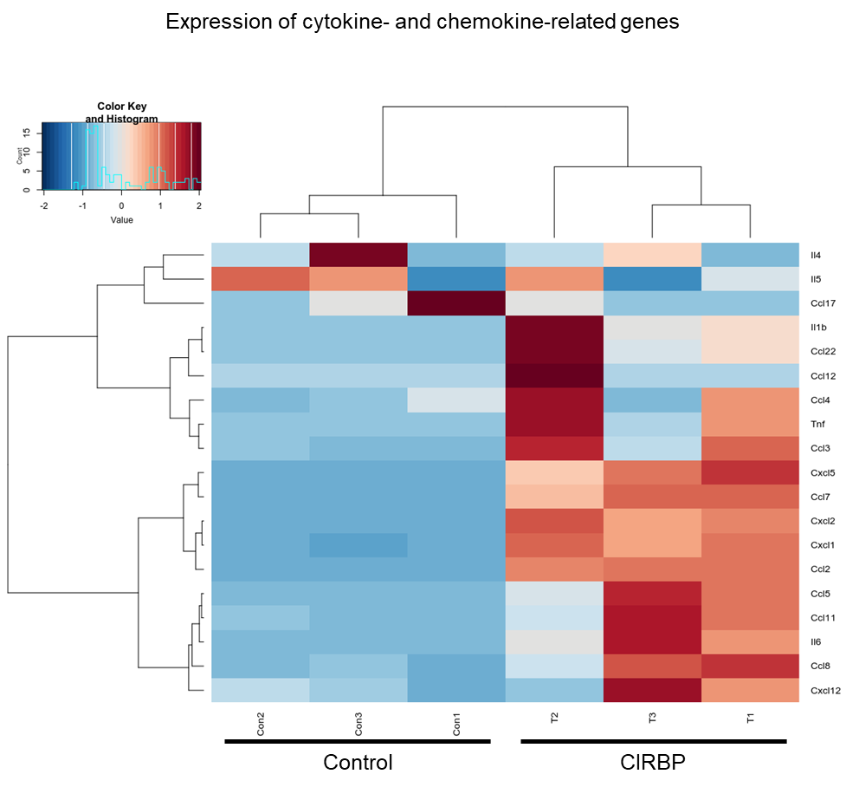
Heatmap showing the differential expression of representative cytokine and chemokine genes in rmCIRBP-treated primary lung fibroblasts compared to controls. Data derived from RNA-seq analysis.
Supplementary Figure 6. Expression of extracellular matrix (ECM)-related genes in fibroblasts treated with CIRBP.
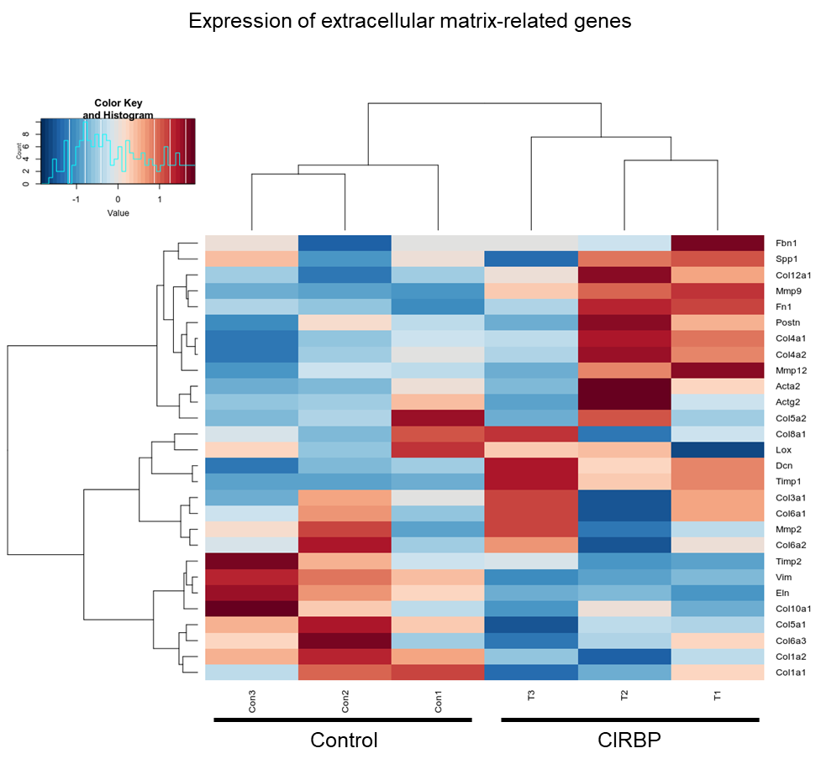
Heatmap showing the expression levels of ECM-associated genes in CIRBP-treated fibroblasts compared to the controls.
Supplementary Figure 7. Expression of growth factor-related genes in fibroblasts treated with CIRBP.
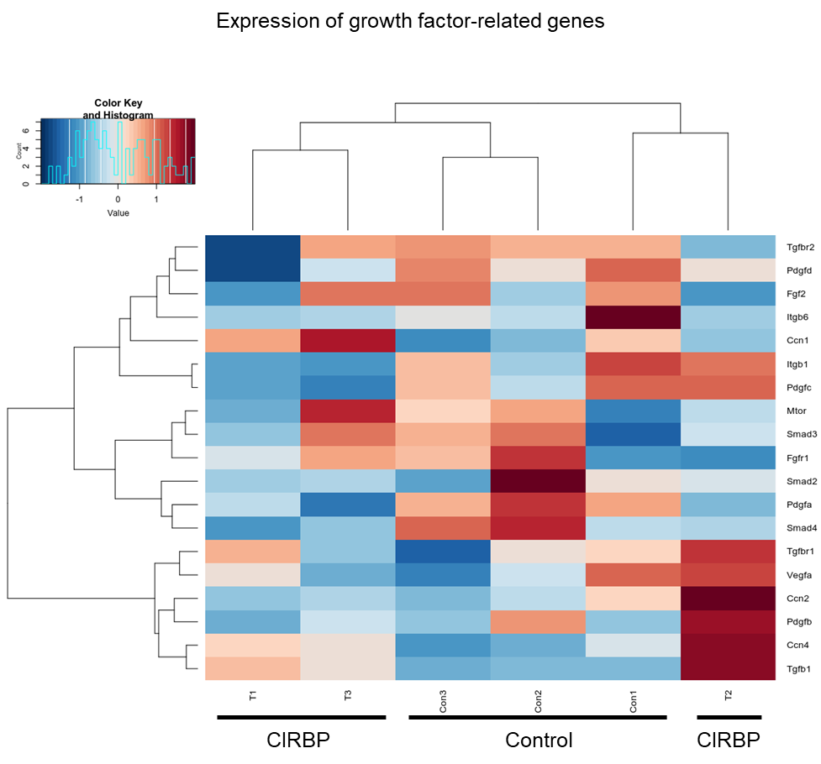
Heatmap showing the expression levels of growth factor-associated genes in CIRBP-treated fibroblasts compared to controls.

