Supramentary Materials

Predicting climate change induced-temperature variability on under-five children nutritional status in 22 Sub-Saharan Africa countries; A machine learning approach

Jovine Bachwenkizi^{1,8*}, Cheng He¹, Yixiang Zhu², Alice Mugisha^{1,3}, Boikhutso Tlou^{1,4}, Candida Moshiro⁵, Henry Mwambi⁶, Isabel Madzorera⁷, Renjie Chen², Haidong Kan^{2,9}, Wafaie W. Fawzi^{1,10,11}

- Department of Global Health and Population, Harvard T.H. Chan School of Public Health, Boston, Massachusetts, USA
- School of Public Health, Key Lab of Public Health Safety of the Ministry of Education, NHC Key Lab of Health Technology Assessment, IRDR ICoE on Risk. Interconnectivity and Governance on Weather/Climate Extremes Impact and Public Health, Fudan University, Shanghai, China.
- Department of Information Technology, School of Computing and Informatics Technology, College of Computing and Information Sciences, Makerere University, Kampala, Uganda
- Department of Public Health Medicine, Faculty of Health Sciences, University of KwaZulu-Natal, Durban, South Africa
- Department of Epidemiology and Biostatistics, Muhimbili University of Health and Allied Sciences, Dar es Salaam, Tanzania.
- School of Mathematics, Statistics and Computer Science, University of KwaZulu-Natal, Pietermaritzburg, South Africa
- Division of Community Health Sciences, School of Public Health, University of California, Berkeley, California, USA.
- Department of Environmental and Occupational Health, Muhimbili University of Health and Allied Sciences, Dar es Salaam, Tanzania.
- Children’s Hospital of Fudan University, National Center for Children’s Health, Shanghai, China
- Department of Epidemiology, Harvard T.H. Chan School of Public Health, Boston, Massachusetts
- Department of Nutrition, Harvard T.H. Chan School of Public Health, Boston, Massachusetts

*Correspondence should be addressed to: Dr. Jovine Bachwenkizi, Email:
jbachwenkizi@hsph.harvard.edu

Determination of future importance to predict Nutritional status using Machine Learning
This figure presents the relative importance of selected features in predicting child nutritional status (measured by stunting, underweight and wasting) using a model classifier of Supervised Machine Learning. Variables include household and maternal characteristics, such as access to safe water, maternal education household economic status measured by some indicators in DHS, and child characteristics. The importance scores reflect the mean decrease in impurity attributed to each feature, indicating their contribution to the model’s predictive accuracy. Features are ranked in descending order, with darker red shades representing higher importance. This visualization aids in identifying key socioeconomic and environmental predictors relevant to undernutrition.
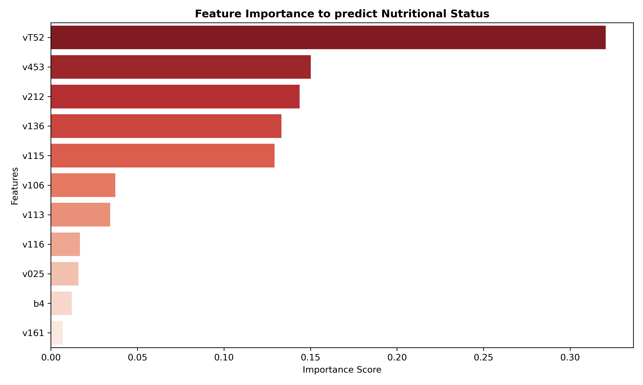
Figure S1. Feature importances which were used to predict nutritional status. Note: vT52- temperature variability, V025-Place of residence, V161-Source of cooking fuel, V113-Access to safe water, V116-Access to toilet facility, V106-Mother education level, b4- Children gender, v212-Women’s age in Year, V115-Average time to get water sources, V136- Number of Household member, V453- Hemoglobin level (g/dl-1 decmal)

V130-religion, V190-wealth index, V116-toilet facility type, V312-contraceptive method, V025-residence, V157-media exposure, V106-educational status, V218-number of children, V501-marrital status, V717-occupation, V040-altitude, V113-source of drinking water, V213-current pregnant, V136-family size, V012-age of respondent, N_status-nutritional status, V151-sex of household, and V463A-smoking.

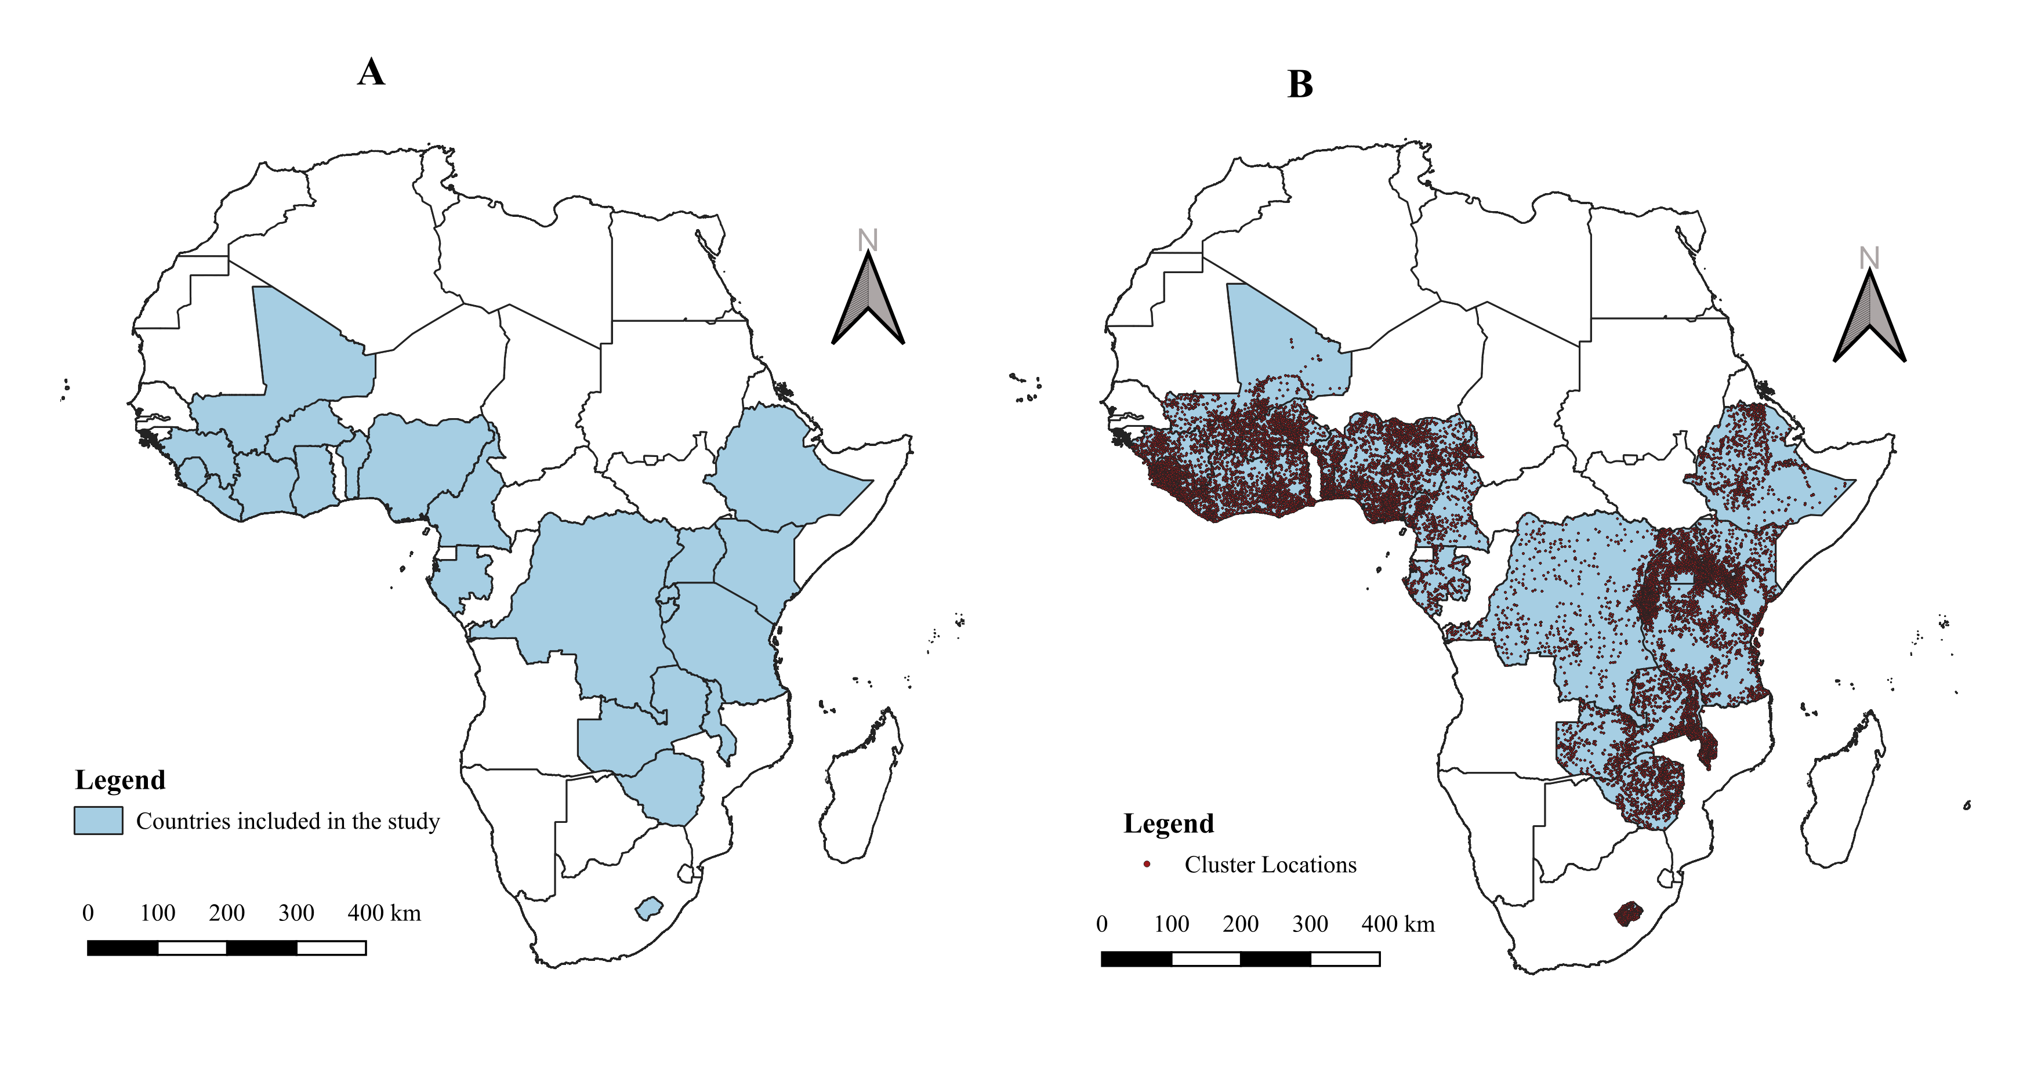
Figure S2. Study locations and clusters

Table S1. Distribution and prevalences of nutritional status across 22 SSA countries.
Country | Survey year (DHS) | Observations | Children stunted (%) | Children wasted (%) | Children underweight (%)
Benin | 2017-18 | 74,673 | 32.2 | 5 | 16.8
 | 2011 | 88,174 | 43.1 | 8.4 | 18.4
Burkina Faso | 2021 | 83,949 | 22.6 | 10.6 | 17.8
 | 2010 | 82,095 | 34.6 | 15.5 | 25.7
Burundi | 2016-17 | 78,367 | 55.9 | 5.1 | 29.3
 | 2010 | 42,420 | 57.7 | 5.8 | 28.8
Cameroon | 2018 | 60,699 | 28.9 | 4.3 | 11
 | 2011 | 72,622 | 32.5 | 5.6 | 14.6
Congo DR | 2013-14 | 95,949 | 42.7 | 7.9 | 22.6
 | 2007 | 48,291 | 45.5 | 10 | 25.1
Cote d'Ivoire | 2021 | 68,429 | 23.4 | 8.4 | 14
 | 2011-12 | 51,187 | 29.8 | 7.5 | 14.9
Ethiopia | 2016 | 75,224 | 38.4 | 9.9 | 23.6
 | 2011 | 77,744 | 44.4 | 9.7 | 28.7
Gabon | 2019-21 | 46,489 | 14.4 | 3.4 | 5.4
 | 2012 | 41,675 | 16.5 | 3.3 | 6
Ghana | 2022 | 69,684 | 17.4 | 6 | 12.3
 | 2014 | 43,945 | 18.8 | 4.7 | 11
 | 2008 | 46,536 | 28 | 8.5 | 13.9
Guinea | 2018 | 49,543 | 30.3 | 9.2 | 16.3
 | 2012 | 45,049 | 31.2 | 9.6 | 18
Kenya | 2022 | 156,571 | 17.6 | 4.9 | 10.1
 | 2014 | 153,840 | 26 | 4 | 11
 | 2008-09 | 38,515 | 35.3 | 6.7 | 16.1
Lesotho | 2014 | 40,197 | 33.2 | 2.8 | 10.3
 | 2009 | 44,546 | 39.2 | 3.8 | 13.2
Liberia | 2019-20 | 41,999 | 29.8 | 3.4 | 10.9
 | 2013 | 48,219 | 31.6 | 6 | 15
 | 2007 | 34,670 | 39.4 | 7.5 | 19.2
Malawi | 2015-16 | 120,492 | 37.1 | 2.7 | 11.7
 | 2010 | 118,850 | 47.1 | 4 | 12.8
Mali | 2018 | 54,571 | 26.9 | 9 | 18.6
 | 2012-13 | 58,330 | 38.3 | 12.7 | 25.5
 | 2006 | 73,685 | 37.7 | 15.2 | 26.7
Nigeria | 2018 | 188,010 | 36.8 | 6.8 | 21.8
 | 2013 | 178,894 | 36.8 | 18 | 28.7
 | 2008 | 156,809 | 40.6 | 13.9 | 23.1
Rwanda | 2019-20 | 55,920 | 33.1 | 1.1 | 7.7
 | 2014-15 | 54,905 | 37.9 | 2.2 | 9.3
 | 2010 | 56,505 | 44.2 | 2.8 | 11.4
Sierra Leone | 2019 | 72,248 | 29.5 | 5.4 | 13.6
 | 2013 | 75,299 | 37.9 | 9.3 | 16.4
 | 2008 | 41,985 | 36.4 | 10.2 | 21.1
Tanzania | 2022 | 73,774 | 30 | 3.3 | 12.1
 | 2015-16 | 64,880 | 34.4 | 4.5 | 13.7
 | 2010 | 50,414 | 42 | 4.8 | 15.8
Uganda | 2016 | 91,167 | 28.9 | 3.5 | 10.5
 | 2011 | 44,977 | 33.4 | 4.7 | 13.8
 | 2006 | 45,439 | 38.1 | 6.1 | 15.9
Zambia | 2018 | 65,454 | 34.6 | 4.2 | 11.8
 | 2013-14 | 83,058 | 40.1 | 6 | 14.8
 | 2007 | 35,562 | 45.4 | 5.2 | 14.6
Zimbabwe | 2015 | 43,706 | 26.8 | 3.2 | 8.4
 | 2010-11 | 41,946 | 32 | 3 | 9.7
 | 2005-06 | 42,698 | 34.6 | 6.9 | 13.2

Table S2. Odds ratio (and corresponding 95% confidence interval) of nutritional status associated with 1⁰C increase in temperature, stratified by potential effect modifiers.
Variables | Underweight | Stunting | Wasting
 | OR (95 %CI) | OR (95 %CI) | OR (95 %CI)
Place of residence
Urban | 0.99 (0.89, 1.05) | 0.85 (0.80, 1.01) | 0.90 (0.80, 1.01)
Rural | 1.08 (1.03, 1.12) | 1.01 (1.00, 1.02) | 1.00 (0.99, 1.04)
Source of cooking fuels
Clean fuel | 0.89 (0.80, 1.02) | 0.79 (0.70, 0.99) | 0.99 (0.90, 1.09)
Unclean fuel | 1.02 (1.00, 1.04) | 1.04 (1.01, 1.06) | 1.00 (0.99, 1.02)
Access to safe water
No access/ Basic | 1.03 (0.99, 1.07) | 1.02 (1.01, 1.05) | 1.05 (0.99, 1.09)
Intermediate | 1.00 (0.97, 1.03) | 0.93 (0.90, 1.00) | 1.02 (0.97, 1.06)
optimal | 0.91 (0.89, 0.95) | 0.97 (0.94, 0.99) | 0.99 (0.96, 1.07)
Access to the toilet facility
Yes | 0.84 (0.80, 0.90) | 0.97 (0.95, 1.00) | 0.89 (0.86, 1.07)
No | 1.04 (1.01, 1.10) | 1.08 (1.04, 1.15) | 1.00 (0.99, 1.10)
Mother education level
No education | 1.03 (1.01, 1.06) | 1.09 (1.05, 1.12) | 1.05 (1.03, 1.08)
Primary | 0.90 (0.84, 1.05) | 1.00 (0.93, 1.03) | 0.95 (0.90, 1.00)
Secondary | 0.98 (0.96, 1.02) | 0.88 (0.80, 1.02) | 0.81 (0.76, 0.99)
Higher | 0.92 (0.89, 0.99) | 0.86 (0.82, 0.96) | 0.99 (0.98, 1.01)
Children gender
Male | 0.95 (0.90, 1.06) | 0.90 (0.83, 1.01) | 1.01 (0.99, 1.02)
Female | 1.04 (0.95, 1.10) | 1.01 (0.99, 1.04) | 1.07 (1.01, 1.10)

Table S3. Multicollinearity test for the independent variables used to predict nutritional status. All Variance Inflation Factor (VIF) were within the range of >1.00, supporting the independence of these factors in subsequent analyse.
Feature | Variance Inflation Factor (VIF)
Place of residence | 1.54
Mother educational level | 1.39
Sources of drinking water | 1.35
Types of toilet facilities | 1.33
Types of cooking fuel | 1.15
Mother’s age | 1.08
Hemoglobin level of the child | 1.07
Time to get to the water sources | 1.06
Number of household members | 1.05
Anemia level | 1.03
Sex of Child | 1.02

