Cytotoxic activity of marine derived bioactive compounds from Red Sea sponges supported by LC-MS/MS profiling and molecular docking
Noha E. Ibrahim ¹, Amal M. El-Feky ^{2*}, Mohamed Aboelmagd ², Nadia A. Mohammed ³ , Rehab A. Mohamed ³, Ahmed A. El-Rashedy ^{4,5}, Hanaa M. Rady ⁶
¹ Microbial Biotechnology Department, National Research Centre, 33 El Bohouth St. (Former El Tahrir St.), P.O. 12622, Dokki, Giza, Egypt.
² Pharmacognosy Department, National Research Centre, 33 El Bohouth St. (Former El Tahrir St.), P.O. 12622, Dokki, Giza, Egypt.
³ Medical Biochemistry Department, National Research Centre, 33 El Bohouth St. (Former El Tahrir St.), P.O. 12622, Dokki, Giza, Egypt.
⁴ Natural and Microbial Products Department, National Research Center, 33 El Bohouth St. (Former El Tahrir St.), Dokki, P.O. 12622, Giza, Egypt, ⁵ Department Organic and Medicinal Chemistry, Faculty of Pharmacy, University of Sadat City, Menoufia, 32897, Egypt

⁶ Chemistry of Natural Compounds Department, National Research Centre, 33 El Bohouth St. (Former El Tahrir St.), P.O. 12622, Dokki, Giza, Egypt.

Correspondence: Amal M. El-Feky , email: ammelfeky@hotmail.com

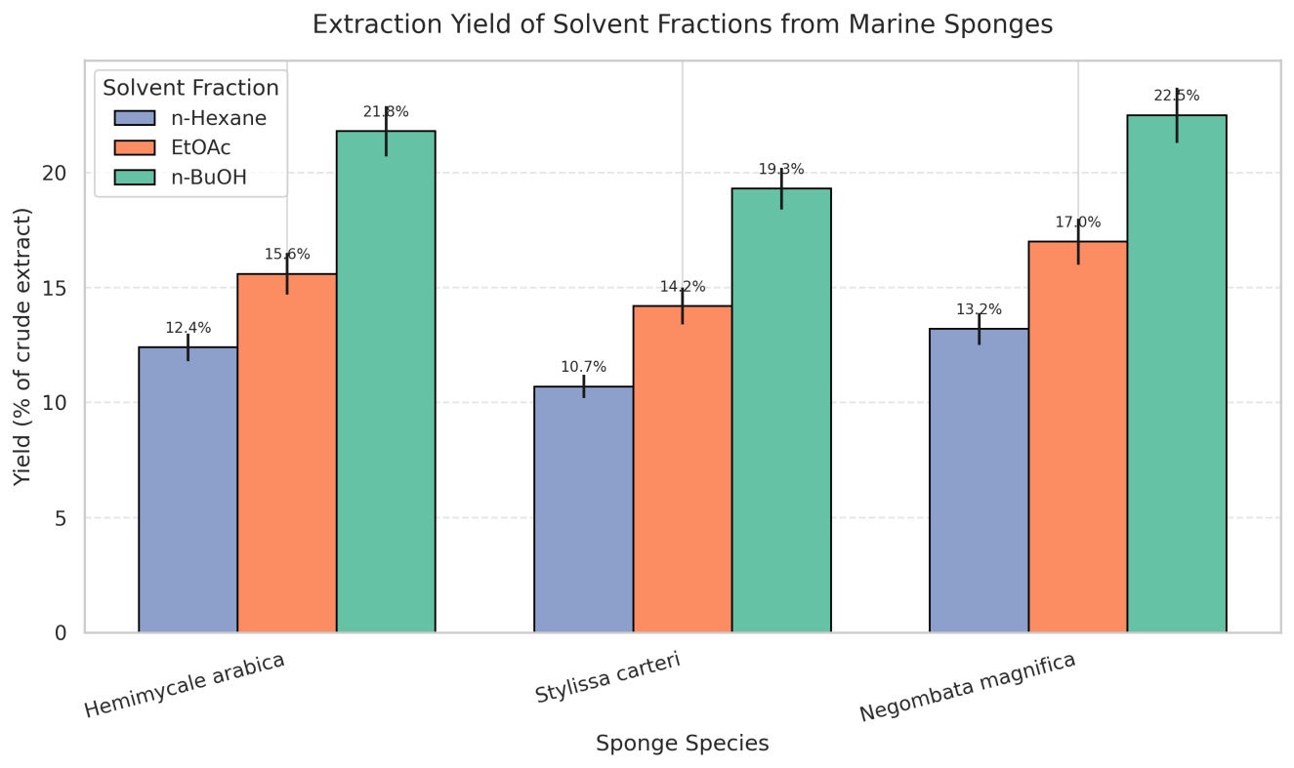 Figure S1. Extraction yields (% w/w of crude extract) of sequential solvent fractions (n-hexane, ethyl acetate, and n-butanol) obtained from three marine sponge species: Hemimycale arabica, Stylissa carteri, and Negombata magnifica. Values are expressed as mean ± SD (n = 3). Bars with different lowercase letters (a–c) differ significantly among solvent fractions within the same species, while uppercase letters (A–C) indicate significant differences for the same solvent among species (p < 0.05, one-way ANOVA followed by Tukey’s post hoc test). Error bars represent standard deviations.

Table S1: Summary of docking results using autodock vein for the identified compounds in Stylissa carteri total extract with the chk2 receptor.

ligands | Hydrogen bonds between atoms of ligands and amino acids of receptor |  |  |  |  | S- score  (binding energy)  (kcal/mol)
ligands | ligands  Atoms | Receptor |  | Type | Distance (Å) | S- score  (binding energy)  (kcal/mol)
ligands | ligands  Atoms | Atoms | Residues | Type | Distance (Å) | S- score  (binding energy)  (kcal/mol)
Hymenialdisine  (1) | H 2175 | O 992 | GLU351 | H-don | 2.13 | -8.35
Hymenialdisine  (1) | H 2174 | O 992 | THR 367 | H-don | 1.87 | -8.35
Spongiacidin D  (2) | O 4390 | N 1253 | MET 304 | H-acc | 2.05 | -7.30
Dermacozine H (3) | N 27 | OD2 | ASP 311 | H-don | 3.03 | -6.53
 | O 32 | O | Glu302 | H-don | 2.71
Hymenidin(4) | N26 | OD1 | Asn 352 | H-don | 3.23 | -6.42
 | N22 | N | Cys231 | H-acceptor | 3.22
Oroidin(5) | O9 | N | Met304 | H-acceptor | 3.24 | -6.55
 | 5-ring | CB | Leu226 | Pi-H | 4.08
Debromohymenialdisine(6) | 5-ring | CB | Leu226 | Pi-H | 4.00 | -5.86

