SUPPLEMENTARY INFORMATION

Table of Contents
Title | Page Number
Microbial community shifts observed during antibiotic administration | 2
BB-12 supplementation increased Coprococcus, a known short chain fatty acid producer | 2
Absolute Distribution of ARG Resistance Mechanisms | 2
Absolute Distribution of ARG Drug Classes | 3
Alpha Diversity changes are correlated with ARG abundances | 3
Figure S1: Bristol Stool Chart | 4
Figure S2: Comparison of the longitudinal alpha diversity changes | 4
Figure S3: Correlation plot displaying Pearson’s correlations between percent alpha diversity change compared to baseline (Shannon diversity) and total RPKM abundance within each of the seven ARG resistance mechanisms. | 5
Figure S4: Boxplots displaying the longitudinal alpha diversity changes | 6
Table S1: t-test results describing percent alpha diversity changes (Shannon index) between the BB-12 and control treatments using 16S rRNA gene sequencing data | 7
Table S2: Pairwise t-test results for total ARG comparisons between treatments (BB-12, control) at each time point. | 7
Table S3: Pairwise t-test results for total ARG comparisons within treatments (BB-12, control) between time points. | 8

Microbial community shifts observed during antibiotic administration
Principal coordinates analysis (PCoA) was performed to visualize the beta diversity using Bray-Curtis dissimilarity method and permutational multivariate analysis of variance (PERMANOVA) was used to detect significant microbial community structure differences between the groups and treatments (Fig. S2). The study day contributes significantly to the variance of the community composition, with the largest community composition shift between day 0 (baseline) and day 7, which gradually recovers as antibiotic (day 7) and BB-12 (day 14) administration ended (PERMANOVA, p= 0.001; Fig. S2A, Table S2). No differences between treatment groups were observed (Fig. S2B).

BB-12 supplementation increased Coprococcus, a known short chain fatty acid producer
We looked at the phyla composition for BB-12 and control recipients throughout the 30 days (Fig. S3, Table S3). On day 7, a reduction in Firmicutes and increase in Proteobacteria is observed across both treatment groups.
In order to gain insights into genera that are differentially abundant across the five study timepoints (Fig. S4 and Fig. S5), we used metagenomeSeq. This approach is designed to determine features (e.g., genera) that are differentially abundant between two (or more) groups of multiple samples and relies on a novel normalization technique and a statistical model that accounts for under-sampling (a common feature of large-scale 16S rRNA gene sequencing studies).

There were no taxa that exhibited significant differences at day 0 between BB-12 and control recipients. At day 7, Coprococcus 2 and CAG-56 were significantly enriched in BB-12 recipients compared to control recipients (Fig. S6, Table S4). A member of the Bacteroidales order was significantly more abundant in the BB-12 recipients at day 14, and at days 21 and 30, the BB-12 treatment resulted in significant increases of Coprococcus 2. Interestingly, Bacteroidales species have been proposed to be reservoirs of antibiotic resistance genes in the human gut (PMID: 35013297).⁵⁵ Coprococcus is a known butyrate-producing bacterium that uses acetate as substrate (PMID: 29178599).⁵⁶

Absolute Distribution of ARG Resistance Mechanisms
We assessed the absolute ARG abundances by grouping them into resistance mechanisms and compared them across participants and time points (Fig. S7 and Fig. S8). None of the ARG resistance mechanism categories were significantly different between the treatments at any of the study time points (t-test, all p > 0.05; Table S5). To determine whether there were any significant shifts due to antibiotic and/or control/probiotic supplementation, we compared the ARG RPKM abundance between time points within each resistance mechanism. The only significant shift between day 0 and day 7 was observed for the antibiotic inactivation ARG resistance mechanism. Control recipients exhibited a significant increase during antibiotic administration (t-test, p = 0.012; Table S6), this increase was sustained throughout the end of control supplementation (t-test, p = 0.045; Table S6). The antibiotic inactivation ARGs reached baseline levels by day 30 (t-test, p = 0.044; Table S6).

Absolute Distribution of ARG Drug Classes
To get a better understanding about the type of antibiotic each of the detected ARG was assigned to, the ARG were assigned to drug classes and compared across treatments and time points (Fig. S9 and Fig. S10). To determine whether there were any significant differences observed, we looked at the top 14 ARG drug classes. There were no significant differences observed between the ARG drug classes between treatments at each time point (t-test, all p > 0.05; Table S7). Despite the overall increase in ARGs from baseline to day 7, none of the shifts reached statistical significance (t-test, all p > 0.05; Table S8). However, for the control recipients, we did record several significant ARG abundance decreases from day 7 to day 14 within the cephalosporin, disinfecting agents and antiseptics, fluoroquinolone, and penam ARG drug classes (t-test, p = 0.012, p = 0.018, p = 0.020, and p = 0.019, respectively; Table S8). Additionally, the control recipients exhibited significant reduction in glycylcycline and phenicol ARGs from day 7 to day 21, and cephamycin and tetracycline ARGs from day 7 to day 30 (t-test, p = 0.038, p = 0.011, and p = 0.050, p = 0.014, respectively; Table S8). The only significant shift that was observed for the BB-12 recipients was a significant reduction in tetracycline ARGs from day 7 to day 30 (t-test, all p = 0.040; Table S8).

Alpha Diversity changes are correlated with ARG abundances
Using a Pearson’s test for correlation analysis, we determined whether there was any correlation between the abundance of ARGs and alpha diversity changes across the study period and treatments. First, we looked at the ARG resistance mechanisms and found that an increase in Shannon diversity was correlated with an increase in antibiotic target protection ARGs at study day 7 for BB-12 recipients (Pearson, p = 0.020; Fig. S11; Table S9). Control recipients exhibited a positive correlation between alpha diversity and antibiotic target replacement ARGs at study days 14 and 21 (Pearson, p = 0.001 and p = 0.034, respectively; Table S9).

Next, we looked at whether a loss of alpha diversity was significantly correlated with changes in ARG drug classes (Table 24). For BB-12 recipients, glycylcycline ARGs were positively correlated with increases in alpha diversity at study day 14 and 21 (Pearson, p = 0.003, p = 0.007, respectively; Fig. S12, Table S10), whereas control recipients only exhibited that positive correlation at study day 14 (Pearson, p = 0.045; Fig. S12, Table S10). Increased diaminopyrimidine ARGs were correlated with increases in alpha diversity for control recipients at days 14 and 21 (Pearson, p = 0.002, p = 0.041, respectively; Fig. S12, Table S10), and glycopeptide ARGs were elevated in control recipients that exhibited increases in alpha diversity at study day 21 (Pearson, p = 0.004; Fig. S12, Table S10). Lastly, BB-12 recipients exhibited higher levels of carbapenem ARGs that correlated with increases in alpha diversity at study day 21 (Pearson, p = 0.018; Fig. S12, Table S10).

Figure S1.
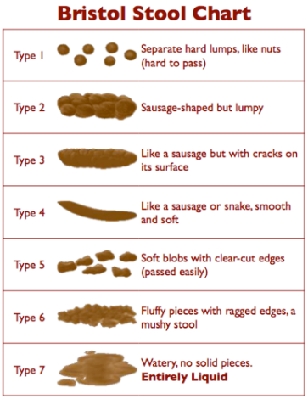
Figure S1 shows the Bristol Stool Chart used during the study. Participants were asked to characterize their stools based on this chart. Stools that are Type 6 or Type 7 are considered a loose stool.²⁸

Figure S2.
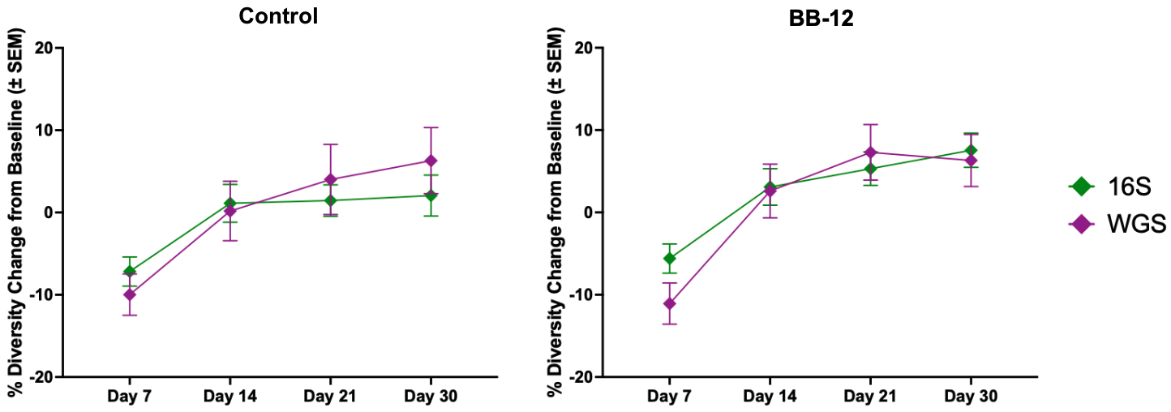
Figure S2. Comparison of the longitudinal alpha diversity changes (± SEM) for each treatment between the whole genome sequencing (WGS; purple diamond/line) data from the subset and the 16S rRNA gene sequencing (16S; green diamond/line) data from the whole cohort. Each graph displays the percent Shannon diversity change compared to day 0 for each of the treatments (BB-12, control).

Figure S3.
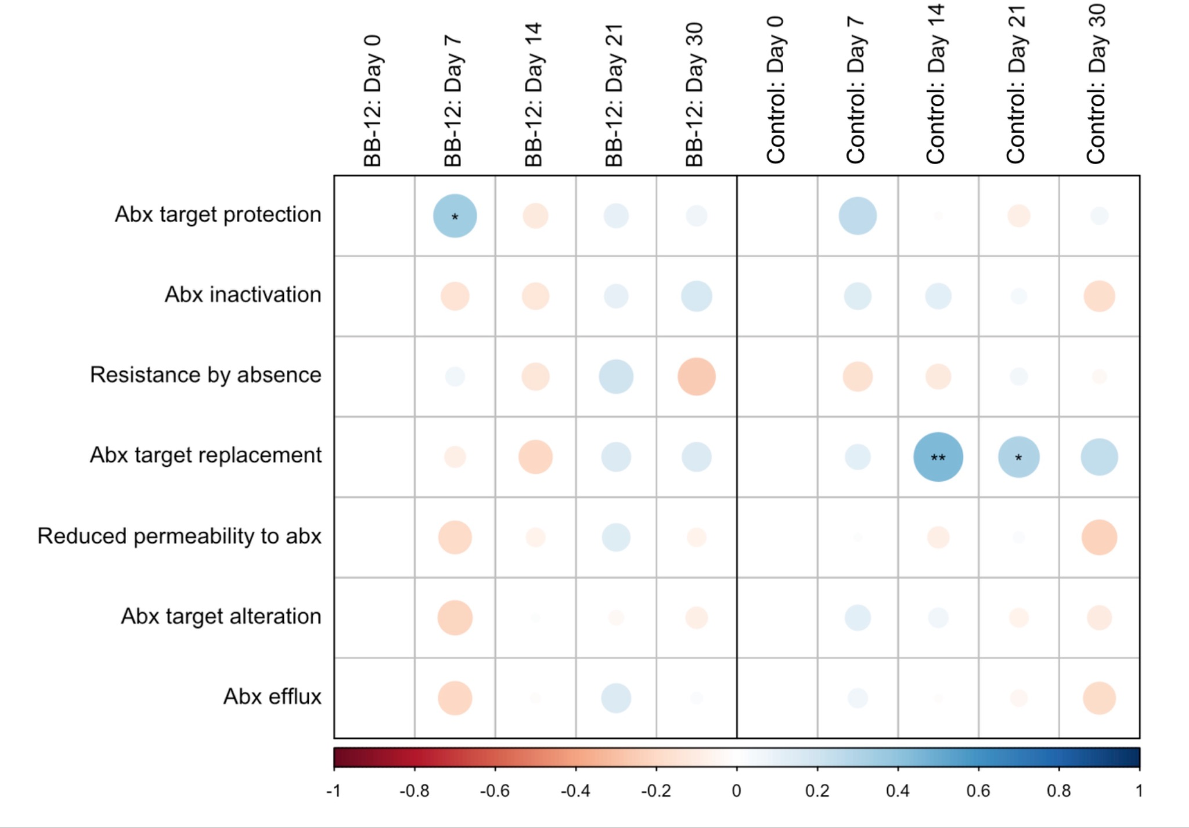
Figure S3: Correlation plot displaying Pearson’s correlations between percent alpha diversity change compared to baseline (Shannon diversity) and total RPKM abundance within each of the seven ARG resistance mechanisms. The correlations were separated by treatments (BB-12 and control) and study day. Blue and red colors represent negative and positive correlations, respectively. The color intensity is proportional to the degree of association. Asterisks indicate correlation significance: ** p<0.01, * p<0.05.

Figure S4.

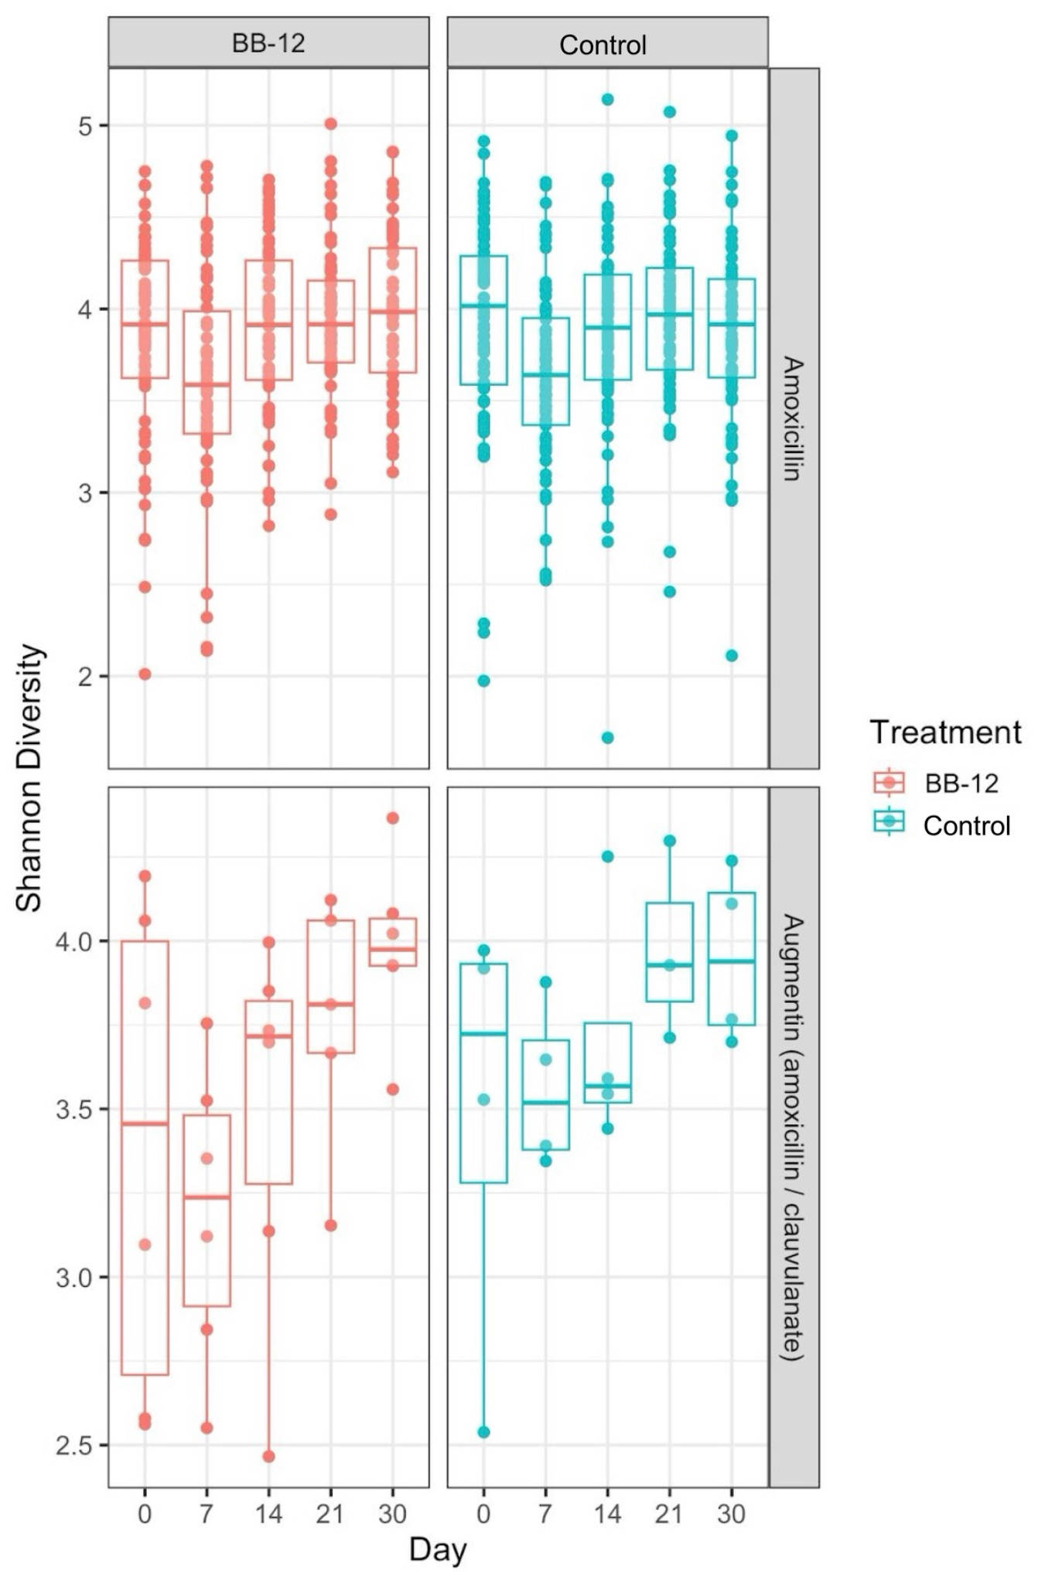
Figure S4. Boxplots displaying the longitudinal alpha diversity changes (Shannon Diversity) for each treatment (BB-12, control), separated by study day and prescribed antibiotic (amoxicillin, augmentin) using the 16S rRNA gene sequencing data.

Table S1: t-test results describing percent alpha diversity changes (Shannon index) between the BB-12 and control treatments using 16S rRNA gene sequencing data. Percent change within each treatment group was calculated comparing the Shannon diversity index at each follow-up day (i.e., day 7, day 14, day 21, and day 30) to day 0. Mean and standard deviation (SD) shown for day 7, day 14, day 21, and day 30 for each BB-12/control treatment group.

 | Control vs. BB-12 |  | Control |  | BB-12
 | t-test | p-value | Mean | SD | Mean | SD
Day 7 | -0.622 | 0.535 | -7.174 | 16.223 | -5.604 | 15.624
Day 14 | -0.611 | 0.542 | 1.122 | 21.226 | 3.092 | 18.974
Day 21 | -1.385 | 0.168 | 1.448 | 16.592 | 5.315 | 17.027
Day 30 | -1.649 | 0.102 | 2.060 | 21.414 | 7.550 | 16.228

Table S2: Pairwise t-test results for total ARG comparisons between treatments (BB-12, control) at each time point.

Study Day | Average Total RPKM | group1 | group2 | n1 | n2 | t statistic | df | p
0 | RPKM | BB-12 | Control | 46 | 50 | 0.34881237 | 82.8188739 | 0.728
7 | RPKM | BB-12 | Control | 46 | 49 | 0.7511762 | 56.889452 | 0.456
14 | RPKM | BB-12 | Control | 44 | 50 | 0.63264922 | 91.2813298 | 0.529
21 | RPKM | BB-12 | Control | 45 | 48 | 0.44074087 | 79.260338 | 0.661
30 | RPKM | BB-12 | Control | 46 | 50 | 0.77612263 | 88.0583593 | 0.44

Table S3: Pairwise t-test results for total ARG comparisons within treatments (BB-12, control) between time points.

Treatment | Average Total RPKM | group1 | group2 | n1 | n2 | t statistic | df | p
BB-12 | RPKM | 0 | 7 | 46 | 46 | -0.2956709 | 88.9014827 | 0.768
BB-12 | RPKM | 0 | 14 | 46 | 44 | 0.79015733 | 48.8331872 | 0.433
BB-12 | RPKM | 0 | 21 | 46 | 45 | 0.9977991 | 49.5429944 | 0.323
BB-12 | RPKM | 0 | 30 | 46 | 46 | 1.14215429 | 48.3138336 | 0.259
BB-12 | RPKM | 7 | 14 | 46 | 44 | 1.31110585 | 49.7856346 | 0.196
BB-12 | RPKM | 7 | 21 | 46 | 45 | 1.53907723 | 50.6701411 | 0.13
BB-12 | RPKM | 7 | 30 | 46 | 46 | 1.70502649 | 49.1395401 | 0.094
BB-12 | RPKM | 14 | 21 | 44 | 45 | 0.70660245 | 86.5338274 | 0.482
BB-12 | RPKM | 14 | 30 | 44 | 46 | 1.26250411 | 87.1932994 | 0.21
BB-12 | RPKM | 21 | 30 | 45 | 46 | 0.47416805 | 86.5403843 | 0.637
Control | RPKM | 0 | 7 | 50 | 49 | -0.1399605 | 68.63517 | 0.889
Control | RPKM | 0 | 14 | 50 | 50 | 0.7559982 | 56.7847758 | 0.453
Control | RPKM | 0 | 21 | 50 | 48 | 0.97791482 | 53.651934 | 0.333
Control | RPKM | 0 | 30 | 50 | 50 | 1.26681738 | 53.5492215 | 0.211
Control | RPKM | 7 | 14 | 49 | 50 | 1.74546229 | 80.1475413 | 0.085
Control | RPKM | 7 | 21 | 49 | 48 | 2.27608499 | 68.6523842 | 0.026
Control | RPKM | 7 | 30 | 49 | 50 | 2.86368685 | 68.3528756 | 0.006
Control | RPKM | 14 | 21 | 50 | 48 | 0.60277735 | 91.0758637 | 0.548
Control | RPKM | 14 | 30 | 50 | 50 | 1.43499764 | 91.6018466 | 0.155
Control | RPKM | 21 | 30 | 48 | 50 | 0.96146977 | 95.8980178 | 0.339

