Supplementary Information
Machine learning and response surface analysis of mean drop size and dispersed phase holdup in an L-shaped pulsed sieve plate column
Fatemeh Ardestani, Fatemeh Bahmanzadegan, Ahad Ghaemi*
School of Chemical, Petroleum and Gas Engineering, Iran University of Science and Technology, P.O. Box: 16765-163, Tehran, Iran
*Corresponding author’s E-mail: aghaemi@iust.ac.ir

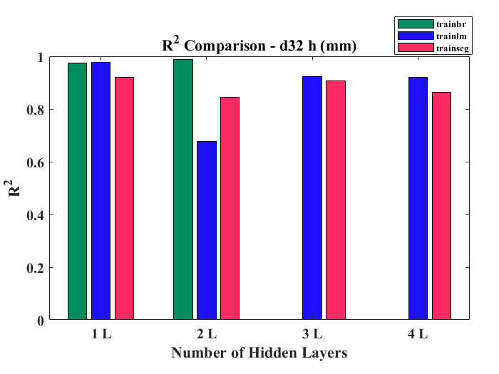 | 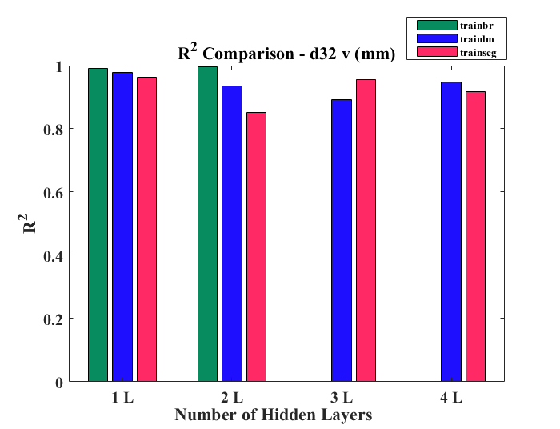
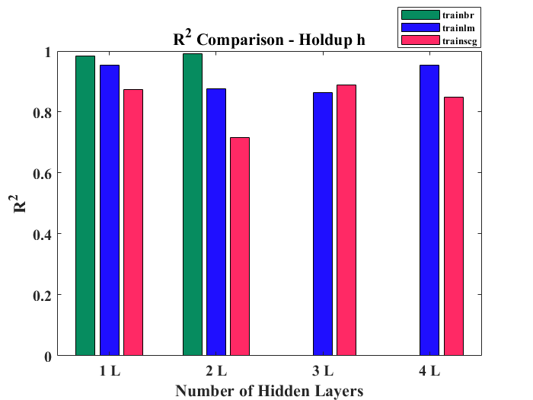 | 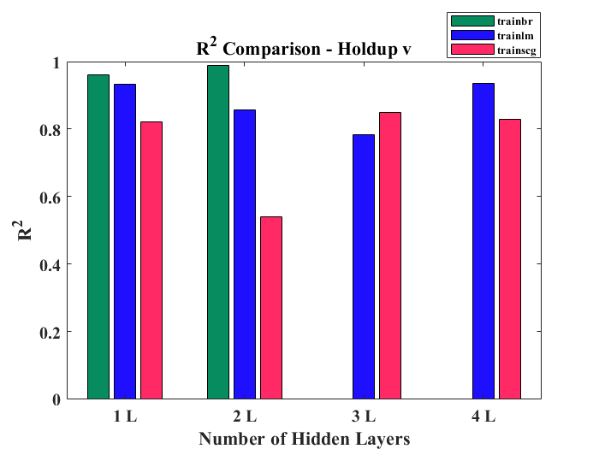
Fig. S1. Comparison of the coefficient of determination (R²) values for different neural network training algorithms (trainbr, trainlm, trainscg) as a function of the number of hidden layers (1–4). Performance was evaluated for four different outputs: (a) Sauter mean diameter in the horizontal direction (d₃₂ h), (b) Sauter mean diameter in the vertical direction (d₃₂ v), (c) liquid holdup in the horizontal direction (holdup h), and (d) liquid holdup in the vertical direction (holdup v). The results demonstrate how the choice of hidden layers and training algorithms impacts the predictive accuracy of the models across various target variables.

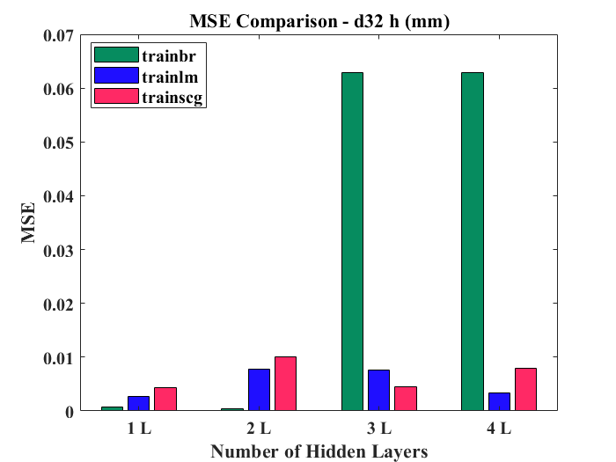 | 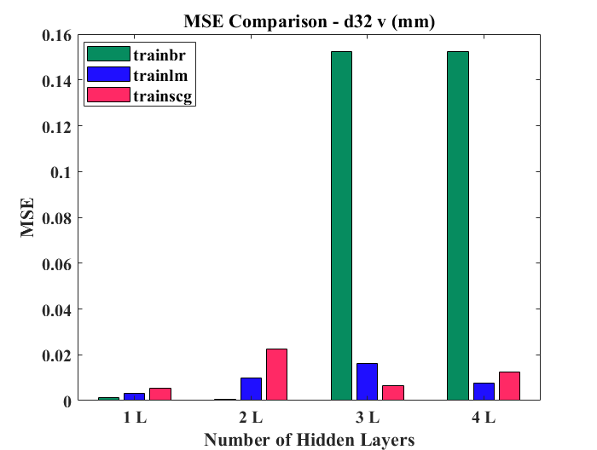
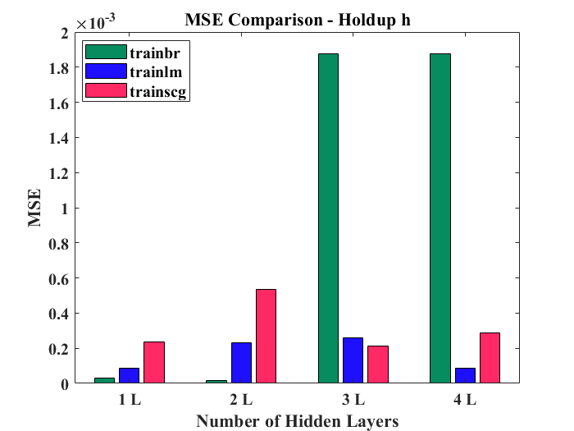 | 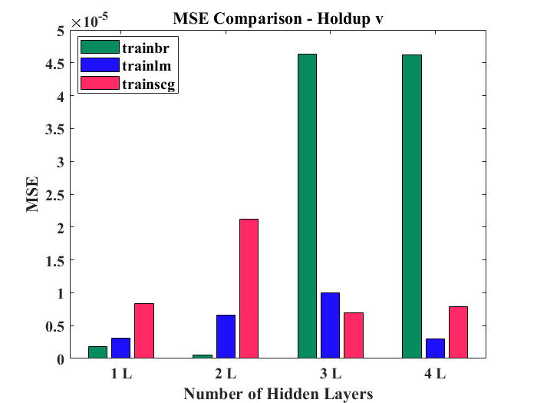
Fig. S2. Comparison of MSE values for different neural network training algorithms (trainbr, trainlm, trainscg) as a function of the number of hidden layers (1–4). Performance was evaluated for four different outputs: (a) Sauter mean diameter in the horizontal direction (d₃₂ h), (b) Sauter mean diameter in the vertical direction (d₃₂ v), (c) liquid holdup in the horizontal direction (holdup h), and (d) liquid holdup in the vertical direction (holdup v).

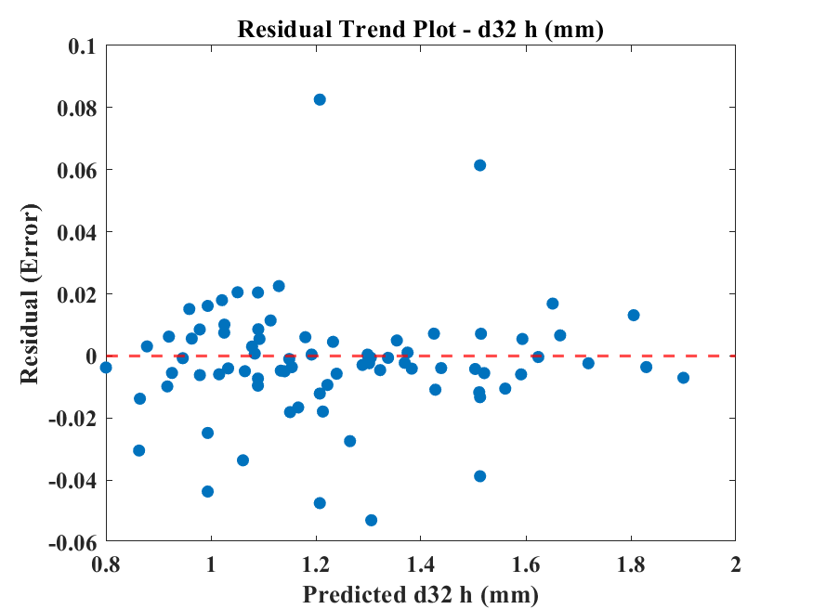 | 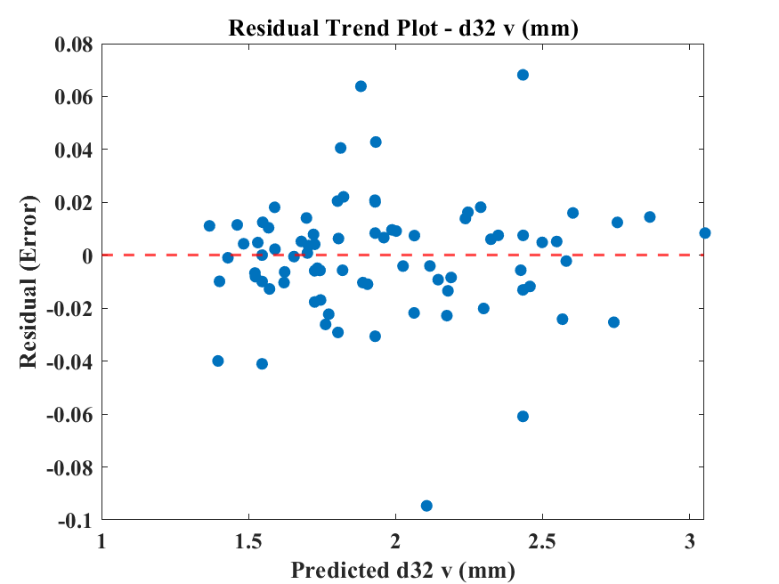
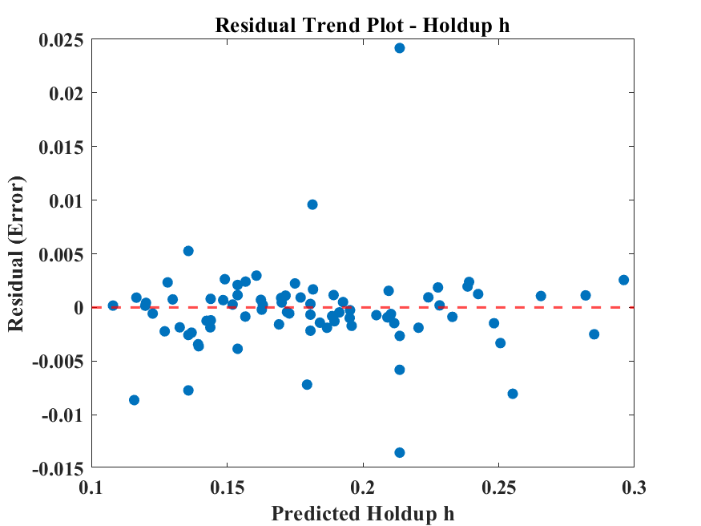 | 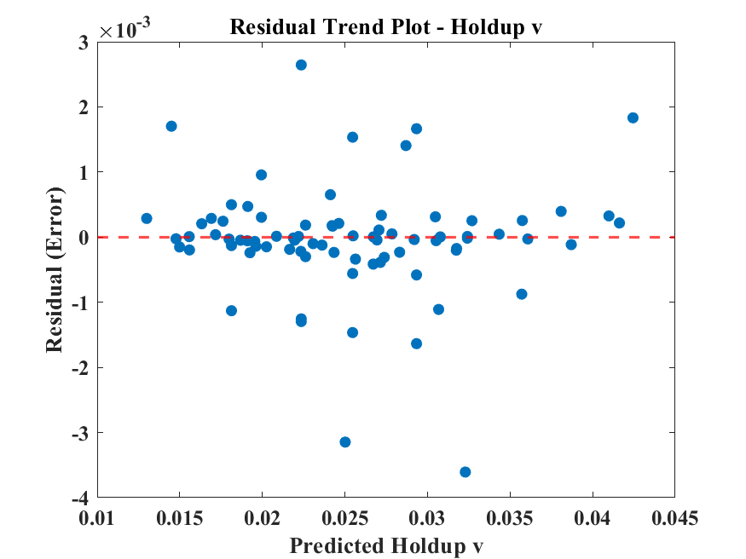
Fig. S3. Residual plots for the developed predictive models: (a) d32 h​, (b) d32 v​, (c) holdup h​, and (d) holdup v.

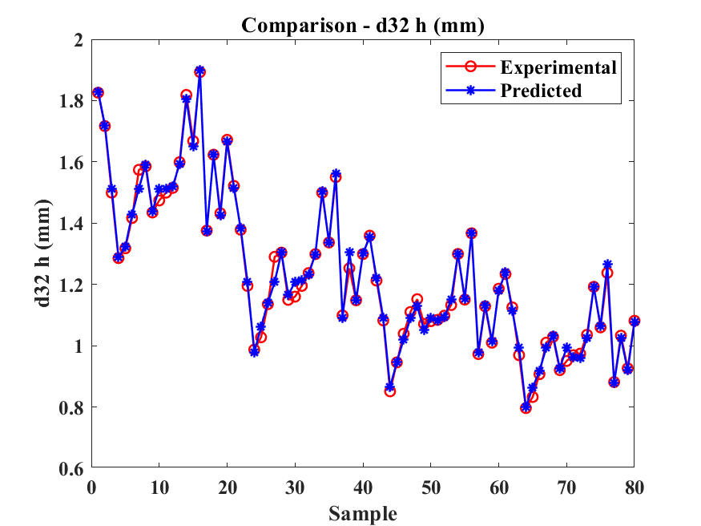 | 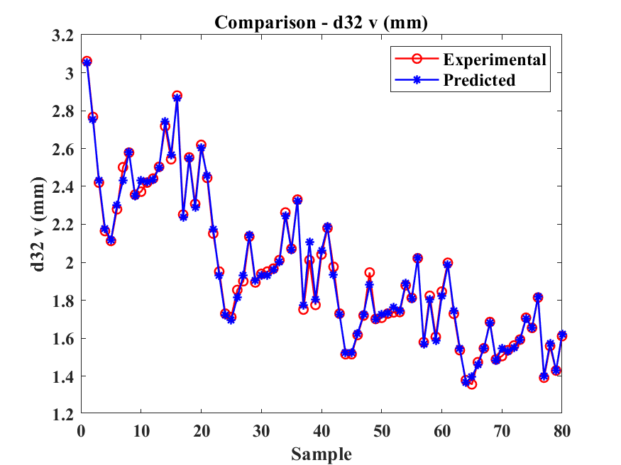
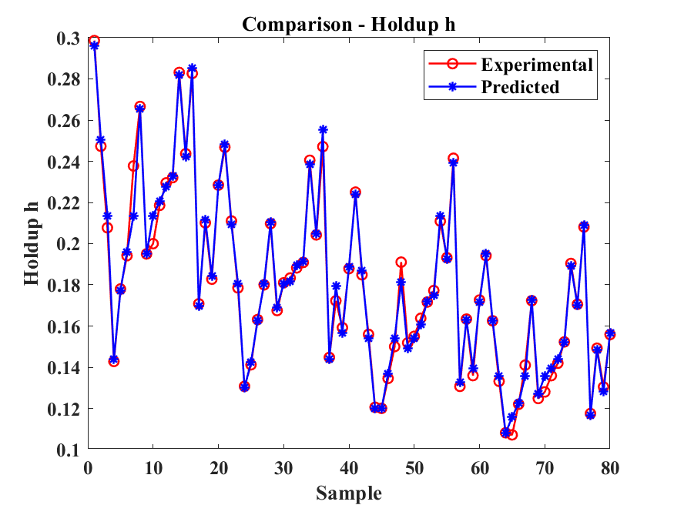 | 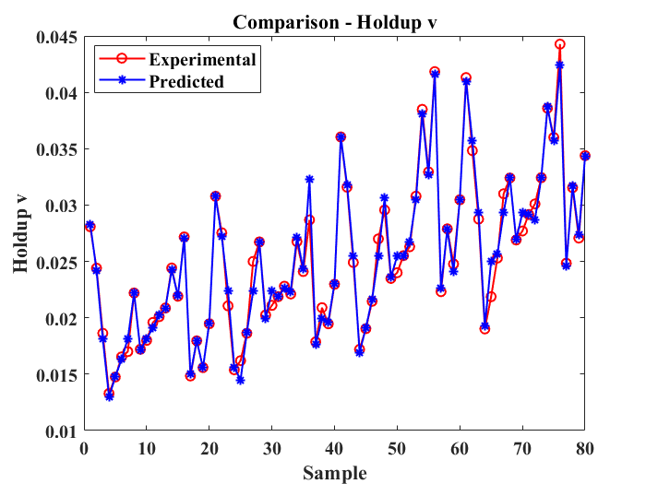
Fig. S4. Comparison between experimental and predicted values for (a) d32 h, (b) d32 v​, (c) holdup h​, and (d) holdup v

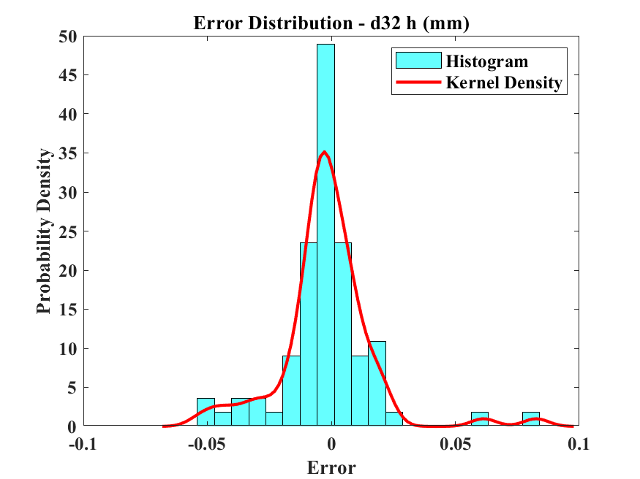 | 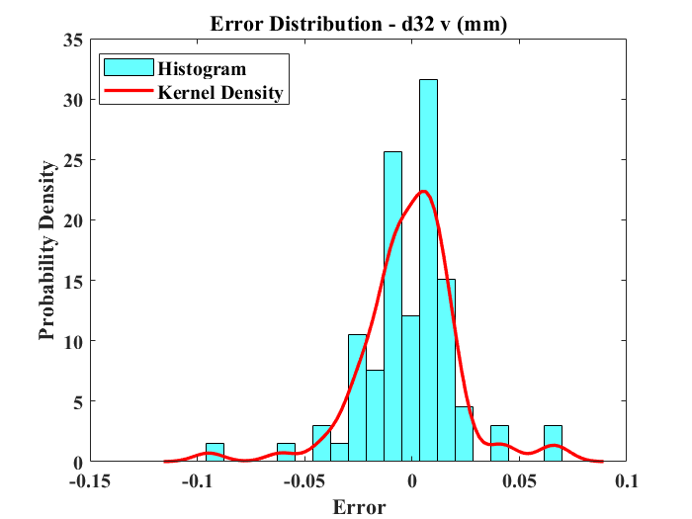
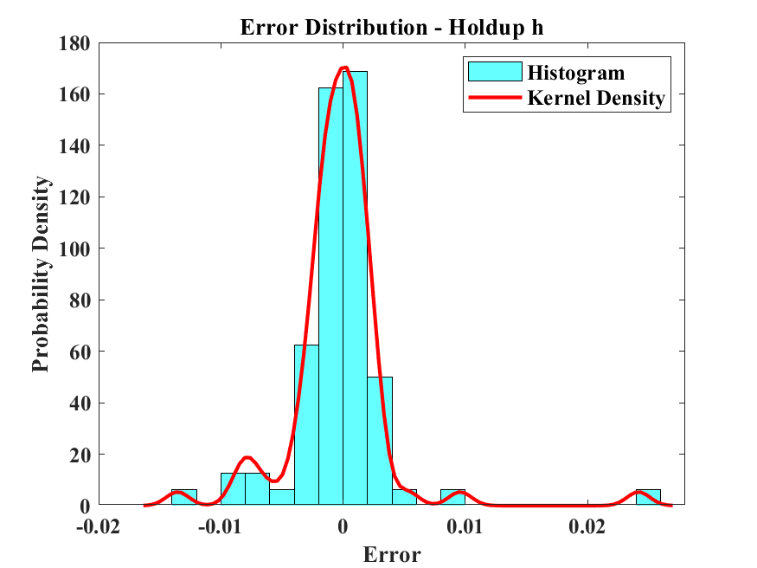 | 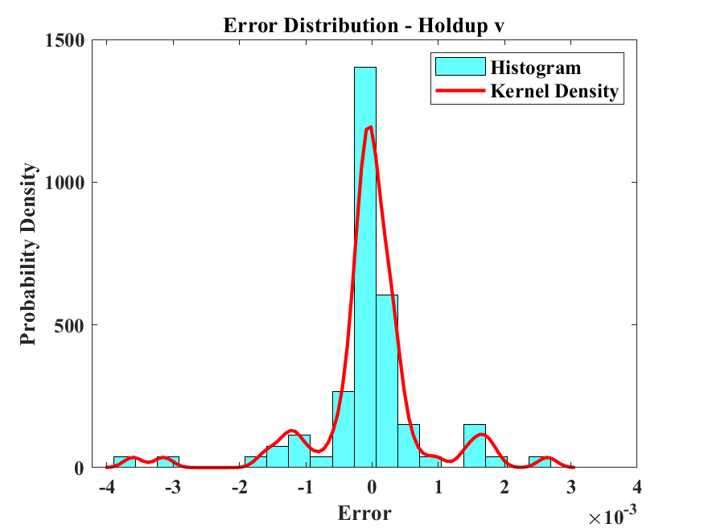
Fig. S5. Error distribution plots for (a) d32 h, (b) d32 v​, (c) holdup h​, and (d) holdup v

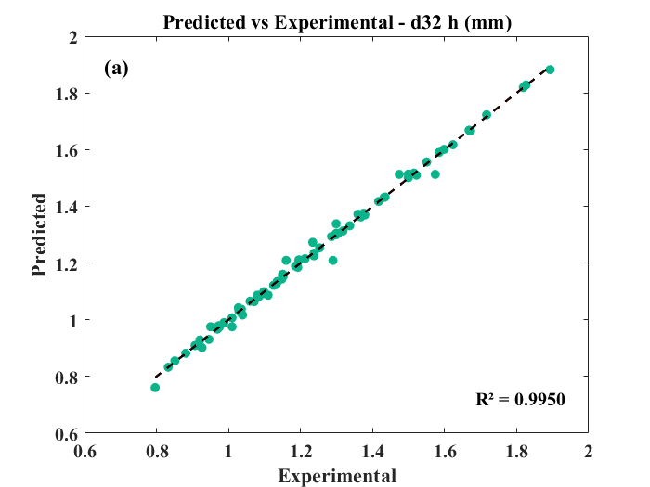 | 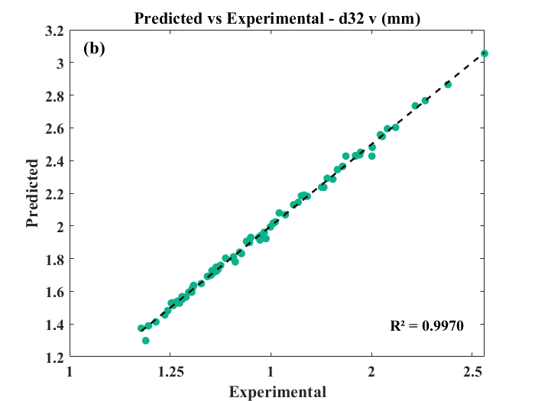
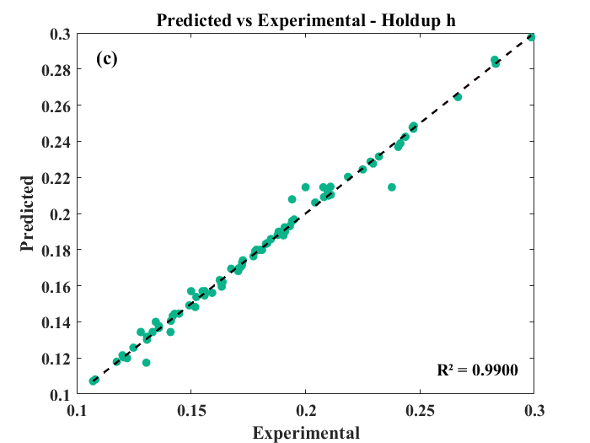 | 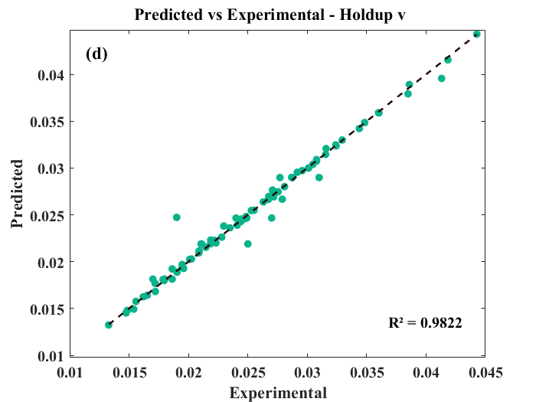
Fig. S6. Comparison between experimental results and predicted values obtained from the MLP model

