Studies on intellectual disability identify variants in established genes as well as confirm candidature of new genes
Amina Iftikhar Butt¹, Fariya Khan Bazai², Kaleemullah Kakar ³, Shakeela Daud⁴, Go Hun Seo⁵, Jamil Ahmad⁴, Sadaf Naz¹

¹School of Biological Sciences, University of the Punjab, Lahore, Pakistan
²Department of Health, Government of Balochistan, Quetta, Pakistan
³Centre for Advanced Studies in Vaccinology and Biotechnology, University of Balochistan, Quetta, Pakistan
⁴Department of Biotechnology, Balochistan University of Information Technology, Engineering and Management Sciences (BUITEMS), Quetta, Pakistan
⁵3billion Inc., Seoul, South Korea

Correspondence
Jamil Ahmad, Balochistan University of Information Technology, Engineering and Management Sciences (BUITEMS), Quetta, Pakistan. Email: jamil_48@yahoo.co.in
Sadaf Naz, School of Biological Sciences, University of the Punjab, Quaid-i-Azam Campus, Lahore, 54590, Pakistan. Email: naz.sbs@pu.edu.pk, Ph:9242-99231819

Supplementary Data
Supplementary Table 1: Homozygous variants prioritized from the exome date of individual VII:3 in family PKID01
Gene | RefSeq ID | *gDNA position | cDNA and  amino acid change | Aggregated  allele frequency | ACMG  Classification | Prediction |  |  |  |  |  |  | Comment
 |  |  |  |  |  | CADD | REVEL | MT | SIFT | PolyPhen2 | FATHMM | SpliceAI | Comment
UFSP2 | NM_018359.5 | chr4-186337011 A>T | c.344T>A, p.Val115Glu,  missense | 0.00007131 | Likely Pathogenic  PP1, PP4, PS3, PS4, PM2, PP5 | 25.7 | 0.33  U | 0.99  D | 0.001  U | 0.88  U | 0.48  U | 0  B | Prioritized
ARFGEF3 | NM_020340.5 | chr6-138657559 G>A | c.6470G>A,  p. Arg2157Lys,  missense | 0.000006198 | VUS  PM2 | 25.9 | 0.27  B | 1.0  D | 0.037  U | 0.97  U | 2.26  U | 0.09  B | Predicted uncertain, amino acid conserved
SLCO1B3 | NM_019844.4 | chr12-21036518 TTATC>T | c.1666_1669del  p.Ile556CysfsTer2  frameshift | 0.00008360 | Likely pathogenic  PVS1, PM2, BS2 | N/A | N/A | N/A | N/A | N/A | N/A | 0.09  B | Associated with hyperbilirubinemia OMIM#237450  and only pathogenic when inherited with a biallelic variant of SLCO1B1, 2 homozygotes in gnomAD v4.1.0
TMTC1 | NM_001193451.2 | chr12-29670436 C>T | c.2093G>A  p.Arg698Gln  missense | 0.00007993 | VUS  PM2, BP4 | 27.5 | 0.14  B | 1.0  D | 0.057  U | 0.66  U | 0.83  U | 0  B | Predicted uncertain, amino acid conserved
TRPM7 | NM_017672.6 | chr15-50940881 T>C | c.321+3A>G  intronic | 0.0004518 | VUS  PM2, BS2, PP3 | N/A | N/A | N/A | N/A | N/A | N/A | 0.02  B | Predicted benign by SpliceAI, nucleotide not conserved among vertebral orthologues,  9 homozygotes in gnomAD v4.1.0
*Positions according to Human Feb.2009 (GRCh37/hg19) assembly, gnomAD= Genome Aggregation Database, RefSeq= Reference Sequence, ACMG= The American College of Medical Genetics, CADD= Combined Annotation Dependent Depletion (score greater than 15 indicates the likelihood of deleteriousness), REVEL Rare Exome Variant Ensemble Learner (ranges from 0 to 1, 0 shows strongly benign and 1 indicates strongly pathogenic), SIFT= Sorting Intolerant from Tolerant algorithm, PolyPhen2= Polymorphism Phenotyping v2, MT= Mutation Taster, FATHMM= Functional Analysis through Hidden Markov Models, VUS= Variant of uncertain significance, U= Uncertain D= Damaging or deleterious, M=Moderate, N/A= Not applicable, highlighted variant was prioritized, aggregated allele frequency was assessed in gnomAD v4.1.0.

Supplementary Table 2: Filtered shared homozygous variants in exome data of patients IV:8 and IV:9 in family PKID03
Gene | RefSeq ID | *gDNA position | cDNA and  Amino acid change | Aggregated  allele frequency  in gnomAD v4.1.0 | ACMG  Classification | Prediction |  |  |  |  |  |  | Comment
 |  |  |  |  |  | CADD | REVEL | MT | SIFT | PolyPhen2 | FATHMM | SpliceAI | Comment
ADAMTSL4 | NM_019032.6 | chr1-150530002 C>T | c.2080C>T  p.Arg694Cys  missense | 0.00004589 | VUS  PM2 | 34 | 0.33  U | 1.0  D | 0  D | 0.96  U | 0.12  U | 0  B | Predicted uncertain, amino acid conserved, associated with ectopia lentis  OMIM#225100
LRRFIP2 | NM_006309.4 | chr3-37147022 T>C | c.715-8A>G  intronic | 0.002990 | Likely  Benign  PM2, BS2, BP4 | N/A | N/A | N/A | N/A | N/A | N/A | 0.05  B | Predicted benign, 1 homozygote in gnomAD v4.1.0, nucleotide not conserved
FAN1 | NM_014967.5 | chr15-31220767 G>A | c.2500G>A  p.Glu834Lys  missense | 0.000004969 | VUS  PM2, PP3 | 33 | 0.74  D | 1.0  D | 0  D | 1.0  D | -0.43  U | 0.03  B | Predicted uncertain, amino acid conserved, variants in this gene are known to cause interstitial nephritis  OMIM#614817,  not related to ID
SMPX | NM_014332.3 | chrX-21772422 T>TA | c.-12-3dup  frameshift | 0.00008793 | Benign  BS1, BS2 BP4 | N/A | N/A | N/A | N/A | N/A | N/A | 0.01  B | Predicted benign, 66 hemizygotes in gnomAD v4.1.0, Variants in this gene are reported to cause myopathy OMIM#301075
*Positions according to Human Feb.2009 (GRCh37/hg19) assembly, gnomAD= Genome Aggregation Database, RefSeq= Reference Sequence, ACMG= The American College of Medical Genetics, CADD= Combined Annotation Dependent Depletion (score greater than 15 indicates the likelihood of deleteriousness), REVEL Rare Exome Variant Ensemble Learner (ranges from 0 to 1, 0 shows strongly benign and 1 indicates strongly pathogenic), SIFT= Sorting Intolerant from Tolerant algorithm, PolyPhen2= Polymorphism Phenotyping v2, MT= Mutation Taster, FATHMM= Functional Analysis through Hidden Markov Models, VUS= Variant of uncertain significance, U= Uncertain, D= Damaging or deleterious, M=Moderate, N/A= Not applicable, aggregated allele frequency was assessed in gnomAD v4.1.0

Supplementary Table 3: Filtered suspected compound heterozygous variants detected in exome data of individuals IV:8 and IV:9 in family PKID03
Gene | RefSeq ID | *gDNA position | cDNA and  Amino acid change | Aggregated  allele frequency  in gnomAD v4.1.0 | ACMG  Classification | Prediction |  |  |  |  |  |  | Comment
 |  |  |  |  |  | CADD | REVEL | MT | SIFT | PolyPhen2 | FATHMM | SpliceAI | Comment
CROCC2 | NM_001351305.2 | chr2-241905306 C>T | c.3857C>T  p.Ala1286Val  missense | 0.0008703 | VUS  PM2 | 5.624 | N/A | N/A | N/A | N/A | N/A | 0  B | Predicted uncertain, amino acid not conserved, 6 homozygotes in gnomAD v4.1.0
CROCC2 | NM_001351305.2 | chr2-241874765 C>G | c.1939-10C>G  intronic | 0.004978 | VUS  PM2, BP2 | 5.228 | N/A | N/A | N/A | N/A | N/A | 0.05  B | Predicted uncertain
WDR87 | NM_001291088.2 | chr19-38385973 AG>A | c.369del  p.Tyr124ThrfsTer5  frameshift | 0.00007669 | VUS  PM2 | N/A | N/A | N/A | N/A | N/A | N/A | 0  B | Gene variants known to cause congenital cataracts, 3 homozygotes in gnomAD v4.1.0
WDR87 | NM_001291088.2 | chr19-38379248 T>TC | c.5062dup  p.Glu1688GlyfsTer26  frameshift | 0.00007603 | VUS  PM2 | N/A | N/A | N/A | N/A | N/A | N/A | 0  B | Gene variants known to cause congenital cataracts, 3 homozygotes in gnomAD v4.1.0
*Positions according to Human Feb.2009 (GRCh37/hg19) assembly, gnomAD= Genome Aggregation Database, RefSeq= Reference Sequence, ACMG= The American College of Medical Genetics, CADD= Combined Annotation Dependent Depletion (score greater than 15 indicates the likelihood of deleteriousness), REVEL Rare Exome Variant Ensemble Learner (ranges from 0 to 1, 0 shows strongly benign and 1 indicates strongly pathogenic), SIFT= Sorting Intolerant from Tolerant algorithm, PolyPhen2= Polymorphism Phenotyping v2, MT= Mutation Taster, FATHMM= Functional Analysis through Hidden Markov Models, VUS= Variant of uncertain significance, U= Uncertain, D= Damaging or deleterious, M=Moderate, N/A= Not applicable, aggregated allele frequency was assessed in gnomAD v4.1.0.

Supplementary Table 4: Identified homozygous variants in exome data of patient IV:9 in family PKID03
Gene | RefSeq ID | *gDNA position | cDNA and  Amino acid change | Aggregated allele frequency  in gnomAD v4.1.0 | ACMG  Classification | Prediction |  |  |  |  |  |  | Comment
 |  |  |  |  |  | CADD | REVEL | MT | SIFT | PolyPhen2 | FATHMM | SpliceAI | Comment
EXOSC10 | NM_001001998.3 | chr1-11132232 T>C | c.2158-4A>G  splice site | 0.00002618 | VUS  PM2 | 12.35 | N/A | N/A | N/A | N/A | N/A | 0.21  M | Predicted uncertain, nucleotide not conserved
ATP13A2 | NM_022089.4 | chr1-17316244 AGACAGTGCCCT>A | c.2540_2550del,  p. (Gln847LeufsTer7)  frameshift | 0 | Pathogenic  PP1, PP4, PM3, PVS1, PM2, PP5 | N/A | N/A | N/A | N/A | N/A | N/A | N/A | Prioritized  Known to cause ID  OMIM#606693
ABCB5 | NM_001163941.2 | chr7-20687667 T>A | c.1172T>A  p.Val391Asp  missense | 0.00002299 | VUS  PM2, PP3 | 26.6 | 0.88  D | 1.0  D | 0  D | N/A | -3.06  U | 0.01  B | Predicted deleterious by three programs,  1 homozygote in gnomAD v4.1.0,  affected amino acid not conserved in fish and reptiles
MYBPC3 | NM_000256.3 | chr11-47360238 G>C | c.2149-8C>G  intronic | 0.00005418 | Likely benign  PM2, BP4, BP6 | 3.507 | N/A | N/A | N/A | N/A | N/A | 0.01  B | Predicted benign, Nucleotide not conserved
P2RY2 | NM_002564.4 | chr11-72945502 C>T | c.298C>T p.Pro100Ser  missense | 0.0001022 | VUS  PM2, BS2 | 27.7 | 0.49  U | 1.0  D | 0.004  U | 0.99  D | 1.18  U | 0  B | Predicted uncertain, amino acid conserved, 3 homozygotes in gnomAD v4.1.0.
C11orf95 | NM_001144936.2 | chr11-63533334 TTCCTCC>T | c.576_581del  p.Glu199_Glu200del  inframe deletion | 0.0001506 | VUS  PM2, BP3 | N/A | N/A | N/A | N/A | N/A | N/A | N/A | Associated with ependymoma PMID#28895660, 1 homozygote in gnomAD v4.1.0.
HERC1 | NM_003922.4 | chr15-63966772 C>T | c.7615G>A  p.Ala2539Thr  missense | 0.0003337 | VUS  PM2, PP2, BP4 | 23.1 | 0.14  B | 1.0  D | 0.047  B | 0.03  B | 1.87  U | 0  B | Predicted uncertain,  2 homozygotes in gnomAD v4.1.0., amino acid not conserved in naked-mole rat, zebrafish, platyfish
DCC | NM_005215.4 | chr18-50705417 G>A | c.1504G>A  p.Val502Ile  missense | 0.00003593 | VUS | 24.4 | 0.36  U | 1.0  D | 0.139  B | 0.99  D | -0.51  U | 0 | Predicted uncertain,  1 homozygote in gnomAD v4.1.0., amino acid conserved, pathogenic gene variants reported to cause mirror movement disease OMIM#157600
*Positions according to Human Feb.2009 (GRCh37/hg19) assembly, gnomAD= Genome Aggregation Database, RefSeq= Reference Sequence, ACMG= The American College of Medical Genetics, CADD= Combined Annotation Dependent Depletion (score greater than 15 indicates the likelihood of deleteriousness), REVEL Rare Exome Variant Ensemble Learner (ranges from 0 to 1, 0 shows strongly benign and 1 indicates strongly pathogenic), SIFT= Sorting Intolerant from Tolerant algorithm, PolyPhen2= Polymorphism Phenotyping v2, MT= Mutation Taster, FATHMM= Functional Analysis through Hidden Markov Models, VUS= Variant of uncertain significance, U= Uncertain, D= Damaging or deleterious, M=Moderate, N/A= Not applicable, highlighted variant was prioritized, a aggregated allele frequency was assessed in gnomAD v4.1.0

Supplementary Table 5: Homozygous variants prioritized from the exome data of patient IV:8 in family PKID03
Gene | RefSeq ID | *gDNA position | cDNA and  Amino acid change | Aggregated  allele frequency  in gnomAD v4.1.0 | ACMG  Classification | Prediction |  |  |  |  |  |  | Comment
 |  |  |  |  |  | CADD | REVEL | MT | SIFT | PolyPhen2 | FATHHMM | SpliceAI | Comment
CX3CR1 | NM_001337.4 | chr3-39307927 T>C | c.74A>G  p.Asp25Gly  missense | 0.001741 | Likely benign  PM2, BS2, BP6 | 19.12 | 0.24  B | 0.98  D | 0.202  B | 0.79  U | -0.25  U | 0 | Amino acid conserved, 3 homozygotes in gnomAD v4.1.0.
BNC2 | NM_017637.6 | chr9-16436244 C>T | c.1948G>A  p.Ala650Thr  missense | 0.0004808 | VUS  PM2, BS2 | 24.1 | 0.23  B | 1.0  D | 0.08  B | 0.98  D | 0.69  U | 0  B | Predicted uncertain, amino acid conserved, gene implicated with congenital urinary tract obstruction OMIM#618612,  9 homozygotes in gnomAD v4.1.0.
KCNV2 | NM_133497.4 | chr9-2718871 G>GTCATGCGC | c.1141_1149dup  p.Leu381_Arg383dup  inframe insertion | 0.0002660 | VUS  PM2, PM4 | N/A | N/A | N/A | N/A | N/A | N/A | N/A | Variants in this gene cause cone dystrophy  OMIM#610356
HMCN2 | NM_001291815.2 | chr9-133058061 C>T | c.891+10C>T  Intronic | 0.00008928 | VUS  PM2 | 1.675 | N/A | N/A | N/A | N/A | N/A | N/A | Predicted uncertain Nucleotide not conserved
TJP1 | NM_001330239.4 | chr15-29997807 C>T | c.4993G>A  p.Glu1665Lys  missense | 0.0002862 | VUS  PM2, BS2 | 26.6 | 0.2  B | 1.0  D | 0.018  U | 1.0  D | 0.94  U | 0  B | Predicted uncertain, amino acid conserved, gene variants cause Arrhythmogenic Right Ventricular Cardiomyopathy, 1 homozygote in gnomAD v2.1.1. and 3 homozygotes in gnomAD v4.1.0.
QPCTL | NM_017659.4 | chr19-46201949 C>T | c.778C>T  p.Gln260Ter  nonsense | 0.00001301 | VUS  PM2 | 42 | N/A | 1.0  D | N/A | N/A | N/A | 0  B | Nonsense variant, prioritized
*Positions according to Human Feb.2009 (GRCh37/hg19) assembly, gnomAD= Genome Aggregation Database, RefSeq= Reference Sequence, ACMG= The American College of Medical Genetics, CADD= Combined Annotation Dependent Depletion (score greater than 15 indicates the likelihood of deleteriousness), REVEL Rare Exome Variant Ensemble Learner (ranges from 0 to 1, 0 shows strongly benign and 1 indicates strongly pathogenic), SIFT= Sorting Intolerant from Tolerant algorithm, PolyPhen2= Polymorphism Phenotyping v2, MT= Mutation Taster, FATHMM= Functional Analysis through Hidden Markov Models, VUS= Variant of uncertain significance, U= Uncertain, D= Damaging or deleterious, M=Moderate, N/A= Not applicable, highlighted variant was prioritized, aggregated allele frequency was assessed in gnomAD v4.1.0

Supplementary Table 6: Filtered homozygous variants from exome data of patient IV:8 in family PKID04
Gene | RefSeq ID | *gDNA position | cDNA and  Amino acid change | Aggregated  allele frequency  in gnomAD v4.1.0 | ACMG  Classification | Prediction |  |  |  |  |  |  | Commet
 |  |  |  |  |  | CADD | REVEL | MT | SIFT | PolyPhen2 | FATHMM | SpliceAI | Commet
HSPG2 | NM_005529.7 | chr1-22155455 C>A | c.12110G>T  p.Arg4037Leu  missense | 0.001057 | VUS  BS1 | 26.6 | 0.45  U | 0.61  D | 0.136  B | 1.0  D | -0.88  U | 0  B | Predicted uncertain, amino acid conserved, this gene variant (PMID# 25504735) known to cause scoliosis (dyssegmential dysplasia) OMIM#224410,  3 homozygotes in gnomAD v4.1.0.
CROCC2 | NM_001351305.2 | chr2-241904793 C>T | c.3466-5C>T  intronic | 0.00001226 | VUS  PM2 | 8.125 | N/A | N/A | N/A | N/A | N/A | 0  B | Predicted uncertain, nucleotide not conserved
RBSN | NM_022340.4 | chr3-15116371-C>T | c.1273G>A  p.Gly425Arg  missense | 0.005262 | VUS  PM2, BS2 | 24.0 | 0.20  B | 1.0  D | 0.03  U | 0.97  U | 0.49  U | 0  B | Predicted uncertain, amino acid conserved, 8 homozygotes in gnomAD v4.1.0, gene implicated with congenital neutropenia, myelofibrosis
ABHD11 | NM_148912.4 | chr7-73152705 T>C | c.214A>G  p.Asn72Asp  missense | 0.0001196 | VUS  PM2 | 25.6 | 0.63  U | 1.0  D | 0.003  U | 1.0  D | -0.28  U | 0  B | Predicted uncertain, amino acid conserved
KLHL38 | NM_001081675.3 | chr8-124664560 A>G | c.607T>C  p.Trp203Arg  missense | 0.0004108 | VUS  PM2, BS2, PP3 | 27.7 | 0.91  D | 1.0  D | 0  D | 1.0  D | -2.01  U | 0  B | Predicted deleterious, amino acid conserved, 7 homozygotes in gnomAD v4.1.0.
VWF | NM_000552.5 | chr12-6219743 G>A | c.329C>T  p.Ser110Phe  missense | 0.00001239 | VUS  PM2, PP2 | 24.2 | 0.47  U | 1.0  D | 0.003  U | 0.99  D | 0.08  U | 0.11  U | Predicted uncertain, amino acid conserved, variants of the gene associated with VonWillbrand disease OMIM#277480, 1 homozygote in gnomAD v4.1.0.
PLEKHH3 | NM_024927.5 | chr17-40828410 CG>C | c.162+9del  intronic | 0 | VUS  PM2 | N/A | N/A | N/A | N/A | N/A | N/A | 0  B | Predicted uncertain, nucleotide not conserved
HOXB9 | NM_024017.5 | chr17-46700495 T>C | c.520A>G  p.Asn174Asp  missense | 0 | VUS  PM2 | 23.9 | 0.37  U | 1.0  D | 0.078  U | 0.001  B | -3.72  U | 0  B | Predicted uncertain, conserved
WDR62 | NM_001083961.2 | chr19-36549752 G>GC | c.250dupC  p.His84ProfsTer25  frameshift | 0.000001239 | Pathogenic  PVS1, PM2, PP5 | N/A | N/A | N/A | N/A | N/A | N/A | 0  B | Prioritized
*Positions according to Human Feb.2009 (GRCh37/hg19) assembly, gnomAD= Genome Aggregation Database, RefSeq= Reference Sequence, ACMG= The American College of Medical Genetics, CADD= Combined Annotation Dependent Depletion (score greater than 15 indicates the likelihood of deleteriousness), REVEL Rare Exome Variant Ensemble Learner (ranges from 0 to 1, 0 shows strongly benign and 1 indicates strongly pathogenic), SIFT= Sorting Intolerant from Tolerant algorithm, PolyPhen2= Polymorphism Phenotyping v2, MT= Mutation Taster, FATHMM= Functional Analysis through Hidden Markov Models, VUS= Variant of uncertain significance, U= Uncertain, D= Damaging or deleterious, M=Moderate, N/A= Not applicable, highlighted variant was prioritized, aggregated allele frequency was assessed in gnomAD v4.1.0

Supplementary Table 7: Homozygous variants identified in the exome data of patient IV:4 in family PKID16
Gene | RefSeaq ID | *gDNA position | cDNA an\d  Amino acid change | Aggregated  allele frequency  in gnomAD v4.1.0 | ACMG  Classification | Prediction |  |  |  |  |  |  | Comment
 |  |  |  |  |  | CADD | REVEL | MT | SIFT | PolyPhen2 | FATHMM | SpliceAI | Comment
FMO4 | NM_002022.3 | chr1-171310853 T>TG | c.1558dupG  p.Ala520GlyfsTer13  frameshift | 0.00002974 | Likely  Pathogenic  PP1, PP4, PM2 | N/A | N/A | N/A | N/A | N/A | N/A | 0  B | Prioritized
HOXA1 | NM_005522.5 | chr7-27135310-GTGGCGA-G | c.216_221del  p.Arg73_His74del  in frame deletion | 0.0004403 | Likely benign  PM2, BS2, BP4 | N/A | N/A | N/A | N/A | N/A | N/A | N/A | Predicted benign, gene associated with Athabaskan brainstem dysgenesis syndrome OMIM#601536, 4 homozygotes in gnomAD v4.1.0.
GPSM1 | NM_001145638.3 | chr9-139250133 C>G | c.1456-9C>G  intronic | 0.00004531 | VUS  PM2, BP4 | 7.407 | N/A | N/A | N/A | N/A | N/A | 0.03  B | Predicted uncertain, Nucleotide not conserved
FAM168A | NM_015159.3 | chr11-73179452 G>A | c.68C>T  p.Thr23Me  missense | 0.00003904 | VUS  PM2, PP3 | 29.0 | 0.21  B | 1.0  D | 0.006  D | 0.96  U | N/A | 0.01  B | Predicted uncertain, amino acid conserved, 1 homozygote in gnomAD v4.1.0.
FAM76B | NM_144664.5 | chr11-95504802 C>A | c.943G>T  p.Glu315Ter  nonsense | 0 | VUS  PM2 | 44 | N/A | 1.0  D | N/A | N/A | N/A | 0.11  U | Prioritized, nonsense variant
RDX | NM_002906.4 | chr11-110126019 C>G | c.790G>C  p.Ala264Pro  missense | 0.0001597 | VUS  PP3, BS1 | 31 | 0.81  D | 1.0  D | 0.001  U | 0.87  U | -1.61  U | 0  B | Predicted uncertain, amino acid conserved, variants of this gene are known to cause autosomal recessive nonsyndromic hearing loss OMIM#611022, 2 homozygotes in gnomAD v4.1.0.
ARHGEF6 | NM_004840.3 | chrX-135829705 A>G | c.296T>C  p.Val99Ala  missense | 0.000004132 | VUS  PM2, BS2, PP3 | 25.3 | 0.88  D | 1.0  D | 0  D | 1.0  D | -3.85  U | 0  B | Predicted deleterious, amino acid  conserved, 4 hemizygote in gnomAD v4.1.0., variants of this gene have been implicated with non-syndromic X-linked ID
CNGA2 | NM_005140.1 | chrX-150912155 C>T | c.1180C>T  p.His394Tyr  missense | 0.0001653 | VUS  PM2, BS2, PP3 | 25.3 | 0.67  D | 1.0  D | 0.004  U | 1.0  D | -4.07  U | 0  B | Predicted deleterious by three software, associated with congenital anosmia, 9 hemizygotes in gnomAD v4.1.0.
*Positions according to Human Feb.2009 (GRCh37/hg19) assembly, gnomAD= Genome Aggregation Database, RefSeq= Reference Sequence, ACMG= The American College of Medical Genetics, CADD= Combined Annotation Dependent Depletion (score greater than 15 indicates the likelihood of deleteriousness), REVEL Rare Exome Variant Ensemble Learner (ranges from 0 to 1, 0 shows strongly benign and 1 indicates strongly pathogenic), SIFT= Sorting Intolerant from Tolerant algorithm, PolyPhen2= Polymorphism Phenotyping v2, MT= Mutation Taster, FATHMM= Functional Analysis through Hidden Markov Models, VUS= Variant of uncertain significance, U= Uncertain, D= Damaging or deleterious, M=Moderate, N/A= Not applicable, highlighted variant was prioritized, aggregated allele frequency was assessed in gnomAD v4.1.

Supplementary Table 8: Primers for PCR Amplification of UFSP2, ATP13A2, QPCTL, WDR62 and FMO4
Primer name | Sequence (5′-3′) | Tm  (°C) | GC content  (%) | Product  Size  (bp)
UFSP2-IF | GTTGACATTTCCAGCATAAGATCTATATCTT | 62.0 | 44.0 | 238
UFSP2-IR | ATTACTGTTTATCTATATAGCATCAAATGGT | 58.0 | 25.89 | 343
UFSP2-OFn* | TGCTACCCTACTTCCTCCAAATAAC | 60.10 | 44.0 | 520
UFSP2-ORn* | TATCTCAGTTGATCATTCACAGCCA | 60.10 | 40.0 | 520
UFSP2-OF** | TGTATTTGCTCTTTGTGGATAAAGG | 60.7 | 36.0 | 532
UFSP2-OR** | TGAACTCCTTGTTCTCTACTCTTTCC | 60.6 | 42.31 | 532
ATP13A2-F | TGAGGAGGGGTGACAGCTCT | 62.4 | 60.0 | 505
ATP13A2-R | TGACCCAGGCCCCAACTCTC | 67.0 | 65.0 | 505
ATP13A2-FdelWt | CCATGCGGGCAAAGACAGT | 64.2 | 57.89 | 331
ATP13A2-FdelMt | CATGCGGGCAAAGGACCA | 66.5 | 61.1 | ~320
QPCTL-F | CAAGCGGGCAAGAAGTGTGG | 66.3 | 60.0 | 495
QPCTL-R | CACCGCCCTGTACCCCATAC | 64.6 | 65.0 | 495
WDR62-F | AGAAGCTCAGTGTGGGTGTTGA | 62.2 | 50.0 | 494
WDR62-R | GGTTACCTGACACCACAGCG | 61.6 | 60.0 | 494
FMO4-F | CATGGATGATATCGCTGCCTG | 63.7 | 52.38 | 498
FMO4-R | GGAGATGACTGGGCCTGAAT | 61.4 | 55.0 | 498
The bold letter denotes allele-specific mismatch, and underlined letters signify deliberate mismatch introduced to increase the specificity of amplification. The bold italics letters indicate sequences mismatched or missing from the wild-type or the deletion allele, respectively. *used for segregation analysis of UFSP2 along with the inner pair of primers by Tetra primer ARMS PCR, **used for Sanger sequencing of USFP2

Supplementary Table 9: Primers for PCR amplification of Qpctl and Fmo4 partial cDNA fragments
Primer name | Sequence (5′-3′) | Tm  (°C) | GC content  (%) | Product  Size  (bp)
QPCTL-mcdOF | TGGCCTCATGAAACCACCCTCACTT | 70.7 ºC | 52.0 | 967
QPCTL-mcdOR | CGGGACCCCTCTGCGAAGGAA | 71.8 ºC | 66.67 | 967
QPCTL-mcdIF | CCAAGTGAGAAAGTTCCTGGAGGCTACG | 70.4 ºC | 53.57 | 557
QPCTL-mcdIR | GGCGCTTCTCAATGCTCCTCAGTC | 69.6ºC | 58.33 | 557
FMO4-mcdOF | AAGCGCCCAGACTTCTCTGAAACTG | 68.1 ºC | 52.0 | 912
FMO4-mcdOR | CACACCCCTTTTAATGAGCTGCTCC | 67.9 ºC | 52.0 | 912
FMO4-mcdIF | CTCTGGAGTCCTTTCCTGGAATCCA | 67.8 ºC | 52.0 | 716
FMO4-mcdIR | GAGTCCTTTGAATACTCTTGTGGCCCA | 68.3 ºC | 48.15 | 716
The outer (OF and OR) primers were used to obtain a larger sized product. The amplicon reactions were diluted 1:10 with distilled water. A second nested PCR was performed using inner (IF and IR) primers on the diluted reactions. This strategy ensures high specificity to the cDNA of interest.
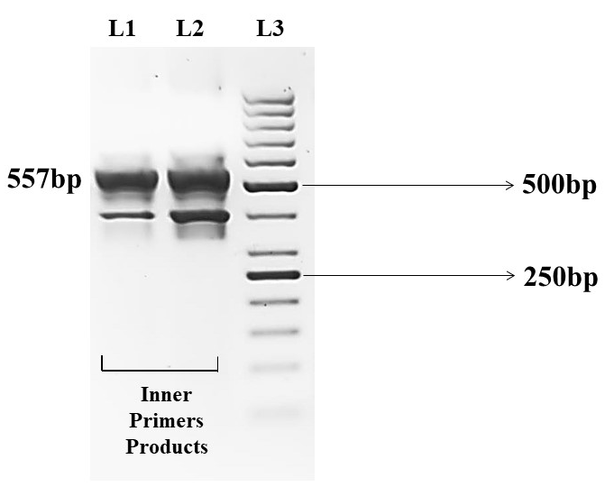
Supplementary Figure 1: Nested PCR of Qpctl partial cDNA. A larger product from amplification of Qpctl cDNA was diluted and used for nested PCR. From left to right L1 and L2= the expected inner product of 557bp amplified from inner primers of Qpctl. The smaller 400bp product may be due to amplification of a different isoform or could be an artifact and was not checked further. L3=DNA Ladder Mix

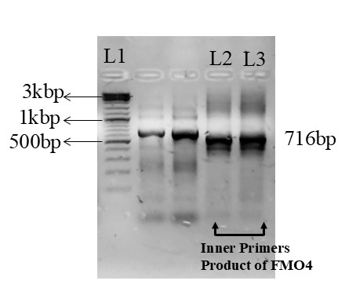
Supplementary Figure 2: Nested PCR for Fmo4 partial cDNA. Using FMO4-mcdIF/IR primers on the first larger PCR product obtained from the cDNA library, the expected 716bp (L2, L3) PCR product was amplified, L1= DNA Ladder mix.
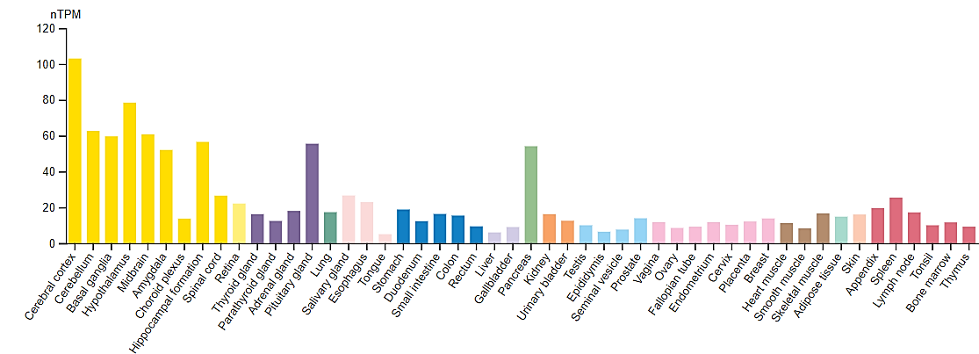
Supplementary Figure 3: Expression of ATP13A2 in various tissues. The highest expression of ATP13A2 is observed in the different parts of the human brain. nTPM= normalized transcripts per million. (https://www.proteinatlas.org/)

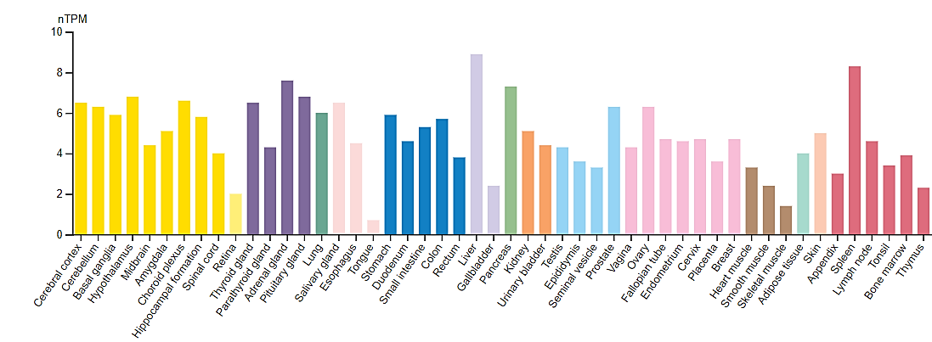
Supplementary Figure 4: Expression of QPCTL. High expression of QPCTL is observed in many human tissues, including different parts of the human brain. nTPM= normalized transcripts per million. (https://www.proteinatlas.org/)

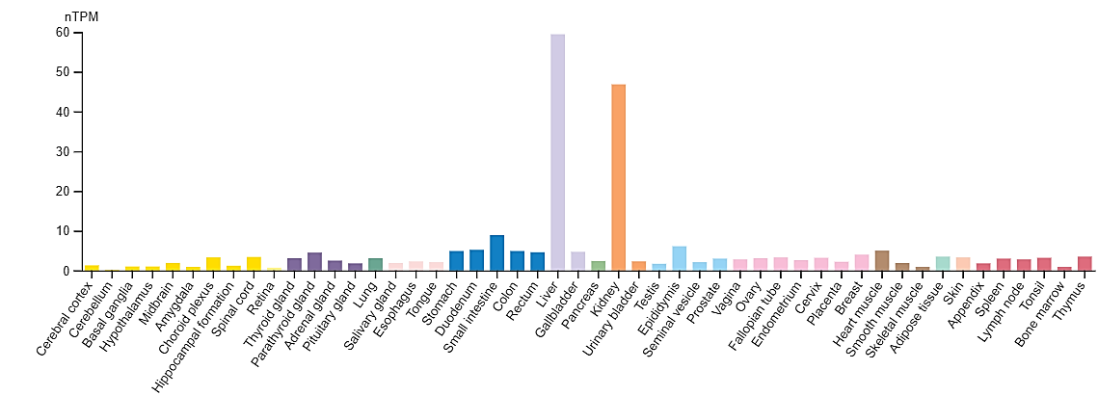
Supplementary Figure 5: Expression of FMO4 in different tissues. FMO4 is expressed in many tissues with the highest levels observed in the liver and kidney. nTPM= normalized transcripts per million. (https://www.proteinatlas.org/)
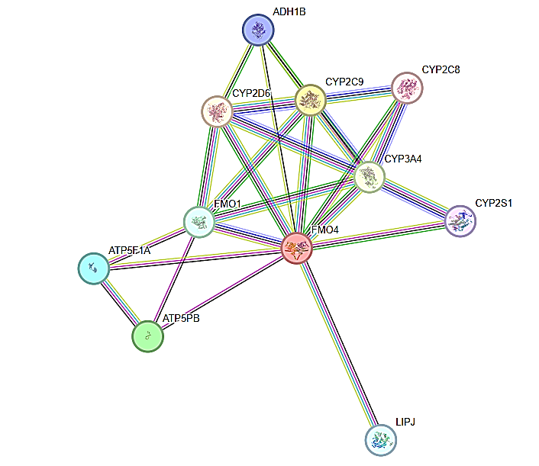
Supplementary Figure 6: Protein-protein interactions of FMO4. FMO4 is predicted to interact with many proteins. Mustard lines indicate the protein interaction based on text-mining. Purple lines show the protein interactions determined through experimentation. Blue lines show homology between interacting proteins. Black lines illustrate the co-expression of proteins.

