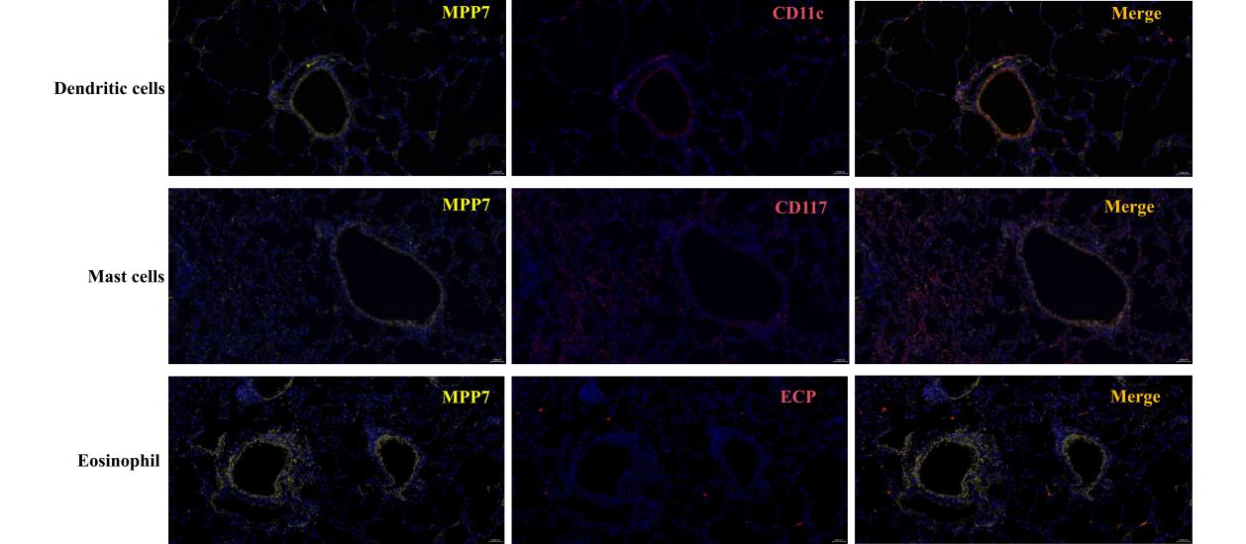
Fig. S1 MPP7 expression in DCs, mast cells, and eosinophil of mice. Immunofluorescence of lung sections from mice.

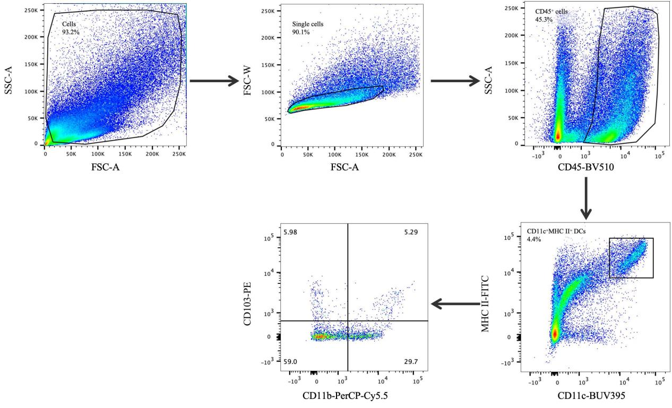
Fig. S2 Gating strategies for flow cytometric analyses. Flow cytometry gating scheme for lung DCs subsets. DCs were identified as CD11c⁺MHC II⁺ cells and were gated out of singlet CD45⁺ cells. Gated DCs then analyzed by their expression of CD11b and CD103.

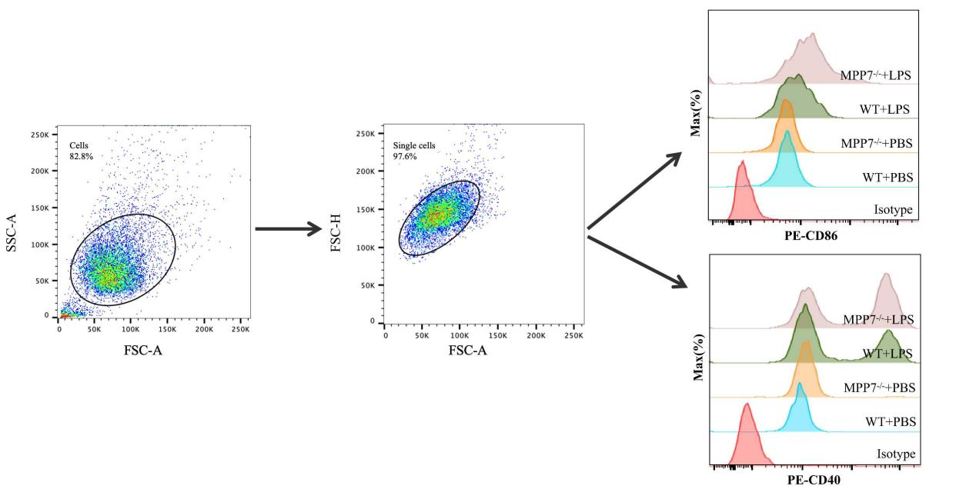Fig. S3 Gating strategies for flow cytometric analyses. Flow cytometry gating scheme for BMDCs. BMDCs were gated by FSC/SSC, followed by singlet selection (FSC-A vs FSC-H) and live-cell gating prior to quantification of CD86 and CD40 expression.

Table S1 The clinical characterization of asthmatic patients.
Number | Sex | Age | IgE | Asthma severity | Medication use
92304001 | Male | 7 | 869.00 | Severe | Methylprednisolone sodium succinate, nebulized salbutamol, budesonide
92350701 | Male | 10 | 203.00 | Severe | Methylprednisolone sodium succinate, nebulized salbutamol, budesonide, cefotaxime
92338401 | Male | 9 | 453.00 | Severe | Methylprednisolone sodium succinate, nebulized salbutamol, budesonide
92345301 | Male | 9 | 150.00 | Severe | Methylprednisolone sodium succinate, nebulized salbutamol, budesonide
61581102 | Female | 7 | 329.00 | Severe | Methylprednisolone sodium succinate, nebulized salbutamol, budesonide, ceftriaxone
91209604 | Female | 6 | 169.00 | Moderate | Methylprednisolone sodium succinate, nebulized salbutamol, budesonide, ceftriaxone
64828401 | Female | 8 | 414.00 | Mild | Methylprednisolone sodium succinate, nebulized salbutamol, budesonide
65435203 | Female | 5 | 982.00 | Moderate | Methylprednisolone sodium succinate, nebulized salbutamol, budesonide, ceftriaxone
91907001 | Male | 10 | 2500.00 | Mild | Nebulized salbutamol, budesonide, ceftriaxone
92065401 | Male | 6 | 869.00 | Mild | Methylprednisolone sodium succinate, nebulized salbutamol, budesonide

