Supplementary Information

Functional changes of precuneus architecture across newborns, infants, and adolescents
Jiaojian Wang^{1,2,}, Qinmu Peng^{1,2,}, Minhui Ouyang^{1,2}, Ruolin Li^{1,3}, Wentao Wu^{1,3}, Lu Zhang^{1,4}, Yun Peng⁵, Hao Huang^{1,2,*}

¹Department of Radiology, Children’s Hospital of Philadelphia, Philadelphia, PA, 19104, USA
²Department of Radiology, Perelman School of Medicine, University of Pennsylvania, Philadelphia, PA, 19104, USA
³Department of Bioengineering, University of Pennsylvania, Philadelphia, PA, 19104, United States
⁴Graduate School of Education, Peking University, Beijing, 100871, China
⁵Department of Radiology, Beijing Children’s Hospital, Capital Medical University, Beijing, China.

*Corresponding author:
Hao Huang, PhD
Department of Radiology, Children’s Hospital of Philadelphia
Perelman School of Medicine, University of Pennsylvania
3401 Civic Center Blvd, Philadelphia, PA 19104
Email: huangh6@chop.edu
P: 267-425-1599

Supplementary Figures
Figure S1. Individual parcellation of the left and right precuneus in neonate subjects.

Figure S2. Individual parcellation of the left and right precuneus in 1-year-old subjects.

Figure S3. Individual parcellation of the left and right precuneus in 2-year-old subjects.

Figure S4. Individual parcellation of the left and right precuneus in around-puberty subjects.

Figure S5. Mean voxel ratios of left and right precuneus (PCun) subregions in neonate, 1-year-old, 2-year-old, and around-puberty (AP) age groups, calculated by averaging individual subregion proportions within each group.

Figure S6. Whole brain functional connectivity patterns for each left and right precuneus (PCun) subregion in neonates, 1-year-old, 2-year-old, and around-puberty subjects before multiple comparison correction.
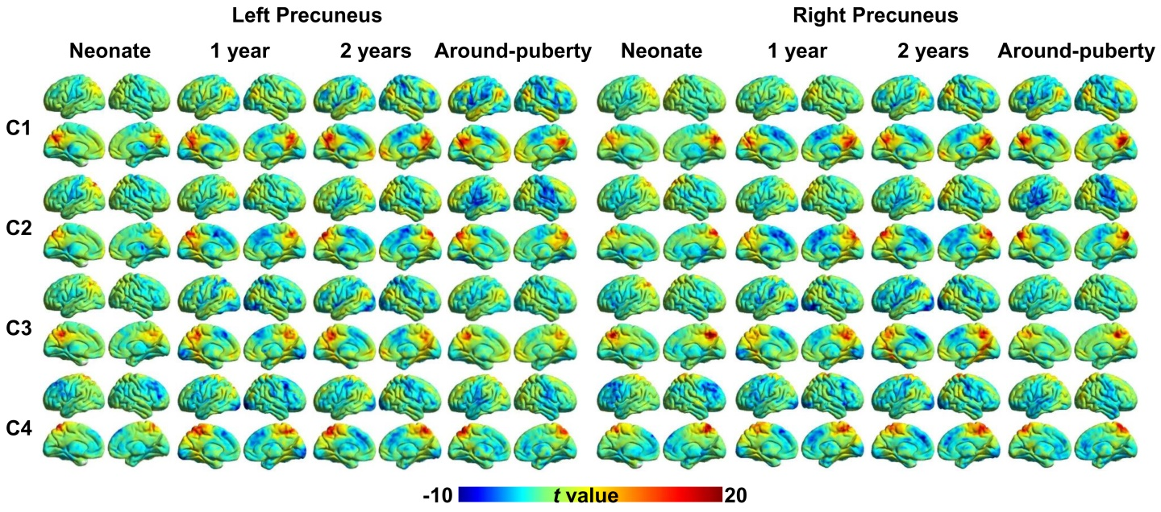

Figure S7. Spatial correlation of whole brain functional connectivity pattern of each left and right precuneus subregion between neonate (Neo), 1-year-old, 2-year-old, and around-puberty (AP) subjects.

Figure S8. Eleven target brain areas were defined based on the whole brain functional connectivity patterns of PCun subregions in around-puberty subjects.
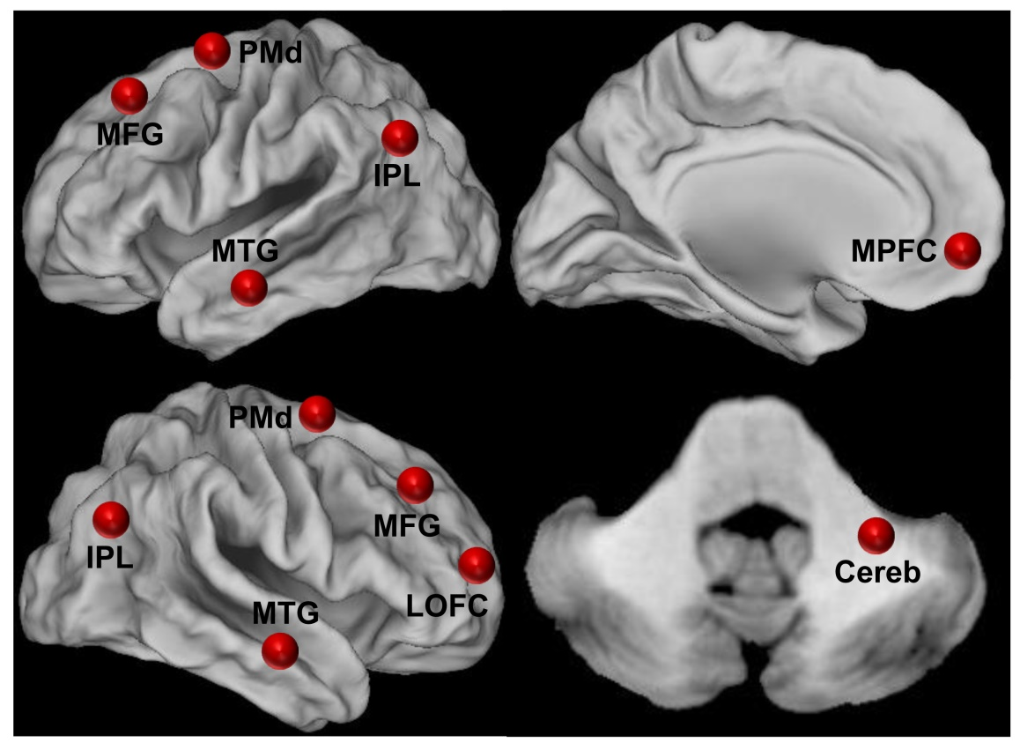

Figure S9. No significant developmental changes of functional connectivity of precuneus subregions with motor network from neonate (Neo) to 1-year-old, 2-year-old, and around-puberty (AP) subjects.

Figure S10. Default mode network (DMN) related subregion in precuneus. Functional connectivity between each precuneus subregion and medial prefrontal cortex (MPFC) was calculated to identify the DMN related subregion in precuneus in all neonate (Neo), 1-year-old, 2-year-old, and around-puberty (AP) subjects. Functional connectivity analyses identified the strongest connection between C1 and MPFC in all the four groups’ subjects.

Figure S11. Individual parcellation of the left and right precuneus in subjects with autism spectrum disorder (ASD).

Supplementary Table
Table S1. The peak MNI coordinates of target brain regions were identified based on significant functional connectivity patterns with precuneus subregions in around-puberty subjects.
Brain Regions | Abbreviation | L/R | Peak MNI Coordinates
Brain Regions | Abbreviation | L/R | x | y | z
Dorsal premotor cortex | PMd | L | -18 | 5 | 66
Dorsal premotor cortex | PMd | R | 27 | 3 | 63
Inferior parietal lobule | IPL | L | -45 | -69 | 30
Inferior parietal lobule | IPL | R | 48 | -66 | 33
Middle frontal gyrus | MFG | L | -38 | 22 | 48
Middle frontal gyrus | MFG | R | 24 | 39 | 36
Middle temporal gyrus | MTG | L | -66 | -12 | -18
Middle temporal gyrus | MTG | R | 57 | -6 | -18
Lateral orbitofrontal cortex | LOFC | R | 30 | 63 | 12
Medial prefrontal cortex | MPFC | L | -4 | 60 | -12
Cerebelum_9 | Cereb | R | 27 | -42 | -48

