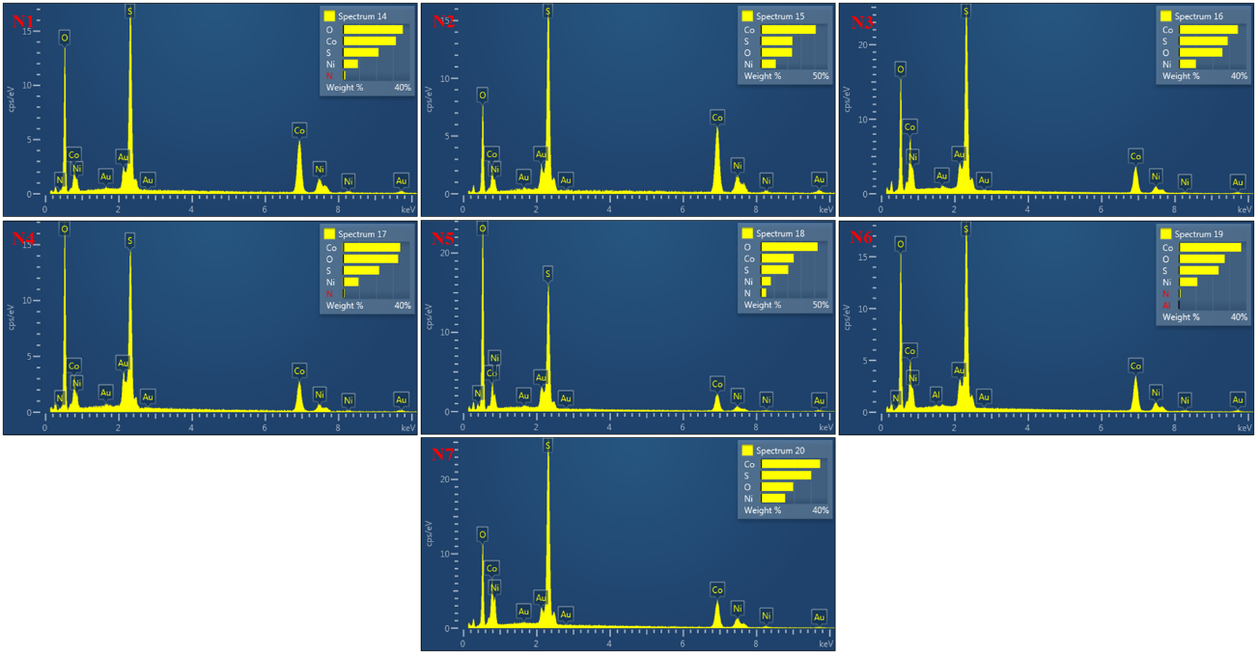
Supplementary Figure S1. EDS spectra of Ni₂CoS₄ nanoparticles (N1–N7) showing elemental composition.

Table S1. Antibacterial susceptibility patterns of S. aureus ATCC and MDR
Antimicrobial | S. aureus ATCC |  | S. aureus MDR
Antimicrobial | MIC (µg/mL) | Susceptibility | MIC (µg/mL) | Susceptibility
Gentamicin-Syn | <=500 | S | <=500
Gentamicin | <=2 | S | <=2 | S
Cefoxitin | <=2 | S | <=2
Cefotaxime | <=8 | S | <=8 | S
Ceftaroline | <=0.25 | S | <=0.25 | S
Ampicillin | X | X | X
Penicillin G | <=0.13 | X | >1 | R
Oxacillin | <=0.25 | S | <=0.25 | S
Daptomycin | <=1 | S | <=1 | S
Trimethoprim-Sulfamethoxazole | <=1/19 | S | X
Teicoplanin | <=1 | S | <=1 | S
Vancomycin | <=1 | S | <=1 | S
Clindamycin | <=0.5 | S | >2 | R
Erythromycin | <=0.25 | S | >4 | R
Linezolid | <=1 | S | <=1 | S
Mupirocin High level | <=256 | S | <=256 | S
Nitrofurantoin | <=16 | S | <=16 | S
Ciprofloxacin | <=0.5 | S | >2 | R
Levofloxacin | <=1 | S | >4 | R
Moxifloxacin | <=0.5 | S | 1 | I
Rifampin | <=0.5 | S | <=0.5 | S
Tetracycline | <=0.5 | S | >8 | R
Tigecycline | <=0.25 | S | <=0.25 | S
(S: Susceptible, I: Intermediate, R: Resistant, X: Invalid).

Table S2 Antibacterial susceptibility patterns of P. aeruginosa ATCC and XDR
Antimicrobial | P. aeruginosa ATCC |  | P. aeruginosa XDR
Antimicrobial | MIC (µg/mL) | Susceptibility | MIC (µg/mL) | Susceptibility
Amikacin | <=8 | S | 32 | I
Gentamicin | <=2 |  | >8
Ertapenem | 1 | R | >1 | R
Imipenem | 2 | S | >4 | R
Meropenem | <=0.5 | S | >4 | R
Cefazolin | >16 | R | >16 | R
Cefuroxime | >16 | R | >16 | R
Ceftazidime | 4 | S | >16 | R
Ceftriaxone | 32 | R | >32 | R
Cefepime | 2 | S | >16 | R
Ceftolozane-Tazobactam | <=1/4 | S | >8/4 | R
Ampicillin | >16 | R | >16 | R
Amoxicillin-Clavulanate | >16/8 | R | >16/8 | R
Piperacillin-Tazobactam | <=4/4 | S | >64/4 | R
Colistin | <=1 | X | <=1 | R
Trimethoprim-Sulfamethoxazole | 2/38 | R | >4/76 | R
Nitrofurantoin | >64 | R | >64 | R
Ciprofloxacin | <=0.5 | S | >2 | R
Levofloxacin | <=1 | S | >4 | R
Tigecycline | >4 | R | >4 | R
(S: Susceptible, I: Intermediate, R: Resistant, X: Invalid).

