Supplementary Material

List of contents

A. Supplementary Tables
Supplementary Table 1. Comparison of the main characteristics of the plant-based burger versus a traditional beef burger (uncooked)
Supplementary Table 2. Effect of plant burger vs beef burger on study outcomes without log transformation
Supplementary Table 3. Outcomes distribution by sequence allocation
Supplementary Table 4. Diet compliance, side effects and impression
Supplementary Table 5. Significant metabolites identified in the volcano plot
Supplementary Table 6. Enrichment analysis for the significant metabolites from the Volcano plot

B. Supplementary Figures
Supplementary Figure 1. Study outline
Supplementary Figure 2. Distribution of TMAO
Supplementary Figure 3. PLS-DA and VIP scores
Supplemental Figure 4. Heatmap for the significant metabolites ranked by Fold Change

C. Appendix
Appendix 1. TMAO analysis
Appendix 2. Metabolomic analysis

A. Supplementary Tables

Supplementary Table 1. Comparison of the main characteristics of the plant-based burger versus a traditional beef burger (uncooked).
Characteristics | Beyond Burger plant-based patties | Kirkland signature beef patties
Serving size | 113g | 113g
Calories | 230Kcal | 210Kcal
Total fat | 14g | 15g
Saturated fat | 5g | 7g
Cholesterol | 0 | 65mg
Sodium | 390mg | 55mg
Carbohydrate | 7g | 2g
Fiber | 2g | 0
Protein | 20g | 17g
Iron | 4mg | 1.75mg

Sources:
- Beyond Burger:
https://www.goodhousekeeping.com/health/diet-nutrition/a29074114/beyond-burger-nutrition-ingredients/ & https://www.beyondmeat.com/en-US/products/the-beyond-burger#:~:text=Water%2C%20pea%20protein*%2C%20expeller,%2C%20vinegar%2C%20lemon%20juice%20concentrate%2C
- Costco Kirkland Beef patties:
https://www.costcuisine.com/post/costco-kirkland-signature-lean-ground-beef-patties-review

Supplementary Table 2. Effect of plant burger vs beef burger on study outcomes without log transformation

Outcome | Plant vs Red-meat  Plant - Meat Mean Differences (95%CI) | Effect  Coefficient | Diet Effect P-value | Sequence  P-value | Period  P-value
Primary
TMAO, ng/mL | -366.11 (-704.45 to -27.77) | -370.13 | 0.034 | 0.127 | 0.336
Secondary
Total bilirubin, umol/L | -0.57 (-3.59 to 2.44) | -0.58 | 0.705 | 0.909 | 0.920
C-reactive protein, mg/L | 0.81 (-1.58 to 3.19) | 0.83 | 0.502 | 0.654 | 0.523
NTproBNP, pg/mL | -22.51 (-243.63 to 198.61) | -22.11 | 0.840 | 0.788 | 0.883
Legend: NTproBNP, N-terminal pro b-type natriuretic peptide; TMAO, trimethylamine N-oxide.

Supplementary Table 3. Outcomes distribution by sequence allocation
Outcome measure | Red meat | Plant
TMAO (log) | 6.0±0.9 | 5.4±0.6
TMAO, ng/mL* | 388 (274-607) | 238 (127-346)
Total cholesterol, mg/dL | 175±45 | 168±43
LDL cholesterol, mg/dL | 94±34 | 89±33
HDL cholesterol, mg/dL | 51±13 | 50±12
Non-HDL cholesterol, mg/dL | 124±43 | 117±41
Triglycerides, mg/dL | 150±95 | 157±129
Weight, Kg | 79.5±19.8 | 80.0±20.1
Heart rate, bpm | 73±13 | 71±10
SBP, mmHg | 117±12 | 119±11
DBP, mmHg | 69±9 | 69±9
eGFR, ml/min | 98±19 | 100±18
Total bilirubin (log) | -0.5±0.5 | -0.5±0.5
Total bilirubin, mg/dL* | 0.6 (0.4-0.8) | 0.6 (0.4-0.8)
C-reactive protein (log) | 0.4±1.1 | 0.6±1.2
C-reactive protein, mg/L* | 1.5 (0.6-3.4) | 1.5 (0.9-3.1)
NTproBNP (log) | 4.0±1.4 | 4.2±1.3
NTproBNP, pg/mL* | 54 (16-106) | 57 (27-148)
Legend: DBP, diastolic blood pressure; eGFR, estimated glomerular filtration rate (CKD-EPI-creatinine); NTproBNP, N-terminal pro b-type natriuretic peptide TMAO, trimethylamine N-oxide; SBP, systolic blood pressure.
*Median (IQR).

Supplementary Table 4. Diet compliance, side effects and impression.

Parameter | Red meat | Plant | P-value
Compliance with diet instructions
Meat intake | 2 (4.9%) | 2 (4.9%) | 1
Fish intake | 4 (13.3%) | 0 | 0.05
Seafood intake | 6 (14.6%) | 2 (4.9%) | 0.14
Egg intake | 2 (4.9%) | 2 (4.9%) | 1
Side effects
Fatigue | 4 (9.8%) | 8 (19.5%) | 0.39
Nausea | 4 (9.8%) | 5 (12.2%) | 0.35
Flatulence | 5 (12.2%) | 10 (24.4%) | 0.33
Diarrhea | 0 | 4 (9.8%) | 0.08
Abdominal pain | 0 | 2 (4.9%) | 0.08
Impression
Red meat | 35 (85.4%) | 6 (14.6%) | <0.01
Plant | 5 (12.2%) | 31 (75.6%) | <0.01
Unsure | 1 (2.4%) | 4 (9.8%) | <0.01

Supplementary Table 5. Significant metabolites from the volcano plot.
Metabolites | Fold Change | Fold Change  (Log2) | Adjusted  p value | Log10  (adjusted P value)
2-Hydroxycaproic acid | 2.35 | 1.23 | 0.019 | 1.72
N-Methylphenylethanolamine | 1.93 | 0.95 | 6.02E-07 | 6.22
N-Hexadecanoylpyrrolidine | 1.33 | 0.41 | 0.002 | 2.82
Glutamylglycine | 1.31 | 0.39 | 0.093 | 1.03
3-(3,4,5-Trimethoxyphenyl)propanoic acid | 1.23 | 0.30 | 0.022 | 1.66
Diethyl phthalic acid | 1.22 | 0.29 | 0.019 | 1.72
9,10-methylene-9-octadecenoic acid | 1.21 | 0.27 | 0.080 | 1.10
3-Indoleacetonitrile | 1.20 | 0.27 | 0.062 | 1.20
3-Hydroxycapric acid | 0.79 | -0.34 | 0.065 | 1.19
Histidyltryptophan | 0.71 | -0.49 | 0.062 | 1.20
N-Propionylmethionine | 0.58 | -0.79 | 0.065 | 1.19

Caption: Significant metabolites were identified from volcano plot analysis in Figure 3. Paired non-parametric equal group variance tests, with thresholds of Fold Change> 1.2 and False Discovery Rate (FDR) < 0.10 were used to identify significant metabolites up or downregulated by plant-based diet vs red meat diet. The order of metabolites is based on Fold Change values for Plant-based / Red-meat based diets.
Supplementary Table 6. Enrichment analysis for the significant metabolites from the Volcano plot
Metabolite Set | Total | Hits | Expect | P value | Holm P | FDR | Metabolites | References
Male steroid hormones in cardiomyocyte energy metabolism | 15 | 1 | 0.00701 | 0.007 | 1.0 | 1.0 | Androsterone; Androstenedione; Cholesterol; Dehydroepiandrosterone; Estrone; Testosterone; Pregnenolone; 17a-Hydroxypregnenolone; 2-Hydroxycaproic acid; Progesterone; Testosterone sulfate; Dihydrotestosterone; Testosterone glucuronide; 5-Androstenediol; Estradiol | WikiPathways
Fatty Acid Biosynthesis | 34 | 1 | 0.0159 | 0.0158 | 1.0 | 1.0 | 3-Hydroxybutyric acid; Biotin; Butyric acid; Acetic acid; Acetoacetic acid; Palmitic acid; 3-Hydroxydodecanoic acid; Caprylic acid; Capric acid; Caproic acid; Dodecanoic acid; Malonic acid; Myristic acid; Malonyl-CoA; Acetyl-CoA; Manganese; 2-Octenoic acid; 3-Hydroxycapric acid; 3-Oxohexanoic acid; (R)-3-Hydroxyhexanoic acid; trans-Hex-2-enoic acid; But-2-enoic acid; 3-Oxooctanoic acid; 3-Hydroxyoctanoic acid; 3-Oxodecanoic acid; trans-Dec-2-enoic acid; 3-Oxododecanoic acid; trans-Dodec-2-enoic acid; 3-Oxotetradecanoic acid; (R)-3-Hydroxy-tetradecanoic acid; trans-Tetra-dec-2-enoic acid; 3-Oxohexadecanoic acid; (R)-3-Hydroxy-hexadecanoic acid; Trans-Hexa-dec-2-enoic acid | SMPDB
Caption: Pathways enriched by using the 8 significantly up and 3 down regulated metabolites in volcano plot with FDR<0.10 and FDR>1.2, and by using the RaMP database from MetaboAnalyst 6.0 (RaMP-DB: Metabolite Library of 3694 metabolite and metabolite pathways, integrating HMDB, KEGG, Reactome, WikiPathways).
Reference: Ewald, J.D., Zhou, G., Lu, Y. et al. Web-based multi-omics integration using the Analyst software suite. Nat Protoc (2024). https://doi.org/10.1038/s41596-023-00950-4.

B. Supplementary Figures

Supplementary Figure 1. Study outline

Supplementary Figure 2. Distribution of TMAO

Legend: TMAO, trimethylamine N-oxide.

Supplementary Figure 3. PLS-DA and VIP scores
- PLS-DA 2D plot.
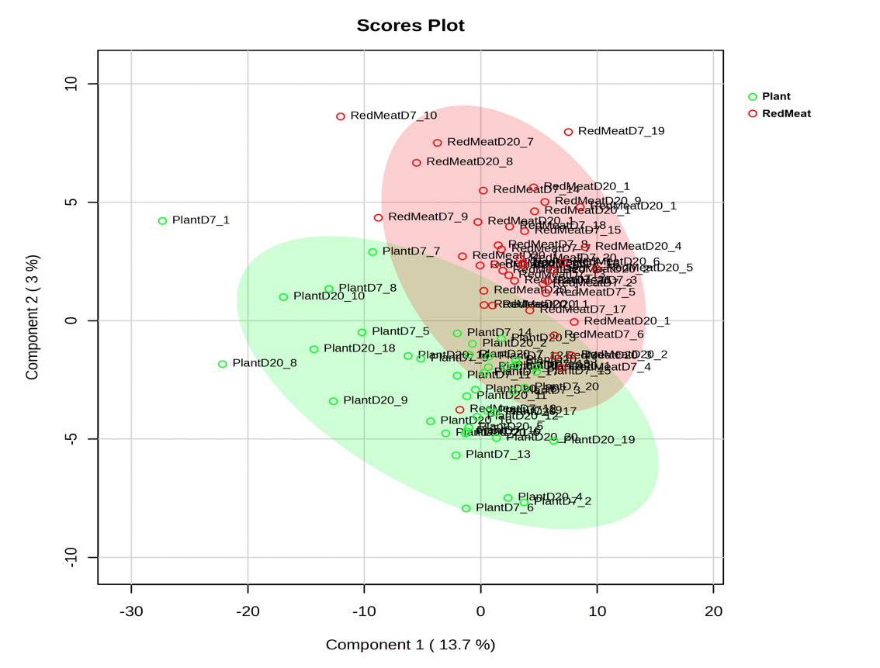
- Top 25 metabolites ranked by VIP scores based on PLS-DA Component 1.
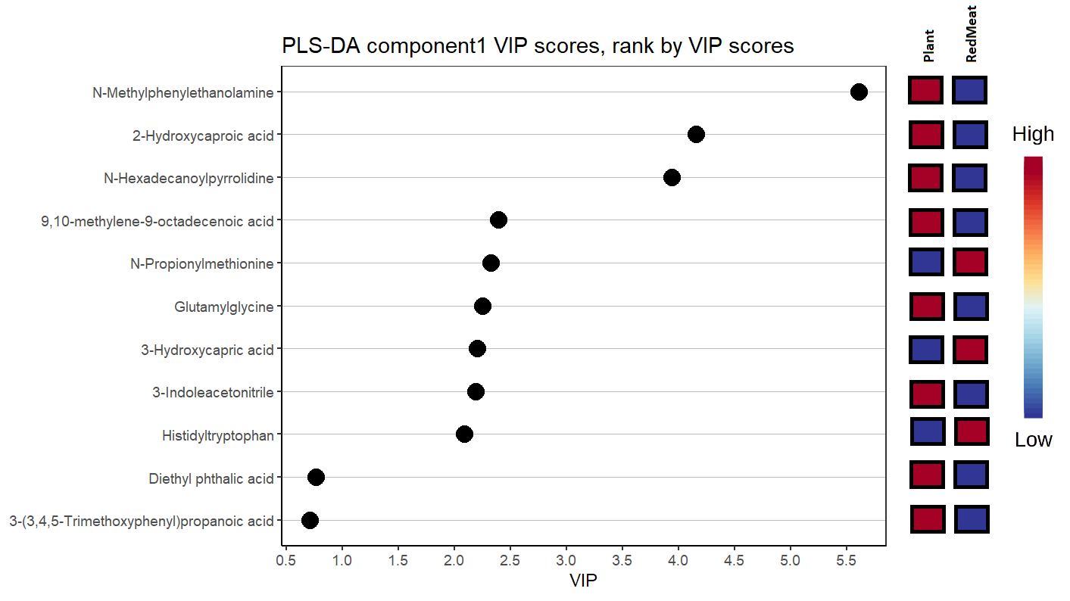
Caption: Multivariate analysis using PLS-DA for classifying samples into Plant-based and Red-meat based diets using all the metabolites peak intensities.
Legend: PLS-DA: Partial least squares-discriminant analysis; VIP: Variable Importance in Projection

Supplemental Figure 4. Heatmap for the significant metabolites ranked by Fold Change

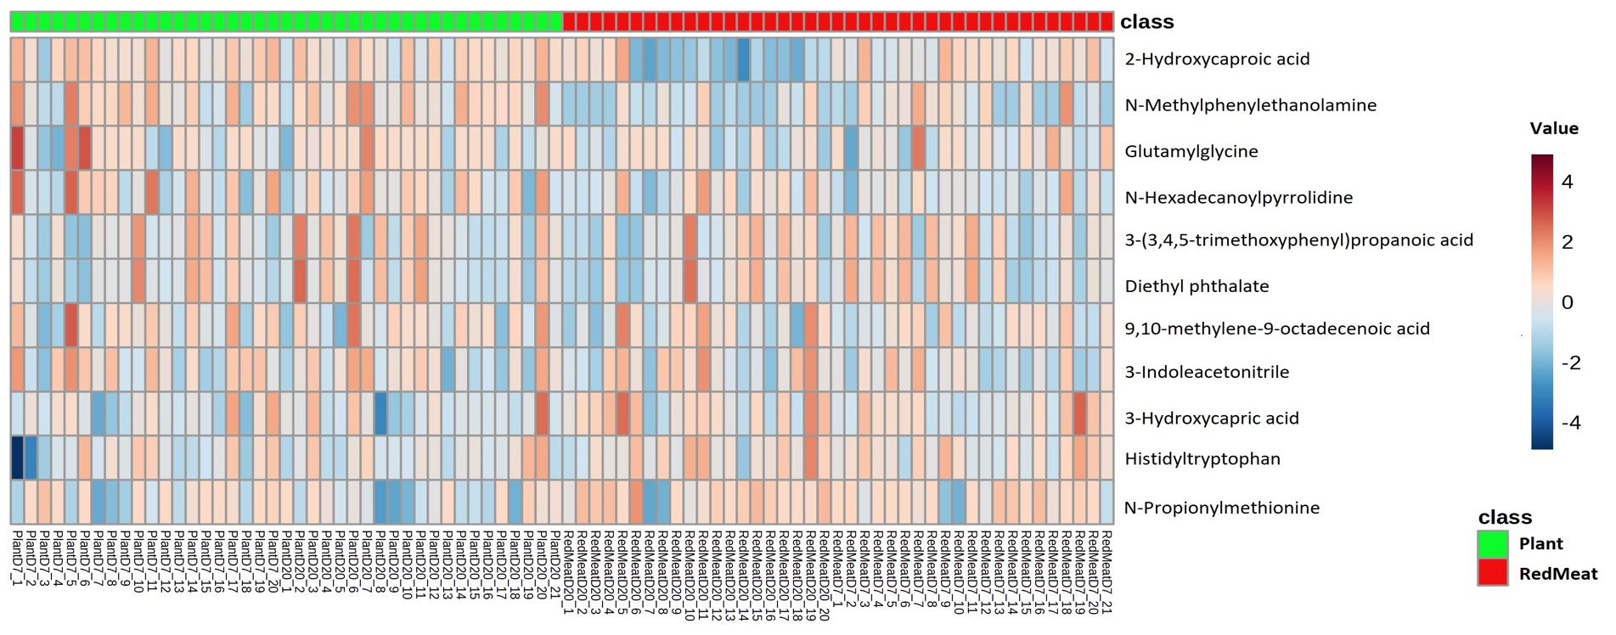

Caption: Heatmap for the 11 significant metabolites identified in volcano plot analysis in Figure 3. The relative values are based on their normalized peak intensities values, ranked by Fold Change values, with the highest Fold Change values for Plant-diet / Red meat-diet at the top.
Heatmap generated using the web-based and R package from MetaboAnalyst: https://www.metaboanalyst.ca/

C. Appendix

Appendix 1. Study Outcomes Modified IIT

There were 5 households, 4 participants who switched the randomization sequence to accommodate the household diet. We have included these changes in the modified ITT analysis (primary analysis). In the primary analysis using the revised diet order reflecting actual intake after household-driven switching, plant-based protein intake was associated with a −0.61 unit difference in log(TMAO) compared with red meat (β = −0.613), corresponding to an approximately 46% lower TMAO concentration. A modest sequence effect was observed (β = 0.322), while the period effect was small (β = 0.063). Random-effects estimates indicated substantial inter-individual variability (random intercept SD 0.36) relative to residual variability (SD 0.66). In a sensitivity analysis using the original randomized diet order, results were highly consistent: plant-based protein intake was associated with a −0.54 unit difference in log(TMAO) (β = −0.537; ~41% reduction), with similar sequence (β = 0.330) and period (β = 0.061) effects and comparable variance components. Together, these findings demonstrate that the reduction in TMAO associated with plant-based protein intake is robust to household-driven changes in diet sequence and analytic approach.

Appendix 2. TMAO analysis
TMAO concentrations in plasma samples were assessed in collaboration with the Proteomics and Molecular Analysis platform at the Research Institute of the McGill University Health Centre (Montreal, Quebec). Plasma aliquots were precipitated and analyzed alongside a calibration curve with quality controls using reversed phase ultra-performance liquid chromatography mass spectrometry (UPLC-MS).
Extraction recovery was 100% so samples were prepared and analyzed along with a 25-10,000 ng/mL calibration curve containing TMAO (Sigma-Aldrich, St. Louis, Missouri, USA) in water. Quality controls were prepared in plasma with and without spiked TMAO. An internal standard working solution (ISWS) containing 100 ng/mL TMAO-d9 (Sigma-Aldrich, St. Louis, Missouri, USA) in methanol was added to the experimental, calibration and quality control sample aliquots. After vortexing and centrifugation, plasma supernatants or solution aliquots were transferred to injection vials containing 75:25 ACN: 10mM NH4Formate+0.1% formic acid in water (v:v) and vortexed.
Samples were analyzed by UPLC-MS using a SCIEX TripleTOF mass spectrometer (Framingham, MA, USA) coupled with a Shimadzu Nexera UPLC system (Columbia, MD, USA). Samples were injected onto a Halo PFP 50 x 2.1 mm (2 µm) column and chromatographed using 10mM ammonium formate with 0.1% formic acid in water and acetonitrile. TMAO and TMAO-d9 electrospray positive mode ionization followed by MS/MS fragmentation. Data acquisition was performed using Sciex Analyst TF (version 1.7.1) software. Peak area measurements from selected product ions, calibration curve regression analysis and resulting sample quantification were performed using Sciex MultiQuant (version 3.02) software.

Appendix 3. Untargeted Metabolomics Analysis.
Human Plasma samples of the 41 FOOD-1 participants were sent to Creative Proteomics for untargeted metabolomics analysis. In brief, for metabolite extraction, 100 µl of plasma were homogenized by 30s of cold vortexing and sonication after the addition of 3 volumes of ice-cold aqueous methanol. Samples were kept at -20°C for 1 hour, then vortexed for 30s and kept on ice for another 30 min. After sample centrifugation (12000rpm, 15min, 4°C), 200µl of the supernatant was used for separation using liquid mass chromatography spectrum (LC-MS). For internal standard, we used 5µl of 0.14mg/ml of DL-o Chlorophenylalanine. For the assessment of reliability and instrument stability over time, quality control (QC) was performed, using QC samples prepared by pooling equal volumes from all participant plasma samples. For metabolite separation, we used the Vanquish Flex UPLC combined with Q Exactive MS (Thermo) LC-MS screened with ESI-MS. The LC system is comprised of the ACQUITY UPLC HSS T3 (100×2.1 mm×1.8 μm) with UPLC. The mobile phase was composed of solvent A (0.05% formic acid water) and solvent B (acetonitrile) with a gradient elution of 0-1 min, 5% B; 1-12.5 min, 5%-95% B; 12.5-13.5 min, 95% B; 13.5-13.6 min, 95%-5% B; 13.6-16 min, 5% B. The flow rate of the mobile phase was set to 0.3 mL / min. The column temperature was maintained at 40°C, and the sample manager temperature was set at 4°C. Both MS parameters in ESI+ and ESI- mode were captured. For metabolite annotation, the raw data was acquired and aligned using the Compound Discover (3.0, Thermo) software based on the m/z value and the retention time of the metabolite signals at an accuracy higher than 95%. For metabolites simultaneously detected in both LC-MS positive and negative extraction modes, the values showing the highest average mean were utilized for final analysis and duplicates were then removed from the datasets. Identified features peak intensities were further filtered based on the ability to identify them using the HMDB identifier. The matched 619629 metabolites and associated peak intensities of the 82 plasma samples were then used for the univariate and multivariate statistical analysis on MetaboAanalyst. The peak intensities were normalized by median values, auto-scaled, and generalized by log10 transformation. The volcano plot combining the Fold Change (FC) analysis and the T-tests was used to select the significant metabolites. The Partial Least Squares – Discriminant Analysis (PLS-DA) was also used to classify samples into plant-based and red-meat diets. The significant metabolites were used in the Enrichment and Pathway analysis, and their peak intensities were displayed in the heatmap.
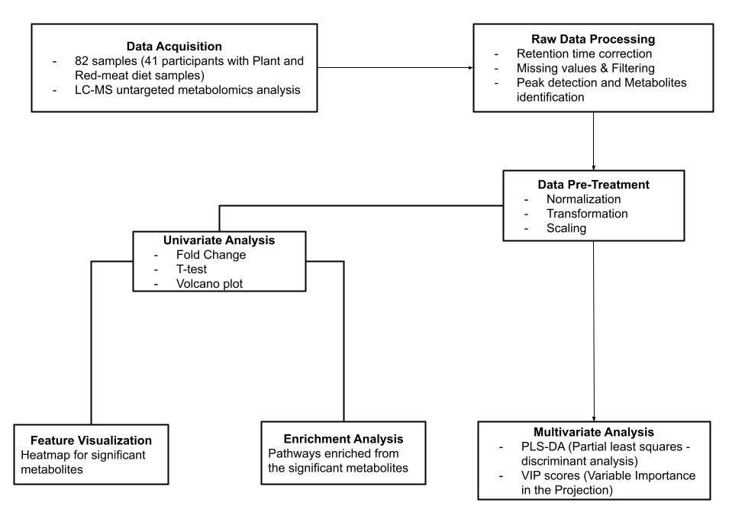
Caption: Untargeted metabolomics analysis flowchart.

