Supplementary Table 1. List of the seafood (common and scientific names) of wild and/or farmed origin sampled in the present study. Species name and location derived from product packaging or other product information available at time of purchase.
Common name | Scientific name¹ | Wild/Farmed | Location² | n
FRESHWATER FISH
Arctic char | Salvelinus alpinus | Farmed | UK | 4
Common carp | Cyprinus carpio | Farmed | Poland | 5
Milkfish | Chanos chanos | Farmed | Indonesia | 4
Nile Tilapia | Oreochromis niloticus | Farmed | China | 4
Rainbow trout | Oncorhynchus mykiss | Farmed | UK | 5
Siberian sturgeon | Acipenser baerii | Farmed | France | 4
Striped catfish (Basa) | Pangasius hypophthalmus | Farmed | Vietnam | 5
Zander (Pike-perch) | Sander luciopersa | Wild | Kazakhstan | 4
MARINE FISH
Anguilliformes
Daggertooth pike-conger | Muraenesx cinerus | Wild | FAO 27 | 4
European conger | Conger conger | Wild | FAO 27 | 4
Clupeiformes
Atlantic herring | Clupea harengus | Wild | FAO 27 IV, VII | 7
European anchovy | Engraulis encrasicolus | Wild | FAO 37.1 | 3
European pilchard (Sardine) | Sardina pilchardus | Wild | FAO 27 (IV, VII) | 5
European sprat | Sprattus sprattus | Wild | FAO 27 (VII) | 6
Gadiformes
Alaskan pollock | Theragra chalcogramma | Wild | FAO 61, 67 | 3
Atlantic cod | Gadus morhua | Wild | FAO 27 (I, II, IV, V) | 6
Cape hake | Merluccius capensis | Wild | FAO 47 | 4
European hake | Merluccius merluccius | Wild | FAO 27 (IV, VII) | 4
Haddock | Melanogrammus aeglefinus | Wild | FAO 27 (I, II, IV, V, VII) | 5
Ling | Molva molva | Wild | FAO 27 | 5
Pollack (Atlantic pollock) | Pollachius pollachius | Wild | FAO 27 (IV) | 3
Pouting | Trisopterus luscus | Wild | FAO 27 (IV, VII) | 3
Saithe (Coley) | Pollachius virens | Wild | FAO 27 (IV, VII) | 4
Whiting | Merlangius merlangus | Wild | FAO 27 (IV, VII) | 5
Lophiformes
Monkfish | Lophius piscatorius | Wild | FAO 27 | 4
Mugilformes
Flathead grey mullet | Mugil cephalus | Wild | FAO 27 | 5
Thicklip grey mullet | Chelon labrosus | Wild | FAO 27 | 4
Percoideri
Atlantic horse mackerel | Trachurus trachurus | Wild | FAO 27 (IX) | 3
Barramundi (Asian seabass) | Lates calcarifer | Farmed | Vietnam | 6
Black seabream | Spondyliosoma cantharus | Wild | FAO 27 | 6
European seabass | Dicentrachus labrax | Farmed | Greece, Turkey | 6
European seabass | Dicentrachus labrax | Wild | FAO 27 | 4
Gilthead seabream | Sparus aurata | Farmed | Greece, Turkey | 6
Meagre | Argyrosomus regius | Farmed | Greece, Turkey | 4
Red mullet (Indian goatfish) | Parupeneus indicus, P. heptacanthus | Wild | FAO 51, 57 | 8
Red snapper | Lutjanus malabaricus, L. sebae, Pinjalo pinjalo | Wild | FAO 71 | 4
Yellow croaker | Larimichthys polyactis | Wild | FAO 61 | 3
Pleuronectiformes
Atlantic halibut | Hippoglossus hippoglossus | Farmed | Norway | 7
Atlantic halibut | Hippoglossus hippoglossus | Wild | FAO 27 | 6
Brill | Scophthalmus rhombus | Wild | FAO 27 | 5
Common dab | Limanda limanda | Wild | FAO 27 IV, VII | 4
Common sole (Dover sole) | Solea solea | Wild | FAO 27 IV, VII | 6
European flounder | Platichys flesus | Wild | FAO 27 | 4
European plaice | Pleuronectes platessa | Wild | FAO 27 (IV, V, VII) | 6
Lemon sole | Microstomus kitt | Wild | FAO 27 (IV, V, VII) | 7
Megrim | Lepidorhombus whiffiagonis | Wild | FAO 27 (IV, VII) | 4
Turbot | Psetta maxima  (Scopthalmus maximus) | Farmed | France, Portugal, Spain | 5
Turbot | Psetta maxima  (Scopthalmus maximus) | Wild | FAO 27 | 5
White trevally (Trevally jack) | Pseudocaranx dentex | Wild | FAO 81 | 3
Witch flounder (Witch sole) | Glyptocephalus cynoglossus | Wild | FAO 27 | 5
Yellowfin sole | Limanda aspera | Wild | FAO 67 | 3
Rajiformes
Ray wings | Leucoraja naevus, Raja montagui, R. clavata | Wild | FAO 27 (II, IV, VI, VII) | 4
Salmoniformes
Atlantic salmon | Salmo salar | Farmed | UK, Norway | 78
Atlantic salmon | Salmo salar | Wild | UK, Norway | 6
Keta salmon (Chum) | Oncorhynchus keta | Wild | FAO 67 | 5
Pink salmon (Humpback) | Oncorhynchus gorbuscha | Wild | FAO 67 | 4
Rainbow trout | Oncorhynchus mykiss | Farmed | UK | 5
Sea trout | Salmo trutta | Wild | FAO 27 (IV) | 4
Sockeye salmon (Red) | Oncorhynchus nerka | Wild | FAO 61, 67 | 6
Scombroideri
Albacore tuna | Thunnus alalunga | Wild | FAO 31, 51, 57, 71, 77 | 5
Atlantic mackerel | Scomber scombrus | Wild | FAO 27 (IV, VI, VII, VIII) | 7
Black marlin | Makaira indica | Wild | FAO 71 | 5
Largehead hairtail (Beltfish) | Trichiurus lepturus | Wild | FAO 71 | 3
Savalai hairtail (Ribbonfish) | Lepturacanthus savala | Wild | FAO 51 | 3
Swordfish | Xiphias gladius | Wild | FAO 51, 57, 71, 77 | 5
Wahoo (Kingfish) | Acanthocybium solandri | Wild | FAO 51, 57 | 4
Yellowfin tuna | Thunnus albacares | Wild | FAO 71, 77, 81, 87 | 6
Scorpaeniformes
Gurnard | Chelidonichthys lucerne, C. spinosus, Eutrigla gurnadus | Wild | FAO 27 (IV, VII) | 8
Redfish (Norway redfish) | Sebastes spp. | Wild | FAO 27 (V) | 4
Squaliformes
Picked dogfish (Huss) | Squalus acanthias | Wild | FAO 21 | 3
Stromateoidei
Silver pomfret | Pampus argentus | Wild | FAO 51 | 4
Zoarcoidei
Atlantic wolfish | Anarhichas lupus | Wild | FAO 27 | 4
Zeiformes
John dory | Zeus faber | Wild | FAO 27 | 7
Oreo dory (Smooth oreo) | Pseudocyttus maculatus | Wild | FAO 81 | 5
SHELLFISH
CRUSTACEANS
American lobster | Homarus americanus | Wild | FAO 21 | 4
*Edible crab – brown meat | Cancer pagrus | Wild | FAO 27 (IV, VII) | 4
*Edible crab – white | Cancer pagrus | Wild | FAO 27 (VII) | 3
*Edible crab - whole | Cancer pagrus | Wild | FAO 27 (VII) | 3
King prawn | Litopenaeus vannamei | Farmed | Ecuador, Honduras, Vietnam | 4
Langoustines (Norway lobster) | Nephrops norvegicus | Wild | FAO 27 | 4
Northern prawn | Pandalus borealis | Wild | FAO 21, FAO 27 (I, II) | 4
Tiger prawn | Penaeus monodon | Farmed | Vietnam | 4
MOLLUSCS
Bivalves
Atlantic scallop (Deep-Sea) | Plactopecten magellancius | Wild | FAO 21 | 3
Atlantic razor clam | Ensis directus | Wild | FAO 27 (IV) | 5
Blue mussels | Mytilus edulis | Farmed | UK | 4
*Blue mussels | Mytilus edulis | Wild | FAO 27 | 4
Chilean mussels | Mytilus chilensis | Farmed | Chile | 4
Clams | Tawera gayi | Wild | FAO 87 | 3
*Common edible cockle | Cerastoderma edule | Wild | FAO 27 IV | 4
Green-lipped mussels | Perna canaliculus | Farmed | New Zealand | 4
King scallop + roe | Pecten maximus | Wild | FAO 27 | 3
Pacific oyster | Crassostrea gigas | Farmed | Ireland, UK | 3
Patagonian scallop | Zygochlamys patagonica | Wild | FAO 41 | 3
Cephalopods
Horned octopus (curled) | Eledone cirrhosa | Wild | FAO 27 (IV, VII) | 5
Pharoah cuttlefish | Sepia pharaonis | Wild | FAO 51 | 4
Squid | Loligo vulgaris, L. forbesi | Wild | FAO 51, 57, 71 | 4
PROCESSED
Seafood sticks (surimi) | - | - | - | 4
¹Food and Agriculture of the United Nations (FAO) nomenclature (ASFIS List of Species for Fishery Statistics Purposes. Available online: https://www.fao.org/fishery/collection/asfis/en).
²Location according to product label/information provided at time of purchase and relevant FAO fishing ground (FAO Major Fishing Areas. Available online: https://www.fao.org/fishery/area/search/en).
All samples raw unless indicated by *

Supplementary Figure 1. Proportion of 18:1n-9 (% of total fatty acids) of wild and/or farmed seafood of marine and/or freshwater origin. Samples ranked in descending order. indicates median lipid value. All samples analysed were raw unless denoted by *. Refer to Supplementary Table 1 for further sample information.
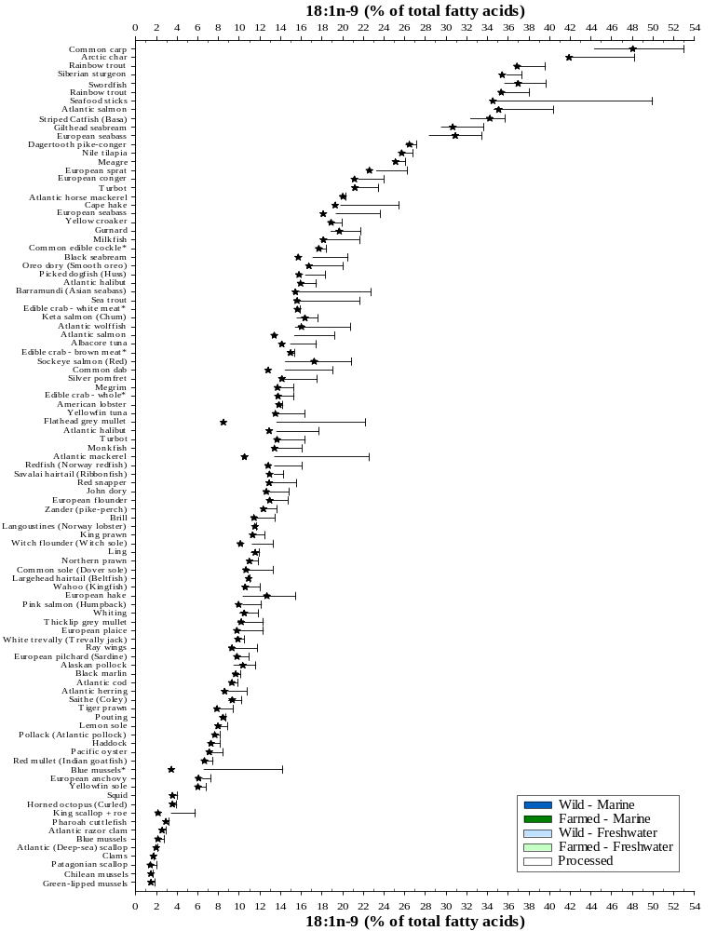
Supplementary Figure 2. Proportion of 18:2n-6 (% of total fatty acids) of wild and/or farmed seafood of marine and/or freshwater origin. Samples ranked in descending order. indicates median lipid value. All samples analysed were raw unless denoted by *. Refer to Supplementary Table 1 for further sample information.
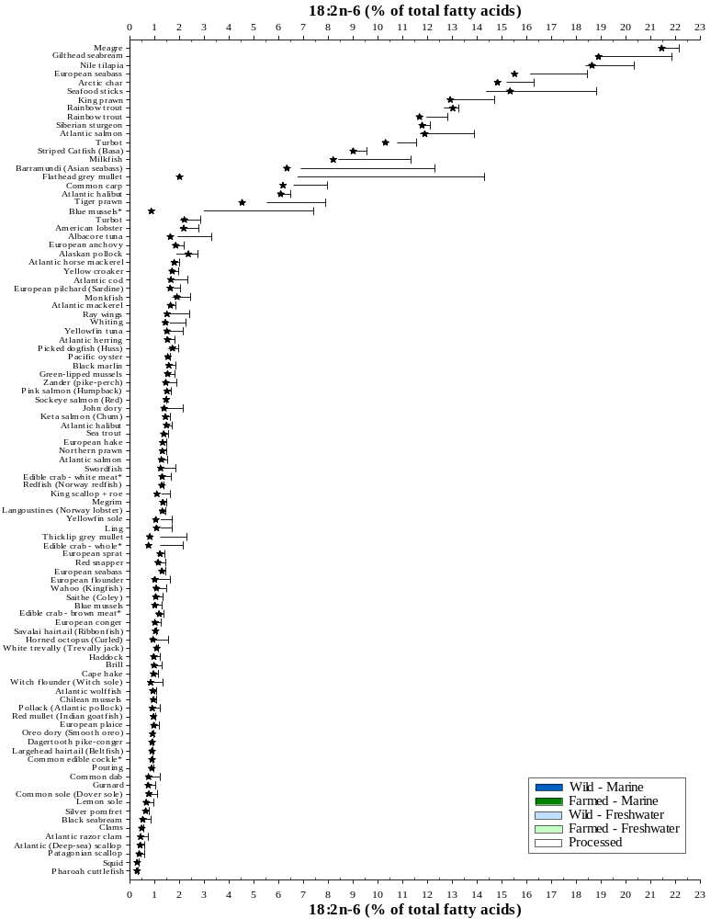
Supplementary Figure 3. Proportion of 18:3n-3 (% of total fatty acids) of wild and/or farmed seafood of marine and/or freshwater origin. Samples ranked in descending order. indicates median lipid value. All samples analysed were raw unless denoted by *. Refer to Supplementary Table 1 for further sample information.
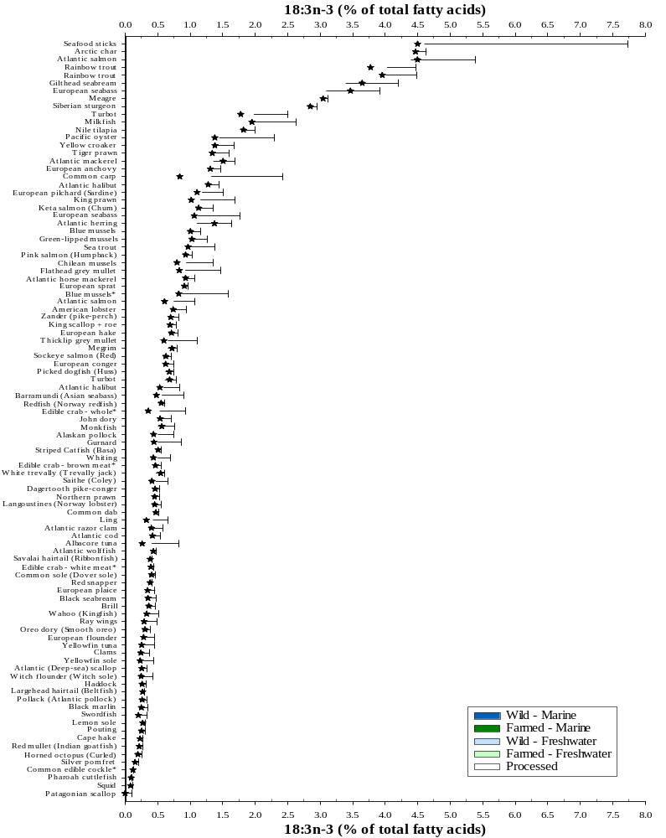

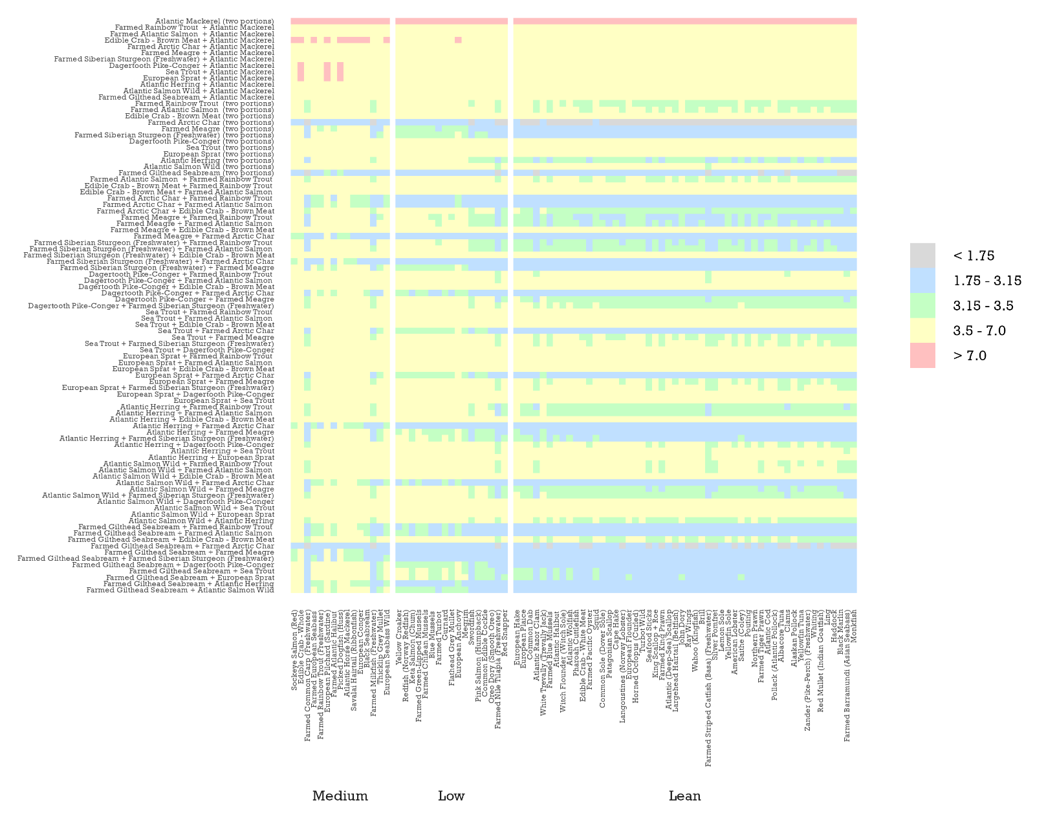
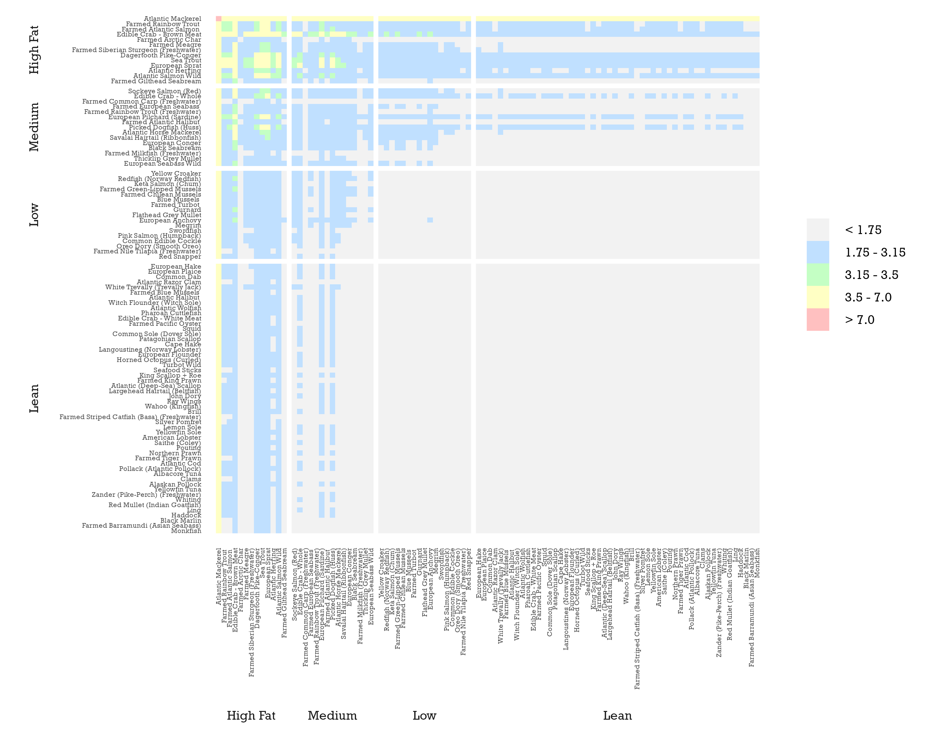
Supplementary Figure 4. Combination of any three portions of seafood, where two are oily (>8 % fat), and the weekly recommended EPA+DHA intake achieved, based on average EPA+DHA contents: EFSA 1.75 g.week⁻¹ [25]; UK 3.15 g.week⁻¹ [23]; GOED/ISSFAL, 3.50 g.week⁻¹ [24,27]; and AHA 7 g.week⁻¹ for those with history of cardiovascular disease [26]. Samples ranked and grouped according to lipid content based on Ackman [39]. Portion sizes based on the UK’s 140 g recommendation.
< 1.75 g
1.75 – 3.15 g (EFSA)
3.15 – 3.5 g (UK)
3.5 – 7 g (GOED)
>7 g (AHA)
MEDIUM
4-8 %
LOW
2-4 %
LEAN
< 2 %
HIGH
> 8 %

