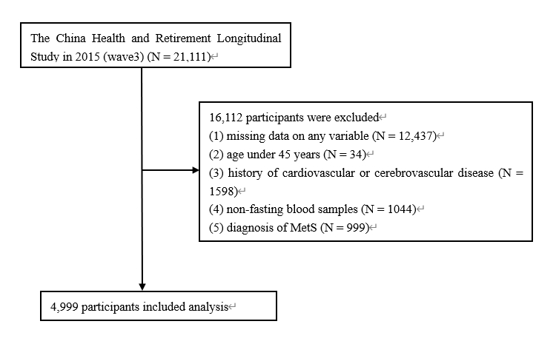
Supplementary Figure. 1 Flow chart of participants in CHARLS. MetS, metabolic syndrome

Supplementary Figure. 2 Subgroup analysis of the association between eGDR and heart disease. Model 1, unadjusted; Model 2, adjusted for age and sex; Model 3, adjusted for age, sex, marital status, education level, residence, smoking and drinking status, SBP, DBP, BMI, dyslipidemia, pre-DM, DM, TG, TC, HDL-C, LDL-C, FBG, CRP, Scr, BUN, and UA
Abbreviations: eGDR, estimated glucose disposal rate; CVD, cardiovascular disease; SBP, systolic blood pressure; DBP, diastolic blood pressure; BMI, body mass index; pre-DM, prediabetes mellitus; DM, diabetes mellitus; TG, triglycerides; TC, total cholesterol; HDL-C, high-density lipoprotein cholesterol; LDL-C, low-density lipoprotein cholesterol; FBG, fasting blood glucose; HbA1c, glycated hemoglobin; CRP, C-reactive protein; Scr, serum creatinine; BUN, blood urea nitrogen; UA, uric acid
Supplementary Figure. 3 Subgroup analysis of the association between eGDR and stroke. Model 1, unadjusted; Model 2, adjusted for age and sex; Model 3, adjusted for age, sex, marital status, education level, residence, smoking and drinking status, SBP, DBP, BMI, dyslipidemia, pre-DM, DM, TG, TC, HDL-C, LDL-C, FBG, CRP, Scr, BUN, and UA
Abbreviations: eGDR, estimated glucose disposal rate; CVD, cardiovascular disease; SBP, systolic blood pressure; DBP, diastolic blood pressure; BMI, body mass index; pre-DM, prediabetes mellitus; DM, diabetes mellitus; TG, triglycerides; TC, total cholesterol; HDL-C, high-density lipoprotein cholesterol; LDL-C, low-density lipoprotein cholesterol; FBG, fasting blood glucose; HbA1c, glycated hemoglobin; CRP, C-reactive protein; Scr, serum creatinine; BUN, blood urea nitrogen; UA, uric acid

