Experiment
Synthesis of 3-amino-3-(hydroxyimino)-N-(4-(N-(pyrimidin-2-yl)sulfamoyl)phenyl)propenamide (2)
Compound 1 (0.30 g, 0.001 mol) and hydroxylamine hydrochloride (0.08 g, 0.0012 mol) was refluxed in boiling EtOH (25 mL) with few drops of TEA (3 drops) for 3 h. The obtained solid material on cooling was filtered and recrystallized from ethanol to give compound 2.
Yield, 73%; m.p. 187-189 °C; IR (KBr): ν_{max}, cm⁻¹: 3510 (OH), 3430 (NH₂), 3230, 3210 (2NH), 1675 (amidic CO), 1620 (C=N), 1600 (C=C), 1330 (SO₂); ¹H-NMR (DMSO-d₆) δ ppm: 3.09 (s, 2H, CH₂), 6.20 (s, 2H, NH₂), 6.99-7.07 (m, 1H, pyrimidine-C₅H), 7.70 (d, 2H, Ar-H), 7.79 (d, 2H, Ar-H), 8.51 (d, 2H, pyrimidine-C₄H + C₆H), 9.06 (s, 1H, OH), 9.93 (s, 1H, NH), 11.24 (s, 1H, NH); ¹³C-NMR (DMSO-d₆) δ ppm: 42.9, 116.0, 118.8 (2C), 129.7, 134.9 (2C), 141.6, 156.6, 158.0 (2C), 165.5, 170.0. MS (m/z, %): 350 (M⁺, 66). Anal. Calced for C₁₃H₁₄N₆O₄S (350.35): C, 44.57; H, 4.03; N, 23.99%. Found: C, 44.51; H, 3.97; N, 23.95%.
Synthesis of 4-(3-amino-5-oxo-4,5-dihydro-1H-pyrazol-1-yl)-N-(pyrimidin-2-yl)benzenesulfonamide (5)
A mixture of compound 2 (0.35 g, 0.001 mol) and acetic anhydride (25 mL) was heated in water bath for 8 h. The solid material was separated by filtration, crystallization from hot ethanol to give compound 5.
Yield, 77%; m.p. 215-217 °C; IR (KBr): ν_{max}, cm⁻¹: 3410 (NH₂), 3210 (NH), 1680 (amidic CO), 1618 (C=N), 1595 (C=C), 1310 (SO₂); ¹H-NMR (DMSO-d₆) δ ppm: 3.19 (s, 2H, CH₂), 6.40 (s, 2H, NH₂), 7.10–7.20 (m, 1H, pyrimidine–C₅H), 7.84 (d, 2H, Ar-H), 8.25 (d, 2H, Ar-H), 8.65 (d, 2H, pyrimidine-C₄H + C₆H), 11.27 (s, 1H, NH); ¹³C-NMR (DMSO-d₆) δ ppm: 72.0, 115.5, 120.6 (2C), 129.0 (2C), 134.7, 142.9, 157.0 (2C), 160.0, 169.4, 172.3. MS (m/z, %): 332 (M⁺, 54). Anal. Calced for C₁₃H₁₂N₆O₃S (332.34): C, 46.98; H, 3.64; N, 25.29%. Found: C, 46.93; H, 3.59; N, 25.20%.
Synthesis of 2-(4-oxo-4,5-dihydrothiazol-2-yl)-N-(4-(N-(pyrimidin-2-yl)sulfamoyl)phenyl)acetamide (7)
A mixture of thioglycolic acid (0.09 mL, 0.001 mol) in glacial acetic acid (20 mL), compound 1 (0.30 g, 0.001 mol) was refluxed for 6h. The yield of solid material was obtained in cooling to room temperature was crystallized from hot ethanol to give compound 7.
Yield, 71%; m.p. 191-193 °C; IR (KBr): ν_{max}, cm⁻¹: 3290-3250 (2NH), 1680, 1675 (2 amidic CO), 1620 (C=N), 1610 (C=C), 1330 (SO₂); ¹H-NMR (DMSO-d₆) δ ppm: 3.10 (s, 2H, CH₂), 4.04 (s, 2H, thiazole-CH₂), 7.03-7.13 (m, 1H, pyrimidine–C₅H), 7.80 (d, 2H, Ar-H), 7.90 (d, 2H, Ar-H), 8.54 (d, 2H, pyrimidine-C₄H + C₆H), 9.84 (s, 1H, NH), 11.40 (s, 1H, NH); ¹³C-NMR (DMSO-d₆) δ ppm: 38.1, 40.8, 114.9, 117.9 (2C), 129.4 (2C), 134.8, 141.1, 157.5 (2C), 163.9 (2C), 169.5, 176.9. MS (m/z, %): 391 (M⁺, 60). Anal. Calced for C₁₅H₁₃N₅O₄S₂ (391.42): C, 46.03; H, 3.35; N, 17.89%. Found: C, 46.00; H, 3.28; N, 17.82%.
Synthesis of 2-(4,6-diamino-3,5-dicyanopyridin-2-yl)-N-(4-(N-(pyrimidin-2-yl)sulfamoyl)phenyl)acetamide (8)
Method A.
A mixture of 1 (0.30 g, 0.001 mol) and malononitrile (0.13 g, 0.002 mol) was refluxed in boiling ethanol (25 mL) with few drops of piperidine (0.5 mL) for 3 h. The solid material was filtered and crystallized from ethanol to give 8.
Method B.
A mixture of 1 (0.30 g, 0.001 mol) and malononitrile dimer (0.13 g, 0.001 mol) with few drops of piperidine (0.5 mL) was heated at 140˚C in pressure tube in silicon oil bath for 0.5 h. The separated solid material was washed with ethanol and recrystallization from EtOH to afford 8.
Yield, 77%; m.p. 215-217 °C; IR (KBr): ν_{max}, cm⁻¹: 3460 (NH₂), 3330, 3260 (2NH), 1677 (amidic CO), 1615 (C=N), 1597 (C=C), 1333 (SO₂); ¹H-NMR (DMSO-d₆) δ ppm: 4.15 (s, 2H, CH₂), 5.26 (s, 1H, NH), 6.45 (s, 2H, NH₂), 6.74 (s, 2H, NH₂), 7.00-7.10 (m, 1H, pyrimidine-C₅H), 7.74 (d, 2H, Ar–H), 7.99 (d, 2H, Ar-H), 8.40 (d, 2H, pyrimidine-C₄H + C₆H), 11.20 (s, 1H, NH); ¹³C-NMR (DMSO-d₆) δ ppm: 38.1, 75.2, 86.0, 113.4, 115.0, 117.0, 119.0 (2C), 129.5 (2C), 134.5, 140.9, 157.2 (2C), 163.9 (3C), 168.7, 169.4. MS (m/z, %): 449 (M⁺, 64). Anal. Calced for C₁₉H₁₅N₉O₃S (449.45): C, 50.78; H, 3.36; N, 28.05%. Found: C, 50.72; H, 3.30; N, 28.00%.
Synthesis of 2-imino-N-(4-(N-(pyrimidin-2-yl)sulfamoyl)phenyl)-2H-chromene-3-carboxamide (9)
A mixture of compound 1 (0.30 g, 0.001 mol) and salicylaldehyde (0.13 mL, 0.0012 mol) was refluxed in boiling ethanol (25 mL) with few drops of piperidine (0.5 mL) for 3 h. The obtained solid material on cooling was separated and recrystallized from ethanol to give 9.
Yield, 71%; m.p. 176-178 °C; IR (KBr): ν_{max}, cm⁻¹: 3210, 3190 (NH), 2219 (CN), 1680 (amidic CO), 1617 (C=N), 1605 (C=C), 1335 (SO₂); ¹H-NMR (DMSO-d₆) δ ppm: 6.87-7.40 (m, 5H, Ar-H), 7.66 (d, 2H, Ar-H), 7.79 (d, 2H, Ar–H), 8.54 (d, 2H, pyrimidine-C₄H + C₆H), 8.71 (s, 1H, chromene-C₄H), 9.33 (s, 1H, NH), 11.09 (s, 1H, NH), 11.43 (s, 1H, NH); ¹³C-NMR (DMSO-d₆) δ ppm: 112.4, 113.9, 116.9 (2C), 117.9 (2C), 122.0, 129.8 (2C), 130.3 (3C), 134.6, 141.8, 154.9, 158.0 (2C), 161.9, 163.8, 170.5. MS (m/z, %): 421 (M⁺, 61). Anal. Calced for C₂₀H₁₅N₅O₄S (421.43): C, 57.00; H, 3.59; N, 16.62%. Found: C, 56.95; H, 3.54; N, 16.57%.
Synthesis of 2-cyano-2-(3,3-dimethyl-5-oxocyclohexylidene)-N-(4-(N-(pyrimidin-2-yl)sulfamoyl)phenyl)acetamide (10)
A mixture of cyanoacetanilide 1 (0.30 g, 0.001 mol) and dimedone (0.17 mL, 0.001 mol) was refluxed in boiling EtOH (25 mL) with 4 drops of piperidine for 3 h. The solid material was separated and recrystallization from dry EtOH to afford 10.
Yield, 78%; m.p. 187-189 °C; IR (KBr): ν_{max}, cm⁻¹: 3440 (NH₂), 3320, 3290 (NH), 1685 (amidic CO), 1620 (C=N), 1600 (C=C), 1325 (SO₂); ¹H-NMR (DMSO-d₆) δ ppm: 1.07 (s, 6H, 2CH₃), 1.78 (s, 2H, CH₂), 2.22 (s, 2H, CH₂), 3.04 (s, 2H, CH₂), 6.94-7.05 (m, 1H, pyrimidine-C₅H), 7.40 (d, 2H, Ar-H), 7.74 (d, 2H, Ar–H), 8.45 (d, 2H, pyrimidine-C₄H + C₆H), 10.23 (s, 1H, NH), 11.44 (s, 1H, NH); ¹³C-NMR (DMSO-d₆) δ ppm: 27.3 (2C), 31.8, 38.3, 45.5, 55.7, 97.5, 114.9, 115.9, 117.6 (2C), 129.5 (2C), 135.6, 140.6, 157.5 (2C), 162.1, 167.8, 169.1, 198.0. MS (m/z, %): 439 (M⁺, 55). Anal. Calced for C₂₁H₂₁N₅O₄S (439.49): C, 57.39; H, 4.82; N, 15.94%. Found: C, 57.33; H, 4.77; N, 15.89%.
Synthesis of 2-amino-N-(4-(N-(pyrimidin-2-yl)sulfamoyl)phenyl)-4,5,6,7-tetrahydrobenzo[b]thiophene-3-carboxamide (11)
To a solution of compound 1 (0.30 g, 0.001 mol) in absolute EtOH (20 mL) including catalytically morpholine (0.5 mL), cyclohexanone (0.092 g, 0.001 mol), and elemental sulfur (0.03 g, 0.001 mol) were added. Continuously stirring reaction at 60 ̊C was conducted for 3 h, and then the reaction contents were added drop wise to a crushed ice/water blend acidified by few drops of hydrochloric acid. The yielded precipitate that formed was isolated by filtration, air dried, and recrystallized via a mixture of DMF and ethanol (3:1) to afford compound 11.
Yield, 73%; m.p. 188-190 °C; IR (KBr): ν_{max}, cm⁻¹: 3450 (NH₂), 3260 (NH), 3210 (NH), 1675 (CO amide), 1622 (C=N), 1600 (C=C), 1360 (SO₂); ¹H-NMR (DMSO-d₆) δ ppm: 1.79-1.82 (m, 4H, 2CH₂), 2.59-2.63 (m, 4H, 2CH₂), 7.03-7.15 (m, 1H, pyrimidine-C₅H), 7.48 (s, 2H, NH₂), 7.75 (d, 2H, Ar-H), 7.99 (d, 2H, Ar-H), 8.51 (d, 2H, pyrimidine-C₄H + C₆H), 9.59 (s, 1H, NH), 11.46 (s, 1H, NH); ¹³C-NMR (DMSO-d₆) δ ppm: 22.1 (2C), 23.6, 25.5, 115.2, 116.4, 119.0 (2C), 125.6, 128.0 (2C), 135.1, 138.8, 141.0, 157.5 (2C), 162.4, 164.9, 169.6. MS (m/z, %): 429 (M⁺, 67). Anal. Calced for C₁₉H₁₉N₅O₃S₂ (429.51): C, 53.13; H, 4.46; N, 16.31%. Found: C, 53.08; H, 4.39; N, 16.26%.
General procedure for coupling reaction of 1 with different primary aromatic amine diazonium salts
- Preparation of diazonium salt:
A solution of sodium nitrite (0.05 g, 0.001 mol) in cold water (5 mL) was added drop wise to ice cold solution of the appropriate aromatic amine (0.001 mol) namely 4-aminoantipyrine, 4-aminoazobenzene, 3-amino-4,6-dimethyl-1H-pyrazolo[3,4-b]pyridine, and 2-amino-1H-benzo[d]imidazole, containing adequate amount of hydrochloric acid (1.5 mL) was left to stand in ice cold bath for 1 h.
- Coupling reaction:
To a cold solution of 1 (0.30 g, 0.001 mol) in pyridine (20 mL) was added to appropriate diazonium chloride solution drop wise over a period 25 min. with continuous stirring. The reaction mixture was left overnight in refrigerator. The separate solid material was filtered and recrystallized from ethanol to give compounds 12a, 12b, 13 and 14, respectively.
N-(1,5-dimethyl-3-oxo-2-phenyl-2,3-dihydro-1H-pyrazol-4-yl)-2-oxo-2-((4-(N-(pyrimidin-2-yl)sulfamoyl)phenyl)amino)acetohydrazonoyl cyanide (12a)
Yield, 68%; m.p. 166-168 °C; IR (KBr): ν_{max}, cm⁻¹: 3330-3255 (NH), 2218 (CN), 1680 and 1675 (2 CO), 1615 (C=N), 1596 (C=C), 1350 (SO₂); ¹H-NMR (DMSO-d₆) δ ppm: 2.25 (s, 3H, CH₃), 3.15 (s, 3H, N-CH₃), 5.33 (s, 1H, NH), 6.95-7.09 (m, 1H, pyrimidine-C₅H), 7.44-7.69 (m, 5H, Ar-H), 7.78 (d, 2H, Ar-H), 7.98 (d, 2H, Ar-H), 8.39 (d, 2H, pyrimidine-C₄H + C₆H), 9.86 (s, 1H, NH), 11.22 (s, 1H, NH). MS (m/z, %): 531 (M⁺, 60). Anal. Calced for C₂₄H₂₁N₉O₄S (531.55): C, 54.23; H, 3.98; N, 23.72%. Found: C, 54.15; H, 3.94; N, 23.66%.
2-Oxo-N-(4-(phenyldiazenyl)phenyl)-2-((4-(N-(pyrimidin-2-yl)sulfamoyl)phenyl)amino)acetohydrazonoyl cyanide (12b)
Yield, 71%; m.p. 173-175°C; IR (KBr): ν_{max}, cm⁻¹: 3345-3260 (NH), 2220 (CN), 1677 (C=O), 1620 (C=N), 1605 (C=N), 1560 (N=N), 1330 (SO₂); ¹H-NMR (DMSO-d₆) δ ppm: 6.99-7.87 (m, 12H, Ar-H), 8.50 (d, 2H, pyrimidine-C₄H + C₆H), 8.66 (d, 2H, Ar-H), 9.85 (s, 1H, NH), 11.55 (s, 1H, NH), 11.76 (s, 1H, NH). MS (m/z, %): 525 (M⁺, 50). Anal. Calced for C₂₅H₁₉N₉O₃S (525.55): C, 57.14; H, 3.64; N, 23.99%. Found: C, 57.09; H, 3.60; N, 23.92%.
N-(4,6-dimethyl-1H-pyrazolo[3,4-b]pyridin-3-yl)-2-oxo-2-((4-(N-(pyrimidin-2-yl)sulfamoyl)phenyl)amino)acetohydrazonoyl cyanide (13)
Yield, 74%; m.p. 181-183 °C; IR (KBr): ν_{max}, cm⁻¹: 3370 – 3310 (NH), 2219 (CN), 1680 (C=O), 1625 (C=N), 1600 (C=C), 1360 (SO₂); ¹H-NMR (DMSO-d₆) δ ppm: 2.56 (s, 3H, CH₃), 2.77 (s, 3H, CH₃), 6.81 (s, 1H, pyridine-CH), 7.15-7.22 (m, 1H, pyrimidine-C₅H), 7.71 (d, 2H, Ar-H), 7.88 (d, 2H, Ar-H), 8.49 (d, 2H, pyrimidine-C₄H + C₆H), 9.96 (s, 1H, NH), 10.44 (s, 1H, NH), 11.39 (s, 1H, NH), 12.25 (s, 1H, NH); ¹³C-NMR (DMSO-d₆) δ ppm: 19.6, 24.7, 92.0, 105.9, 110.5, 116.2, 117.7 (2C), 122.0, 129.5 (2C), 135.9, 140.7, 145.5, 150.4, 155.0, 157.1 (3C), 159.5, 169.7. MS (m/z, %): 490 (M⁺, 69). Anal. Calced for C₂₁H₁₈N₁₀O₃S (490.50): C, 51.42; H, 3.70; N, 28.56%. Found: C, 51.35; H, 3.66; N, 28.50%.
N-(1H-benzo[d]imidazol-2-yl)-2-oxo-2-((4-(N-(pyrimidin-2-yl)sulfamoyl)phenyl)amino)acetohydrazonoyl cyanide (14)
Yield, 77%; m.p. 157-159 °C; IR (KBr): ν_{max}, cm⁻¹: 3355 (NH), 2220 (CN), 1675 (C=O), 1621 (C=N), 1605 (C=C), 1353 (SO₂); ¹H-NMR (DMSO-d₆) δ ppm: 7.08-7.20 (m, 1H, pyrimidine-C₅H), 7.19 (s, 4H, Ar-H), 7.66 (d, 2H, Ar-H), 7.88 (d, 2H, Ar-H), 8.43 (d, 2H, pyrimidine-C₄H + C₆H), 9.77 (s, 1H, NH), 10.69 (s, 1H, NH), 11.38 (s, 1H, NH), 12.44 (s, 1H, NH); ¹³C-NMR (DMSO-d₆) δ ppm: 106.4, 110.9, 115.8 (3C), 118.9 (2C), 124.1 (2C), 129.9 (2C), 135.6, 136.6 (2C), 140.9 (2C), 157.6 (2C), 160.0, 169.9. MS (m/z, %): 461 (M⁺, 66). Anal. Calced for C₂₀H₁₅N₉O₃S (461.46): C, 52.06; H, 3.28; N, 27.32%. Found: C, 52.00; H, 3.22; N, 27.27%.
Synthesis of pyrazolo[5,1-c][1,2,4]triazine and imidazo[2,1-c][1,2,4]triazine derivatives (15 and 16)
General procedure
Compounds 15 and 16 were prepared by heating compounds 13 and 14 in glacial acetic acid for 4 h. The reaction mixture was cooled at room temperature and the separated solid material was filtered off, dried and recrystallized ethanol to give the corresponding 15 and 16 respectively.
4-Imino-8,10-dimethyl-N-(4-(N-(pyrimidin-2-yl)sulfamoyl)phenyl)-4,6-dihydropyrido[2',3':3,4]pyrazolo[5,1-c][1,2,4]triazine-3-carboxamide (15)
Yield, 71%; m.p. 197-199 °C; IR (KBr): ν_{max}, cm⁻¹: 3260 (NH), 1681 (C=O), 1622 (C=N), 1600 (C=C), 1360 (SO₂); ¹H-NMR (DMSO-d₆) δ ppm: 2.61 (s, 3H, CH₃), 2.68 (s, 3H, CH₃), 6.87 (s, 1H, pyridine-CH), 6.89-6.99 (m, 1H, pyrimidine-C₅H), 7.56 (d, 2H, Ar-H), 7.73 (d, 2H, Ar-H), 8.15 (s, 1H, NH), 8.48 (d, 2H, pyrimidine-C₄H + C₆H), 9.34 (s, 1H, NH), 9.99 (s, 1H, NH), 11.36 (s, 1H, NH); ¹³C-NMR (DMSO-d₆) δ ppm: 19.7, 24.5, 109.9, 114.8, 119.0 (2C), 120.0, 129.4 (2C), 135.6, 140.4, 145.9, 147.6, 157.0 (4C), 159.9, 161.0, 162.9, 170.0. MS (m/z, %): 490 (M⁺, 54). Anal. Calced for C₂₁H₁₈N₁₀O₃S (490.50): C, 51.42; H, 3.70; N, 28.56%. Found: C, 51.37; H, 3.66; N, 28.49%.
4-Imino-N-(4-(N-(pyrimidin-2-yl)sulfamoyl)phenyl)-4,10-dihydrobenzo[4,5]imidazo[2,1-c][1,2,4]triazine-3-carboxamide (16)
Yield, 73%; m.p. 205-207 °C; IR (KBr): ν_{max}, cm⁻¹: 3310-3260 (NH), 1685 (C=O), 1621 (C=N), 1605 (C=C), 1365 (SO₂); ¹H-NMR (DMSO-d₆) δ ppm: 5.20 (s, 1H, NH), 6.80-7.00 (m, 5H, Ar-H), 7.72 (d, 2H, Ar-H), 8.00 (d, 2H, Ar-H), 8.30 (d, 2H, pyrimidine-C₄H + C₆H), 9.44 (s, 1H, NH), 9.90 (s, 1H, NH), 11.46 (s, 1H, NH); ¹³C-NMR (DMSO-d₆) δ ppm: 109.7, 110.7, 115.0, 118.9 (2C), 119.7 (2C), 128.9, 129.4 (2C), 129.9, 134.6, 142.2, 147.3 (2C), 151.4, 156.4 (2C), 160.5, 169.0. MS (m/z, %): 461 (M⁺, 58). Anal. Calced for C₂₀H₁₅N₉O₃S (461.46): C, 52.06; H, 3.28; N, 27.32%. Found: C, 51.99; H, 3.23; N, 27.26%.
Synthesis of 2-cyano-3-(methylthio)-3-(phenylamino)-N-(4-(N-(pyrimidin-2-yl)sulfamoyl)phenyl)acrylamide (17)
To a solution of 1 (0.30 g, 0.001 mol) in DMF (25 mL) and KOH (0.056 g, 0.001 mol), phenyl isothiocyanate (0.14 mL, 0.001 mol) was added and the reaction mixture was stirred for 6 h. Dimethyl sulfate (0.11 mL, 0.0012 mol) was added and stirring with continued for 3 h more, then poured into ice cold water. The obtained product was filtered and recrystallizrd from EtOH to give compound 17.
Yield, 74%; m.p. 184-186 °C; IR (KBr): ν_{max}, cm⁻¹: 3260 (NH), 2220 (CN), 1677 (C=O), 1622 (C=N), 1603 (C=C), 1355 (SO₂); ¹H-NMR (DMSO-d₆) δ ppm: 2.30 (s, 3H, CH₃), 6.65-6.91 (m, 6H, Ar-H), 7.60 (d, 2H, Ar-H), 7.89 (d, 2H, Ar-H), 8.20 (d, 2H, pyrimidine-C₄H + C₆H), 10.19 (s, 1H, NH), 10.77 (s, 1H, NH), 11.31 (s, 1H, NH); ¹³C-NMR (DMSO-d₆) δ ppm: 16.1, 68.7, 114.2, 115.0, 117.0 (2C), 121.8, 126.0 (2C), 130.4 (4C), 137.6 (2C), 139.7, 157.5 (2C), 164.5, 169.5, 178.8. MS (m/z, %): 466 (M⁺, 62). Anal. Calced for C₂₁H₁₈N₆O₃S₂ (466.53): C, 54.06; H, 3.89; N, 18.01%. Found: C, 54.00; H, 3.84; N, 17.95%.
Synthesis of 7-amino-5-(phenylamino)-N-(4-(N-(pyrimidin-2-yl)sulfamoyl)phenyl)-[1,2,4]triazolo[1,5-a]pyrimidine-6-carboxamide (18)
An equimolar amount of 17 (0.37 g, 0.0008 mol) and 3-amino-1H-1,2,4-triazole (0.07 g, 0.0008 mol) was dissolved in pyridine (25 mL) and refluxed for 3 h then left to cool. The reaction mixture was cooled in ice cold water and acidified by few drops of HCl. The isolated solid material was recrystallizrd from EtOH to afford 18.
Yield, 70%; m.p. 189-191 °C; IR (KBr): ν_{max}, cm⁻¹: 3440 (NH₂), 3310–3260 (NH), 1681 (C=O), 1622 (C=N), 1605 (C=C), 1350 (SO₂); ¹H-NMR (DMSO-d₆) δ ppm: 7.03-7.75 (m, 10H, Ar-H + NH₂), 7.98 (d, 2H, Ar-H), 8.65 (d, 2H, d, 2H, pyrimidine-C₄H + C₆H) 8.77 (s, 1H, triazole-CH), 8.85 (s, 1H, NH), 10.33 (s, 1H, NH), 11.49 (s, 1H, NH); ¹³C-NMR (DMSO-d₆) δ ppm: 99.0, 116.0, 117.7 (2C), 118.0 (2C), 123.7, 128.7 (2C), 129.1 (2C), 136.9, 140.0, 142.5, 156.0, 157.4, 159.0 (2C), 166.0, 170.0, 170.6, 171.9. MS (m/z, %): 502 (M⁺, 55). Anal. Calced for C₂₂H₁₈N₁₀O₃S (502.51): C, 52.58; H, 3.61; N, 27.87%. Found: C, 52.51; H, 3.55; N, 27.82%.
Synthesis of 2-cyano-2-(imidazolidin-2-ylidene)-N-(4-(N-(pyrimidin-2-yl)sulfamoyl)phenyl)acetamide (19)
Equimolar mixture of compound 17 (0.37 g, 0.0008 mol) and ethylenediamine (0.05 g, 0.0008 mol) in absolute ethanolic (25 mL) solution, was heated for 3 h, then left to cool. The yielded precipitate was isolated by filtration, and recrystallized from EtOH to afford 19.
Yield, 68%; m.p. 167-169 °C; IR (KBr): ν_{max}, cm⁻¹: 3330-3260 (NH), 2220 (CN), 1670 (CO amidic), 1620 (C=N), 1597 (C=C), 1352 (SO₂); ¹H-NMR (DMSO-d₆) δ ppm: 3.64 (s, 4H, 2CH₂), 6.35 (s, 2H, 2NH), 7.09-7.19 (m, 1H, pyrimidine-C₅H), 7.50 (d, 2H, Ar-H), 7.81 (d, 2H, Ar-H), 8.38 (d, 2H, pyrimidine-C₄H + C₆H), 10.15 (s, 1H, NH), 11.37 (s, 1H, NH); ¹³C-NMR (DMSO-d₆) δ ppm: 42.8 (2C), 56.6, 115.5, 117.8, 118.2 (2C), 129.4 (2C), 135.4, 140.8, 158.0 (2C), 163.0, 169.6, 184.9. MS (m/z, %): 385 (M⁺, 52). Anal. Calced for C₁₆H₁₅N₇O₃S (385.40): C, 49.86; H, 3.92; N, 25.44%. Found: C, 49.79; H, 3.86; N, 25.40%.
Synthesis of 5-amino-3-(phenylamino)-N-(4-(N-(pyrimidin-2-yl)sulfamoyl)phenyl)-1H-pyrazole-4-carboxamide (20)
Hydrazine hydrate (0.04 mL, 0.0008 mol) was added to an ethanolic (25 mL) solution of 17 (0.37 g, 0.0008 mol), the mixture was refluxed for 3 h and then allowed to cool. The solid precipitate that yielded was filtered off and recrystallized from EtOH to afford 20.
Yield, 73%; m.p. 174-176 °C; IR (KBr): ν_{max}, cm⁻¹: 3460 (NH₂), 3275 (NH), 1687 (C=O), 1627 (C=N), 1610 (C=C), 1365 (SO₂); ¹H-NMR (DMSO-d₆) δ ppm: 6.05 (s, 2H, NH₂), 7.05-7.30 (m, 8H, Ar-H), 7.99 (d, 2H, Ar-H), 8.44 (d, 2H, pyrimidine-C₄H + C₆H), 10.25 (s, 1H, NH), 10.60 (s, 1H, NH), 11.35 (s, 1H, NH), 12.69 (s, 1H, NH); ¹³C-NMR (DMSO-d₆) δ ppm: 84.2, 114.8, 118.4 (2C), 119.5 (2C), 122.7, 128.1 (4C), 136.8, 141.0, 141.9, 151.7 (2C), 157.8 (2C), 164.0, 169.8. MS (m/z, %): 450 (M⁺, 57). Anal. Calced for C₂₀H₁₈N₈O₃S (450.48): C, 53.33; H, 4.03; N, 24.87%. Found: C, 53.28; H, 3.97; N, 24.81%.
Synthesis of 5,7-dimethyl-2-(phenylamino)-N-(4-(N-(pyrimidin-2-yl)sulfamoyl)phenyl)pyrazolo[1,5-a]pyrimidine-3-carboxamide (21)
To a (25 mL) glacial acetic acid solution, equimolar mixture of 20 (0.40 g, 0.0009 mol) and acetylacetone (0.092 mL, 0.0009 mol) was added and heated for 3 h, then left to cool, the reaction contents added drop wise to ice cold water. The formed solid material was isolated by filtration, purified by recrystallization from EtOH/benzene to give 21.
Yield, 74%; m.p. 178-180 °C; IR (KBr): ν_{max}, cm⁻¹: 3260 (NH), 1689 (C=O), 1622 (C=N), 1600 (C=C), 1353 (SO₂); ¹H-NMR (DMSO-d₆) δ ppm: 2.31 (s, 3H, CH₃), 2.79 (s, 3H, CH₃), 7.06-7.51 (m, 9H, Ar-H), 8.00 (d, 2H, Ar-H), 8.32 (d, 2H, pyrimidine-C₄H + C₆H), 10.29 (s, 1H, NH), 10.69 (s, 1H, NH), 11.31 (s, 1H, NH); ¹³C-NMR (DMSO-d₆) δ ppm: 17.7, 24.0, 67.4, 97.3, 108.5, 116.9, 117.9 (2C), 118.0 (2C), 122.6, 129.7 (2C), 129.9 (2C), 135.7, 140.0, 140.7, 144.8, 148.2, 153.7, 157.2 (2C), 166.0, 170.5. MS (m/z, %): 514 (M⁺, 66). Anal. Calced for C₂₅H₂₂N₈O₃S (514.56): C, 58.36; H, 4.31; N, 21.78%. Found: C, 58.30; H, 4.25; N, 21.71%.
Synthesis of N-(3-(phenylamino)-4-((4-(N-(pyrimidin-2-yl)sulfamoyl)phenyl)carbamoyl)-1H-pyrazol-5-yl)carbonohydrazonoyl dicyanide (23)
- Preparation of diazonium salt:
A solution of sodium nitrite (0.062 g, 0.0009 mol, in 2 mL water) was added drop wise to ice cold solution of compound 20 (0.4 g, 0.0009 mol) in a mixture of acetic acid and conc. HCl [(8:2) 10 mL (1/4) Vol.].
- Coupling reaction:
To a cold solution of malononitrile (0.06 g, 0.0009 mol) in pyridine (10 mL) was added to above formed diazonium chloride solution drop wise over a period 25 min. with continuous stirring. The reaction mixture was left overnight in refrigerator. The separate solid material was filtered and recrystallized from EtOH to give compounds 23.
Yield, 71%; m.p. 180-182 °C; IR (KBr): ν_{max}, cm⁻¹: 3340-3313 (NH), 2219, 2198 (2CN), 1702 (C=O), 1622 (C=N), 1605 (C=C), 1573 (N=N), 1350 (SO₂); ¹H-NMR (DMSO-d₆) δ ppm: 7.15-7.37 (m, 6H, Ar-H), 7.81 (d, 2H, Ar-H), 8.09 (d, 2H, Ar-H), 8.38 (d, 2H, pyrimidine-C₄H + C₆H), 10.22 (s, 1H, NH), 10.50 (s, 1H, NH), 10.77 (s, 1H, NH), 11.55 (s, 1H, NH), 12.64 (s, 1H, NH); ¹³C-NMR (DMSO-d₆) δ ppm: 84.3 (2C), 111.8 (2C), 115.5, 117.7 (2C), 118.3 (2C), 122.9, 130.3 (4C), 137.0, 139.5, 140.0, 144.9, 152.0, 157.3 (2C), 164.0, 168.8. MS (m/z, %): 527 (M⁺, 62). Anal. Calced for C₂₃H₁₇N₁₁O₃S (527.52): C, 52.37; H, 3.25; N, 29.21%. Found: C, 52.33; H, 3.20; N, 29.16%.
Synthesis of 4-amino-3-cyano-7-(phenylamino)-N-(4-(N-(pyrimidin-2-yl)sulfamoyl)phenyl)pyrazolo[5,1-c][1,2,4]triazine-8-carboxamide (24)
To a (20 mL) glacial acetic acid solution, equimolar mixture of 23 (0.40 g, 0.0008 mol) was added and heated for 3 h, then left to cool, the reaction contents added drop wise to ice cold water. The formed solid material was isolated by filtration, purified by recrystallization from EtOH/DMF to achieve pyrazolo[5,1-c][1,2,4]triazine 24.
Yield, 73%; m.p. 194-196 °C; IR (KBr): ν_{max}, cm⁻¹: 3460 (NH₂), 3290 (NH), 2220 (CN), 1690 (C=O), 1622 (C=N), 1600 (C=C), 1350 (SO₂); ¹H-NMR (DMSO-d₆) δ ppm: 6.39 (s, 2H, NH₂), 7.09-7.88 (m, 8H, Ar-H), 8.02 (d, 2H, Ar-H), 8.41 (d, 2H, pyrimidine-C₄H + C₆H), 10.21 (s, 1H, NH), 10.61 (s, 1H, NH), 11.37 (s, 1H, NH); ¹³C-NMR (DMSO-d₆) δ ppm: 55.9, 97.3, 113.5, 115.6, 118.0 (2C), 119.7 (2C), 122.5, 129.6 (4C), 135.9, 140.6, 142.9, 144.4, 148.0, 153.4, 157.0 (2C), 164.9, 169.5. MS (m/z, %): 527 (M⁺, 53). Anal. Calced for C₂₃H₁₇N₁₁O₃S (527.52): C, 52.37; H, 3.25; N, 29.21%. Found: C, 52.30; H, 3.18; N, 29.15%.
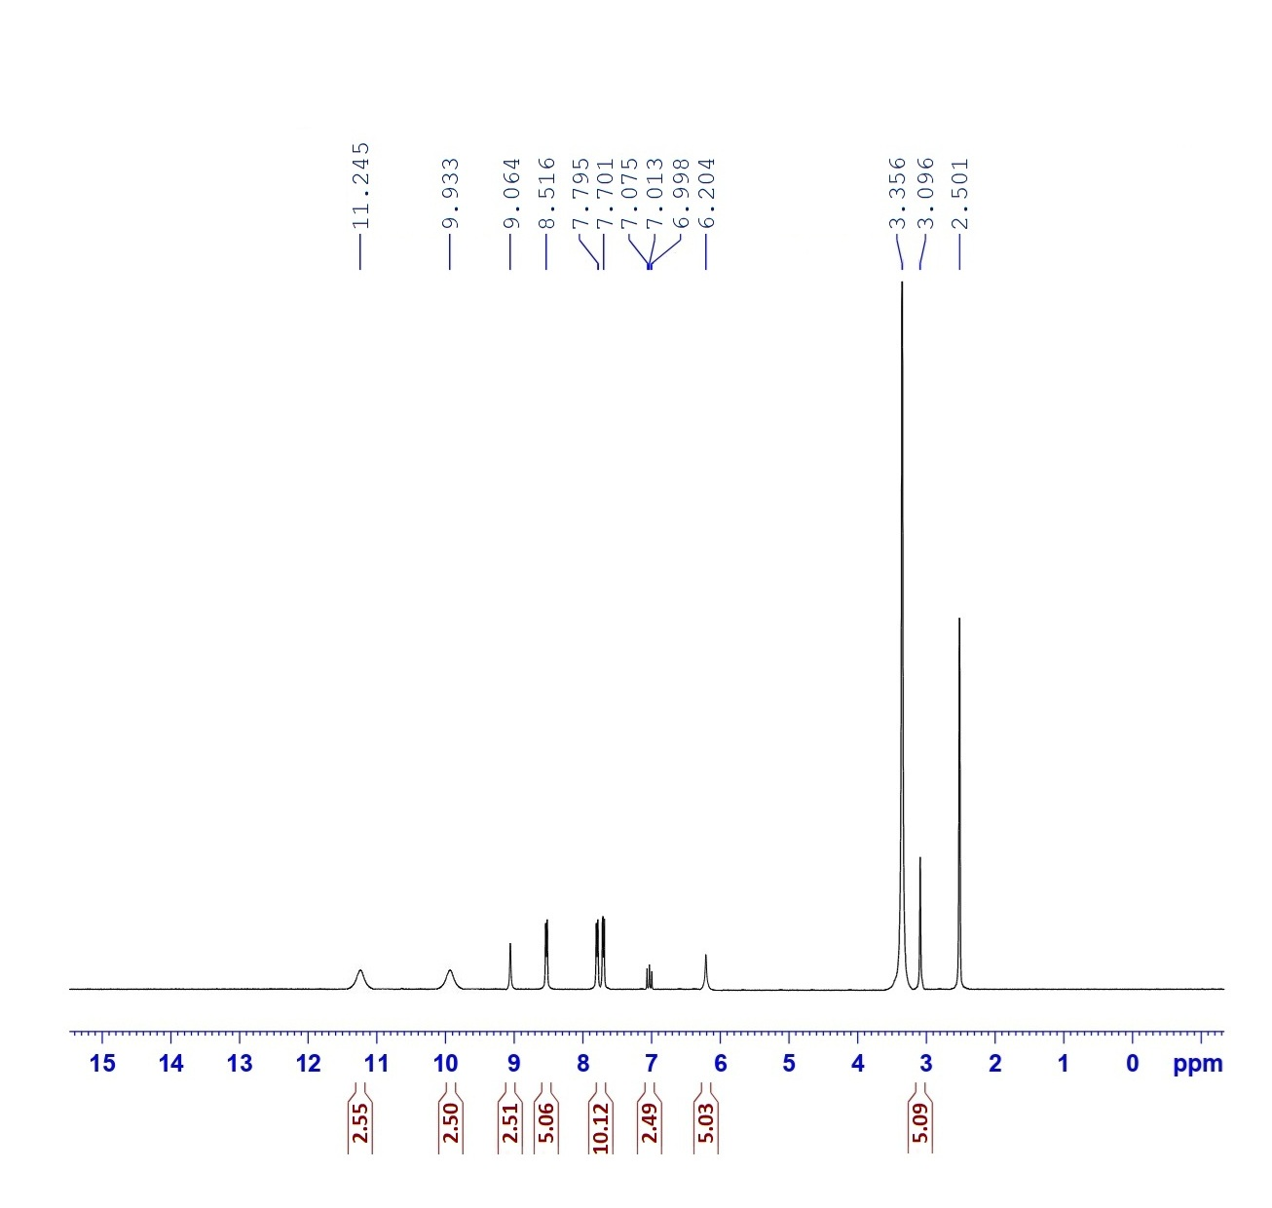
¹H-NMR of compound 2

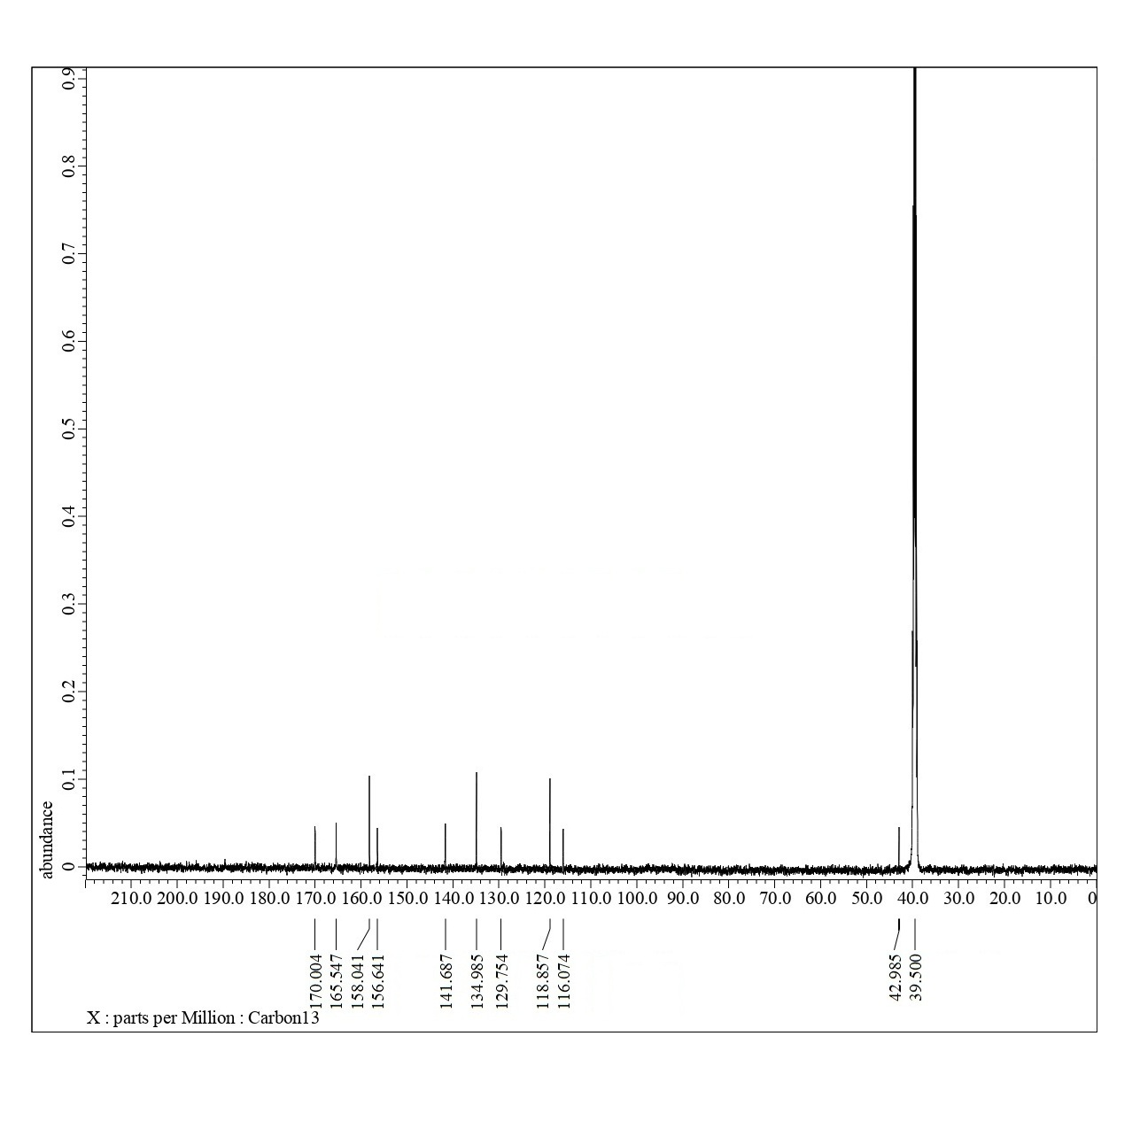
¹³C-NMR of compound 2

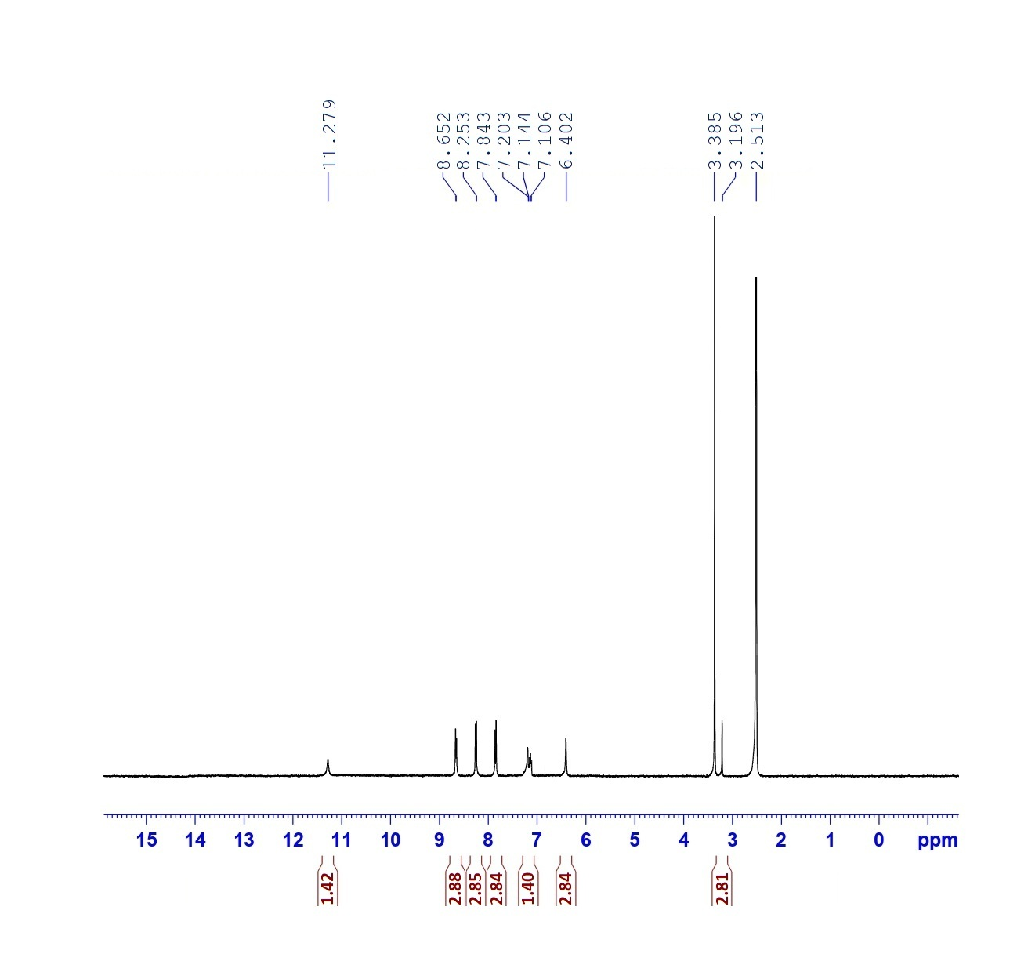
¹H-NMR of compound 5

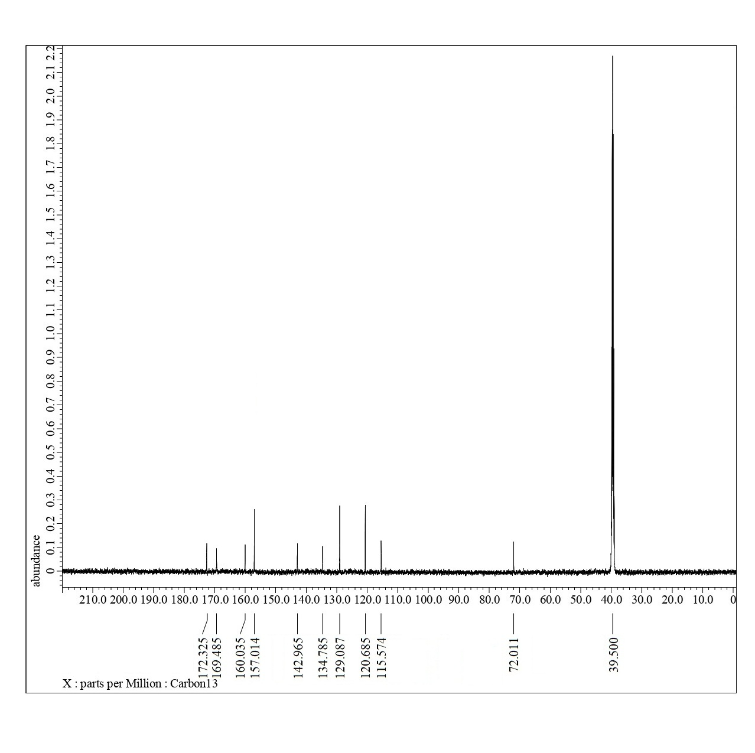
¹³C-NMR of compound 5

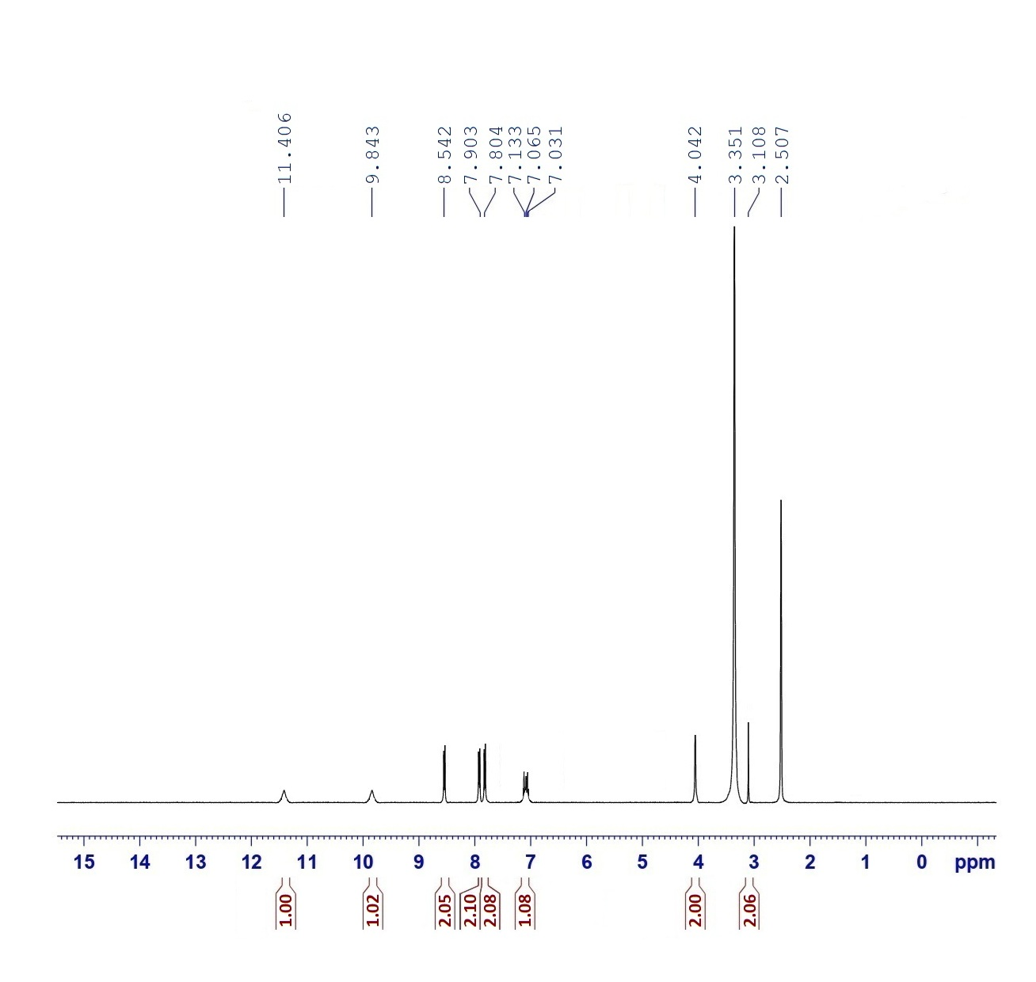
¹H-NMR of compound 7

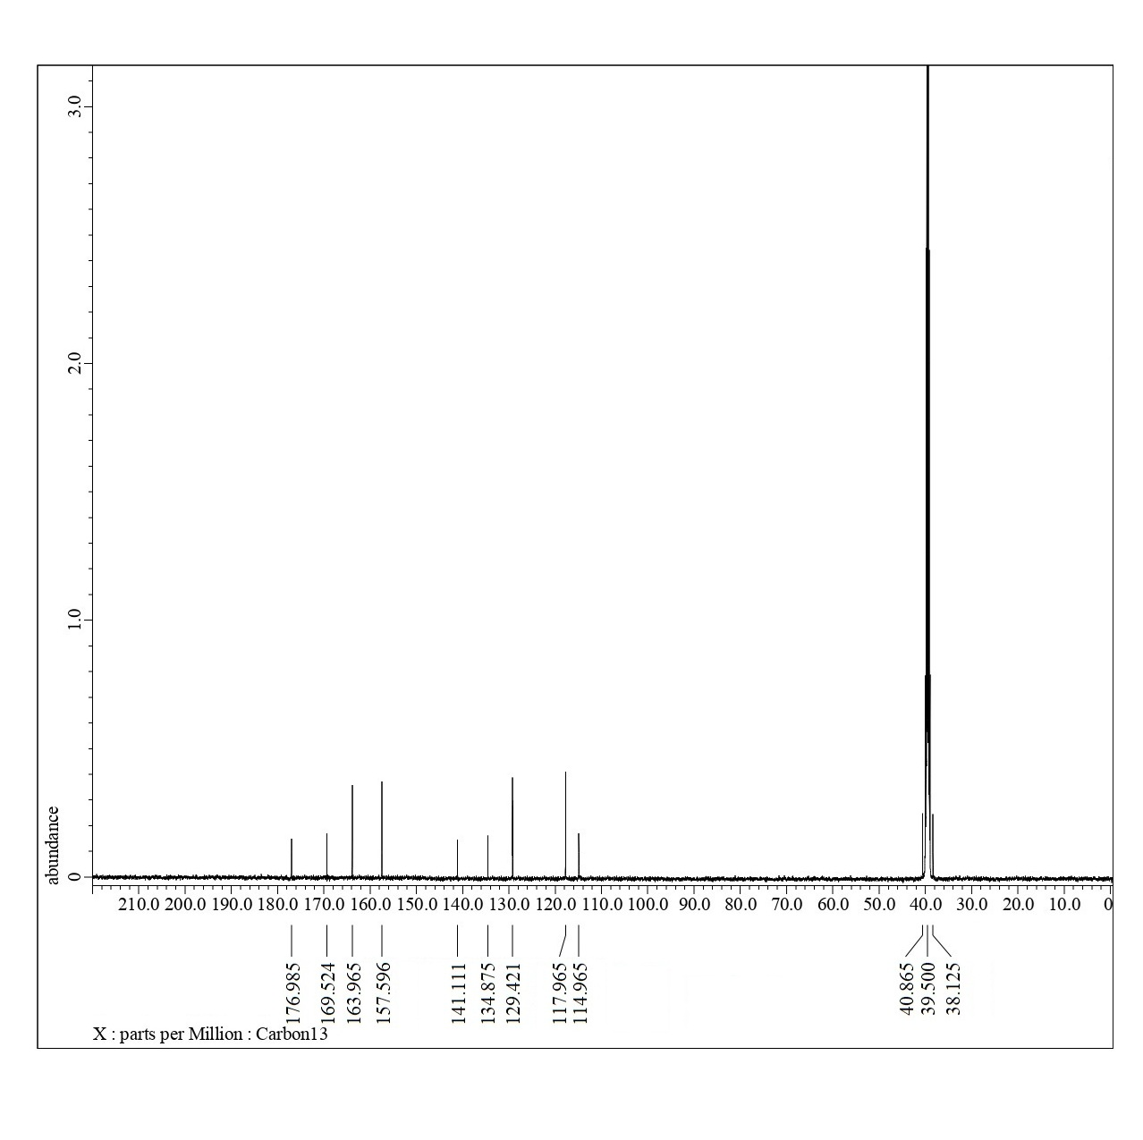
¹³C-NMR of compound 7

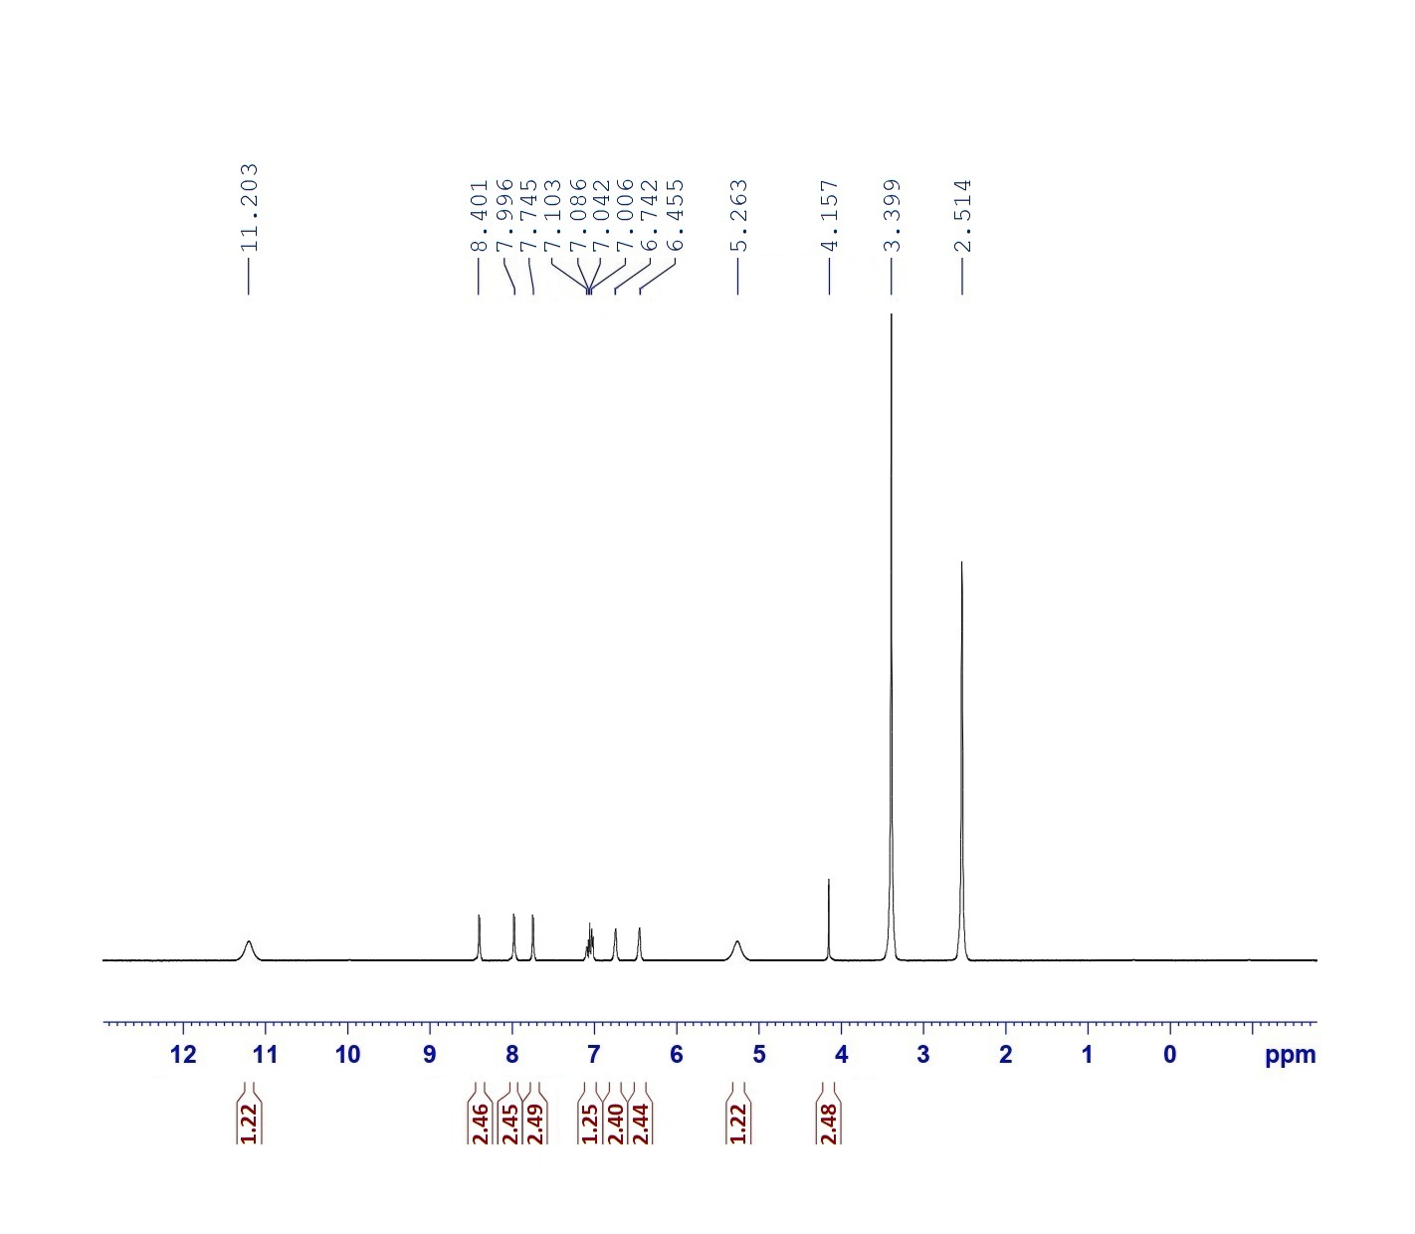
¹H-NMR of compound 8

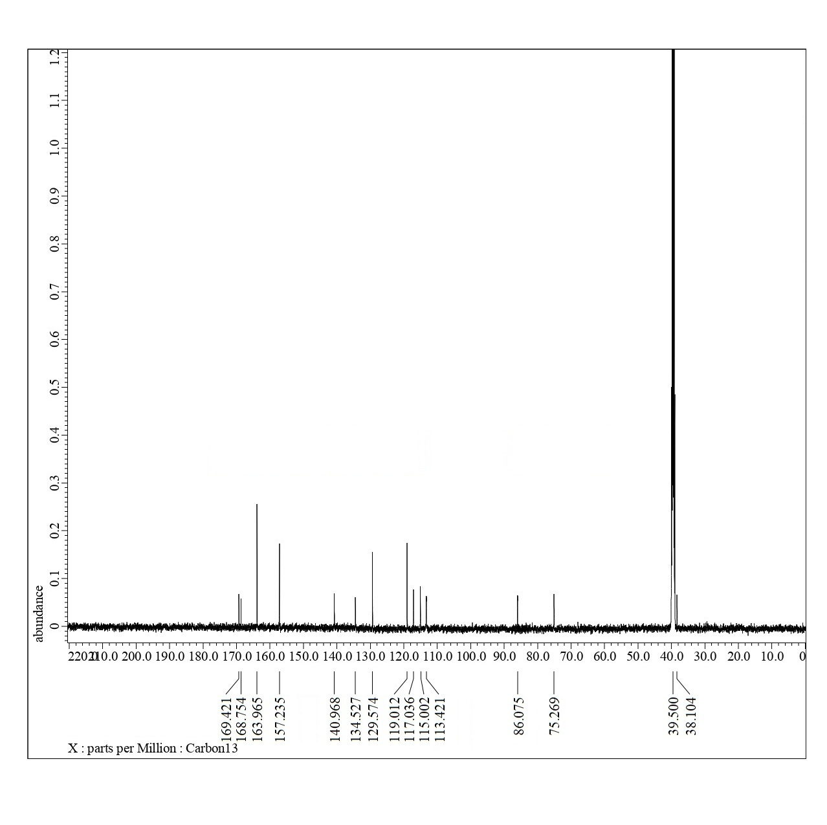
¹³C-NMR of compound 8

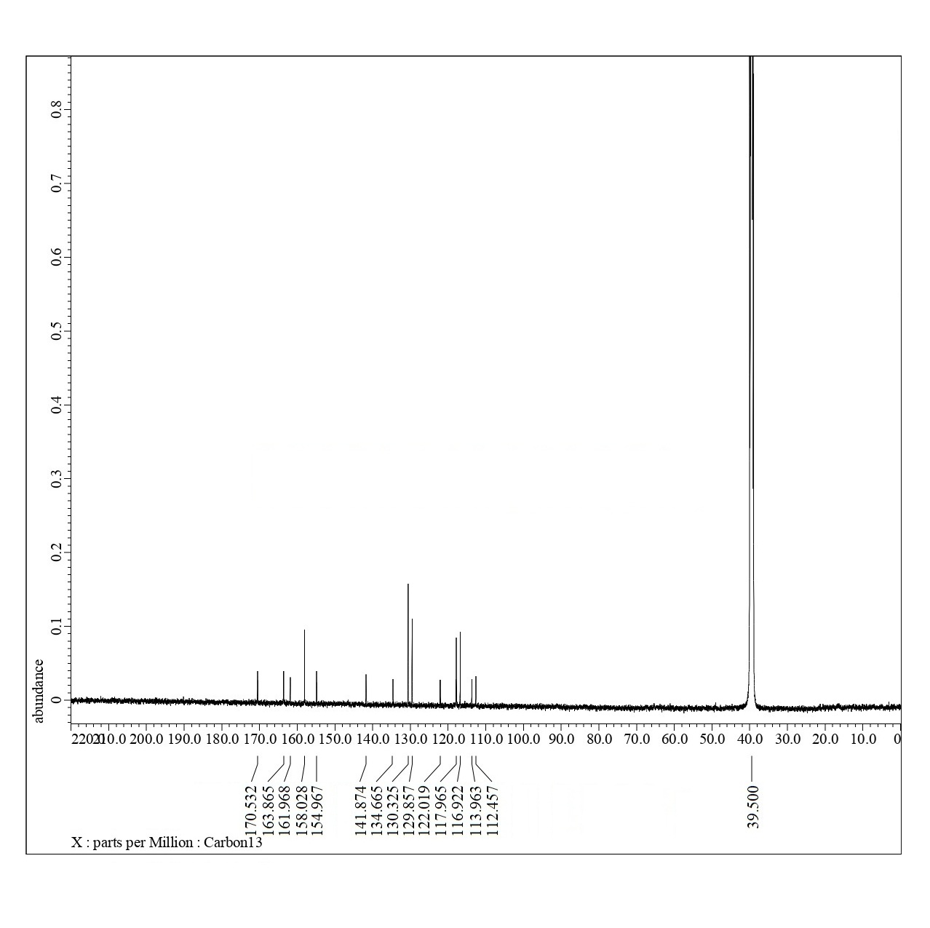
¹³C-NMR of compound 9

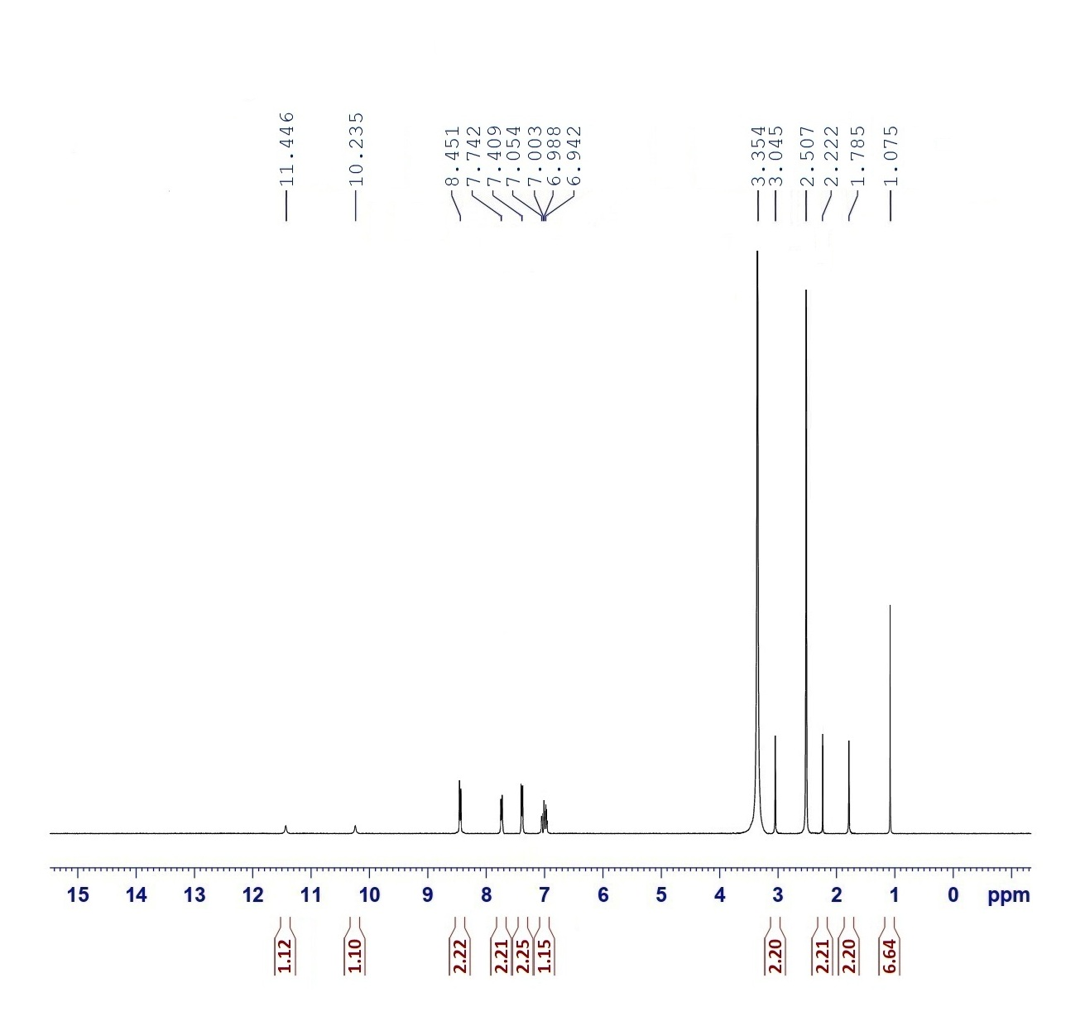
¹H-NMR of compound 10

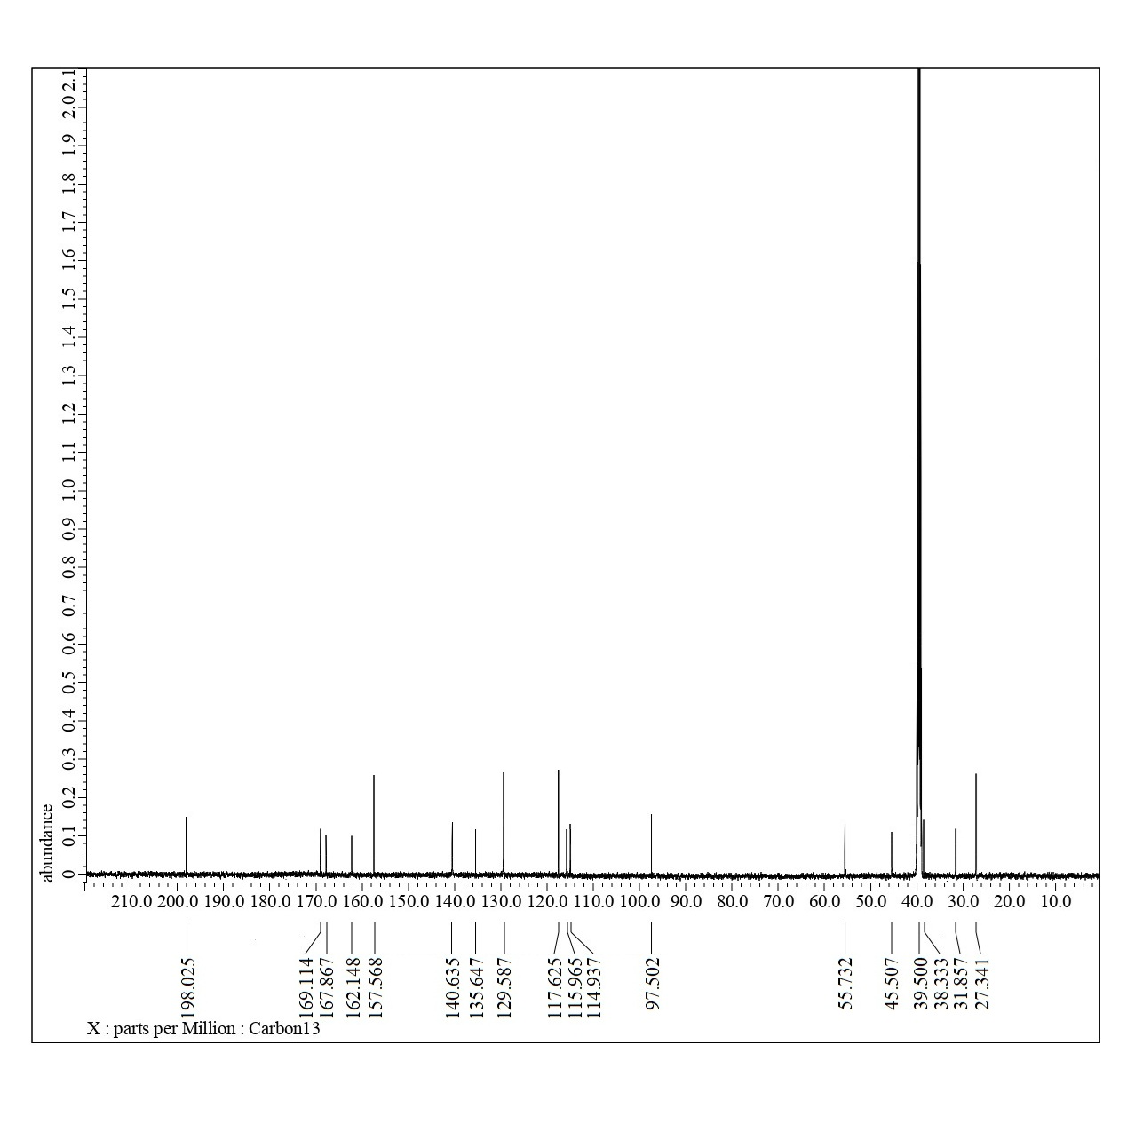
¹³C-NMR of compound 10

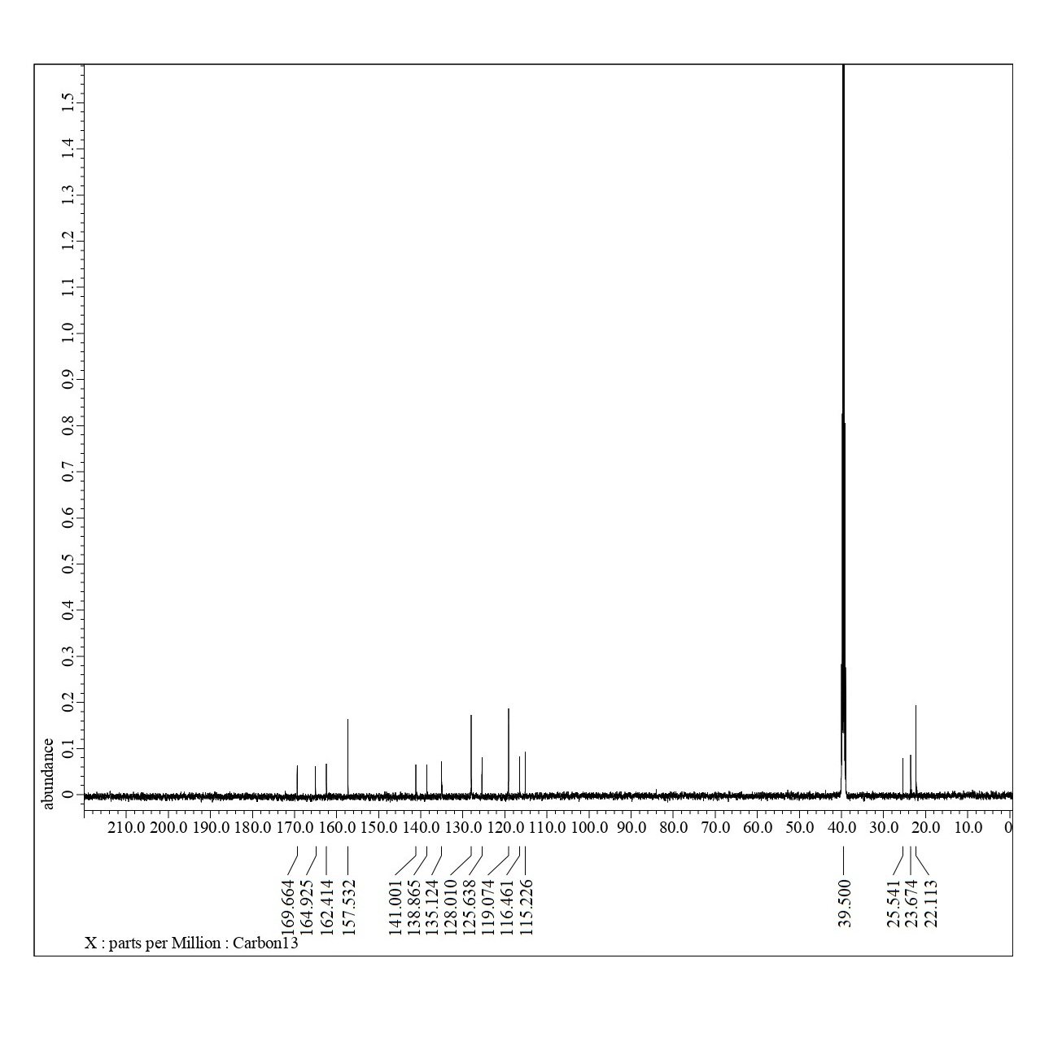
¹³C-NMR of compound 11

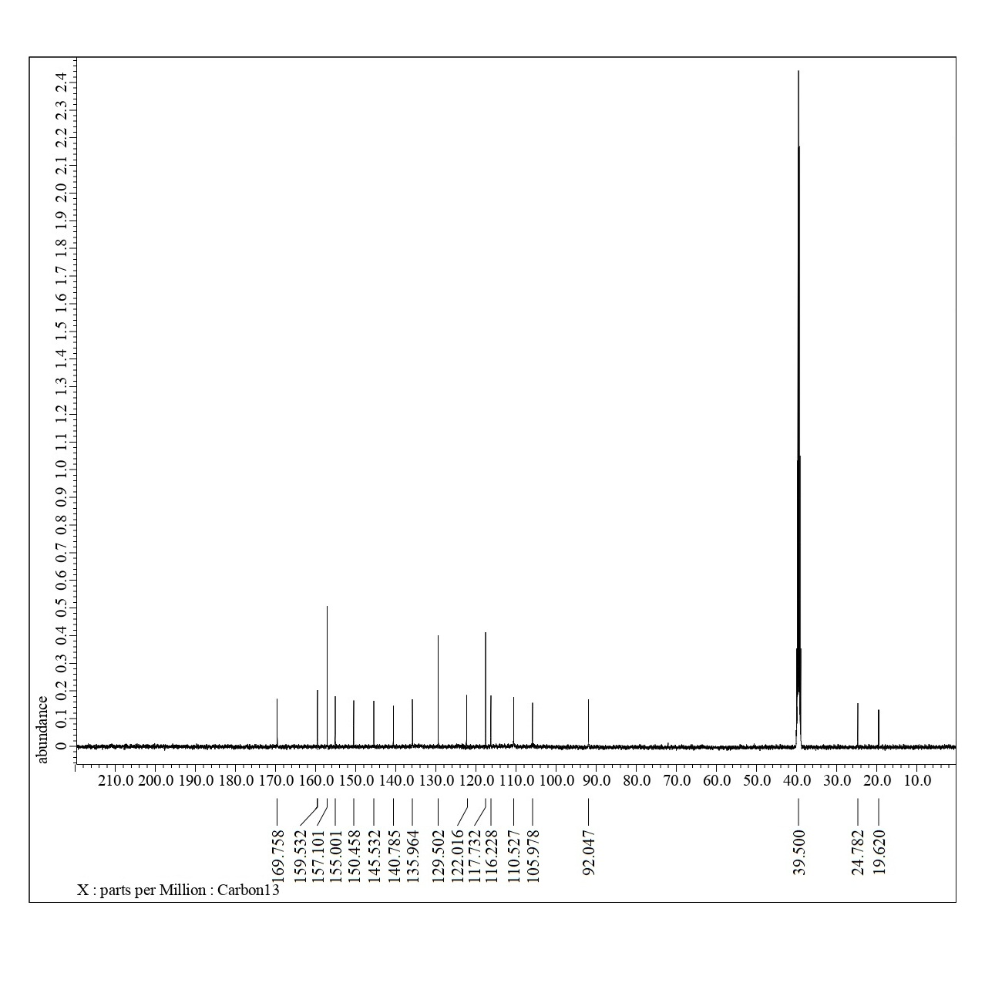
¹³C-NMR of compound 13

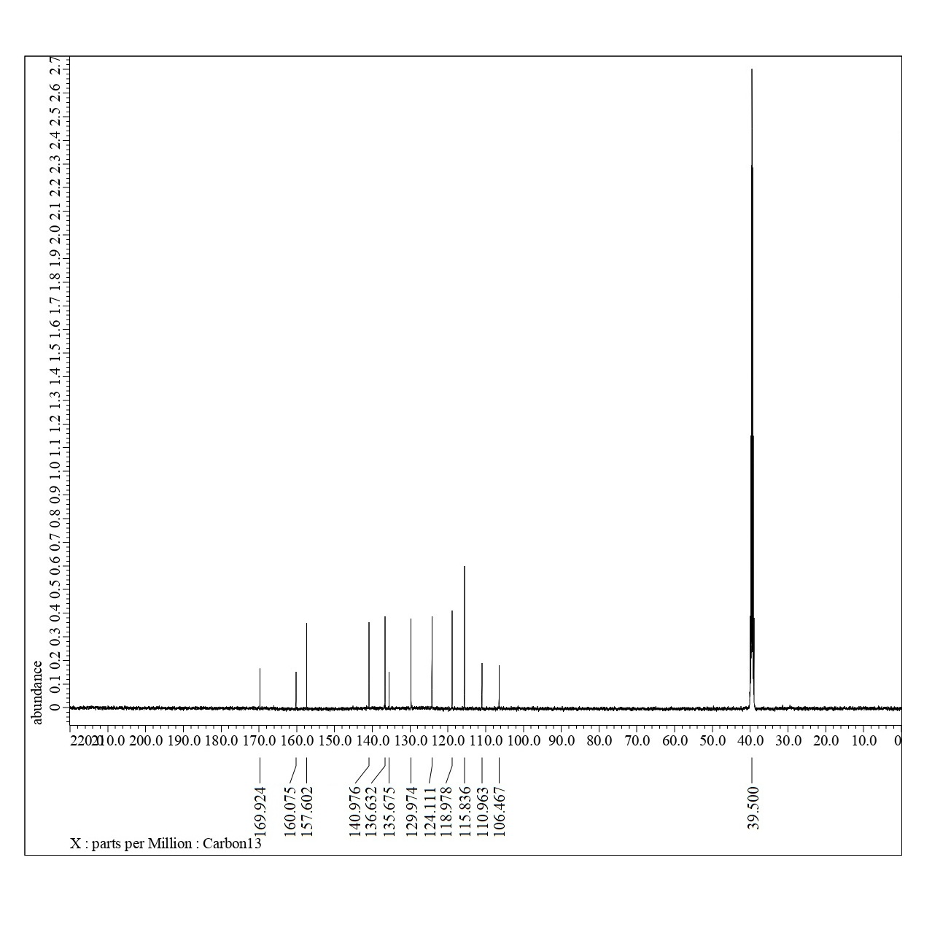
¹³C-NMR of compound 14

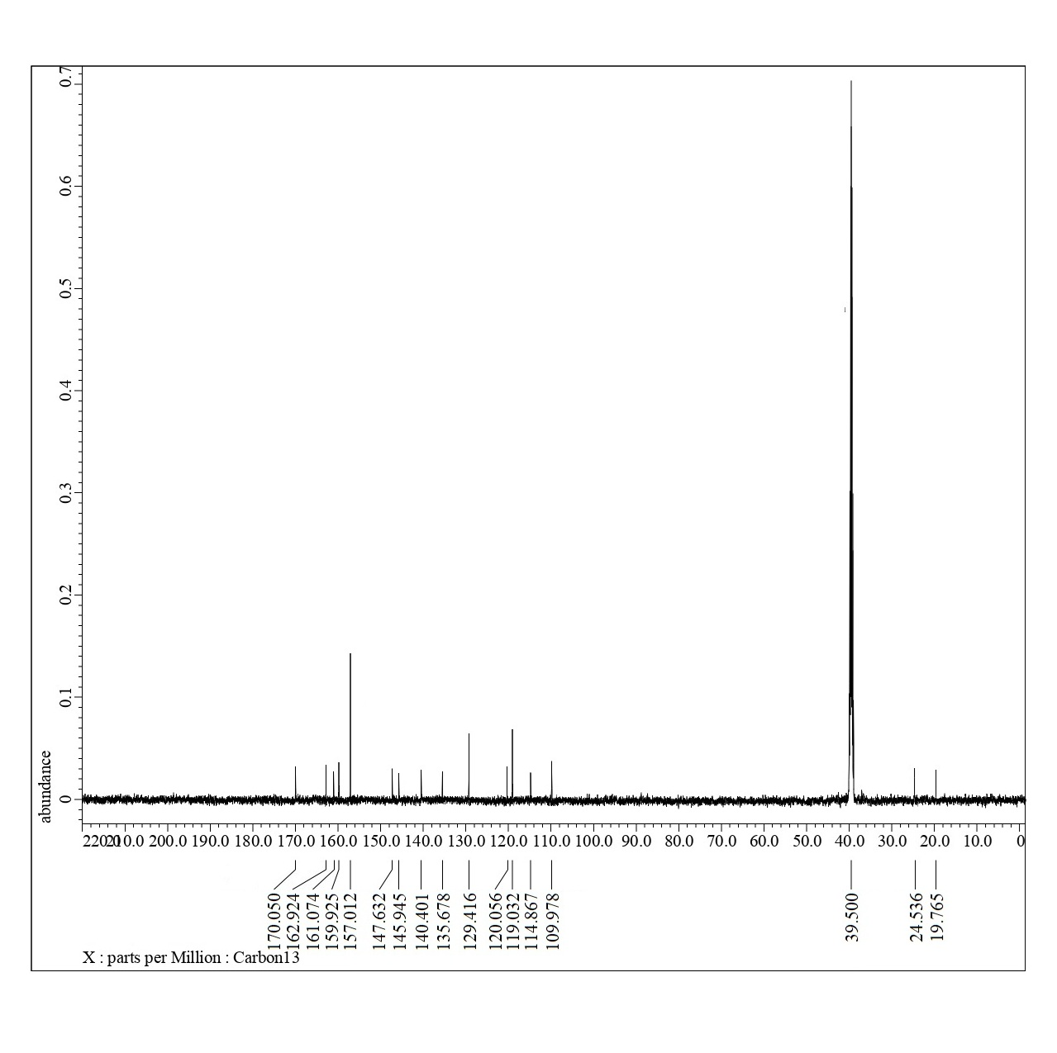
¹³C-NMR of compound 15

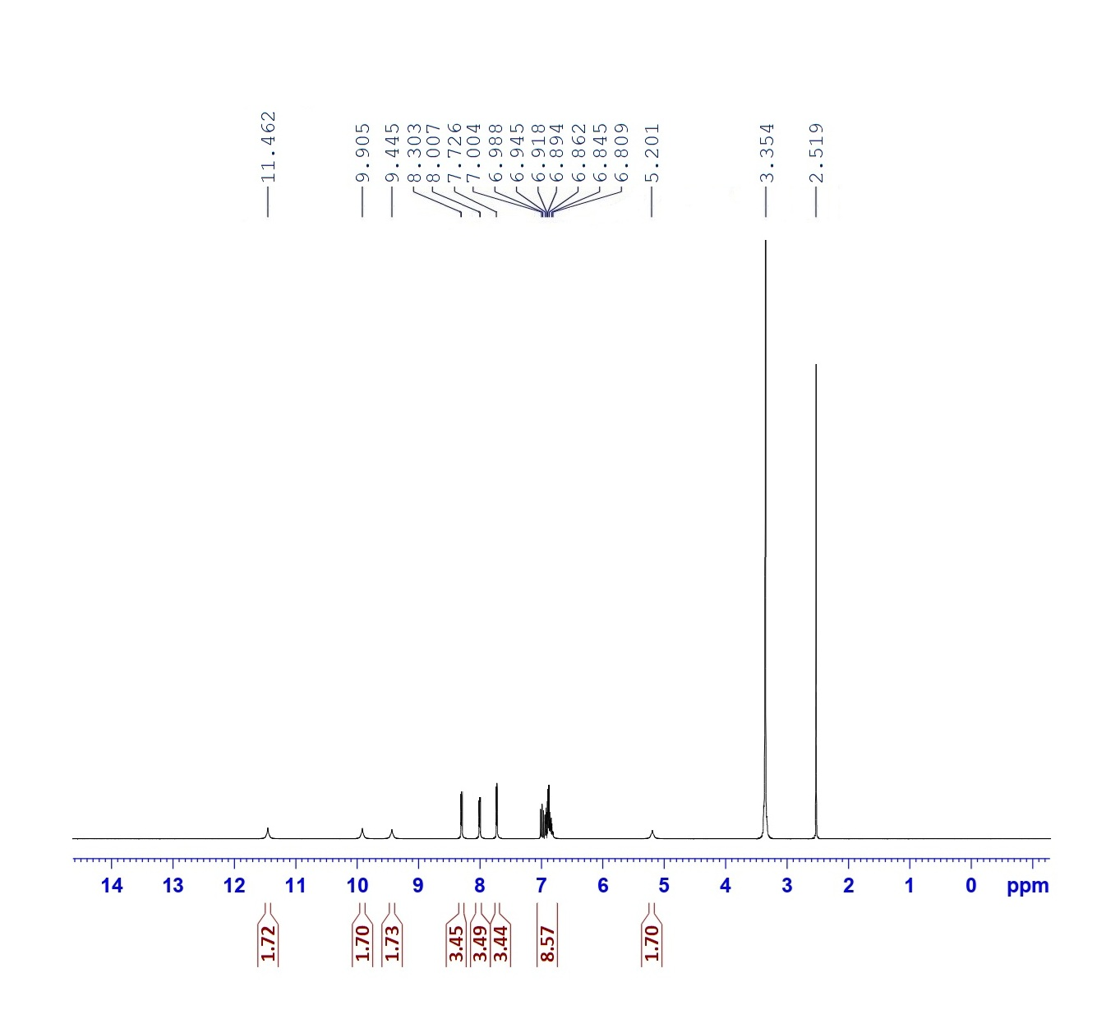
¹H-NMR of compound 16

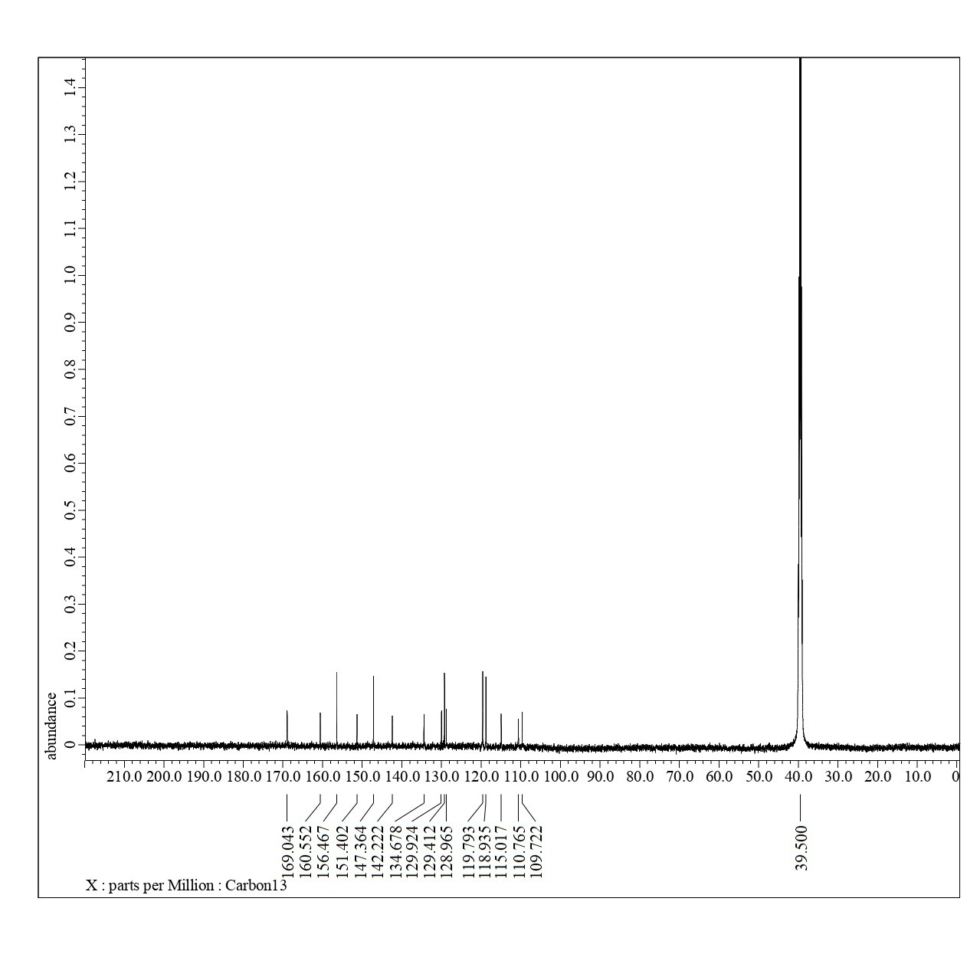
¹³C-NMR of compound 16

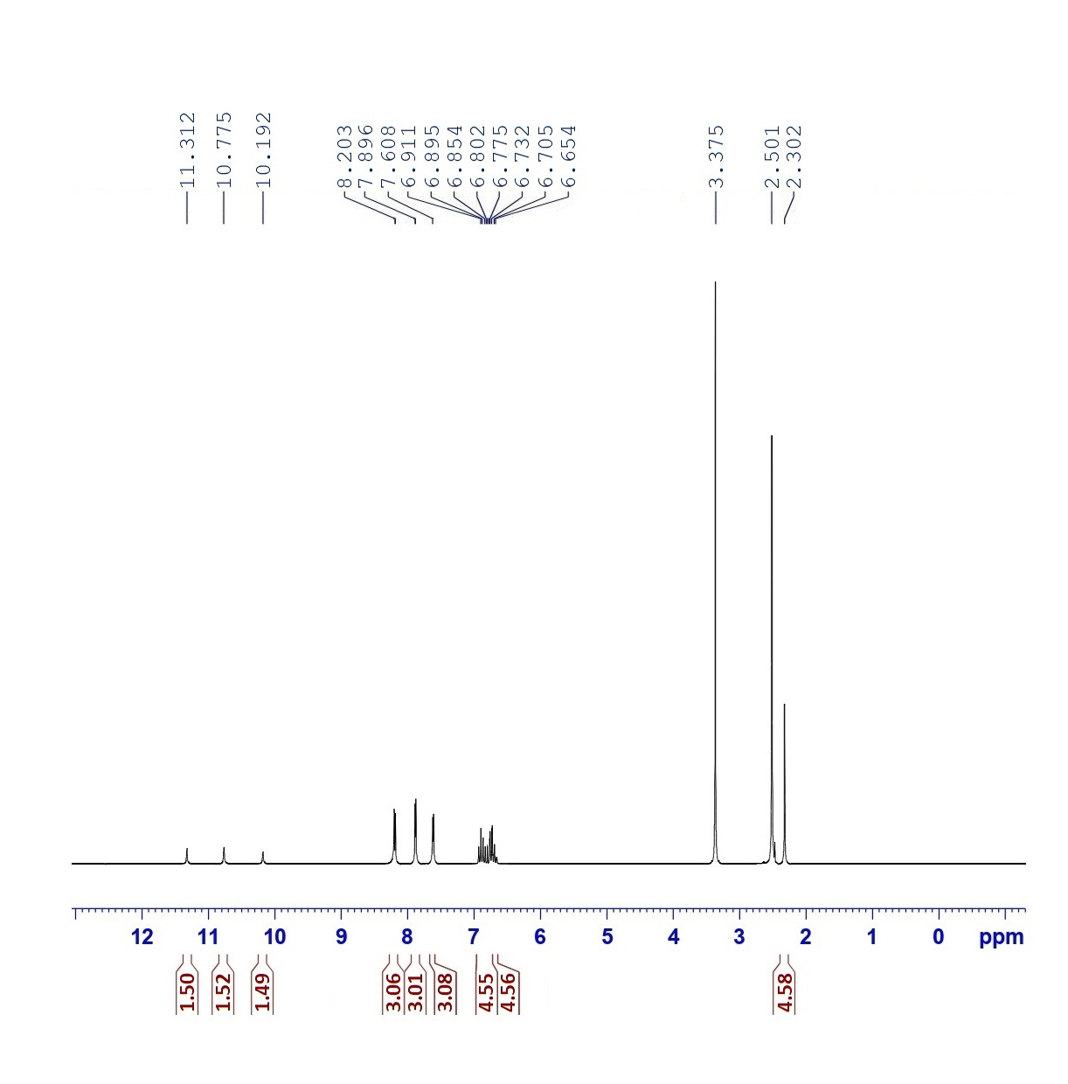
¹H-NMR of compound 17

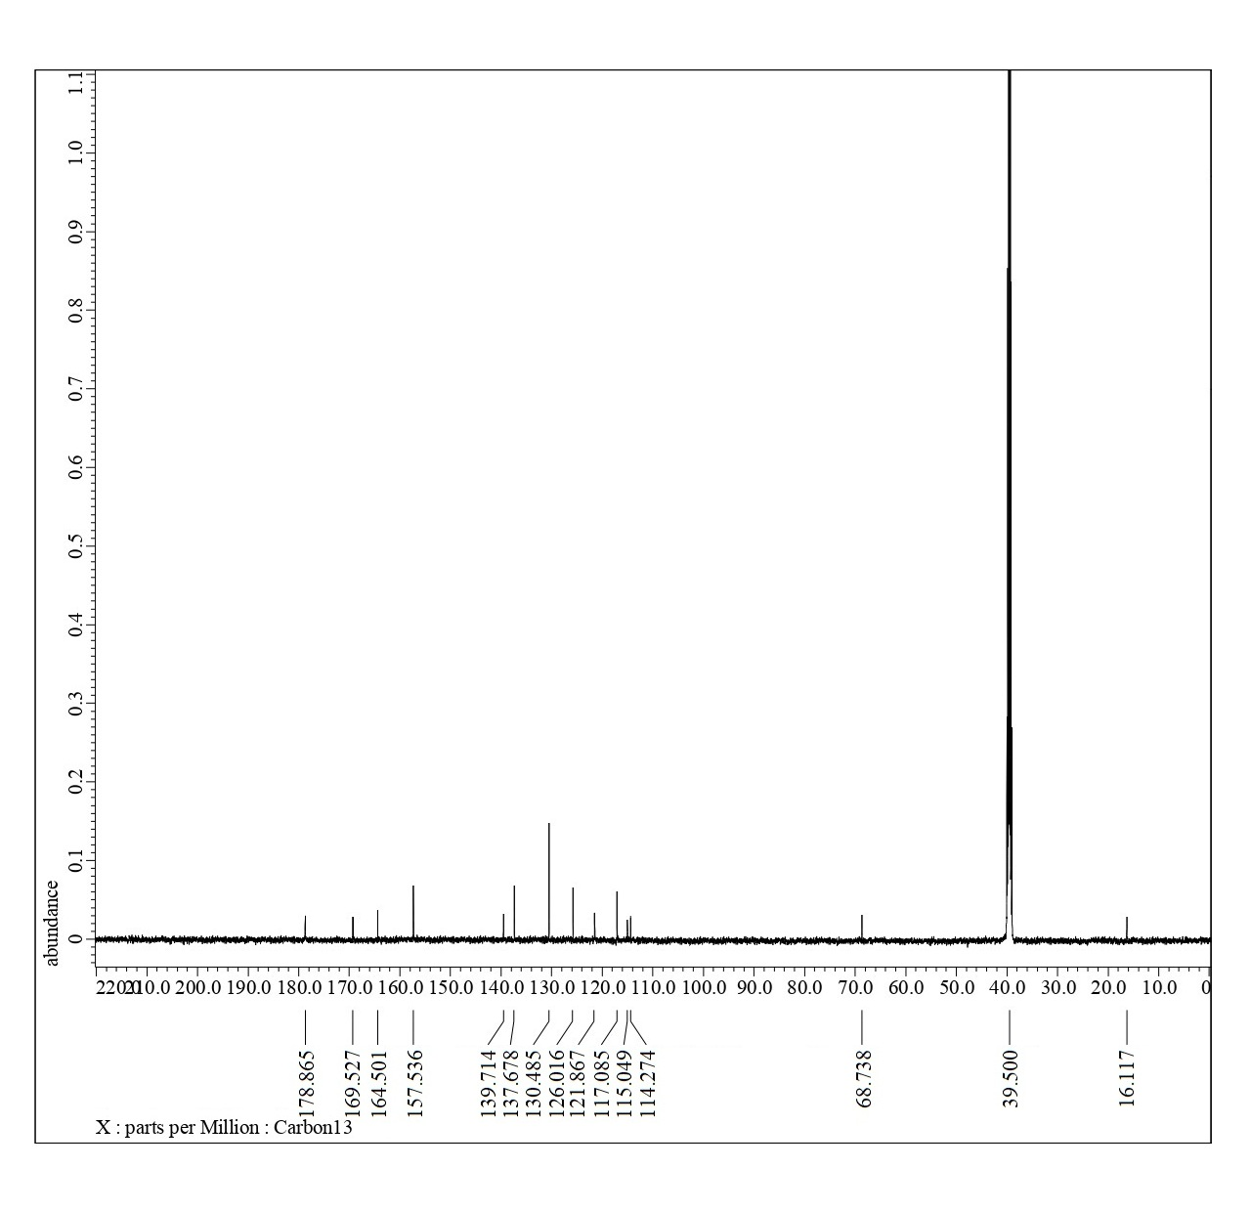
¹³C-NMR of compound 17

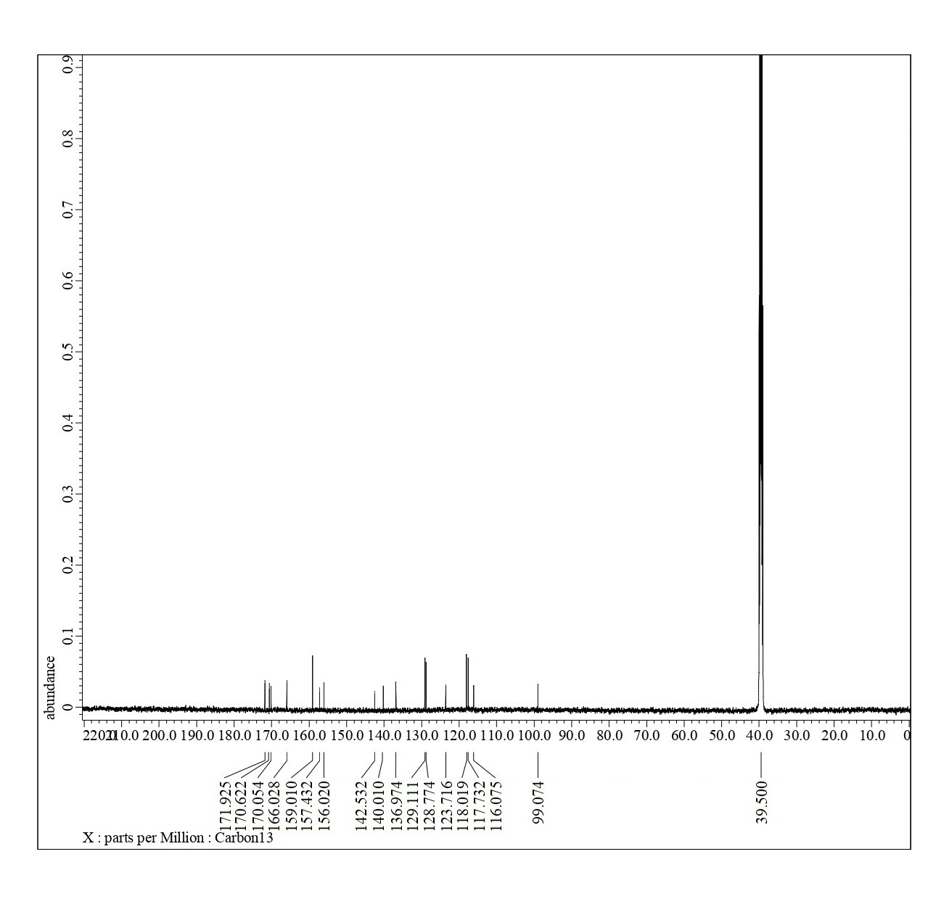
¹³C-NMR of compound 18

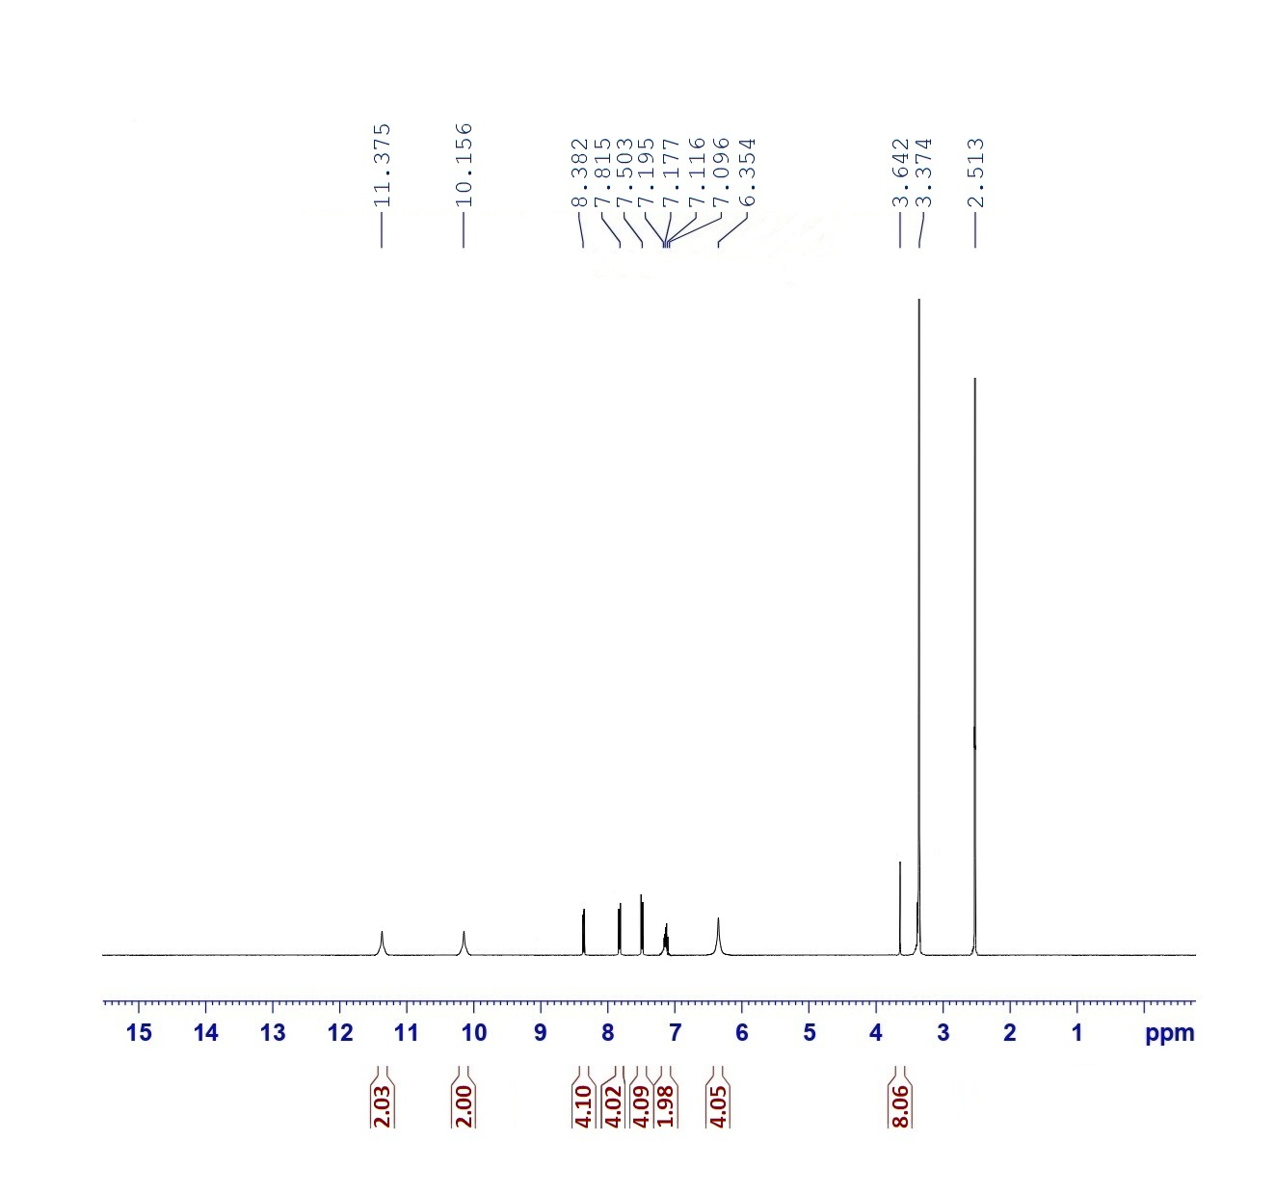
¹H-NMR of compound 19

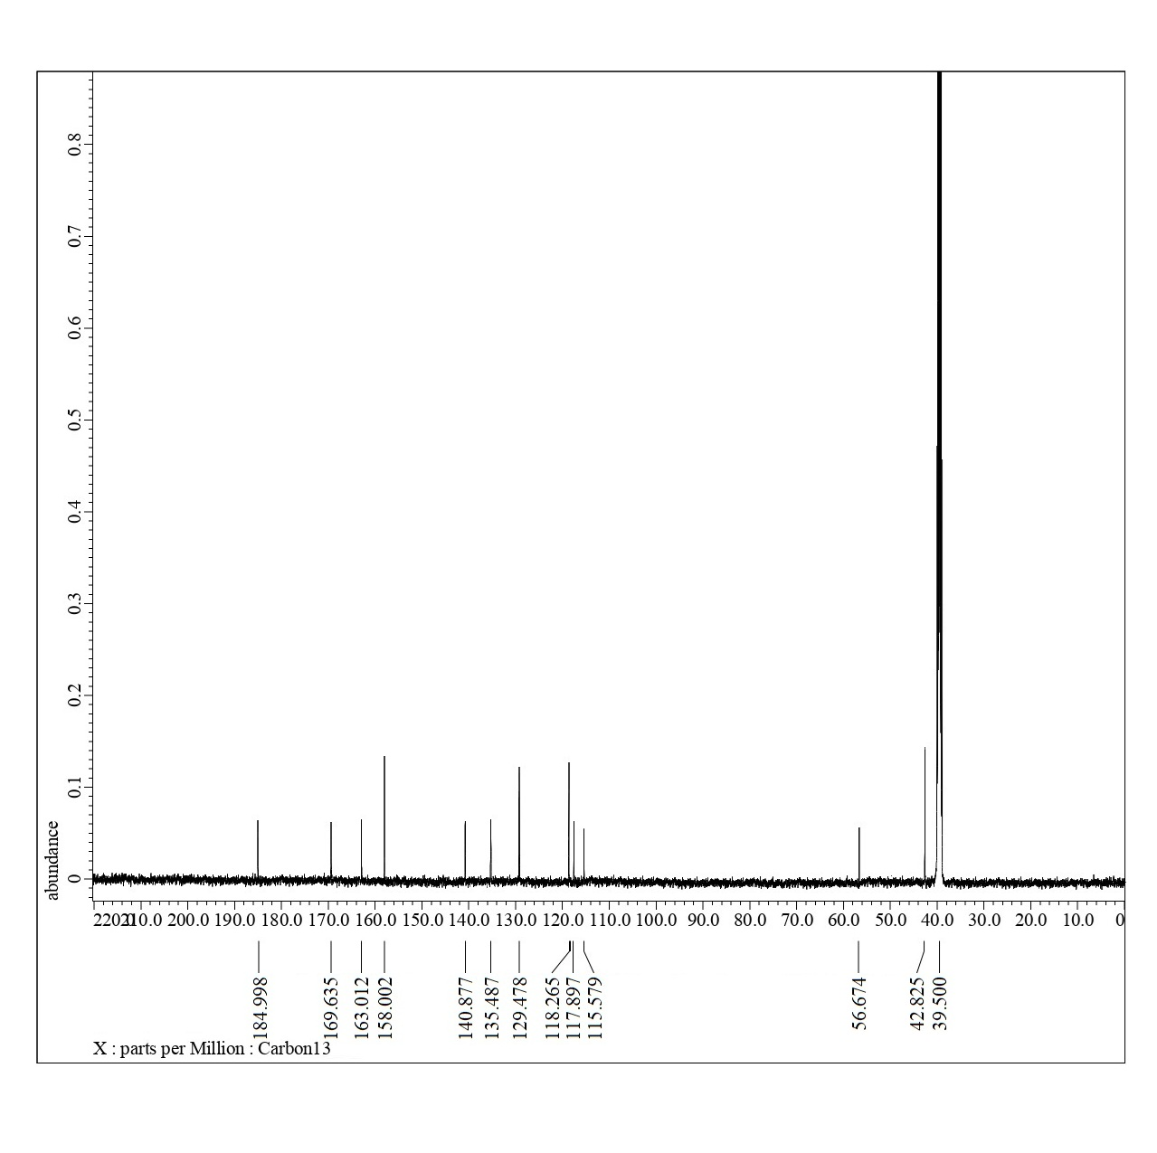
¹³C-NMR of compound 19

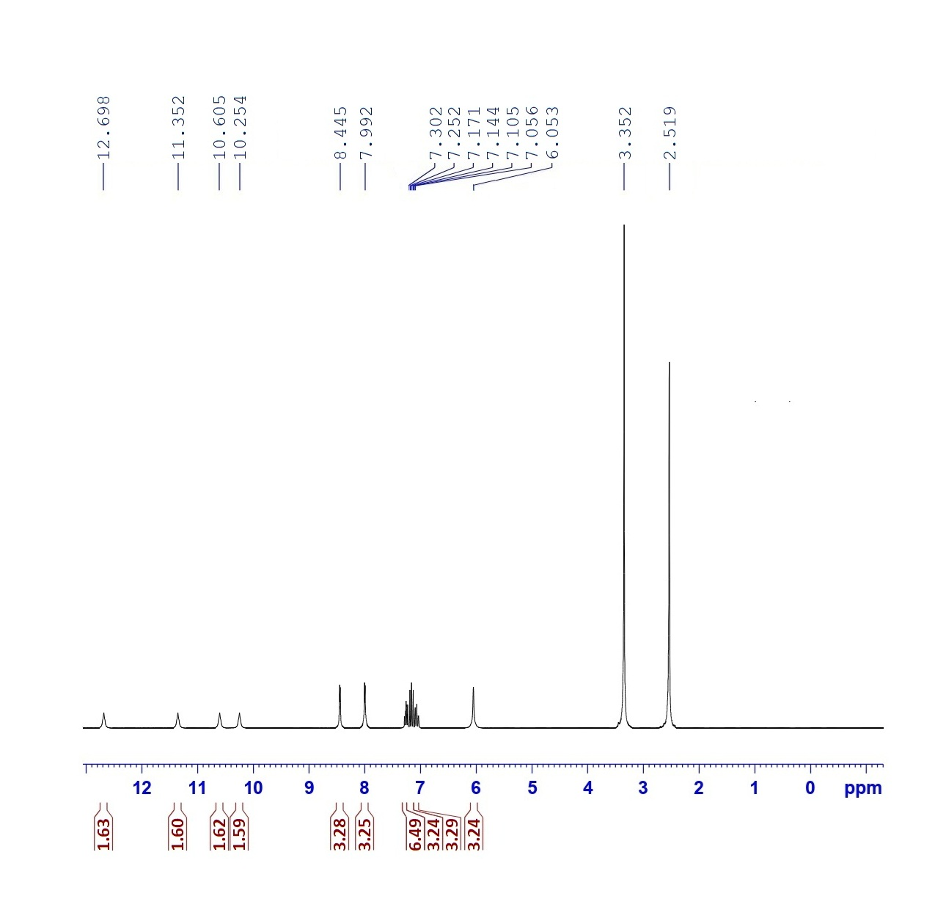
¹H-NMR of compound 20

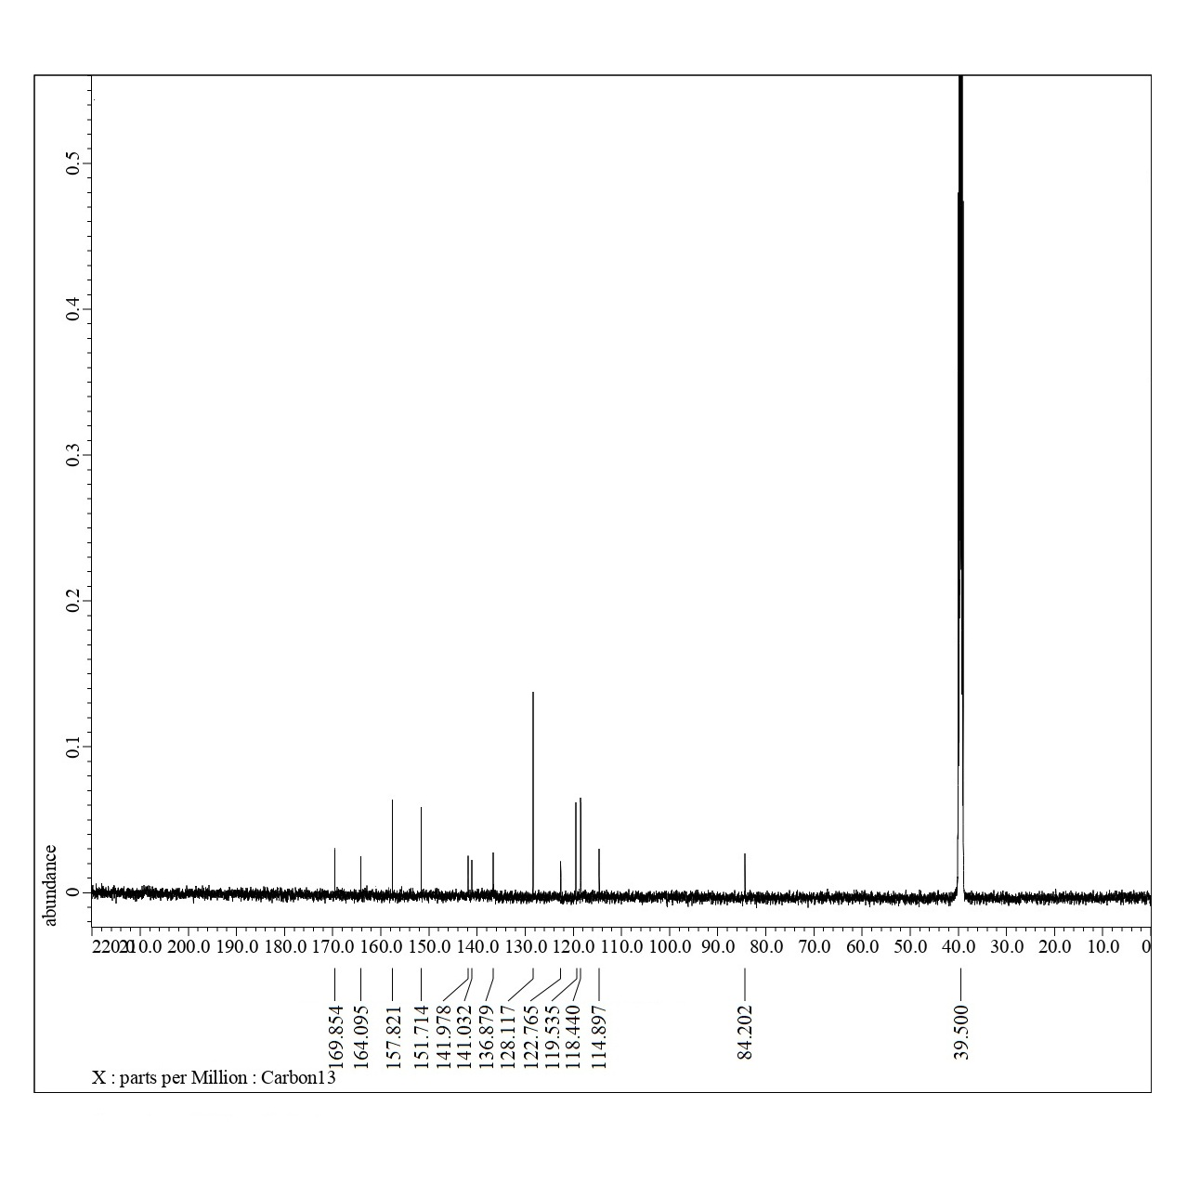
¹³C-NMR of compound 20

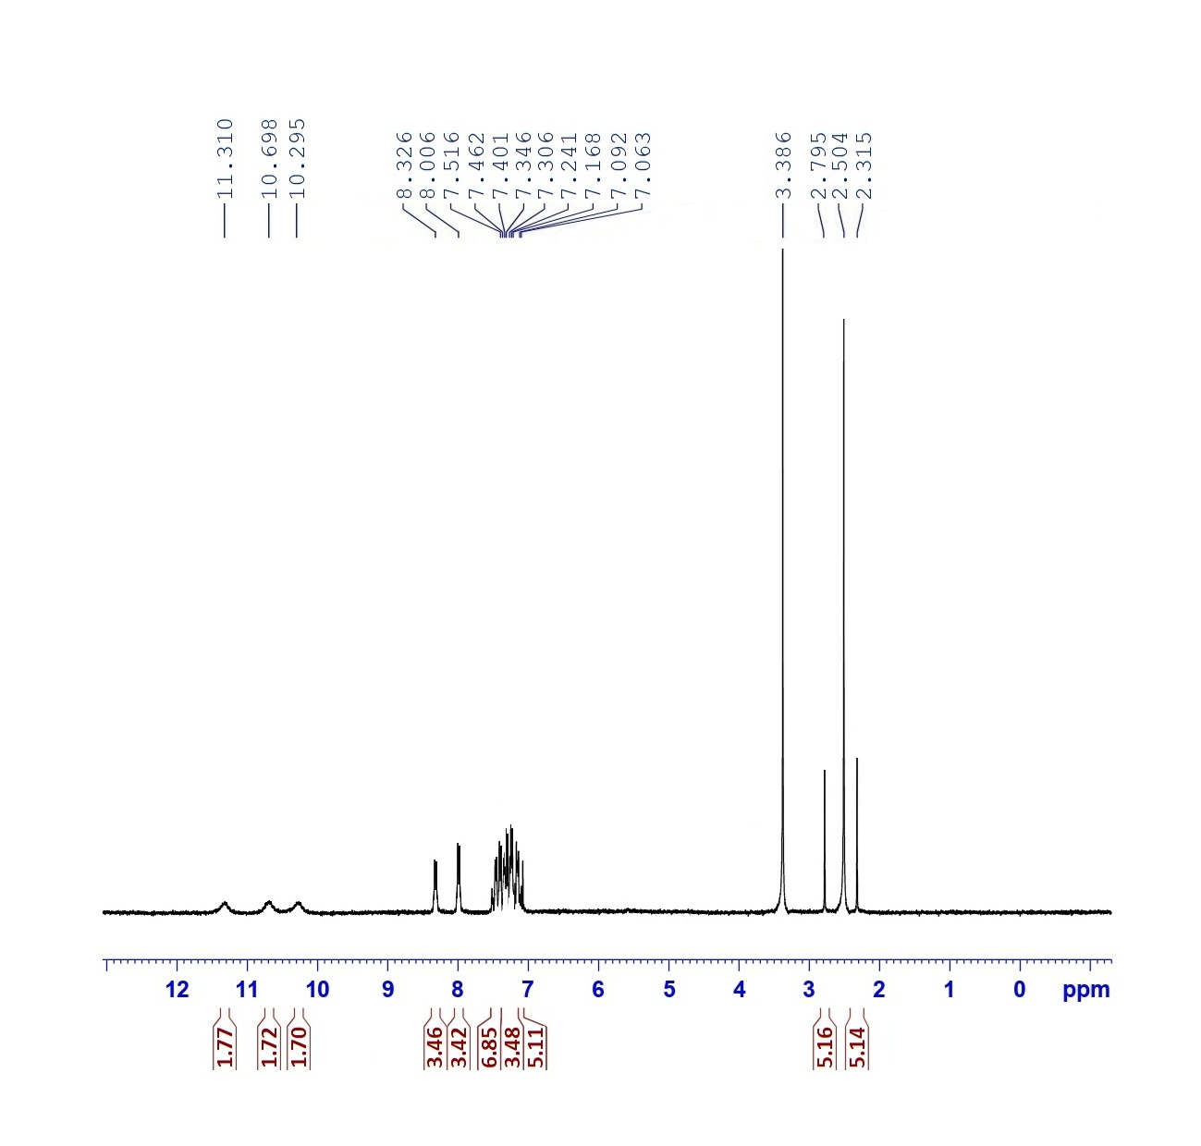
¹H-NMR of compound 21

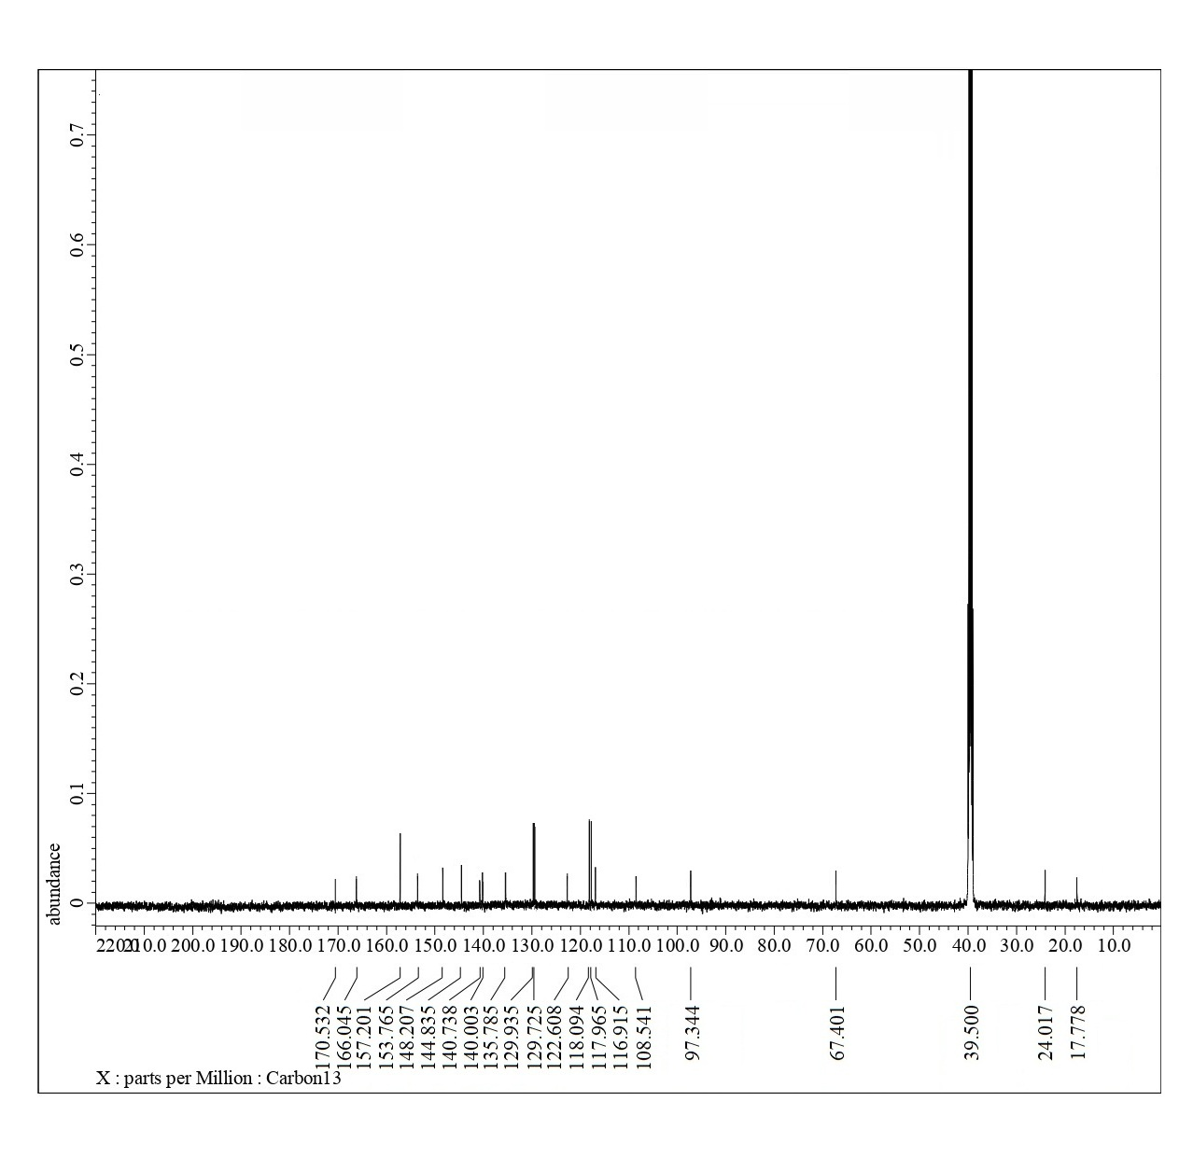
¹³C-NMR of compound 21

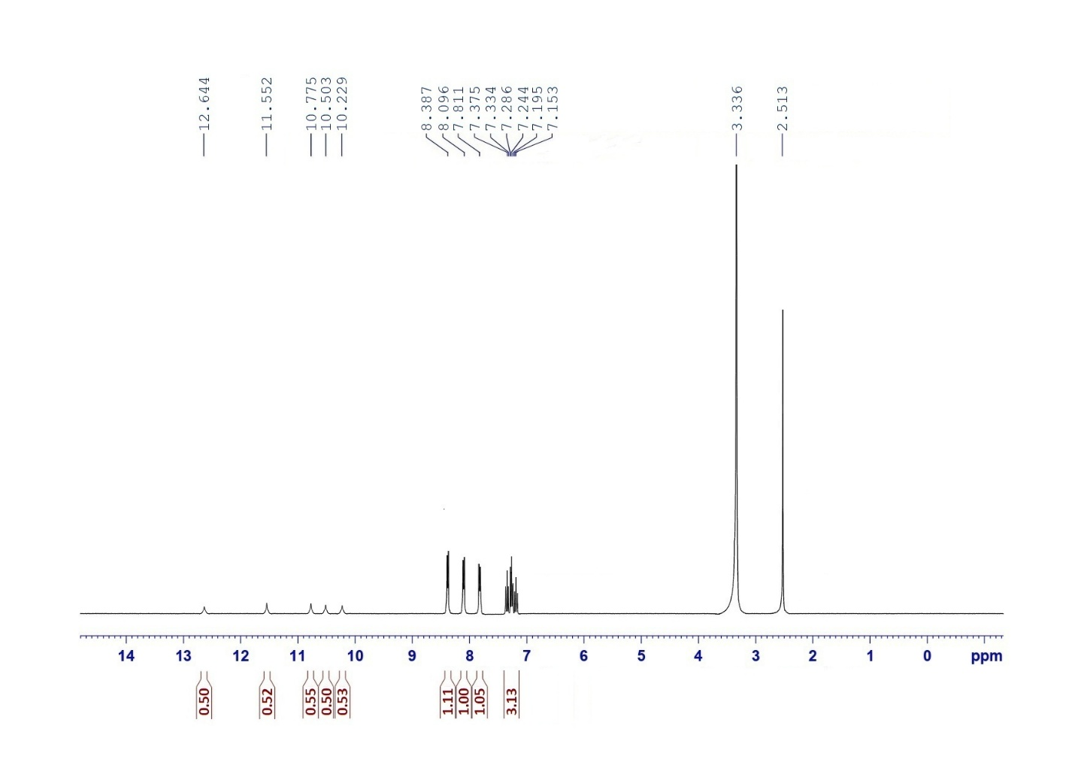
¹H-NMR of compound 23

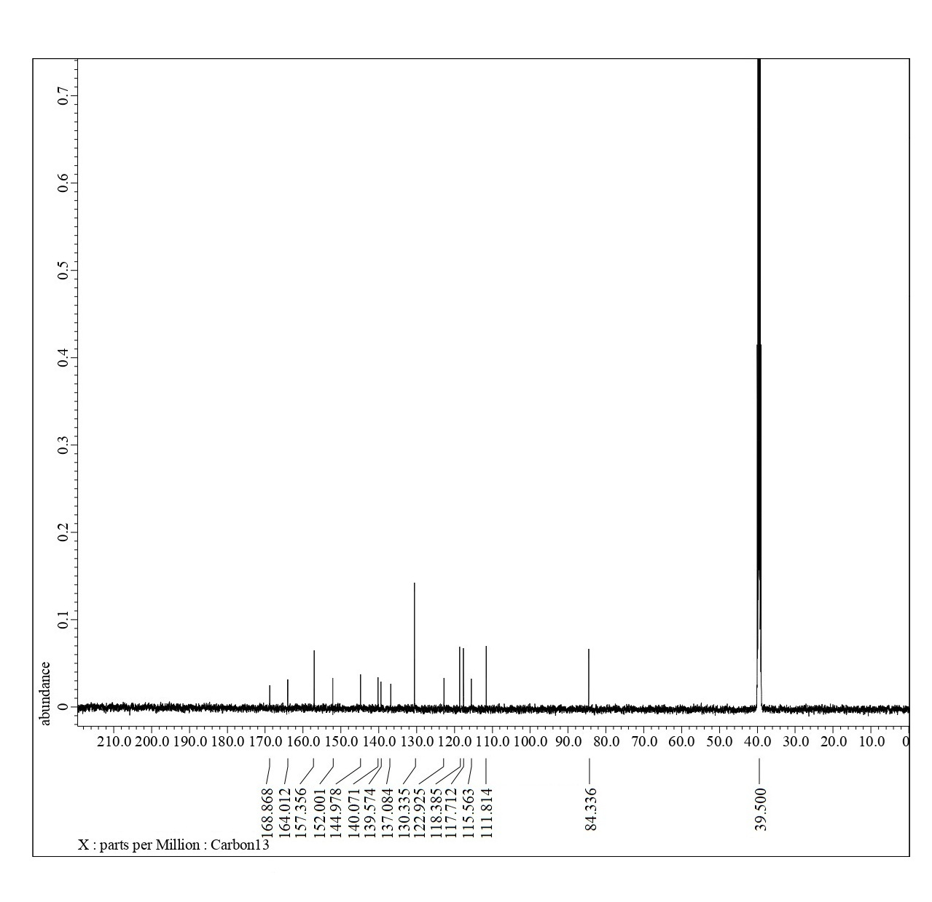
¹³C-NMR of compound 23

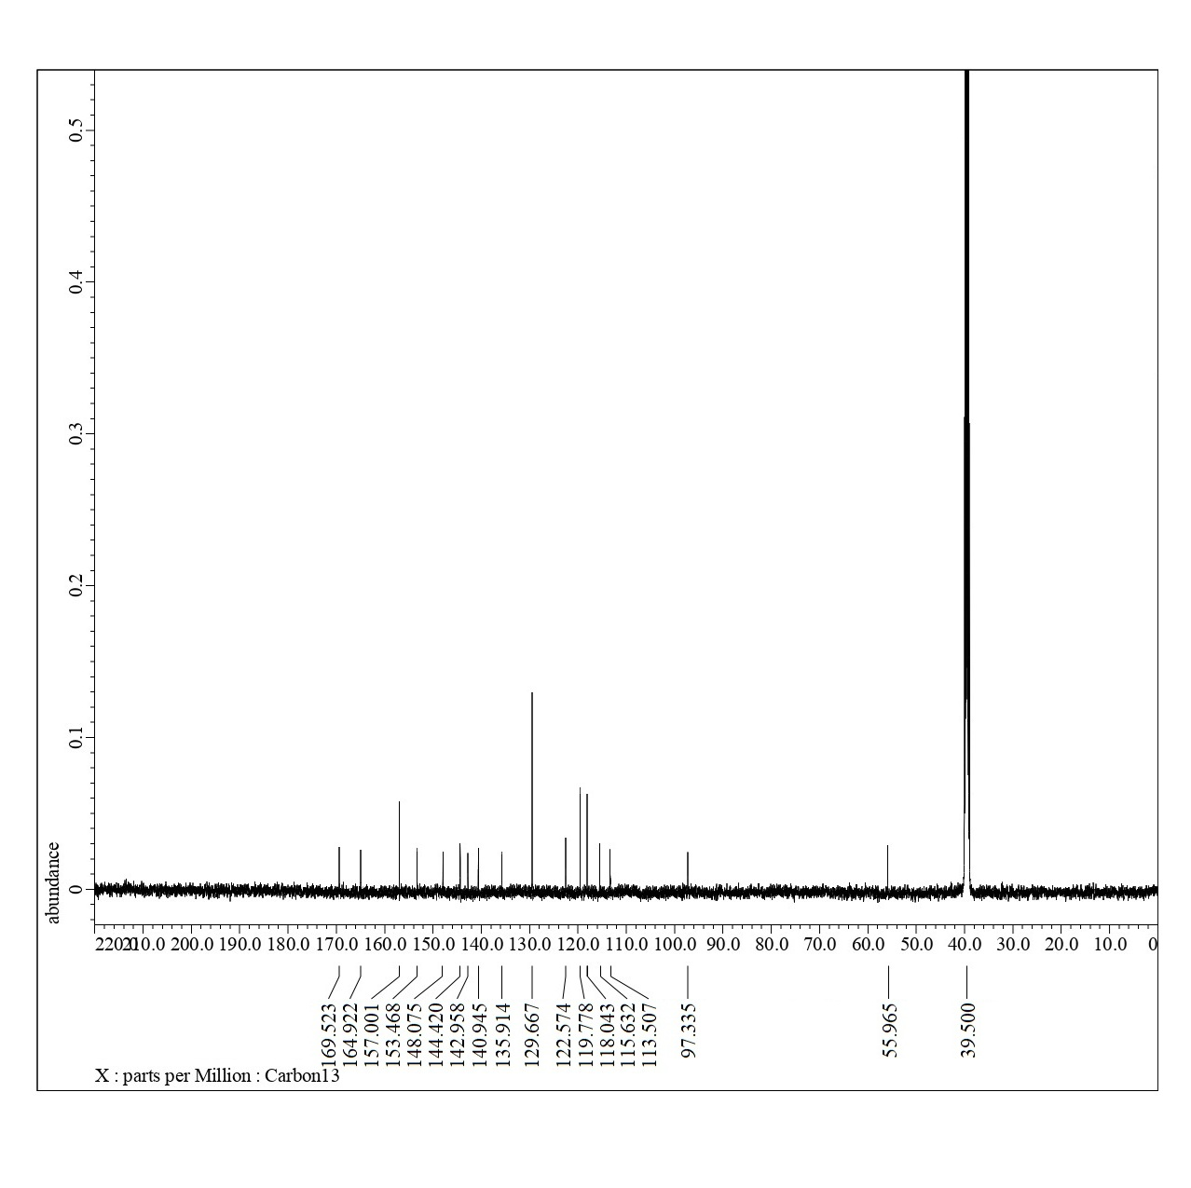
¹³C-NMR of compound 24

