Supplementary Figures S1-S4

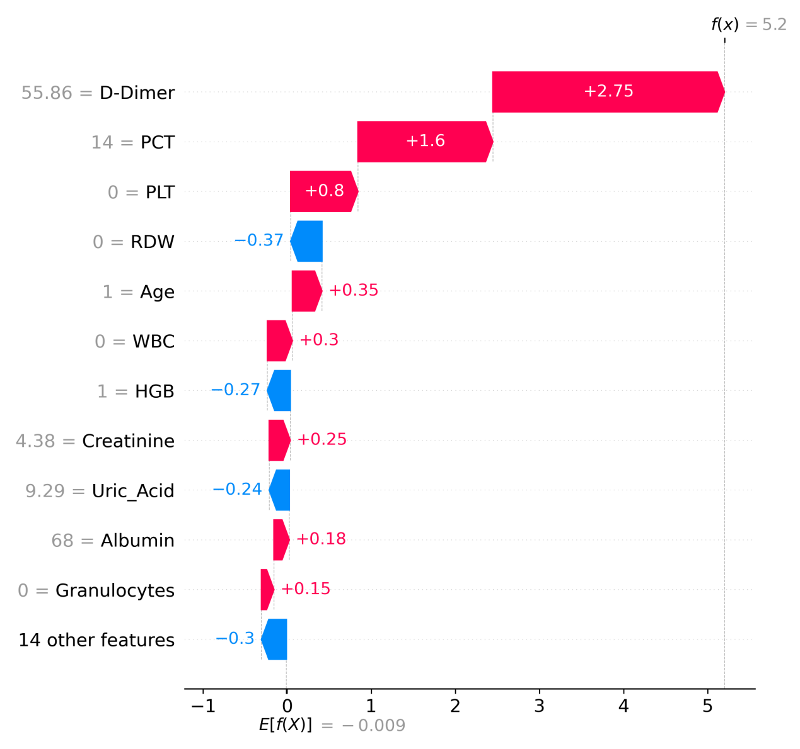
Supplementary Figure S1. Patient-level SHAP waterfall plot for the XGBoost model (test set). A representative bacteremic urosepsis case is shown. Bars indicate each feature’s SHAP contribution to the model output for this patient relative to the baseline (expected value). Red features increase the predicted risk, whereas blue features decrease it. The final prediction is obtained by summing all contributions (model output shown on the top axis). Abbreviations: D-dimer, fibrin degradation product D-dimer; PCT, procalcitonin; CAD, coronary artery disease; PLT, platelet count; CRP, C-reactive protein; WBC, white blood cell count; HGB, hemoglobin; Uric_Acid, serum uric acid; RDW, red cell distribution width.
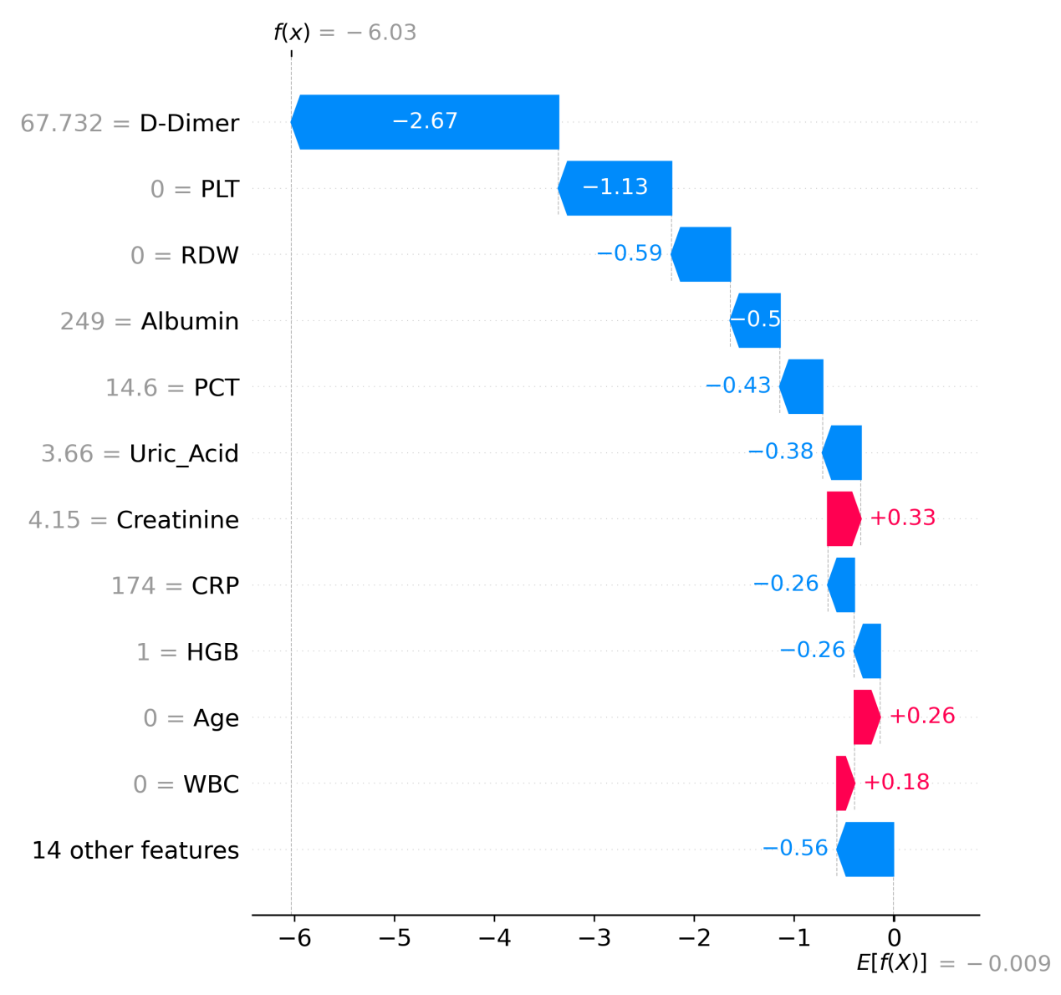
Supplementary Figure S2. Patient-level SHAP waterfall plot for the XGBoost model (test set). A representative non-bacteremic UTI case is shown. Interpretation is identical to Figure S1: SHAP contributions are displayed relative to the baseline (expected value), with red indicating higher predicted risk and blue indicating lower predicted risk. Abbreviations: D-dimer, fibrin degradation product D-dimer; PCT, procalcitonin; CAD, coronary artery disease; PLT, platelet count; CRP, C-reactive protein; WBC, white blood cell count; HGB, hemoglobin; RDW, red cell distribution width; Uric_Acid, serum uric acid.

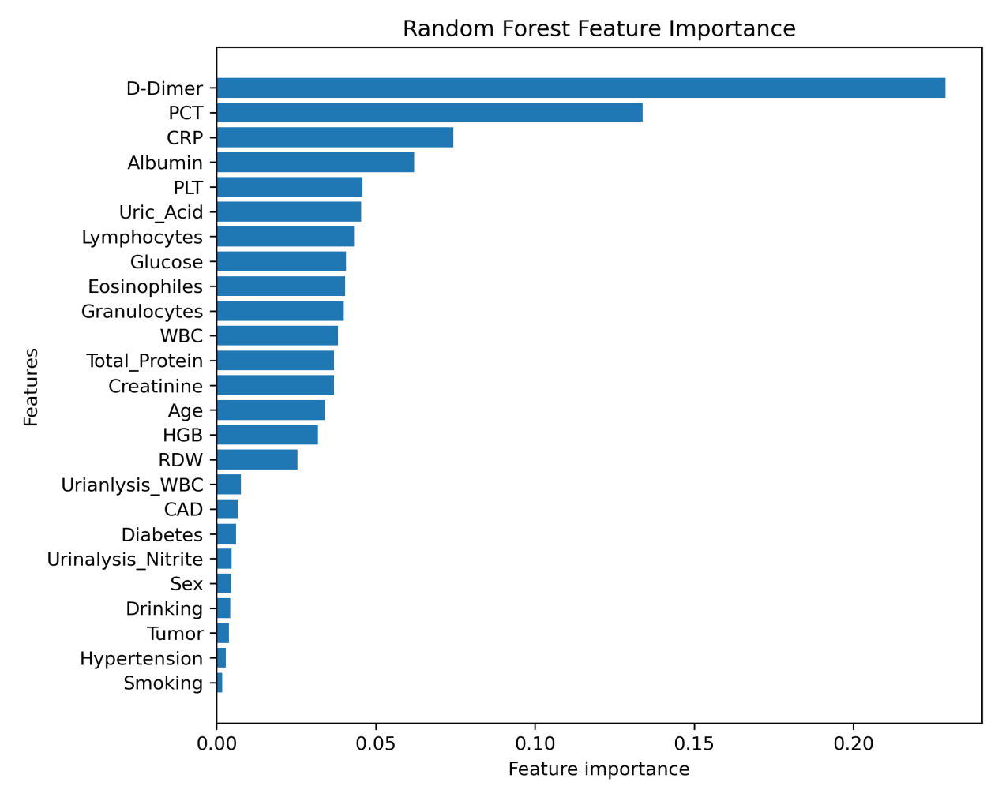
Supplementary Figure S3. Random Forest feature importance. Global feature importance derived from the trained Random Forest model (training set). Importance reflects the model’s impurity-based contribution aggregated across trees and is shown in descending order. Abbreviations: D-dimer, fibrin degradation product D-dimer; PCT, procalcitonin; CAD, coronary artery disease; PLT, platelet count; CRP, C-reactive protein; WBC, white blood cell count; HGB, hemoglobin; RDW, red cell distribution width; Uric_Acid, serum uric acid; Total_Protein, serum total protein; Urinalysis_WBC, urine white blood cells (urinalysis); Urinalysis_Nitrite, urine nitrite (urinalysis).

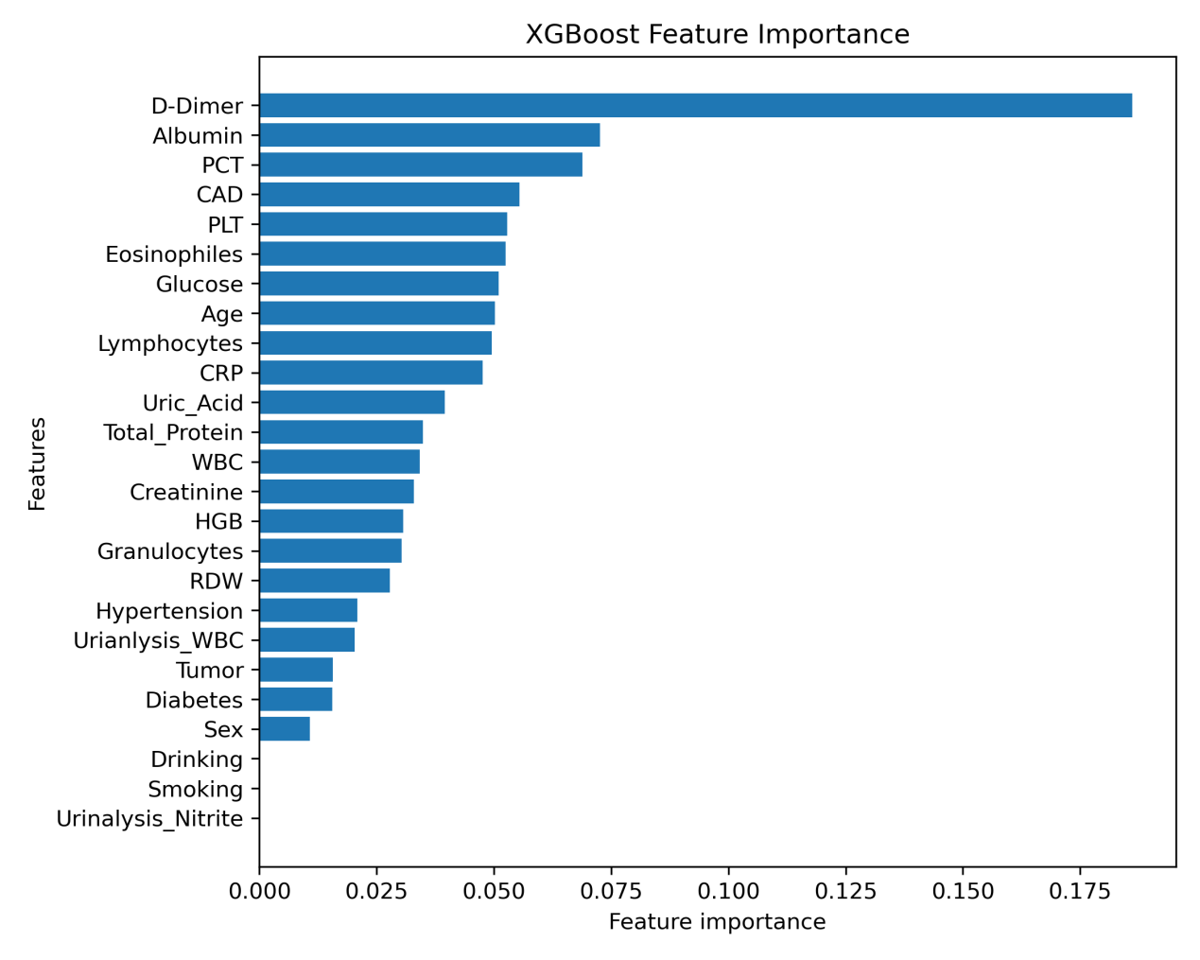
Supplementary Figure S4. XGBoost feature importance. XGBoost feature importance. Global feature importance derived from the trained XGBoost model (training set) using XGBoost’s built-in importance scores (normalized). Features are ranked in descending order. Abbreviations: D-dimer, fibrin degradation product D-dimer; PCT, procalcitonin; CAD, coronary artery disease; PLT, platelet count; CRP, C-reactive protein; WBC, white blood cell count; HGB, hemoglobin; RDW, red cell distribution width; Uric_Acid, serum uric acid; Total_Protein, serum total protein; Urinalysis_WBC, urine white blood cells (urinalysis); Urinalysis_Nitrite, urine nitrite (urinalysis).

