Table1. Primers for RPA method
Login Number | Number | Primer sequence（5'→3'） | Length
MK609547.1 | 1 | CAGTTATAGTTTATTTGATGTTCGTTTTAC | 295bp
MK609547.1 | 1 | TCTTAGATGTGGTAGCCGTTTCTCAGG | 295bp
MK609547.1 | 2 | GGAAAGCAGCAGGCGCGCAAATTACCCA | 243bp
MK609547.1 | 2 | GGAAGCGAGATTAATGACAAGGCAGA A | 243bp
MK609547.1 | 3 | ATCTAAACCCTTCCCAGAGTATCAATTGGA | 338bp
MK609547.1 | 3 | CCAACTGCTCCTATTAACCATTACTCTGGC | 338bp
MK609547.1 | 4 | CCAGAGTAATGGTTAATAGGAGCAGTTGG | 295bp
MK609547.1 | 4 | CTCTAGTCGGCATAGTTTATGGTTAGGAC | 295bp
MK609547.1 | 6 | TCCAGACATAGAGAGGATTGACAGATTGAT | 222bp
MK609547.1 | 6 | ACCTGTTATTGCCTTACACTTCCTTGCGTT | 222bp
MK609547.1 | 7 | CGGCTACCACATCTAAGGAAGGCACG | 191bp
MK609547.1 | 7 | CTATTGGAGCTGGAATTACCGCGGCT | 191bp

Table2. Primers for Nested PCR
 | Primer name | Primer sequence（5'→3'）
First round | CRYPTORN | GAATGATCCTTCCGCAGGTTCACCTAC
First round | CRYPTOFL | AACCTGGTTGATCCTGCCAGTAGTCAT
Second round | Bab1 | GTCTTAGTATAAGCTTTTATACAGCG
Second round | Bab4 | GATAGGTCAGAAACTTGAATGATACATCG

Table 3 Density of parasitess in various groups of blood Babesia microti

Group | Density of Babesia microti（parasite/ul）
1 | 445200
2 | 89040
3 | 17808
4 | 3561.6
5 | 712.32
6 | 142.46
7 | 28.49
8 | 5.7
9 | 1.14
10 | 0.23
11 | 0.046
12 | 0.0092
13 | 0.0018
14 | 0.00037

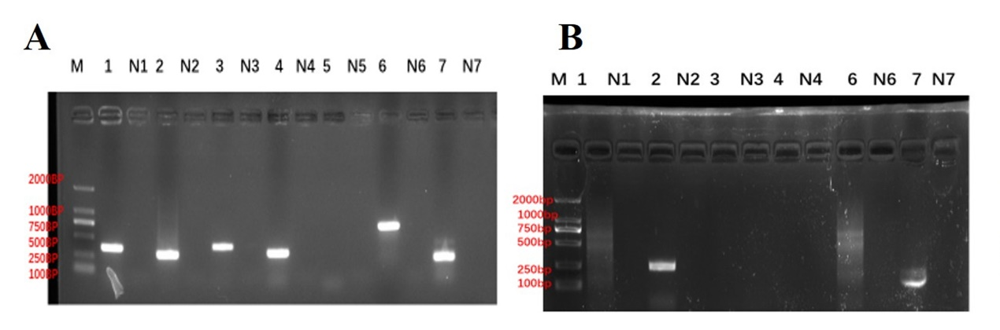
Figure1 PCR Results of RPA primers selection
(A) represent corresponds to primers for PCR, 1-7 from 18SrRNA .N1-N7 represent the negative control, M represents DNA makers. 1st, 2nd, 3rd, 4th, 6th, 7th-which produced positive PCR results. (B) 1, 2,3,4,6,7 represent corresponds to primers for RPA.N1、N2、N3、N4、N6、N7 represent the negative control, M represent DNA Makers. The 2nd, 7th primer groups yielded clear, distinct bands.
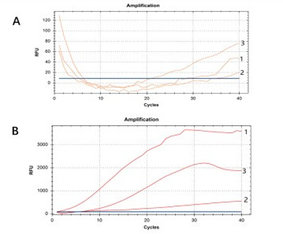

Figure 2 Selection results of primers with different sequences
- 1-3 respectively represent the first pair, the second pair, and the third pair of primers of the group 2 sequence. (B) 1-3respectively represent the first pair, second pair, and third pair of primers in the group 7 sequence.

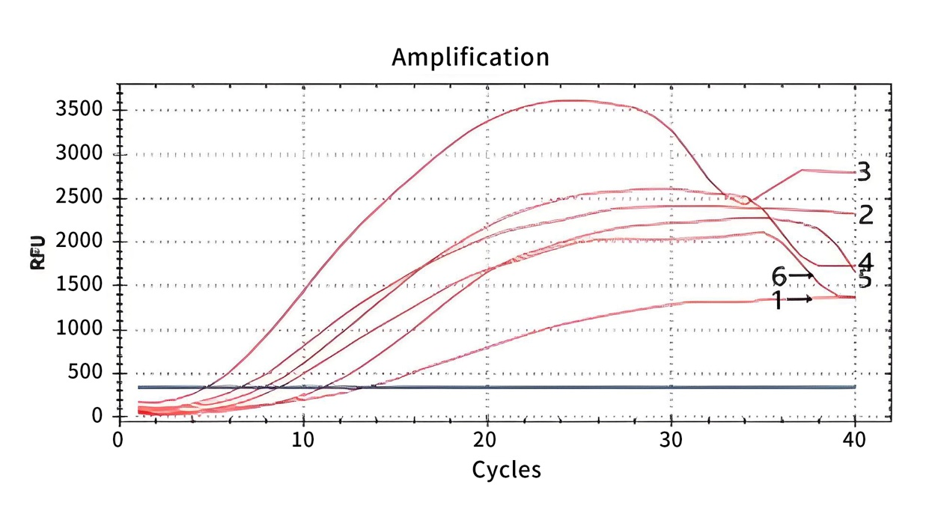
Figure 3 Optimization of fluorescence RPA reaction temperature. Curves 1-6 represents the B. microti genomic DNA amplification profile of group 7 sequence at 37°C, 38°C, 39°C, 40°C, 41°C, and 42°C, respectively.

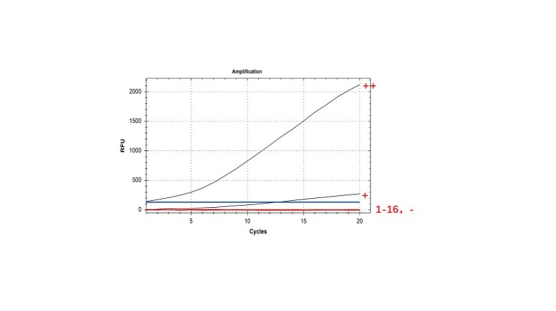

Figure 4 Specificity detection of the fluorescence RPA method. Curves 1-8 represent the amplification profile of B. microti genomic DNA from the blood samples of patients infected with P. falciparum. Curves 9-16 represent P. ovale and the controls. ++ represents the positive control, + represents the fluorescence threshold, - represents the negative control. The primers and fluorescent probes both designed based on the 18S rRNA sequences of Group 7.

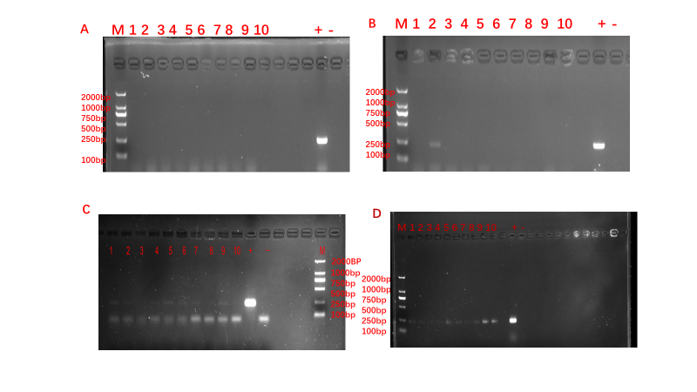
Figure 5 Results of nested PCR of B. microti infected in mouse models of post infection days
(A) 1-10 represent PCR results of 6th post infection days. All samples were negative. + represents positive control, - represents the negative control. (B) 1-10 represent PCR results of 9th post infection days, samples of No.2 was positive, and the other ones were negative. + represents positive control, - represents the negative control. (C) 1-10 represent PCR results of 12th post infection days, No.1,,No.2, No.4, No.5,No.6,No.7, No.9 samples were positive. + represents positive control, - represents the negative control. (d) 1-10 represent PCR results of 15th post infection days, all samples were positive. + represents positive control, - represents the negative control.

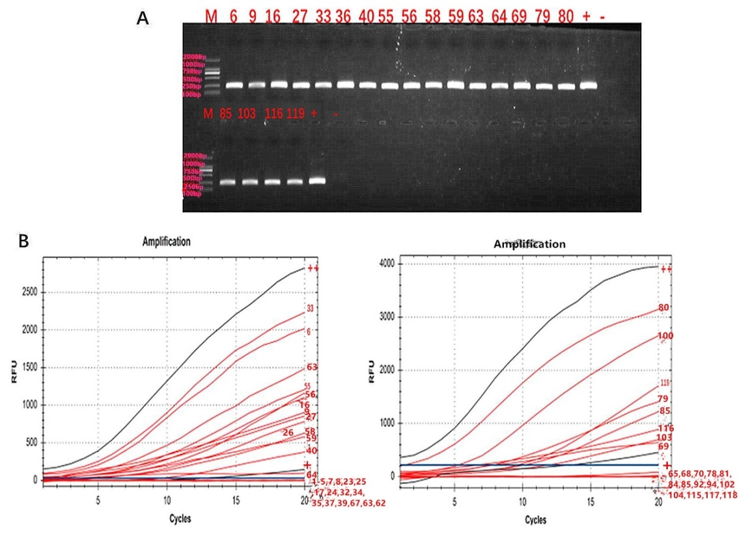
Figure 6 Nested-PCR and Fluorescence RPA results in patients with fever and thrombocytopenia in Xinyang City Henan Province in 2015.
Samples of No. 6, No.9, No.16, No.27, No.33, No.36, No.40, No.55, No.56, No.58, No.59, No.63, No.64, No.69, No.79, No.80, No.85, No.103, No.116, No.119 represent nested-PCR positive results of samples from patients with fever and thrombocytopenia in Xinyang City Henan Province in 2015. + represents the fluorescence threshold. – represents the negative control. (B) Curves 1-119 represent samples from patients with fever and thrombocytopenia in Xinyang City Henan Province in 2015. Samples of No. 6, No.9, No.16, No.27, No. 33, No.36, No.40, No.55, No.56, No.58, No.59, No.63, No.69, No.79, No.80, No.85, No.93, No.103, No.116, and No.119 were tested positive. The fluorescence intensity of sample No.64 is close to the fluorescence threshold, indicating a weak positive sample. The fluorescence intensity of other samples is much lower than the threshold, indicating a negative result. ++ represents the positive control. + represents the fluorescence threshold. - represents the negative control. Full-length gel of part A was included in a Supplementary Information file.

