SUPPLEMENTARY INFORMATION

Challenges associate with microbiome diversity, glucocorticoids, and condition in a wild songbird

Morgan C. Slevin^{1*}, Jennifer L. Houtz^{2,3}, Maren N. Vitousek^{2,4}, Rindy C. Anderson¹

¹Florida Atlantic University, Department of Biological Sciences, Davie, Florida, USA
²Cornell University, Department of Ecology and Evolutionary Biology, Ithaca, New York, USA
³Allegheny College, Department of Biology, Meadville, Pennsylvania, USA
⁴Cornell Lab of Ornithology, Ithaca, New York, USA
*corresponding author: slemc425@gmail.com

TABLES

Table S1. Pairwise comparisons and relative effect sizes between treatment groups with respect to beta diversity between a Northern cardinal male’s pair of samples pre- and post-treatment. STI=Simulated Territorial Intrusion, TH=Temporary Hold, and C=Control.
Parameter | Beta Diversity Metric | Pairwise Comparison | Means  Contrast | Adjusted P
Treatment | Bray-Curtis | TH – C | 0.04 | 0.231
Treatment | Bray-Curtis | TH – STI | 0.04 | 0.736
Treatment | Bray-Curtis | STI – C | 0.00 | 0.231
Treatment | Unweighted UniFrac | TH – C | 0.03 | 0.002
Treatment | Unweighted UniFrac | TH – STI | 0.02 | 0.047
Treatment | Unweighted UniFrac | STI – C | 0.01 | 0.071
Treatment | Weighted UniFrac | TH – C | <0.01 | 0.001
Treatment | Weighted UniFrac | TH – STI | <0.01 | 0.005
Treatment | Weighted UniFrac | STI – C | <0.01 | 0.334

Table S2. Pairwise comparisons and relative effect sizes for the significant interaction effect between ∆body condition and beta diversity between Northern cardinal microbiome sample timepoints, organized by treatment and beta diversity metric. STI=Simulated Territorial Intrusion, TH=Temporary Hold, and C=Control. Effect Size “Low” and “High” refer to, respectively, the effect size at the lowest and highest end of the spectrum of values for ∆body condition.
Beta Diversity Metric | Pairwise Comparison | Slope Contrast | Adjusted P | Effect Size  High | Effect Size Low
Bray-Curtis | STI – TH | 0.03 | 0.011 | 202% | 51%
Bray-Curtis | STI – C | 0.02 | 0.014 | 244% | 68%
Bray-Curtis | C – TH | 0.01 | 0.265 | 19% | 28%
Unweighted UniFrac | STI – TH | 1.00 | 0.001 | 272% | 76%
Unweighted UniFrac | STI – C | 0.81 | 0.002 | 366% | 67%
Unweighted UniFrac | C – TH | 0.19 | 0.251 | 26% | 28%
Weighted UniFrac | STI – TH | Interaction not significant
Weighted UniFrac | STI – C
Weighted UniFrac | C – TH

Table S3. Pairwise comparisons and relative effect sizes for the significant interaction effect between ∆beak coloration and beta diversity between Northern cardinal microbiome sample timepoints, organized by treatment and beta diversity metric. STI=Simulated Territorial Intrusion, TH=Temporary Hold, and C=Control. Effect Size “Low” and “High” refer to, respectively, the effect size at the lowest and highest end of the spectrum of values for each ∆beak coloration metric.
Parameter | Beta Diversity Metric | Pairwise Comparison | Slope Contrast | Adjusted P | Effect Size  High | Effect Size Low
Hue | Bray-Curtis | STI – C | -0.02 | 0.015 | 35% | 171%
Hue | Bray-Curtis | STI – TH | -0.02 | 0.017 | 48% | 90%
Hue | Bray-Curtis | TH – C | <0.01 | 0.949 | 127% | 189%
Hue | Unweighted UniFrac | STI – C | -0.45 | 0.001 | 17% | 424%
Hue | Unweighted UniFrac | STI – TH | -0.44 | <0.001 | 38% | 275%
Hue | Unweighted UniFrac | TH – C | -0.01 | 0.838 | 192% | 154%
Hue | Weighted UniFrac | Interaction not significant
Brightness | Bray-Curtis | STI – C | -0.02 | 0.065 | 34% | 173%
Brightness | Bray-Curtis | STI – TH | 0.00 | 0.860 | 25% | 10%
Brightness | Bray-Curtis | TH – C | -0.01 | 0.261 | 14% | 192%
Brightness | Unweighted UniFrac | STI – C | -0.33 | <0.001 | 41% | 199%
Brightness | Unweighted UniFrac | STI – TH | -0.24 | 0.749 | 51% | 130%
Brightness | Unweighted UniFrac | TH – C | -0.09 | 0.813 | 121% | 153%
Brightness | Weighted UniFrac | Interaction not significant
Saturation | Bray-Curtis | Interaction not significant
Saturation | Unweighted UniFrac | STI – C | 0.03 | 0.779 | 163% | 26%
Saturation | Unweighted UniFrac | STI – TH | 0.00 | 0.779 | 35% | 116%
Saturation | Unweighted UniFrac | TH – C | 0.03 | 0.779 | 250% | 36%
Saturation | Weighted UniFrac | Interaction not significant

Table S4. Pairwise comparisons and relative effect sizes for the significant interaction effect between ∆glucocorticoid response to capture stress and beta diversity between Northern cardinal microbiome sample timepoints, organized by treatment and beta diversity metric. STI=Simulated Territorial Intrusion, TH=Temporary Hold, and C=Control. Glucocorticoid response measured by corticosterone (CORT) concentrations at three timepoints to encapsulate baseline CORT, speed of response, and scope of response. Effect Size “Low” and “High” refer to, respectively, the effect size at the lowest and highest end of the spectrum of values for each CORT metric.
Parameter | Beta Diversity Metric | Pairwise Comparison | Slope Contrast | Adjusted P | Effect Size  High | Effect Size Low
Baseline CORT | Bray-Curtis | STI – C | -0.03 | 0.003 | 57% | 266%
Baseline CORT | Bray-Curtis | TH – C | -0.03 | 0.004 | 33% | 251%
Baseline CORT | Bray-Curtis | STI – TH | -0.01 | 0.648 | 36% | 106%
Baseline CORT | Unweighted UniFrac | STI – C | 0.00 | 0.063 | 52% | 236%
Baseline CORT | Unweighted UniFrac | TH – C | 0.00 | 0.005 | 34% | 252%
Baseline CORT | Unweighted UniFrac | STI – TH | 0.00 | 0.085 | 28% | 6%
Baseline CORT | Weighted UniFrac | Interaction not significant
CORT speed | Bray-Curtis | Interaction not significant
CORT speed | Unweighted UniFrac | Interaction not significant
CORT speed | Weighted UniFrac | Interaction not significant
CORT scope | Bray-Curtis | STI – C | 0.02 | 0.023 | 181% | 34%
CORT scope | Bray-Curtis | TH – C | 0.03 | 0.023 | 251% | 34%
CORT scope | Bray-Curtis | STI – TH | -0.01 | 0.437 | 28% | 0.3%
CORT scope | Unweighted UniFrac | STI – C | 0.00 | 0.020 | 213% | 38%
CORT scope | Unweighted UniFrac | TH – C | 0.00 | 0.233 | 208% | 8%
CORT scope | Unweighted UniFrac | STI – TH | 0.00 | 0.983 | 102% | 32%
CORT scope | Weighted UniFrac | STI – C | <0.01 | 0.450 | 135% | 12%
CORT scope | Weighted UniFrac | TH – C | <0.01 | 0.057 | 343% | 39%
CORT scope | Weighted UniFrac | STI – TH | >-0.01 | 0.102 | 60% | 144%

Table S5. List of Amplicon Sequence Variants in post-treatment cloacal microbiome samples whose relative abundances significantly correlated with ∆Shannon diversity between pre- and post-treatment timepoints. The majority are genera (italicized), while non-italicized Amplicon Sequence Variants represent orders or families.
Amplicon Sequence Variant | Coefficient ± se | p
Microvirga | 0.68 ± 0.18 | 0.001
67-14 | 0.49 ± 0.12 | <0.001
Novosphingobium | 0.79 ± 0.21 | 0.001
Gordonia | 1.58 ± 0.46 | 0.001
Microbacteriaceae | 1.48 ± 0.43 | 0.001
uncultured JG30-KF-CM45 | 0.78 ± 0.26 | 0.005
uncultured JG30-KF-CM45 | 0.87 ± 0.29 | 0.005
Nakamurella | 0.85 ± 0.29 | 0.005
uncultured Rubrobacteria | 0.43 ± 0.14 | 0.005
Paenibacillus | 0.81 ± 0.27 | 0.005
Candidatus_Nitrocosmicus | 0.83 ± 0.27 | 0.003
Mycobacterium | 1.18 ± 0.38 | 0.003
Mycobacterium | 0.55 ± 0.19 | 0.005
Novosphingobium | 0.54 ± 0.18 | 0.004
Bosea | 0.74 ± 0.25 | 0.005
uncultured Gaiellales | 0.45 ± 0.16 | 0.007
Nocardioides | 0.67 ± 0.23 | 0.007
Mycobacterium | 1.33 ± 0.46 | 0.006
Bosea | 0.99 ± 0.35 | 0.007
Devosia | 1.22 ± 0.44 | 0.008
Bacillus | 0.29 ± 0.11 | 0.009
Microvirga | 0.88 ± 0.32 | 0.009
Leucobacter | 0.51 ± 0.20 | 0.013
Burkholderia-Caballeronia-Paraburkholderia | 0.59 ± 0.23 | 0.014
uncultured Beijerinckiaceae | 0.47 ± 0.18 | 0.013
Methylobacterium-Methylorubrum | 1.14 ± 0.44 | 0.014
67-14 | 0.65 ± 0.26 | 0.015
Enterococcus | 1.39 ± 0.55 | 0.016
uncultured JG30-KF-CM45 | 0.46 ± 0.19 | 0.017
Gaiella | 0.29 ± 0.12 | 0.020
Gaiella | 0.54 ± 0.22 | 0.020
Rhodococcus | 0.71 ± 0.29 | 0.019
Intrasporangiaceae | 0.78 ± 0.32 | 0.018
Aureimonas | 0.72 ± 0.30 | 0.019
Achromobacter | 0.85 ± 0.34 | 0.018
Aeromicrobium | 0.45 ± 0.19 | 0.024
Raoultibacter | 0.48 ± 0.20 | 0.024
Solirubrobacterales | 0.58 ± 0.25 | 0.025
67-14 | 0.57 ± 0.25 | 0.026
Solirubrobacteraceae | 0.57 ± 0.25 | 0.026
Pseudolabrys | 0.25 ± 0.10 | 0.023
Rhodoplanes | 0.38 ± 0.16 | 0.024
Reyranella | 0.38 ± 0.16 | 0.026
Campylobacter | -1.33 ± 0.58 | 0.028
Paracoccus | 0.66 ± 0.29 | 0.028
Gordonia | 0.51 ± 0.23 | 0.030

Table S6. Descriptive statistics by group for diversity measures. Treatment group designations: C = Control, STI = Simulated Territorial Intrusion, TH = Temporary Hold. CORT stands for corticosterone. All measures reported are the mean value ± standard error.
Treatment Group | Shannon Diversity | Faith’s Phylogenetic Diversity | Bray-Curtis | Unweighted UniFrac | Weighted UniFrac
C | -0.41 ± 0.25 | -0.37 ± 0.32 | 0.08 ± 0.01 | 0.08 ± 0.01 | 0.01 ± 0.001
STI | -0.05 ± 0.34 | 0.04 ± 0.23 | 0.08 ± 0.01 | 0.08 ± 0.01 | 0.01 ± 0.001
TH | 0.16 ± 0.44 | 0.20 ± 0.31 | 0.10 ± 0.01 | 0.11 ± 0.01 | 0.01 ± 0.001

Table S7. Descriptive statistics by group for fitness-associated measures. Treatment group designations: C = Control, STI = Simulated Territorial Intrusion, TH = Temporary Hold. CORT stands for corticosterone. All measures reported are the mean value ± standard error for the change in value from pre-treatment to post-treatment sample.
Treatment Group | Body Condition | Beak Hue | Beak Saturation | Beak Brightness | Baseline CORT | CORT Speed | CORT Scope
C | -0.03 ± 0.01 | 0.005 ± 0.006 | 0.01 ± 0.02 | -0.004 ± 0.01 | 0.24 ± 2.40 | 0.08 ± 0.10 | 3.28 ± 4.34
STI | -0.03 ± 0.01 | 0.001 ± 0.007 | 0.02 ± 0.03 | -0.001 ± 0.02 | 3.34 ± 1.92 | -0.16 ± 0.15 | 4.64 ± 5.81
TH | -0.004 ± 0.02 | 0.005 ± 0.009 | -0.003 ± 0.02 | -0.01 ± 0.01 | 0.94 ± 2.45 | -0.08 ± 0.10 | -4.34 ± 4.38
Table S8. Table of Amplicon Sequence Variants (ASVs) identified as contaminants. Contaminants were identified in R package decontam analyzing frequency and prevalence. For frequency (Freq), decontam uses the frequency of each ASV as a function of the input DNA concentration. For prevalence (Prev), the presence or absence across samples of each ASV in true positive samples is compared to the prevalence in negative controls. An asterisk indicates unknown taxonomy at the given level.

p | 0.042 | 0.031 | 0.017 | 0.004 | 0.028 | 0.045 | 0.041 | 0.013 | 0.010 | 0.033 | 0.039 | 0.017 | 0.002 | 0.006 | 0.022 | 0.031 | 0.025
p Prev | 0.549 | 0.549 | 0.533 | 0.533 | 0.533 | 0.533 | 0.549 | 0.549 | 0.533 | 0.533 | 0.565 | 0.533 | 0.533 | 0.533 | 0.533 | 0.533 | 0.084
p Freq | 0.013 | 0.009 | 0.005 | 0.001 | 0.008 | 0.014 | 0.013 | 0.003 | 0.002 | 0.010 | 0.011 | 0.004 | 0.000 | 0.001 | 0.006 | 0.009 | 0.046
Prev | 3 | 3 | 3 | 2 | 3 | 2 | 3 | 3 | 3 | 2 | 11 | 3 | 2 | 2 | 4 | 2 | 13
Freq | 2.6e-06 | 2.6e-06 | 7.0e-06 | 4.2e-06 | 4.1e-06 | 1.2e-05 | 4.9e-06 | 7.6e-06 | 4.1e-06 | 2.0e-06 | 2.5e-05 | 7.5e-06 | 2.8e-06 | 4.1e-06 | 1.70E-04 | 4.1e-06 | 0.002
EPITHET | * | uncultured bacterium | * | uncultured Acidobacteriales | uncultured bacterium | * | * | metagenome | uncultured actinobacterium | * | * | * | uncultured bacterium | * | * | uncultured bacterium | geothermalis
GENUS | Bryobacter | Aurantisolimonas | uncultured | uncultured | uncultured | Gemmataceae | Actinoplanes | PeM15 | Acidothermus | Nocardioides | Gaiella | IMCC26256 | MB-A2-108 | Chryseobacterium | Lachnoclostridium | uncultured | Deinococcus
FAMILY | Bryobacteraceae | Chitinophagaceae | uncultured | uncultured | Pirellulaceae | Gemmataceae | Micromonosporaceae | PeM15 | Acidothermaceae | Nocardioidaceae | Gaiellaceae | IMCC26256 | MB-A2-108 | Weeksellaceae | Lachnospiraceae | Chroococcidiopsaceae | Deinococcaceae

p | 0.030 | 0.006 | 0.032 | 0.032 | 0.005 | 0.016 | 0.032 | 0.022 | 0.048 | 0.050 | 0.009 | 0.030 | 0.007 | 0.028 | 0.032 | 0.005
p Prev | 0.533 | 0.533 | 0.020 | 0.051 | 0.007 | 0.004 | 0.029 | 0.533 | 0.533 | 0.533 | 0.533 | 0.084 | 0.013 | 0.051 | 0.051 | 0.007
p Freq | 0.009 | 0.001 | 0.252 | 0.100 | 0.097 | 0.582 | 0.176 | 0.006 | 0.015 | 0.016 | 0.002 | 0.057 | 0.064 | 0.084 | 0.100 | 0.097
Prev | 2 | 5 | 14 | 3 | 63 | 6 | 15 | 2 | 5 | 4 | 5 | 11 | 19 | 14 | 3 | 63
Freq | 2.6e-06 | 7.7e-06 | 0.002 | 1.9e-05 | 0.004 | 0.001 | 0.001 | 6.0e-06 | 7.2e-06 | 8.9e-06 | 1.7e-05 | 2.3e-05 | 0.001 | 0.0003 | 1.9e-05 | 0.004
EPITHET | Solirubrobacterales bacterium | alginolyticus | * | * | * | * | * | * | * | * | * | * | * | diminuta | * | *
GENUS | 67-14 | Paenibacillus | Staphylococcus | Geobacillus | Geobacillus | Anaerococcus | Phyllobacterium | Sphingomonas | Novosphingobium | Candidatus | Allorhizobium-Neorhizobium-Pararhizobium-Rhizobium | Ramlibacter | * | Brevundimonas | Geobacillus | Geobacillus
FAMILY | 67-14 | Paenibacillaceae | Staphylococcaceae | Bacillaceae | Bacillaceae | Peptostreptococcales-Tissierellales | Rhizobiaceae | Sphingomonadaceae | Sphingomonadaceae | Geminicoccaceae | Rhizobiaceae | Comamonadaceae | Comamonadaceae | Caulobacteraceae | Bacillaceae | Bacillaceae

Table S9. The cross reactivities are listed below for the Arbor Assays Enzyme Immunoassay kit (Catalog No. K014-H) used to estimate corticosterone from blood samples collected from male Northern cardinals.
Steroid | Cross Reactivity (%)
Corticosterone | 100%
1-dehydrocorticosterone | 18.9%
Desoxycorticosterone | 12.3%
1α-hydroxycorticosterone | 3.3%
11-dehydrocorticosterone | 2.4%
Tetrahydrocorticosterone | 0.76%
Aldosterone | 0.62%
Cortisol | 0.38%
Progesterone | 0.24%
Dexamethasone | 0.12%
Testostrone | 0.03%
Corticosterone-21-hemisuccinate | < 0.1%
Cortisone | < 0.08%
Estradiol | < 0.08%
17-hydroxyprogesterone | < 0.01%
Allopregnanolone | < 0.01%
Dehydroepiandrosterone sulfate | < 0.01%
Estrone-3-glucuronide | < 0.01%
Estrone-3-sulfate | < 0.01%

FIGURES

A. B.
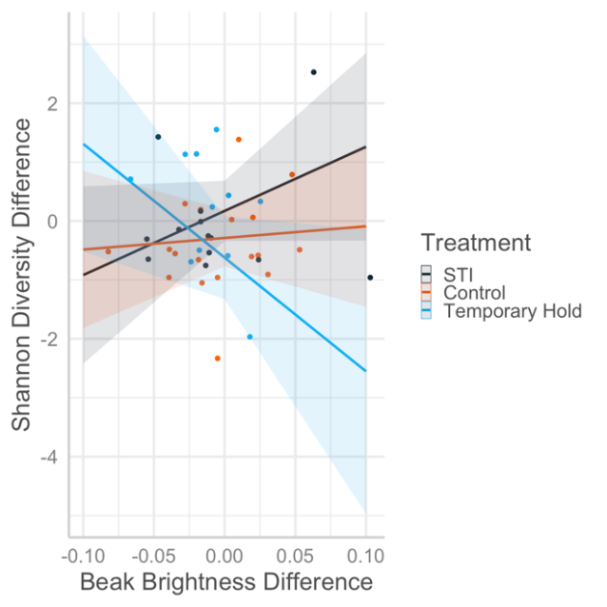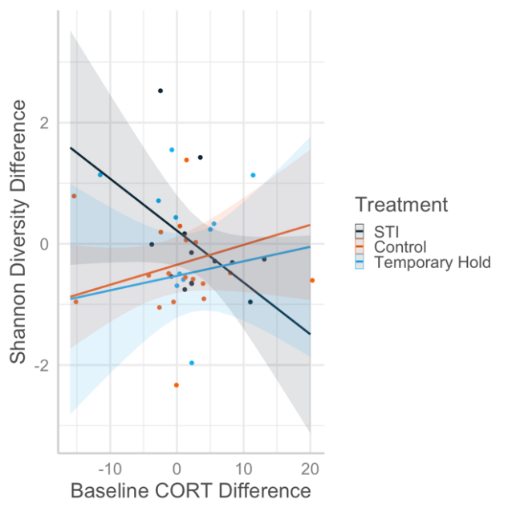
C.
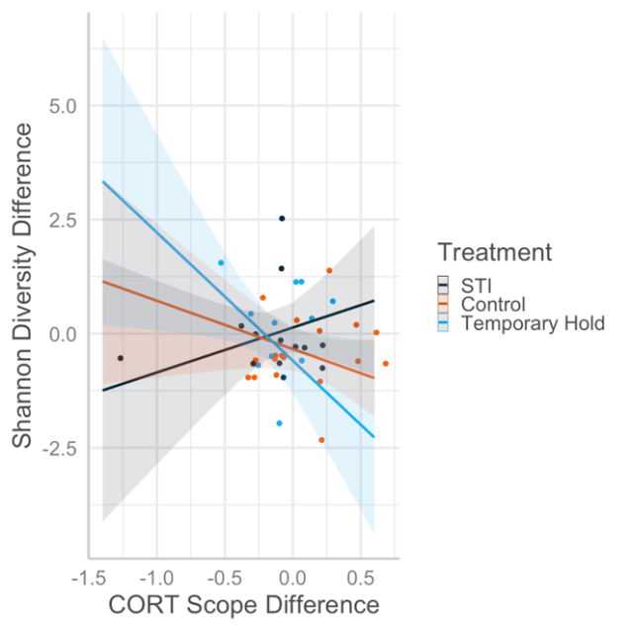
Figure S1. ∆Shannon Diversity between pre- and post-treatment cloacal microbiome samples of Northern cardinal males. Interaction effects were seen between treatment and change in A) beak brightness (p=0.060), B) baseline corticosterone (CORT; p=0.099), and C) CORT speed (p=0.086), but none of these were significant after multiple test correction. “STI” stands for simulated territorial intrusion.

- B.
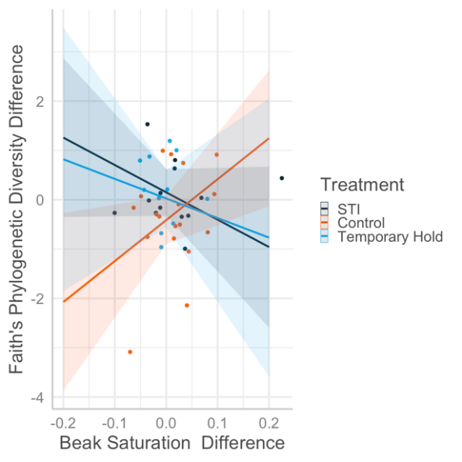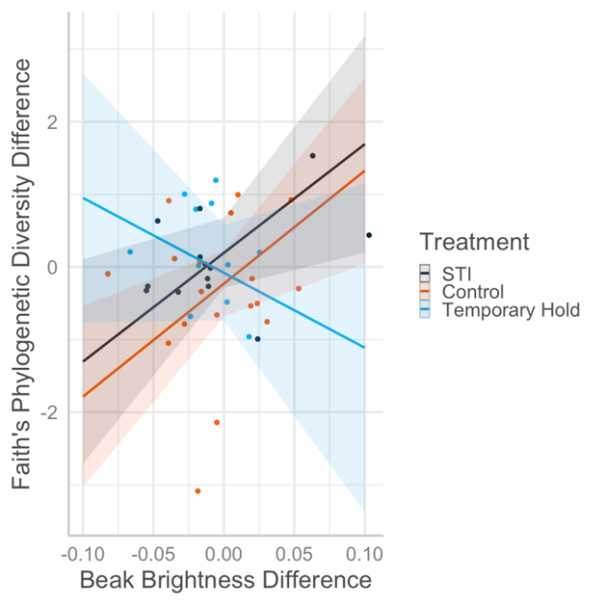
Figure S2. Change in Faith’s Phylogenetic Diversity between pre- and post-treatment cloacal microbiome samples of Northern cardinal males. Significant interaction effects were seen between treatment and change in A) beak saturation (p=0.034), and B) beak brightness (p=0.058), but none of these were significant after multiple test correction. “STI” stands for simulated territorial intrusion.

A. B.
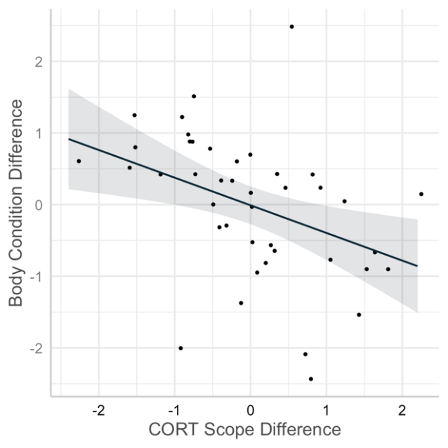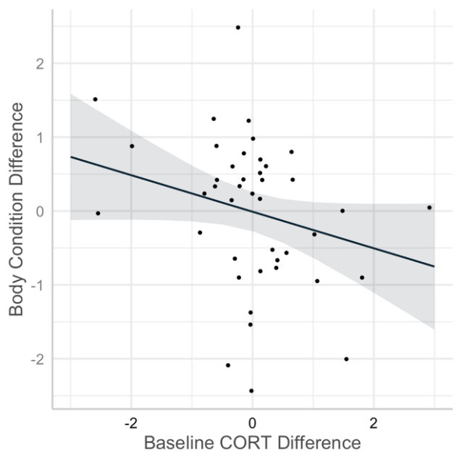
Figure S3. Data and trendlines from a post-hoc generalized linear model of samples collected from male Northern cardinals documenting changes between capture timepoints in body condition and corticosterone (CORT) response to stress (model: “change in body condition” ~ “change in baseline CORT” + “change in CORT scope”). Specifically, A) a significant relationship between the changes in CORT scope and body condition, and B) a relationship approaching significance between changes in baseline corticosterone and body condition.

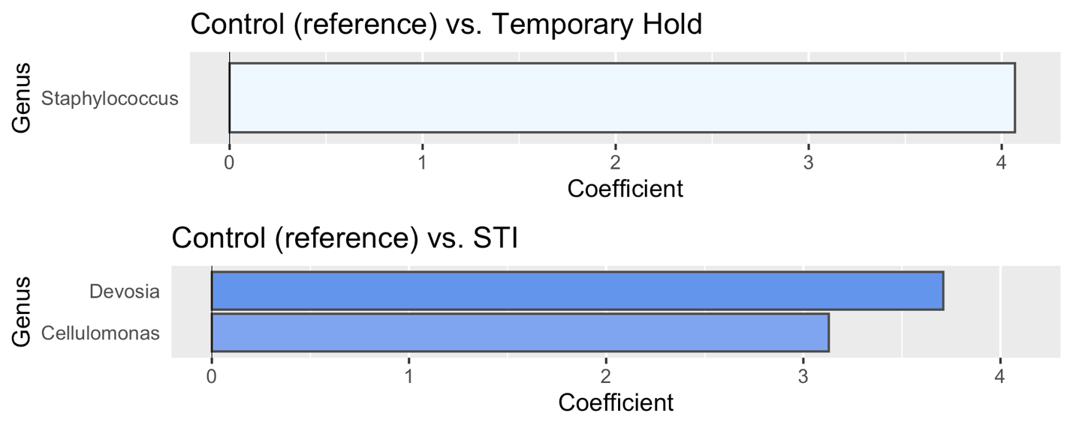
Figure S4. Divergence barplots showing the coefficients from differential abundance modeling. Model coefficients in the top panel compare abundances of Amplicon Sequence Variants that were significantly differentially abundant in post-treatment cloacal microbiome samples of male Northern cardinals receiving various treatments between 2 sample timepoints. The top plot shows birds in the Temporary Hold group compared to the Control group, while the bottom panel compares that of the Simulated Territorial Intrusion (STI) group relative to the Control group.

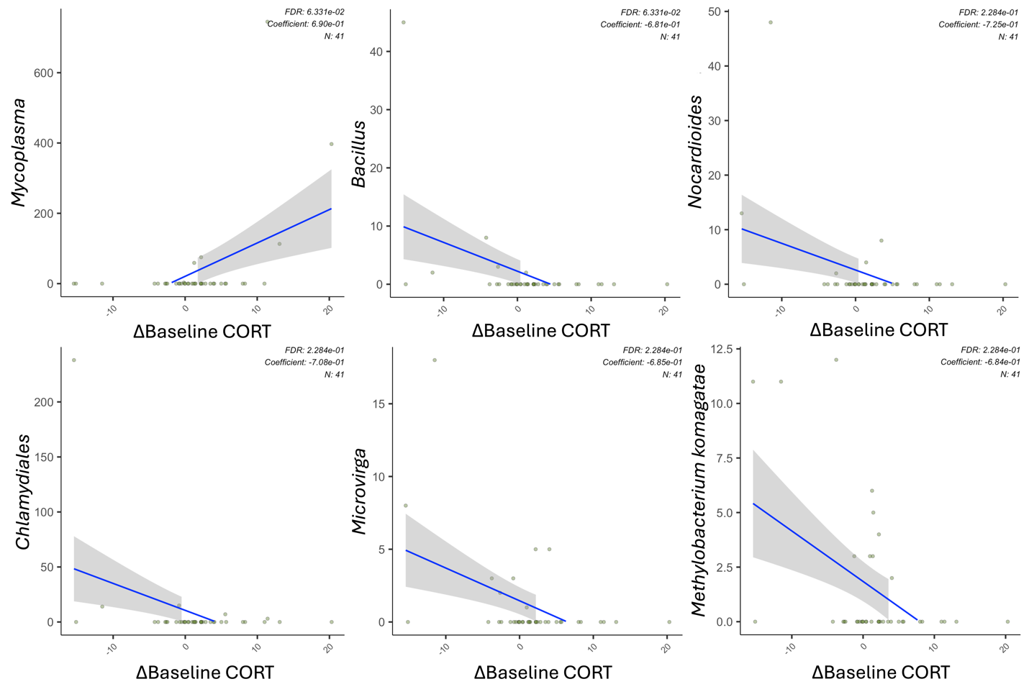
Figure S5. Scatterplots showing significant correlations between change (∆) in baseline corticosterone (CORT) concentration and relative abundances of six Amplicon Sequence Variants found in post-treatment cloacal microbiome samples of male Northern cardinals.

