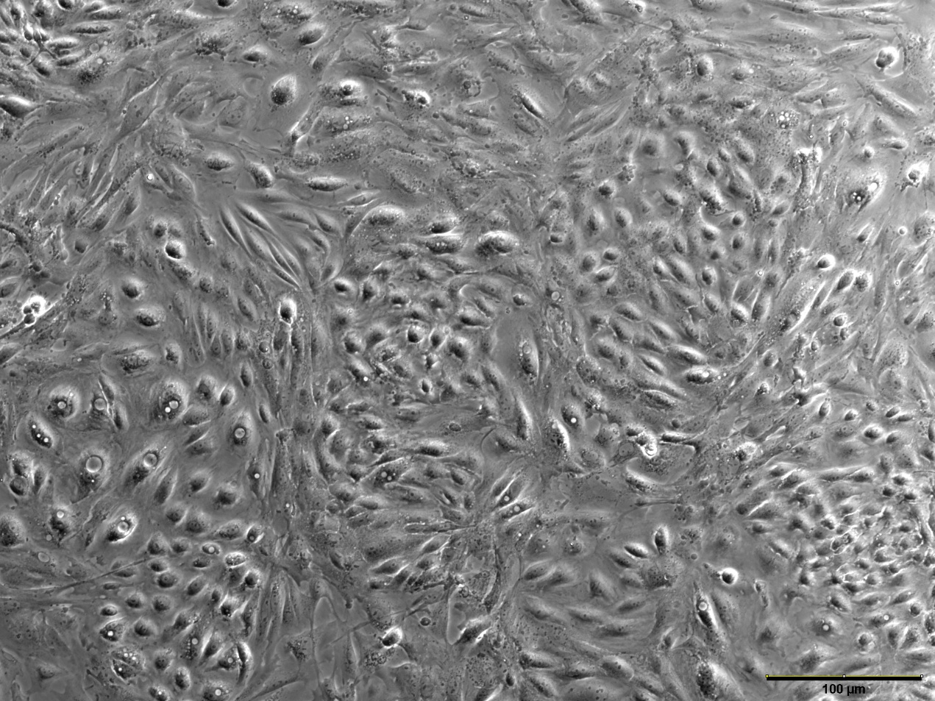
Supplementary Figure 2. Primary renal tubular epithelial cells (P1 1:2)

