List of Tables
Table S1. International Classification of Diseases for Oncology, Third Edition (ICD-O-3) codes for Identification of Non-Small Cell Lung Cancer Diagnosis
Table S2. Codes for identification of Immune Checkpoint Inhibitors (ICI)
Table S3. International Classification of Diseases (ICD) Codes for Immune-related Adverse Events (irAE)
Table S4. List of Systemic Immunosuppressive Medications Used to Identify Severe irAEs
Table S5. Identification Codes for Baseline Comorbidities
Tables S6. Codes for Identification of Baseline Medications, Surgery, Chemotherapy, and Targeted Therapy
Table S7. Full Patient Characteristics
Table S8. Immunosuppressive Claims Received within 14 days of Immune Checkpoint Inhibitor Therapy
Table S9. Time to Severe irAE by Organ System in Days

List of Figures
Figure S1. Cohort Attrition Flow Chart
Figure S2. Cumulative Incidence Function Plots of Time to Severe irAE Development for Selected Patient Characteristics, Accounting for Competing Risk of Death
Figure S3. Model Validation Parameters for the Final Fine and Gray Regression for Risk Factors of Severe irAE

Figure S1. Cohort Attrition Flow Chart
All cases in the SEER-Medicare linked dataset of lung cancer diagnosed from 2010 to 2017
N = 327,241
70,736 cases histology not NSCLC
131 cases ascertained by death certificate or autopsy only
1,324 cases not primary and only advanced NSCLC
912 patients with age <66 yrs at ICI initiation
Study population
n = 2,729 patients
2,606 patients with <12 months pre-and/or post-ICI initiation non-HMO parts A, B, and C Medicare coverage
148,057 patients without pembrolizumab, nivolumab, or atezolizumab as the first ICI claim from March 2015 to December 2017
2,007 patients who received surgery or chemotherapy/targeted therapy >28 days before the first ICI claim
68,704 cases not advanced (regional or distant NSCLC)
29,734 cases with age <65 years at NSCLC diagnosis and missing diagnosis dates
301 patients with no missing or certified date of death record

Table S1. International Classification of Diseases for Oncology, Third Edition (ICD-O-3) codes for Identification of Non-Small Cell Lung Cancer Diagnosis
Site | C34.0, C34.1, C34.2, C34.3, C34.8, C34.9, C33.9
Histology | Adenocarcinoma: 8140-8141, 8143-8147, 8250-8255, 8260, 8310  Squamous cell carcninoma: 8050-8052, 8070-8078, 8082-8084  Large cell carcinoma: 8010-8015, 8020-8022, 8030-8035  Sarcomatoid/mixed: 8560, 8570-8573, 8575  Not otherwise specified: 8046, 8003-8004, 8022, 8120, 8200, 8240-8241, 8243-8246, 8249, 8430, 8525, 8560, 8562
Stage | SEER Combined Summary Stage 2000 (2000+) Coding Scheme:
  Code | Stage category | Definition
  2 | Regional by direct extension | Tumor extended beyond primary organ to adjacent tissues/structures
  3 | Regional to lymph nodes | Spread to regional lymph nodes (with or without direct extension)
  4 | Regional (both direct extension & lymph nodes) | Combines codes 2 and 3 (local invasion + nodal involvement)
  5 | Regional, NOS | Regional spread documented but insufficient detail to assign 2, 3, or 4
  7 | Distant | Metastasis to remote organs/sites (e.g., liver, lung, bone)

Table S2. Codes for identification of Immune Checkpoint Inhibitors (ICI)
ICI type | National Drug Code (NDC) | Healthcare Common Procedure Coding System (HCPCS)
Nivolumab | 00003-3774-12  00003-3772-11  00003-3734-13 | C9453  J9299
Pembrolizumab | 00006-3029-02  00006-3026-02 | C9027  J9271
Atezolizumab | 50242-0918-86  50242-0918-01  50242-0917-86  50242-0917-01 | C9483  J9022

Table S3. International Classification of Diseases (ICD) Codes for Immune-related Adverse Events (irAE)
Organ System | Category | ICD-9 Codes | ICD-10 Codes
Cardiovascular | Arrhythmia | 427.x | I48.x, I47.x, I49.x, I46.x
 | Acute MI | 410.x | I21.x
 | Myocarditis | 422.x, 429.x | I40.x, I51.4, I51.8, I51.9
 | Pericarditis | 420.x, 423.x | I30.x, I31.4, I31.8-9
 | Cardiomyopathy | 425.4, 425.9 | I42.0, I42.7, I42.9
 | Giant cell arteritis | 446.5 | M31.5, M31.6
 | Polyarteritis nodosa and allied conditions (systemic vasculitis) | 446, 447.6 | M39.0, M30.1, M30.8, M31.9
Central Nervous System | Encephalitis/myelitis | 323.8, 323.81, 323.82, 323.7, 323.71, 323.72, 323.9 | G92, G04.81, G04.89, G04.90, G04.91
 | Guillain-Barre syndrome (GBS) | 357.0 | G61.0
 | Meningitis | 047.9, 322.9 | G03.9, A87.9
 | Myasthenia gravis | 358.0 | G70.0
 | Peripheral neuropathy | 357.89 | G64
 | Multiple sclerosis | 340 | G35
Dermatologic | Bullous Pemphigoid | 694.5 | L12.0
 | Eruption | 693.0 | L27.0, L27.1
 | Lichen planus | 697.0 | L43.x, L44.3, L66.1
 | Pruritus | 698.8 | L29.8, L29.9
 | Stevens-Johnson syndrome (SJS)/TEN | 695.13, 695.14 | L51.1, L51.3
 | Vitiligo | 709.00, 709.01, 709.09 | L80, L81.8, L81.9
 | Ankylosing spondylitis | 720.0 | M45
 | Dermatomyositis/polymyositis | 710.3, 710.4 | M33.0-M33.1; M33.2-M33.9
 | Felty's syndrome | 714.1 | M05.0
 | Systemic lupus erythematosus | 710.0 | M32.1-M32.9
 | Polymyalgia rheumatica | 725 | M35.3
 | Reactive arthritis | 99.3 | M02.3-M02.9
 | Rheumatoid arthritis | 714.0, 714.2 | M05.x, MO6.x
 | Sarcoidosis | 135 | D86.0-D86.9
 | Sjogren's syndrome | 710.2 | M35.0
 | Systemic sclerosis/scleroderma | 710.1 | M34.0-M34.9
 | Alopecia areata | 704.01 | L63.0, L63.1, L63.2, L63.8, L63.9
 | Dermatitis herpetiformis and other bullous dermatoses | 694.0, 694.4-694.9 | L13.0, L10-L14
 | Discoid lupus | 695.4 | L93.0
 | Localized scleroderma and other hypertrophic and atrophic conditions of the skin | 701.0, 701.1-701.9 | L94.0, L90.0-L90.0, L91.0-L91.9
 | Psoriasis and similar disorders | 696.1, 696.0 | L40.0-L40.9
Endocrine | Adrenal insufficiency | 255.41 | E27.1, E27.3, E27.4
 | Autoimmune hepatitis | 571.42 | K75.4
 | Chronic thyroiditis | 245.2 | E06.3
 | Diabetes Type I | 250.xx | E09.x, E10.x, E13
 | Diabetic ketoacidosis (DKA) | 250.11, 250.13 | E10.1
 | Hyperthyroidism | 242.x | E05.x
 | Hypophysitis | 253.8 | E23.6
 | Hypothyroidism | 244.3, 244.8, 244.9 | E03.2, E03.8, E03.9
 | Primary adrenal insufficiency | 255.4 | E27.1
 | Primary biliary cirrhosis | 571.6 | K74.3
 | Cushing's syndrome | 255.0 | E24.0, E24.9, E24.1, E24.2
 | Hypopituitarism | 253.2, 253.7 | E23.0
Gastrointestinal | Colitis | 558.2, 558.3, 558.4, 558.9, 555, 556.8, 556.9 | K52.1, K52.29, K52.3, K52.9, K52.89, K53.82
 | Mucositis | 528.x | K12.30, K12.31
 | Stomatitis and pancreatitis | 577.0 | K85.x
 | Gastroenteritis and colitis excluding ulcerative colitis | 009.0, 009.1, 558 | K52.9
 | Diarrhea | 787.91 | R19.7
 | Pancreatitis | 577.0, 577.1 | K85.x, K86.1
 | Hepatitis | 573.3, 573.1 | K75.9, K71.9, K72.9
 | Myalgia and myositis, not otherwise specified | 729.1 | M60.9
 | Hepatitis | 573.3, 790.5 | K71.x, K75.4, K75.9, R74.8, R94.5
 | Celiac disease | 579.0 | K90.0
 | Regional enteritis/Crohn's disease | 555.x | K50.x
 | Ulcerative colitis | 556.x | K51.x
Hematologic | Autoimmune hemolytic anemia | 2830 | D590, D5910, D5911, D5912, D5913, D5919
 | Leukopenia | 288.00, 288.03, 288.09, 288.4, 288.5x, 288.8, 288.9 | D70.2, D70.4, D70.9, D72.1, D72.81, D72.810, D72.818, D72.819, D76.1, D76.3
 | Thrombocytopenia | 287.3, 287.31, 287.4, 287.49, 287.5, 287.8, 287.9 | D69.3, D69.41, D69.49, D69.59, D69.6
 | Giant cell arteritis | 446.5 | M31.6
 | Polyarteritis nodosa | 446, 447.6 | M30.0
Lung | Pneumonitis | 486.x, 508.8, 508.9, 516.3x, 516.9 | J18.9, J70.2, J70.3, J70.4, J70.8, J70.9, J84.11x, J84.89, J84.9
Musculoskeletal | Dermatopolymyositis/polymyositis | 710.3, 710.4 | M33.x
 | Myalgia | 729.1 | M79.1
 | Neuritis/neuralgia | 729.2 | M79.2
 | Polymyalgia rheumatica (PMR)/GCA | 725, 446.5 | M31.5, M31.6, M35.5
 | Rheumatoid arthritis | 714.x | M05.x, M06.x, M08.0, M08.2, M08.3, M08.4, M08.8, M08.9, M12.0
Ocular | Ocular myositis | 376.12 | H05.221–H05.229
 | Optic neuritis | 377.30, 377.32 | H46.0, H46.9
 | Uveitis and Iritis | 364.00-364.04, 364.10-364.14 | H20.0x–H20.1x
Renal | Acute Kidney Injury (AKI) | 584.x | N17.x
 | Acute interstitial nephritis | 591.10, 591.11, 583.89 | N10.x, N12.x, N14.1, N14.2
 | Glomerulonephritis | 580.x, 581.x, 583.x
Systemic | Infusion related reaction | 999.88 | T80.89

Table S4. List of Systemic Immunosuppressive Medications Used to Identify Severe irAEs‡
Adalimumab | J0135, J0139
Azathioprine | J7500, J7501
Cyclophosphamide | J8530, J9070, J9072, J9090
Everolimus | J7527
Infliximab | G9914, J1745, J1748, Q5103, Q5104, 59359, Q5102, Q5105, Q5121, Q5128
IVIG | J1568, Q2052
Jakafi | J3590, C9399 (unspecified)
Leflunomide | G9914
Methotrexate | J9255, J8610, J9260, J9250, J8611, J8612, J0640, J0641, J0642, J1808, J9255,
Methylprednisolone | J1010, J2919, J1040, J2920, J7509, J1030, J2930, J2930, J1020
Mycophenolate | J7517, J7514, J7518, J7519
Prednisolone | J7510, J2650, J7512, J7506, J2670
Rituximab | J9310, J9311, J9312, Q5115, Q5119, Q5123
Sirolimus | J7520
Tacrolimus | J7503, J7507, J7508, J7515, J7521, J7525
Tocilizumab | J3262, M0249, M0250, Q0249, Q5133, Q5125, Q5135
Vedolizumab | J3380
‡ National Drug Codes (NDC) were additionally used to identify these immunosuppressants. NDC codes were obtained from the National Library of Medicine RxNav. https://lhncbc.nlm.nih.gov/RxNav/

Table S5. Identification Codes for Baseline Comorbidities
 | ICD-9-CM | ICD-10-CM
Pre-existing autoimmune disease
Acute disseminated encephalomyelitis | 3236 | G040
Addison’s disease | 2554 | E271, E272, E274
Alopecia areata | 70401 | L63
Amyotrophic sclerosis | 33520 | G1221
Ankylosing spondylitis | 7200 | M081, M45
Antiphospholipid antibody syndrome | 28653 | D6861, D68312
Aplastic anemia | 2840, 2848, 2849 | D610, D611, D612, D613, D6189, D619
Autoimmune hemolytic anemia | 2830 | D591
Autoimmune hepatitis | 57142 | K754
Autoimmune hypoparathyroidism | 2521 | E209
Autoimmune hypophysitis | 2538 | E236
Autoimmune myocarditis | 4290 | I514
Autoimmune oophoritis | 6141, 6142 | N7092
Autoimmune orchitis | 60490 | N452
Autoimmune thrombocytopenic purpura | 28731 | D693
Behcet’s disease | 1361 | M352
Bullous pemphigoid | 6945 | L120
Celiac disease | 5790 | K900
Chronic fatigue syndrome | 78071 | G9332
Chronic inflammatory demyelinating polyneuropathy | 35781 | G6181
Chronic rheumatic heart disease | 393, 394, 395, 396, 397, 398 | I05, I06, I07, I08, I09
Chronic thyroiditis/Hashimoto thyroiditis | 2452 | E063
Churg-Strauss syndrome | N/A | M301
Crohn’s disease | 555 | K50
Dermatitis herpetiformis | 6940 | L130
Dermatomyositis/polymyositis | 7103, 7104 | M33
Diabetes mellitus, type 1 | 25001, 25003, 25011, 25013, 25021, 25023, 25031, 25033, 25041, 25043, 25051, 25053, 25061, 25063, 25071, 25073, 25081, 25083, 25091, 25093 | E10
Discoid lupus erythematosus | 6954 | L930, L932
Dysautonomia | 3379 | G909
Epidermolysis bullosa acquisita | 75739 | L1230
Felty’s syndrome | 7141 | M050
Gestational pemphigoid | 64683 | O264
Giant cell arteritis | 4465 | M315, M316
Goodpasture’s syndrome | 44621 | M310
Graves’ disease | 2420 | E0500, E0501
Guillain-Barré syndrome | 3570 | G610
IgA nephropathy | 5839 | N028
Interstitial cystitis | 5951 | N301
Kawasaki’s disease | 4461 | M303
Lambert-Eaton myasthenic syndrome | 3581, 3583 | G7080, G7081, G731
Localized scleroderma (Morphea) | 7010 | L940
Lyme disease - chronic | 08881 | A692
Meniere’s syndrome | 3860 | H810
Mooren’s ulcer | 37007 | H1605
Multiple sclerosis | 340 | G35
Myasthenia gravis | 3580 | G7000, G7001
Neuromyotonia | 35929 | G7119
Opsoclonus myoclonus syndrome | 3332 | G253
Optic neuritis | 3773 | H468, H469
Pemphigus | 6944 | L10
Pernicious anemia | 2810 | D510
Polyarteritis nodosa | 4460 | M300, M302, M308, M317
Polyarthritis | 71659, 7149 | M130, M064
Polyglandular autoimmune syndrome | 2581 | E310
Polymyalgia rheumatica | 725 | M353
Primary biliary cirrhosis | 5716 | K743, K745
Psoriasis | 6960, 6961 | L40
Reiter’s syndrome | 0993 | M023
Rheumatoid arthritis | 714 | M05, M06, M080, M082, M083, M084, M088, M089, M120
Rheumatic fever | 390, 391, 392 | I00, I01, I02
Sarcoidosis | 135 | D86
Sjogren’s syndrome | 7102 | M350
Stiff-man syndrome | 33391 | G2582
Systemic lupus erythematosus | 7100 | M32
Systemic sclerosis/scleroderma | 7101 | M34
Takayasu’s arteritis | 4467 | M314
Ulcerative colitis | 556 | K51
Vitiligo | 70901 | L80
Vogt-Koyanagi-Harada disease | 36424 | H2082
Wegener’s granulomatosis | 4464 | M313
Autoimmune disease, NOS | 27949 | D8989
Charlson Comorbidities | ICD-9-CM codes and ICD-10-CM codes for Deyo-adapted Charlson comorbidities developed by Quan et al were used. Codes for malignancies and metastatic solid tumor were excluded.
Frailty | Claim-based algorithm was used.  Min Ji Kwak, Caroline Schaefer, Youngran Kim, Sunyang Fu, Chan Mi Park, Abhijeet Dhoble, Nahid Rianon, Holly M Holmes, Dae Hyun Kim, Application of Claims-based Frailty Index to a Structured Electronic Health Record Data, The Journals of Gerontology: Series A, Volume 80, Issue 7, July 2025, glaf099, https://doi.org/10.1093/gerona/glaf099

Tables S6. Codes for Identification of Baseline Medications, Surgery, Chemotherapy, and Targeted Therapy‡
Surgery | Surgery in SEER file
Pneumonectomy | CPT: 32440, 32442, 32445, 32488
 | ICD-9-CM: 32.41, 32.49, 32.6
 | ICD-10-CM: 0BTC0ZZ, 0BTC4ZZ, 0BTD0ZZ, 0BTD4ZZ
Lobectomy | CPT: 32480, 32482, 32484, 32486, 32663
 | ICD-9-CM: 32.41, 32.49, 32.6
 | ICD-10-CM: 0BBT0ZZ, 0BBL0ZZ, 0BBM0ZZ, 0BBS4ZZ
Wedge/segmental resection | CPT: 32500, 32505, 32506, 32507, 32657, 32666-32668
 | ICD-9-CM: 32.30, 32.39
 | ICD-10-CM: 0BBN0ZZ, 0BBN4ZZ, 0BBP4ZZ
Chemotherapy
Ado-trastuzumab emtansine | C9131, J9354
Aflibercept | J0178, J9400, Q2046
Alemtuzumab | C9110, J9010, S0087
Arsenic | C9012, J9017
Asparaginase | J9019, J9020
Azacitidine | J9025, C9218
Belinostat | J9032
Bendamustine | J9033
Bevacizumab | C9214, C9257, J9035, Q2024, S0116
Bleomycin | C9417, J9040
Blinatumomab | J9039
Bortezomib | C9207, J9041, S0115
Brentuximab | C9287, J9042
Busulfan | C1178, J0594, J8510
Cabazitaxel | J9043
Capecitabine | J8520, J8521
Carboplatin | J9045
Carfilzomib | J9047
Carmustine | C9437, J9050
Cetuximab | C9215, J9055
Chlorambucil | S0172
Cisplatin | C9418, J9060, J9062
Cladribine | C9419, J9065
Clofarabine | J9027
Cyclophosphamide | C9420, C9421, J8530, J9070, J9080, J9090, J9091, J9092, J9093, J9094, J9095, J9096, J9097
Cytarabine | C1166, C9422, J9098, J9100, J9110
Dacarbazine | C9423, J9130, J9140
Dactinomycin | J9120
Daunorubicin | C9424, J9150, J9151
Decitabine | J0894
Docetaxel | J9170, J9171
Doxorubicin | C9415, J9000, J9001, J9002, Q2048, Q2049, Q2050
Epirubicin | C1167, J9178, J9180
Eribulin | J9179
Etoposide | C9414, C9425, J8560, J9181, J9182
Everolimus | J7527, J8561
Floxuridine | C9426, J9200
Fludarabine | C9262, J8562, J9185
Fluorouracil | J9190
Gefitinib | J8565
Gemcitabine | J9201
Gemtuzumab | C9004, J9300
Hydroxyurea | S0176
Idarubicin | C9429, J9211
Ifosfamide | C9427, J9208
Imatinib | S0088
Irinotecan | J9206
Ixabepilone | J9207
Leucovorin | J0640
Levoleucovorin | J0641
Lomustine | S0178
Mechlorethamine | J9230
Melphalan | J8600, J9245
Methotrexate | J8610, J9250, J9260
Mitomycin | C9432, J9280, J9290, J9291
Mitoxantrone | J9293
Nelarabine | J9261
Obinutuzumab | J9301
Ofatumumab | J9302
Omacetaxine | J9262
Oxaliplatin | C9205, J9263
Paclitaxel | C9431, J9264, J9265, J9267, C9127
Panitumumab | C9235, J9303
Pegasparagase | J9266
Pemetrexed | C9213, J9305
Pentostatin | J9268
Pertuzumab | J9306
Plicamycin | J9270
Pralatrexate | J9307
Procarbazine | S0182
Ramucirumab | J9308
Rituximab | J9310
Romidepsin | C9265, J9315
Sipuleucel | Q2043
Streptozocin | J9320
Temozolomide | C1086, J8700, J9328
Temsirolimus | J9330
Teniposide | Q2017
Thiotepa | C9433, J9340
Topotecan | J8705, J9350, J9351
Trastuzumab | J9355
Valrubicin | J9357
Vinblastine | J9360
Vincristine | J9370, J9371, J9375, J9380
Vinorelbine | C9440, J9390
Targeted therapy
EGFR inhibitors | C9083, C9215, C9235, C9475, J9055, J9295, J9303, J9061
Cytokines | C1084, J9015, J9160, J9212, J9213, J9214, J9215, J9216, S0145, S0146, S0148, C9169  00.15 (ICD-9-CM), 3E04002 (ICD-10-CM)
Radiotherapy
HCPCS | C1325, C1348, C1350, C1700-C1712, C1715-  C1720, C1728, C1790-C1806, C2616, C2632, C2633, C9714,  C9715, G0174, G0178, G0179, G0261, G0256, G0273, G0274, G0338-G0340
CPT | 77261-77299, 77300-77399, 77401-77499, 77520, 77523, 76370,  76950, 77750-77799
ICD-9-CM | Diagnostic: V58.0, V67.1  Procedure: 92.21-92.29
ICD-10-CM | Diagnostic: Z51.0, Z08-Z09  Procedure: DWYZZZ, D0YZZZ, D10ZZZ, D60ZZZ
Hormonal therapy
Immunosuppressants
Steroids
Betamethasone | J0702, J0704
Budesonide
Cortisone
Dexamethasone | J110, J8540
Fludrocortisone
Hydrocortisone | J1700, J1710, J1720
Methylprednisolone | J1010, J2919, J1040, J2920, J7509, J1030, J2930, J2930, J1020
Prednisolone | J7510, J2650, J7512, J7506, J2670
Triamcinolone | J3300, J3301, J3302, J3303
Others
Abatacept
Adalimumab | J0135, J0139
Azathioprine | J7500, J7501
Certolizumab | J0717
Cyclosporine | J7502, J7515, J7516
Cyclophosphamide | J9070, J8530
D-penicillamine
Everolimus | J7527
Etanercept | J1438
Gold | J1600
Golimumab | J1602
Hydroxychloroquine
Infliximab | G9914, J1745, J1748, Q5103, Q5104, 59359, Q5102, Q5105, Q5121, Q5128
IVIG | J1568, Q2052
Jakafi | J3590, C9399 (unspecified)
Leflunomide | G9914
Methotrexate | J9255, J8610, J9260, J9250, J8611, J8612, J0640, J0641, J0642, J1808, J9255
Mycophenolate | J7517, J7514, J7518, J7519
Rituximab | J9310, J9311, J9312, Q5115, Q5119, Q5123
Sirolimus | J7520
Sulfasalazine
Tacrolimus | J7503, J7507, J7508, J7515, J7521, J7525
Tocilizumab | J3262, M0249, M0250, Q0249, Q5133, Q5125, Q5135
Vedolizumab | J3380
‡ HCPCS codes are provided unless otherwise specified. National Drug Codes (NDC) were additionally used to identify medications. NDC codes were obtained from the National Library of Medicine RxNav. https://lhncbc.nlm.nih.gov/RxNav/ or the Surveillance, Epidemiology, and End Results Program (SEER) Observational Research in Oncology Toolbox (CanMED) website https://seer.cancer.gov/oncologytoolbox/canmed. Where no code was provided, NDC was used to identify therapy. First-line therapy was identified as the record of first course of treatment in the SEER file and/or surgery, chemotherapy, or targeted therapy claim in the Medicare files (MEDPAR, Carrier claims (NCH), OUTPT, and DME) within 90 days of first ICI claim.

Table S7. Full Patient Characteristics
Characteristics | All patients  (n = 2729) | Without severe irAEs  (n =2342) | With severe irAEs ª  (n=386) | p value
Patient-level demographics
Age, years
65-70 | 775 (28.4) | 668 (28.5) | 107 (27.7) | 0.90
71-75 | 899 (32.9) | 770 (32.9) | 129 (33.3)
76-80 | 659 (24.2) | 561 (24.0) | 98 (25.3)
>80 | 396 (14.5) | 343 (14.7) | 53 (13.7)
Median (IQR) | 74 (70 – 78) | 74 (70 – 78) | 75 (70 – 78) | 0.83
Sex
Female | 1354 (49.6) | 1172 (50.0) | 182 (47.0) | 0.27
Male | 1375 (50.4) | 1170 (50.0) | 205 (53.0)
Race/ Ethnicity
Non-Hispanic White | 2275 (83.4) | 1954 (83.4) | 321 (83.0) | 0.24
Non-Hispanic Black | 172 (6.3) | 153 (6.5) | 19 (4.9)
Others ^{b} | 282 (10.3) | 235 (10.1) | 47 (12.1)
Marital status
Not married | 930 (34.1) | 792 (33.8) | 138 (35.7) | 0.72
Married | 982 (36.0) | 849 (36.3) | 133 (34.4)
Unknown | 817 (29.9) | 701 (29.9) | 116 (30.0)
Medicare-Medicaid dual eligibility
No | 2152 (78.9) | 1856 (79.3) | 296 (76.5) | 0.22
Yes | 577 (21.1) | 488 (20.8) | 91 (23.5)
Original reason for enrolment
Old age | 2424 (88.8) | 2084 (89.0) | 340 (87.9) | 0.51
Disability/End Stage Renal Disease | 305 (11.2) | 258 (11.0) | 47 (12.1)
SEER region
Midwest | 194 (7.1) | 168 (7.2) | 26 (6.7) | 0.80
Northeast | 1011 (37.1) | 875 (37.4) | 136 (35.1)
South | 579 (21.2) | 495 (21.1) | 84 (21.7)
West | 804 (34.3) | 804 (34.3) | 141 (36.4)
Metropolitan statistical area
Metropolitan | 2378 (87.1) | 2052 (87.6) | 326 (84.2) | 0.07
Non-metropolitan | 351 (12.9) | 290 (12.4) | 61 (15.8)
Rural-Urban density ^{c}
Big metro | 1646 (60.3) | 1421 (60.7) | 225 (58.1) | 0.31
Metro | 311 (11.4) | 256 (10.9) | 55 (14.2)
Urban | 732 (26.8) | 631 (26.9) | 101 (26.1)
Rural | 40 (1.5) | 34 (1.5) | 6 (1.2)
Census tract characteristics ^{d}
Demographic characteristics
% Black residents | 11.57 ± 19.75 | 11.36 ± 19.46 | 12.89 ± 21.40 | 0.42
% Hispanic residents | 14.63 ± 18.87 | 14.57 ± 18.72 | 14.95 ± 19.77 | 0.71
% White residents | 73.37 ± 24.60 | 73.64 ± 24.31 | 71.72 ± 26.29 | 0.52
Population density (per sq mile) | 7,389 ± 17,412 | 7,487 ± 17,740 | 6,792 ± 15,291 | 0.93
Education Characteristics
% Without a high school diploma | 14.40 ± 10.68 | 14.28 ± 10.59 | 15.14 ± 11.16 | 0.16
% High school only | 27.76 ± 10.28 | 27.69 ± 10.36 | 28.19 ± 9.78 | 0.51
% Some college education | 28.80 ± 7.78 | 28.67 ± 7.79 | 29.59 ± 7.68 | 0.02
% College graduates (≥4 years) | 28.95 ± 17.98 | 29.28 ± 18.15 | 26.98 ± 16.79 | 0.04
Language Proficiency
% Households with limited English (age 65+) | 7.58 ± 13.06 | 7.57 ± 13.10 | 7.63 ± 12.82 | 0.66
Economic Characteristics
Median household income ($) | 62,205 ± 28,995 | 62,591 ± 29,207 | 59,871 ± 27,595 | 0.09
Per capita income ($) | 30,690 ± 16,147 | 30,968 ± 16,357 | 29,008 ± 14,719 | 0.02
Poverty Rates
% Below poverty (all ages) | 13.79 ± 10.56 | 13.73 ± 10.59 | 14.16 ± 10.44 | 0.26
% Below poverty (<65 years) | 14.34 ± 11.21 | 14.26 ± 11.24 | 14.82 ± 11.01 | 0.16
% Below poverty (65-74 years) | 8.78 ± 10.46 | 8.85 ± 10.60 | 8.34 ± 9.60 | 0.91
% Below poverty (≥75 years) | 11.17 ± 11.98 | 11.24 ± 12.03 | 10.75 ± 11.70 | 0.46
Census-tract poverty level
Unknown | 222 (8.1) | 188 (8.0) | 34 (8.8) | 0.02
Low (0-<5%) | 513 (18.8) | 436 (18.6) | 77 (19.9)
Moderate (5-9.9%) | 664 (24.3) | 597 (25.5) | 67 (17.3)
High (10-19.9%) | 789 (28.9) | 665 (28.4) | 124 (32.0)
Very High (≥20%) | 541 (19.8) | 456 (19.5) | 85 (22.0)
Tumor characteristics
Histology
Adenocarcinoma | 1362 (49.9) | 1170 (50.0) | 102 (49.6) | 0.82
Squamous cell carcinoma | 800 (29.3) | 682 (29.1) | 118 (30.5)
Other histologic types | 567 (20.8) | 490 (20.9) | 77 (19.9)
Stage ^{e}
Regional | 896 (32.8) | 1569 (67.0) | 264 (68.2) | 0.64
Distant | 1833 (67.2) | 773 (33.0) | 123 (31.8)
Grade
I-II | 538 (19.7) | 449 (19.2) | 89 (23.0) | 0.15
III-IV | 774 (28.4) | 662 (28.3) | 112 (28.9)
Unknown | 1417 (51.9) | 1231 (52.6) | 186 (48.1)
Laterality ^{f}
Left | 1042 (38.2) | 925 (39.5) | 117 (30.3)
Right | 1546 (56.7) | 1354 (57.8) | 192 (49.7) | <0.0001
Bilateral | 140 (5.1) | 63 (2.7) | 77 (19.9)
Metastatic site
Brain | 237 (8.7) | 215 (9.2) | 22 (5.7) | 0.02
Bone | 518 (19.0) | 470 (20.1) | 48 (12.4) | 0.0004
Liver | 207 (7.6) | 190 (8.1) | 17 (4.4) | 0.01
Lung | 466 (17.1) | 399 (17.0) | 67 (17.3) | 0.89
Distant lymph node | 131 (4.8) | 110 (4.7) | 21 (5.4) | 0.53
Any metastatic site at diagnosis | 1200 (44.0) | 1051 (44.9) | 149 (38.5) | 0.02
No. of metastatic sites at diagnosis
0 | 1529 (56.0) | 1291 (55.1) | 238 (61.5) | 0.01
1 | 717 (26.3) | 615 (26.3) | 102 (26.4)
2 | 331 (12.1) | 302 (12.9) | 29 (7.5)
≥3 | 152 (5.6) | 134 (5.7) | 18 (4.7)
Comorbidities
Charlson comorbidity score
0 | 388 (14.2) | 329 (14.1) | 59 (15.3) | 0.51
1 | 649 (23.8) | 557 (23.8) | 92 (23.8)
2 | 567 (20.8) | 497 (21.2) | 70 (18.1)
3 | 420 (15.4) | 364 (15.5) | 56 (14.5)
≥4 | 705 (25.8) | 595 (25.4) | 110 (28.4)
NCI comorbidity index (mean, SD) | 0.79 (0.52 – 1.29) | 0.79 (0.53 -1.29) | 0.80 (0.52 – 1.46) | 0.22
Frailty
Non-frail | 314 (11.5) | 650 (27.8) | 99 (25.6) | 0.63
Pre-frail | 1435 (52.6) | 193 (8.2) | 38 (9.8)
Mildly frail | 749 (27.5) | 267 (11.4) | 47 (12.1)
Moderate to severely frail | 231 (8.5) | 1232 (52.6) | 203 (52.5)
Pre-existing autoimmune condition (PAID)
No | 2209 (81.0) | 1907 (81.4) | 302 (68.0) | 0.01
Yes | 520 (19.1) | 435 (18.6) | 85 (22.0)
No. of pre-existing PAID
0 | 2209 (81.0) | 1907 (81.4) | 302 (78.0) | 0.23
1 | 405 (14.8) | 341 (14.6) | 64 (16.5)
≥2 | 115 (4.2) | 94 (4.0) | 21 (5.4)
Months since last PAID claim  (median, Q1, Q3) | 17 (7 – 22) | 17 (6 – 22) | 16 (8 – 21) | 0.67
Prior non-irAE related hospitalization | 2001 (73.4) | 1724 (73.6) | 279 (72.1) | 0.81
Prior irAE-related hospitalization | 986 (36.1) | 832 (35.5) | 213 (55.2) | <0.0001
Length of stay during hospitalization in days (median, Q1, Q3) ** | 5 (0 – 14) | 5 (0 – 14) | 5 (0 – 13) | 0.29
Treatments
Prior immunosuppressant use
No | 1465 (53.7) | 1453 (62.0) | 12 (3.1) | <0.0001
Yes | 1264 (46.3) | 352 (15.0) | 79 (20.4)
Prior opioid use
No | 1941 (71.1) | 1638 (69.9) | 303 (78.3) | 0.0008
Yes | 788 (28.9) | 704 (30.1) | 84 (21.7)
Prior radiation therapy
No | 1296 (47.5) | 1097 (46.8) | 199 (51.4) | 0.09
Yes | 1433 (52.5) | 1245 (53.2) | 188 (48.6)
Time to ICI initiation | 11 (5 – 19) | 11 (5 – 19) | 11 (3 – 20) | 0.22
ICI type
Nivolumab | 1646 (60.3) | 1410 (60.8) | 236 (66.0) | 0.002
Pembrolizumab | 1055 (32.7) | 874 (32.3) | 181 (18.3)
Atezolizumab | 215 (7.0) | 162 (6.9) | 53 (15.7)
ICI or ICI combination therapy at initiation
PD1 only | 525 (19.2) | 427(18.2) | 98 (25.3) | <0.0001
PD1 plus chemotherapy | 2015 (73.8) | 1769 (75.5) | 246 (63.6)
PDL1 or PDL1 combination | 189 (6.0) | 146 (6.2) | 43 (11.1)
ICI initiation year
2015 | 252 (9.2) | 212 (9.1) | 40 (10.3) | 0.34
2016 | 877 (32.1) | 750 (32.0) | 127 (32.8)
2017 | 942 (34.5) | 814 (34.8) | 128 (33.1)
2018 | 502 (18.4) | 439 (18.7) | 63 (16.3)
2019 | 156 (5.7) | 127 (5.4) | 29 (7.5)
ª Severe irAEs were defined operationally as events requiring systemic (oral, intravenous, intramuscular) immunosuppressant (listed in Table S4) therapy within 14 days of ICI claim and leading to a delay or discontinuation of ICI treatment, indicated by a gap of more than 60 days from the previous ICI dose within the first 24 months of therapy initiation
^{b} “Other” race refers to Hispanic, Asian/Pacific Islander, American Indian/Alaska Native, other racial groups, or individuals of mixed race
^{c} Big metro = Counties of metro areas of 1 million population or more; Metro = Counties in metro areas of 250,000 to 1 million population; Urban = Counties in metro areas of 2,500 to 250,000 population; Rural = Completely rural or less than 2,500 urban population, adjacent or not to a metro area
^{d} estimates were obtained using the U.S. Census Bureau American Community Survey (ACS) 5-year estimates, linked to SEER-Medicare. Values presented as Mean ± Standard Deviation. All percentages represent census tract-level characteristics. Poverty levels (Low – Very High) were categorized based on the percentage of residents living below the federal poverty line within each census tract
^{e} Cancer stage was classified using the SEER Summary Stage variable: Localized (confined to primary site), Regional (spread to adjacent tissues or regional lymph nodes), and Distant (metastatic spread to distant organs or lymph nodes). SEER-Medicare staging is based on pathologic, clinical, and imaging data available at diagnosis
^{f} Missing data imputation was used to input missing laterality values (n = 106)

Table S8. Immunosuppressive Claims Received within 14 days of Immune Checkpoint Inhibitor Therapy
Immunosuppressant | Inpatient / Outpatient Prescriptions⁑
Immunosuppressant | n | %
Prednisolone | 1870 | 85.5
Methylprednisolone | 1325 | 48.6
Infliximab | 234 | 8.6
Mycophenolate | 233 | 8.5
Methotrexate | 157 | 5.8
Azathioprine | 15 | 0.5
Rituximab | 23 | 0.8
Rituximab | 18 | 0.7
Cyclophosphamide | 17 | 0.6
⁑ Number or percentages may not total 100% due to multiple claims for
each immunosuppressant per patient

Table S9. Time to Severe irAE by Organ System in Days
Organ system | Median | Q1 | Q3 | Range
Cardiovascular | 128 | 56 | 190 | 0 – 1136
Dermatologic | 140 | 55 | 318 | 0 – 1338
Endocrine | 145 | 55 | 370 | 0 – 1449
Gastrointestinal | 217 | 98 | 440 | 0 – 1565
Hematologic | 60 | 14 | 189 | 0 – 1412
Lung | 201 | 74 | 437 | 0 – 1442
Musculoskeletal | 109 | 37 | 266 | 0 – 1255
Nervous system | 167 | 49 | 336 | 0 – 1673
Renal | 200 | 82 | 435 | 0 – 964
Ocular | 211 | 78 | 445 | 0 – 1032

Figure S2. Cumulative Incidence Function Plots of Time to Severe irAE Development for Selected Patient Characteristics, Accounting for Competing Risk of Death

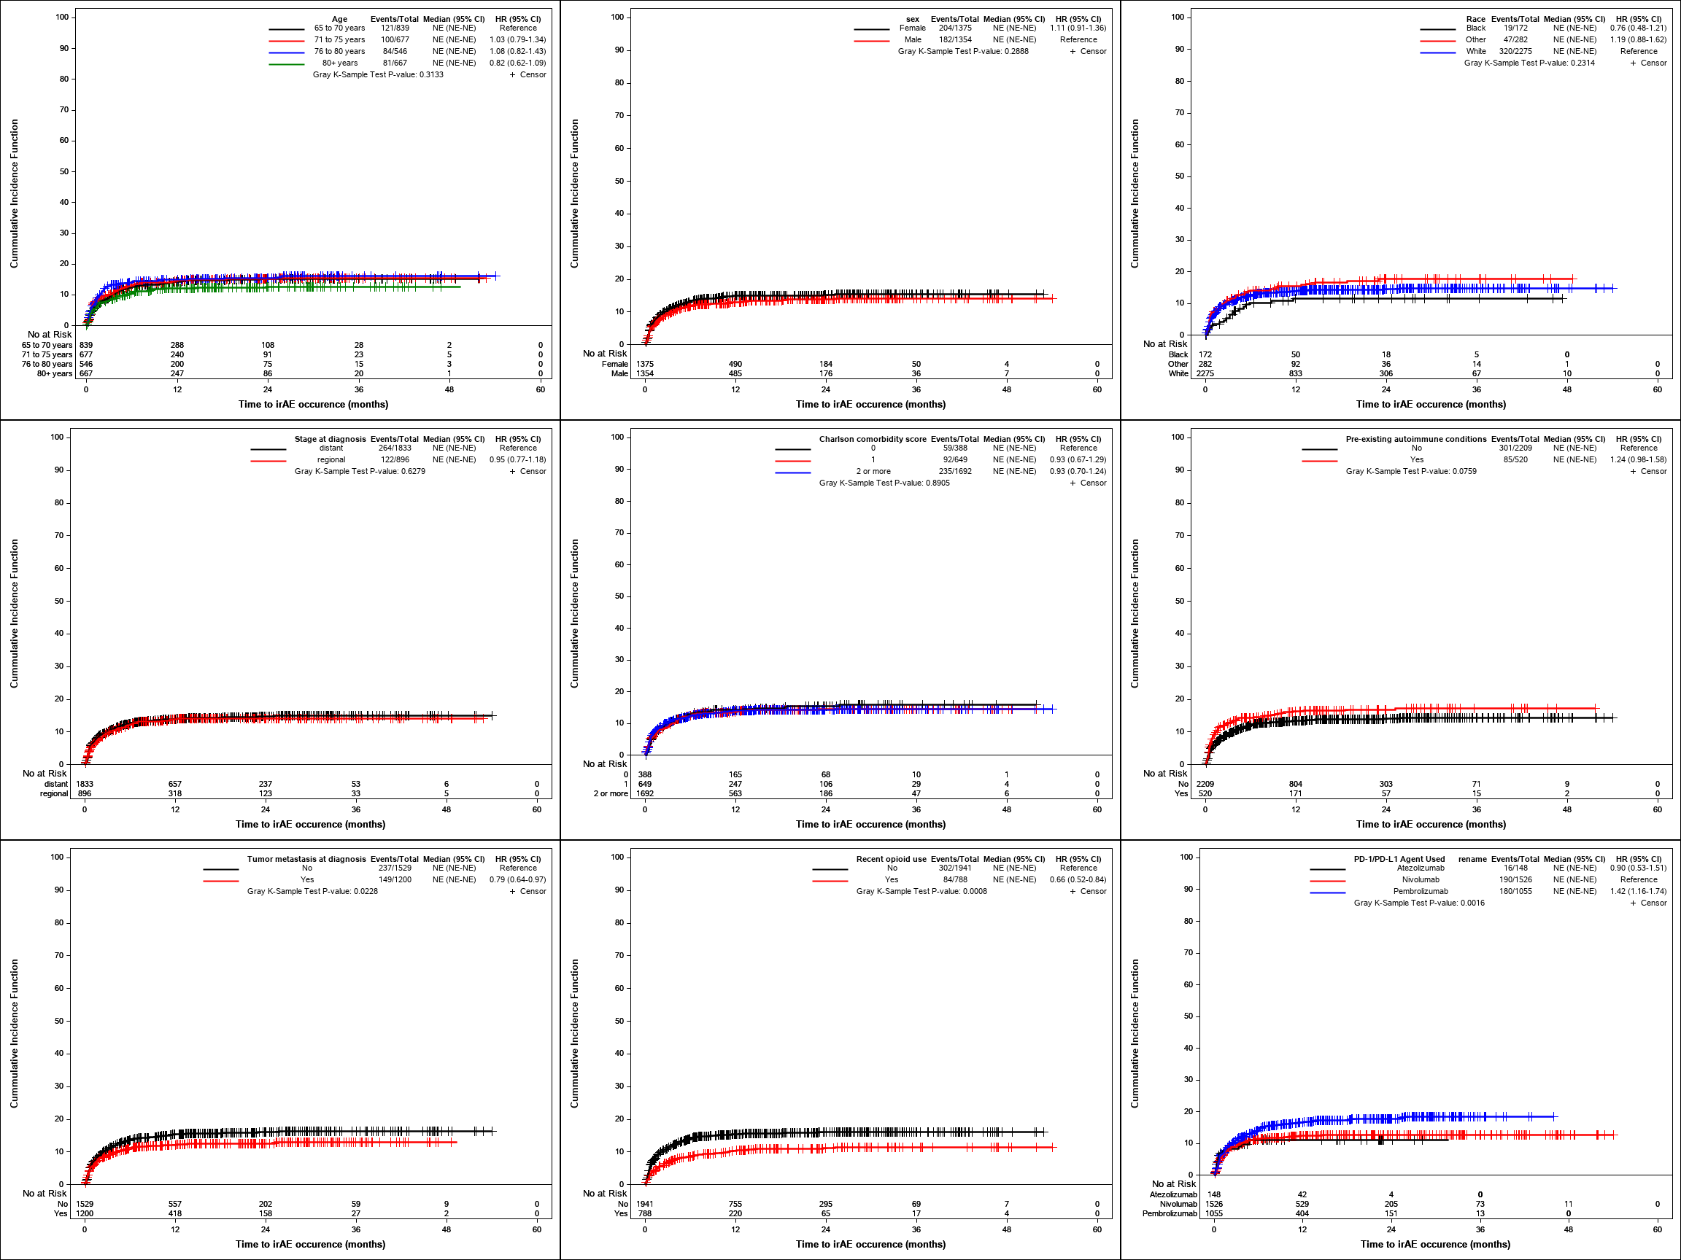
Figure S3. Model Validation Parameters for the Final Fine and Gray Regression for Risk Factors of Severe irAE

- Area under the curve over follow-up period
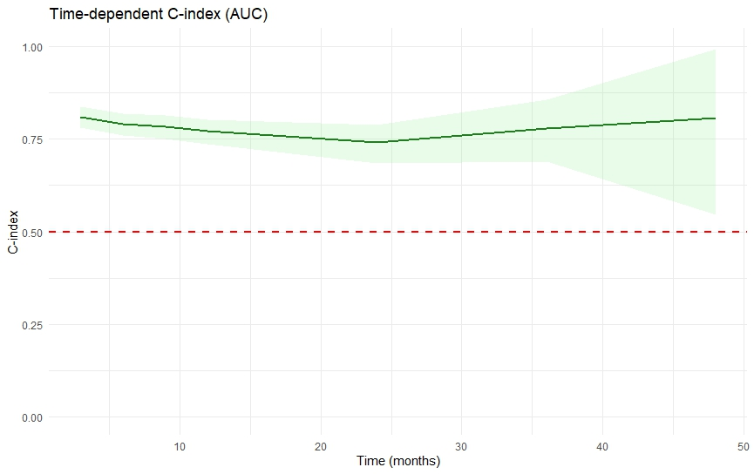

- Time-dependent Brier score
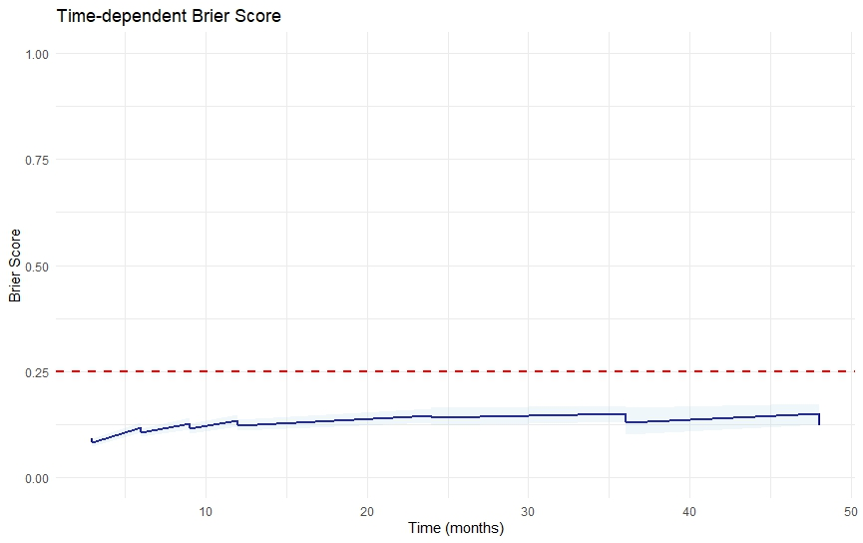

- C-index at selected time points
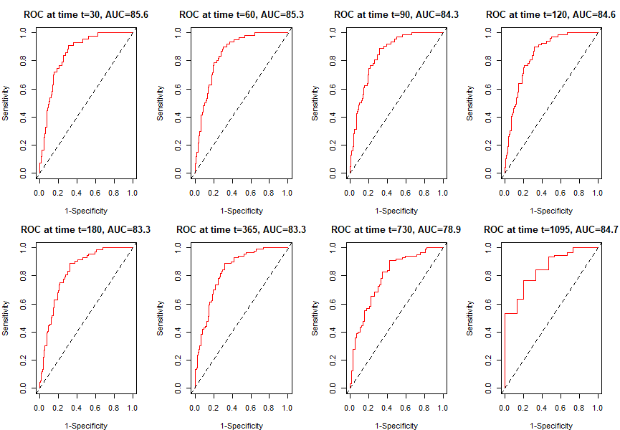

d. Calibration slope at selected time points
