Chitosan/Pectin Bio-composite Films Enriched with bioactive fraction of Acalypha indica L. as Active Packaging: A Comparative Assessment of Postharvest Fruit Quality
Uma Venkatesan¹, Rajiniraja Muniyan*¹
School of Bio - Sciences and Technology¹, Vellore Institute of Technology, Vellore 632014,
India

Fig. S1 (a) A. cepa treated with various concentrations of the ethanol extract of A. indica leaves shown, (b) After 48 hours of exposure to different concentrations of the ethanol extract of A. indica leaves and the control, the percentage of root growth inhibition in A. cepa and (c) The different stages of mitosis is represented as (a) early prophase, (b) prophase, (c) metaphase, (d) (i, ii) anaphase, (e) anaphase with multiple bridges, (f) sticky chromosome with fragments, (g) lagging chromosome, (h) chromosome bridge and disturbance in metaphasic spindle, (i) C-metaphase, (j) vagrant chromosome, (k) C-mitosis, (l) giant nucleus, (m) binucleated cells, (n) fragmented chromosome, (o) spindle disturbances,(p) nuclear lesions and (q) telophase

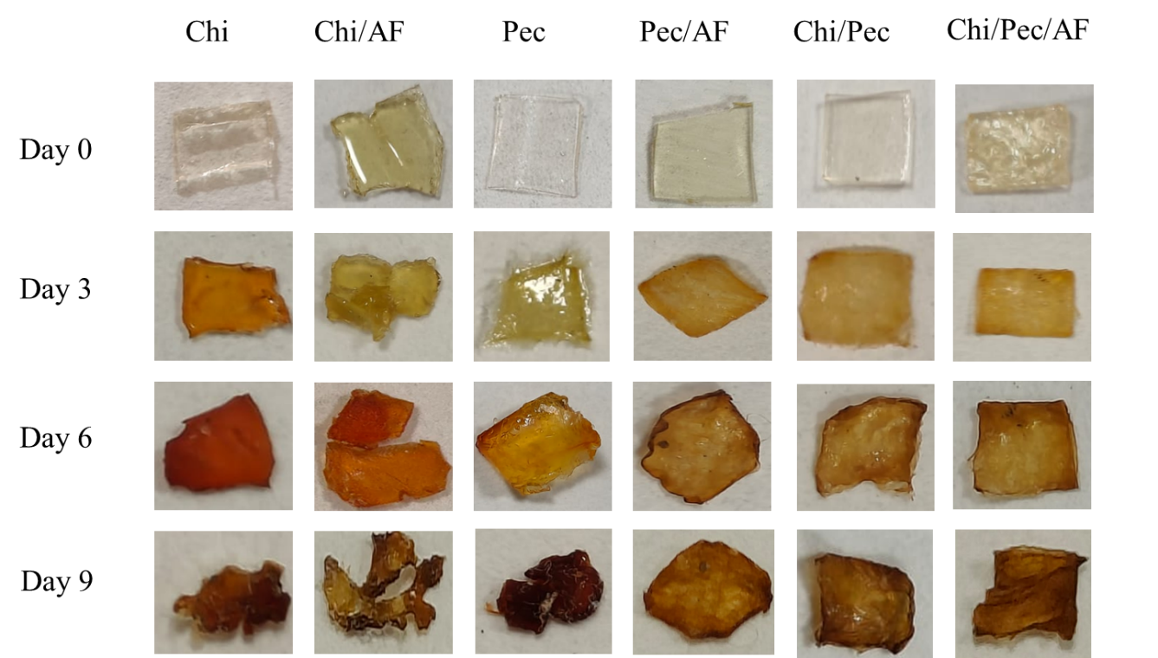

Fig. S2 Degradation of films through soil burial during a period of 0 to 9 days.

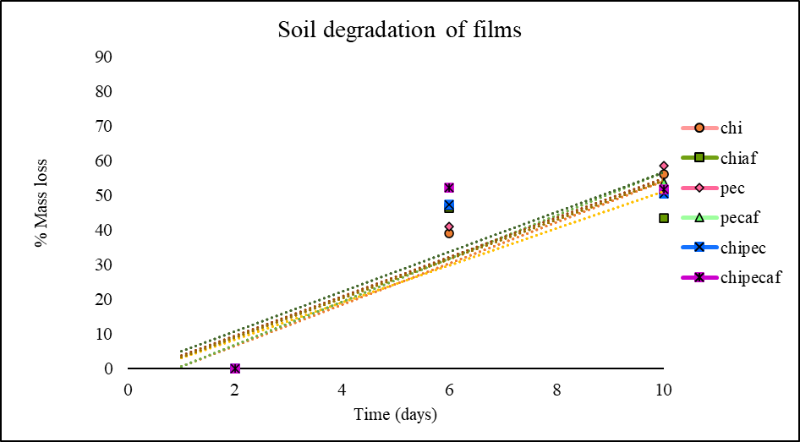

Fig. S3 Initial soil breakdown of all films in soil during a period of 0-9 days

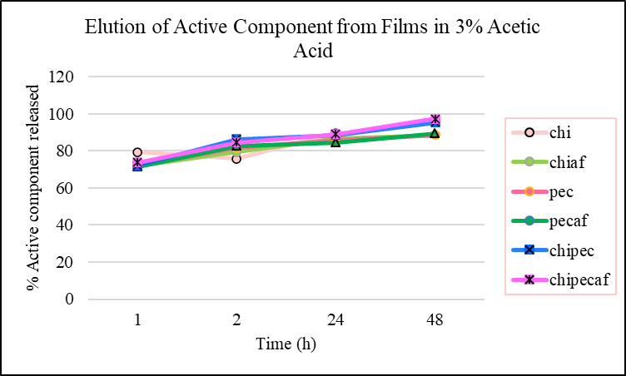

Fig. S4 Elution of the active component from six films in 3% acetic acid over a duration of 48 hours. The data represent mean values derived from three replicates

Table S1 Initial soil degradation of all films (0 to 9 days)
Film samples | Slope (%/time) | Intercept (% mass loss at t=0) | Zero-order rate constant, k (%/time) | First-order rate constant k₁ (1/time) | Interpretation
Chitosan | 5.96 | -5.37 | 5.37 | 0.28 | Fast degradation
Chi/AF | 5.3508 | -2.2385 | 2.2385 | 0.12 | Slower due to AF
Pectin | 6.242 | -5.6955 | 5.6955 | 0.30 | Fast degradation
Pec/AF | 5.6823 | -1.8205 | 1.8205 | 0.10 | Slower due to AF
Chi/pec | 5.6725 | - 2.23 | 2.23 | 0.13 | Moderate degradation
Chi/pec/AF | 5.7585 | -0.803 | 0.803 | 0.05 | Slowest degradation

