Supplementary Material

Statistical optimization for removal of basic dyes from aqueous solutions using chitosan-assembled zinc oxide nanocomposite

Tables captions
Table S1. The removal of BB41 and BR46.
Table S2. Optimum conditions of variables.

Figures captions
Fig. S1. a) FTIR, b) SEM, c) pH_{pzc}, d) XRD, and e) BET of CTS/ZnO.
Fig. S2. Normal probability for a) BB41 and b) BR46; Correlation between experimental and predicted values for c) BB41 and d) BR46.

Table S1. The removal of BB41 and BR46.
 | Variables |  |  |  | %R of BB41 |  | %R of BR46
Run | CTS/ZnO dosage  (g) | Solution pH | Initial concentration (mg L⁻¹) | Ultrasound contact time (min) | Experimental | Predicted | Experimental | Predicted
1 | 0.15 | 7 | 30 | 30 | 86.10 | 87.85 | 81.37 | 83.01
2 | 0.2 | 5 | 40 | 40 | 60.67 | 62.46 | 52.51 | 51.14
3 | 0.05 | 7 | 30 | 30 | 40.05 | 38.26 | 35.83 | 35.33
4 | 0.25 | 7 | 30 | 30 | 82.90 | 81.18 | 71.65 | 70.43
5 | 0.2 | 5 | 40 | 20 | 42.59 | 42.81 | 38.79 | 40.49
6 | 0.1 | 9 | 40 | 20 | 36.94 | 39.35 | 45.06 | 47.43
7 | 0.1 | 5 | 40 | 20 | 33.00 | 31.19 | 29.63 | 27.85
8 | 0.15 | 7 | 30 | 30 | 87.48 | 87.85 | 81.73 | 83.01
9 | 0.15 | 7 | 30 | 30 | 85.86 | 87.85 | 85.55 | 83.01
10 | 0.15 | 11 | 30 | 30 | 70.49 | 68.13 | 68.52 | 67.62
11 | 0.1 | 5 | 20 | 40 | 56.93 | 56.18 | 55.69 | 55.82
12 | 0.15 | 7 | 30 | 10 | 54.55 | 53.71 | 55.97 | 54.12
13 | 0.2 | 9 | 40 | 20 | 59.29 | 60.32 | 62.27 | 62.43
14 | 0.1 | 9 | 40 | 40 | 47.74 | 47.98 | 52.34 | 49.99
15 | 0.1 | 9 | 20 | 40 | 62.46 | 65.47 | 66.76 | 66.49
16 | 0.2 | 9 | 20 | 40 | 94.67 | 96.76 | 86.88 | 88.95
17 | 0.1 | 5 | 20 | 20 | 51.14 | 54.68 | 44.60 | 44.70
18 | 0.2 | 5 | 20 | 40 | 77.31 | 78.13 | 76.84 | 75.90
19 | 0.1 | 9 | 20 | 20 | 65.13 | 63.62 | 58.04 | 59.70
20 | 0.15 | 7 | 30 | 30 | 87.76 | 87.85 | 81.92 | 83.01
21 | 0.15 | 7 | 50 | 30 | 44.01 | 43.00 | 43.52 | 42.91
22 | 0.15 | 7 | 30 | 30 | 91.10 | 87.85 | 82.31 | 83.01
23 | 0.15 | 7 | 30 | 50 | 77.89 | 75.22 | 71.44 | 71.57
24 | 0.15 | 7 | 30 | 30 | 88.78 | 87.85 | 85.19 | 83.01
25 | 0.2 | 9 | 20 | 20 | 82.25 | 83.52 | 79.83 | 78.39
26 | 0.1 | 5 | 40 | 40 | 37.50 | 39.46 | 31.88 | 34.75
27 | 0.15 | 7 | 10 | 30 | 85.43 | 82.93 | 81.05 | 79.94
28 | 0.2 | 5 | 20 | 20 | 65.21 | 65.25 | 58.39 | 61.03
29 | 0.2 | 9 | 40 | 40 | 80.63 | 80.32 | 67.43 | 68.76
30 | 0.15 | 3 | 30 | 30 | 42.49 | 41.34 | 35.82 | 35.00

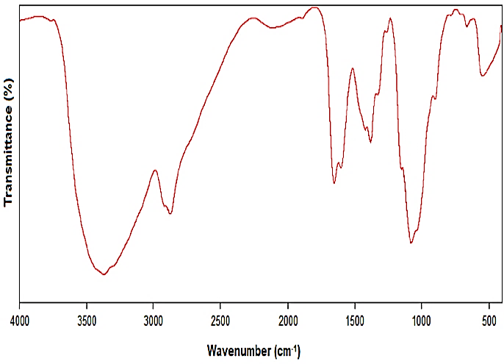  a) | 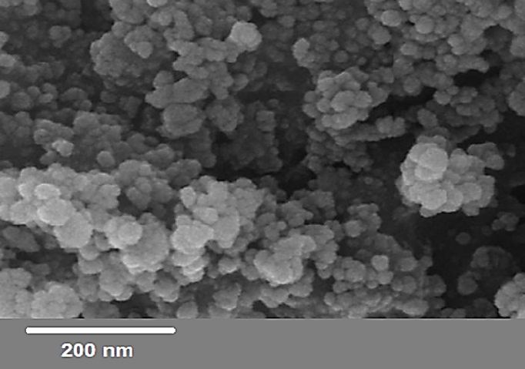  b)
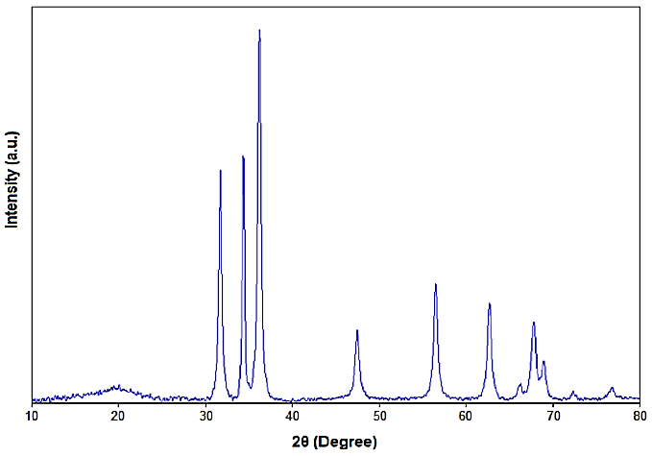
d)
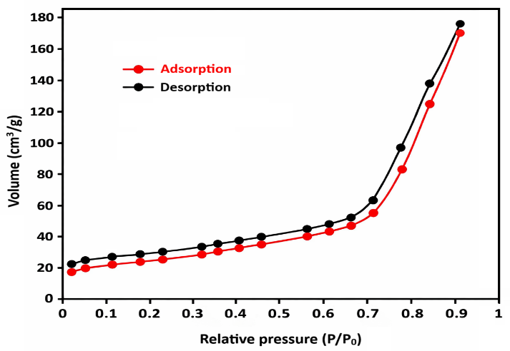
e)
Fig. S1. a) FTIR, b) SEM, c) pH_{pzc}, d) XRD, and e) BET of CTS/ZnO.
c)

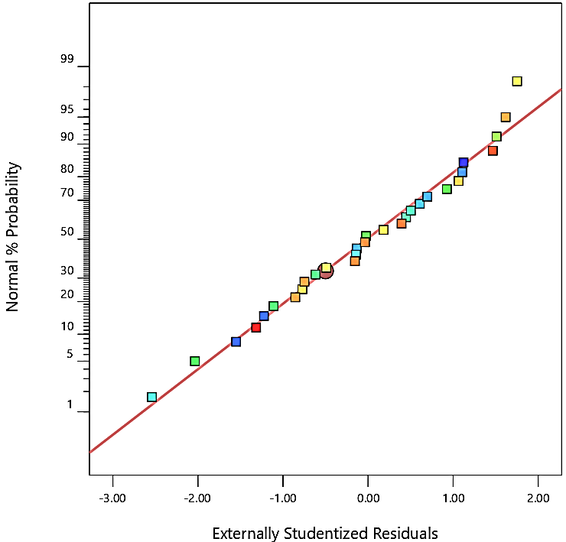  a)  b) | 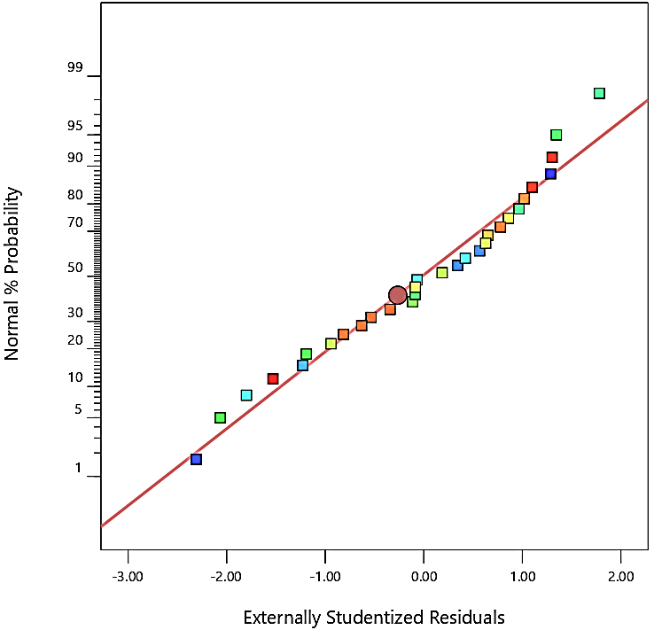
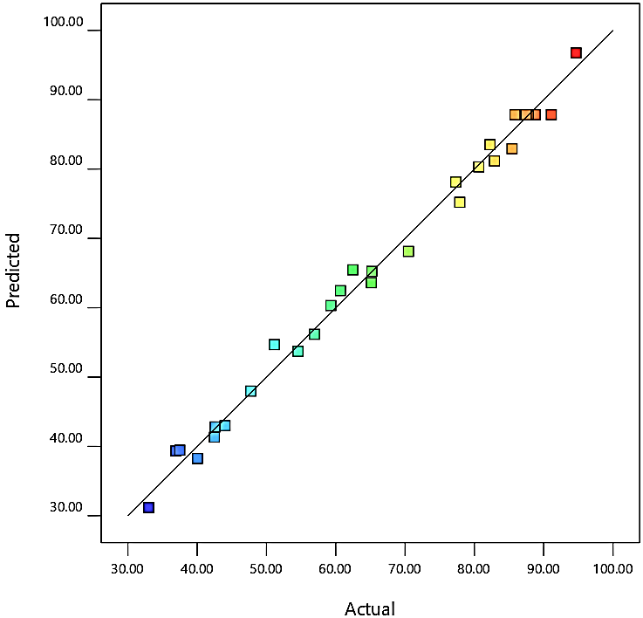  c) | 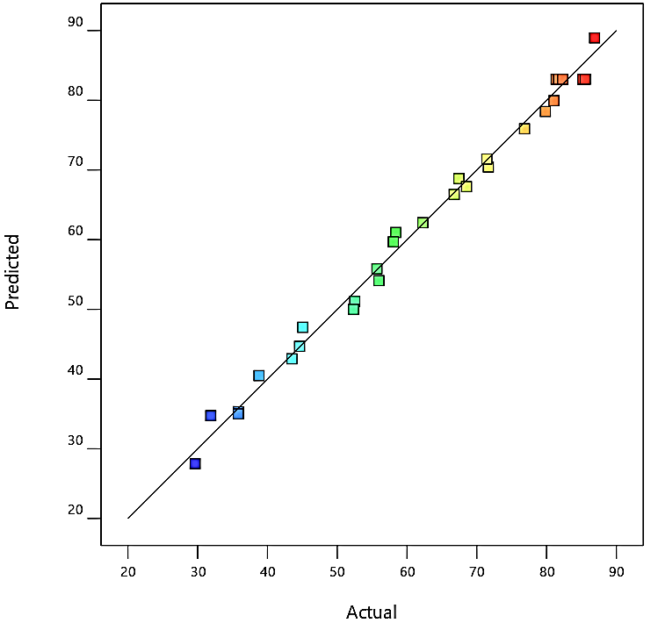  d)
Fig. S2. Normal probability for a) BB41 and b) BR46; Correlation between experimental and predicted values for c) BB41 and d) BR46.

Table S2. Optimum conditions of variables.
Optimal conditions |  |  |  | %R of BB41 ± RSD (n= 3) |  |  | %R of BR46 ± RSD (n= 3)
CTS/ZnO dosage  (g) | Solution pH | Initial concentration  (mg L⁻¹) | Ultrasound contact time (min) |  | Experimental | Predicted |  | Experimental | Predicted
0.18 | 7 | 16 | 36 |  | 96.19 ± 2.4 | 94.75 |  | 91.87 ± 2.3 | 91.01

