a. 10
MDM + HIV
iMg + HIV
iMg + dI
iMg + LPS
Supplementary Figure 1

8
log₂(transcripts per million)

6

4

2

0
ns ns ✱✱✱✱ b.

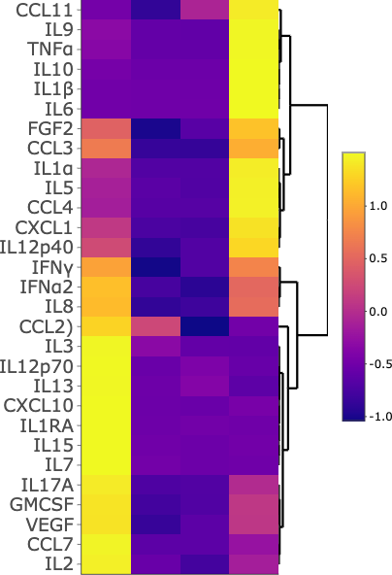
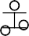
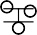
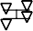
MDM iMg
CD4
CXCR4
CCR5

a. ✱✱✱✱ ns
✱✱✱✱
ns
Supplementary Figure 2
10

9

8
log₂(transcripts per million)

7

6

5
TNFRSF1A
TFRSF1B

MDM iMg iMg + HIV

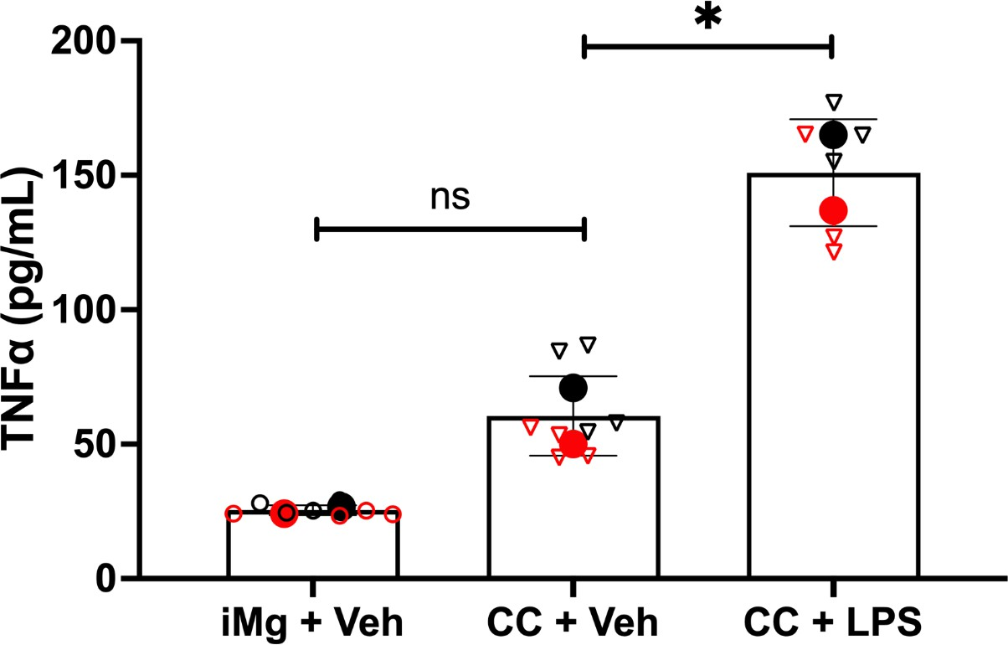
a. ns
IL-6 pg/mL
Supplementary Figure 3
✱✱✱
800
b.
600
400
200
0
iMg + HIV CC + HIV iAst + iMg HCM

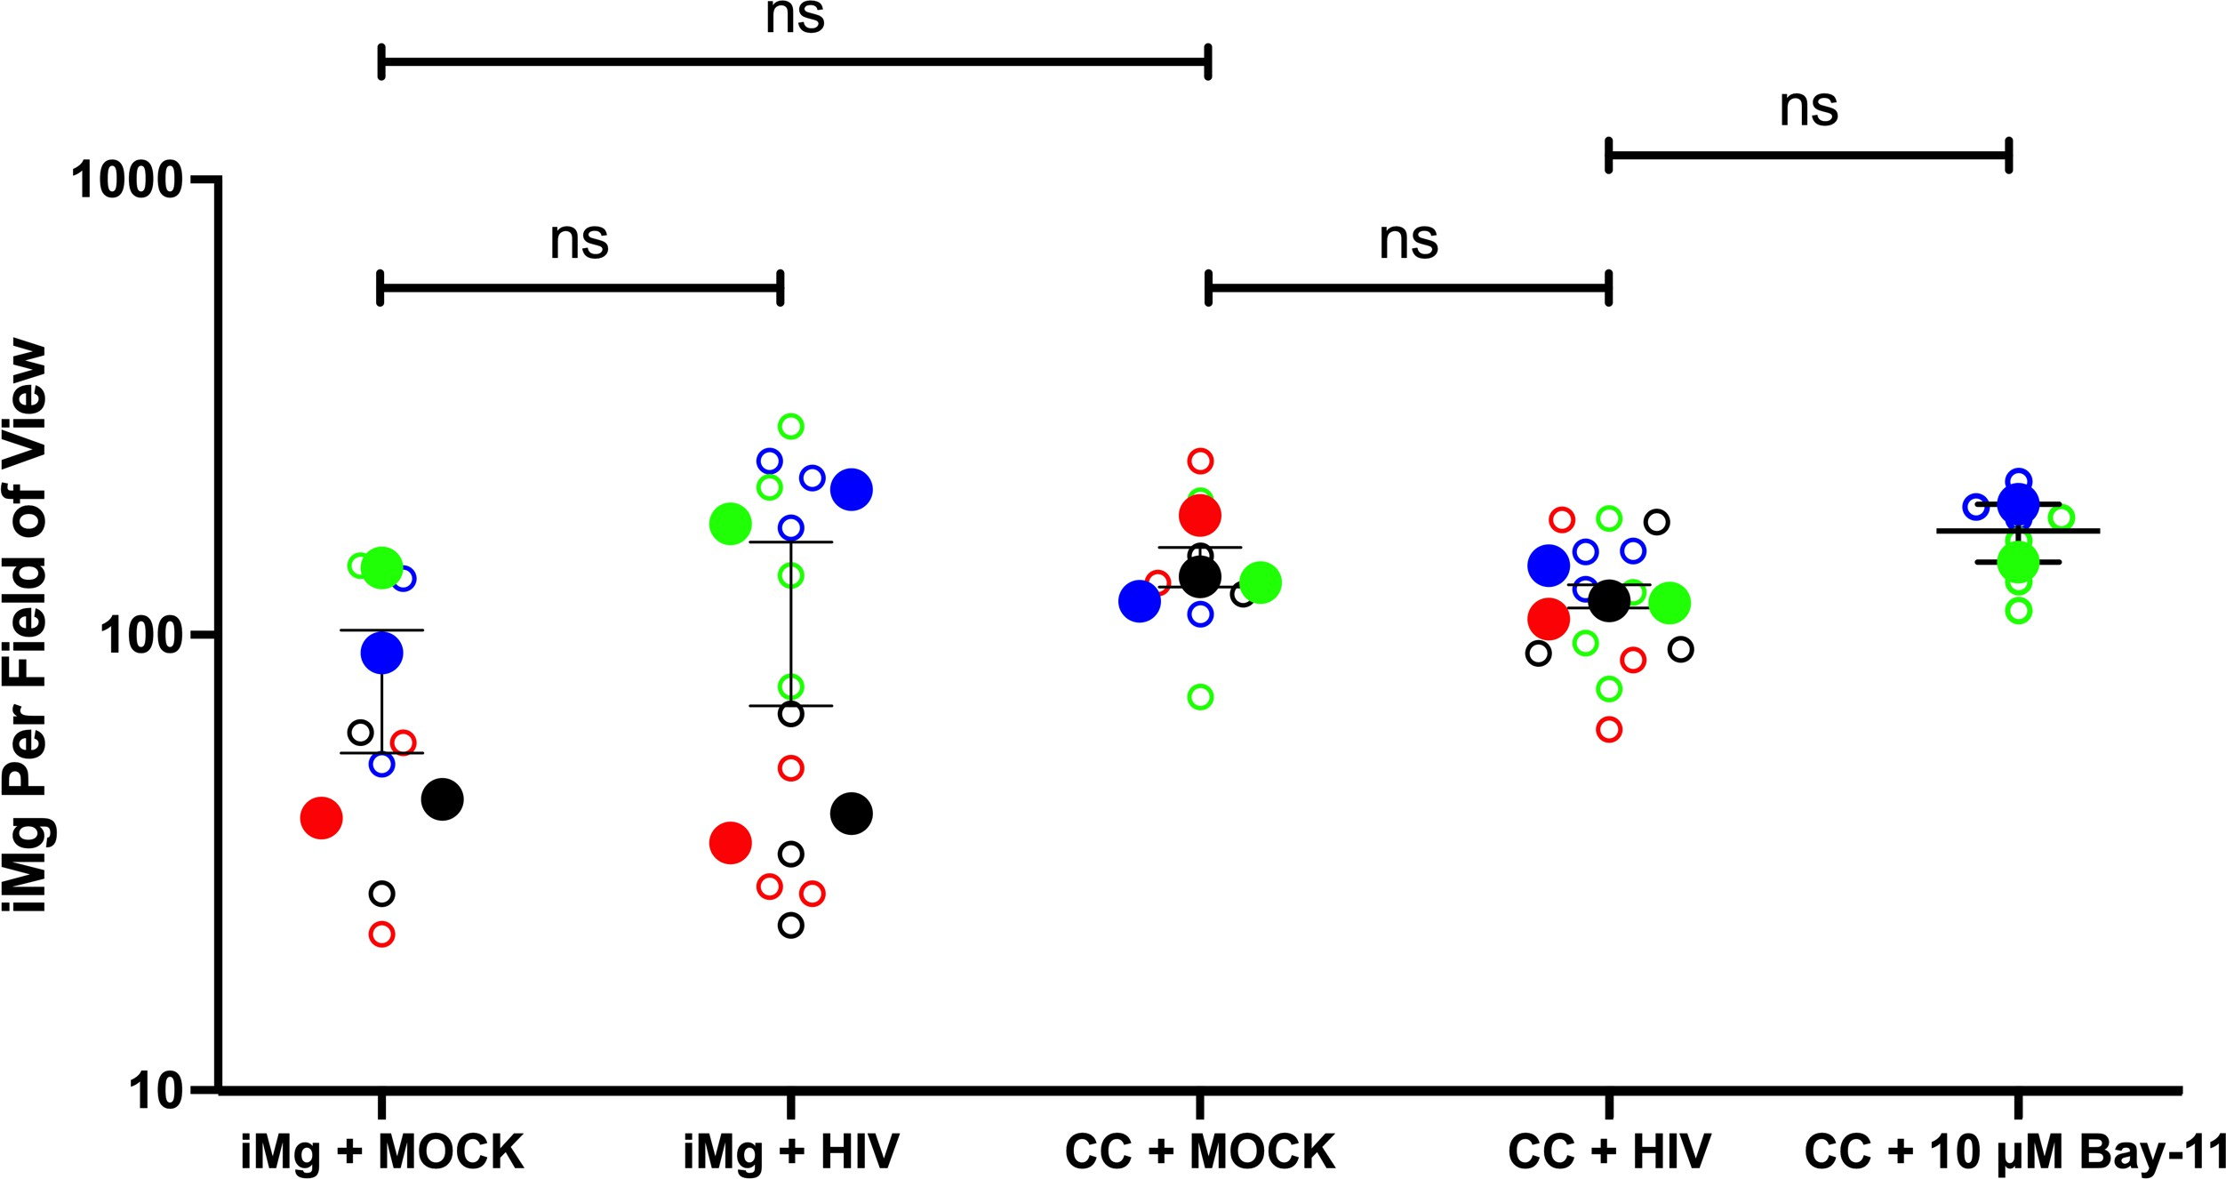
Supplementary Figure 4
a.

a.
Supplementary Figure 5
