Supplementary Materials

The file includes:
S1 Data
S2 Models
S3 Metrics
S4 Twitter
S5 Distribution of Polarizing Discourse across Users
S6 Robustness Checks for Data Source and Base Model
Figure S1 to Figure S27
Table S1 to Table S23

S1 Data

S1.1 Total number of comments, tweets, and authors

We show the total number of posts collected, the subset which contain a reference to a political entity (one of the 215 in our list) and the total number of authors of these posts.

Group | Total Posts | Political Posts | Total Authors
Twitter | 988,344,411 | 66,791,701 | 1,188,080
Politicians | 2,197,330 | 197,295 | 1,361
Journalist | 2,129,798 | 442,967 | 1,165
Media | 251,065 | 33,503 | 93
Reddit | 1,514,559,439 | 29,513,175 | 467,438
Table S1: Total number of tweets, comments, and authors
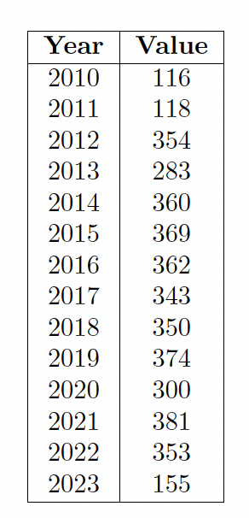
Table S2: Number of data points in training set by year

S1.2 Partisan Scores on Reddit and Twitter
We show below here the distribution of scores measuring the partisanship of the Twitter and Reddit users in our sample computed from the method from (1). These scores were computed based on the following patterns of political elite on Twitter and on subreddit commenting patterns on Reddit. Users with scores greater than zero were classified as left-leaning, while users below -1.2 were classified as right-leaning.
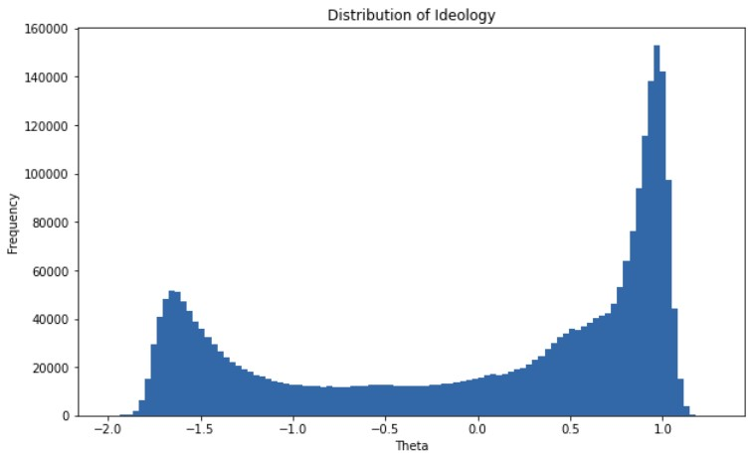
Figure S1: Distribution of Twitter partisan scores
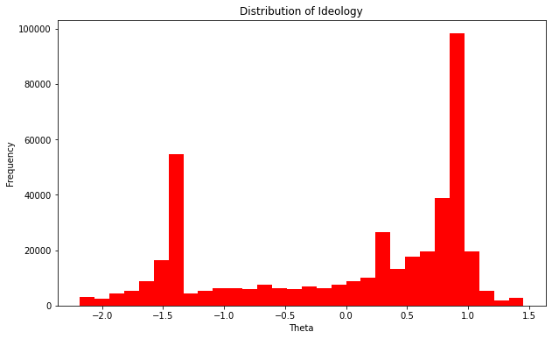
Figure S2: Distribution of Reddit partisan scores

S1.3 Subreddits
These were the subreddits we used to find “politically active” users and infer their political orientation using Barbera’s method (1) on Reddit.

Left | Right
AntiTrumpAlliance, PutinsB****, socialanarchism, antifascism,  Delete_The_Donald, justicedemocrats, Egalitarianism, CornbreadLiberals, Drumpf, neoprogs, EnoughHillHate, N***Hunting, TinyTrumps, Trump_Watch, NeverTrump,  StillSandersForPres, BernTheConvention,  HillaryForAmerica, S***The_DonaldSays, SandersForPresident, Impeach_Trump, alltheleft, WayOfTheBern,  Enough_Sanders_Spam, EnoughTrumpSpam, liberalgunowners, hillaryclinton, F***thealtright, democrats, esist, centerleftpolitics, Political_Revolution,  MarchAgainstTrump, BlueMidterm2018,  Trumpgret, OurPresident,  Kossacks_for_Sanders, Liberal, TrumpCriticizesTrump, progressive, anarcho_socialism, chapotraphouse2, ChapoTrapHouse, AOC, obama, bidenbro, TinyhandsInc | randpaul, BenCarson, HillaryMeltdown, new_right, PresidentKushner, TheRightBoycott, AltRightChristian,  JohnKasich, Sorosforprison, Romney,  BobbyJindal, EnoughObamaSpam, TedCruz,  CarlyFiorina, TeaParty, MartinOMalley, ChrisChristie, presidentbannon, Mr_Trump, republicans, RickSantorum,  EnoughPaulSpam, trump, HillaryForPrison, ronpaul, tucker_carlson, The_Donald,  ConservativesOnly, Conservative,  Republican, conservatives
Table S3: Subreddits used to find politically active Reddit users and infer their partisanship

After collecting all comments left by users in our sample, we collect the political comments left by those users from 38,818 subreddits. However, the distribution of comments by subreddits follows a power-law distribution, with a few large subreddits dominating political discussion (such as r/politics and r/The_Donald). Below, we show the top twenty subreddits by number of political comments for left and right-leaning users and compute the percentage of all political comments contributed by users in that subreddit. We also compute the percentage of comments that contain a reference to a political entity to gauge the extent to which discussion in the subreddit is political. In seventeen percent of subreddits in our sample, more than five percent of the comments contain a reference to a political entity (indicating high levels of political discussion in those subreddits). Twenty-two percent of subreddits contain between one and five percent political comments, and sixty percent contain fewer than one percent (indicating low levels of political discussion).

Subreddit | # Political Comments | Total Comments | # Political Comments / Total Comments | % All Political Comments
politics | 7,215,371 | 68,382,543 | 11% | 27%
The_Donald | 2,509,869 | 33,738,019 | 7% | 9%
worldnews | 812,462 | 24,868,187 | 3% | 3%
Conservative | 682,694 | 7,376,589 | 9% | 3%
news | 642,870 | 21,730,984 | 3% | 2%
AskReddit | 552,080 | 78,446,702 | 1% | 2%
PoliticalHumor | 544,022 | 5,914,005 | 9% | 2%
SandersForPresident | 484,457 | 5,564,400 | 9% | 2%
neoliberal | 483,628 | 8,674,826 | 6% | 2%
ChapoTrapHouse | 383,323 | 7,114,333 | 5% | 1%
pics | 317,885 | 18,044,027 | 2% | 1%
conspiracy | 291,480 | 7,685,055 | 4% | 1%
PoliticalDiscussion | 282,094 | 2,885,286 | 10% | 1%
Enough_Sanders_Spam | 229,407 | 2,297,626 | 10% | 1%
WayOfTheBern | 193,312 | 2,556,913 | 8% | 1%
Libertarian | 179,639 | 4,169,073 | 4% | 1%
EnoughTrumpSpam | 169,127 | 1,600,278 | 11% | 1%
PublicFreakout | 152,042 | 6,337,561 | 2% | 1%
PoliticalCompassMemes | 139,804 | 4,084,629 | 3% | 1%
hillaryclinton | 138,628 | 1,155,687 | 12% | 1%
Table S4: Top 20 subreddits by number of political comments on Reddit

S1.4 List of political keywords
We show below the list of political keywords use to both filter the data to a set of “political content” and determine the entity being referenced in the text. We filtered content that contained a reference to both a left and right-leaning entity.
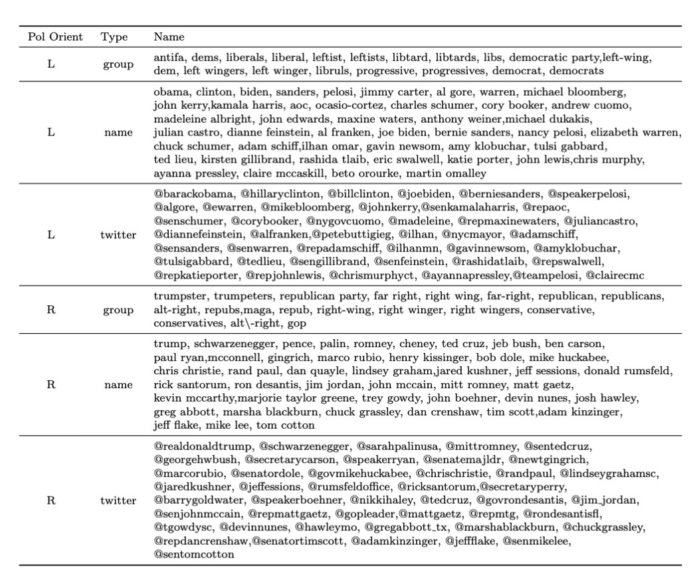
Table S5: Political groups and entities used to filter data and identify whether the content refers to a left or right-leaning entity

S1.5 Polarizing Speech Examples
We show below different types of polarizing speech we labeled. These were eventually combined into one category due to high subjectivity in which category the speech would fall into (so if content was coded as either affectively polarizing or partisan, we considered it to be polarizing speech).

Affectively Polarizing Speech
Affectively polarizing speech encompasses ad hominem attacks as well as comments that express distrust that the group/party is doing what’s right (for themselves and the country). This is grounded in the feeling thermometer and trust questions that surveys use, as well as the general definition of affective polarization that is “dislike and distrust to those from the out party”.

Comment |  | Affect
i can’t stand you @aoc your green deal sucks like you suck as a politician | Negative
i'm not sure people grasp how far to the right gop is going and has gone. i'm not sure people | Negative
understand that their freedom, democracy is on the line.
@wikileaks @hillaryclinton haha!!!!! go wikileaks! good thing hillary can laugh at the mess she's made!” | Negative
at least they're admitting that blm was burning towns down and committing violence because obama told them it was | Negative
yes, the gop is a lawless party led by an as yet-unindicted criminal. | Negative
@premr that was credit card reform measure signed into law by president obama.... | Neutral
obama was not the most leftist president in history. contextually (contrasting the politics of the time they were in office), the most leftist president in history was probably thomas jefferson. | Neutral
i don’t see why trump would pardon him. has he said anything on the matter? this isn’t even related to anything about trump either. | Neutral
Happy birthday joe biden! | Positive
i absolutely adore maxine waters. she doesn't pull any punches. | Positive
conservative women are level headed and actually use their head when they process information | Positive
Table S6: Examples of affective polarizing speech
Partisan Speech
These comments are not necessarily ad hominem attacks. However, they often blame negative outcomes on a group/person or criticize their governance. The comment explicitly blames/praises a certain group/person or clearly implying a positive/negative sentiment and often attempts to criticize their competence.
Comment | Affect

there is one major political party in the world that doesn't believe in climate change. the republican party. as long as the party that continue to deny the problem is in power, we won't be able to make the changes necessary to solve it. #climatechange | Negative
the way to keep guns out of our schools is not to put guns in them. trumps suggestion today is absolutely unfathomable and must be stopped. | Negative
if gop senators spent more time doing their job, they'd realize america is broke and a health entitlement program is stupid! | Negative
the fact that the biden administration is spending $86 million to pay for hotel rooms for illegal immigrants is absurd. let’s take care  of our homeless veterans and hurting americans first. | Negative
over and over again, obama's foreign policy actions have proven reckless and not in our nation's best interest. | Negative
i mean, it makes sense. they are a publicly traded company subject to sec and congressional oversight. since all 3 houses are controlled by liberals, only makes sense to silence the opposing party. | Neutral
i don't refute that point. my point is that obama has taken more total below-the-belt punches than his predecessors, and that you'd have to be an, extremist, not a moderate, to believe/claim otherwise. | Neutral
not sure what to think of this..."hacker group claims to have romney's tax returns" http.//t.co/rdlbsrrf via @mashable | Neutral
sarah palin suggests she will get involved in kentucky senate race #politics | Neutral
thanks @realdonaldtrump for approving sd's disaster declaration for severe storms and flooding. this will help local units of | Positive
government &amp; certain non-profit organizations to rebuild critical infrastructure and facilities that have been severely damaged.
so glad that @debrarodman73, @vvfordelegate, @adamsfordel,  @pwcdanica, @chrishurstva and so many more progressive leaders are headed to the house of delegates! @vahousedems | Positive
@ingrahamangle i can’t think of a more important reason to support president trump in his re-election. | Positive
Table S7: Examples of partisan speech

S2 Models

S2.1 Polarization Model
We fine tune the cardiffnlp/twitter-roberta-base-sentiment, bert-base-uncased, and gpt2 classifiers from Huggingface on our 4399 labeled examples using five-fold cross-validation to get a robust estimate of out of sample performance. For data cleaning, we keep all comments that are under 240 characters and longer than ten characters and lowercase all text. We chose to do this since we are comparing text across different platforms and users, and we wanted to standardize the data as much as possible. However, we acknowledge that this may lead to lost information for the model. We fine tune all the models for three epochs, with a batch size of eight and performance evaluation every 200 gradient updates. The only hyperparameter tuning we do is on the learning rate, which we adjust to 1.25e-5 for bertbase-uncased and gpt2 and 2.5e-5 for cardiffnlp/twitter-roberta-base-sentiment to ensure smooth training. We then use the weights of the model with the lowest evaluation cross-entropy loss. We see that fine-tuning the base models allows us to reach the best performance across our outcomes, as measured by the macro and weighted F1 scores.
S2.1.2 Main Polarization Classifier Performance
Below, we show the classification report from our classifier used in the main text of the manuscript.
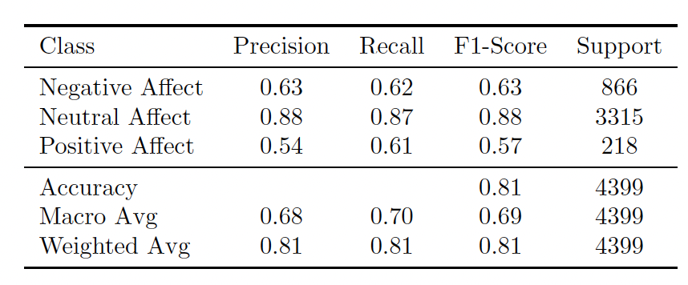
Table S8: The classification report from our main model to measure polarizing discourse across all data
S2.1.2 Performance across Time and User-types
We also estimate the model performance separately across the political orientations of users, the political entity reference groups, user types, and time periods to ensure that any biases in performance would not be materially impacting our results. We find similar performance when grouping by these various subsets of data, though the model is slightly better at predicting polarization of content by left-leaning users over right-leaning users as well as politicians and politically active users over journalist. However, we also note that we run several robustness checks such as varying the base models and political keywords and find that the results are consistent.
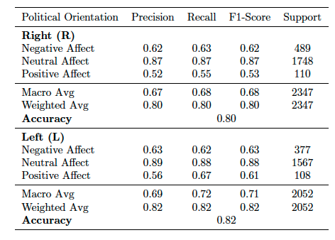
Table S9: Classifier performance across users of different political orientations
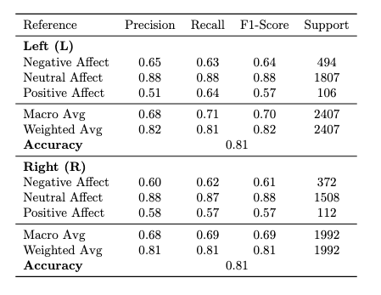
Table S10: Classifier performance across content with left versus right-leaning political entities mentioned
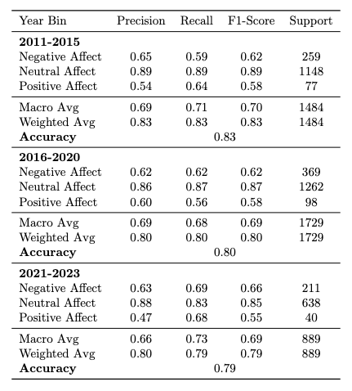
Table S11: Classifier performance across different periods of time
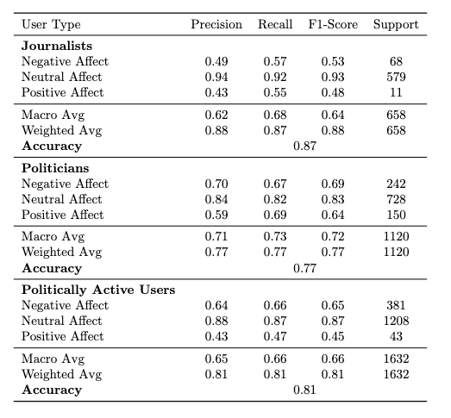
Table S12: Classifier performance across different types of users
S2.1.2 Performance comparison across Classifiers
To benchmark our main classifier’s performance, we also report our models’ performance against an untrained BERT sentiment classifier as well as the VADER model, which only uses keywords to create a sentiment score. To ensure our results are not dependent on the base model, we train a base BERT model and base GPT-2 model on our labeled dataset and ensure our results are robust to this choice (see S7 Robustness Checks for Data Source and Base Model). Below, we report the results for the main model used in the manuscript (Senti (FT)), as well as the GPT-2 and BERT models used for robustness checks. We compare their performance to a baseline sentiment classifier and VADER, which infers sentiment based on keywords, finding that our fine-tuned models outperform both.
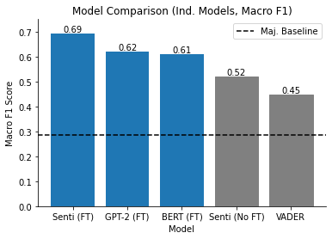
Figure S3: Macro F1 performance of our main models versus baseline sentiment classifiers
Additionally, we report the precision and recall breakdown by class for each classifier. We make two observations; first, the untuned sentiment model has high recall but low precision, likely due to the data distribution being different between the pre-training data (predicting sentiment) and the task of predicting polarizing rhetoric. However, after fine-tuning the model we see a more reasonable balance between precision and recall is found that maximizes the F1-score. Additionally, since the fine-tuned sentiment model has better recall on polarizing comments than the original BERT or GPT models, we see that this model is more likely to predict a comment as being polarizing. However, while the models display different sensitivities to predicting whether a comment is polarizing, we show that all our main findings are robust to the choice of model.
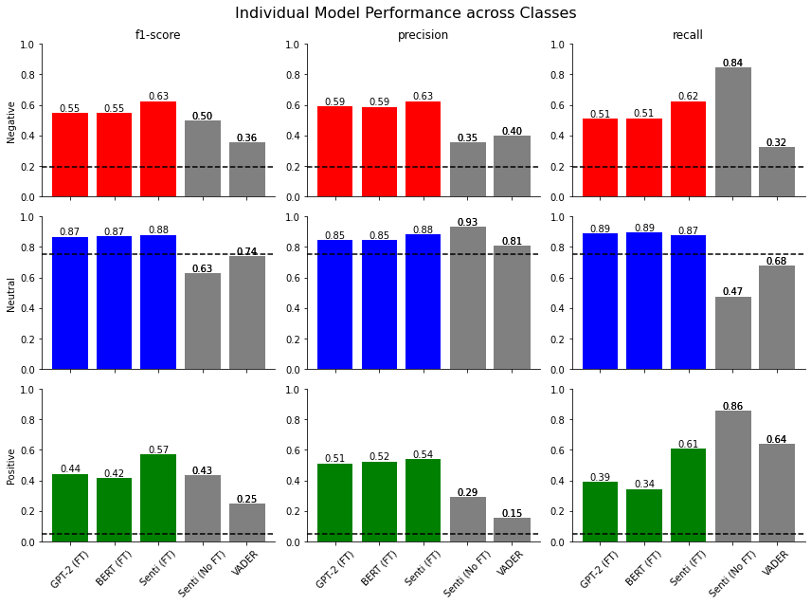
Figure S4: Precision, recall, and F1 breakdown of our classifiers versus baseline sentiment classifiers

S2.2 Topic Model Performance
Although most comments did not contain any specific topic, we can still reasonably classify the topics when they do occur. Our overall accuracy is 91% when including tweets with no topic and 66% when only considering tweets that contained a given topic. Given the large number of topics and their relative sparsity of occurrence, the classifier’s performance is modest. However, this seems roughly in line with other work that attempts to use topic classifiers on political social media data (2) .
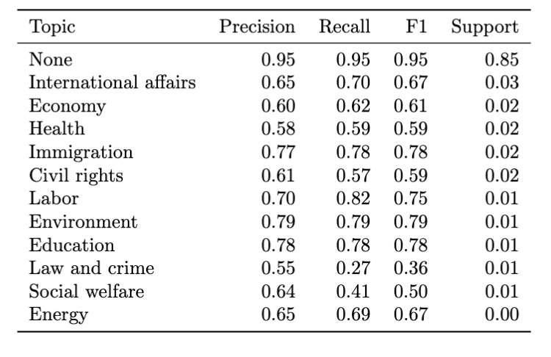
Table S13: Topic model performance

S3 Metrics

S3.1 Alternative Metrics
When assessing the degree of polarizing discourse in online discussions, different measurement approaches can lead to varying interpretations. One alternative to our chosen method involves creating a metric that measures the overall likelihood of a comment displaying politically polarizing rhetoric, relative to all comments—both political and apolitical. In this framework, apolitical comments are treated as “neutral.”
However, this approach has several limitations. First, it is highly sensitive to fluctuations in the volume of political content on the platform. For example, an observed increase in polarizing rhetoric may simply reflect a rise in the proportion of political discussion, rather than a genuine increase in polarization. Similarly, differences between groups may reflect how often each group engages in political conversation, rather than differences in how polarizing their content is.
Second, this metric often yields relatively small values because political content makes up only a portion of all online discourse, and polarizing content is only a subset of that. This can make the results harder to interpret. That said, one could argue that this approach provides a more holistic view of platform dynamics: even if both neutral and polarizing political content increase, the overall rise in politically charged rhetoric still signals a shift in the nature of discourse.
Given these trade-offs, we separate our analysis into two parts: first, we examine how prevalent political content is across different groups and platforms. Then, we explore how our metric behaves when we allow it to vary in tandem with the volume of political content.
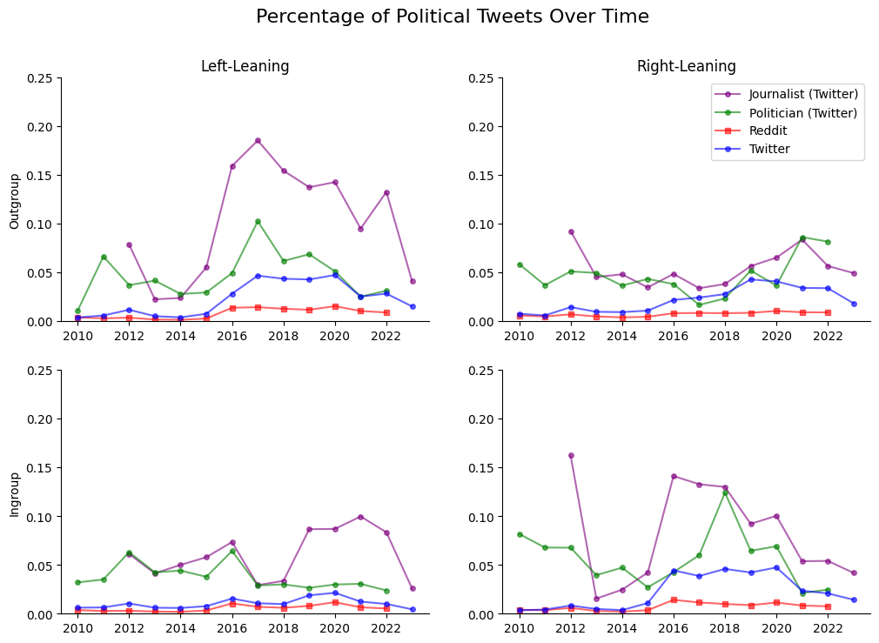
Figure S5: Percentage of all statements containing a reference to a political group or entity.
Figure S5 shows the percentage of political comments relative to all comments over time. As expected, journalists and politicians produce the highest proportion of political content in our dataset. We also observe distinct temporal patterns. For instance, left-leaning users showed an increase in references to their political outgroups shortly after the 2016 election—likely in response to Donald Trump's victory—followed by a gradual decline. In contrast, right-leaning politicians peaked in their outgroup mentions during 2021 and 2022. Reddit users, on the other hand, generally exhibit a lower proportion of political speech in their overall commenting behavior.
It is important to stress that our goal here is not to draw definitive conclusions about any group's inherent tendency to engage in political speech. Rather, we aim to illustrate the varying levels of political discourse observed across groups and platforms, and how these variations could affect metrics that are sensitive to such fluctuations.

There are also key limitations to consider. Differences in platform behavior—such as estimating political leaning on Reddit and Twitter using a similar method, despite their distinct user cultures—can influence the observed patterns. Additionally, how we define what counts as "political" may shape these trends.
To reduce the risk of our metric being overly influenced by the total volume of political speech, we instead use a measure that is conditional on the content being political. We also believe this approach offers a more intuitive interpretation. For example, in 2015, about 30% of tweets from right-leaning politicians that mentioned the political left contained negative outgroup sentiment. By 2022, that figure had risen to over 60%. In practical terms, this means that in 2015, if a user saw a tweet from a right-leaning politician about the left, there was a 30% chance it conveyed negative sentiment. By 2022, that probability had nearly doubled.
We present an alternative approach—illustrated in Figure S6—that treats apolitical comments as neutral. This method calculates the level of polarizing discourse by taking the difference between the number of negative and positive comments and dividing it by the total number of comments, including both political and apolitical ones.
This analysis reveals two main trends. First, temporal changes in polarizing discourse are largely driven by shifts in the proportion of political content relative to all content. Second, while journalists frequently discuss politics, their rhetoric tends to be less polarized than that of politicians, who consistently show the highest levels of outgroup derogation.
We also find that the rise in polarizing discourse among right-leaning politicians after 2016 is due to both an increase in the proportion of political content and a greater likelihood that this content is polarizing. In contrast, left-leaning users show a decline in political speech over time—a trend that may reflect the heightened volume of tweets about President Trump during and after the 2016 election.
It's important to note the limitations of comparing platforms, especially when our metric is influenced by the volume of political discussion. For example, Reddit appears significantly less polarized than Twitter using this measure, but this may be due to differences in how users were sampled. Many Reddit comments likely occur in apolitical subreddits, reducing the chance of referencing political entities and thereby lowering measured polarizing discourse.
Given these considerations, we see that filtering the data using a set of political keywords helps reduce potential biases introduced by differences in how often various groups or platforms engage in political discussion over time.
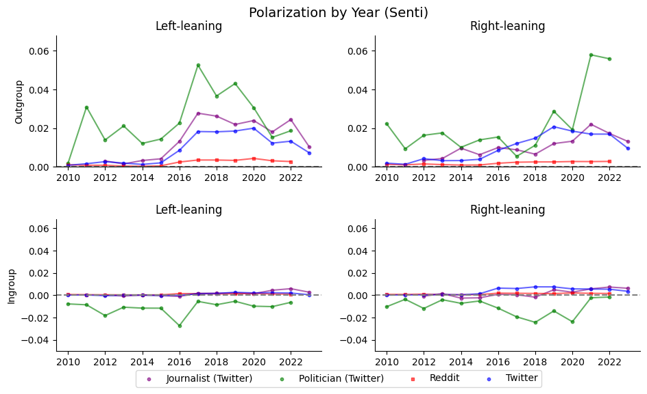
Figure S6: An alternative measure of polarizing discourse where we compute the difference between the number of negative affect comments and the number of positive affect comments and divide by the total number of comments (political and apolitical).
Finally, we note that any metric we choose will have imperfections; although we motivate our work with types of measures often used in the political science literature to measure polarization, it is difficult to find a perfect mapping from the motivating idea (e.g., a thermometer scale rating given by survey participants) and the practical implementation.

S3.2 Robustness to Political Keywords
We also test the robustness of our approach to choice of political keywords. To simulate any potential missing keywords, we randomly drop ten percent of the keywords and re-create our main chart five times. We find that all our main results hold; rising outgroup derogation over time, with a significant increase by right-leaning politicians starting in 2016.

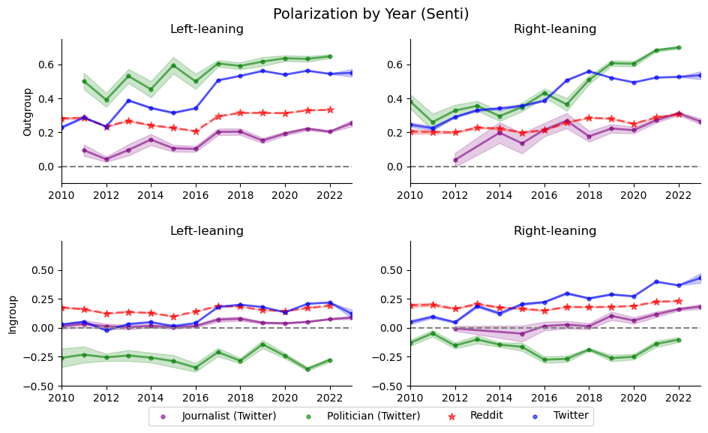
Figure S7: First run dropping 10% of political keywords and re-creating our main visualization

Figure S8: Second run dropping 10% of political keywords and re-creating our main visualization
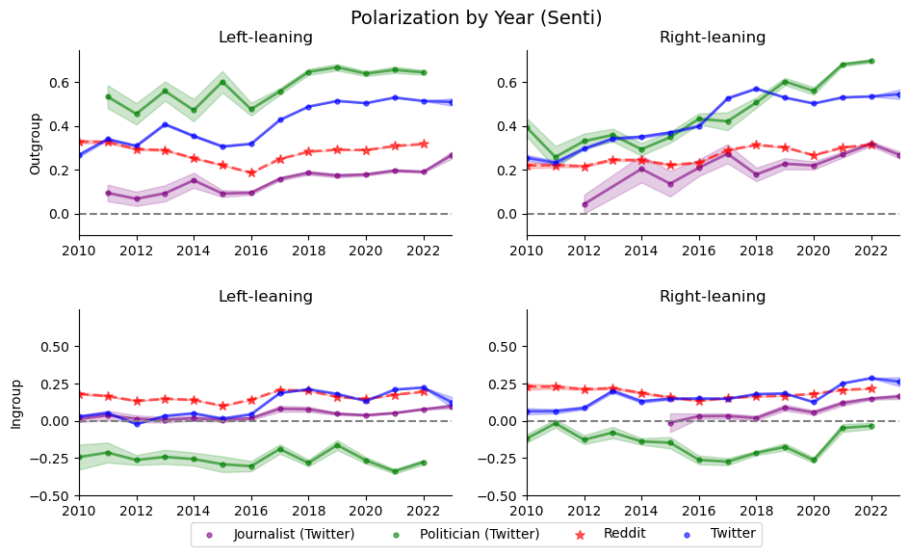
Figure S9: Third run dropping 10% of political keywords and re-creating our main visualization

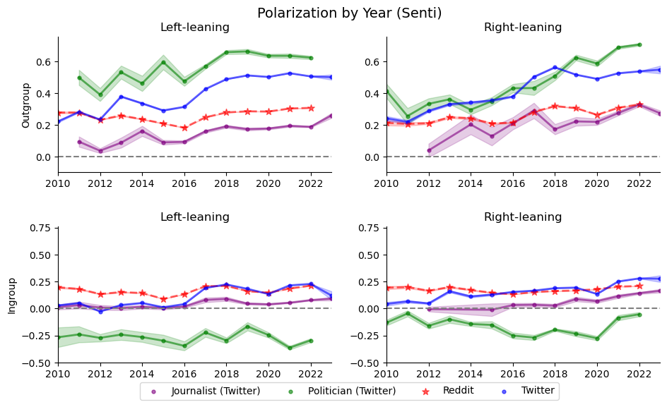
Figure S10: Fourth run dropping 10% of political keywords and re-creating our main visualization

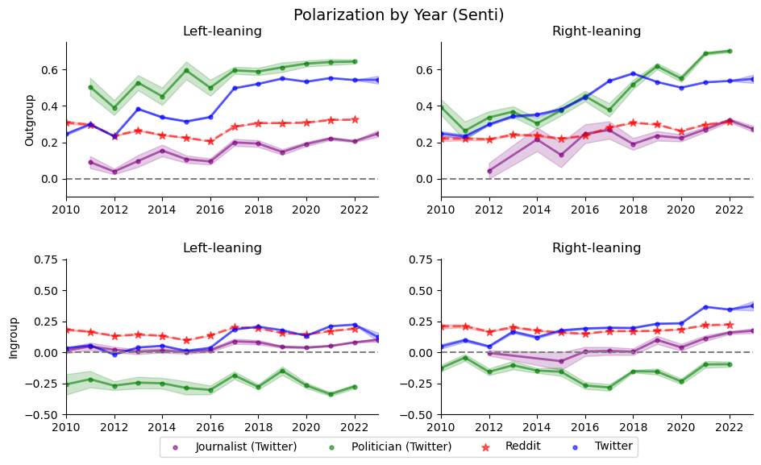
Figure S11: Fifth run dropping 10% of political keywords and re-creating our main visualization

S3.3 Validation with External Metrics

S3.3.1 DW-Nominate versus Politician Polarization
To validate our metric of polarizing discourse against existing measures, we first follow Ballard et al. (3) and Yu et al. (4), who hypothesize (and show) that ideological extremity is associated with polarizing tweeting behavior among U.S. politicians. Ballard et al. (3) claim that “ideological polarization and partisan animosity are distinct concepts (5), but related”. To test this relationship, we follow their approach and regress the outgroup animosity of a politician against their DW-Nominate score, a measure of political extremity based on the co-sponsorship of bills. We also find that polarizing speech tends to increase with ideological extremity, confirming our metric follows expected trends and previous findings in the literature.
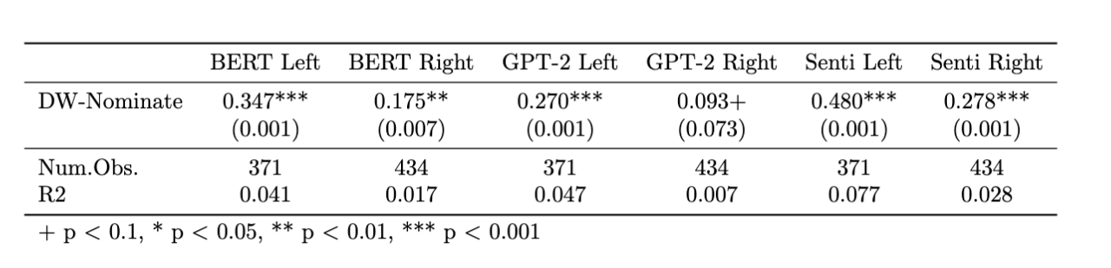
Table S14: We regress the mean outgroup affect of politicians versus their DW-Nominate score (a measure of ideological extremity based on voting patterns) across our three fine-tuned models.

S3.3.2 Comparison to Following Patterns
We initially used the approach by Barbera (1) based on Twitter following patterns to infer the political orientation of users. In their work, they validated their measure against various external measures (e.g. the DW-NOMINATE score as well as the political orientation of users matched to their voting records) and found that their measure predicted these external metrics well. We test whether our measure of polarizing discourse (based on the content of tweets) is positively correlated to a metric of partisanship based on structural patterns (i.e. who the users follow). We indeed find that the measures are positively related; users that are inferred to be more partisan based on who they follow are also more likely to exhibit outgroup derogation.
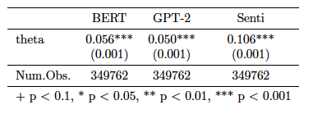
Table S15: We regress the level of outgroup derogation for each right-leaning Twitter user based on their tweets against their inferred level of partisanship based on their following patterns of elite politicians.
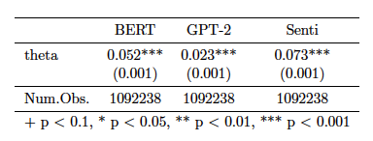
Table S16: We regress the level of outgroup derogation for each left-leaning Twitter user based on their tweets against their inferred level of partisanship based on their following patterns of elite politicians.

S3.2.3 State Voting Patterns versus Polarizing Discourse
In addition to examining the relationship between politicians' ideological extremity and polarizing rhetoric on Twitter, we also investigate, at the state level, whether tweets authored by users in more ideologically extreme states tend to exhibit higher levels of outgroup animosity. To achieve this, we geolocate approximately two hundred thousand users based on self-reported location information in their Twitter bios. Subsequently, we calculate the outgroup derogation for each state using this data. We then compare this state-level metric of outgroup animosity with a measure of partisan leaning by state provided by the site 538 (6). Their metric, derived from voting patterns by state, reflects the degree to which states lean further left or right than the national average, offering insights into the relationship between state-level ideological positioning and Twitter discourse polarization.
We note that there are several limitations with this comparison. First, ideological extremity and polarizing speech are distinct concepts and there may be differences in how they manifest. Additionally, social media users are not a representative sample of U.S. voters and there may also be a bias in types of users that self-report their location.
Using this measure of ideological extremity by state, we make two comparisons. First, we regress the level of outgroup derogation on Twitter among the users in each state against the absolute value of the ideological extremity based on the voting patterns of the state. When including all states, these are positively related (i.e., more ideologically extreme states have higher levels of outgroup derogation). However, further inspection reveals that Washington, D.C. and Wyoming are outliers with high ideological polarization and high levels of polarizing discourse on Twitter. After removing these from the analysis, the relationship weakens considerably and is not statistically significant (see Figure S12).
We then investigate the relationship between the original measure of partisan leaning (without taking the absolute value) and polarizing discourse. The results indicate that tweets authored by users from right-leaning states tend to exhibit higher levels of outgroup derogation compared to those from left-leaning states, a trend that persists even after excluding Washington D.C. and Wyoming from the analysis (see Figure S13). While the exact reason for this may involve the idiosyncrasies of Twitter as a platform, it could also be related to other forms of asymmetric polarization (7).

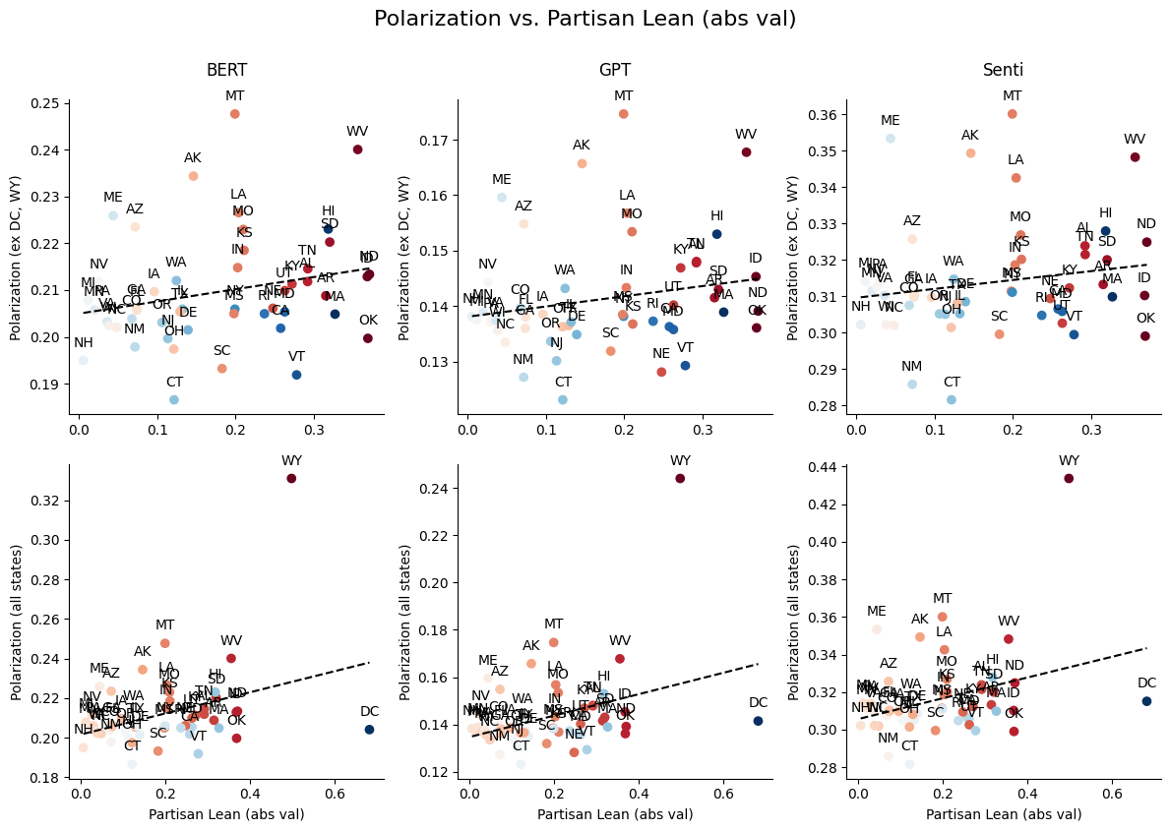
Figure S12: We measure the average level of outgroup derogation of users located in each state in our sample. We then regress this against the absolute value of the ideological extremity of the state based on their voting patterns. Top charts exclude DC and WY, bottom chart has all states.
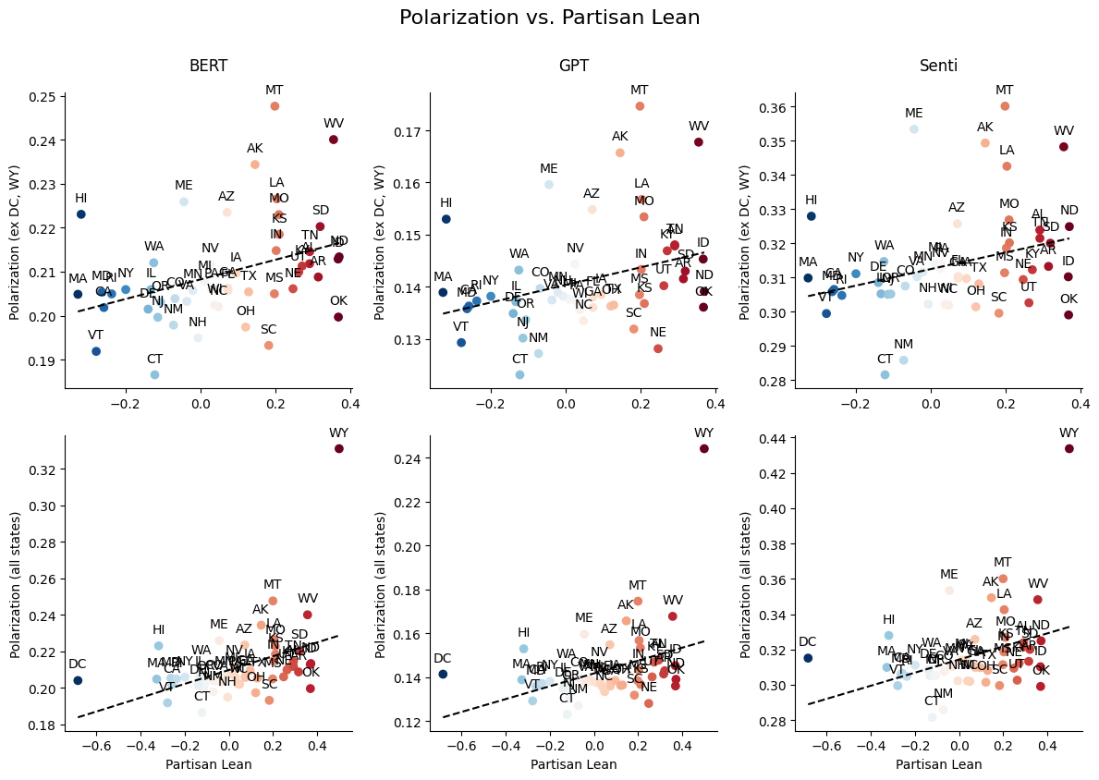
Figure S13: We measure the average level of outgroup derogation of users located in each state in our sample. We then regress a measure of ideological extremity where a higher value indicates the state is more right-leaning and a lower value indicates the state is more left-leaning
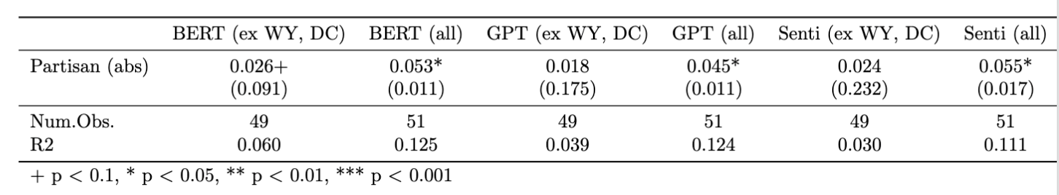
Table S17: We regress the level of outgroup derogation by state against the absolute value of that state’s ideological extremity.
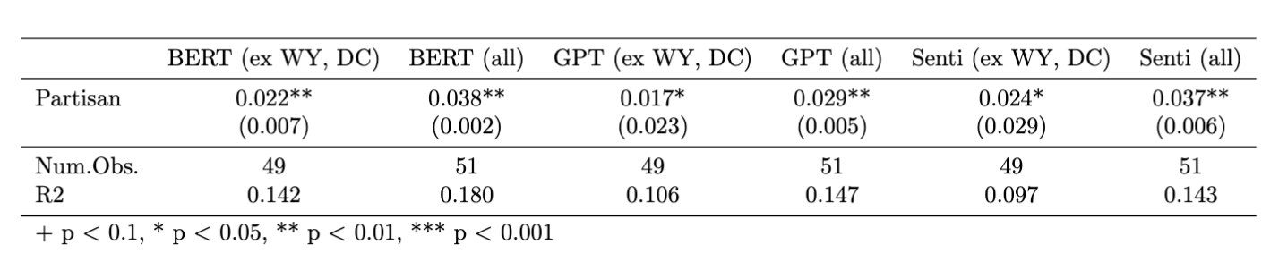
Table S18: We regress the level of outgroup derogation by state against that state’s ideological extremity, where higher values are more right-leaning and lower values are more left-leaning.

S4 Twitter Ordinal Logistic Regressions
4.1 Group Trends
We compare how different groups have evolved in their use of polarizing discourse by using an ordinal logistic regression where we regress the affect of a comment on an indicator variable corresponding to the period the comment was posted, as well as an interaction between the period and the type of user.
$$logit(Pr(Y≤j))=θ_{j}​-(β_{1}​⋅Period+β_{2}​⋅UserType+β_{3}​⋅(Period×UserType))$$
We focus on $β_{3}$, which indicates whether a certain user type (politician, journalist, or partisan user) has a higher likelihood of using polarizing rhetoric in each period of time. We run separate models corresponding to the political orientation of the users as well as the reference group (ingroup or outgroup). The following regressions are all performed using the Historical PowerTrack data, as it has the least probability of a temporal bias, and we also control for time using a covariate representing the year when necessary. These results confirm our finding that right-leaning politicians used higher levels of outgroup derogation than other groups in recent years.

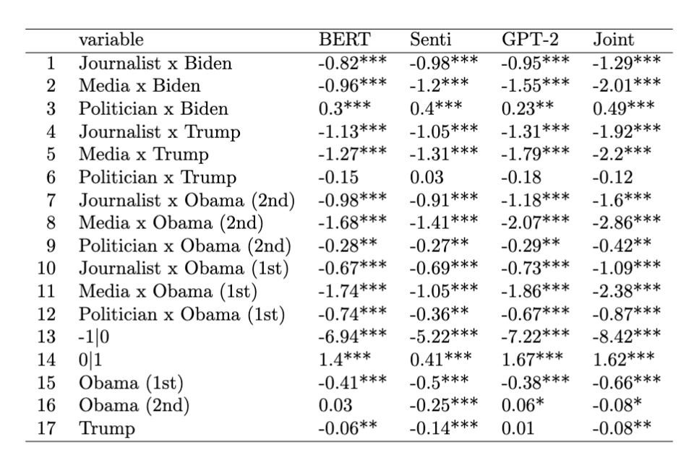
Table S19: For comments where right-leaning Twitter users are discussing their outgroup, we regress the affect of each tweet on the type of user, the presidential term in which the tweet was made, and an interaction between the two. We highlight the coefficients of politicians in the red boxes.

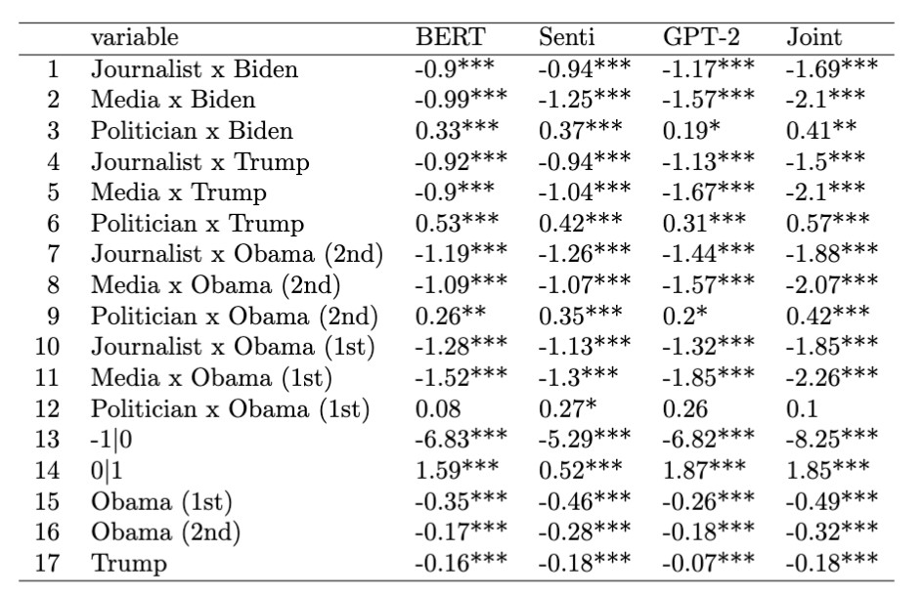
Table S20: For comments where left-leaning Twitter users are discussing their outgroup, we regress the affect of each tweet on the type of user, the presidential term in which the tweet was made, and an interaction between the two. We highlight the coefficients of politicians in the red boxes.
We then focus on confirming our findings that right-leaning politicians have become more negative towards their outgroups at a faster rate than other groups. We regress the affect of a comment on an interaction between the year (represented as the number of years from the earliest comment) and the user type. A higher coefficient essentially corresponds to a higher rate of growth in outgroup animosity of the group relative to other groups. On the right, outgroup animosity by politicians also grew faster than the other right-leaning groups.
$$logit(Pr(Y≤j))=θ_{j}-(β_{1}​⋅Year​+β_{2}​⋅UserType​+β_{3}​⋅(Year​×UserType​))$$
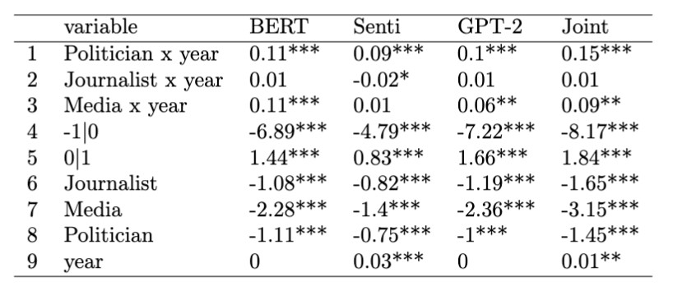
Table S21: For right-leaning partisan users, we regress the affect of the comment on the type of user, year, and interaction between the year and type of user. A positive coefficient indicates that the rate of growth in outgroup derogation of right-leaning politicians and media exceeded that of partisan users.
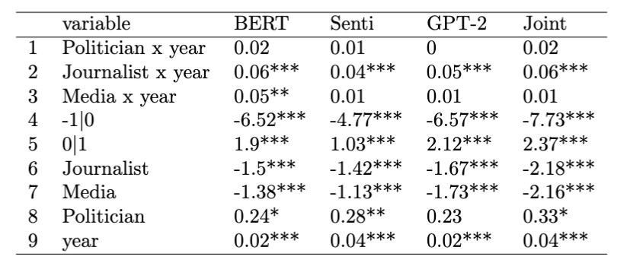
Table S22: For left-leaning partisan users, we regress the affect of the comment on the type of user, year, and interaction between the year and type of user.

S5 Distribution of Polarizing Discourse across Users
In addition to examining aggregate measures of polarizing discourse, we also analyze how users contribute differently to negative and neutral-affect political content. As established in prior research, user activity on platforms like Reddit and Twitter tends to follow a power-law distribution—a small subset of users generates a disproportionate share of the content. However, we observe that these distributions vary depending on the affective tone of the content.
In Figure S14, we present a Lorenz curve to visualize these differences. The x-axis represents user deciles, ranked by the percentage of political comments or tweets they post, while the y-axis shows the cumulative percentage of total content contributed by users in each decile or higher. To ensure uniform group sizes, we randomly broke ties so that each decile contains the same number of users.
Our findings show that on Twitter, the top 10% of users by volume of neutral affect political content contribute 39% of all such comments for left-leaning users, and 35% for right-leaning users. In contrast, when it comes to negative affect political content, the top decile of users contribute 46% (left-leaning) and 40% (right-leaning) of all posts. These results suggest that a more concentrated group of users is responsible for spreading negative affect content compared to neutral content.
To confirm that the distributions are indeed statistically significantly different, we discretize the contributions into percentiles and run a one-sided Kolmogorov–Smirnov test to determine whether the CDF of negative comments is higher than that of neutral comments. For all users except left-leaning politicians and media on Twitter, the distribution of negative comments is indeed more skewed than neutral comments (p < .05).

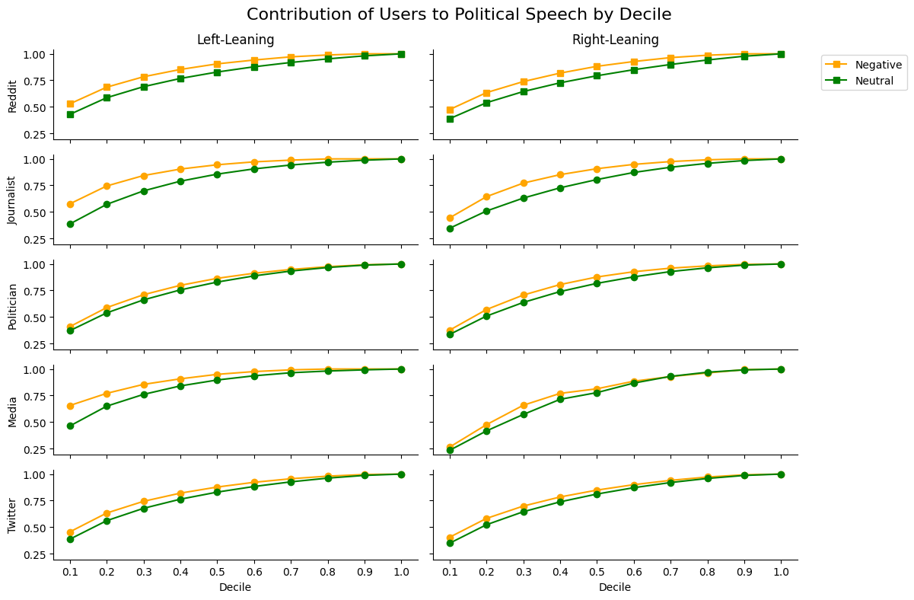
Figure S14: We plot the Lorenz curves of neutral and negative affect political content. For each decile of users, ranked by the amount of content posted, we compute the percentage of neutral/negative content contributed by that decile of users or higher. If one curve is higher than other, this indicates a more unequal distribution, with the top deciles contributing more.

Type | Pol Orient | K-S Statistic | p-value
Journalist | L | 0.31 | 0
Reddit | L | 0.29 | 0
Reddit | R | 0.29 | 0
Journalist | R | 0.24 | 0.003
Politician | R | 0.19 | 0.027
Twitter | L | 0.17 | 0.056
Twitter | R | 0.17 | 0.056
Media | L | 0.09 | 0.446
Politician | L | 0.08 | 0.529
Media | R | 0.04 | 0.853
Table S23: We report the K-S statistic and corresponding p-value for each group and political orientation, which compares whether the difference between the CDFs of negative versus neutral affect political content is statistically significantly different. We discretized the distribution into percentiles to compare CDFs.
We also plot the same Lorenz curves as above but now compare the two platforms. On the top chart we examine the distribution of neutral affect political content across users on the two platforms, while on the bottom we examine the distribution of negative affect political content. The red curve (Reddit) above the blue curve (Twitter) indicates that the distribution is more skewed on Reddit than on Twitter.

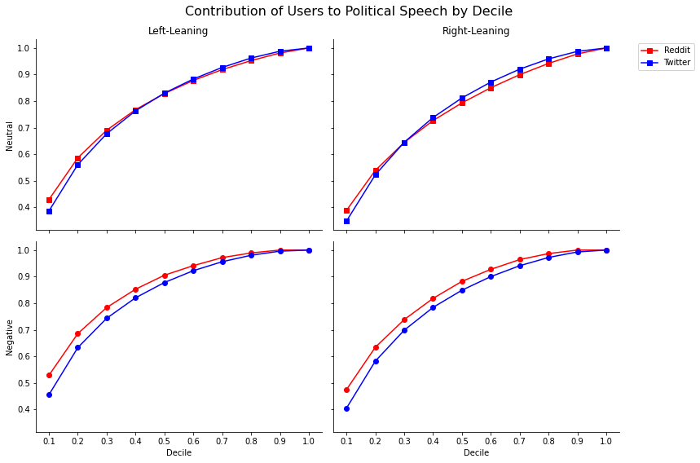
Figure S15: We plot the Lorenz curves of neutral and negative affect political content on Reddit versus Twitter. For each decile of users, ranked by the amount of content posted, we compute the percentage of neutral/negative content contributed by that decile of users or higher. If one curve is higher than other, this indicates a more unequal distribution, with the top deciles contributing more.

S6 Robustness Checks for Data Source and Base Model

S6.1 Historical PowerTrack Groups/Platforms
Using data from the Historical PowerTrack API (a different API to source data from Twitter as opposed to pulling from users’ timelines) yields the same results as using timeline data. We show below a version of our main figure recreated with this data.
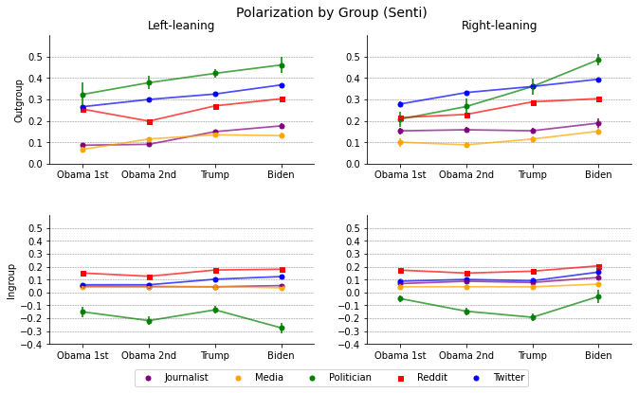
Figure S16: Using only our sample of Historical PowerTrack data, we plot changes in polarizing discourse over time across groups.

S6.2 Recreating Plots with Different Base Classifier Models
We re-create all our main charts using different base models to ensure robustness to the underlying model used. We see that the high-level results remain consistent; outgroup animosity is rising for all groups and right-leaning politicians have accelerated the most since 2016. We see that levels of outgroup derogation of left-leaning politicians peaks in 2019 and then declines, although our most accurate model (the fine-tuned sentiment model) shows less of a decline than fine-tuned base BERT and GPT models. When investigating this difference, we find that the higher recall of the fine-tuned sentiment model makes it more likely to find speech that is polarizing but does not include explicit personal attacks. Thus, the greater decline we see for the fine-tuned BERT/GPT models could be due to the shifting nature of the types of polarizing speech that left-leaning politicians are using, although in all cases we find that while polarizing speech by right-leaning politicians has been increasing since around 2016 and is at its peak in 2022, the peak for left-leaning politicians occurred in 2019.

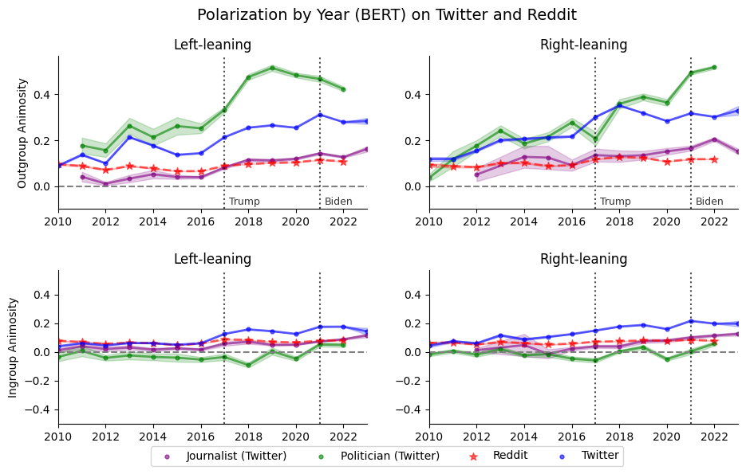
Figure S17: Recreating our main visualization of polarizing discourse over time using BERT as the base model
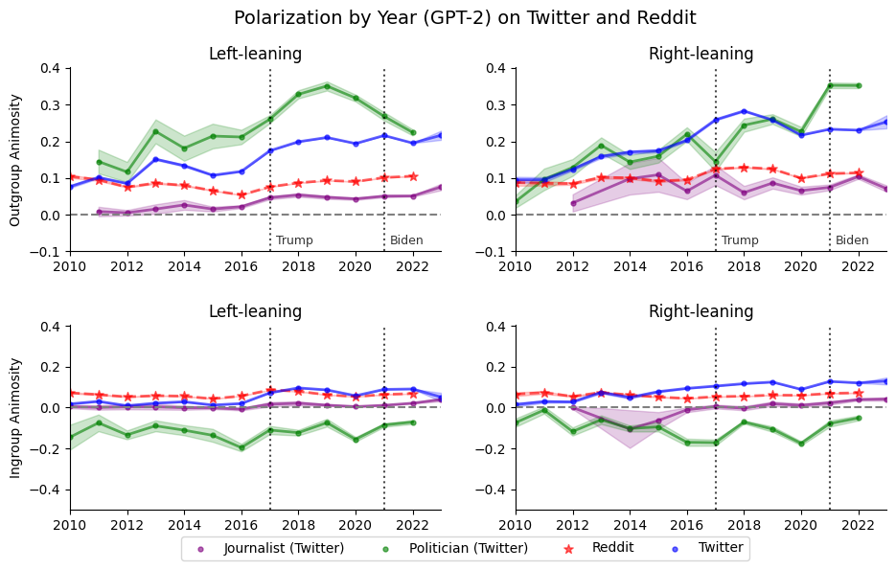
Figure S18: Recreating our main visualization of polarizing discourse over time using GPT-2 as the base model

S6.3 Subreddit and Cohort Contributions
We recreate our subreddit contribution charts with BERT and GPT-2 as our base models.

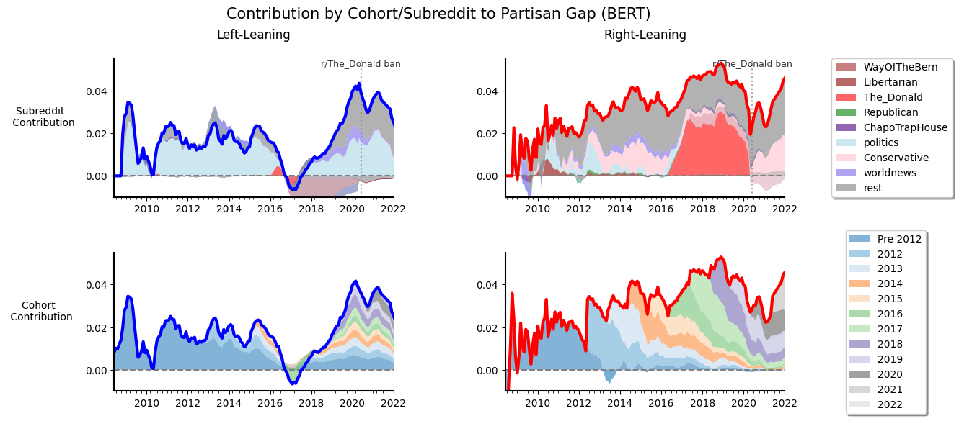
Figure S19: Recreating our subreddit contribution chart with BERT as the base model
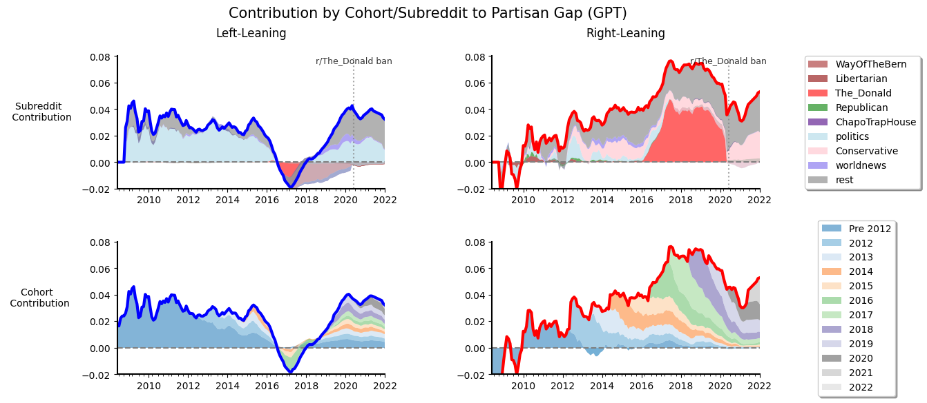
Figure S20: Recreating our subreddit contribution chart with GPT-2 as the base model
S6.4 Influencer Polarizing Discourse
We recreate our charts breaking down polarizing discourse by influencers when using BERT and GPT-2 as our base models.
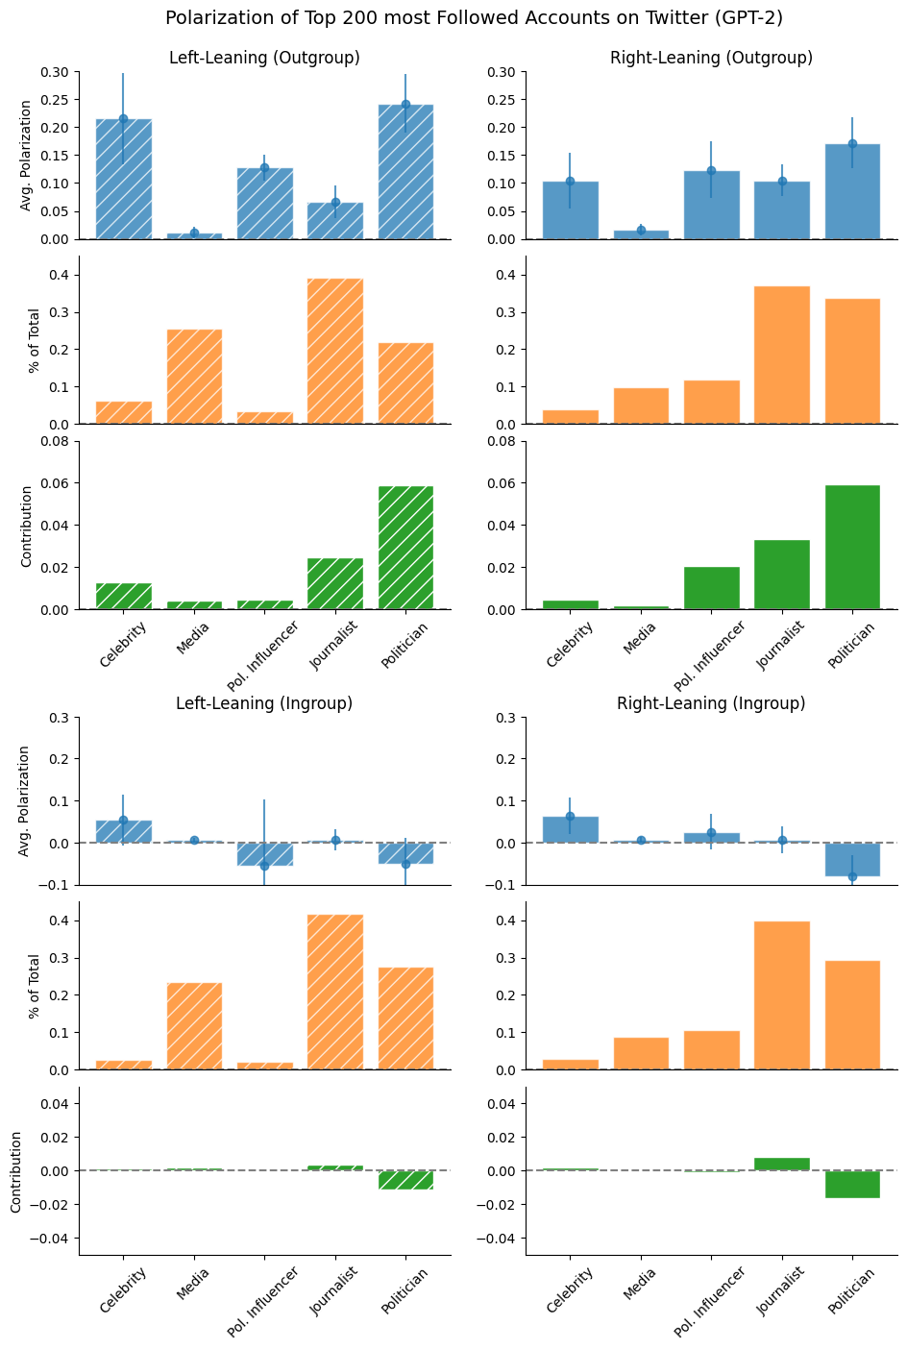
Figure S21: Recreating our chart of influencer polarization using GPT-2 as the base model
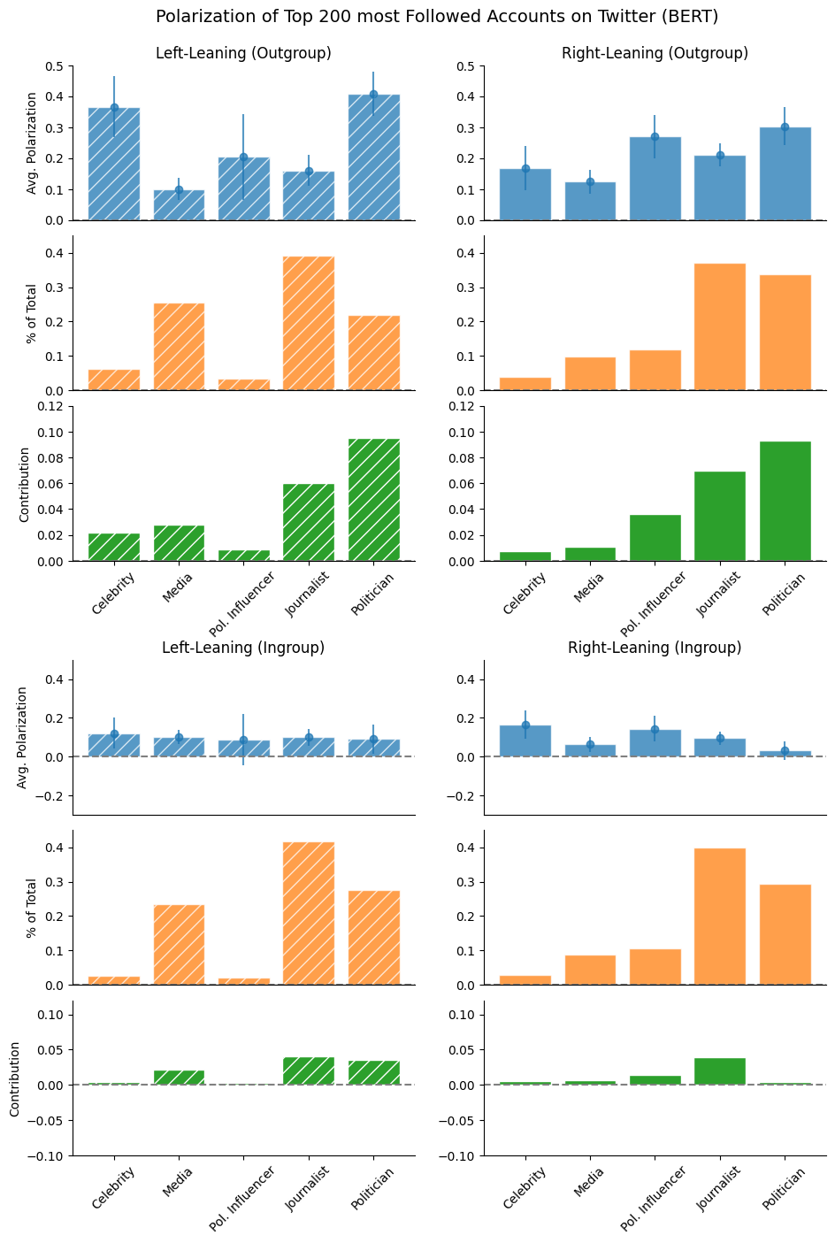
Figure S22: Recreating our chart of influencer polarization using BERT as the base model

S6.5 Followers vs. Polarizing Rhetoric
Figures Figure S23 to Figure S25 illustrate the shifts in polarizing discourse across varying follower counts. To compute the number of followers, we take the latest number of followers that an account has, as this can shift over time. Overall, we observe a consistent negative relationship for both left- and right-leaning users. Notably, accounts with over one million followers appear to show significantly higher outgroup animosity among right-leaning users. However, a closer look reveals that this spike is largely driven by a single influencer who repeatedly posts the same highly negative tweet about Joe Biden. This heavily skews the average. After removing this outlier, the polarization trends between left- and right-leaning users align more closely.

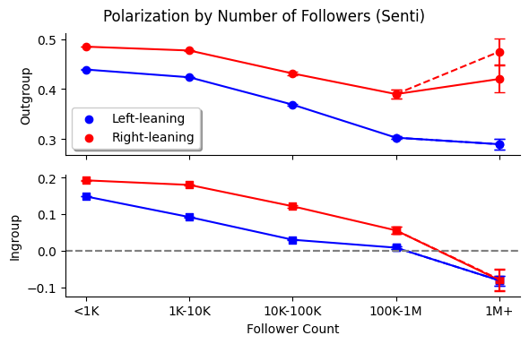
Figure S23: The level of polarizing discourse across accounts with different amounts of followers using our main model
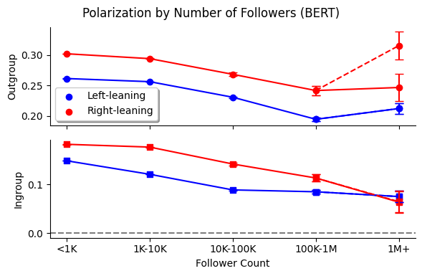
Figure S24: The level of polarizing discourse across accounts with different amounts of followers using a BERT base model
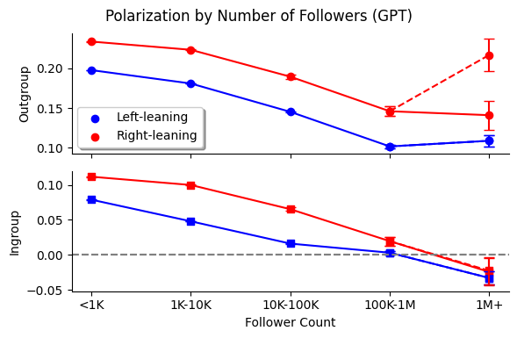
Figure S25: The level of polarizing discourse across accounts with different amounts of followers using GPT-2 as the base model

S6.6 Topics
We re-create our charts showing polarizing discourse on different topics using BERT and GPT-2 as our base models.
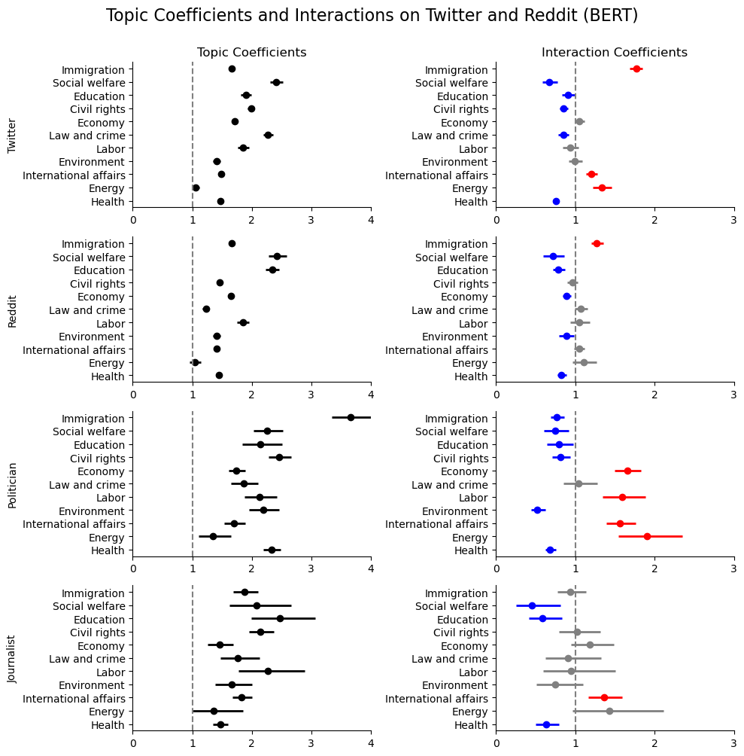
Figure S26: Re-creating our topic chart with BERT as the base model

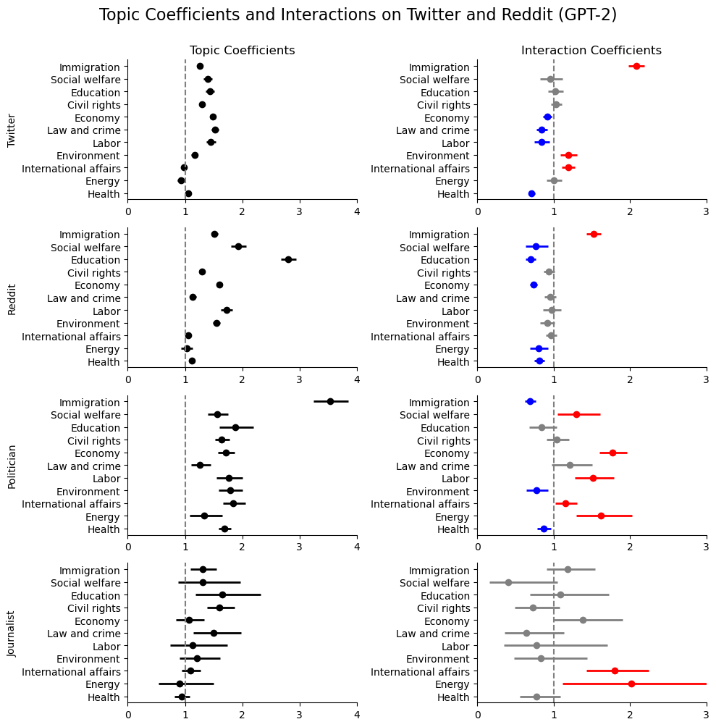
Figure S27: Re-creating our topic chart with GPT-2 as the base model

