Supplementary Information
of
Effects of plate interface roughness and frictional heterogeneities Earthquake Cycle Dynamics in Subduction Zones
Sayak Ray¹, Abhijit Ghosh^{2*}, Bhaskar Kundu^{1*}, Batakrushna Senapati³
¹Department of Earth and Atmospheric Sciences, NIT Rourkela, Rourkela, India, 769008.
²Department of Earth Sciences, University of California-Riverside, 900 University Ave, Riverside, CA 92521, USA.
³Department of Earth Science, National Central University, No. 300, Jhongda Rd., Chungli, Taoyuan 320, Taiwan.

*Corresponding authors: Abhijit Ghosh, Department of Earth Sciences, University of California-Riverside, 900 University Ave, Riverside, CA 92521, USA (aghosh.earth@gmail.com); Bhaskar Kundu, Department of Earth and Atmospheric Sciences, NIT Rourkela, Rourkela-769008, India, (email: rilbhaskar@gmail.com).

The contents include:
- Table S1 - Parameters for laboratory experiments.
- Details of Surface Roughness parameters
- Schematic representation of L_{b}/L
- Results of continuous linear barrier experiments
- Schematic representation of xz-plane of a fault with alternating VS and VW patches
- Table S2: Parameters for QDYN Numerical Simulation for Fig. 8, 9 and 10.

- Table S1: Parameters for laboratory experiments.
Parameters |  | Values
Normal Load of the sample |  | 0.5N
Area of the sample (contact area) |  | 25 cm²
Force sensor (capacity) |  | 1 kg
Accelerometer (frequency) |  | 201 Hz
Loading Velocity (V_{L}) |  | 2 µm/s
Roughness parameters (µm) | R_{a} | 3.68 ± 0.39 | 3.97 ± 0.03 | 10.56 ± 0.99
Roughness parameters (µm) | R_{q} | 3.82 ± 0.45 | 4.02 ± 0.11 | 10.68 ± 0.94
Roughness parameters (µm) | R_{z} | 10.18 ± 0.60 | 10.96 ± 0.22 | 29.87 ± 2.79
Roughness parameters (µm) | R_{t} | 10.28 ± 0.75 | 11.27 ± 0.15 | 30.16 ± 2.81
Frictional Surfaces |  | Sample | p2000(asperity) | p400(barrier)

- Roughness parameters:
Surface roughness is a critical parameter in characterizing the topography of a material's surface, influencing its mechanical properties, frictional behaviour, and contact interactions. It provides quantitative insights into surface texture, which can affect adhesion, wear resistance, and tribological performance. Maximum Profile Peak Height, Rp, the distance between the highest point of the profile and the mean line (M) within the evaluation length (L). Maximum profile valley depth, Rv, the distance between the deepest valley of the profile and the mean line (M) within the evaluation length (L):
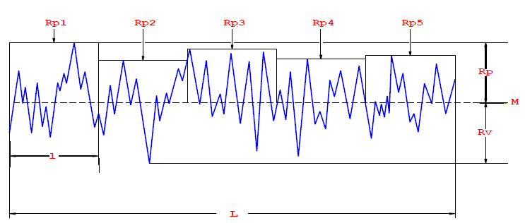
Fig. S1: Schematic representation of Maximum Profile Peak Height (Rp) and Maximum profile valley depth (Rv) with respect to the Mean line (M, dotted line) in an evaluation length (L).
Various roughness parameters are used to describe different aspects of surface irregularities, each capturing specific features of the surface profile. The following parameters are commonly used to assess surface roughness:
- Roughness average (R_{a}) is the arithmetic average of the absolute values of the profile heights (h) over the evaluation length.
$$R_{a}= \frac{1}{n}\sum_{i=1}^{n}{{Rp}_{i}}$$
- R_{q} is the Root mean square average of the profile heights (h) over the evaluation length
$$R_{q}= \sqrt{\frac{{Rp}_{1}^{2}+{Rp}_{2}^{2}+{Rp}_{3}^{2}…………+{Rp}_{n}^{2}}{n}}$$
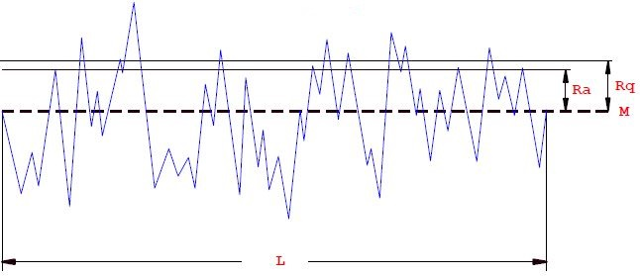
Fig S2: Schematic representation of R_{a} and R_{q}.
- Ten Point Height of Irregularities (R_{z}): the average value of the absolute values of the heights of five highest profile peaks and the depths of five deepest valleys within the evaluation length.
$$R_{z}= \frac{1}{5}\sum_{j=1}^{5}{\left(R_{P_{j}}+R_{V_{j}}\right)}$$
$$R_{z}=average maximum height of the profile$$
$$R_{P_{j}}=height of peaks$$
$$R_{V_{j}}=depth of valleys$$
$R_{v_{j}}$ + $R_{v_{j}}= h_{j}$
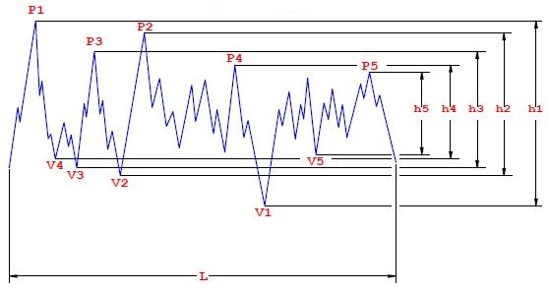
Fig S3: Schematic representation of R_{Z}
- Maximum Heights within a Sampling Length (R_{t}): the vertical distance between the highest and lowest points of the profile within a sampling length.

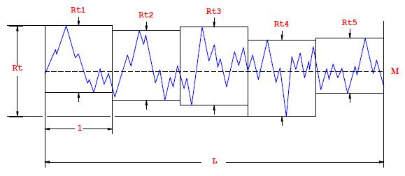
Fig. S4: Schematic representation of R_{t}.

- Schematic representation of L_{b}/L

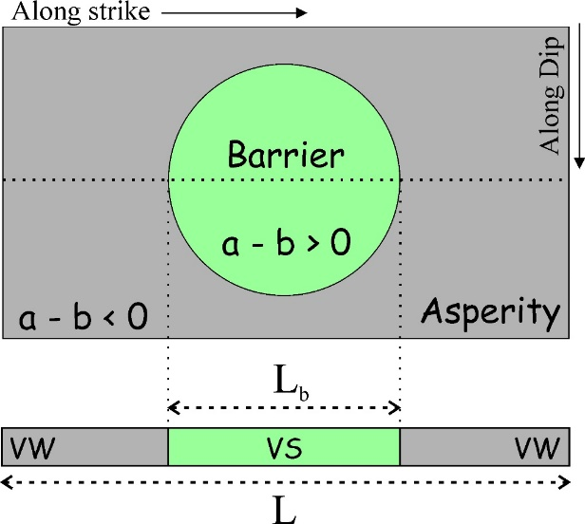
Figure S5: Schematic representation of the diameter of the barrier (L_{b}) and along-strike length of the sample contact surface (L).
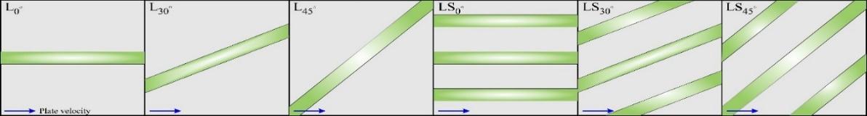
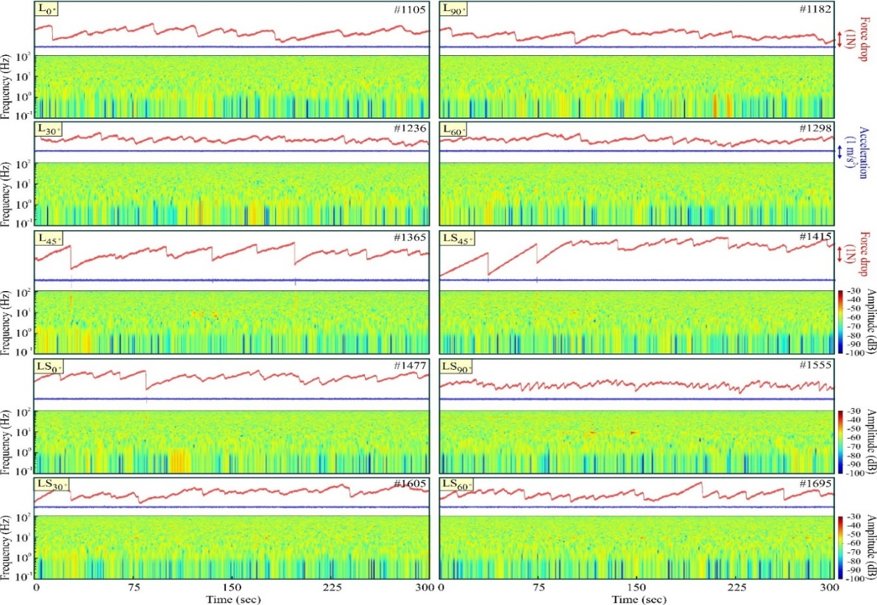
- Results of continuous linear barrier experiments

Figure S6: Results of single (L_{θ}) and multiple (LS_{θ}) linear barrier stick-slip experiments. Shear stress (in red) and acceleration (in blue) are recorded from the force sensor and accelerometer data, respectively, and their corresponding spectrogram of each experiment are plotted for 200s of experimental run time. The experiment number is mentioned in the top right corner of each plot.
- Schematic representation of xz-plane of a fault with alternating VS and VW patches
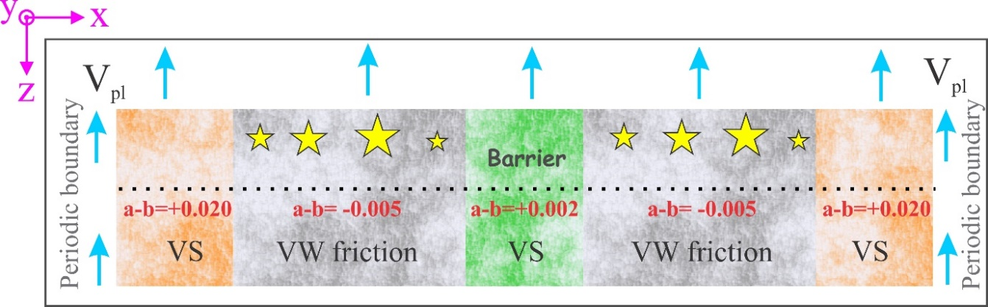
Figure S7: Schematic representation VS barrier (green) and VW (grey) patches on either side, bounded by VS buffer zones (orange). Earthquakes (yellow stars) occur in the VW region. Values of the rate and state parameters are shown in red.

- Table S2: Parameters for QDYN Numerical Simulation for Fig.8, 9 and 10.
Region | Parameters | Symbols | Values
Synthetic Fault simulation | Fault length along the strike (including buffer zone, in km) | L | 305/310/325/  350/375/400/450/500
Synthetic Fault simulation | Shear modulus (GPa) | µ | 32
Synthetic Fault simulation | Shear wave speed (km/s) | C_{s} | 3.4
Synthetic Fault simulation | Plate velocity (mm/year) | V_{pl} | 50
Synthetic Fault simulation | Characteristic slip length (m) | D_{c} | 0.004
Synthetic Fault simulation | Effective normal stress (MPa) | $$\overline{σ}$$ | 25
Synthetic Fault simulation | Size of the VS segment (km) | D_{VS} | 5/10/25/50/75/100/150/200
Synthetic Fault simulation | Size of the VW segment (left/right of the VS segment) (km) | D_{VW1}  D_{VW2} | 100  100
Synthetic Fault simulation | Size of the two VS buffer zones (km) | B_{VS} | 100
Synthetic Fault simulation | Rate and state parameter a-b in VW | (a-b)_{VW} | -0.005
Synthetic Fault simulation | Rate and state parameter a-b in VS | (a-b)_{VS} | +0.002
Synthetic Fault simulation | Rate and state parameter a-b in the VS buffer zones on both the side | (a-b)_{B} | +0.020
Synthetic Fault simulation | Reference slip velocity (m/s) | V₀ | 10⁻⁶
Synthetic Fault simulation | Reference friction coefficient | f₀ | 0.6
Synthetic Fault simulation | Cell size (m) | ∆x | 141
Alaska Aleutian Subduction zone simulation | Fault length along strike (including buffer zone, in km) | L | 910
Alaska Aleutian Subduction zone simulation | Shear modulus (GPa) | µ | 32
Alaska Aleutian Subduction zone simulation | Shear wave speed (km/s) | C_{s} | 3.4
Alaska Aleutian Subduction zone simulation | Plate velocity (mm/year) | V_{pl} | 57
Alaska Aleutian Subduction zone simulation | Characteristic slip length (m) | D_{c} | 0.004
Alaska Aleutian Subduction zone simulation | Effective normal stress (MPa) | $$\overline{σ}$$ | 50
Alaska Aleutian Subduction zone simulation | Size of the VS segment (km) | D_{VS} | 270
Alaska Aleutian Subduction zone simulation | Size of the VW segment (left/right of the VS segment) (km) | D_{VW1}  D_{VW2} | 160  280
Alaska Aleutian Subduction zone simulation | Size of the two VS buffer zones (km) | B_{VS} | 100
Alaska Aleutian Subduction zone simulation | Rate and state parameter a-b in VW | (a-b)_{VW} | 40
Alaska Aleutian Subduction zone simulation | Rate and state parameter a-b in VS | (a-b)_{VS} | 71.5
Alaska Aleutian Subduction zone simulation | Rate and state parameter a-b in the VS buffer zones on both the side | (a-b)_{B} | 67.5
Alaska Aleutian Subduction zone simulation | Reference slip velocity (m/s) | V₀ | 76.5
Alaska Aleutian Subduction zone simulation | Reference friction coefficient | f₀ | 0.6
Alaska Aleutian Subduction zone simulation | Cell size (m) | ∆x | 141
Himalaya Deformation Front simulation | Fault length along strike (including buffer zone, in km) | L | 535
Himalaya Deformation Front simulation | Shear modulus (GPa) | µ | 32
Himalaya Deformation Front simulation | Shear wave speed (km/s) | C_{s} | 3.4
Himalaya Deformation Front simulation | Plate velocity (mm/year) | V_{pl} | 40
Himalaya Deformation Front simulation | Characteristic slip length (m) | D_{c} | 0.004
Himalaya Deformation Front simulation | Effective normal stress (MPa) | $$\overline{σ}$$ | 25
Himalaya Deformation Front simulation | Size of the VS segments (left to right, in km) | D_{VS} | 15/20/20
Himalaya Deformation Front simulation | Size of the VW segment (left to right, in km) | D_{VW} | 125/120/85/100
Himalaya Deformation Front simulation | Size of the two VS buffer zones (km) | B_{VS} | 25
Himalaya Deformation Front simulation | Rate and state parameter a-b in VW | (a-b)_{VW} | -0.005
Himalaya Deformation Front simulation | Rate and state parameter a-b in VS | (a-b)_{VS} | +0.002
Himalaya Deformation Front simulation | Rate and state parameter a-b in the VS buffer zones on both the side | (a-b)_{B} | +0.020
Himalaya Deformation Front simulation | Reference slip velocity (m/s) | V₀ | 10⁻⁶
Himalaya Deformation Front simulation | Reference friction coefficient | f₀ | 0.6
Himalaya Deformation Front simulation | Cell size (m) | ∆x | 141

