Figure.7A
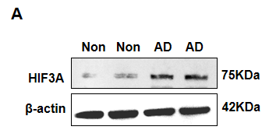
70KDa
85KDa
HIF3A 75KDa
Non Non AD AD
Extended Data Fig.1 The original blotting of HIF3A in Fig.7A. Left, original blotting of HIF3A and corresponding sample names; Right, cropped version in manuscript.
β-actin 42KDa
40KDa
50KDa
Non Non AD AD
Extended Data Fig.2 The original blotting of β-actin in Fig.7A. Left, original blotting of β-actin and corresponding sample names; Right, cropped version in manuscript.

Figure.7E
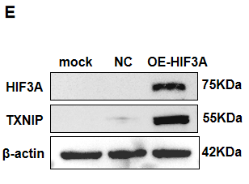
mock NC OE-HIF3A
70KDa
85KDa
HIF3A 75KDa
Extended Data Fig.3 The original blotting of HIF3A in Fig.7E. Left, original blotting of HIF3A and corresponding sample names; Right, cropped version in manuscript.
mock NC OE-HIF3A
TXNIP 55KDa
50KDa
70KDa
Extended Data Fig.4 The original blotting of TXNIP in Fig.7E. Left, original blotting of TXNIP and corresponding sample names; Right, cropped version in manuscript.
mock NC OE-HIF3A
40KDa
50KDa
β-actin 42KDa
Extended Data Fig.5 The original blotting of β-actin in Fig.7E. Left, original blotting of β-actin and corresponding sample names; Right, cropped version in manuscript.

Figure.7F
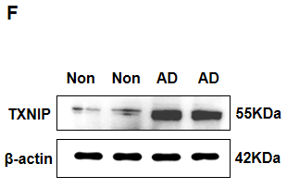
Non Non AD AD
TXNIP 55KDa
50KDa
70KDa
Extended Data Fig.6 The original blotting of TXNIP in Fig.7F. Left, original blotting of TXNIP and corresponding sample names; Right, cropped version in manuscript.

β-actin 42KDa
40KDa
50KDa
Non Non AD AD
Extended Data Fig.7 The original blotting of β-actin in Fig.7F. Left, original blotting of β-actin and corresponding sample names; Right, cropped version in manuscript.

Figure.7G
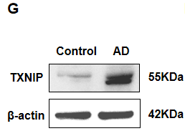
Control AD
50KDa
70KDa
TXNIP 55KDa
Extended Data Fig.8 The original blotting of TXNIP in Fig.7G. Left, original blotting of TXNIP and corresponding sample names; Right, cropped version in manuscript.

40KDa
50KDa
Control AD
β-actin 42KDa
Extended Data Fig.9 The original blotting of β-actin in Fig.7G. Left, original blotting of β-actin and corresponding sample names; Right, cropped version in manuscript.

