Supplementary Material
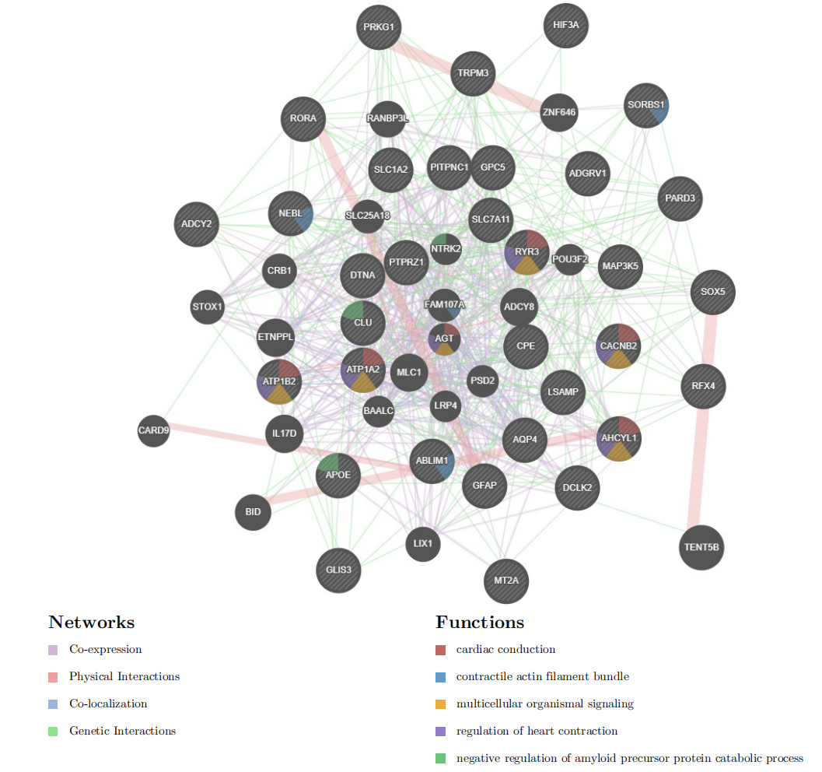
Supplementary Figure.1 PPI network for the up-regulated genes and their involvement in key biological processes.
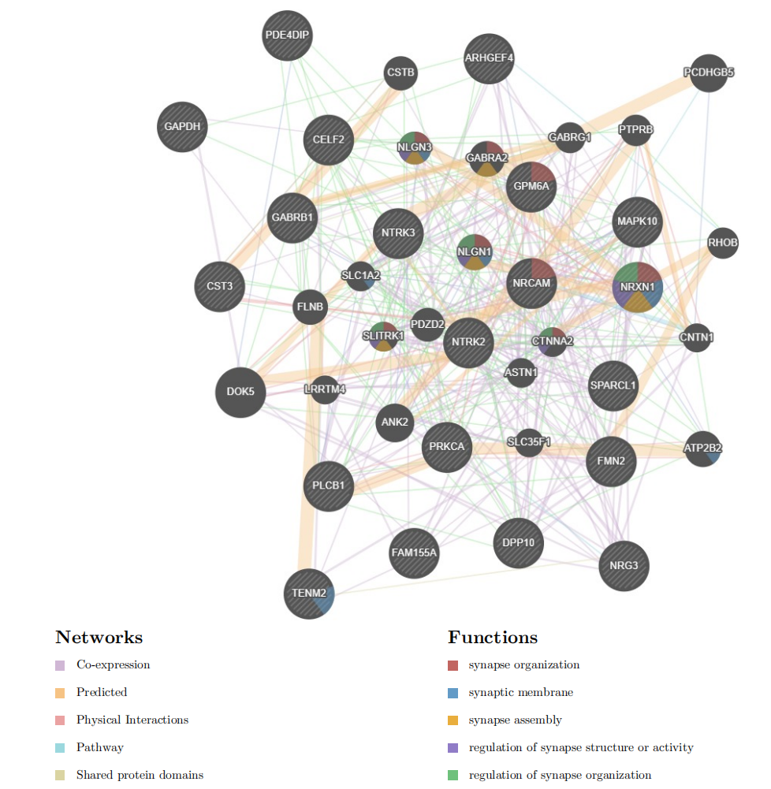
Supplementary Figure.2 PPI network for the down-regulated genes and their involvement in key biological processes.

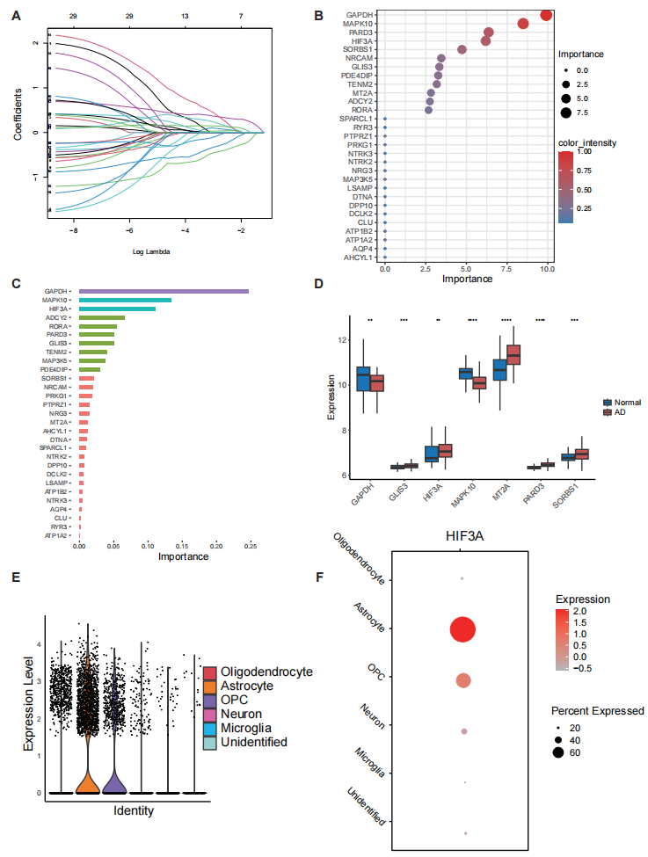
Supplementary Figure.3 HIF3A promoted AD progression by TXNIP activation. (A): The results of LASSO algorithm. (B): The results of RF algorithm. (C): The results of XgBoost algorithm. (D): The expression of HIF3A was significantly elevated in the AD group from GSE132903 dataset. (E): The results of violin plot for HIF3A gene. (F): HIF3A exhibited high expression on astrocytes.
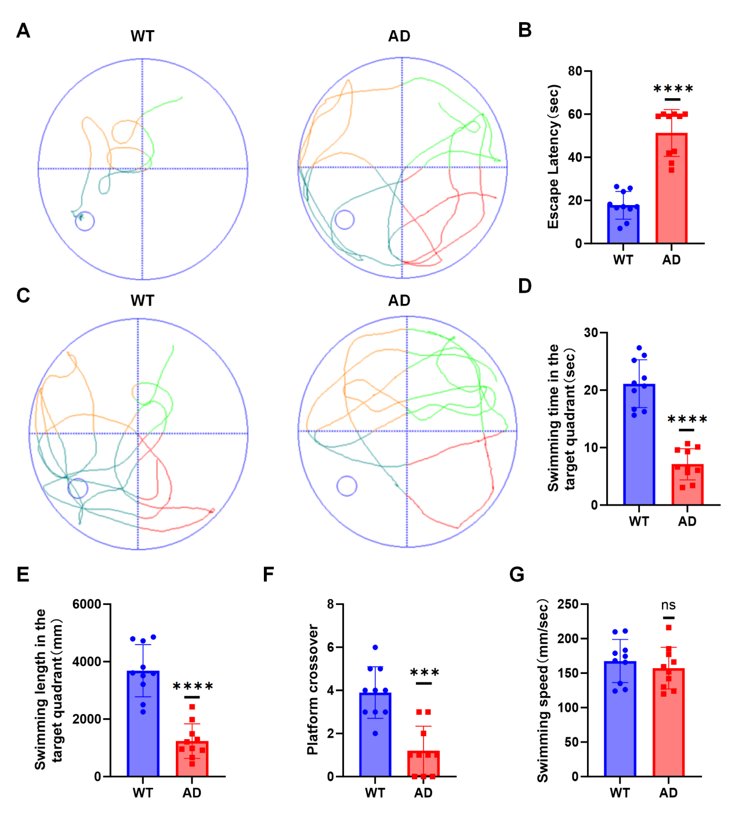
Supplementary Figure.4 Behavioral validation of the AD model. (A): Representative trajectory plots of mice in the place navigation trial. (B): Quantification of escape latency in mice. (C): Representative trajectory plots of mice in the spatial probe trial. (D): Quantification of swimming time in the target quadrant. (E): Quantification of swimming length in the target quadrant. (F): Quantification of the number of platform crossings. (G): Quantification of swimming speed.

