Article title: Integrated proteomic and single-cell transcriptomic profiling elucidates immunomodulatory effects of L-serine in autism spectrum disorder

Author names: Jaemyung Jang ^{a 1}, Seungeun Yeo ^{b 1}, Jong Pil Kim ^{c}, Soonbong Baek ª, Hyun Jin Jung ª, Su-Kyeong Hwang ^{d}, Youngshik Choe ª *

Affiliations:
ª Developmental Disorders & Rare Diseases Research Group, Korea Brain Research Institute, Research Division, 61 Cheomdan-ro, Daegu, 41062, Republic of Korea
^{b} Gut-Brain System Regulation Korean Medicine Research Center, Dongshin University, Naju-si, 58245, Korea, Republic of Korea
^{c} Hanyang Institute of Bioscience and Biotechnology, Hanyang University, Seoul, 04763, Korea, Republic of Korea
^{d} Department of Pediatrics, School of Medicine, Kyungpook National University, 680 Gukchaebosang-ro, Daegu, 41944, Republic of Korea; Astrogen Inc., 440 Hyeoksin-daero, Daegu, 41072, Republic of Korea

Corresponding author: Youngshik Choe
61 Cheomdan-ro, Dong-gu, Daegu, 41062, Korea
E-mail: dallarae@kbri.re.kr
Phone: 82-53-980-8340
Fax: 82-53-980-8399

¹ These authors contributed equally to this work.

Supplementary Figure 1
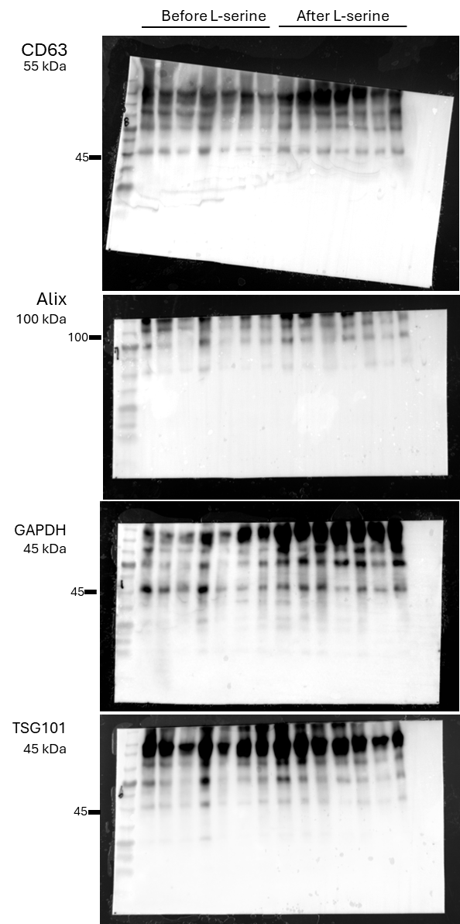

Whole uncropped images of the original western blots showing the expression of EV markers (CD63, GAPDH, ALIX, and TSG101) in plasma EVs from patients with ASD before and after L-serine treatment. The Cropped blots presented in Figure 1C were derived from these full-length blots. All blots were derived from the same experiment and processed in parallel. Membrane edges are visible, and arrows indicate the regions shown in Figure 1C.
Supplementary Figure 2
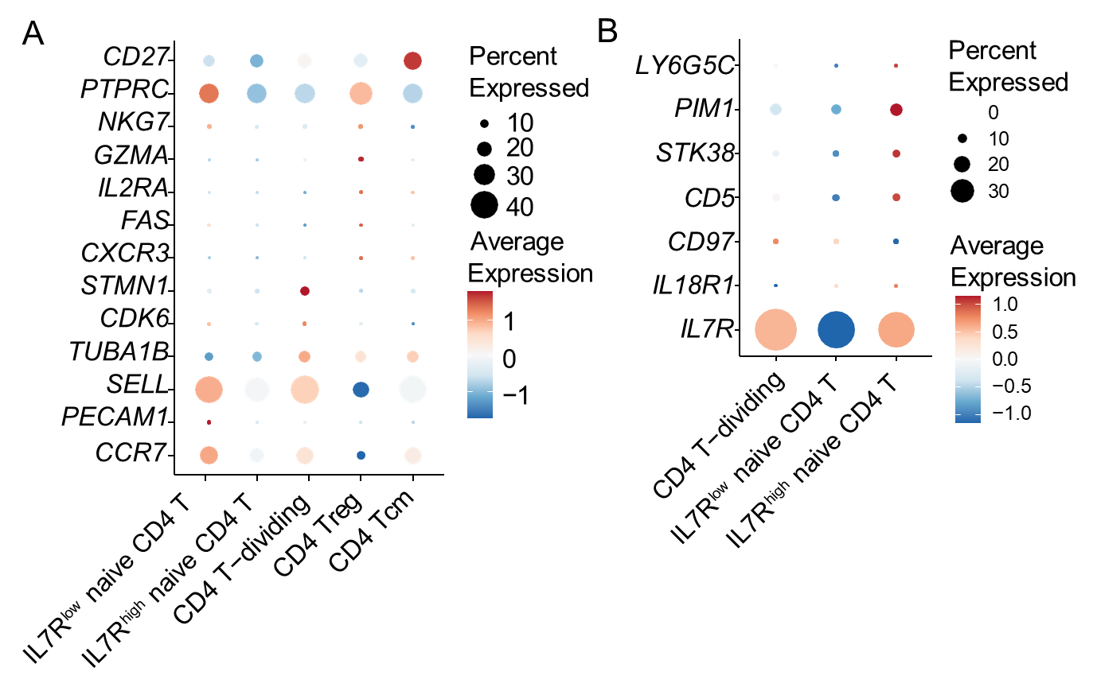
Cellular-specific expressed genes in the CD4 T subsets
- Dot plot identifying five specific CD4 T-cell subsets using canonical marker genes. Dot size represents the percentage of cells expressing the marker genes, and color intensity indicates the averaged scaled expression value (blue: low, red: high). The identified subsets are IL7R^{low} naive CD4 T cells, CD4 Treg cells, CD4 T-dividing cells, IL7R^{high} naive CD4 T cells, and CD4 Tcm (central memory) cells.
- Dot plot depicting the average expression of marker genes across naive CD4 T subclusters, including the CD4 T-dividing, IL7R^{low}, and IL7R^{high} naive CD4 T cell subsets. Dot size indicates the percentage of cells expressing the genes, and color represents the averaged scaled expression value (blue: low, red: high). Marker genes include PIM1, STK38, CD5, CD97, IL18R1, and IL7R.

Supplementary Figure 3
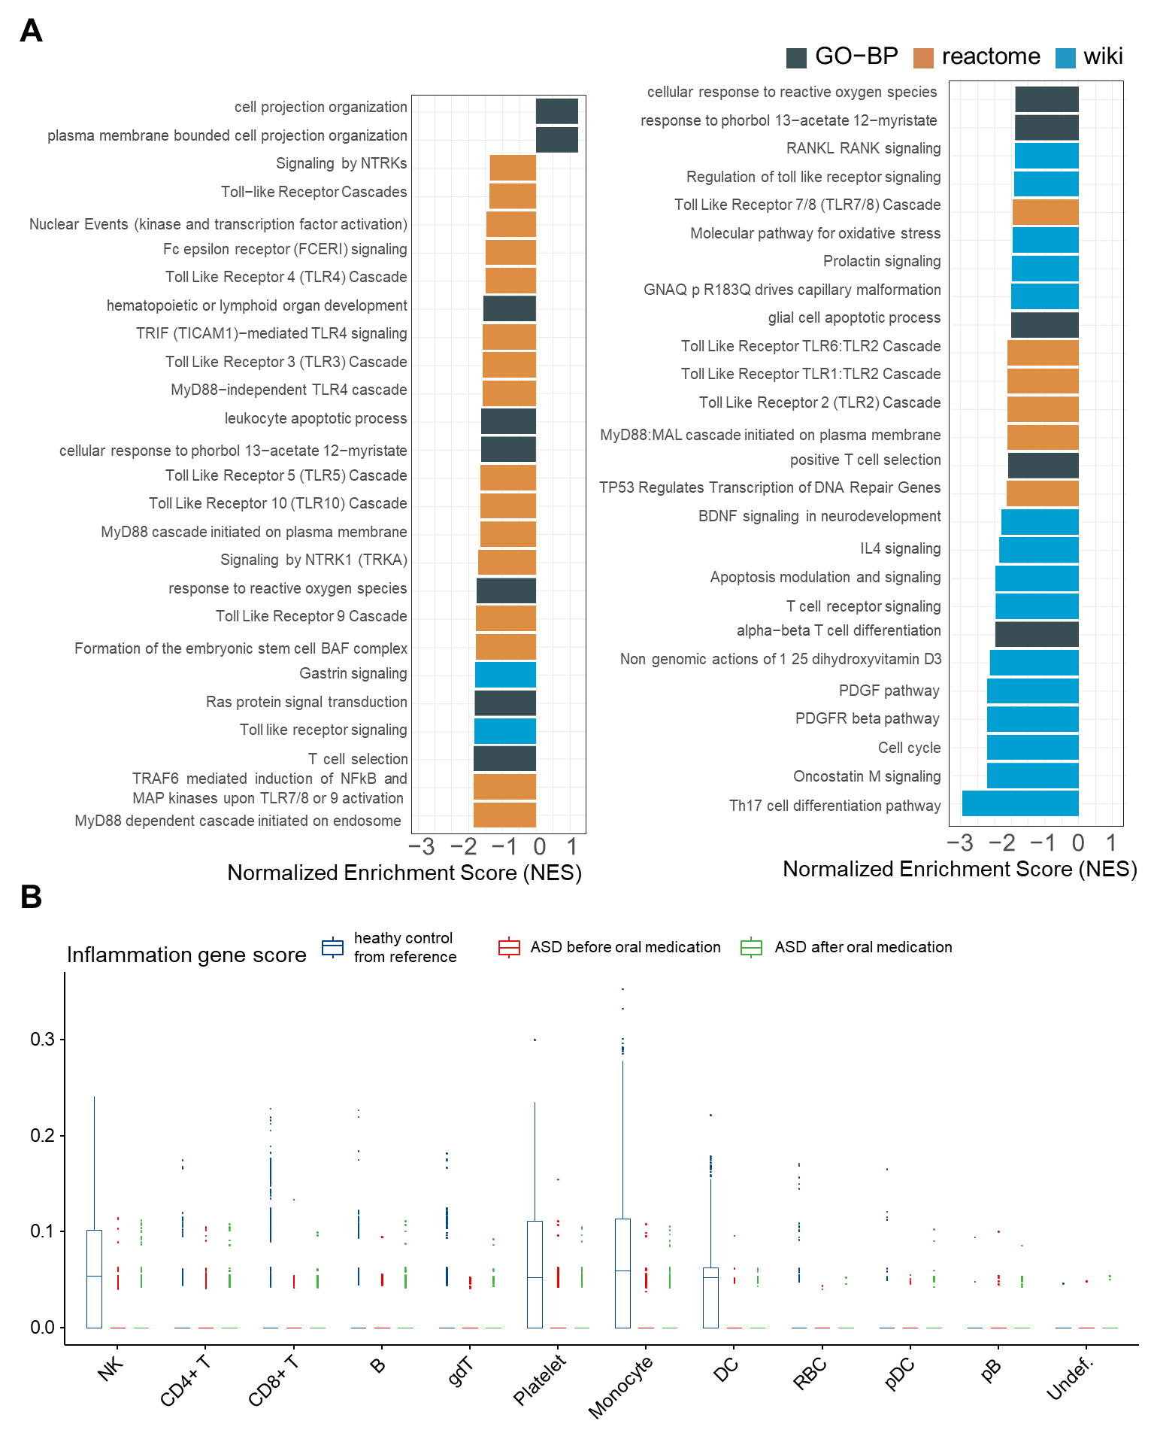
Enrichment analysis using DEG in IL7R^{low} naive CD4 T cell subtype
- Functional enrichment analysis of GO-BP, Reactome, and WikiPathways of differentially expressed genes between the patients with ASD before L-serine treatment and the healthy controls. P-value < 0.05
- Box plot depicting inflammatory response gene scores in major PBMC types. Scores were calculated based on the expression of a curated set of genes, including cytokines (IFNG, IL1B, IL6, IL8, IL10, IL12A, IL12B, IL13, and TNF), chemokines (CXCL10, CCL2, CCL3, and CCL4), and molecules involved in cell adhesion and inflammatory response (ICAM1, SELE, and SELP). Colors differentiate between healthy controls (from reference, blue), patients with ASD before oral L-serine administration (red), and patients with ASD after oral L-serine administration (green). Statistical analysis results are provided in supplementary data.

Supplementary Figure 4
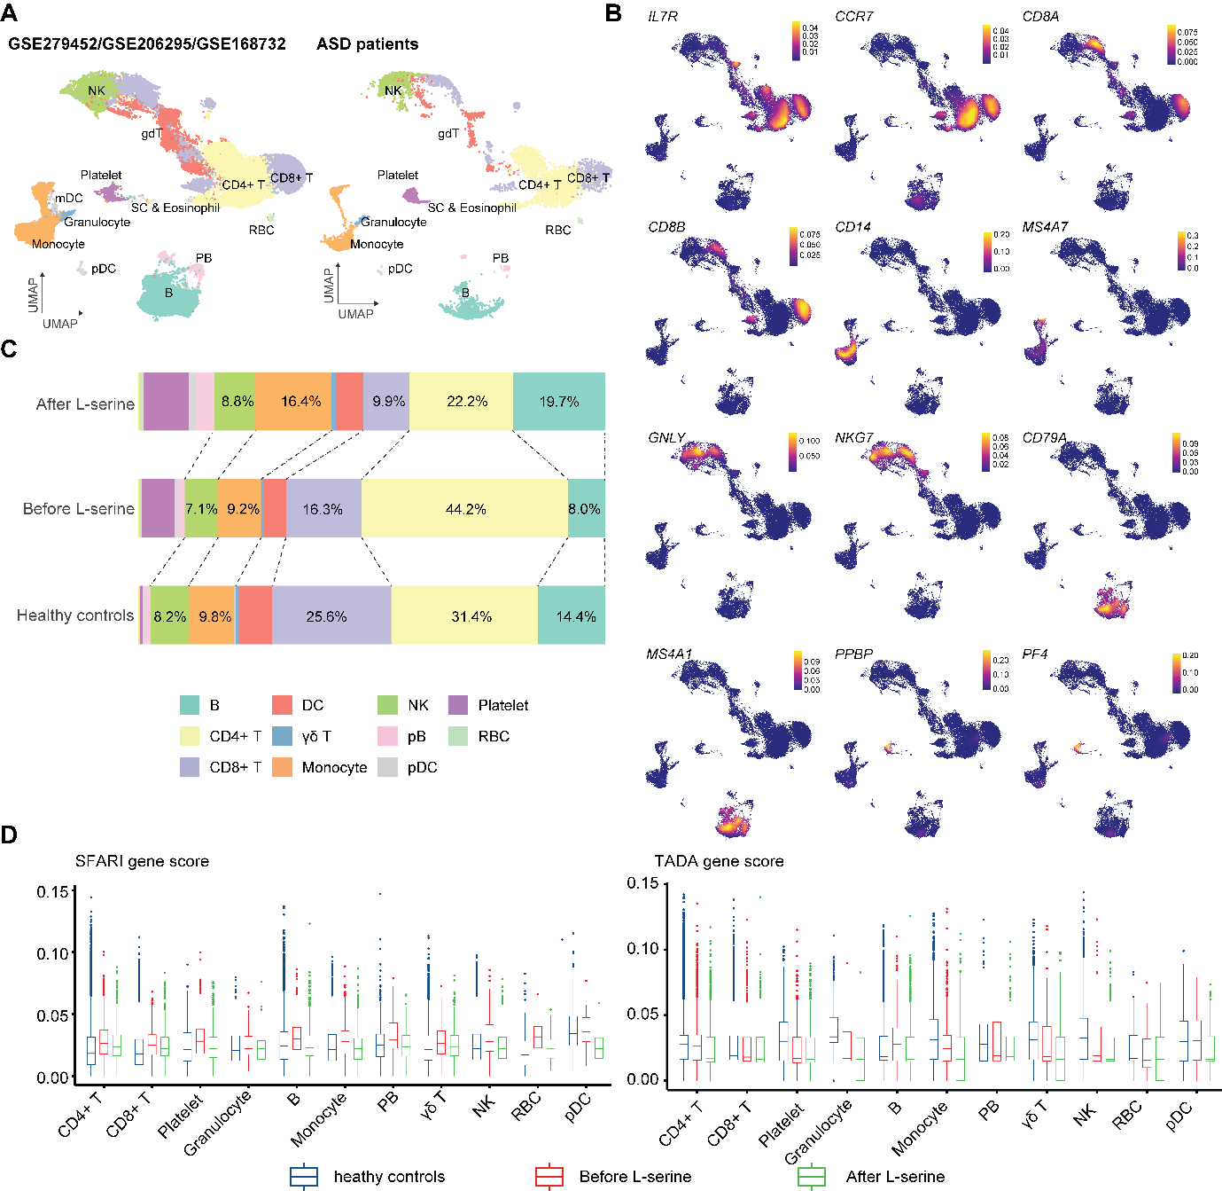
Sensitivity analysis using China/Asia-based PBMC scRNA-seq reference datasets.
- UMAP embedding of integrated PBMC scRNA-seq data from three China/Asia-based cohorts (GSE279452, GSE206295, GSE168732) with our ASD cohort, annotated by major immune cell types. Cells are colored according to their assigned cell types. pDC: plasmacytoid dendritic cells, DC: dendritic cells, NK: natural killer cells, pB: plasma blasts, γδ T: gamma-delta T cells, RBC: red blood cells. Undef.: undefined cells
- Density plots of canonical markers used for cell-type annotation (e.g., IL7R/CCR7 for CD4 T cells, CD8A/CD8B for CD8 T cells, CD14/MS4A7 for monocytes, GNLY/NKG7 for NK cells, CD79A/MS4A1 for B cells, and PPBP/PF4 for platelets).
- Distribution of cell compositions across identified cell types, using the same color scheme as in (B)
- SFARI and TADA gene-set scores across major cell types in healthy controls and patients with ASD before/after L-serine, demonstrating qualitatively consistent trends.
Supplementary Figure 5
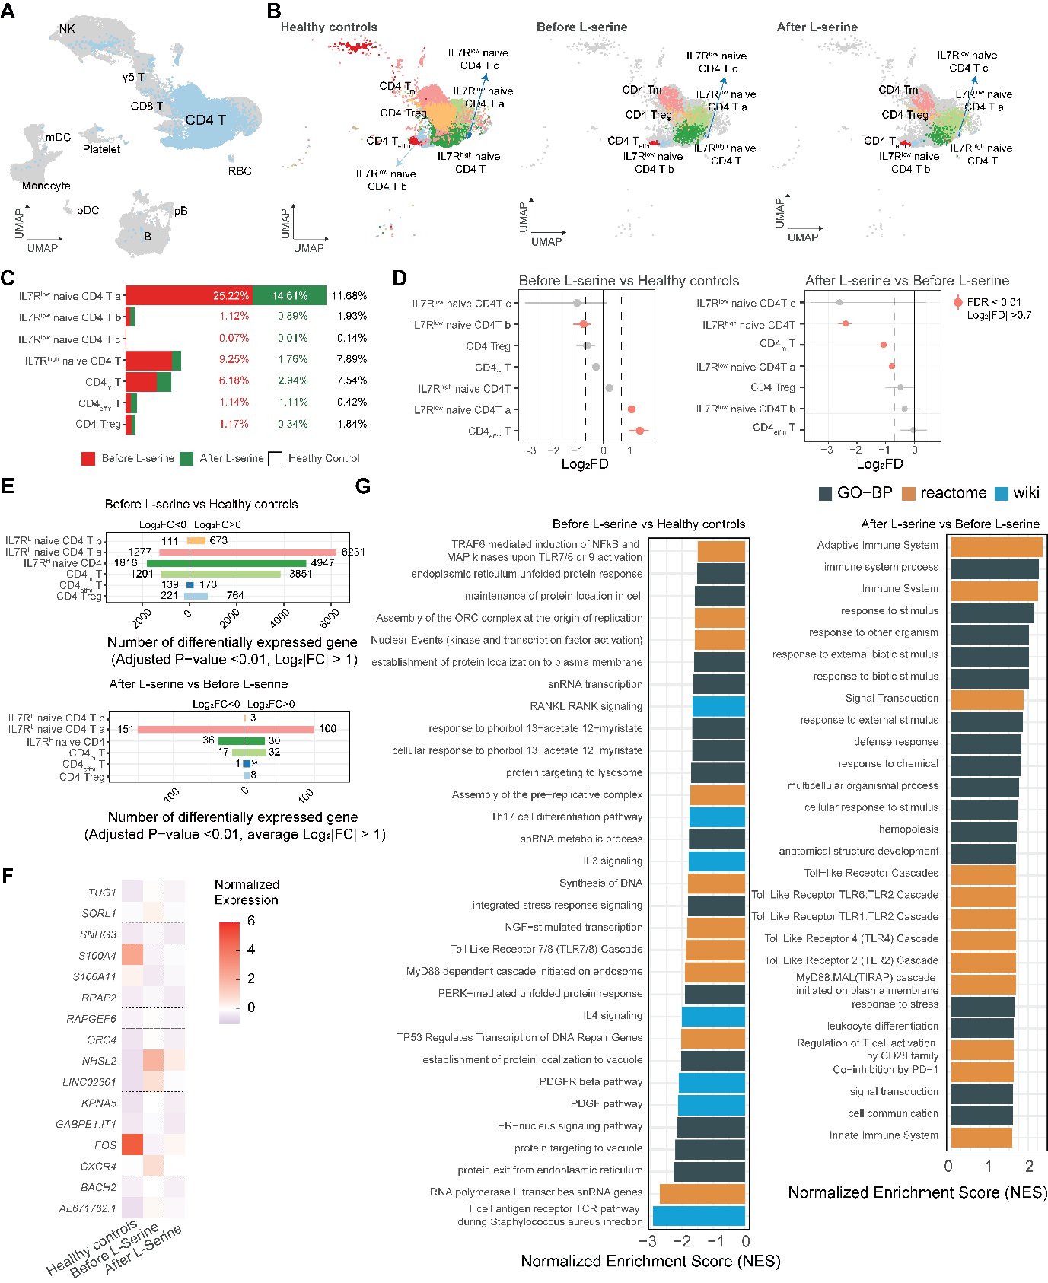
L-serine-associated composition changes in CD4 T cells in patients with ASD
- UMAP visualizing of all single PBMCs, with the 29,554 identified CD4 T cells highlighted (left panel) within the broader immune cell landscape
- UMAP embedding of the extracted CD4 T cell population, colored by annotated cell subtypes for healthy controls (n = 25,044 cells), patients with ASD before L-serine treatment (n = 2,558 cells), and after L-serine treatment (n = 1,952 cells)
- Bar plot depicting the relative proportions of each CD4 T cell subtype within healthy controls (% on the right), patients with ASD before (red) and after (green) L-serine treatment. Treg: T-regulatory cells, Tm: memory T cells, Teffm: effector memory T cells
- Permutation plots comparing the proportions of cell clusters between the patients with ASD before L-serine treatment and the healthy controls (left), and between the patients with ASD before and after L-serine treatment (right). Red circle: Adjusted P-value < 0.01, |Log2 Fold Difference| > 0.7
- Bar graphs showing the number of upregulated and downregulated genes in each CD4 T cell subtype between healthy controls and patients with ASD (top) and between patients with ASD before and after L-serine treatment (bottom). The number of differentially expressed genes was calculated using an adjusted P-value < 0.01 and average |Log₂FC| > 1.
- Heatmap showing the average expression of shared genes between the two types of differently expressed genes across all groups in the IL7R^{low} naive CD4 T subcluster. Purple indicates a negative average of normalized expression values, whereas red indicates a positive average of normalized expression values.
- Functional enrichment analysis of GO-BP, Reactome, and WikiPathways for differentially expressed genes between the patients with ASD before L-serine treatment and healthy controls (left), and between the patients with ASD before and after L-serine treatment (right). P-value < 0.05

Supplementary Figure 6
Trajectory inference and pseudotime-associated genes in CD4 T-cell development
- UMAP visualization of all single PBMCs, with the 29,554 identified CD4 T cells highlighted (left panel) within the broader immune cell landscape
- UMAP embedding of the extracted CD4 T cell population, colored by annotated cell subtype for healthy controls (n = 25,044 cells), patients with ASD before L-serine treatment (n = 2,558 cells), and after L-serine treatment (n = 1,952 cells)
- Bar plot depicting the relative proportions of each CD4 T cell subtype within healthy controls (% on the right), patients with ASD before (red) and after (green) L-serine treatment. Treg: T-regulatory cells, Tm: memory T cells, Teffm: effector memory T cells
- Permutation plots comparing the proportions of cell clusters between the patients with ASD before L-serine treatment and healthy controls (left), and between the patients with ASD before and after L-serine treatment (right). Red circle: Adjusted P-value < 0.01, |Log2 Fold Difference| > 0.7
- Bar graphs showing the number of upregulated and downregulated genes in each CD4 T cell subtype between healthy controls and patients with ASD (top) and between patients with ASD before and after L-serine treatment (bottom). Differentially expressed genes were calculated by adjusted P-value < 0.01 and average |Log₂FC| > 1.
- Heatmap showing the average expression of genes shared between the two differential expression comparisons across all groups in the IL7R^{low} naive CD4 T subcluster. Purple indicates negative average normalized expression values, whereas red indicates a positive average normalized expression values.
- Functional enrichment analysis of GO-BP, Reactome, and WikiPathways for differentially expressed genes between the patients with ASD before L-serine treatment and healthy controls (left), and between the patients with ASD before and after L-serine treatment (right). P-value < 0.05

Supplementary Figure 7
Sensitivity analysis of inferred cell–cell interactions and co-expression networks
- Heatmaps summarizing inferred cell–cell communication patterns (CellPhoneDB) among major PBMC populations, including CD4 T cells, CD8 T cells, monocytes, NK cells, RBCs, γδ T cells, and pDCs in the patients with ASD before (left) and after (right) L-serine treatment. Color intensity reflects the total number of statistically significant (p < 0.05) interactions.
- Dot plots showing selected CD4 T cell-centered LR pairs in before (top) and after L-serine treatment (bottom). Dot size corresponds to the interaction's statistical significance (larger dots indicate smaller P-values), and color intensity indicates the mean expression of the interacting molecules.
- Volcano plots showing differentially expressed genes in CD8 T cells (left), NK cells (center), and monocytes (right) highlight representative genes encoding LR and immune signaling molecules. Each point represents one gene; red denotes |Log₂ fold-change| > 0.75 and adjusted P-value < 0.1.
- WGCNA of CD8 T cells. Left: UMAP embedding of the WGCNA network. Center: Volcano plot showing differential module eigen gene (eigenvector gene) analysis, which reveals up- or down-regulation after L-serine treatment. The points are colored by their module assignment. Right: Dot plot showing GSEA of genes from brown and turquoise modules, displaying selected GO Biological Process pathways significantly enriched within these key co-expression modules.
- WGCNA of NK cells. Left: UMAP embedding of the WGCNA network. Right: Volcano plot showing changes in the module eigen gene after L-serine treatment. Each point represents a module. Bottom: plot displaying selected GO Biological Process pathways significantly enriched within the key brown and turquoise co-expression modules.
- WGCNA of monocytes. Left: UMAP embedding of the WGCNA network. Right: Volcano plot showing changes in module eigen gene after L-serine treatment. Each point represents a module. Bottom: plot displaying selected GO Biological Process pathways significantly enriched within the key brown and turquoise co-expression modules.

